Insert data to table region

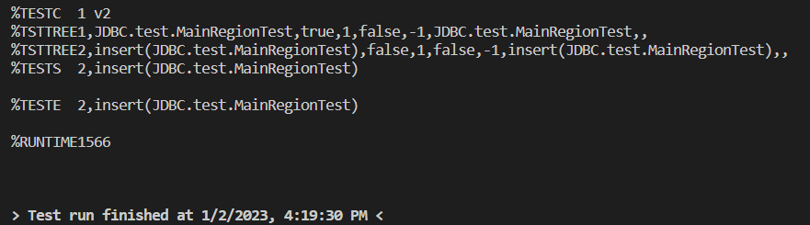

Update data from table region

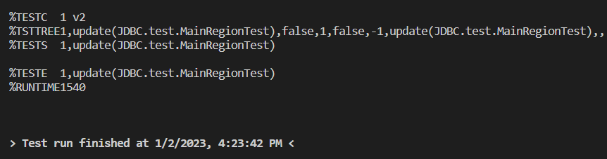

Delete data from table region

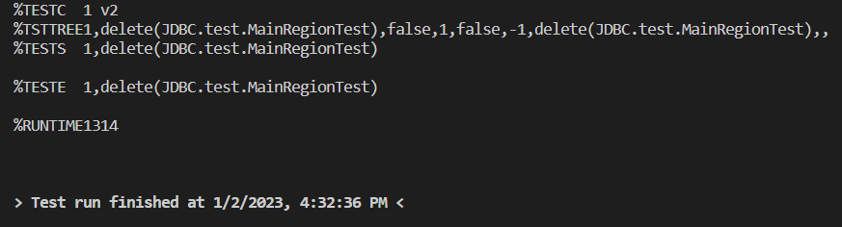

Read data by Id from table region

Insert data to table division

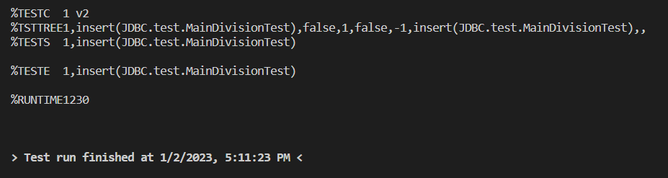

Update data from table division

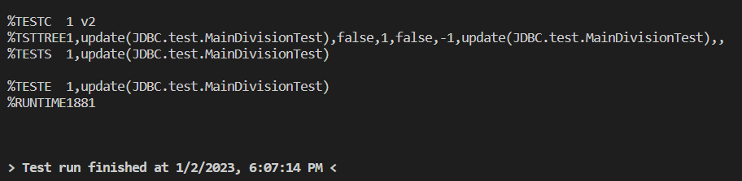

Delete data from table division

