Chapter 1. Dimension Reduction Problem in Petrophysics
Abstract
There are many physical and chemical properties of rock you deal with when studying its interactions with fluids. Though call is to define which of the properties have a real impact on a process of consideration. If some factors do not make any contribution, some others may be dependent. Both situations are highly undesirable and unpleasant, however, it often happens that both are present. For them to be eliminated different techniques can be used. Common ones applied in data mining are found to be difficult in the sense of the implementation even despite their adequate efficiency. Not worse and often better results may be obtained with the use of the fractal dimension concept which is also cost-effective. This method is well-known and seems to be the best choice for addressing dimension reduction tasks and particularly those from petrophysics.

Nomenclature

Symbols | Definitions
E | embedding space, number of dimensions
D | fractal dimension (FD)
D1 | FD estimate calculated with formula 1-1
D2 | correlation FD (see equation 1-2)
n | number of samples
m | number of columns
N(δ) | number of filled boxes of size δ
C_{δ,i} | count of points in cell i
δ | size of m-dimensional cell (box); length of its side
r | scale factor
y | predicted attribute
x | predictive attribute
delmin | minimal size of a cell

1.1 Fractals and Fractal Dimension
A fractal dimension (FD) is an index for characterizing patterns or sets by quantifying their complexity as a ratio of the change in detail to the change in scale [1]. For self-similar fractals mathematically it can be stated as follows:

where N is the number of parts of a scaling factor ϵ which cover the original set.

In contrast to the topological dimension, FD can be fractional and usually exceeds the first. They coincide on Euclidean objects, which seem familiar to us in terms of perception, however, the latter are only mathematical abstracts and our world is replete with fractals. For instance, it is coastlines, clouds, mountains, treetops, snowflakes, circulatory system, alveoli.

To better understand the concept of fractional dimension one can grasp by a specific example. In Section 1.5 we will consider the Sierpinski triangle which FD dimension is about 1.58. It has an infinite perimeter, so it is not a 1-dimensional object. And it has no area, so it is not 2-dimensional.

For a real dataset which preserves the property of self-similarity on the range of scales from r₁ to r₂ one can choose the appropriate estimate for their purposes. In this report we have tested and used box-counting and correlation dimensions, which are defined below respectively:

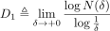 (Equation 1 - 1)

(Equation 1 - 2)
1.2 Box-counting method
This section presents an algorithm to compute the FD of any given set of points in any E-dimensional space. Theoretically, the box-counting approach gives a close approximation of the FD and we will see it in Section 1.5. The main idea is quite straightforward. One builds a histogram of a given set and applies formula (1-2). Or you can just count the number of boxes which contain at least one point. In this case, formula (1-1) works. The tricky part is to implement the algorithm and make it more efficient. In the designed program it takes the same amount of steps – each of constant cost – as the number of points to build one histogram. You can construct a lot of histograms but, likely, it would be far fewer than n. So the time-complexity is O(n). Since we do not have to know anything about empty boxes, the memory used is bounded above by n. This implies O(n) memory complexity.

1.3 Application to a dataset
The way of applying the method to data depends on data. As it was shown in [2], with the help of the FD concept one can spot attributes that have nonlinear and even non-polynomial correlations. If we have x₁,…,x_{m} predictive attributes (let X be their union) and one attribute y which is to be predicted the feature selection algorithm is divided into 2 parts.
The first is to find all the independent attributes according the following algorithm:
Algorithm 1 -1
input: X, threshold t
output: list of independent attributes B within the set X, and its fractal dim. D
Begin
1. Compute the fractal dimension D of X;
2. Initially set all predictive attributes as the significant ones, the whole fractal dimension as the current D, and β as + inf.
3. While there are significant attributes and β > t do:
4. For every significant attribute i, compute the partial fractal dimensions pDi using all significant attributes excluding attribute i;
5. Sort the partial fractal dimensions pDi obtained in step 4 and select the attribute ɑ which leads to the minimum difference (current D - pDi ) and set β to the maximum one.
6. Set the pDi obtained removing attribute ɑ as the current D;
7. Output attribute ɑ and remove it from the set of important attributes;
End

The algorithm below described the steps to take in the second part:

Algorithm 1 - 2
input: list of independent attributes B, its fractal dim. D and another threshold t = 0.9
output: list of informative and independent features C
Begin
- For every attribute b_{i} in B, compute the pD_{i} of the set (B U y) / b_{i} (extraction with return) and calculate the values D – pD_{i}
- Select b_{i} for which D – pD_{i} > t and remove them from B
End

If there is no predicted attribute the process of the feature selection is reduced to one first step

1.4 Carrying out an experiment
The points generation starts from the half size of the smallest dimension and proceeds either to the average pair distance in set or to its minimum value — two variants of delmin initialization. One can set the number of points n, which will be evenly spaced in log-scale of the chosen range. The default value is 20 and it already guarantees the ability to visually determine the segment of linear dependence. From here you can manually specify the borders of a fitting with a line or fit the entire graph with a kind of sigmoid function and get the value of its derivative in the focal point. In the last case there is a loss in accuracy: the resulting values are slightly greater than those which are precise.
1.5 Algorithm Justification
For an algorithm validation an image of the Sierpinski triangle was converted to a 2d array of positions of filled pixels and passed to the program input. The calculated D1 and D2 do not differ from the expected value 1.58 within 2 digits accuracy. The Sierpinski triangle is derived from an equilateral triangle. At each step triangles built on the middle points of triangles from the previous step are removed. The object resulting in the infinite number of iterations is what is called Sierpinski triangle. Since one triangle generates three of half size, D = log3/log2 ~ 1.58. Though, this proves that the program works properly and its results may be treated and interpreted.

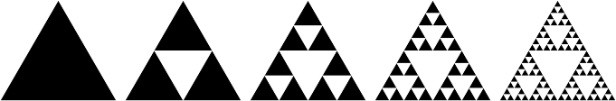
Figure 1 – 1. The Sierpinski triangle generation
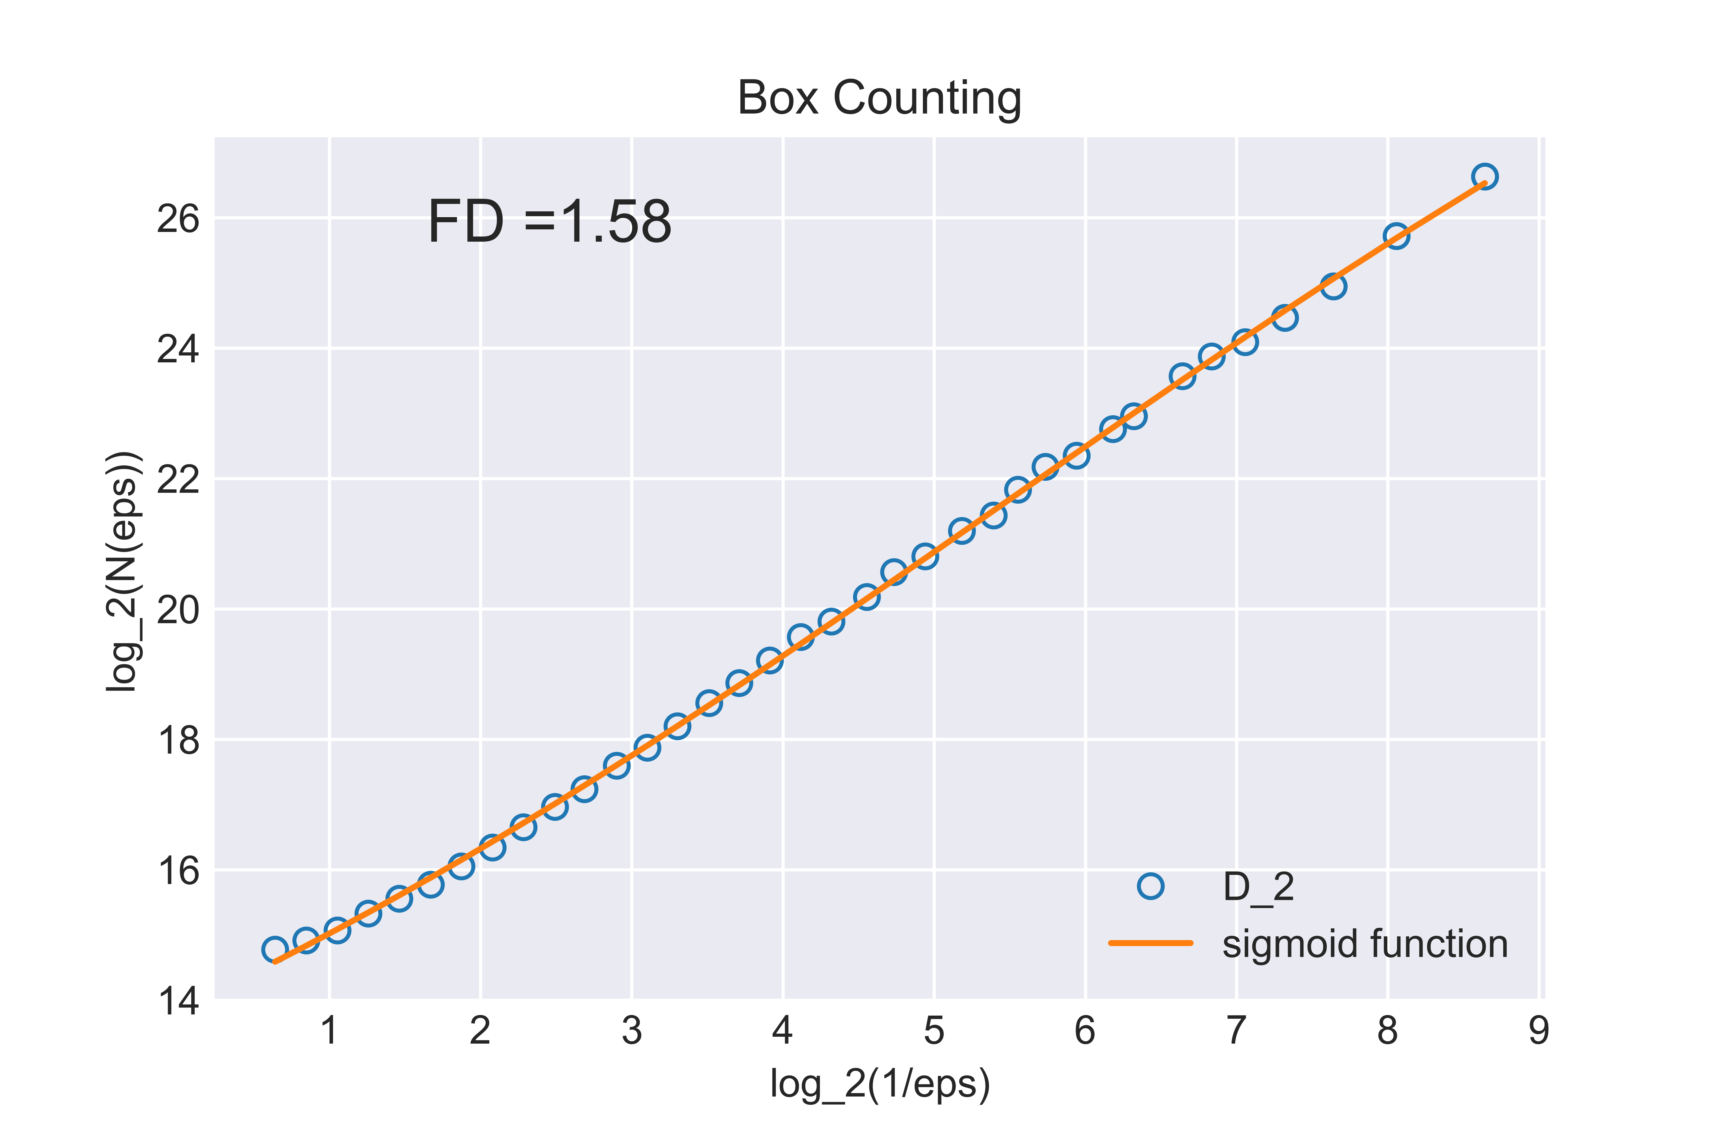
Figure 1 – 2. The box-counting plot for the Sierpinski triangle image

1.6 Results
- Synthetic Data
The table below presents the results of an algorithm execution on the data with n = 50 000 samples.
As the value of delmin minimum pairwise distance is chosen. The slope was calculated with a lsq fitting of line segment with a first degree polynomial (i.e with line). The program is written on Python, so the running time is several seconds. If rewritten in C++ code or with Cython for example, it may become many times faster, however, it is not the point of this report. The experimental data were synthesized with np.random. Each value of the parameters is generated from the uniform distribution on the range [0.1, 3). Equal boundaries for all attributes correspond to the scaling procedure which is necessary when dealing with real data. As well as the normalization which is accounted in the sense that all features are identically distributed. Now about what the data is. There was no need to attach some kind of physical meaning to the data at this stage, nevertheless, the predicted attribute is a flow rate in a flat pipe and predictive features are the pressure gradient dp/dx (in the table below it is simply referred to as dp), the pipe radius h and the quantity a which is reciprocal to the viscosity.

Attributes |  | D₂
1 | 'a', 'dp', 'h', 'red1', 'y' | 3.99
2 | 'a', 'dp', 'h', 'y' | 3.00
3 | 'a', 'dp', 'h', 'dp+h', 'dp*h', 'y' | 3.16
4 | 'dp', 'h', 'y' | 2.43
5 | 'a','dp', 'h', 'red1', 'dp*h', 'y' | 3.96
6 | 'red1', 'red2', 'red3', 'y' | 3.96
7 | 'a', 'h', 'dp*h' | 2.76
8 | 'dp', 'h', 'sqrt(dp)*h+exp(h)*dp**2' | 1.93
9 | 'red1', 'red2' | 1.99
10 | 'a', 'y' | 1.71
11 | 'dp', 'y' | 1.73
12 | 'red1', 'y' | 1.99

Table 1 – 1. FD estimates for different attribute sets. Here redi is a non-informative (“redundant”) attribute which does not affect the flow rate y.

What we can see here is that appending informative features which are not “new” (i.e. they depend on the attributes which are already in the set) almost does not alter the FD (rows 3,5,8), even if the dependence is non-linear (row 8). When removing or adding “noisy” features the FD goes up or down by 1 (rows 1,5,6,9,12). Therefore, the algorithms 1-1, 1-2 are correct and can be built and exploited on real problems.

- Real Data
The collected data contains information on 12 features obtained for different rocks (about 350 samples). There are categorical features like lithotype, sample diameter, age of rocks and so on. The continuous data are bulk and mineral density, absolute permeability, solubility of salts and etc.
Like most real datasets, this one is not without missing values (see figure 1-3)
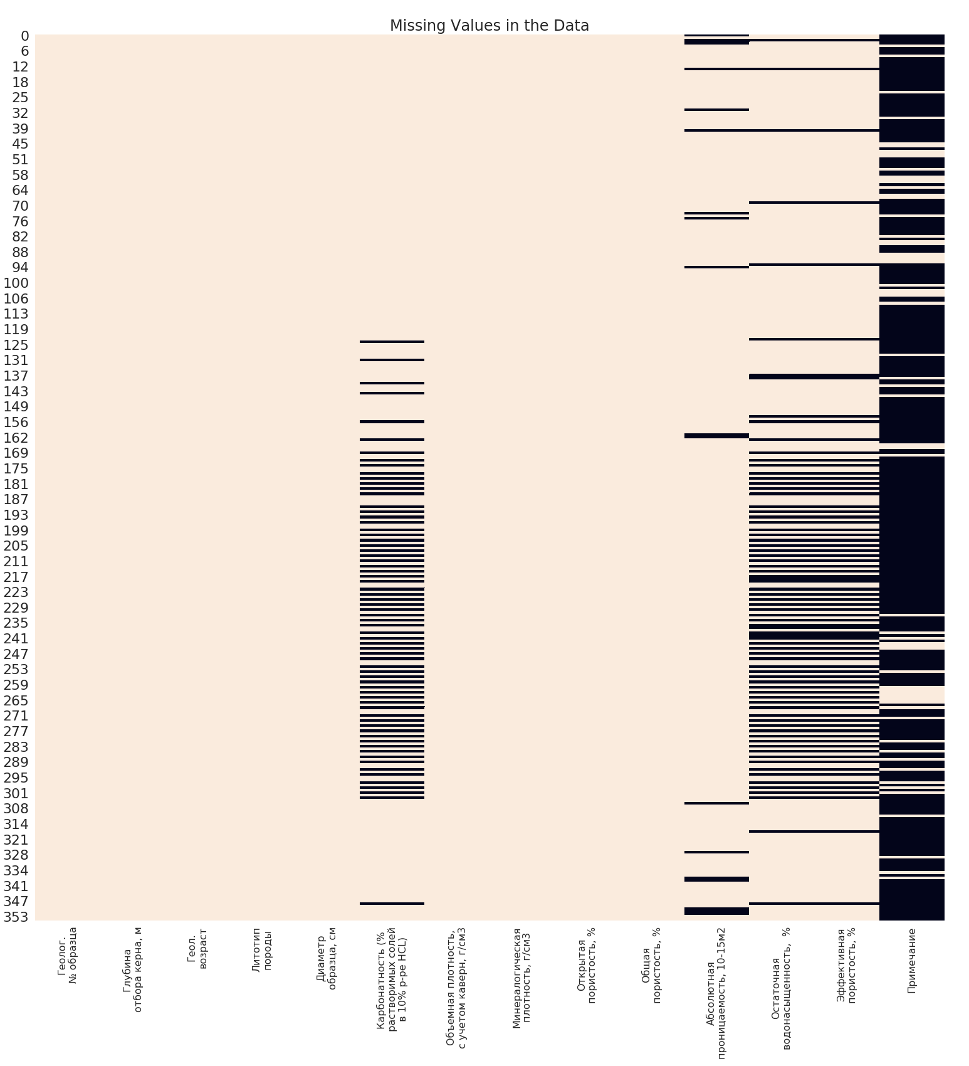
Figure 1 – 3.
Missing values in the Dataset
Labels from left to right: Геолог. № образца; Глубина отбора керна, м; Геол. возраст; Литотип породы; Диаметр образца, см; Карбонатность (% растворимых солей в 10% р-ре HCL); Объемная плотность, с учетом каверн, г/см3; Минералогическая плотность, г/см3; Открытая пористость, %; Общая пористость, %; Абсолютная проницаемость, 10-15м²; Остаточная водонасыщенность, %; Эффективная пористость, %; Примечание

The simplest way of processing NaNs is to drop them out. This approach makes our experiment feasible (all points for which we count must be of the same dimension – zero completion leads to obvious result: dimension flattening - FD decreases) and releases from taking into account any factors connected with a method of data imputation. However, it reduces the number of samples by 100 (~30%). Still we are agree with that. Discarding the last column (it is almost empty) and rows with at least one value missing, we compute FD for the resulting dataset and check whether our findings are consistent with what is obtained by other dimension reduction methods.

Let us start with the Pearson correlation coefficient (PCC). For N attributes we get a square matrix of height N. Its entries can drop a hint: between which two features there is a dependency (generally, it is about linear dependence). From figure 1-4 we conclude that in the dataset there are some features are (anti)correlated. For example, apparent porosity (открытая пористость) and total porosity (общая пористость), bulk density and total porosity, and so on.
Calculating for these pairs of features FD we get the similar results: for apparent porosity and total porosity – FD = 0.96. (see figure 1-5) So, we can proceed testing the suitability of the method based on FD by comparing it with other classes of dimensionality reduction methods.

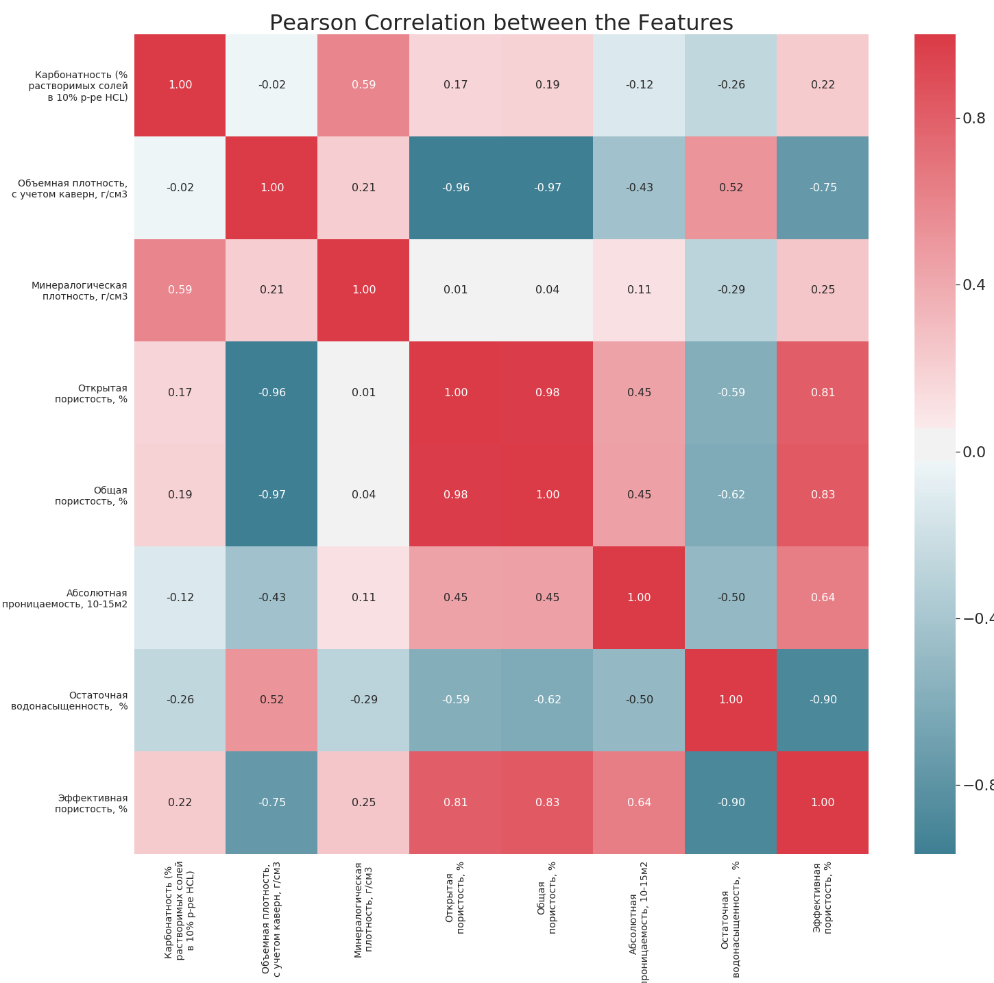
Figure 1 – 4.
Pearson Correlation Matrix for the presented set of features
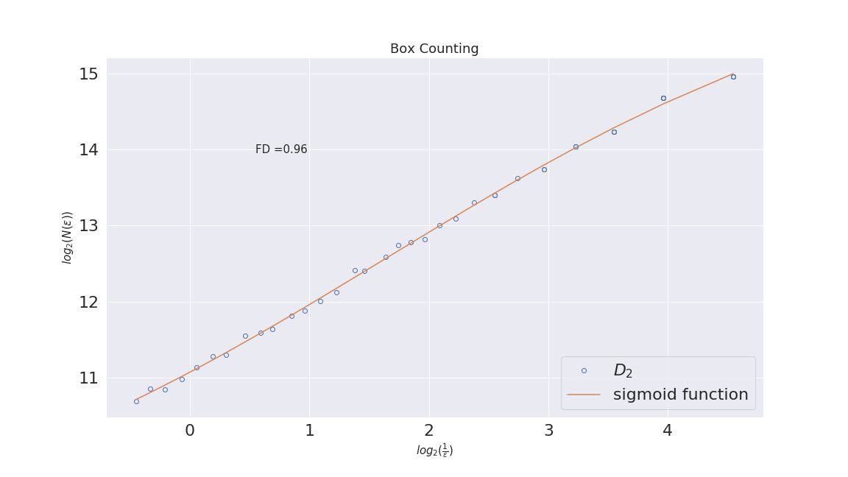
Figure 1 – 5.
FD estimate for total porosity and apparent porosity

Quite effective approach in feature selection is LASSO method. It is linear regularization model which performs both variable screening and regularization. We use this procedure in the following way. As a target variable we have chosen absolute permeability which we are going to predict using the rest continuous attributes in the table (5-9,11,12 columns). We train the model by selecting weights w which minimize the cost function L(X) = ¹/_{N} Σ _{i} <w,x_{i}> + ¹/₂ C||w||₁. Here ||w||₁ = Σ _{i} |w_{i}|. The optimal value of the hyper parameter C we choose from cross validation procedure (3-fold). At the end of the oprimization we get 3 features kicked out: bulk density, mineral density, apparent porosity.

Feature | Weight
Карбонатность | -1.49
Объёмная плотность с учётом каверн | 0.0
Миниралогическая плотность | 0.0
Открытая пористость | 0.0
Общая пористость | -13.84
Остаточная пористость | 4.37
Эффективная пористость | 43.44

Table 1 – 2. Feature weights in LASSO model

So, what we can do, is to calculate FD for the same set, eliminate the same 3 features, calculate it again, and check if FD has not changed. And this holds true:
Before discarding zero-weight features FD = 1.434
After FD = 1.429

Dubious part
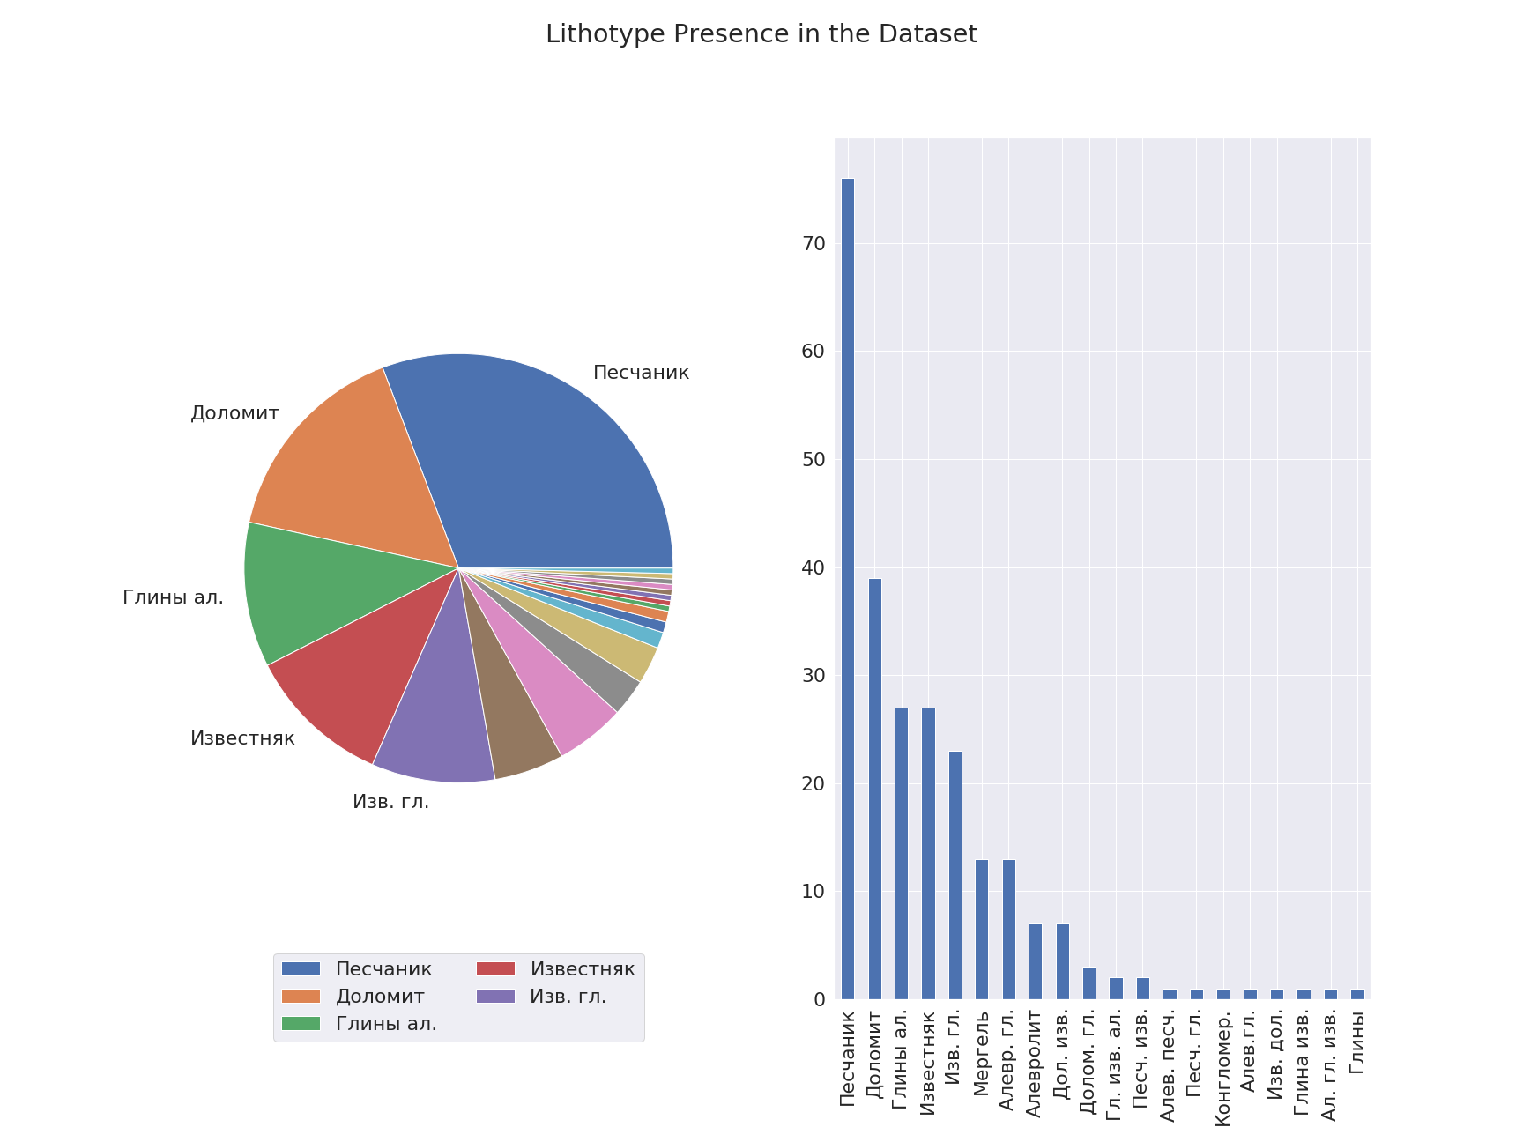
One thing that would be interesting to check is whether for different kind of rocks it is different sets of key features. We can get a quick answer to this using FD estimate. Let us start with showing some statistics. As it can be seen from the histogram plot, we do not have much data about the features separately. So, for calculated FD estimates we likely cannot draw reliable conclusions.

Figure 1 – 6.
Lithotype distribution in the dataset

Lithotype | FD
sanstone | 1.13
dolomite | 1.32
limestone | 1.75

Table 1 – 3. FD estimates for 3 chosen largest categories (before the imputation)

We can try to improve the situation by appending the samples which were dropped out during data processing having imputed (with MICE method) the missing values.
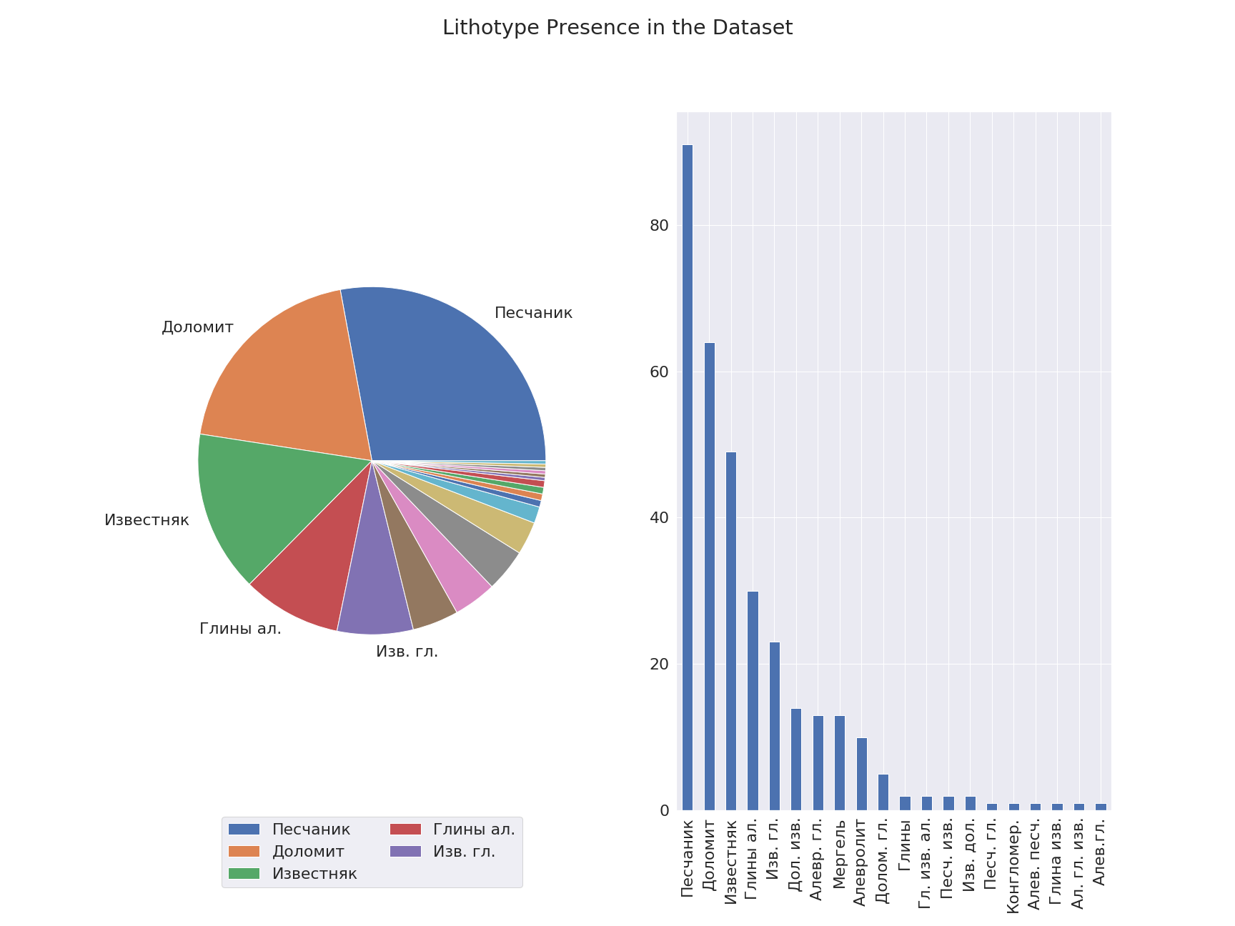
Figure 1 – 7.
Lithotype distribution in the dataset after the missing values imputation

Lithotype | FD
sanstone | 1.12
dolomite | 1.58
limestone | 1.62

Table 1 – 4. FD estimates for the chosen lithotypes after the data imputation

It is difficult to conclude whether the change in the dolomite’s and limestone’s values of FD are connected with the inappropriate data imputation or data instability due to lack of the samples.
Probably, it is the former, since the largest number of object which were thrown out initially (and then re-added after the imputation) are exactly dolomite and limestone.
Despite it is probable that for different lithotypes there are different dependencies, it remains unconfirmed.

1.7 Conclusions
In this chapter, we have discussed a usual implementation of feature selection with fractal dimension for colinear attributes and proposed a variant of screening of non-informative noisy features. The effectiveness of the method has been validated on the synthetic data and real data as well.

References
- Wiki-article about fractals https://en.wikipedia.org/wiki/Fractal
- C. Triana, A.Triana, L. Wu et al. “Fast feature selection using fractal dimension”
https://pdfs.semanticscholar.org/6205/f55544b7409bf4b356a263d187e8b503298c.pdf

