CSID 6823 Assignment 2 – Explanation of the Visualisations

Dashboard 1

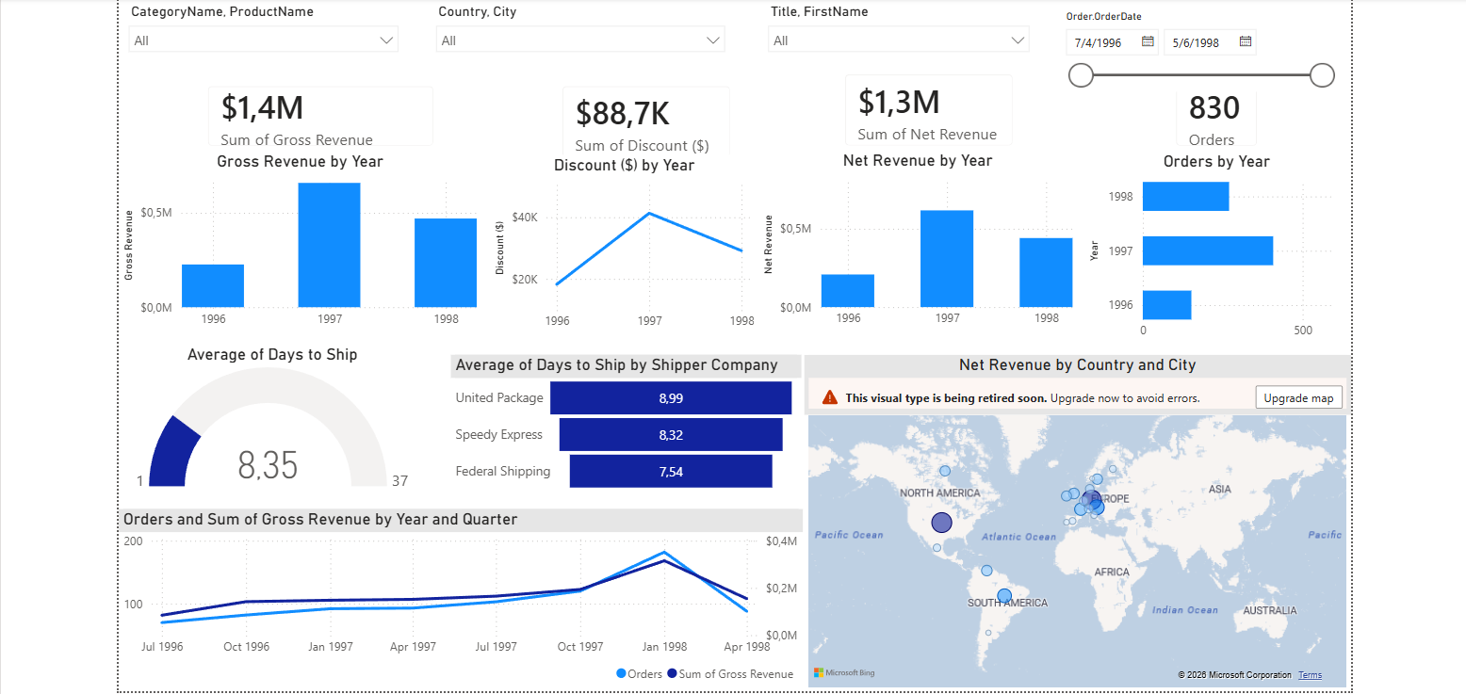
Slicers:
Four slicers were placed across the top of the page: CategoryName/ProductName, Country/City, and Title/FirstName were each built as two-level hierarchy slicers (dragging both fields into the same field well), formatted to the Dropdown style with "Select All" enabled. The OrderDate slicer uses the "Between" option, so it renders as the date-range control with start/end date pickers and a slider.

KPI Cards + Year Charts
- Sum of Gross Revenue - Card visual, formatted to currency with 1 decimal place, paired with a Clustered Column Chart ("Gross Revenue by Year") showing Sum of Gross Revenue by Year.
- Sum of Discount ($) - Card visual, same currency formatting, paired with a Line Chart ("Discount ($) by Year") rather than a column chart, since the original highlights the rise-then-fall trend shape of the discount total across the three years.
- Sum of Net Revenue - Card visual, paired with a Clustered Column Chart ("Net Revenue by Year"). X–axis by OrderDate (Year) and Y-axis by Net Revenue (sum)
- Orders - Card visual using the Orders measure, paired with a horizontal bar chart ("Orders by Year") rather than a column chart, so the Year labels stay horizontal and legible. For all four chart titles, the x-axis title was toggled off in Format Visual → X-axis, to match the clean look of the target dashboard.

Gauge:
Average of Days to Ship gauge visual was used, with Value = Average of Days to Ship, Minimum = Min of Days to Ship, Maximum = Max of Days to Ship. The Days to Ship column initially produced an incorrect (negative) average because rows with no ShippedDate were being treated as 0 rather than excluded. This was resolved by updating the DAX formula to return BLANK() whenever either OrderDate or ShippedDate was empty (`Days to Ship = IF ( ISBLANK ( Order_Details[Order.OrderDate] ) || ISBLANK ( Order_Details[Order.ShippedDate] ), BLANK (), Order_Details[Order.ShippedDate] - Order_Details[Order.OrderDate] )`), after which AVERAGE correctly ignored those rows and the gauge displayed 8.35, matching the target. The title was renamed to "Average of Days to Ship" and centered horizontally.
Funnel Chart:
I used an Average of Days to Ship by Shipper Company A funnel chart rather than a plain bar chart, since the target's decreasing-width horizontal bars match Power BI's funnel shape. Category = Shipper CompanyName, Values = Average of Days to Ship. Data labels were set to "Inside center" with content "Data value", and the default conversion-rate labels were turned off since they aren't relevant to this non-sequential comparison.
Map:
Net Revenue by Country and City A Map visual was used with Location = Country, City added for drill capability, and Bubble size = Sum of Net Revenue. For the colour, a gradient was applied via Format Visual → Bubbles → Colors → fx (conditional formatting), set to Format style "Gradient" with Minimum = near-white/light blue, a Middle value in mid-blue, and Maximum = Navy. This produces bubbles that scale in both size and colour intensity with Net Revenue, keeping the map to a single accessible colour family rather than one colour per country.

Dual Line Chart:
Orders and Sum of Gross Revenue by Year and Quarter A Line Chart was used with the OrderDate hierarchy (Year, Quarter) on the x-axis, Orders on the primary y-axis, and Sum of Gross Revenue on a second y-axis. The legend was moved to bottom-right, both axis titles were turned off, and the second y-axis was formatted to currency so it displays with a $ prefix.

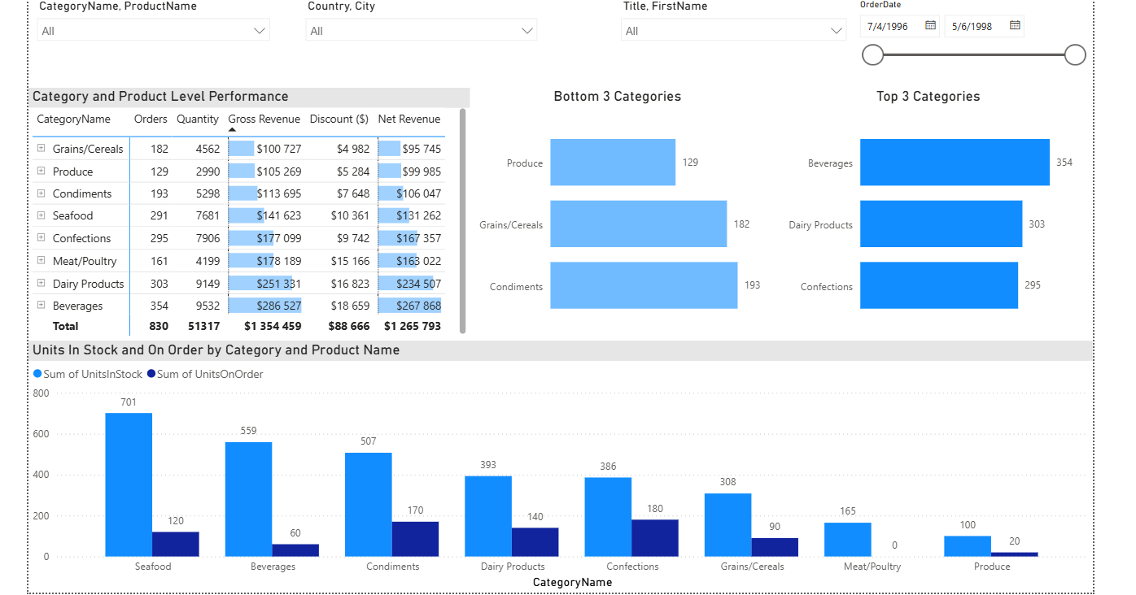
Dashboard 2

Matrix:
Category and Product Level Performance A Matrix visual was used (not a plain Table) so that CategoryName and ProductName could be placed together in the Rows well as a two-level hierarchy, producing the expandable "+" icon next to each category. Values added were Orders, Quantity, Gross Revenue, Discount ($), and Net Revenue, each renamed from their default "Sum of..." labels to the plain field names shown in the target. The three currency columns were formatted to currency with 0 decimal places. Data Bars conditional formatting was applied to the Gross Revenue and Net Revenue columns,. A Total row was enabled at the bottom. Sort by ascending

Top 3 Categories:
A Stacked Bar Chart (horizontal) was used: the category field in the Y-axis, the metric field in the X-axis. A Top N filter was applied (3 items, by value) to isolate Beverages, Dairy Products, and Confections. Both axis titles were removed for a minimalist look, and data labels were turned on with position "Outside end" so the exact values sit beside each bar.

Bottom 3 Categories:
The same Stacked Bar Chart (horizontal) type was used. A Top N filter set to "Bottom 3" by value was applied first; an additional advanced filter ("does not contain: Meat/Poultry") was layered on top to exclude an item that was otherwise distorting the bottom-3 selection, allowing the correct next-lowest categories to populate. Axis titles were removed, vertical gridlines turned off, and data labels set to "Outside end," matching the Top 3 chart's styling for visual consistency.

Drill-Down Column Chart:
Units In Stock and On Order by Category and Product Name A Clustered Column Chart was used, with CategoryName and ProductName both placed in the X-axis well (in that order) to build the drill hierarchy. Sum of UnitsInStock and Sum of UnitsOnOrder were placed in the Y-axis well, with the legend relabelled and recoloured to Blue (UnitsInStock) and Navy (UnitsOnOrder). The chart was sorted descending by Sum of UnitsInStock so categories with the highest stock align left to right. The single-click drill-down icon was enabled in the visual header so that clicking a category bar (e.g. Seafood) drills directly into that category's individual products, matching the before/after behaviour required by the brief.

Dashboard 3
Overall Idea:
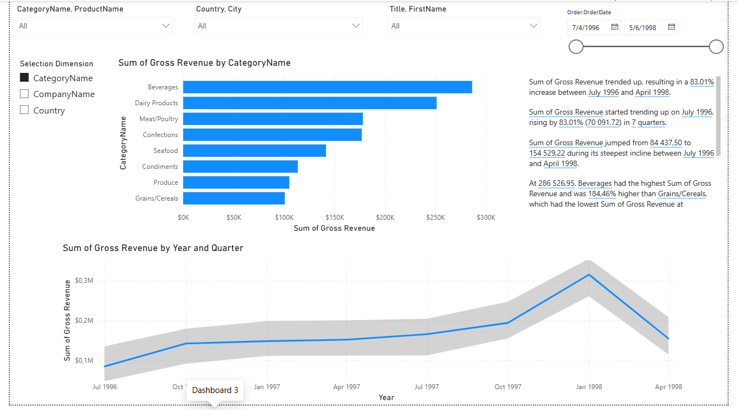
I designed it around a single theme rather than picking features at random: letting the viewer *investigate* the data instead of just reading fixed totals, since that's what Dashboards 1 and 2 already do well. I settled on four features that each let the user ask a different kind of question, is anything unusual in the trend, how does performance break down if I choose my own dimension, and what's the one-sentence takeaway.

Field Parameter - Selection Dimension:
Idea: Different people care about different breakdowns of the same revenue number — Category, Supplier, or Country. Rather than building three separate bar charts and forcing one fixed view, I wanted a single chart the viewer could re-aim themselves.
Steps: Went to Modeling → New parameter → Fields. - Named the parameter "Selection Dimension." - Added Categories[CategoryName], Suppliers[CompanyName], and Suppliers[Country] as the swappable fields. - Clicked Create — this auto-generated a backing configuration table in the Fields list and dropped a single-select slicer onto the canvas. - Positioned the slicer on the left side of the page so it visibly controls the chart beside it.

Dynamic Bar Chart (Field Parameter Integration)
Idea: This is the payoff for the Field Parameter above, one chart that changes what it's grouped by, instead of three static charts competing for space.
Steps: Added a Clustered Bar Chart (horizontal) to the canvas. - Dragged the Selection Dimension field parameter into the Y-axis (category) well. -Dropped Sum of Gross Revenue into the X-axis (value) well. - Set an explicit currency format on the Sum of Gross Revenue field so values display consistently regardless of which dimension is selected.
Result: toggling the Selection Dimension slicer instantly swaps the chart's labels between Category names, Supplier names, or Countries, without needing a second or third chart.

Smart Narrative
Idea: Not every viewer wants to interpret a chart, some just want the headline answer in a sentence. I wanted at least one element on the page that states the key finding outright rather than requiring the chart to be read.
Steps: Selected the Smart Narrative visual from the Visualizations pane and positioned it in the upper-right corner. - Let Power BI's engine automatically evaluate the page's visuals and generate natural-language summary lines (trend direction, percentage change, top/bottom rankings). Clicked the floating + Value option to add two custom dynamic values on top of the auto-generated text: one pulling the specific CategoryName with the highest Sum of Gross Revenue, and one pulling the specific CompanyName with the highest Sum of Gross Revenue, so the single most useful fact is stated directly rather than left for the viewer to find in the bar chart.
Line Chart with Anomaly Detection
Idea: A plain trend line tells you direction but not whether a spike is normal seasonal movement or something worth flagging. I wanted the dashboard to surface that distinction automatically rather than leaving the viewer to guess.
Steps:
- Selected the Line Chart visual.
- X-axis: dragged OrderDate into the field well, using the date hierarchy down to Year and Quarter.
- Y-axis: added Sum of Net Revenue.
- Opened the Analytics pane (magnifying-glass icon next to the paintbrush/format icon). Scrolled to "Find anomalies" and clicked + Add. - Power BI computed a light-grey expected-range band across the timeline
- Left the Anomalies side panel open so it also shows the explanatory breakdown (e.g. Sales Representative as a contributing factor to that spike).

