​分鏡表（Film Story Board）​​₊
​製表日期：​​ 2025 11.26​製表人：​​ 刘啟师​頁碼：​​ 1
場次 SLATE | 鏡頭 TAKE | 分鏡畫面 | 聲音說明 AUDIO | 畫面說明 VIDEO | 景別與運鏡方式 | 时间 | 感想
1 | 1 | 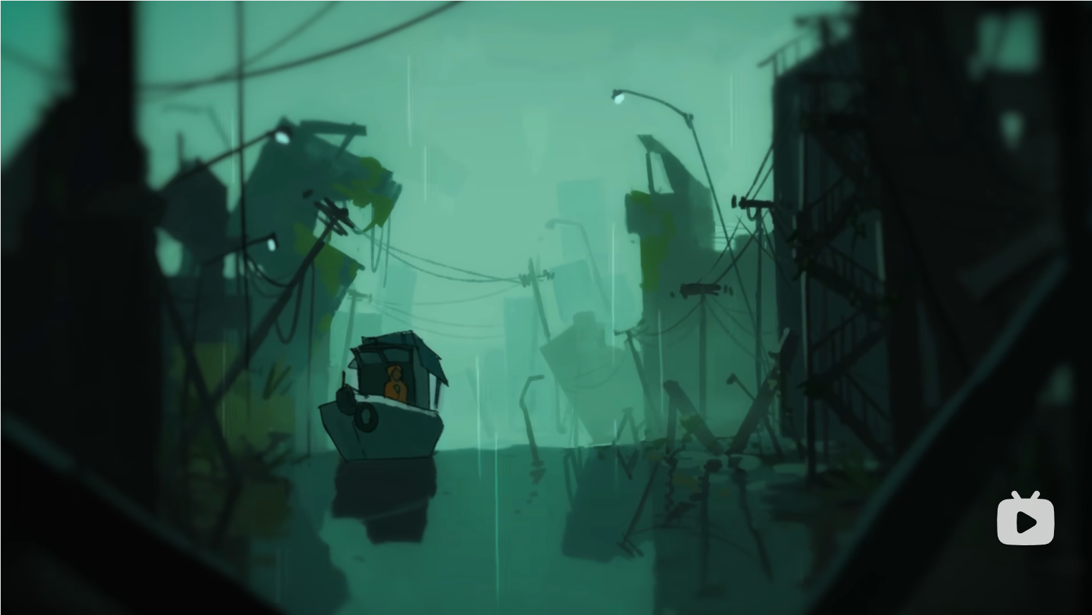 |  |  |  | 3
1 | 2 | 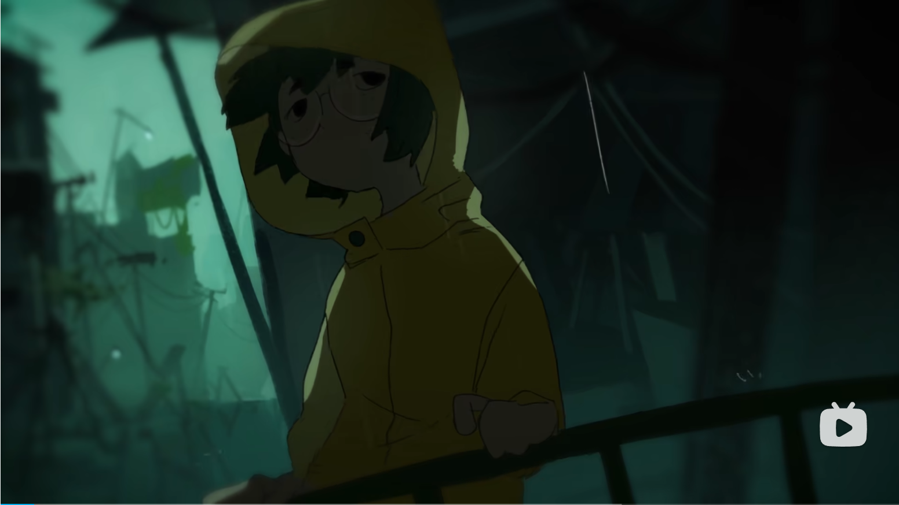 |  |  |  | 1
1 | 3 | 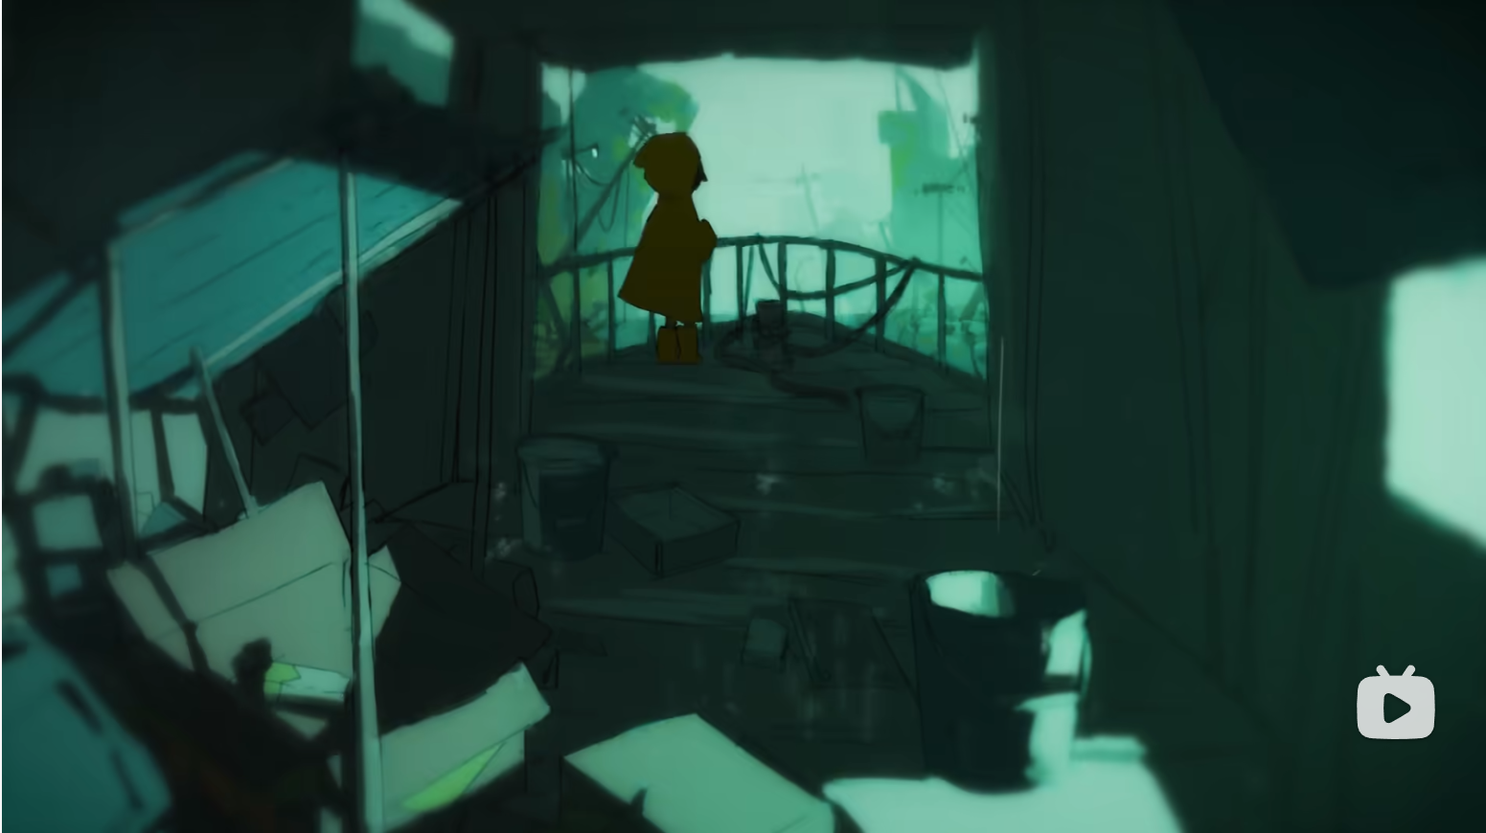
2 | 5 | 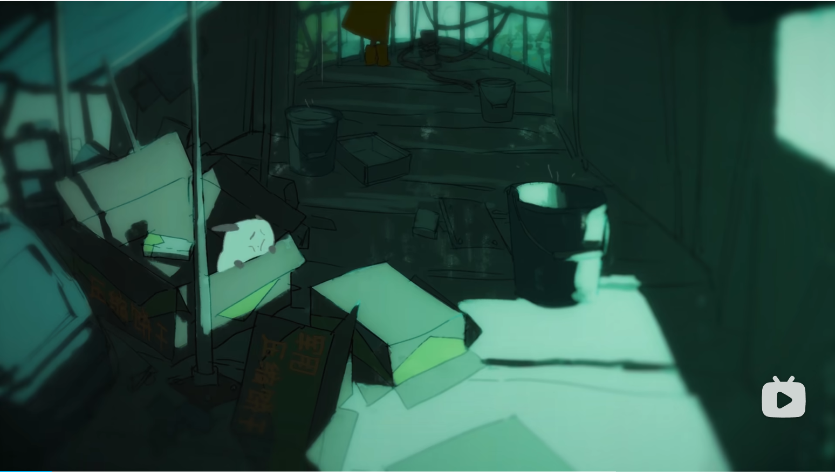 |  |  |  | 4
3 | 6 |  |  |  |  | 1
3 | 7 | 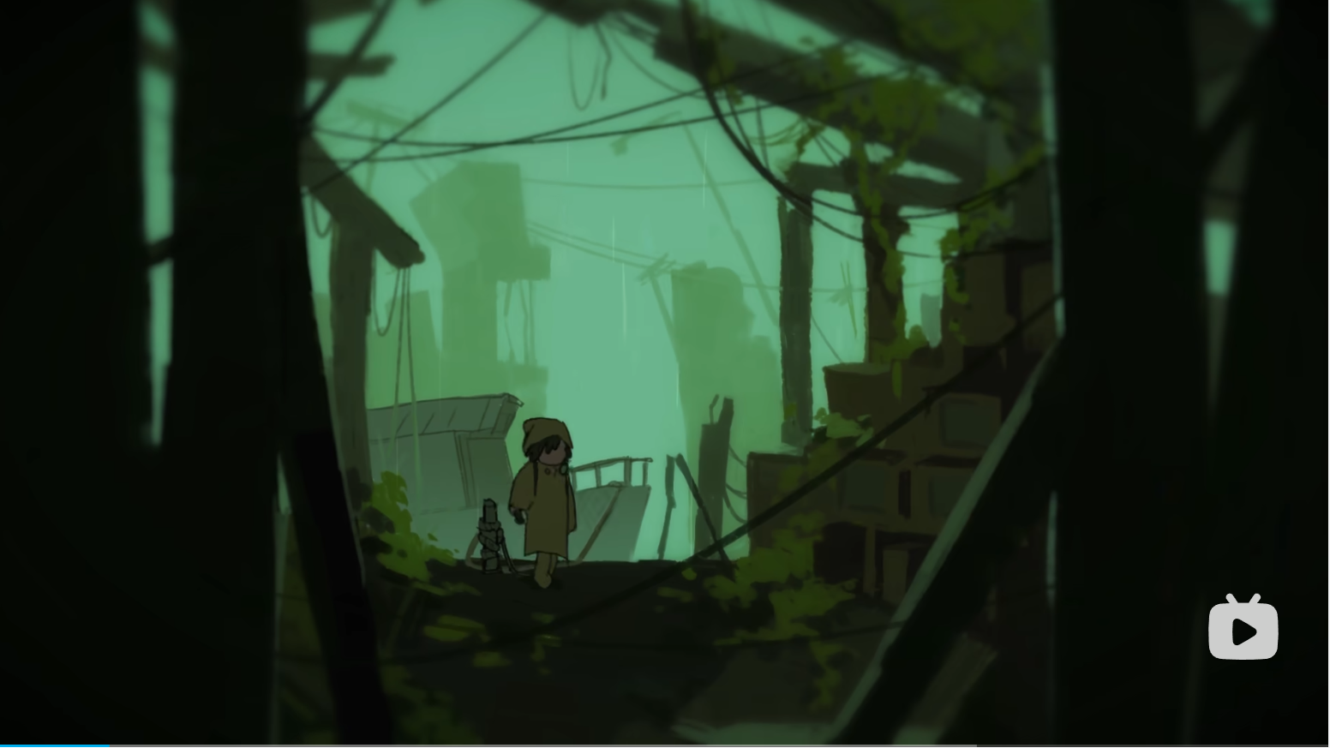 |  |  |  | 2
 |  | 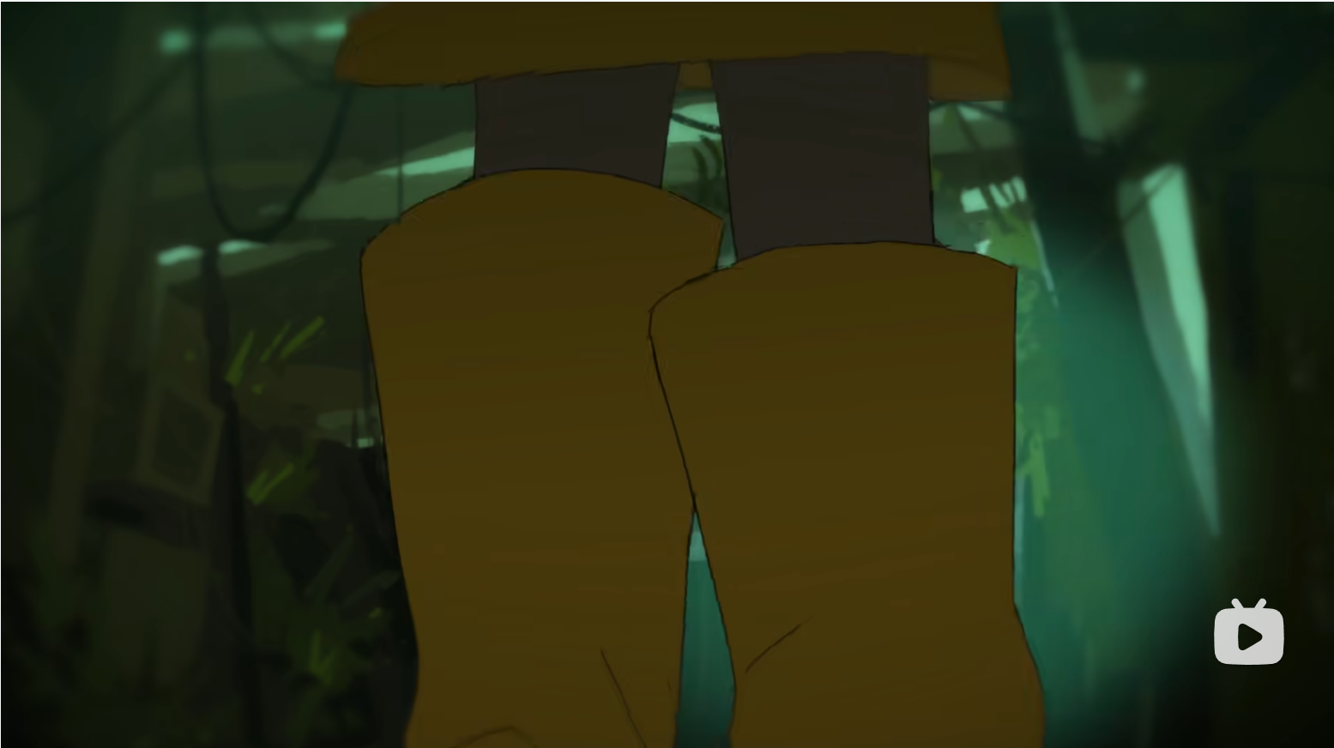 |  |  |  | 1
4 | 11 | 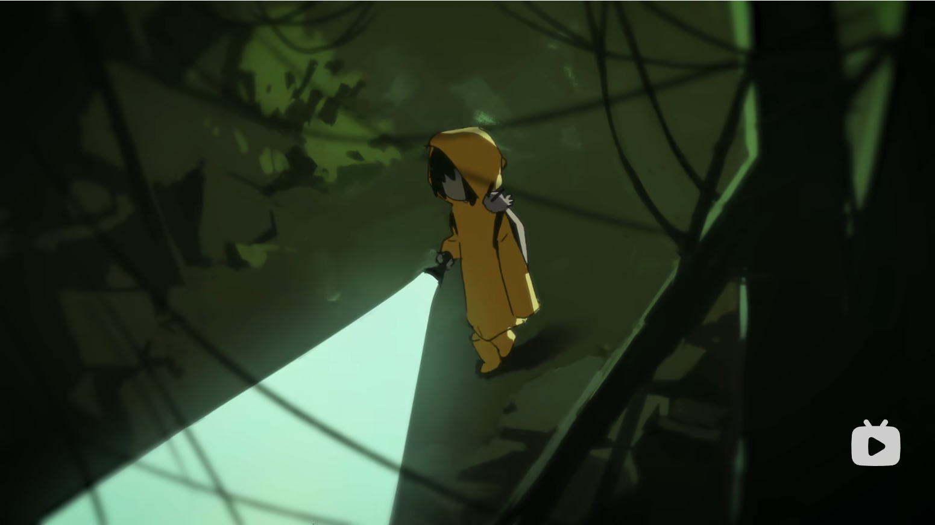 |  |  |  | 1
4 | 12 |  |  |  |  | 2
 |  | 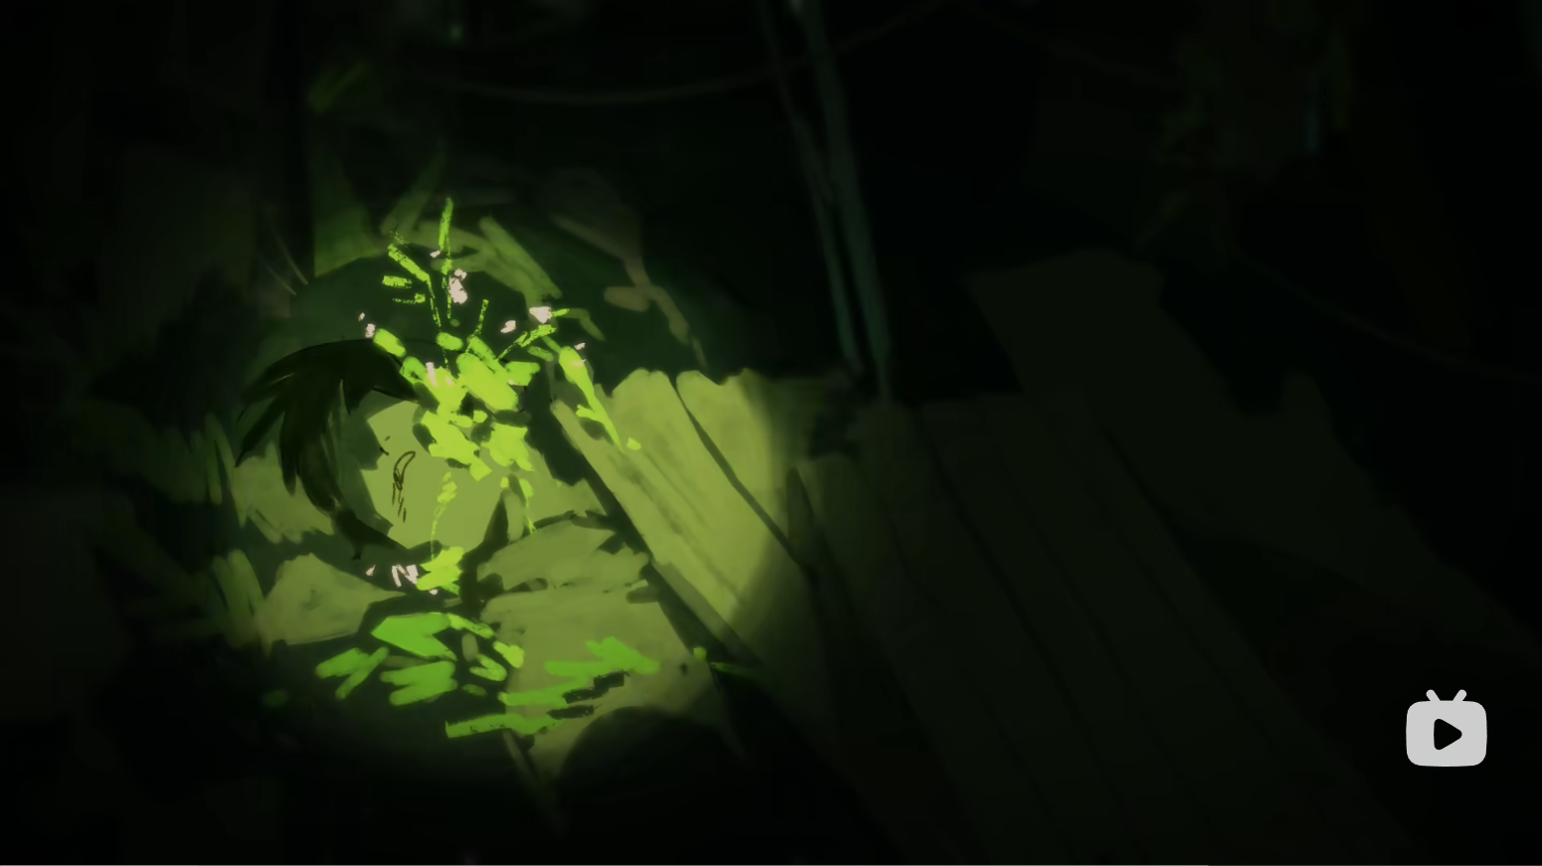 |  |  |  | 7

3 | 7 | 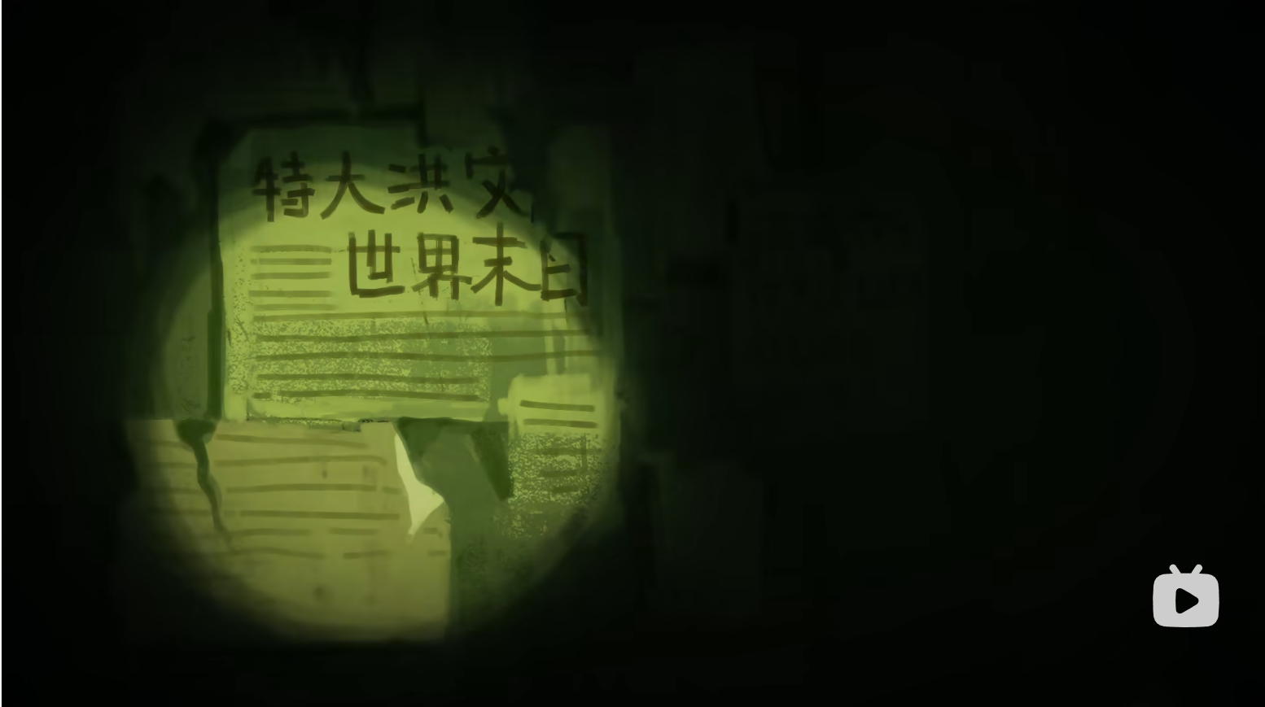 |  |  |  | 2
 |  |  |  |  |  | 1
4 | 11 | 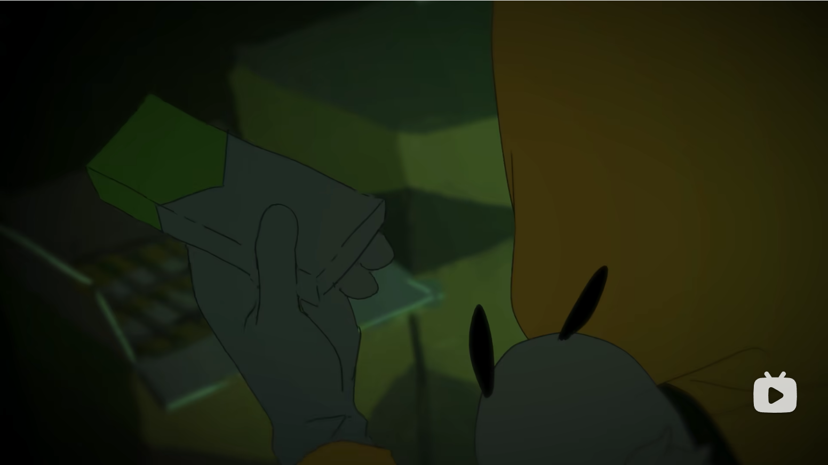 |  |  |  | 1
4 | 12 |  |  |  |  | 2
 |  | 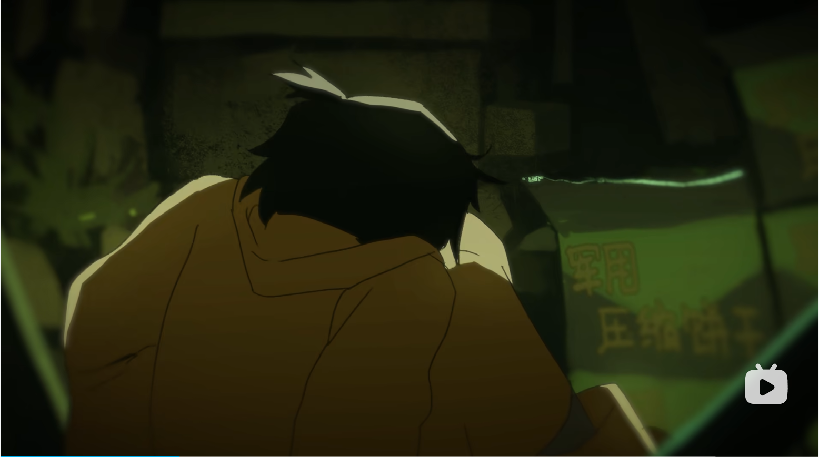 |  |  |  | 7

3 | 7 | 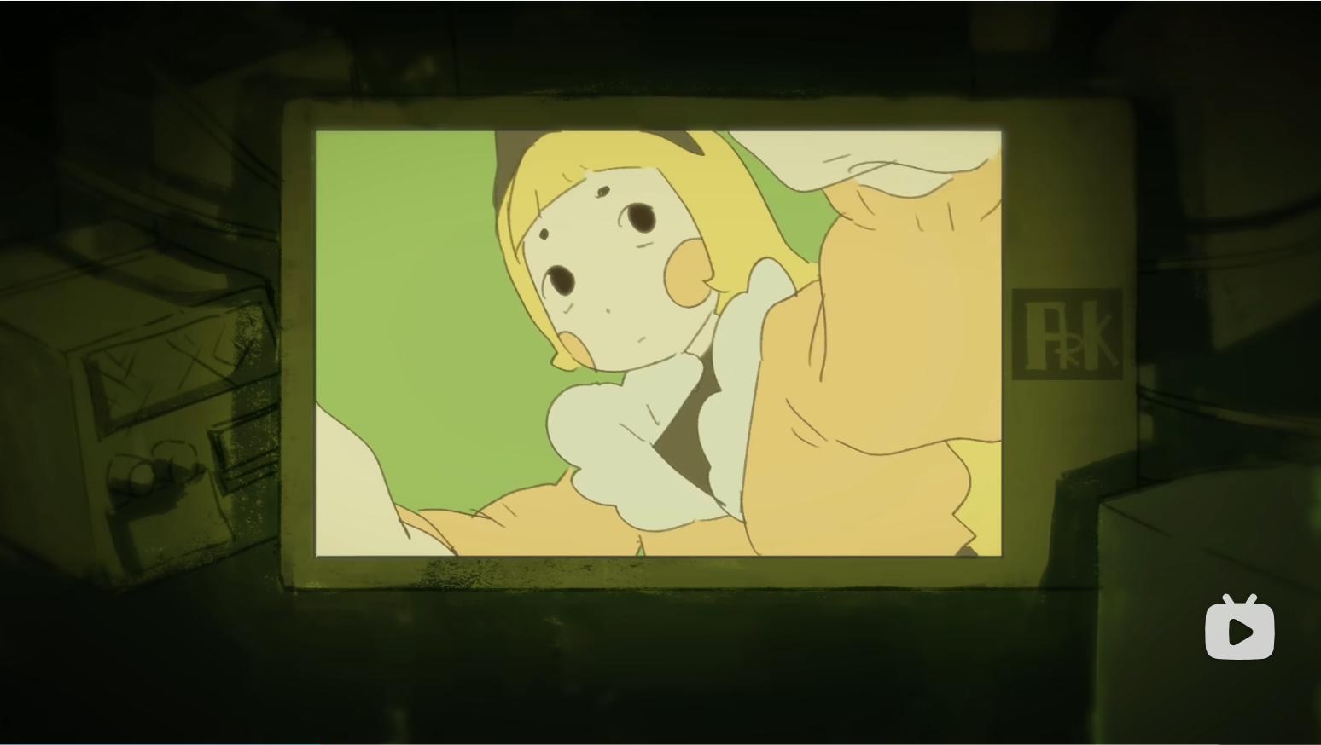 |  |  |  | 2
 |  |  |  |  |  | 1
4 | 11 | 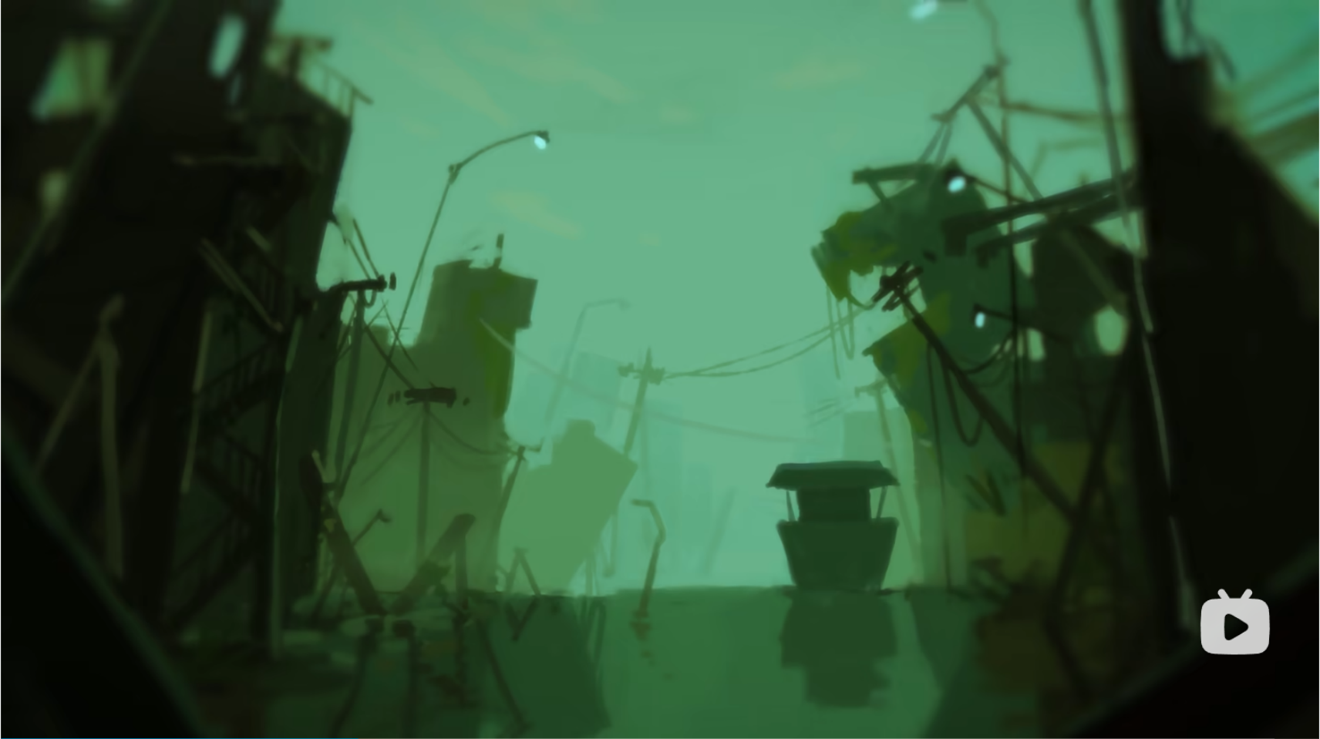 |  |  |  | 1
4 | 12 |  |  |  |  | 2
1 | 1 | 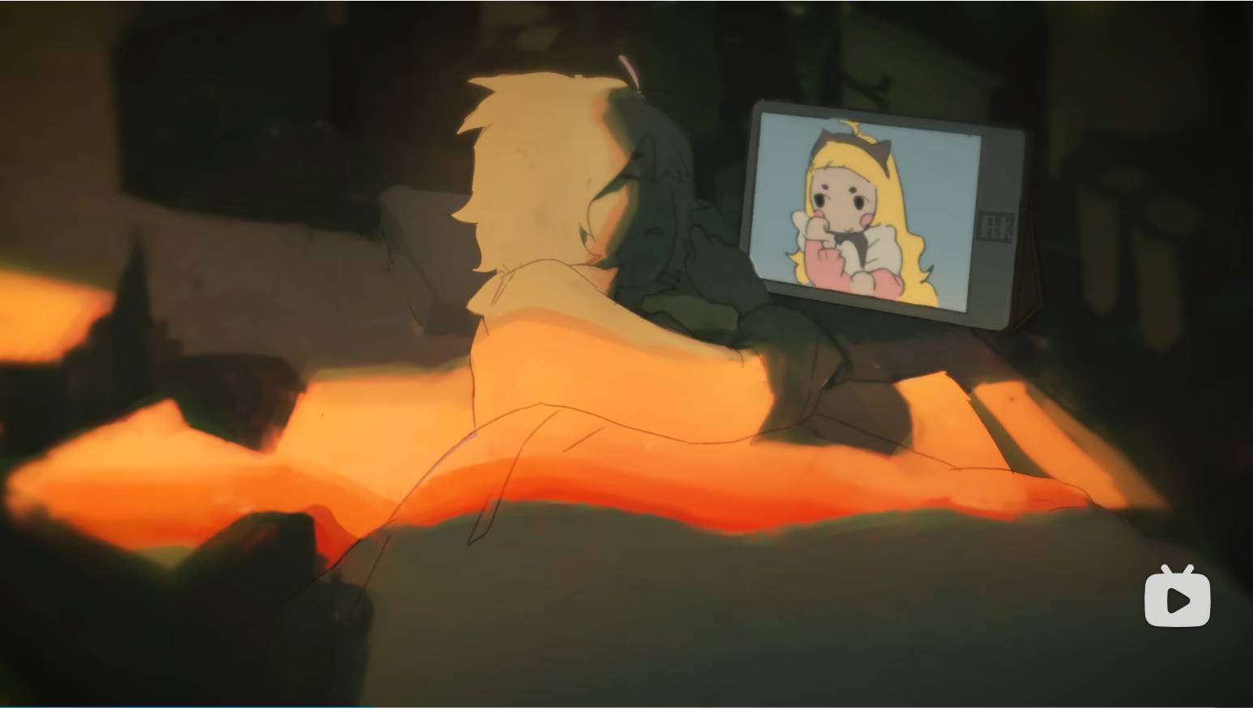 |  |  |  | 3
1 | 2 | 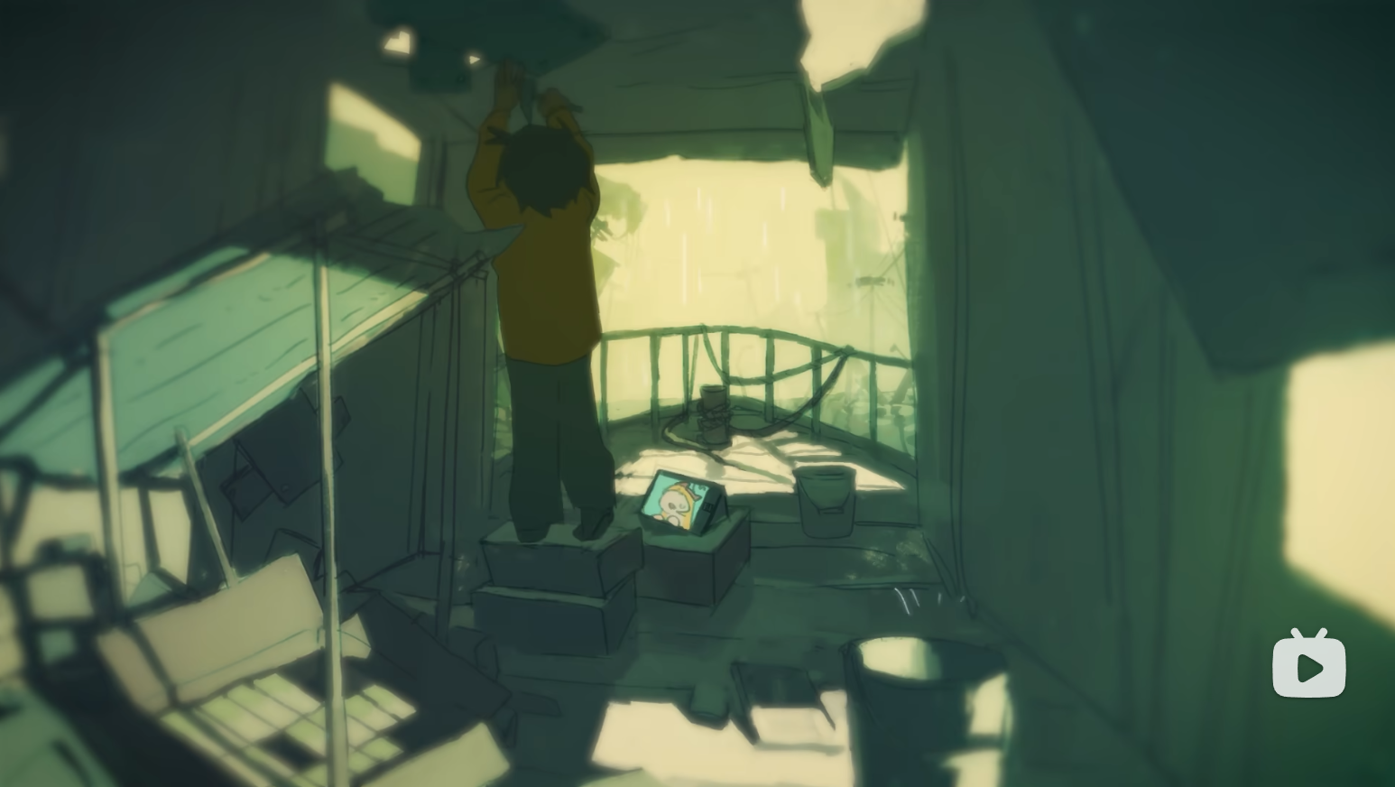 |  |  |  | 1
1 | 3 | 
2 | 5 |  |  |  |  | 4
3 | 6 | 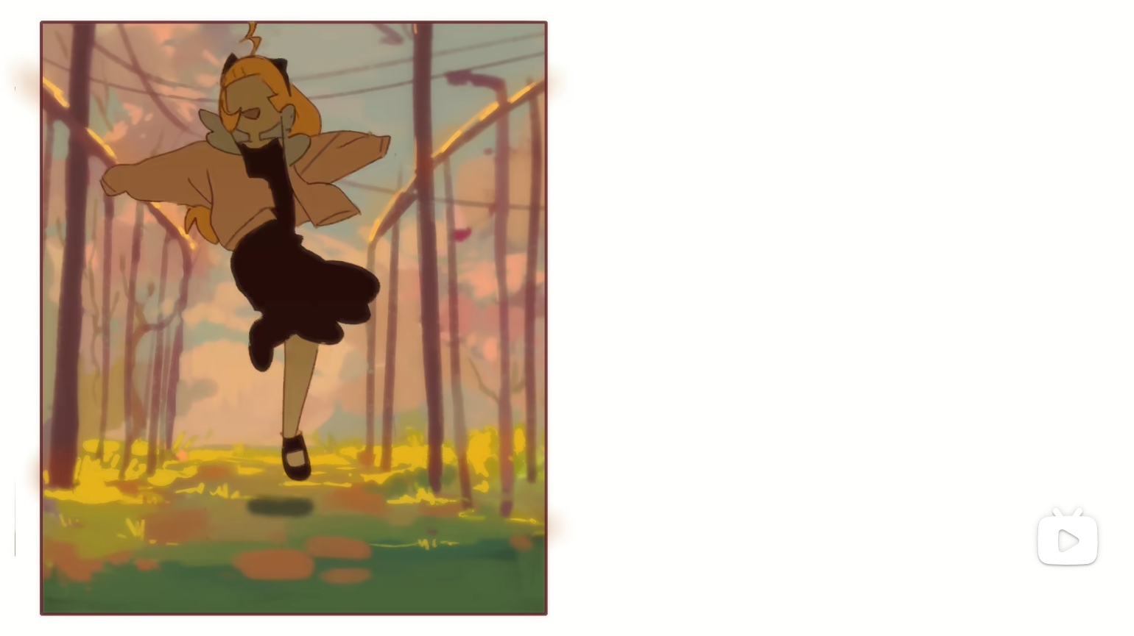 |  |  |  | 1
3 | 7 | 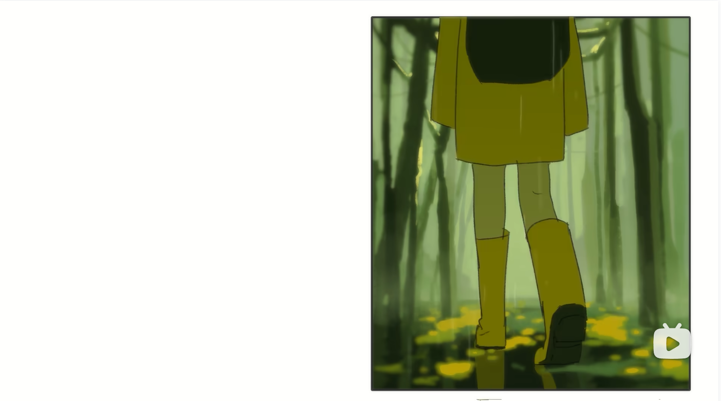 |  |  |  | 2
1 | 1 | 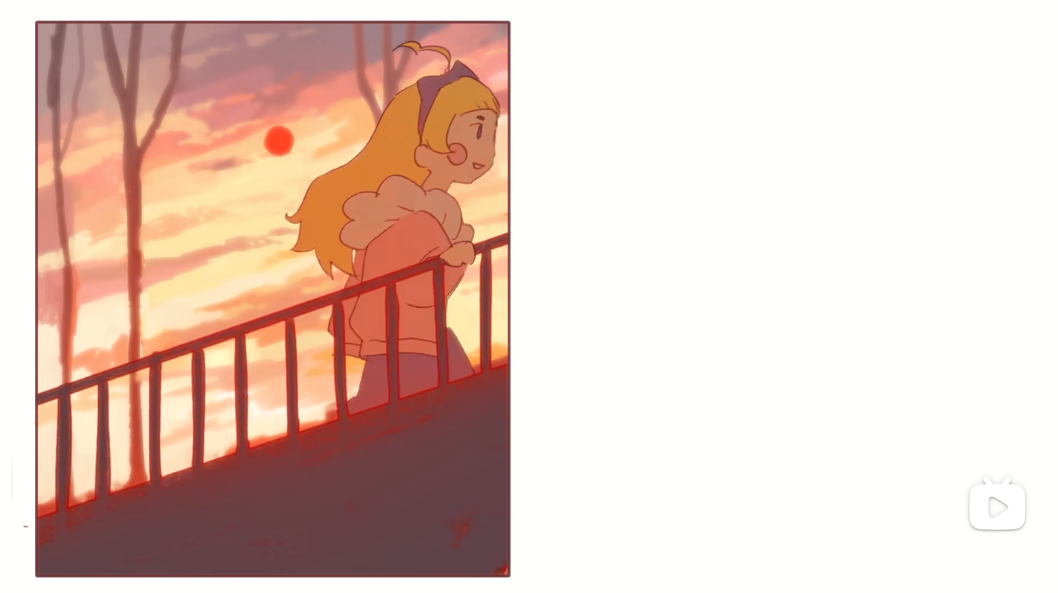 |  |  |  | 3
1 | 2 | 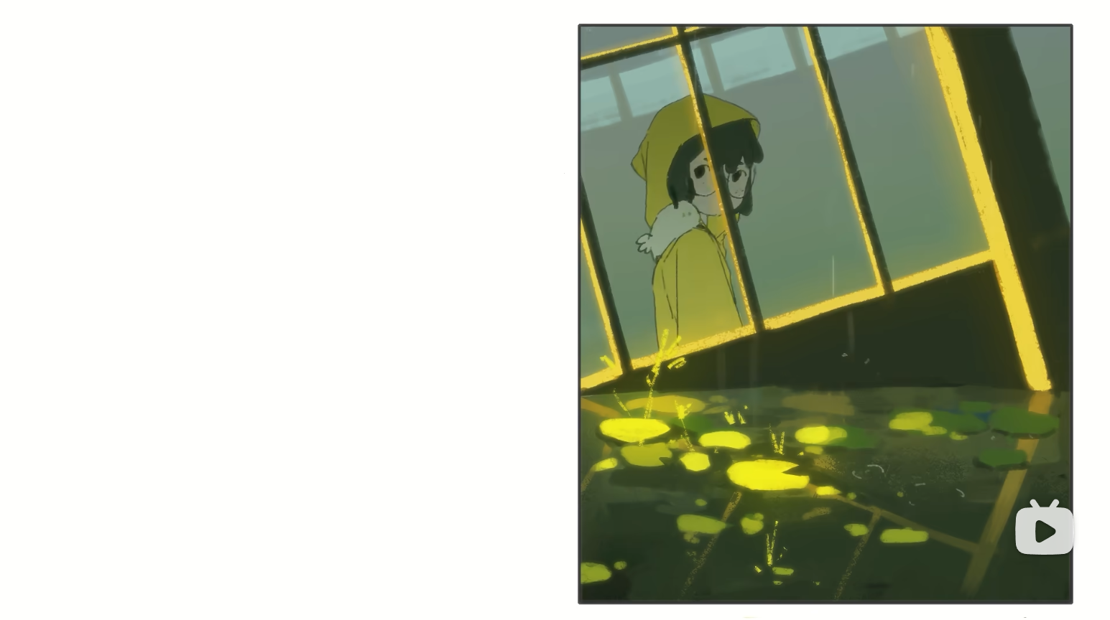 |  |  |  | 1
1 | 3 | 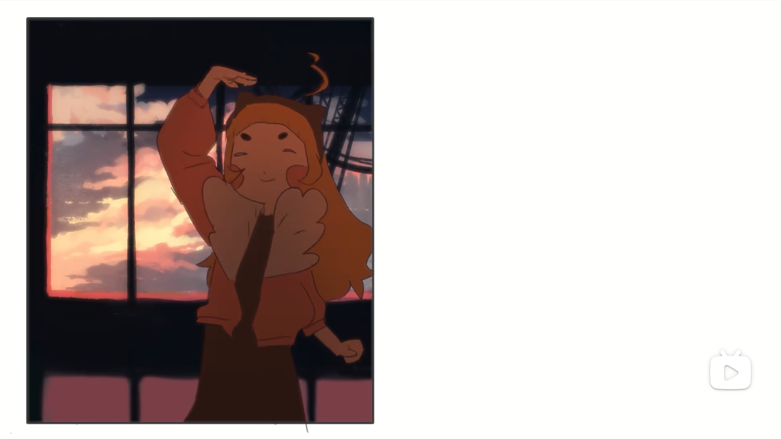
2 | 5 | 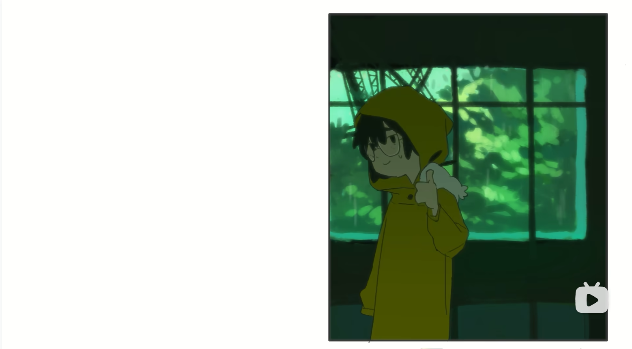 |  |  |  | 4
3 | 6 | 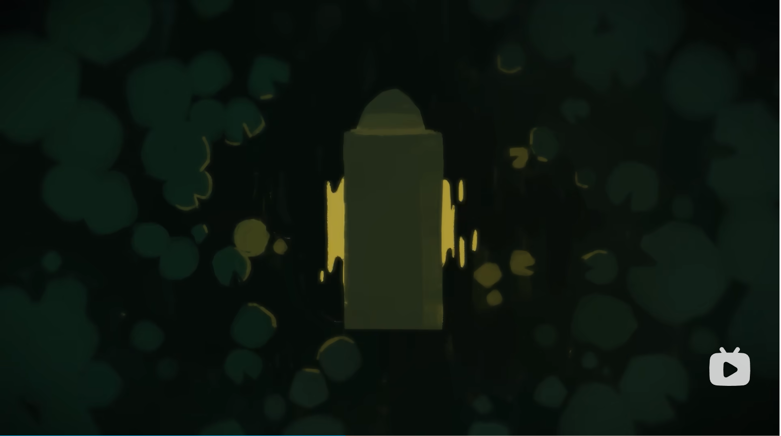 |  |  |  | 1
3 | 7 | 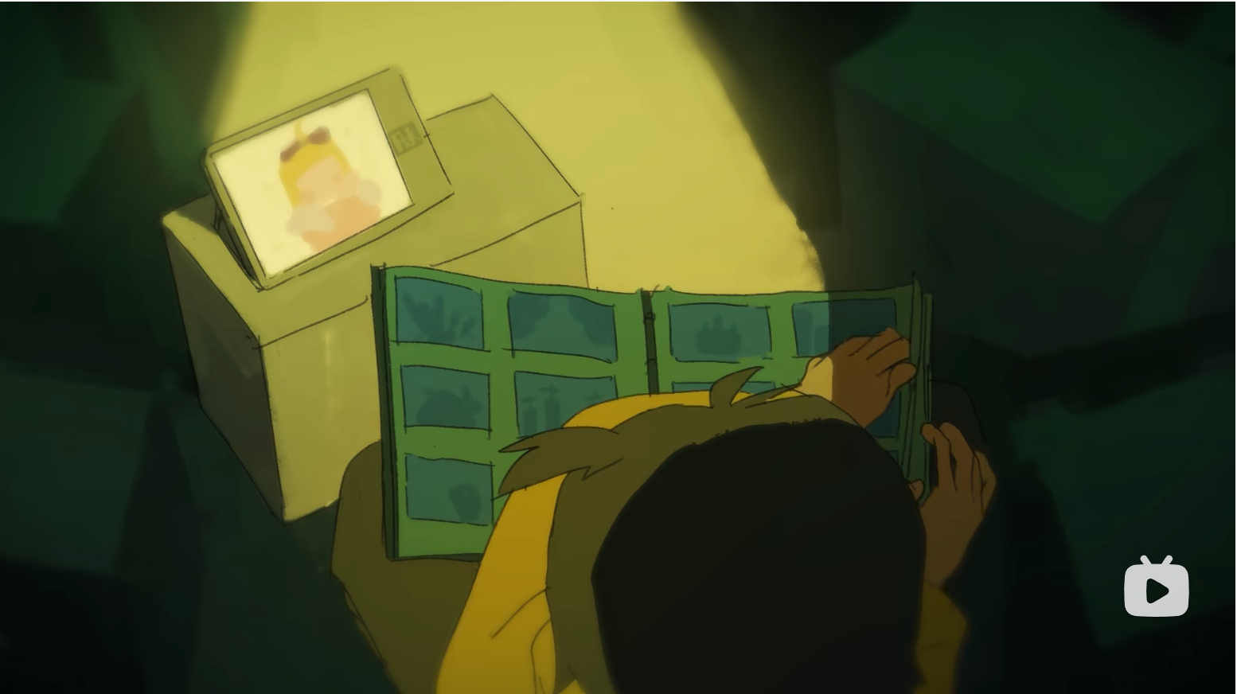 |  |  |  | 2
 |  | 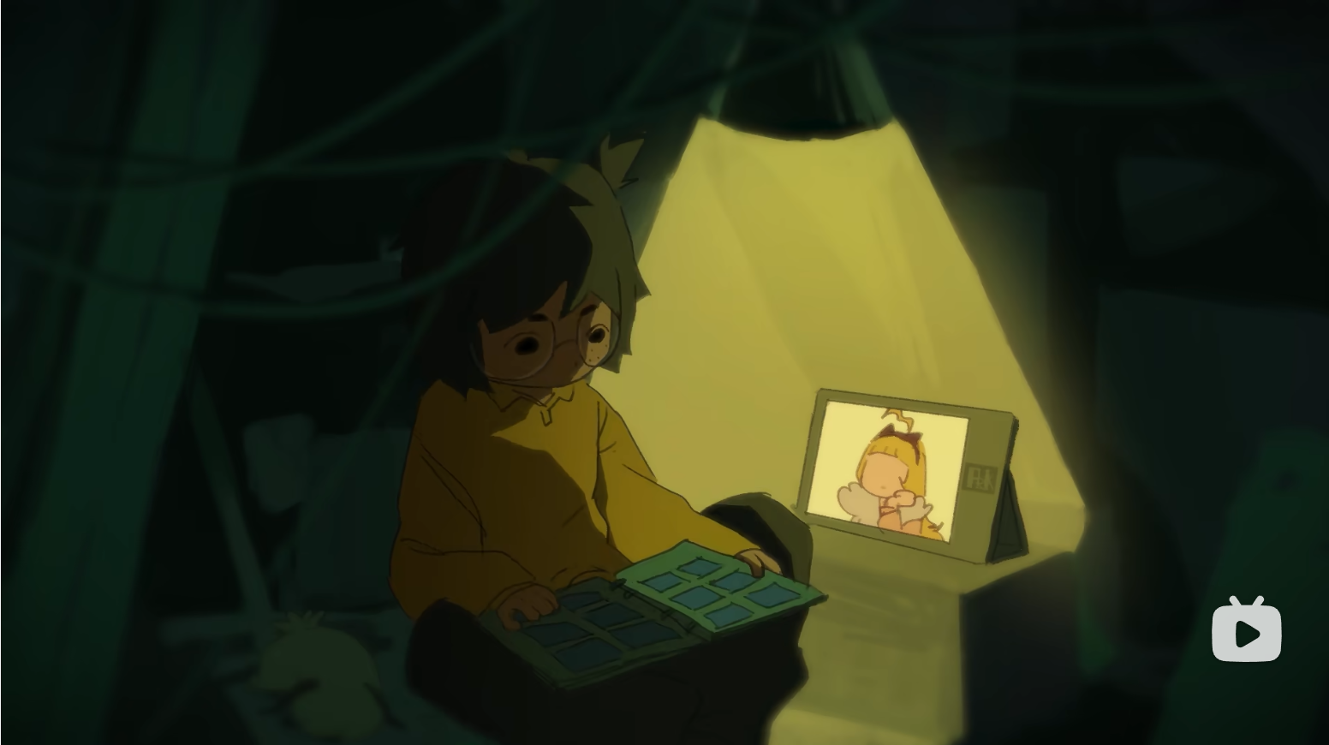
1 | 1 | 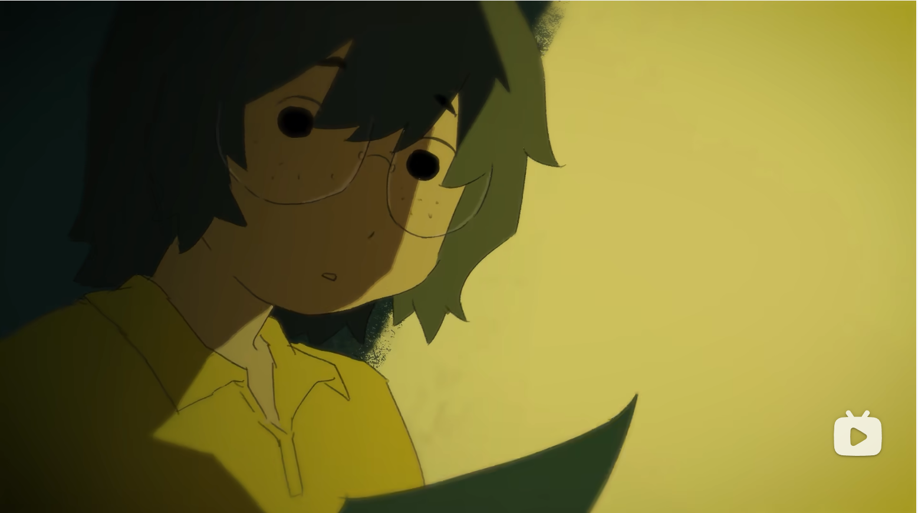 |  |  |  | 3
1 | 2 | 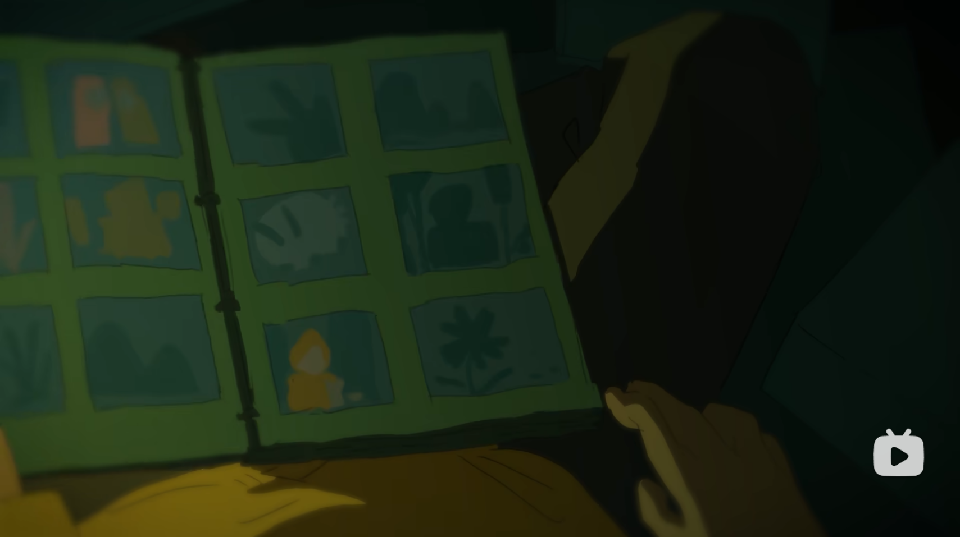 |  |  |  | 1
 |  | 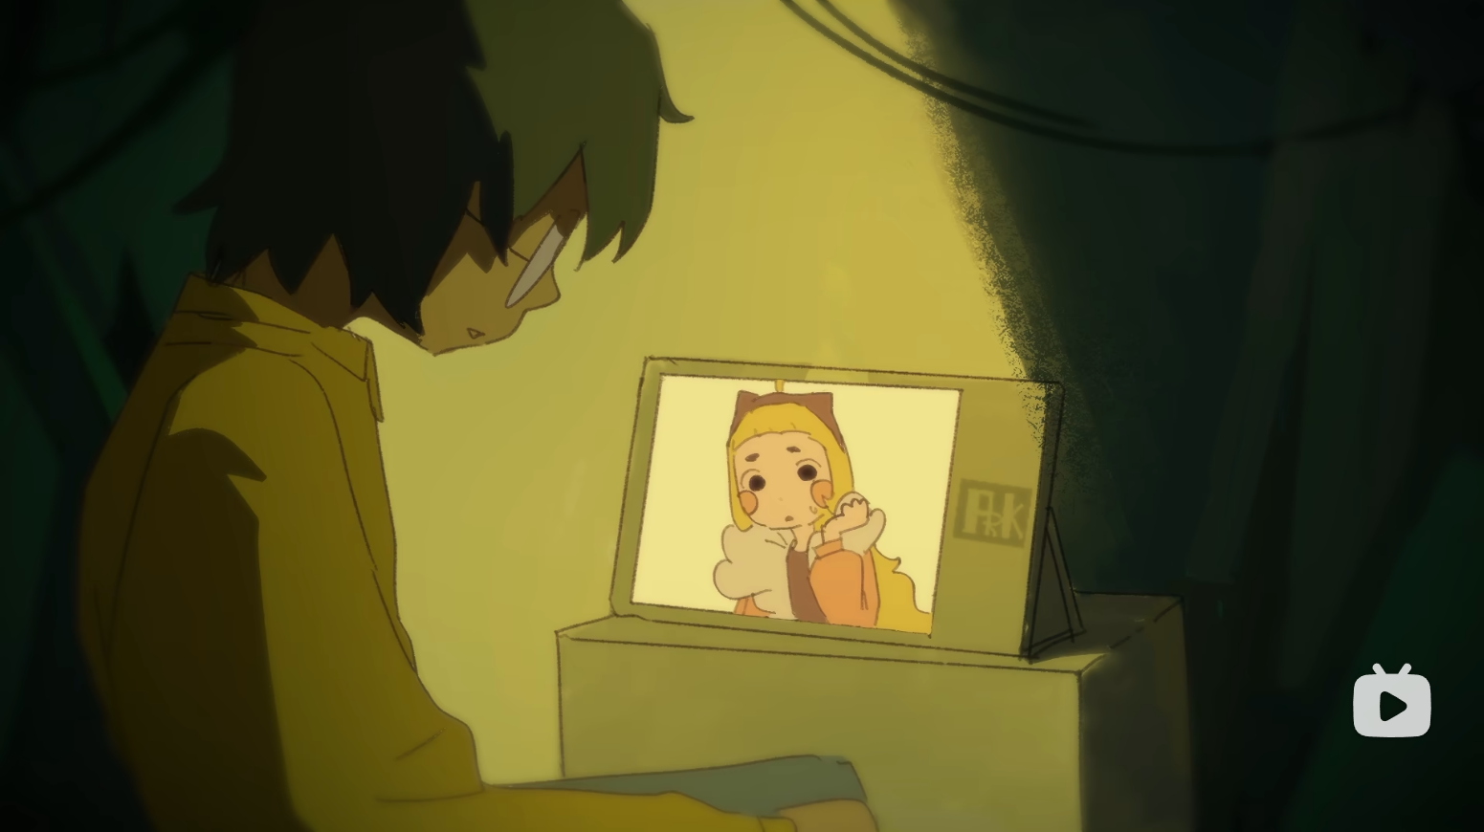
 |  | 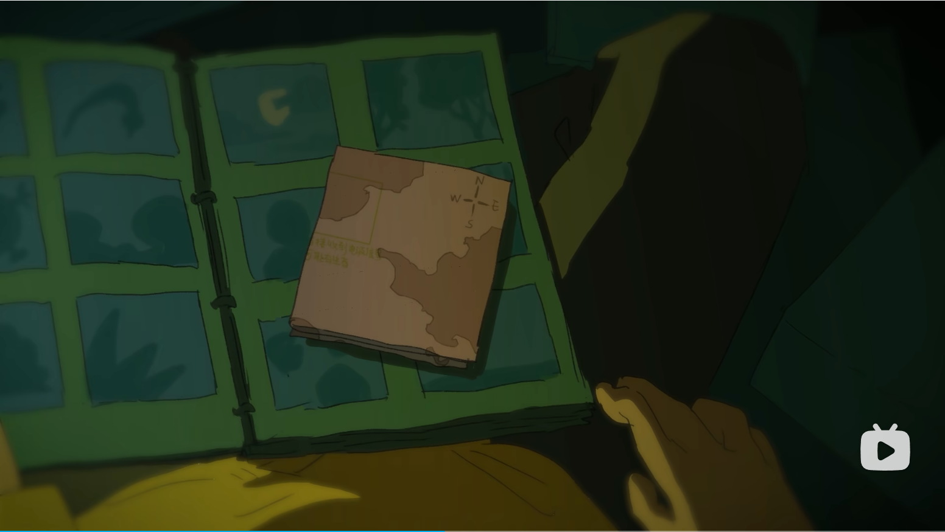
 |  | 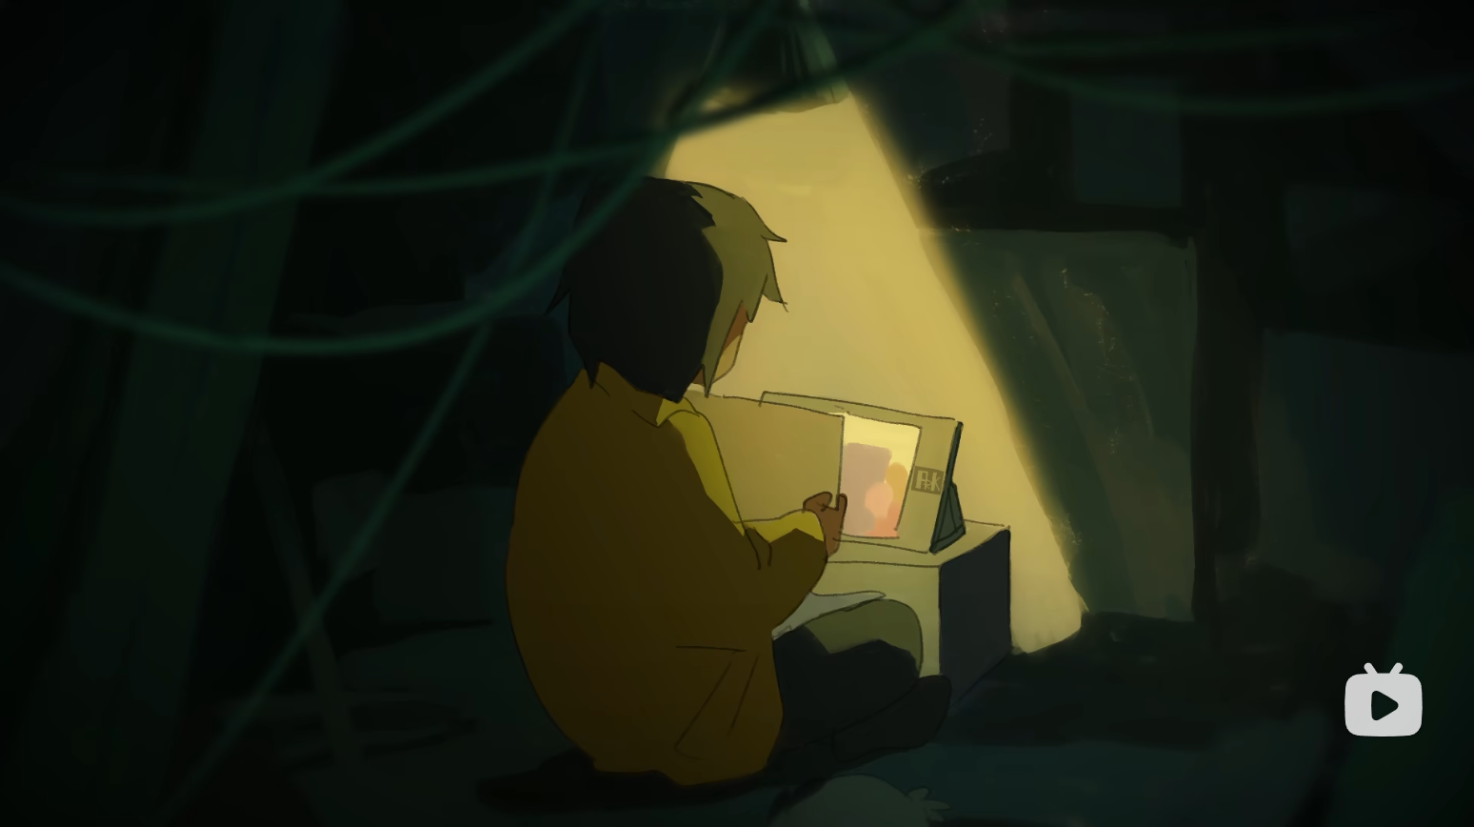
 |  | 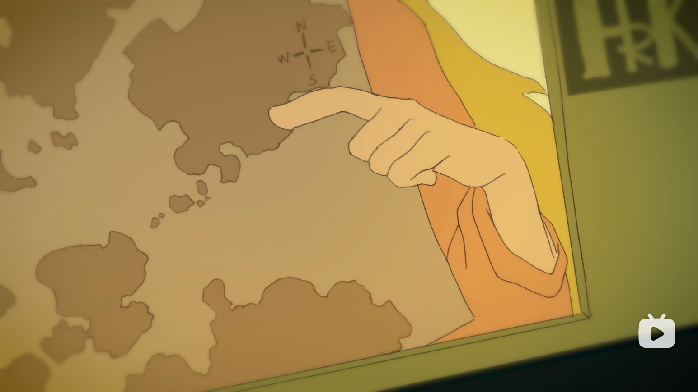
4 | 11
4 | 12
 |  | ----

