# EventHub Website

## Description

The EventHub Website enables event organizers to create, manage, and monitor events. It provides tools to streamline ticket management, monitor user engagement, and offer a seamless event planning experience.

## What It Does

The website allows event organizers to:  
- Create and manage events with detailed information.  
- Track ticket sales and monitor user activity.  
- Manage events through an intuitive admin dashboard.  
  
Attendees can view events, browse details, and purchase tickets seamlessly.

## How to Use

1. **Home Page**: Browse available events and navigate through the website.  
2. **About Page**: Learn about the EventHub platform.  
3. **Admin Dashboard** (for organizers):  
 - Login with your credentials.  
 - Create new events and monitor ongoing ones.  
 - View ticket sales and user engagement stats.  
4. **My Events Page**: Manage the events you have created.  
5. **Profile Page**: Update user details and review ticket purchases.  
6. **Checkout Page**: Attendees can purchase tickets for selected events.

## Tech Stack

- **Frontend**: HTML, CSS, JavaScript  
- **Backend**: Node.js, Express  
- **Database**: MySQL  
- **Tools**: GitHub, VS Code, Firebase (for testing)

## Screenshots

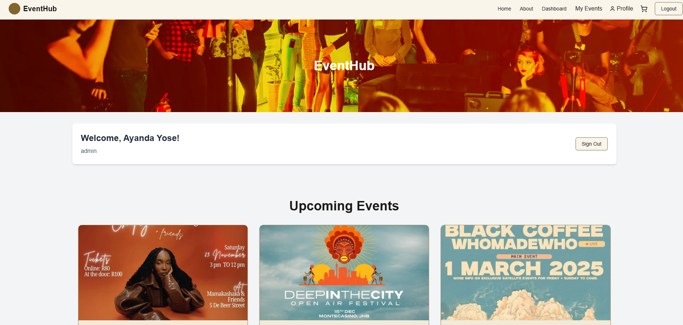

**Homepage: Introduction to EventHub.**

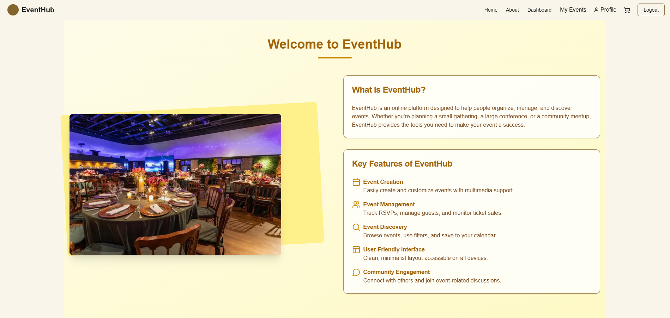

**About Page: Overview of the platform.**

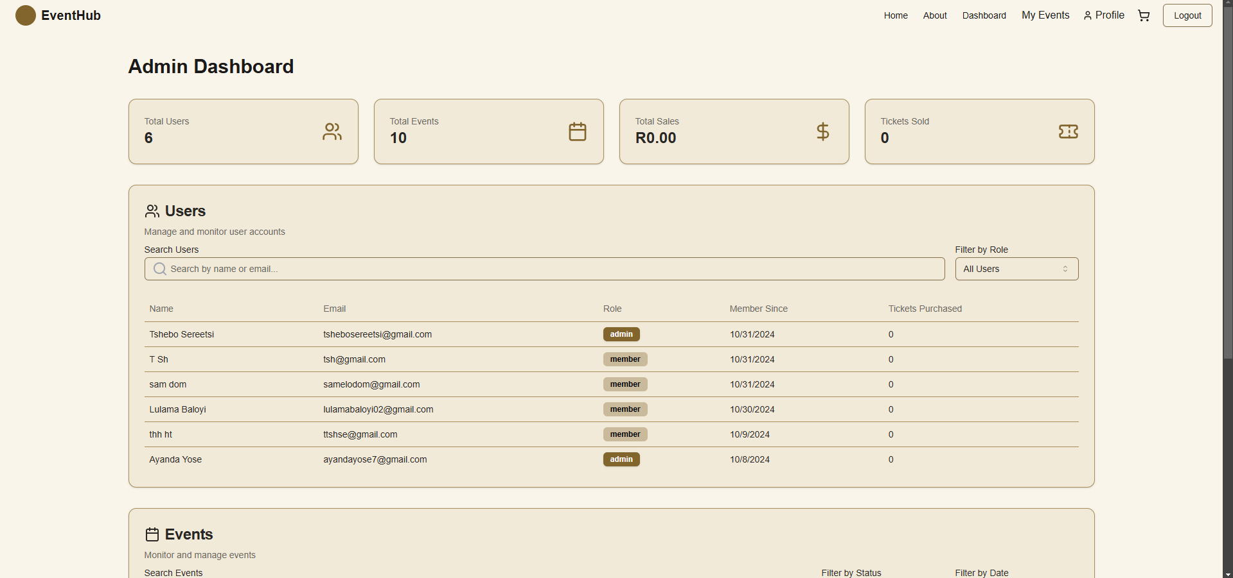

**Dashboard: Monitor events, users, and ticket sales.**

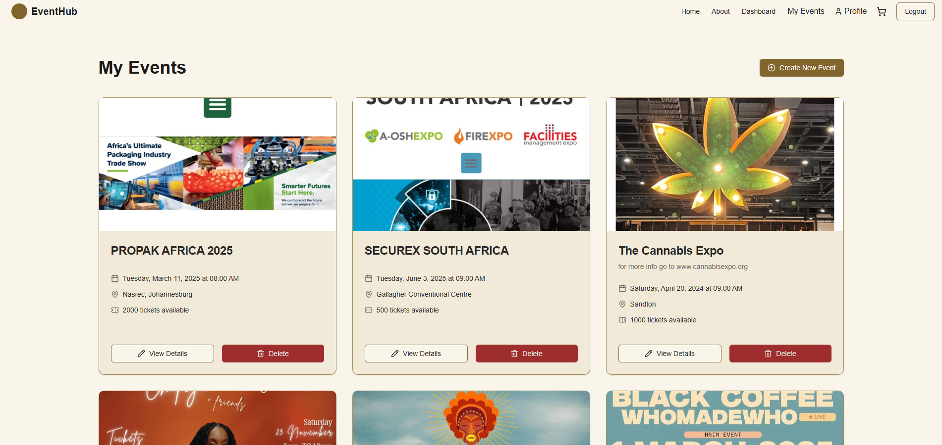

**My Events Page: Manage and monitor created events.**

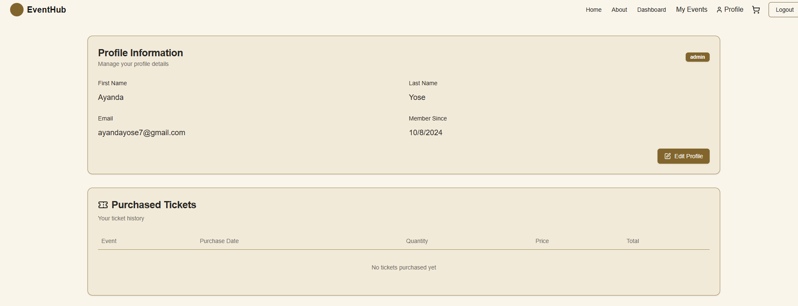

**Profile Page: View and edit user profile.**

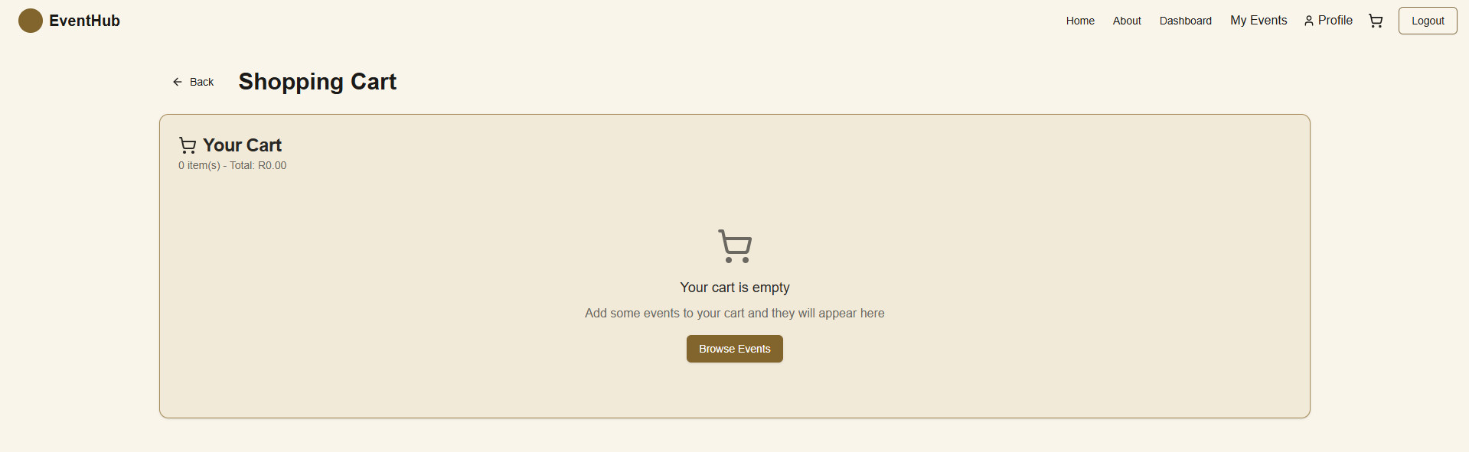

**Shopping Cart: Checkout for ticket purchases.**

## Contact Information

**Lulama Baloyi**  
GitHub: [https://github.com/lulama-baloyi](https://github.com/lulama-baloyi)  
Email: lulamabaloyi02@gmail.com  
LinkedIn: [https://www.linkedin.com/in/lulama-baloyi-354078251](https://www.linkedin.com/in/lulama-baloyi-354078251)