CIVE 202 Project #5 Report
  - Lucas Lee
  - 5/8/2026

Contents
Table of Figures 3
Figures 3
Tables 3
Functions and Methods for Automation 4
Beam Options 4
Function: findLimitState 4
Function: findBeam 5
Function: findBeam_w_inputs 5
Bias and Decision Making 6
Results 7
Scenario 1 7
Scenario 2 8
Scenario 3 9
References 10

Table of Figures

Figures
Figure 1 Beam Strength by Gross Area 6
Figure 2 Scenario 1 inputs and results 7
Figure 3 ASD Rupture Strength by Beam Height 7
Figure 4 Scenario 2 inputs and outputs 8
Figure 5 Scenario 3 inputs and outputs 8

Tables
Table 1 findLimitState inputs 4
Table 2 findBeam inputs 5
Table 3 Scenario 1 inputs 6
Table 4 Scenario 2 inputs 8
Table 5 Scenario 3 inputs 8

Functions and Methods for Automation

Beam Options
The table of beam options, referred to as Table 5-1 in this report, was copied and pasted directly out of the provided Manual for Steel Construction (American Institute of Steel Construction). It was sorted by gross cross-sectional area (Ag) from least to greatest, and a column for beam height was added using a regex function in python.

Function: findLimitState
This function automates the equation to determine the limit state of a beam in tension from the manual (American Institute of Steel Construction):

Ae/Ag >= 1.2*(Fy/Fu)

The inputs for the function are listed in Table 1.

Table 1 findLimitState inputs
Variable | Description
Ae | Net effective area (in^2)
Ag | Gross area (in^2)
Fy | Steel yielding strength (kips)
Fu | Steel rupture length (kips)

The function outputs the limit state as “Yielding Limit State,” “Rupture Limit State,” or “Error Finding Limit State.”

Function: findBeam
This function first uses the “findLimitState” function to determine the limit state of the scenario. It then uses a “for” loop to find the lightest beam and therefor most economical beam that matches the desired height and can support the required load. It looks in either the “Yielding_ASD(kips)” column or the “Rupture_ASD(kips)” column depending on the result of the “findLimitState” function. Which column it looks in is determined using “if” statements. It will return the lightest suitable beam because the CSV it searches in is sorts by gross cross-sectional area, which is directly proportional to the weight of the beam. If it can’t find a beam with the desired height that can support the required load, it returns “ERROR – Load too high for beam height.”

The inputs of this function are listed in Table 2.

Table 2 findBeam inputs
Variable | Description
Ae | Net effective area (in^2)
Ag | Gross area (in^2)
Fy | Steel yielding strength (kips)
Fu | Steel rupture length (kips)
desiredHeight | Desired beam height (in)
load | Tensile load (kips)

The output is the beam shape in the format WAAxBB where “AA” is beam height and “BB” is beam weight per foot in pounds. For example, W12x120 is a beam with a height of 12 inches and a weight of 120 pounds per linear foot.

Function: findBeam_w_inputs
This function is the main function for the automation of the steam beam calculations. It is the exact same as the “findBeam” function, except it prompts the user for the inputs, which are also the exact same as the inputs for “findBeam”. It first prompts the user for the desired beam height and required load, and then it asks the user if they would like to use the assumed values for Ag, Ae, Fy, and Fu from Table 5-1 in the provided Steel Construction Manual (American Institute of Steel Construction). If the user does not want to use the assumed values, then the function will prompt the user for Ae as a decimal percentage of Ag. It was originally set up to also ask for Fy and Fu, but changing Fy and Fu would require recalculating the strength values, so the decision to keep the assumed Fy and Fu values for all scenarios was made.

This function has the exact same outputs as the “findBeam” function.

Bias and Decision Making
The results of two methods of determine beam strength, the ASD method and the LRFD method, were presented in Table 5-1 in the provided manual (American Institute of Steel Construction). It was decided to use the ASD method as it is generally more conservative, and therefore, safer (Figure 1).
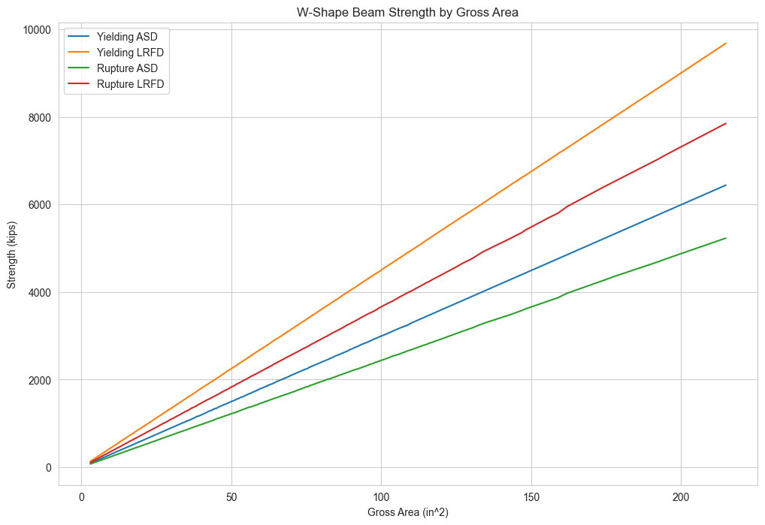
Figure 1 Beam Strength by Gross Area
The methods used to automate the calculations may not be fully correct, but they do fulfill the requirements of this project. It is recommended that this program be used only as proof of concept and not for actual calculations.

Results

The result of this project is a function that can find suitable beam from Table 5-1 given a desired beam height in inches and a required load in kips (as well as effective net area as a decimal percentage of gross area if the user chooses to not use the assumptions from Table 5-1). The function can be used by simply entering “findBeam_w_inputs()” in a blank cell and running the code by either clicking the triangle-shaped “run” button or pressing Shift+Enter. The function will then prompt the user for inputs, which should be typed without units. Pressing Enter will submit a given input and prompt the next input until the function produces a suitable beam. The function has been tested with many different scenarios, and a few of them have been included below.

Scenario 1
The inputs for this test scenario are listed in Table 3.

Table 3 Scenario 1 inputs
Variable | Input
desiredHeight (in) | 8
load (kips) | 800
assumptions | y

The output of this scenario is “ERROR – Could not find suitable beam” (Figure 2). This is because there is not an eight inch tall beam in Table 5-1 that can support an 800 kip load in the rupture limit state (Figure 3). It is worth noting that the assumed values from the table result in a rupture limit state.

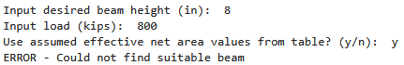
Figure 2 Scenario 1 inputs and results

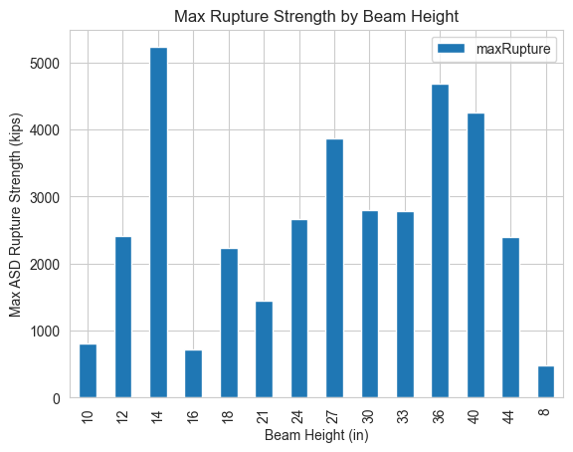
Figure 3 ASD Rupture Strength by Beam Height

Scenario 2
The inputs for this test scenario are listed in Table 4.

Table 4 Scenario 2 inputs
Variable | Input
desiredHeight (in) | 18
load (kips) | 1200
Assumptions | n
Ae (decimal percent of Ag) | 0.7

The output of this scenario is “W18x175.” (Figure 4).

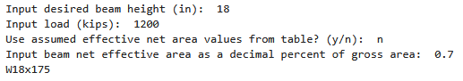
Figure 4 Scenario 2 inputs and outputs

Scenario 3
The inputs for this test scenario are listed in Table 5.

Table 5 Scenario 3 inputs
Variable | Input
desiredHeight (in) | 13
load (kips) | 10
assumptions | y

The output of this scenario is “ERROR – Could not find suitable beam” (Figure 5). This is because there is not a thirteen-inch-tall beam in Table 5-1. In future versions of this program, it would be desirable to add a test to make sure the input height exists in Table 5-1 and an associated error message. As it exists now, there is nothing to tell the user why the program could not find a suitable beam for the input scenario.

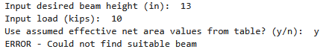
Figure 5 Scenario 3 inputs and outputs

References
American Institute of Steel Construction. (n.d.). Steel Construction Manual, 14th Edition.

