CIVE 202 Project #3 Report
  - Lucas Lee
  - 3/31/2026

Table of Contents
Table of Figures 3
Introduction 4
Methods 4
Plots from NGSIM and NHTS Data 4
Simulation Study Using the Intelligent Drive Model 5
Results and Discussion 6
References 12

Table of Figures
Figure 1Trip Household Type by Census Division 6
Figure 2 Distribution of Vehicle Age 7
Figure 3 Vehicle Age by Vehicle Type 8
Figure 4 Trajectories of Leader and Follower Vehicles 9
Figure 5 Speeds of Leader and Follower Vehicles 9
Figure 6 Trajectories of Leader, Follower, and Simulated Follower Vehicles 10

Introduction
The goal of this project is to analyze and graph data from the National Household Travel Survey (NHTS) and Next Generation Simulation (NGSIM) dataset using Python. The NHTS and NGSIM data was provided by the client for use in this project. This project will also compare data produced with the Intelligent Driver Model (IDM) to NGSIM data.

The NHTS is a survey conducted by the Federal Highway Administration to analyze the travel behavior of the American public (Federal Highway Administration, n.d.). It is comprehensive in its scope. The data used in this project was taken in 2022.

The NGSIM data comes from the Federal Highway Administration’s Next Generation SIMulation program (Federal Highway Administration, n.d.). It was collected on Southbound US 101 and Lankershim boulevard in Los Angeles, CA, eastbound I-80 in Emeryville, CA, and Peachtree Street in Atlanta, GA. It is intended to be used to help create” microscopic behavioral algorithms for modeling and simulation.” It can be used to calibrate and/or validate other algorithms and models, such as done with the IDM in this project.

Methods

Plots from NGSIM and NHTS Data
We begin by importing pandas as "pd", NumPy as "np", Matplotlib as "matt", and seaborn as "sns" into the Jupyter Notebook. Then, the NHTS data is imported as "nhts" using the read_csv function of pandas. Run "nhts.head()" to view a sample of the data.

To create the bar chart of trip household type by census division, first the grouped by "census_divison" and "household_location" is counted within each of these groups. This data is assigned to a variable called "dataGrouped." This data is then displayed in a bar graph using Matplotlib using "dataGrouped.plot()," and a title, labels, and a legend are added to it also using Matplotlib.

To create the histogram of vehicle age distribution, Matplotlib is again used. We run "matt.hist()" displaying vehicle age with 40 bins. We also assign an alpha value (transparency) of 0.6 and a color of maroon with black outlines to the bars of the histogram. Titles and labels are again added using Matplotlib.

Matplotlib is also used to create the boxplot of vehicle age by household income. We run "nhts.boxplot(column = 'vehicle_age', by = 'vehicle_type')" to produce the initial boxplot. We then use "matt.xlabel()", "matt.ylabel()", and "matt.title()" to label each axis and add a title. We also used "matt.xticks(rotation = 90)" to rotate the labels on the x-axis to make them legible.

Before we can create the time-series plots, the NGSIM data is first imported by running "pd.read_csv('NGSIM(in).csv')" and is assigned to the variable "ngsim". A variable to identify which trajectory number we are graphing is named "trajectory_number" and set equal to 10. The data from the NGSIM data for trajectory 10 is then selected by running "ngsim[ngsim['trajectory_number'] == trajectory_number]" and that data is assigned to a variable named "trajectory".

For each of the two time-series line plots, two sets of data, one for leader and one for the follower, are identified and plotted using seaborn. Labels and a title are then assigned using Matplotlib. The procedures for both graphs are identical, with the only difference being that the first graph charts trajectories and the second graph charts speeds.

Simulation Study Using the Intelligent Drive Model
For the simulation study using the Intelligent Driver Model (IDM), we first define a function called “idm_acceleration” to calculate the acceleration of the follower vehicle as simulated by the IDM. The equation for acceleration is “acceleration = a * (1 - (v/v0)**delta - (s_star/s)**2)” where “s_star = s0 + v * T + (v * delta_v) / (2 * np.sqrt(a * b)).” Below is a description of the variables used in the function(Table 1).

Table 1 Variables used in "idm_acceleration" function
Symbol | Parameter | Description
v0 | Desired Velocity | Speed the driver wants to travel at in free flow conditions
s0 | Minimum Spacing | Minimum gap between vehicles when stopped
T | Desired time headway | Desired gap to the leader
a | Maximum acceleration | Maximum comfortable acceleration
b | Comfortable Deceleration | Comfortable braking deceleration
delta | Acceleration exponent | Controls how acceleration decreases with speed
s_star | Desired minimum gap | Desired minimum gap between the lead vehicle and following vehicle
delta_v | Velocity Delta | Difference in velocity between the lead vehicle and the following vehicle
v | Velocity | Velocity of the following vehicle

We will run the simulation using the same NGSIM data and trajectory from the time-series plots. First, we filter out the values for “Time,” “leader_position(m),” and “leader_speed(m/s)” from the NGSIM data. We then identify the time steps “dt” in the data as 0.1 seconds and define the constant variables v0, s0, T, a, b, and delta. We determine the number of time “n_steps” as the length of the “Time” in the NGSIM data and create “blank” vectors of all zeroes for the position, speed, and acceleration of the simulated follower. We then set the initial speed and position of the simulated follower to that of the real follower from the NGSIM data.

To run the simulation, we run “for i in range(n_steps - 1):” to create a “for” loop to calculate the current gap between cars, delta_v, and acceleration of the simulated follower for this current time step as well as the position and speed of the simulated follower for the next time step. The acceleration of the simulated follower is calculated using the “idm_acceleration” function that was previously defined.

To graph the results of the simulation, we follow the same steps we used to create the time-series plots for the NGSIM data. This graph will plot trajectory of the follower and leader from the NGSIM data as well as the trajectory of the simulated follower, so the code will be identical except for the additional line of code needed to add in the simulated follower trajectory.

Results and Discussion
From the NHTS data, households generally complete more trips than rural households (Figure 1). In most Census Divisions, there are at least two-to-three more urban household trips than rural household trips. There are two apparent exceptions to this trend. The East South Central Division and West North Central Division both still have more urban household trips than rural household trips, but they are much closer to being equal than in other regions. Although it requires further analysis, the share of trips by household type in a given Census Division is likely at least somewhat reflective of the share of urban and rural populations in that Division.

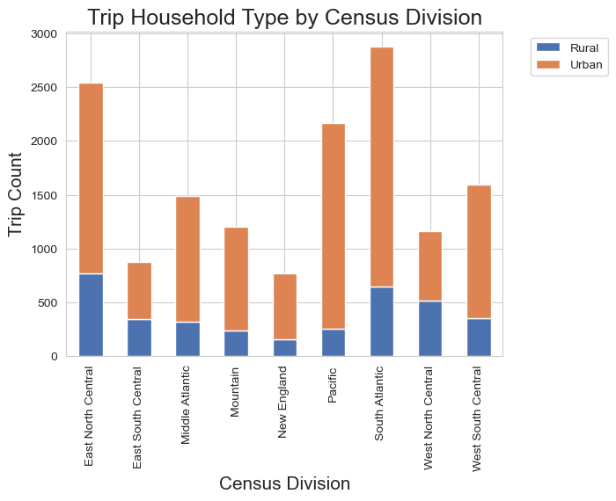
Figure 1Trip Household Type by Census Division

There’s a clear trend in the distribution of vehicles by age, with newer vehicles being far more common than older vehicles (Figure 2). There are two areas in the data where this trend is interrupted. The first is between ten and fifteen years old. Because this data was taken in 2022, that would put this decrease in vehicle counts right around the time of the 2008 Financial Crisis. The second decrease is in vehicles that are only two years old. This is almost certainly due to the COVID-19 pandemic.

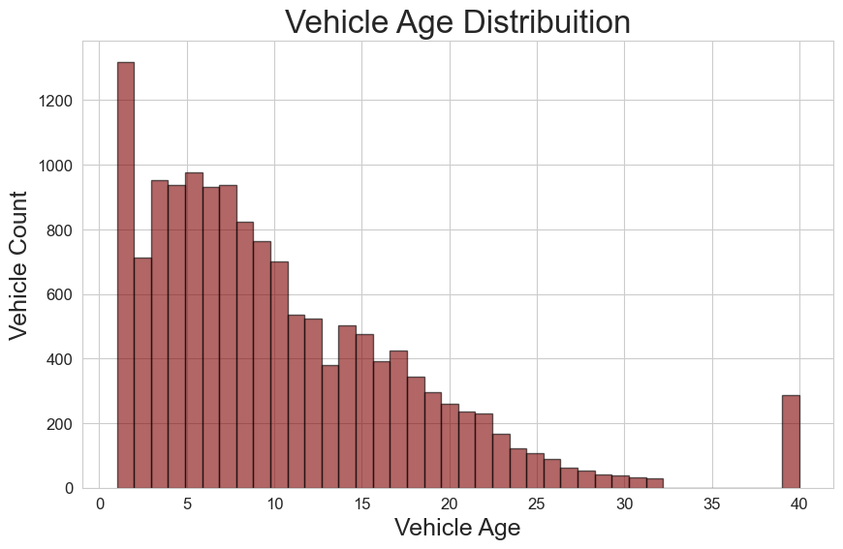
Figure 2 Distribution of Vehicle Age
RVs and Motorhomes clearly have the largest distribution of vehicle age (Figure 3). It’s possible that the generally limited use of motorhomes coupled with the cost of new motorhomes can help explain this. Pick up trucks and other trucks have the next largest distributions. It’s possible with trucks that there is a cultural factor at play where some people take pride in maintaining and operating older trucks, but that is nothing more than a guess. SUVs are generally the newest vehicles. It’s likely that this has to do with the recent increase in popularity of SUVs with some car manufacturers going so far as to completely eliminate sedans and compact cars from their vehicle offerings.
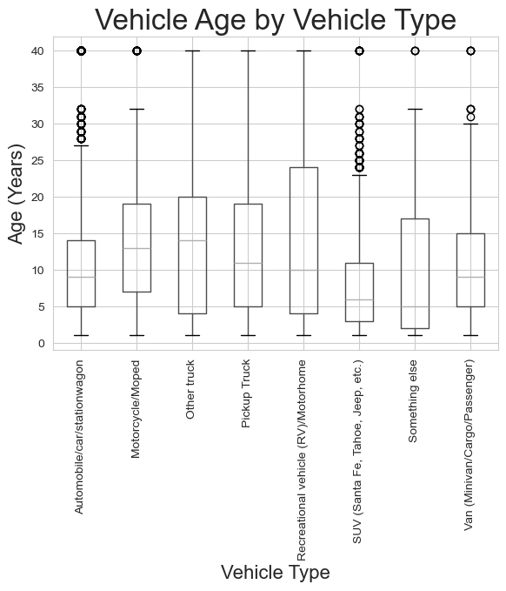
Figure 3 Vehicle Age by Vehicle Type
For trajectory 10 in the NGSIM data, physical distance between the leader vehicle and the follower vehicle seems to be at least somewhat related to the speed of the vehicles. Where speed of the vehicles greater (Figure 5), the gap between the vehicles increases (Figure 4). Where the speed is zero or near-zero, the gap between the vehicles is at its closest. It also appears as though there is a delay between changes in speed of the leader and the follower. This is almost certainly because humans have nonzero reaction times, so it takes a moment for the follower to react to the leader.
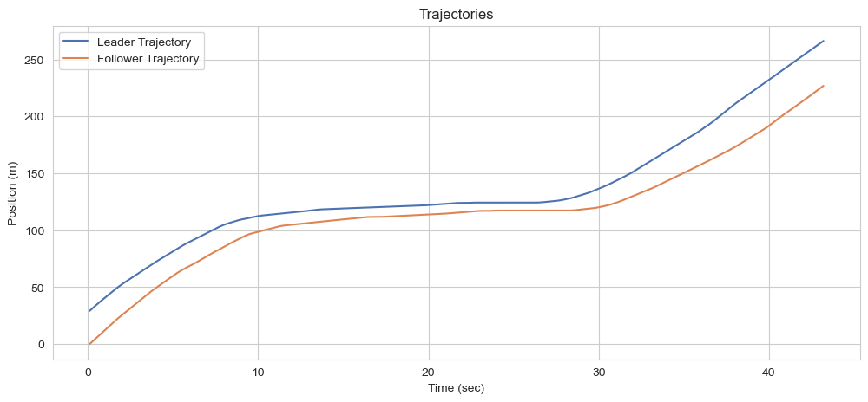
Figure 4 Trajectories of Leader and Follower Vehicles

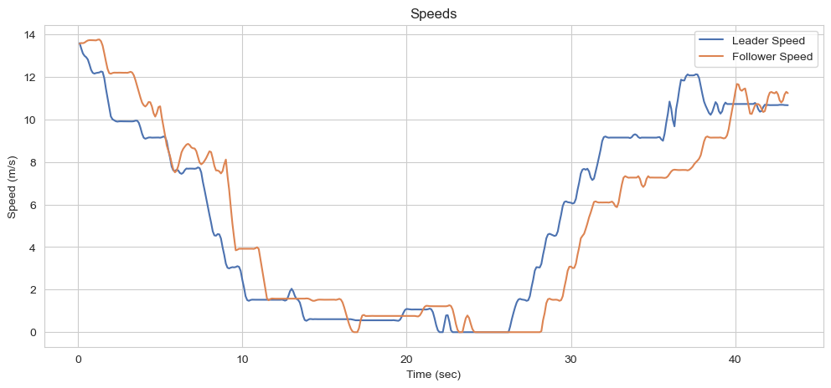
Figure 5 Speeds of Leader and Follower Vehicles
After some guess-and-check work in changing the input variables, the simulated follower from the IDM seems to closely match the follower in the NGSIM data for trajectory 10. It decelerates and accelerates slightly faster than the real-world follower and seems to hold a smoother/more constant distance behind the lead vehicle. This may be because it’s difficult for an equation to perfectly model human behavior, although someone who has more experience working with this model may be able to get a closer approximation of the follower.
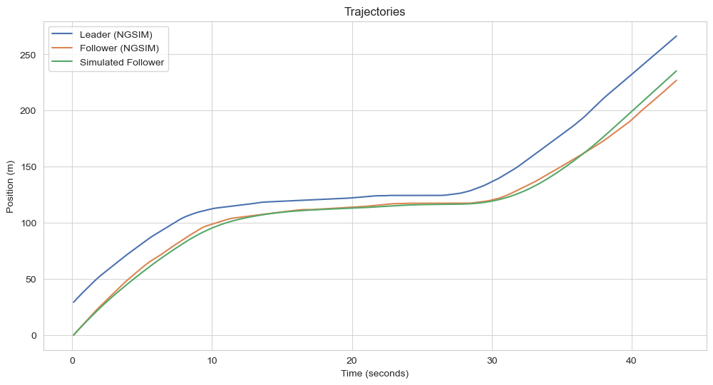
Figure 6 Trajectories of Leader, Follower, and Simulated Follower Vehicles

References
Federal Highway Administration. (n.d.). Retrieved from National Household Travel Survey: https://nhts.ornl.gov/
Federal Highway Administration. (n.d.). Next Generation Simulation (NGSIM) Open Data. Retrieved from Data.Transportation.gov: https://data.transportation.gov/stories/s/Next-Generation-Simulation-NGSIM-Open-Data/i5zb-xe34/#ngsim-program-data-collection-overview

