Uncertainty-aware reduced 2D electro-thermal modeling of transmural lesion formation during radiofrequency cardiac ablation under uncertain contact and cooling conditions
  - Author names and affiliations to be added by the authors
  - Corresponding author: to be added
  - Draft manuscript generated from the current frozen figure set; author metadata and final journal-specific formatting remain to be completed.

Abstract
Background: Short-duration high-power radiofrequency strategies are increasingly used in cardiac ablation, but their performance depends strongly on wall thickness, cooling, and catheter–tissue contact. Objective: To develop a low-cost two-dimensional electro-thermal framework for comparative and uncertainty-aware assessment of standard, high-power short-duration (HPSD), and very-high-power short-duration (vHPSD) protocols. Methods: A reduced catheter–blood–myocardium model was constructed using a quasi-static electrical solve, transient bioheat transfer, and Arrhenius thermal damage. Deterministic scans were performed over protocol, wall thickness, insertion depth as a contact surrogate, and cooling coefficient. Uncertainty propagation over contact and cooling generated transmural-probability maps, overheating-probability maps, and median depth-fraction summaries. Numerical convergence was assessed by grid and time-step refinement. A literature-derived protocol benchmark was used for trend-level external comparison. Results: Across the scanned parameter space, lesion penetration ranked standard > HPSD > vHPSD. Thin-wall conditions favored transmurality, whereas increasing wall thickness suppressed lesion depth for all protocols. vHPSD remained the shallowest protocol yet showed the greatest overheating susceptibility under thin-wall, weak-cooling, and aggressive-contact conditions. The literature benchmark reproduced the protocol-level ranking but indicated systematic underestimation of absolute lesion depth under the nominal reduced-model setup. Conclusion: A reduced 2D electro-thermal model can provide interpretable deterministic and probabilistic protocol maps for radiofrequency lesion formation under uncertain contact and cooling conditions. The present framework is intended for comparative, methodology-focused analysis rather than patient-specific quantitative lesion prediction.
Keywords: radiofrequency catheter ablation, electro-thermal modeling, uncertainty propagation, transmural lesion formation, high-power short-duration ablation

1. Introduction
Radiofrequency catheter ablation is used to create controlled thermal lesions in cardiac tissue, with the practical objective of producing lesions that are deep enough to be durable while avoiding collateral injury. Lesion formation is governed by coupled effects of protocol, tissue thickness, convective cooling, and catheter–tissue contact. These dependencies have motivated extensive computational studies of radiofrequency catheter ablation, including detailed reviews of the governing physics, implementation choices, and open modeling gaps [1].
Short-duration high-power strategies have intensified interest in protocol-specific trade-offs. In particular, ex vivo and in vivo comparisons have shown that shorter, higher-power applications can produce shallower lesions than longer conventional applications, even when lesion width remains clinically useful [3]. In a temperature-controlled very-high-power short-duration (vHPSD) setting, lesion size may also saturate with increasing contact force once contact reaches approximately 15 g, suggesting that more aggressive contact does not necessarily yield deeper lesions [4].
The computational challenge is that high-fidelity three-dimensional or fully coupled models are expensive, difficult to calibrate, and poorly suited to broad parameter sweeps. For an initial methodology-focused study, a reduced two-dimensional model offers a practical compromise: it preserves the dominant electro-thermal lesion-formation mechanisms while remaining cheap enough for systematic deterministic scans and uncertainty propagation. This reduced approach is further supported by previous work showing that a dynamic contact model including heartbeat-induced electrode motion produced lesion sizes that were nearly identical to those obtained using an equivalent average static insertion depth [2].
The specific gap addressed here is not the absence of another deterministic lesion simulator, but the lack of a compact and interpretable framework for protocol-level risk mapping under uncertain contact and cooling conditions. In practice, electrophysiologists are often interested in questions such as: under what combinations of wall thickness, contact, and cooling is a protocol likely to become transmural, and when does that same protocol begin to incur a non-negligible overheating risk? Such questions are more naturally answered by probability maps and trade-off summaries than by single deterministic contours.
Accordingly, this study develops a reduced 2D electro-thermal model to compare a standard protocol (30 W/30 s), an HPSD protocol (50 W/10 s), and a vHPSD protocol (90 W/4 s). Deterministic scans are first used to characterize lesion-depth trends across wall thickness, insertion depth, and cooling strength. Uncertainty propagation over contact and cooling is then used to generate transmural-probability maps, overheating-probability maps, and reduced trade-off summaries. The central hypothesis is that standard radiofrequency ablation will retain the highest transmural potential over the scanned conditions, HPSD will occupy an intermediate regime, and vHPSD will remain shallowest while showing the least favorable overheating trade-off under thin-wall, high-contact conditions.

2. Methods
The computational domain consisted of four regions: an ablation electrode, a superficial blood-pool layer, a myocardial wall, and a bottom thermal buffer (Figure 1). The wall thickness of the physical myocardium was varied, whereas the bottom buffer was included only to reduce artificial thermal-boundary effects and was excluded from lesion-depth measurements. Lateral and bottom boundaries were treated as insulated in the reduced model, and the top boundary included an effective convective cooling condition representing blood-pool cooling. The electrode insertion depth was used as a surrogate for contact rather than solving a full mechanical contact problem. This choice was motivated by prior work showing that average static insertion depth can closely reproduce lesion dimensions predicted by a dynamic heartbeat-induced contact model [2].
A quasi-static electrical solve was used to obtain Joule heating, which then drove the transient bioheat problem. Thermal injury was quantified using an Arrhenius damage model, and the lesion boundary was defined by Ω = 1. The present implementation therefore follows the conventional electrical–thermal–damage structure commonly used in radiofrequency catheter-ablation modeling [1]. The model was not intended to reproduce catheter-specific control logic in full detail; instead, it was designed as a reduced framework for comparative protocol assessment and uncertainty-aware parameter mapping.
Three representative protocols were compared: standard radiofrequency ablation (30 W for 30 s), HPSD (50 W for 10 s), and vHPSD (90 W for 4 s). Deterministic scans were carried out over wall thickness, insertion depth, and cooling coefficient. The nominal insertion depth served as a contact surrogate, and the cooling coefficient represented an effective summary of blood-mediated cooling. The selected ranges were chosen to span thin to thick tissue and low to aggressive contact conditions in a computationally tractable way. A summary of protocol definitions and parameter ranges is provided in Tables 1 and 2.
Model outputs included lesion depth, depth fraction (lesion depth divided by wall thickness), peak temperature, overheating area, and binary transmurality. Deterministic analyses were used to examine how these outputs changed with wall thickness, contact surrogate, and cooling. Uncertainty propagation was then performed over contact and cooling to generate transmural-probability maps, overheating-probability maps, and median depth-fraction summaries. In the present draft, uncertainty maps are based on the current fast-sampling workflow and are therefore intended as first-order probabilistic summaries rather than final high-sample posterior estimates.
Numerical verification was performed through grid and time-step refinement. Relative errors in lesion depth and peak temperature were computed against the finest tested grid and smallest tested time step, respectively. The selected spatial and temporal resolutions were retained for the uncertainty runs after verification indicated acceptably small residual changes in the reported metrics.
Because no direct geometry-matched experimental calibration was available in the present study, an external benchmark was derived from protocol-matched literature values. In the current version, the benchmark uses published lesion depths for 30 W/30 s, 50 W/10 s, and 90 W/4 s reported by Nakagawa et al. [3]. This comparison is interpreted as trend-level external benchmarking rather than strict validation, because the underlying tissue, catheter orientation, and thermal boundary conditions are not matched one-to-one between the literature experiments and the present reduced model.

Table 1. Protocols compared.
Protocol label | Power | Duration | Purpose in this manuscript
Standard RF | 30 W | 30 s | Conventional deeper reference protocol
HPSD | 50 W | 10 s | Intermediate high-power short-duration protocol
vHPSD | 90 W | 4 s | Very-high-power short-duration protocol

Table 2. Parameter ranges and outputs.
Parameter | Values / levels | Role in analysis
Wall thickness | 2, 3, 4, 5, 6 mm | Thin-to-thick myocardium sweep
Insertion depth | 0.5, 1.0, 1.5, 2.0 mm | Contact surrogate
Cooling coefficient h | 800, 1500, 2500 W/m²K | Weak, nominal, strong cooling
Primary deterministic outputs | Depth, depth fraction, peak temperature | Protocol comparison
Primary probabilistic outputs | Transmural probability, overheating probability, median depth fraction | Uncertainty-aware maps
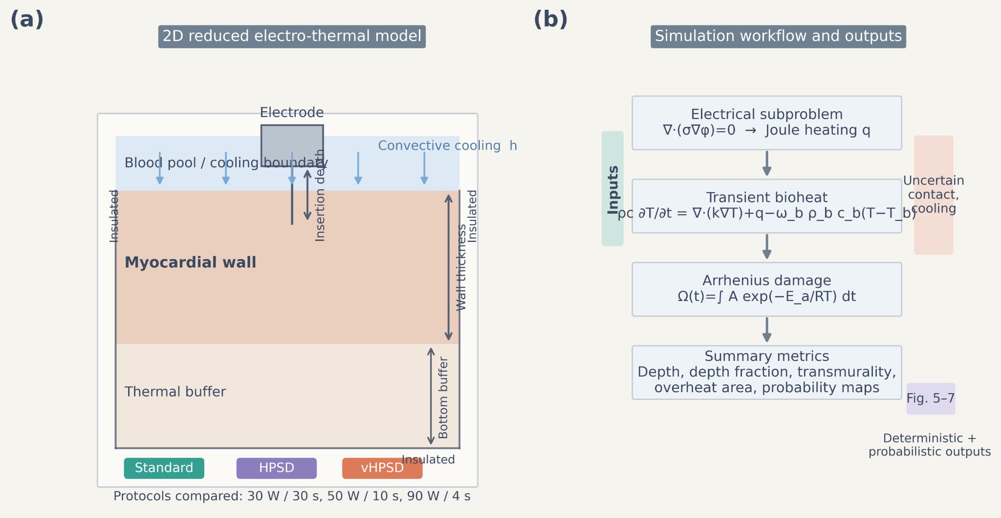
Figure 1. Reduced two-dimensional electro-thermal model and simulation workflow. (a) Schematic of the reduced domain, including the electrode, blood pool, myocardial wall, and bottom thermal buffer. The nominal wall thickness, insertion depth, and top convective cooling boundary are indicated. Lateral and bottom boundaries are insulated. Three protocols were compared: standard RF (30 W/30 s), HPSD (50 W/10 s), and vHPSD (90 W/4 s). (b) Computational workflow. A quasi-static electrical solve is used to obtain Joule heating, followed by transient bioheat simulation and Arrhenius damage accumulation. The framework yields deterministic outputs (depth, depth fraction, peak temperature) and probabilistic outputs (transmurality and overheating maps).

3. Results

3.1. Deterministic protocol comparison and representative spatial fields
Representative temperature and damage fields for the three protocols are shown in Figure 2 for the same nominal wall thickness, cooling, and insertion conditions. Standard radiofrequency ablation produced the deepest lesion, HPSD produced an intermediate lesion, and vHPSD produced the shallowest lesion. This ranking was visible both in the temperature fields and in the Arrhenius damage contours, indicating that the reduced model captured a consistent protocol-dependent lesion morphology.
The deterministic summaries in Figure 3 confirmed this ranking over the scanned parameter space. Under nominal contact and nominal cooling, depth fraction decreased monotonically as wall thickness increased for all three protocols (Figure 3a). Standard radiofrequency ablation retained the highest depth fraction over the entire wall-thickness range, HPSD remained intermediate, and vHPSD stayed consistently shallower. Under thin-wall conditions, increasing nominal insertion depth increased lesion penetration for all protocols without changing the overall ordering (Figure 3b). Under a moderate-thickness wall and elevated contact, stronger cooling reduced depth fraction for all protocols (Figure 3c).
Peak-temperature trends revealed the complementary safety trade-off. Under thin-wall conditions, increasing insertion depth raised peak temperature for all protocols, with vHPSD showing the steepest rise and approaching or exceeding the 100 °C threshold at aggressive contact settings (Figure 3d). Standard radiofrequency ablation remained farthest from the overheating threshold, whereas HPSD occupied an intermediate regime.
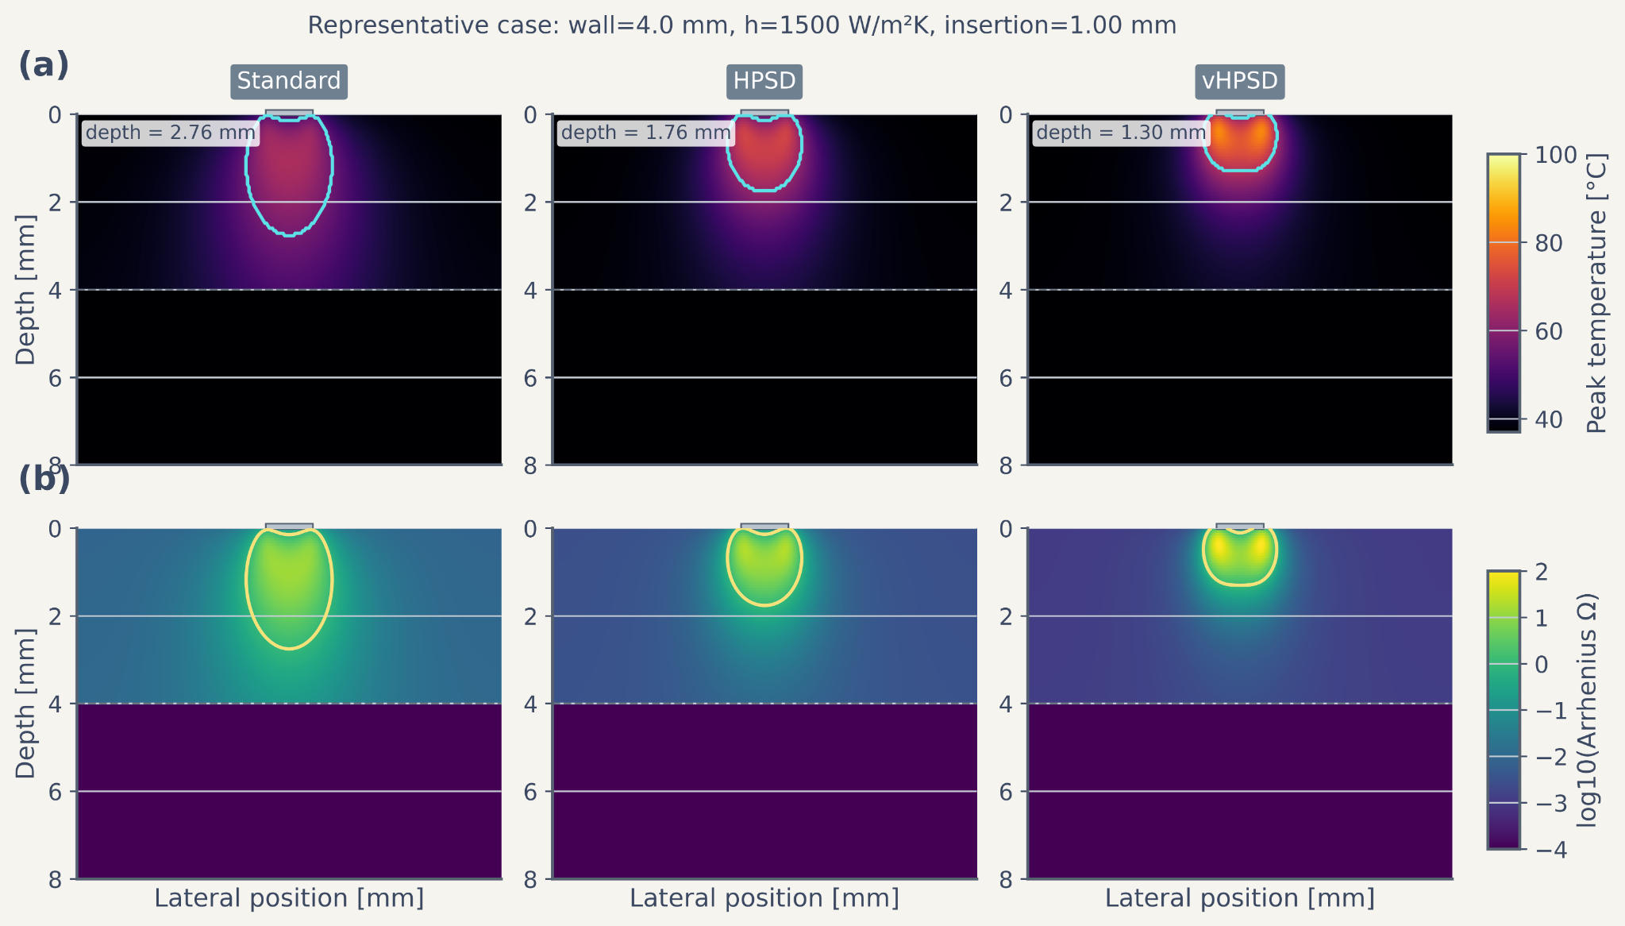
Figure 2. Representative spatial fields for the three radiofrequency protocols. Representative deterministic case with wall thickness = 4.0 mm, cooling coefficient = 1500 W/m²K, and insertion depth = 1.00 mm. (a) Temperature fields for standard RF, HPSD, and vHPSD. The cyan contour denotes the lesion boundary defined by Ω = 1, and the annotation reports lesion depth. (b) Corresponding Arrhenius damage fields shown as log10(Ω). The yellow contour again denotes Ω = 1. The dashed horizontal line marks the interface between the myocardial wall and the bottom thermal buffer.
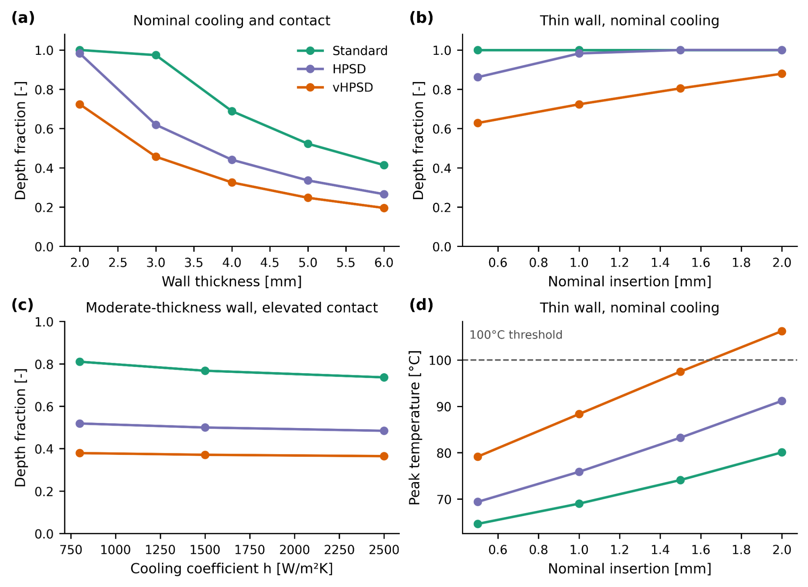
Figure 3. Deterministic protocol comparison across wall thickness, insertion depth, and cooling conditions. (a) Depth fraction versus wall thickness under nominal contact and nominal cooling. (b) Depth fraction versus nominal insertion depth for a thin wall under nominal cooling. (c) Depth fraction versus cooling coefficient for a moderate-thickness wall under elevated contact. (d) Peak temperature versus nominal insertion depth for a thin wall under nominal cooling, with the 100 °C threshold indicated by the dashed line.

3.2. Numerical verification
Numerical verification results are summarized in Figure 4. Grid refinement produced monotonic reductions in relative error for both lesion depth and peak temperature, and the selected grid was already close to the converged solution. Time-step refinement showed similarly small residual discrepancies between the selected time step and the finest temporal solution. These results support the adequacy of the chosen discretization for the reduced-model analyses reported here.
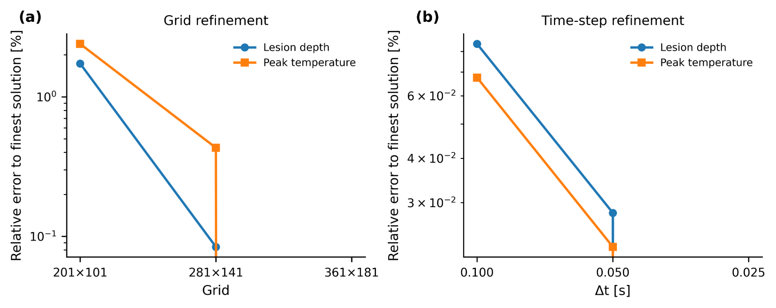
Figure 4. Numerical verification through grid and time-step refinement. (a) Relative error in lesion depth and peak temperature with respect to the finest grid solution. (b) Relative error in lesion depth and peak temperature with respect to the finest temporal solution. The selected grid and time step used in subsequent simulations are highlighted.

3.3. Uncertainty-aware transmural and overheating maps
Probability maps under uncertain contact and cooling are shown in Figure 5. Standard radiofrequency ablation exhibited the broadest region of high transmural probability, particularly in thin-wall conditions. HPSD retained a more restricted success region, largely confined to thin-wall settings and favorable contact conditions. Across the scanned parameter combinations, vHPSD did not achieve transmurality in the present reduced-model parameter range. Supplementary median depth-fraction maps (Figure S1) provided a continuous counterpart to these binary transmural summaries and preserved the same protocol ordering.
Overheating probability maps are shown in Figure 6. No overheating was observed for the standard protocol within the scanned conditions. HPSD displayed a limited overheating-prone region that emerged only under aggressive contact settings. In contrast, vHPSD showed a clear and extended overheating-risk region, especially under thin-wall, weak-cooling, and high-contact conditions. The trade-off summaries in Figure 7 showed that standard radiofrequency ablation clustered near the region of high median depth fraction and low overheating probability, HPSD occupied an intermediate regime, and vHPSD shifted toward reduced penetration together with substantially higher thermal risk under thin-wall conditions.
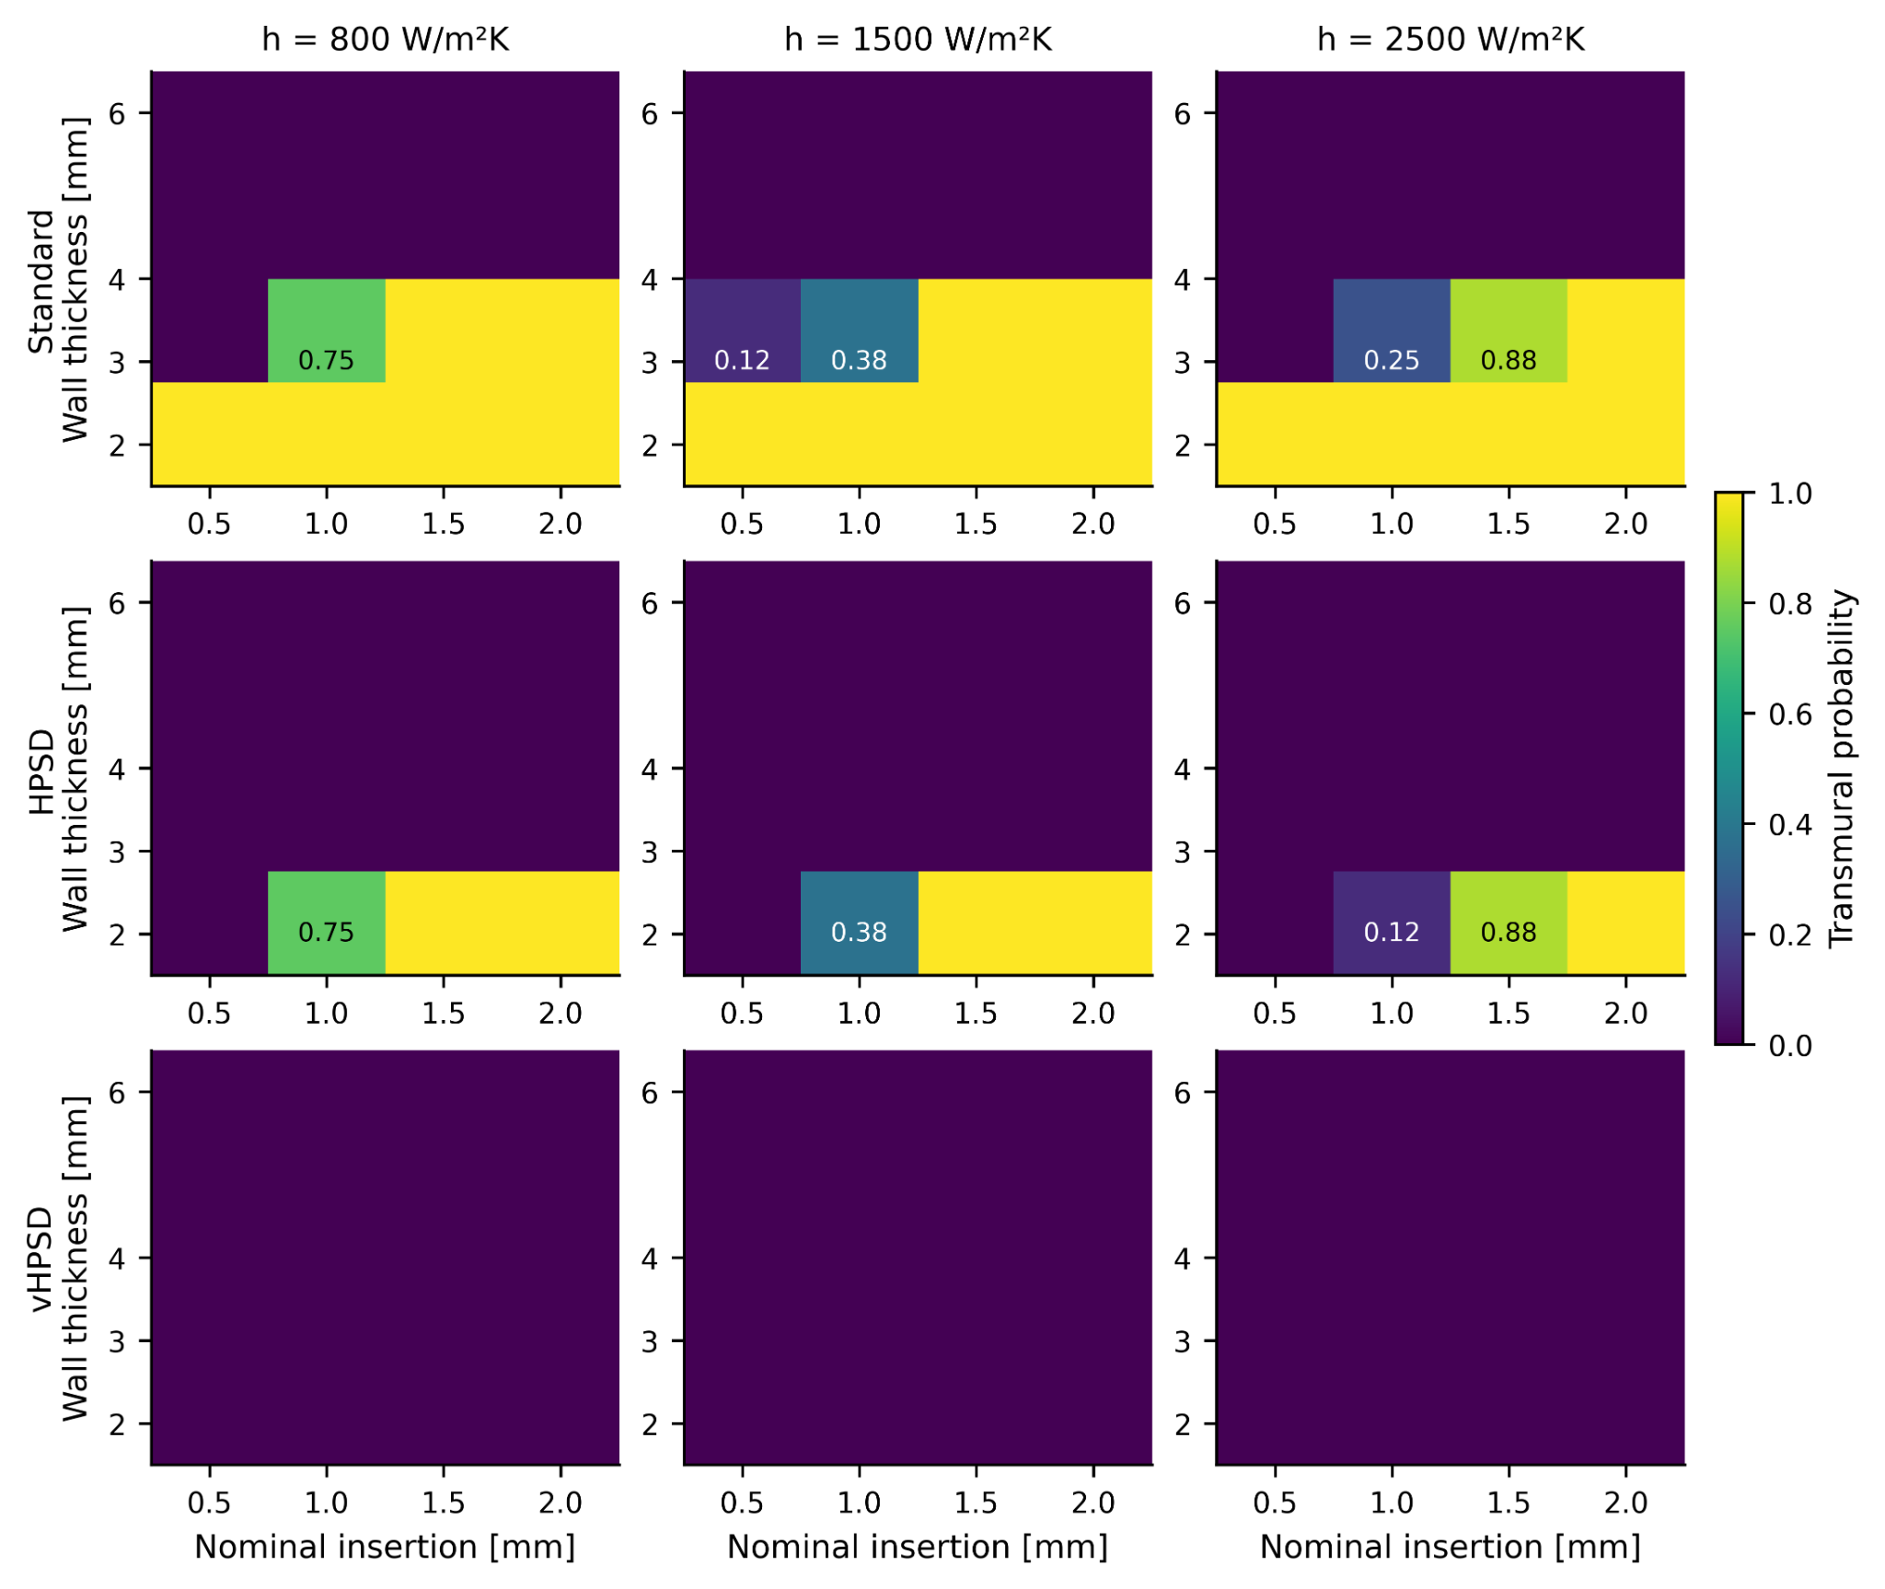
Figure 5. Transmural probability maps under uncertain contact and cooling conditions. Rows correspond to standard RF, HPSD, and vHPSD; columns correspond to weak, nominal, and strong cooling. Each cell reports the estimated probability of achieving a transmural lesion for a given pair of nominal wall thickness and nominal insertion depth after uncertainty propagation in contact and cooling. Only intermediate probabilities (0 < p < 1) are annotated.
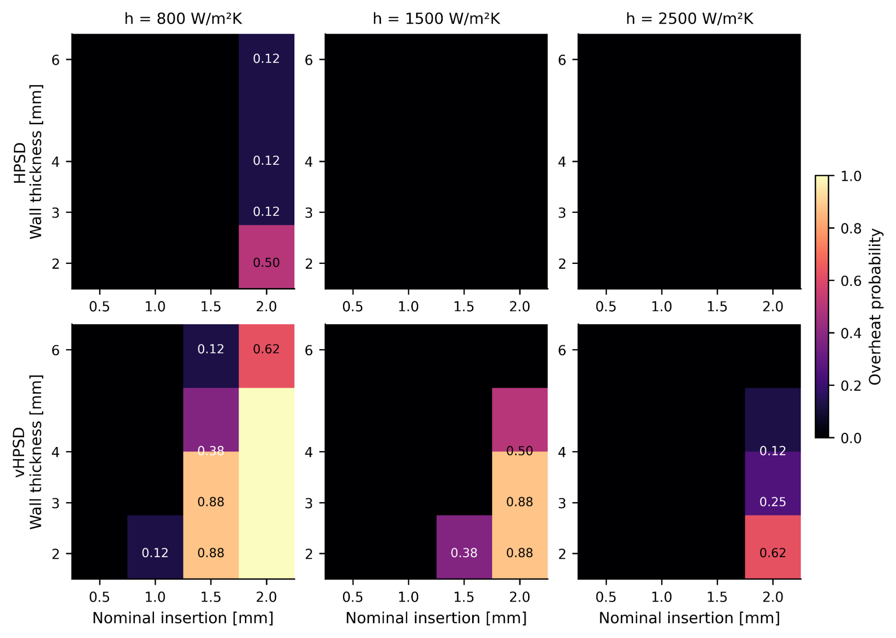
Figure 6. Overheating probability maps under uncertain contact and cooling conditions. Rows correspond to HPSD and vHPSD; columns correspond to weak, nominal, and strong cooling. Each cell reports the estimated probability of overheating, defined here using the model-based overheating criterion associated with temperatures reaching or exceeding 100 °C. Standard RF is omitted because overheating was not observed in the scanned conditions.
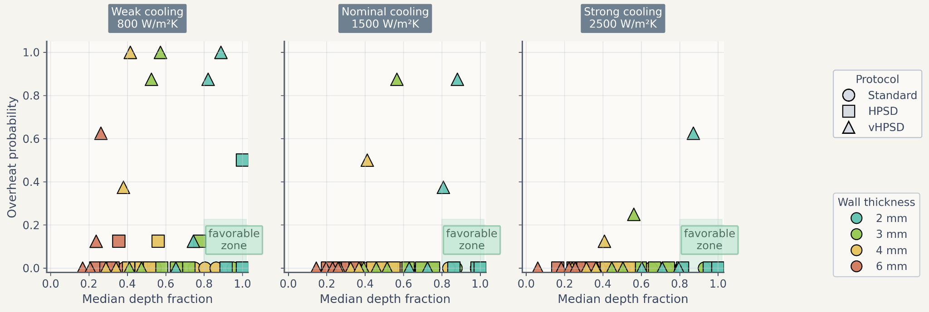
Figure 7. Trade-off between lesion depth and overheating risk. Scatter plots summarize the relationship between median depth fraction and overheating probability under weak, nominal, and strong cooling. Marker shape denotes protocol and marker color denotes wall thickness. The shaded favorable zone indicates parameter combinations with relatively high lesion penetration and low overheating risk.

3.4. Literature-derived benchmark
Figure 8 compares protocol-matched simulated lesion depth with literature-derived depth values. The reduced model reproduced the literature ranking of standard > HPSD > vHPSD at the protocol level (Figure 8b), but the absolute simulated lesion depths were consistently lower than the reported experimental depths (Figure 8a). This pattern supports the use of the present framework as a comparative and uncertainty-aware protocol-mapping tool, while also showing that the current nominal reduced setup should not be interpreted as a geometry-matched quantitative predictor of lesion depth.
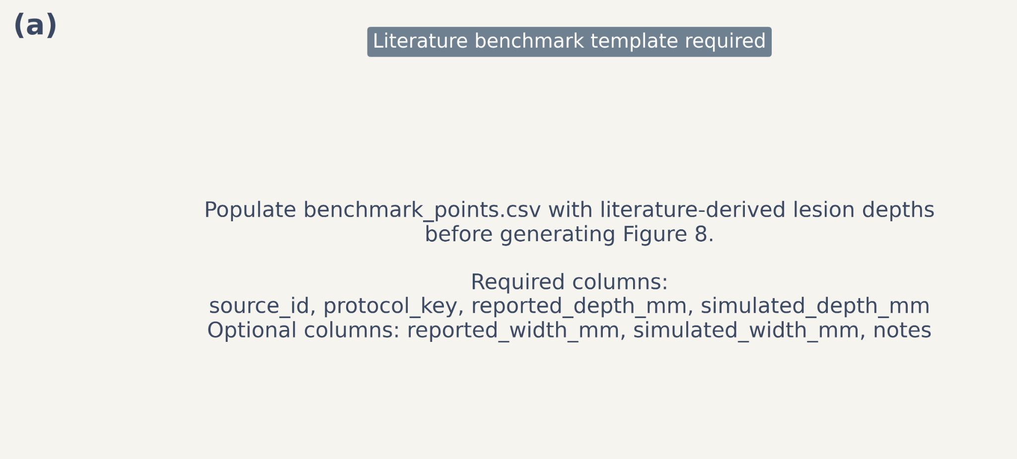
Figure 8. Literature-derived benchmark of lesion depth trends. (a) Agreement plot comparing literature-reported lesion depth with simulated lesion depth for protocol-matched benchmark points. The dashed line indicates identity. (b) Comparison of protocol-level mean lesion depth derived from literature-reported values and the current reduced-model simulations. The reduced model reproduced the protocol-level ranking reported in the literature while underestimating absolute lesion depth under the present nominal reduced-model setup.

4. Discussion
The main finding of this study is that a reduced two-dimensional electro-thermal framework was sufficient to recover a stable protocol ranking across deterministic and probabilistic analyses: standard radiofrequency ablation produced the deepest lesions, HPSD occupied an intermediate regime, and vHPSD remained the shallowest in the scanned parameter range. At the same time, vHPSD displayed the least favorable overheating behavior under thin-wall, weak-cooling, and aggressive-contact settings. The reduced model therefore did not simply reproduce a depth ranking; it also revealed a clinically interpretable trade-off between penetration and thermal risk.
Mechanistically, the current results support the view that longer-duration applications retain an advantage for deeper lesion formation because they allow heat to propagate further into tissue. By contrast, very-short, very-high-power applications concentrate heating near the surface and produce a steeper increase in local temperature without a proportional increase in deep penetration. This interpretation is consistent with prior comparative work showing shallower lesions for 90 W/4 s relative to 50 W/10 s and 30 W/30 s [3]. It is also compatible with the ex vivo contact-force study of Yamaguchi et al., which showed that lesion size in vHPSD no longer increased appreciably once contact force exceeded approximately 15 g [4].
The uncertainty-aware formulation adds a practical layer of interpretation that is not captured by a single deterministic contour. In the present model, standard radiofrequency ablation retained a broad transmural region under thin-wall conditions, whereas HPSD moved into a narrower transition zone and vHPSD remained non-transmural over the scanned parameter combinations. Conversely, overheating probability was negligible for the standard protocol, limited for HPSD, and substantial for vHPSD in aggressive thin-wall settings. These trade-offs are exactly the type of summary that reduced probabilistic models can provide efficiently, even when patient-specific calibration is not yet available.
The literature-derived benchmark should be interpreted conservatively. The current model reproduced the protocol-level ranking reported in the literature, but underestimated absolute lesion depth. This is not unexpected. The present framework uses a reduced two-dimensional geometry, nominalized contact and cooling surrogates, and no geometry-matched experimental calibration. It also does not attempt to reproduce full catheter-specific temperature-control logic or char/steam-pop physics. For these reasons, Figure 8 is best described as a trend-level external benchmark rather than a strict quantitative validation. Even so, agreement in protocol ordering supports the usefulness of the reduced model as a comparative tool under limited computational resources.
The study has several strengths. First, it provides a computationally inexpensive framework that is capable of deterministic sweeps, uncertainty propagation, and protocol trade-off mapping on a standard laptop-class environment. Second, the use of insertion depth as a contact surrogate is physically interpretable and grounded in previous modeling work showing close agreement between average static insertion depth and dynamically varying electrode displacement [2]. Third, the reduced model is transparent: each step of the workflow can be related directly to a physical quantity or modeling assumption.
The limitations should also be acknowledged. The model is two-dimensional and therefore cannot capture full catheter orientation, chamber-scale blood flow, or patient-specific anatomy. Cooling is represented by an effective boundary coefficient rather than by CFD. Contact is represented by insertion depth rather than a full mechanical contact-force calculation. The present uncertainty analysis considers only selected variables, and the current literature benchmark contains a limited number of protocol-level points. Finally, the benchmark highlights that absolute depth prediction still requires calibration against geometry-matched experiments or high-quality in vivo measurements.
Future work should therefore proceed in three directions. First, the probabilistic maps should be rerun with higher sample counts to generate a paper-grade uncertainty set. Second, the benchmark should be expanded to include additional depth and width points from protocol-matched experiments. Third, the current framework could be extended toward more realistic blood-flow, contact-mechanics, or patient-specific geometries while preserving the present uncertainty-aware reporting strategy. In that role, the reduced model could serve as a fast screening or hypothesis-generation tool that complements, rather than replaces, higher-fidelity simulations and experiments.

5. Conclusion
A reduced two-dimensional electro-thermal model was developed to compare standard, HPSD, and vHPSD radiofrequency ablation protocols under uncertain contact and cooling conditions. Across deterministic and probabilistic analyses, the model consistently ranked lesion penetration as standard > HPSD > vHPSD. Standard radiofrequency ablation exhibited the broadest transmural region and the lowest overheating susceptibility, HPSD occupied an intermediate regime, and vHPSD remained shallowest while showing the greatest thermal-risk sensitivity under thin-wall, aggressive-contact conditions.
The model reproduced the protocol-level ranking observed in the literature benchmark but underestimated absolute lesion depth, indicating that the present framework is most appropriate for comparative and uncertainty-aware protocol mapping rather than patient-specific quantitative lesion prediction. Even with that limitation, the framework provides an efficient methodology for identifying favorable and unfavorable operating regions and offers a practical basis for future calibration and higher-fidelity extensions.

Acknowledgements
To be added by the authors.

Funding
To be added by the authors.

Conflict of interest
The authors are expected to complete this section prior to submission.

Data availability
Code, frozen figures, and manuscript assets are available in the accompanying project repository and submission package.

References
1. González-Suárez A, Pérez JJ, Irastorza RM, D'Avila A, Berjano E. Computer modeling of radiofrequency cardiac ablation: 30 years of bioengineering research. Comput Methods Programs Biomed. 2022;214:106546. doi:10.1016/j.cmpb.2021.106546.
2. Pérez JJ, et al. Computer modeling of radiofrequency cardiac ablation including heartbeat-induced electrode displacement. Comput Biol Med. 2022;144:105346. doi:10.1016/j.compbiomed.2022.105346.
3. Nakagawa H, Ikeda A, Sharma T, Govari A, Ashton J, Maffre J, et al. Comparison of In Vivo Tissue Temperature Profile and Lesion Geometry for Radiofrequency Ablation With High Power-Short Duration and Moderate Power-Moderate Duration: Effects of Thermal Latency and Contact Force on Lesion Formation. Circ Arrhythm Electrophysiol. 2021;14(7):e009899. doi:10.1161/CIRCEP.121.009899.
4. Yamaguchi J, Takigawa M, Goya M, Martin CA, Negishi M, Yamamoto T, et al. Impact of contact force on the lesion characteristics of very high-power short-duration ablation using a QDOT-MICRO catheter. J Arrhythm. 2024;40:247-255. doi:10.1002/joa3.12992.

Appendix A. Supplementary materials
Supplementary figure legends and preview images are included here for drafting purposes. They can be moved to a separate supplementary file at submission.
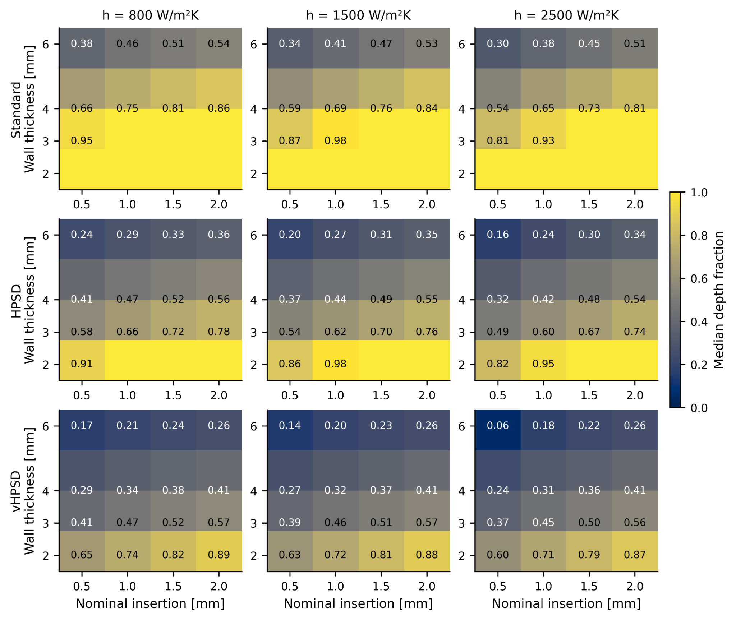
Figure S1. Median depth-fraction maps under uncertain contact and cooling conditions. Rows correspond to standard RF, HPSD, and vHPSD; columns correspond to weak, nominal, and strong cooling. Compared with the binary transmural maps in Figure 5, these maps provide a continuous view of lesion penetration and highlight the progressive reduction in depth fraction from standard RF to HPSD to vHPSD as wall thickness increases.
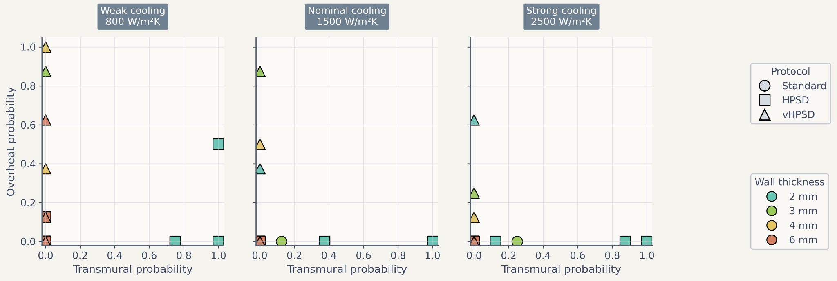
Figure S2. Alternative trade-off summary using transmural probability and overheating probability. Scatter plots summarize the relationship between transmural probability and overheating probability under weak, nominal, and strong cooling. Marker shape denotes protocol and marker color denotes wall thickness.

