Comparator-aware reduced 2D electro-thermal modeling of lesion formation during radiofrequency cardiac ablation

Abstract
Reduced electro-thermal models can support broad comparative radiofrequency (RF) ablation sweeps on modest hardware, but their interpretation depends on comparator definition and on whether post-pulse thermal latency is represented explicitly. We developed a comparator-aware reduced two-dimensional electro-thermal framework that distinguishes fixed-power and generic temperature-limited 90 W / 4 s conditions while comparing them with standard RF (30 W / 30 s) and HPSD (50 W / 10 s) protocols. A vertically contacting electrode-blood-myocardium model combined a quasi-static electrical solution, transient bioheat transfer, and Arrhenius thermal damage. Contact was represented by insertion depth, which modulated effective source strength and local cooling, and all protocols included an 8 s post-pulse latency window. At a representative condition, adding the latency window increased fixed 90 W / 4 s lesion depth from 1.302 to 1.695 mm and lesion area from 3.486 to 4.599 mm^2. Under the same condition, the generic temperature-limited 90 W / 4 s comparator reduced delivered energy from 360.0 to 354.9 J and peak temperature from 83.46 to 81.95 °C, with only a small reduction in lesion depth. Across the phase-preparation grid, controller action was threshold-dependent. The framework therefore supports reduced, assumption-explicit comparator analysis rather than device-level prediction.
Keywords: radiofrequency catheter ablation; electro-thermal modeling; thermal latency; high-power short-duration ablation; comparator definition; reduced model

1. Introduction
Radiofrequency catheter ablation remains a standard thermal strategy for creating irreversible myocardial injury in the treatment of cardiac arrhythmias. Lesion size and shape are governed by the interplay among delivered power, application duration, catheter-tissue contact, local cooling, and tissue thickness (González-Suárez et al. 2016, 2018, 2022). Classical bioheat and thermal-injury models have long been used to study these mechanisms (Pennes 1948; Henriques 1947; Arrhenius 1889; Chang 2010), while contemporary cardiac-ablation reviews show that computational modeling now spans simplified two-dimensional studies, irrigated-electrode models, dynamic contact models, and broader multiphysics frameworks (González-Suárez et al. 2016, 2018, 2022; Pérez et al. 2022).
High-power short-duration strategies have drawn particular interest because they alter the balance between resistive and conductive heating (Nakagawa et al. 2021; Kotadia et al. 2020; Petras et al. 2021; Irastorza et al. 2018; Reddy et al. 2019; Rozen et al. 2018; Barkagan et al. 2018; Chieng et al. 2023; Jin et al. 2023; Liu et al. 2021; Amin et al. 2024). Experimental and clinical studies indicate that HPSD can shorten RF delivery time while maintaining lesion efficacy in selected contexts (Chieng et al. 2023; Jin et al. 2023; Liu et al. 2021; Amin et al. 2024). At the same time, lesion geometry is protocol dependent: computer and experimental studies have shown that increasing power while shortening duration does not simply scale lesion depth proportionally, and vHPSD lesions may remain relatively shallow in thick myocardium (Nakagawa et al. 2021; Irastorza et al. 2018; Reddy et al. 2019; Rozen et al. 2018; Barkagan et al. 2018; Yamaguchi et al. 2024; Iwakawa et al. 2025). In temperature-controlled 90 W/4 s ablation, lesion size also appears to saturate once contact force exceeds approximately 15 g (Yamaguchi et al. 2024).
For methodology development on modest hardware, however, the value of reduced electro-thermal models does not lie in reproducing every catheter-specific control feature or chamber-scale flow phenomenon. Their value lies in providing computationally economical, assumption-explicit frameworks for broad comparative sweeps across tissue thickness, cooling, and contact surrogates. For such reduced models, the central question is not whether they mimic a specific device, but whether comparator definitions, reduction assumptions, and interpretation boundaries are made explicit enough to support defensible comparative inferences.
A key problem arises when a 90 W / 4 s condition is represented only as a fixed-power pulse and when post-pulse thermal latency is omitted. Under those conditions, part of the reported protocol difference may reflect comparator mis-specification and missing thermal latency rather than the intended short high-power behavior itself. In reduced protocol studies, this is not a secondary implementation detail; it is a first-order methodological issue because power titration and post-pulse conduction can materially change lesion depth, delivered energy, and apparent thermal severity.
Accordingly, the objective of the present work is not to reproduce a catheter-specific commercial 90 W / 4 s algorithm, but to establish a comparator-aware reduced 2D electro-thermal methodology that explicitly distinguishes fixed-power and generic temperature-limited 90 W / 4 s cases and includes a finite post-pulse thermal latency window. The main methodological contributions are threefold: separation of comparator definition from protocol labeling, explicit representation of post-pulse latency, and generation of four-way deterministic and phase-preparation maps while keeping interpretation bounded to reduced-model applicability. Within this framing, lesion width and overheating-related quantities are retained as secondary internal proxies rather than promoted as device-level predictive endpoints.

2. Materials and methods

2.1 Reduced two-dimensional electro-thermal lesion model
We considered a reduced two-dimensional cross-sectional model composed of a vertically contacting electrode footprint, the adjacent blood-pool boundary, a myocardial wall, and a lower thermal buffer. The objective was comparative lesion analysis rather than catheter-specific reproduction of irrigation jets, chamber-scale flow, or feedback-controlled temperature regulation. Figure 1 summarizes the reduced geometry and computational workflow.
The electrical subproblem was solved in quasi-static form:
$$∇⋅\left(σ∇ϕ\right)=0$$
where $ϕ$ is electric potential and $σ$ is electrical conductivity. A unit-potential solution was first obtained, and the corresponding unit Joule source was computed as:
$$q_{unit}=σ{\left|∇ϕ\right|}^{2}$$
The thermal problem was represented using a transient bioheat formulation:
$$ρc\frac{∂T}{∂t}=∇⋅\left(k∇T\right)+q_{RF}−ω_{b}ρ_{b}c_{b}\left(T−T_{b}\right)$$
where $T$ is temperature, $ρ$ density, $c$ specific heat, and $k$ thermal conductivity. In the present implementation, the perfusion term was set to zero, so that blood-mediated cooling entered primarily through the surface boundary condition. Thermal injury was quantified using the Arrhenius damage integral:
$$Ω\left(t\right)=\int_{0}^{t}{A}exp​\left(−\frac{E_{a}}{RT\left(τ\right)}\right)dτ$$
and lesion boundary was defined by Ω = 1 (Pennes 1948; Henriques 1947; Arrhenius 1889; Chang 2010).

2.2 Geometry and computational domain
The domain width was 18 mm. Physical myocardial wall thickness was varied from 2 to 6 mm. An additional 4 mm lower thermal buffer was included to reduce boundary contamination, but this buffer was excluded from lesion metrics. The electrode footprint at the tissue surface was represented by a 2-mm-wide top boundary segment. The baseline production grid for the 4-mm wall case used 281 x 141 nodes, with the number of depth nodes rescaled proportionally for other wall-thickness settings.

2.3 Boundary and initial conditions
The lower boundary of the electrical domain was grounded, the electrode segment at the top surface was assigned a unit potential, and the remaining top-surface and lateral boundaries were electrically insulated. For the thermal problem, the lateral and lower boundaries were zero-flux. The top surface was subject to an effective convective condition with nominal coefficient $h_{nom}$, representing combined blood-pool and catheter-adjacent cooling in reduced form. The initial temperature was 37 °C throughout the domain.

2.4 Comparator definition, control logic, and contact surrogate implementation
Four protocol definitions were used in the present methodology: standard RF (30 W / 30 s), HPSD (50 W / 10 s), fixed-power 90 W / 4 s, and generic temperature-limited 90 W / 4 s. Contact was represented using insertion depth rather than explicit force. This reduced contact surrogate was intended to reflect the experimentally observed relation between contact area and lesion size without modelling full contact mechanics (Masnok et al. 2022). The temperature-limited 90 W / 4 s comparator used a generic surface-adjacent temperature surrogate, a target temperature of 70 °C, a ceiling temperature of 80 °C, and a 0.05 s control-update period. This control law was introduced to distinguish fixed-power and temperature-limited short high-power comparators within the reduced framework; it is not intended to reproduce a catheter-specific commercial algorithm. An 8 s post-pulse thermal latency window was applied after energy delivery in all deterministic and phase-preparation analyses. The protocol definitions used throughout the deterministic and phase-preparation analyses are summarized in Table 1.
$$Δy=α_{shift} d_{ins}$$
where $α_{shift}=0.25 mm/mm$. The regularized source q_reg was then scaled to the applied power according to:
$$q_{RF}=κ_{P} P S_{c}\left(d_{ins}\right) \frac{q_{reg}}{∫q_{reg} dA}$$
where $P$ is the protocol power, $κ_{P}=6.8 W m^{−1}$ per applied watt is the calibrated source-amplitude coefficient, and the contact-gain factor is:
$$S_{c}\left(d_{ins}\right)=max​\left(0.5,1+β_{P}\left(d_{ins}−d_{ref}\right)\right)$$
with $d_{ref}=1.0 mm$ and $β_{P}=0.16 mm^{−1}$. Thus, larger insertion depths increase the effective source strength while preserving the regularized spatial pattern.
Contact also modified local cooling over the electrode footprint. On the footprint, the effective convective coefficient was:
$$h_{foot}=h_{nom} S_{h}\left(d_{ins}\right)$$
with
$$S_{h}\left(d_{ins}\right)=clip​\left(1−β_{h}\left(d_{ins}−d_{ref}\right), h_{min}, h_{max}\right)$$
where β_h is the contact cooling-reduction coefficient, d_ref is the reference insertion depth, and h_min is the minimum allowed footprint coefficient. Outside the electrode footprint, the surface coefficient remained equal to h_nom. This construction allowed the contact surrogate to affect both local source intensity and local cooling in a transparent reduced-order manner. For the 90 W / 4 s condition, two distinct computational comparators were defined. The fixed-power case used the nominal 90 W request throughout the 4 s pulse. The generic temperature-limited case used the same nominal request power but updated the applied power from a surface-adjacent temperature signal; between controller updates, the previous applied power was held. After pulse termination, all protocols were advanced through an 8 s zero-source latency window to capture post-pulse heat diffusion. These choices were intended to separate comparator definition from protocol labeling, not to reproduce a catheter-specific commercial control law.

2.5 Material parameters and lesion metrics
Baseline material parameters were $σ=0.6 S/m$, $k=0.55 W m^{−1}K^{−1}$, $ρ=1050 kg m^{−3}$, and $c=3600 J kg^{−1}K^{−1}$. The Arrhenius parameters were $A=7.39×{10}^{39} s^{−1}$ and $E_{a}=2.577×{10}^{5} J mol^{−1}$. Reported outputs were lesion depth, maximum lesion width, lesion area, depth fraction (depth/wall thickness), depth-to-width ratio, transmurality, peak temperature, and the area exposed to temperatures ≥ 100 °C.

2.6 Numerical implementation and verification
The model was implemented in Python using a finite-difference discretization on structured grids. The unit-potential electrical problem and the implicit heat step were solved at each case using sparse linear algebra. Grid convergence was assessed using 201 x 101, 281 x 141, and 361 x 181 grids for the 4-mm baseline case. Time-step convergence was assessed using 0.10 s, 0.05 s, and 0.025 s. The selected production settings were 281 x 141 and Δt = 0.05 s. The reduced source-gain and cooling-reduction coefficients were retained from the preceding implementation and were not formally re-estimated here. Accordingly, the present manuscript should be interpreted as a comparator-aware reduced methodology study rather than as a fully recalibrated predictive model. The solver, control, latency, and phase-preparation settings are summarized in Table 2. Grid- and time-step verification results for the baseline nominal case are shown in Figure 4.

2.7 Deterministic sweeps
Deterministic sweeps were performed across protocol, wall thickness, nominal cooling coefficient, and nominal insertion depth. Wall thickness values were 2, 3, 4, 5, and 6 mm. Nominal cooling coefficients were 800, 1500, and 2500 W m^-2 K^-1. Nominal insertion depths were 0.5, 1.0, 1.5, and 2.0 mm. These sweeps were summarized using lesion depth, depth fraction, delivered energy, and peak-temperature trends, with lesion width and lesion area retained as secondary internal descriptors.

2.8 Phase-preparation grid and output hierarchy
The phase-preparation analysis evaluated all four protocols across a 5 x 3 x 4 grid of wall thickness, cooling coefficient, and insertion depth combinations, yielding 240 protocol-cell evaluations in total. All protocol evaluations used the same 8 s post-pulse thermal latency window. Within this hierarchy, lesion depth, depth fraction, delivered energy, mean applied power, and peak temperature were treated as the primary interpretive outputs. Lesion width, lesion area, and overheat-area proxies were retained for internal comparison but were not used as the principal basis for comparator claims.

2.9 Reference literature benchmark
Because no geometry-matched experimental dataset was available, external comparison remained limited to a protocol-level literature-derived benchmark. That benchmark is treated as trend-level context and not as validation of device-level prediction or of the generic temperature-limited comparator. In particular, the benchmark does not distinguish fixed-power and temperature-limited 90 W / 4 s as separate computational objects.
Table 1. Protocol definitions used throughout the deterministic and phase-preparation analyses.
Protocol | Power (W) | Duration (s) | Nominal energy (J) | Role in comparison
Standard RF | 30 | 30 | 900 | Conventional long-duration comparator
HPSD | 50 | 10 | 500 | Intermediate high-power short-duration comparator
90 W / 4 s fixed | 90 | 4 | 360 | Fixed-power short high-power comparator
90 W / 4 s temperature-limited | 90 | 4 | up to 360 | Generic temperature-limited short high-power comparator
Table 2. Solver, control, latency, and phase-preparation settings.
Item | Value
Deterministic production grid | 281 x 141
Time step | 0.05 s
Wall thickness levels | 2.0, 3.0, 4.0, 5.0, 6.0 mm
Nominal cooling coefficients | 800, 1500, 2500 W m^-2 K^-1
Nominal insertion levels | 0.5, 1.0, 1.5, 2.0 mm
Comparator set | 30 W / 30 s, 50 W / 10 s, 90 W / 4 s fixed, 90 W / 4 s temperature-limited
Controller sensor | Surface-adjacent temperature surrogate
Controller target / ceiling | 70 °C / 80 °C
Controller sample period | 0.05 s
Post-pulse latency window | 8.0 s
Phase-preparation grid size | 5 x 3 x 4 x 4 = 240 protocol-cell evaluations
Primary interpretive outputs | Lesion depth, depth fraction, delivered energy, mean applied power, peak temperature
Secondary internal proxies | Lesion width, lesion area, overheat area (T ≥ 100 °C)
Calibration status | Contact/cooling surrogate coefficients retained from the preceding implementation; no formal re-estimation or identifiability analysis performed here
Supplementary UQ status | Reference uncertainty figures from the fixed-power three-protocol formulation are provided for completeness only and are not the primary evidentiary basis for the comparator-aware conclusions

3. Results

3.1 Comparator definition and protocol set
All deterministic results were generated with four explicitly defined comparators: standard RF (30 W / 30 s), HPSD (50 W / 10 s), fixed-power 90 W / 4 s, and generic temperature-limited 90 W / 4 s. The temperature-limited 90 W / 4 s case was implemented as a generic surface-adjacent feedback controller and should therefore be interpreted as a comparator definition within the reduced model rather than as a catheter-specific commercial control law. An 8 s post-pulse thermal latency window was applied to all four protocols so that short high-power outputs were not evaluated from end-of-pulse fields alone.

3.2 Effect of post-pulse thermal latency
The effect of thermal latency was first examined in a representative 90 W / 4 s fixed-power case. At wall thickness 4 mm, cooling coefficient 1500 W m^-2 K^-1, and insertion depth 1.0 mm, adding an 8 s post-pulse latency window increased lesion depth from 1.302 to 1.695 mm and lesion area from 3.486 to 4.599 mm^2, while the reported peak temperature remained 83.46 °C. This confirms that, within the present reduced framework, short high-power lesion formation is strongly affected by continued post-pulse heat diffusion and should not be interpreted from pulse termination alone.

3.3 Deterministic four-way comparison at representative conditions
At the same representative condition, standard RF produced the deepest lesion (3.113 mm), followed by HPSD (2.114 mm), fixed-power 90 W / 4 s (1.695 mm), and generic temperature-limited 90 W / 4 s (1.670 mm). Peak temperatures followed the opposite trend, with values of 65.77, 72.14, 83.46, and 81.95 °C, respectively. Relative to fixed-power 90 W / 4 s, the temperature-limited comparator reduced delivered energy from 360.0 to 354.9 J and mean applied power from 90.0 to 88.7 W, while causing only a modest depth reduction. Under these representative conditions, the main effect of control was therefore not a collapse of lesion formation, but a limited reduction in thermal severity. Representative spatial fields are shown in Figure 2, and the corresponding deterministic trend slices are summarized in Figure 3.

3.4 Phase-preparation behavior of fixed versus temperature-limited 90 W / 4 s
Across the full phase-preparation grid, the effect of temperature-limited control was threshold-dependent. In more aggressive cells, particularly those combining thinner walls, weaker cooling, and larger insertion depth, the controlled 90 W / 4 s comparator reduced delivered energy and peak temperature substantially relative to the fixed-power case. For example, at wall thickness 2 mm, cooling coefficient 800 W m^-2 K^-1, and insertion depth 1.5 mm, the fixed-power comparator reached 105.59 °C with an overheat-area proxy of 0.426 mm^2, whereas the temperature-limited comparator reduced peak temperature to 83.15 °C, reduced delivered energy to 271.3 J, and remained non-transmural under the present criterion. By contrast, in cooler cells the controller became effectively inactive and the controlled solution converged toward the fixed-power solution. Figures 5 and 6 summarize the resulting depth-fraction and peak-temperature maps for the fixed-power and temperature-limited 90 W / 4 s comparators, and Figure 7 summarizes the corresponding controlled-minus-fixed reductions in delivered energy and peak temperature.

3.5 Boundary of interpretation
These maps should be interpreted as model-internal, assumption-bounded comparator analyses. The most defensible outputs are lesion depth, depth fraction, delivered energy, mean applied power, and peak-temperature trends. Lesion width and overheating-related quantities are retained for internal comparison, but they are not used here as primary validation targets or as device-level predictive claims.

3.6 Reference benchmark status
The retained three-protocol literature-derived benchmark reproduces the expected ranking of standard RF deepest, HPSD intermediate, and fixed-power 90 W / 4 s shallowest. However, that benchmark does not distinguish fixed-power and temperature-limited 90 W / 4 s as separate computational comparators and therefore serves only as trend-level context. It should not be interpreted as validation of the generic temperature-limited comparator or of device-level prediction. The benchmark point set is listed in Table 3, and the protocol-level depth comparison is shown in Figure 8.
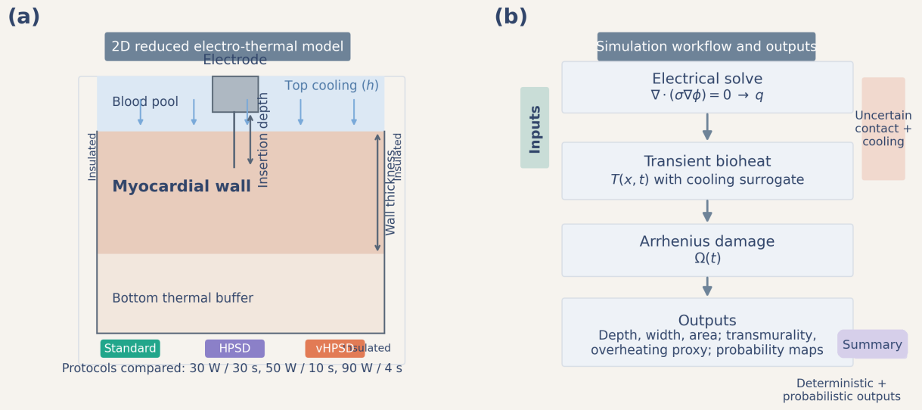
Figure 1. Reduced 2D model geometry and workflow. Panel (a) shows the electrode footprint, blood-pool boundary, myocardium, and lower thermal buffer together with the electrical and thermal boundary conditions. Panel (b) summarizes the computational workflow from unit-potential solution to power-scaled heat source, transient bioheat solution, Arrhenius damage, and lesion metrics.
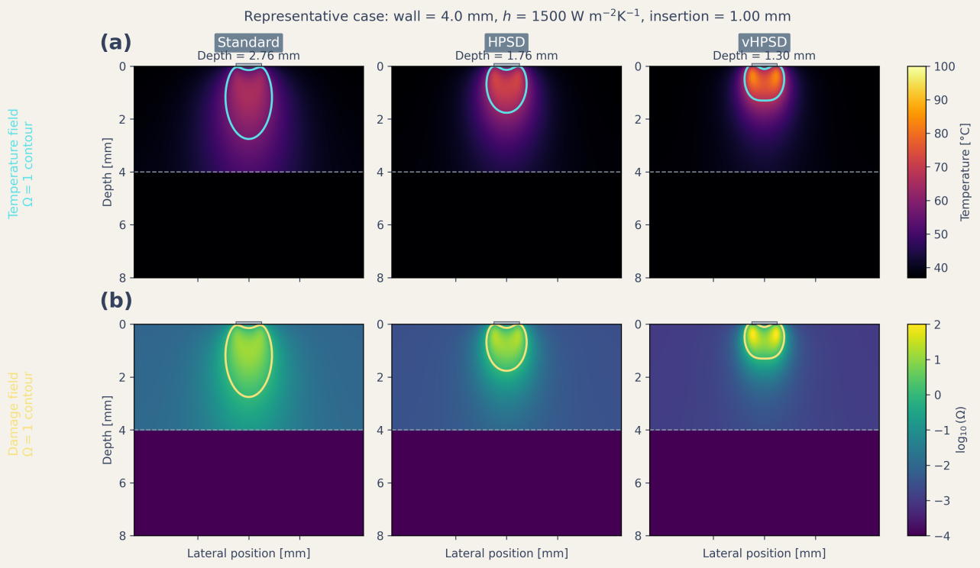
Figure 2. Representative spatial fields for the baseline fixed-power formulation. The top row shows temperature fields and lesion-boundary contours for standard RF, HPSD, and fixed-power 90 W / 4 s under the representative nominal case. The bottom row shows the corresponding thermal-damage fields expressed as log10(Ω).
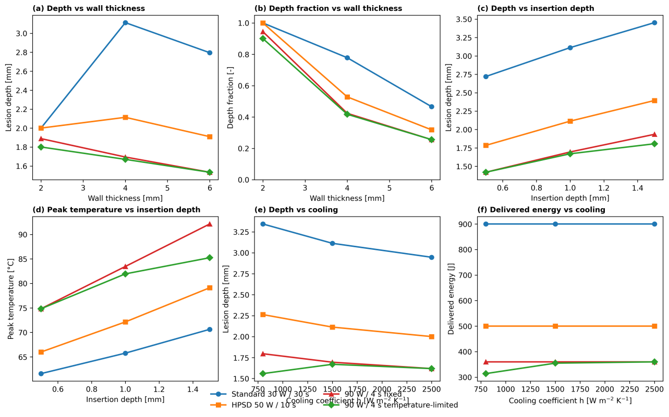
Figure 3. Deterministic four-way comparison across representative wall-thickness, insertion-depth, and cooling slices. Panels summarize lesion depth and depth fraction versus wall thickness, lesion depth and peak temperature versus insertion depth, and lesion depth and delivered energy versus cooling for standard RF, HPSD, fixed-power 90 W / 4 s, and generic temperature-limited 90 W / 4 s.
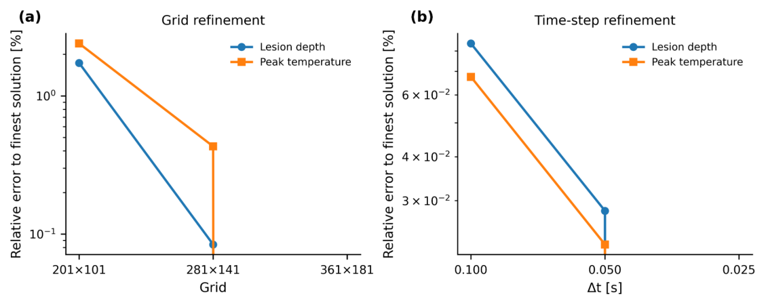
Figure 4. Grid and time-step verification for the baseline nominal case. The selected production grid and time step are indicated directly on the plots.
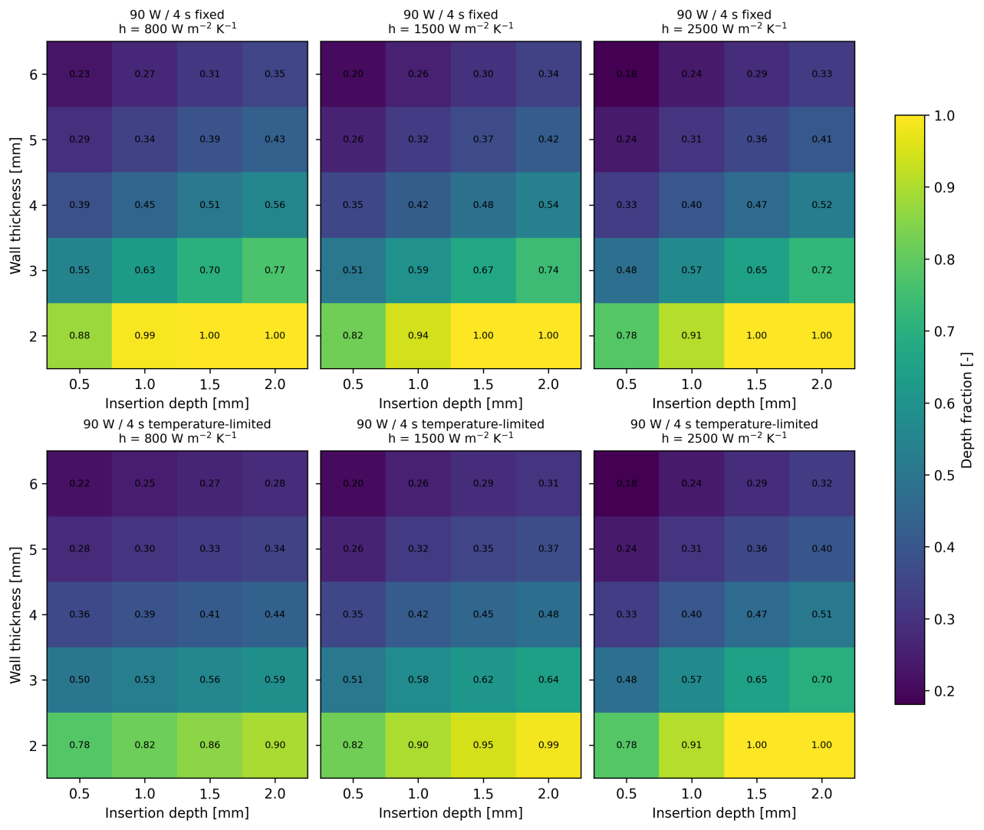
Figure 5. Depth-fraction maps for fixed-power and generic temperature-limited 90 W / 4 s across the phase-preparation grid. Columns correspond to cooling coefficients of 800, 1500, and 2500 W m^-2 K^-1; rows compare the fixed-power and temperature-limited comparators. Values are reported over wall thickness and insertion depth combinations.
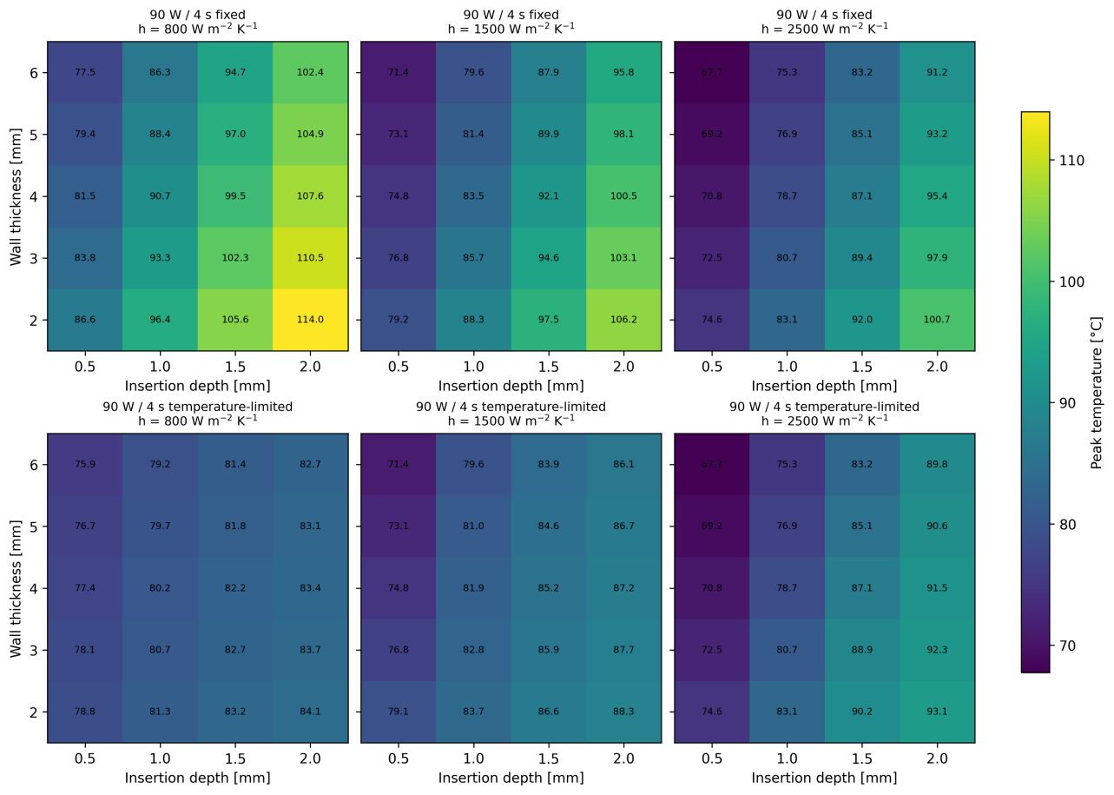
Figure 6. Peak-temperature maps for fixed-power and generic temperature-limited 90 W / 4 s across the phase-preparation grid. Columns correspond to cooling coefficients of 800, 1500, and 2500 W m^-2 K^-1; rows compare the fixed-power and temperature-limited comparators.
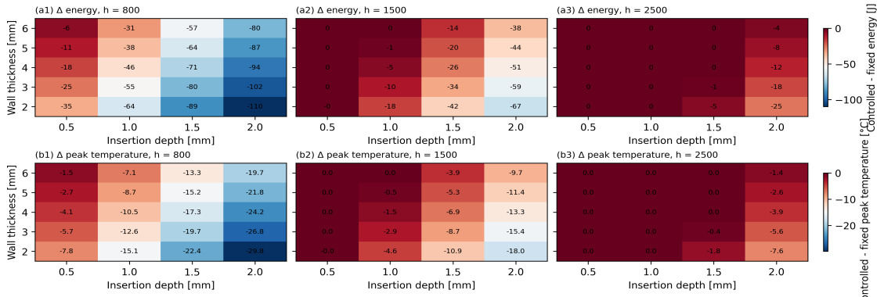
Figure 7. Controlled-minus-fixed difference maps for 90 W / 4 s across the phase-preparation grid. The upper row shows reductions in delivered energy, and the lower row shows reductions in peak temperature, for the generic temperature-limited comparator relative to the fixed-power comparator.
Table 3. Reference literature-derived protocol-level benchmark points.
Source / matched point | Protocol | Reported depth (mm) | Simulated depth (mm) | Reported width (mm) | Simulated width (mm)
Nakagawa2021 | Standard RF | 6.6 | 2.76 | 10.7 | 3.82
Nakagawa2021 | HPSD | 4.9 | 1.76 | 9.2 | 3.15
Nakagawa2021 | 90 W / 4 s fixed-power reference | 3.6 | 1.30 | 8.2 | 2.69
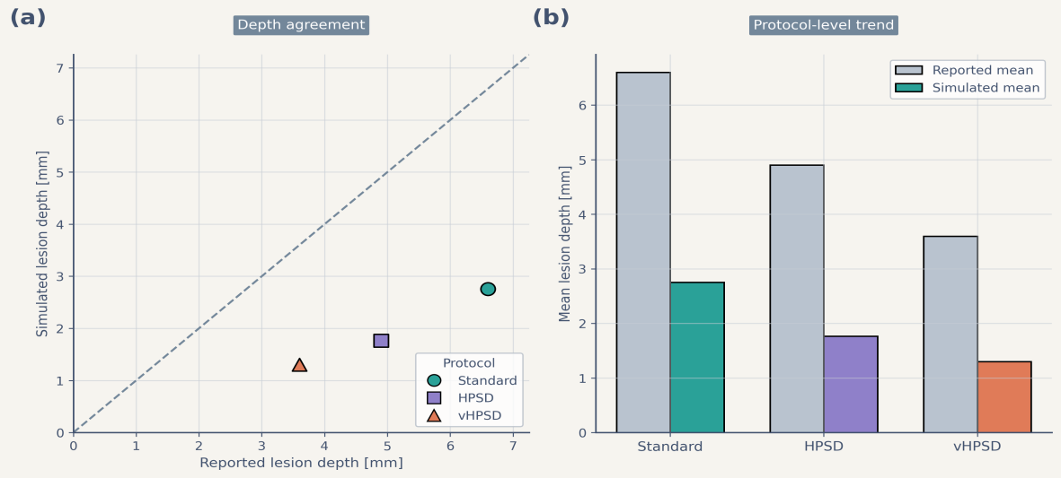
Figure 8. Reference literature-derived benchmark of lesion-depth trends. Panel (a) compares reported lesion depth and simulated lesion depth for the protocol-matched benchmark points using an identity line for visual reference. Panel (b) compares protocol-level mean reported and simulated lesion depth. The benchmark reproduced the protocol-level ranking but underestimated absolute depth and did not distinguish fixed-power and temperature-limited 90 W / 4 s as separate computational comparators.

4. Discussion
This study should be interpreted as a comparator-aware reduced methodology paper. The main contribution is not a claim that one nominal protocol universally dominates another, but the demonstration that comparator definition and post-pulse thermal latency materially change the outputs of a reduced model. Treating 90 W / 4 s as fixed power only and omitting latency would embed a methodological bias directly into the comparison.
The first methodological result is that separating fixed-power and generic temperature-limited 90 W / 4 s changes both delivered energy and apparent thermal severity. At representative conditions, control modestly lowered depth while reducing delivered energy and peak temperature; across the phase-preparation grid, the same effect became stronger in thin-wall, weak-cooling, and larger-insertion cells and weaker where the thermal signal never crossed the control threshold. This threshold-dependent behavior shows that the controlled comparator is not merely a relabeled fixed-power pulse.
The second methodological result is that post-pulse thermal latency is a first-order determinant of short high-power lesion depth. In the representative fixed 90 W / 4 s case, adding the 8 s latency window increased depth and lesion area materially without changing the reported end-of-pulse peak temperature. This supports the view that short high-power lesion formation should not be interpreted from end-of-delivery fields alone in reduced electro-thermal studies.
These results do not justify device-level prediction. The controlled 90 W / 4 s case implemented here is generic, surface-adjacent, and assumption-bounded; it does not reproduce catheter-specific temperature sensing, irrigation-jet physics, chamber-scale flow, or commercial power-titration logic. For the same reason, lesion width and overheating-related quantities should remain secondary internal proxies within this framework rather than primary claims about clinical safety or steam-pop risk.
The external benchmark also remains limited. It is protocol-matched rather than geometry-matched, and the retained three-protocol benchmark does not distinguish fixed-power and temperature-limited 90 W / 4 s as separate comparators. Therefore, the benchmark supports only coarse trend-level context and cannot validate the new comparator definition.
The study has several additional limitations. The model is two-dimensional and reduced-complexity rather than anatomy-matched. Contact is represented by insertion depth rather than explicit mechanics. Cooling is represented through an effective surface coefficient rather than explicit blood flow or irrigation jets. The controller acts on a surface-adjacent temperature surrogate. In addition, the reduced source-gain and cooling-reduction coefficients were retained rather than formally re-identified against geometry-matched data, and no identifiability analysis was performed here. These simplifications are deliberate, because the intended contribution is computational methodology on modest hardware rather than high-fidelity multiphysics reproduction.
Within those boundaries, the framework remains useful as a low-cost comparative screening tool. It can complement higher-fidelity simulation and experimental work by clarifying how comparator definition and post-pulse latency shape reduced-model conclusions before more expensive validation steps are undertaken.

5. Conclusion
A comparator-aware reduced two-dimensional electro-thermal model was used to distinguish standard RF, HPSD, fixed-power 90 W / 4 s, and generic temperature-limited 90 W / 4 s conditions under an explicit 8 s post-pulse latency assumption. Within the present framework, standard RF remained deepest, HPSD was intermediate, and 90 W / 4 s cases were shallower, while the generic temperature-limited comparator frequently reduced delivered energy and peak temperature relative to the fixed-power comparator in more aggressive cells. The principal contribution is therefore methodological: comparator definition and thermal latency materially affect reduced-model conclusions. The present framework is appropriate for assumption-bounded comparative analysis, not for device-level or patient-specific prediction, and it should not be interpreted as a fully recalibrated predictive model.

Data availability statement
The code, frozen figures, benchmark assets, and manuscript materials supporting the findings of this study are available from the corresponding author upon reasonable request.

Funding

Acknowledgements

Disclosure statement
No potential conflict of interest was reported by the authors.

References
Amin AM, et al. 2024. Efficacy and safety of high-power short-duration ablation for atrial fibrillation: a systematic review and meta-analysis of randomized controlled trials. J Interv Card Electrophysiol. 67(6):1445-1461. doi:10.1007/s10840-024-01782-2.
Arrhenius S. 1889. On the reaction velocity of the inversion of cane sugar by acids. Z Phys Chem. 4:226-248.
Barkagan M, et al. 2018. High-power and short-duration ablation for pulmonary vein isolation: safety, efficacy, and long-term durability. J Cardiovasc Electrophysiol. 29(9):1287-1296. doi:10.1111/jce.13651.
Chang IA. 2010. Considerations for thermal injury analysis for RF ablation devices. Open Biomed Eng J. 4:3-12. doi:10.2174/1874120701004010003.
Chieng D, et al. 2023. Higher power short duration vs. lower power longer duration posterior wall ablation for atrial fibrillation and oesophageal injury outcomes: a prospective multi-centre randomized controlled study (Hi-Lo HEAT trial). Europace. 25(2):417-425. doi:10.1093/europace/euac194.
Fahrenholtz SJ, et al. 2013. Generalised polynomial chaos-based uncertainty quantification for planning MRgLITT procedures. Int J Hyperthermia. 29(4):324-335. doi:10.3109/02656736.2013.798036.
González-Suárez A, et al. 2016. Computational modeling of open-irrigated electrodes for radiofrequency cardiac ablation including blood motion-saline flow interaction. PLoS One. 11(3):e0150356. doi:10.1371/journal.pone.0150356.
González-Suárez A, et al. 2018. Should fluid dynamics be included in computer models of RF cardiac ablation by irrigated-tip electrodes? Biomed Eng Online. 17(1):43. doi:10.1186/s12938-018-0475-7.
González-Suárez A, et al. 2022. Computer modeling of radiofrequency cardiac ablation: 30 years of bioengineering research. Comput Methods Programs Biomed. 214:106546. doi:10.1016/j.cmpb.2021.106546.
Henriques FC Jr. 1947. Studies of thermal injury V. The predictability and significance of thermally induced rate processes leading to irreversible epidermal injury. Arch Pathol. 43:489-502.
Irastorza RM, et al. 2018. Thermal latency adds to lesion depth after application of high-power short-duration radiofrequency energy: results of a computer-modeling study. J Cardiovasc Electrophysiol. 29(2):322-327. doi:10.1111/jce.13363.
Iwakawa H, et al. 2025. Lesion depth optimization in high-power radiofrequency ablation: evaluating single high-power and combined very high-power applications. J Cardiovasc Electrophysiol. 36(12):3212-3221. doi:10.1111/jce.70125.
Jin S, et al. 2023. High-power, short-duration ablation under the guidance of relatively low ablation index values for paroxysmal atrial fibrillation: long-term outcomes and characteristics of recurrent atrial arrhythmias. J Clin Med. 12(3):971. doi:10.3390/jcm12030971.
Kotadia ID, et al. 2020. High-power, short-duration radiofrequency ablation for the treatment of AF. Arrhythm Electrophysiol Rev. 8(4):265-272. doi:10.15420/aer.2019.09.
Liu X, et al. 2021. Safety and efficacy of high power shorter duration ablation guided by ablation index or lesion size index in atrial fibrillation ablation: a systematic review and meta-analysis. J Interv Cardiol. 2021:5591590. doi:10.1155/2021/5591590.
Masnok K, Watanabe N. 2022. Catheter contact area strongly correlates with lesion area in radiofrequency cardiac ablation: an ex vivo porcine heart study. J Interv Card Electrophysiol. 63(3):561-572. doi:10.1007/s10840-021-01054-3.
Nakagawa H, et al. 2021. Comparison of in vivo tissue temperature profile and lesion geometry for radiofrequency ablation with high power-short duration and moderate power-moderate duration: effects of thermal latency and contact force on lesion formation. Circ Arrhythm Electrophysiol. 14(7):e009899. doi:10.1161/CIRCEP.121.009899.
Pennes HH. 1948. Analysis of tissue and arterial blood temperatures in the resting human forearm. J Appl Physiol. 1(2):93-122. doi:10.1152/jappl.1948.1.2.93.
Pérez JJ, et al. 2022. Computer modeling of radiofrequency cardiac ablation including heartbeat-induced electrode displacement. Comput Biol Med. 144:105346. doi:10.1016/j.compbiomed.2022.105346.
Petras A, et al. 2021. Systematic characterization of high-power short-duration ablation: insight from an advanced virtual model. Front Med Technol. 3:747609. doi:10.3389/fmedt.2021.747609.
Reddy VY, et al. 2019. Pulmonary vein isolation with very high power, short duration, temperature-controlled lesions: the QDOT-FAST trial. JACC Clin Electrophysiol. 5(7):778-786. doi:10.1016/j.jacep.2019.04.009.
Rozen G, et al. 2018. Safety and efficacy of delivering high-power short-duration radiofrequency ablation lesions utilizing a novel temperature sensing technology. Europace. 20(FI_3):f444-f450. doi:10.1093/europace/euy031.
Wilson EB. 1927. Probable inference, the law of succession, and statistical inference. J Am Stat Assoc. 22(158):209-212. doi:10.1080/01621459.1927.10502953.
Yamaguchi J, et al. 2024. Impact of contact force on the lesion characteristics of very high-power short-duration ablation using a QDOT-MICRO catheter. J Arrhythm. 40(2):247-255. doi:10.1002/joa3.12992.

Appendix A. Supplementary reference figures
The supplementary figures retained from the earlier fixed-power three-protocol formulation are included for archival completeness only. The associated uncertainty workflow reflects the prior generalized-polynomial-chaos and binomial-interval treatment rather than the present comparator-aware four-protocol analysis (Fahrenholtz et al. 2013; Wilson 1927).
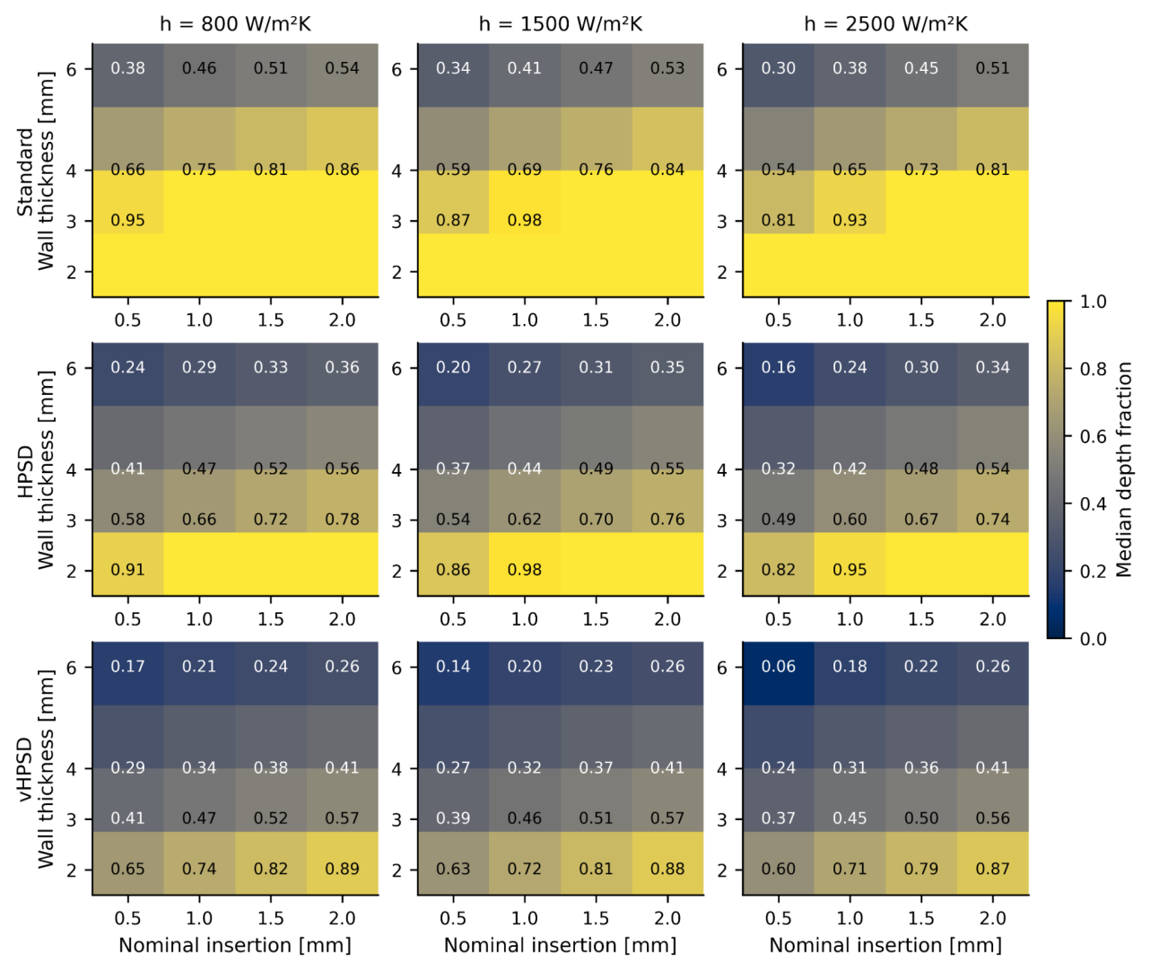
Supplementary Figure S1. Reference depth-fraction maps from the fixed-power three-protocol formulation, provided for completeness.
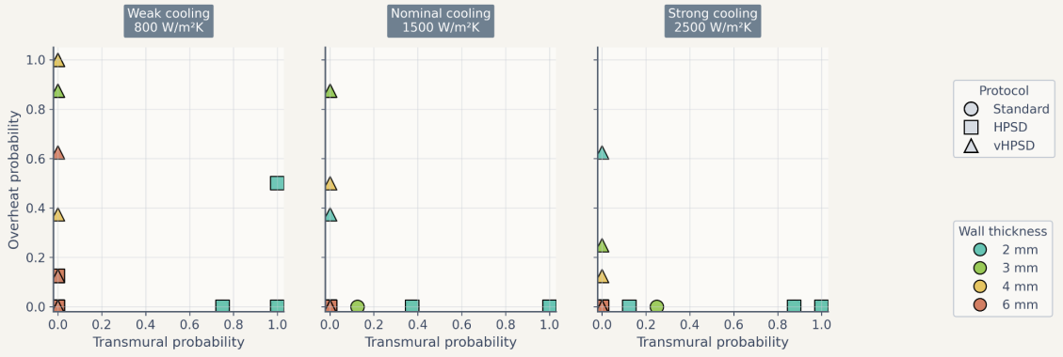
Supplementary Figure S2. Reference trade-off summary from the fixed-power three-protocol formulation, provided for completeness.
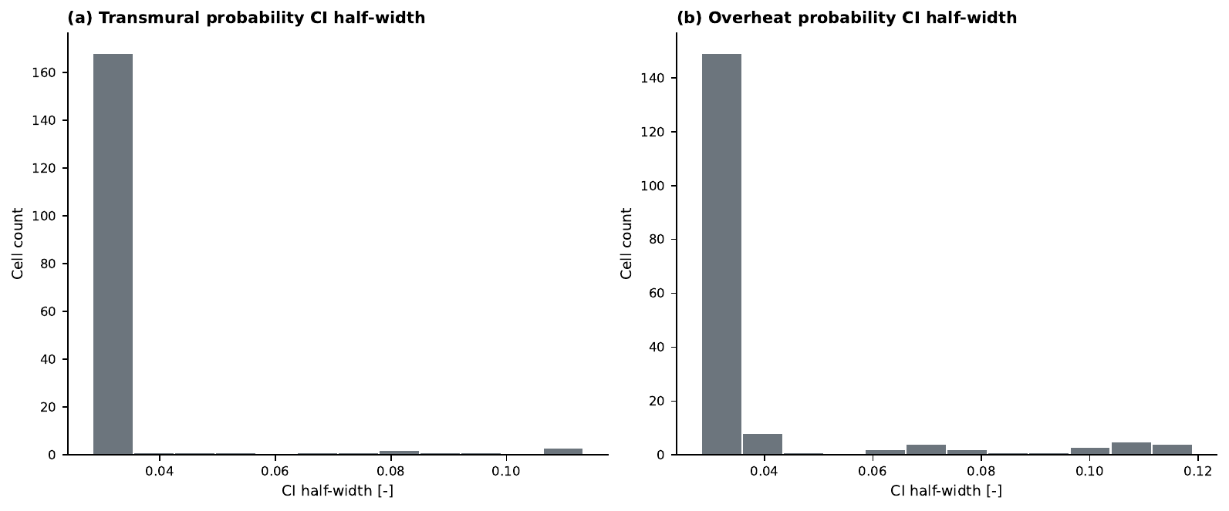
Supplementary Figure S3. Reference distribution of 95% Wilson-score confidence-interval half-widths from the fixed-power three-protocol formulation, provided for completeness.

