Comparator-aware reduced 2D electro-thermal modeling of lesion formation during radiofrequency cardiac ablation
Xue Zhou^{1,2}, Lingfeng Lu^{1,2}
¹ Shanghai Institute of Medical Device Testing, Shanghai 201318, China
² NMPA Key Laboratory for Medical Electrical Equipment, Shanghai 201318, China

Abstract
Reduced electro-thermal models can support broad comparative radiofrequency (RF) ablation sweeps on modest hardware, but their interpretation depends on comparator definition and on whether post-pulse thermal latency is represented explicitly. We developed a comparator-aware reduced two-dimensional electro-thermal framework that distinguishes fixed-power and generic temperature-limited 90 W / 4 s conditions while comparing them with standard RF (30 W / 30 s) and HPSD (50 W / 10 s) protocols. A vertically contacting electrode-blood-myocardium model combined a quasi-static electrical solution, transient bioheat transfer, and Arrhenius thermal damage. Contact was represented by insertion depth, which modulated effective source strength and local cooling, and all protocols included an 8 s post-pulse latency window. At a representative condition, adding the latency window increased fixed 90 W / 4 s lesion depth from 1.302 to 1.695 mm and lesion area from 3.486 to 4.599 mm^2. Under the same condition, the generic temperature-limited 90 W / 4 s comparator reduced delivered energy from 360.0 to 354.9 J and peak temperature from 83.46 to 81.95 °C, with only a small reduction in lesion depth. Across the phase-preparation grid, controller action was threshold-dependent. The framework therefore supports reduced, assumption-explicit comparator analysis rather than device-level prediction.
Keywords: radiofrequency catheter ablation; electro-thermal modeling; thermal latency; high-power short-duration ablation; comparator definition; reduced model

1. Introduction
Radiofrequency catheter ablation remains a standard thermal strategy for creating irreversible myocardial injury in the treatment of cardiac arrhythmias. Lesion size and shape are governed by the interplay among delivered power, application duration, catheter-tissue contact, local cooling, and tissue thickness (González-Suárez et al. 2016, 2018, 2022). Classical bioheat and thermal-injury models have long been used to study these mechanisms (Pennes 1948; Henriques 1947; Arrhenius 1889; Chang 2010), while contemporary cardiac-ablation reviews show that computational modeling now spans simplified two-dimensional studies, irrigated-electrode models, dynamic contact models, and broader multiphysics frameworks (González-Suárez et al. 2016, 2018, 2022; Pérez et al. 2022).
High-power short-duration strategies have drawn particular interest because they alter the balance between resistive and conductive heating (Nakagawa et al. 2021; Kotadia et al. 2020; Petras et al. 2021; Irastorza et al. 2018; Reddy et al. 2019; Rozen et al. 2018; Barkagan et al. 2018; Chieng et al. 2023; Jin et al. 2023; Liu et al. 2021; Amin et al. 2024). Experimental and clinical studies indicate that HPSD can shorten RF delivery time while maintaining lesion efficacy in selected contexts (Chieng et al. 2023; Jin et al. 2023; Liu et al. 2021; Amin et al. 2024). At the same time, lesion geometry is protocol dependent: computer and experimental studies have shown that increasing power while shortening duration does not simply scale lesion depth proportionally, and vHPSD lesions may remain relatively shallow in thick myocardium (Nakagawa et al. 2021; Irastorza et al. 2018; Reddy et al. 2019; Rozen et al. 2018; Barkagan et al. 2018; Yamaguchi et al. 2024; Iwakawa et al. 2025). In temperature-controlled 90 W/4 s ablation, lesion size also appears to saturate once contact force exceeds approximately 15 g (Yamaguchi et al. 2024).
For methodology development on modest hardware, however, the value of reduced electro-thermal models does not lie in reproducing every catheter-specific control feature or chamber-scale flow phenomenon. Their value lies in providing computationally economical, assumption-explicit frameworks for broad comparative sweeps across tissue thickness, cooling, and contact surrogates. For such reduced models, the central question is not whether they mimic a specific device, but whether comparator definitions, reduction assumptions, and interpretation boundaries are made explicit enough to support defensible comparative inferences.
A key problem arises when a 90 W / 4 s condition is represented only as a fixed-power pulse and when post-pulse thermal latency is omitted. Under those conditions, part of the reported protocol difference may reflect comparator mis-specification and missing thermal latency rather than the intended short high-power behavior itself. In reduced protocol studies, this is not a secondary implementation detail; it is a first-order methodological issue because power titration and post-pulse conduction can materially change lesion depth, delivered energy, and apparent thermal severity.
Accordingly, the objective of the present work is not to reproduce a catheter-specific commercial 90 W / 4 s algorithm, but to establish a comparator-aware reduced 2D electro-thermal methodology that explicitly distinguishes fixed-power and generic temperature-limited 90 W / 4 s cases and includes a finite post-pulse thermal latency window. The main methodological contributions are threefold: separation of comparator definition from protocol labeling, explicit representation of post-pulse latency, and generation of four-way deterministic and phase-preparation maps while keeping interpretation bounded to reduced-model applicability. Within this framing, lesion width and overheating-related quantities are retained as secondary internal proxies rather than promoted as device-level predictive endpoints.

2. Materials and methods

2.1 Reduced two-dimensional electro-thermal lesion model
We developed a comparator-aware reduced planar Cartesian two-dimensional electro-thermal model of radiofrequency (RF) lesion formation. The formulation was intended for comparative protocol analysis rather than catheter-specific reproduction of irrigation jets, chamber-scale flow, or device-level temperature regulation. The computational domain was an x-y cross-section with lateral coordinate x and depth coordinate y, and applied power was introduced through a per-depth scaled reduced source. Accordingly, the model should be interpreted as a reduced two-dimensional cross-sectional framework rather than as a direct three-dimensional watt-to-volume predictor.
The electrical subproblem was solved in quasi-static form as
$$∇⋅\left(σ∇ϕ\right)=0,$$
where φ is electric potential and σ is electrical conductivity. A unit-potential solution was obtained first, and the corresponding unit Joule-heating field was computed as
$$q_{unit}=σ{\left|∇ϕ\right|}^{2}.$$
The thermal problem was represented using a transient bioheat equation,
$$ρc\frac{∂T}{∂t}=∇⋅\left(k∇T\right)+q_{RF}−ω_{b}ρ_{b}c_{b}\left(T−T_{b}\right),$$
where T is temperature, ρ density, c specific heat, k thermal conductivity, ω_b the perfusion coefficient, and T_b blood temperature. In the current implementation, perfusion was neglected by setting ω_b = 0, so cooling entered through the imposed boundary condition rather than through a volumetric sink term.
Thermal injury was quantified using the Arrhenius damage integral,
$$Ω\left(t\right)=\int_{0}^{t}{A}exp​\left(−\frac{E_{a}}{RT\left(τ\right)}\right) dτ,$$
and lesion boundary was defined by Ω = 1 (Arrhenius, 1889; Henriques, 1947; Pennes, 1948; Chang, 2010).

2.2 Geometry and computational domain
The domain width was 18 mm. Physical myocardial wall thickness H was varied from 2 to 6 mm. Beneath the physical wall, an additional 4 mm lower thermal buffer was included to reduce lower-boundary contamination; this buffer was excluded from all lesion metrics. The tissue-contacting electrode was represented by a 2-mm-wide footprint on the top boundary.
For the baseline H = 4 mm case, the total domain depth was therefore 8 mm. The baseline production grid used 281 x 141 nodes, corresponding to nominal spacings Δx = 18/(281 - 1) = 0.0643 mm and Δy = 8/(141 - 1) = 0.0571 mm. For the remaining wall-thickness settings, the number of depth nodes was rescaled proportionally so that the wall-normal resolution remained comparable across cases.
No explicit blood subdomain was included in the current stage17 implementation. Instead, blood-side cooling was represented in reduced form through the effective top-boundary cooling profile described below. Lesion area and overheat area therefore denote wall-only two-dimensional cross-sectional areas, not reconstructed three-dimensional lesion volumes.
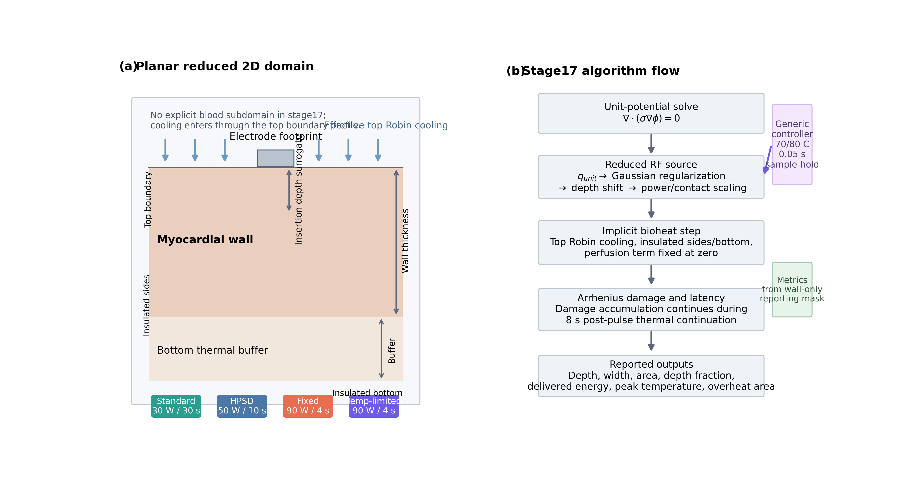
Figure 1. Stage17-aligned schematic of the reduced planar Cartesian 2D model and computational workflow. Panel (a) shows the wall-only computational cross-section with top-boundary cooling, 2-mm electrode footprint, variable wall thickness, and bottom thermal buffer. Panel (b) summarizes the unit-potential electrical solve, algorithmic reduced-source construction, transient heat solve with ω_b = 0, Arrhenius damage update, latency continuation, and the primary versus secondary output hierarchy.

2.3 Boundary and initial conditions
For the electrical problem, the lower boundary was grounded, the electrode footprint on the top boundary was assigned a unit potential, and the remaining top-surface and lateral boundaries were electrically insulated.
For the thermal problem, the lateral and lower boundaries were zero-flux,
$$−k∇T⋅n=0,$$
whereas the top surface was subject to an effective Robin cooling condition,
$$−k∇T⋅n=h\left(x\right)\left(T−T_{∞}\right),$$
with T∞ = 37 °C. Outside the electrode footprint, the surface coefficient remained equal to the nominal cooling coefficient h_nom. On the footprint, the coefficient was modified by the contact-dependent factor S_h(d_ins) defined in Section 2.4. The initial temperature was 37 °C throughout the domain.

2.4 Comparator definition, control logic, and contact surrogate implementation
Four protocol definitions were used throughout the deterministic and phase-preparation analyses: standard RF (30 W / 30 s), HPSD (50 W / 10 s), fixed-power 90 W / 4 s, and generic temperature-limited 90 W / 4 s. Contact was represented by insertion depth d_ins rather than explicit force. This reduced surrogate was intended to let the model respond to more-versus-less embedded contact without introducing full contact mechanics.
In the current stage17 implementation, the reduced RF source was constructed algorithmically rather than through a separate analytic q_reg(x, y) kernel. The unit-potential Joule-heating field was first regularized with a Gaussian kernel using source_smoothing_mm = 0.20 mm, producing the source template q_reg. The regularized template was then translated downward in the wall-normal direction according to
$$Δy=α_{shift}d_{ins},$$
with α_shift = 0.25 mm shift per mm insertion. In the current code, this downward shift depends on absolute insertion depth rather than insertion depth relative to the reference value.
After regularization and translation, the final RF source term was written as
qRFx,y,t=κP Pt Scdins qregx,y;dinsΩdom​qregx,y;dins dA,
where P(t) is the applied power command, κ_P = 6.8 W m^-1 per applied watt is the current source-amplitude coefficient, S_c(d_ins) is the contact-dependent source-gain factor, and normalization by the area integral of q_reg enforces the per-depth scaling of the reduced two-dimensional source.
The contact-dependent source-gain factor was defined as
$$S_{c}\left(d_{ins}\right)=max​\left(0.5, 1+β_{P}\left(d_{ins}−d_{ref}\right)\right),$$
with d_ref = 1.0 mm and β_P = 0.16 mm^-1. Thus, larger insertion depth increased effective source strength while preserving the regularized spatial pattern, subject to the lower clipping limit of 0.5.
Contact also modified the local cooling coefficient on the electrode footprint according to
$$h_{foot}=h_{nom} S_{h}\left(d_{ins}\right),$$
with
$$S_{h}\left(d_{ins}\right)=clip​\left(1−β_{h}\left(d_{ins}−d_{ref}\right), h_{min}, h_{max}\right).$$
where β_h = 0.35 mm^-1, d_ref = 1.0 mm, h_min = 0.50, and h_max = 1.40. Outside the footprint, the surface coefficient remained equal to h_nom. This construction allowed the contact surrogate to affect both local source intensity and local cooling in transparent reduced-order form.
For the 90 W / 4 s condition, two distinct computational comparators were defined. The fixed-power case applied 90 W throughout the 4-s pulse. The generic temperature-limited case used the same nominal request power but activated a surface-adjacent controller only for the vhpsd_90W_4s_controlled protocol. The measured controller temperature was the lateral maximum along the first interior depth row, i.e. T_sens(t_n) = max_x T(x, y_1, t_n), corresponding on the production grid to T[1, :].max().
Controller updates were performed every 0.05 s and the previously computed applied power was held between updates. If T_sens ≤ 70 °C, the controller applied the upper bound of 90 W. If T_sens ≥ 80 °C, it applied the lower bound of 15 W. For intermediate temperatures, the applied power was reduced linearly from the 90 W request with a ramp-down gain of 6.0 W °C^-1 and then clipped to the interval [15, 90] W. This generic controller was introduced only to distinguish fixed-power and temperature-limited short high-power comparators within the reduced framework; it was not intended to reproduce a catheter-specific commercial control law.
Delivered energy and mean applied power over the energized pulse were reported as
$$E_{del}=\sum_{n=0}^{N−1}{P_{n}} Δt_{c},$$
$$\overset{‾}{P}=\frac{E_{del}}{t_{pulse}}.$$
where t_pulse is the energized pulse duration.
After energized delivery, all protocols were advanced through an 8 s zero-source post-pulse latency window,
$$q_{RF}\left(x,y,t\right)=0 \text{for} t_{pulse}<t≤t_{pulse}+8 s,$$
During this latency window, heat diffusion continued, Arrhenius damage continued to accumulate in wall cells, and peak temperature continued to update. This latency step was included in all deterministic and phase-preparation analyses.
Table 1. Protocol set used for the comparator-aware reduced-model analysis.
Protocol | Requested power (W) | Duration (s) | Maximum pulse energy (J) | Role in comparison
Standard RF | 30 | 30 | 900 | Long-duration comparator
HPSD | 50 | 10 | 500 | Intermediate comparator
90 W / 4 s fixed | 90 | 4 | 360 | Fixed-power comparator
90 W / 4 s temperature-limited | 90 | 4 | up to 360 | Temperature-limited comparator
The temperature-limited protocol uses the same 90 W request and 4 s energized window as the fixed-power 90 W / 4 s comparator, but delivered energy may fall below 360 J because the controller can reduce applied power during the pulse.

2.5 Material parameters and lesion metrics
Baseline constant material parameters were σ = 0.6 S m^-1, k = 0.55 W m^-1 K^-1, ρ = 1050 kg m^-3, and c = 3600 J kg^-1 K^-1. Arrhenius parameters were A = 7.39 × 10^39 s^-1 and E_a = 2.577 × 10^5 J mol^-1. In the numerical implementation, Arrhenius damage was accumulated explicitly at each time step as
$$ΔΩ=A exp​\left(−\frac{E_{a}}{RT}\right) Δt, Ω^{n+1}=Ω^{n}+ΔΩ,$$
in wall cells during both the energized pulse and the latency window.
The reported lesion boundary was the wall-only Ω = 1 contour. Lesion depth was measured along the centerline from the tissue surface to the last Ω = 1 crossing within the physical wall. Maximum lesion width was defined as the largest connected lesion width across wall rows; if multiple lesion islands occurred on a given row, the component closest to the centerline was used.
Lesion area was computed from the wall-only lesion mask as
Ales=Ωij≥1​Δx Δy,
reported in mm^2. Depth fraction was defined as
$$f_{d}=\frac{d_{les}}{H},$$
where d_les is lesion depth and H is physical wall thickness. Transmurality was recorded as a binary indicator when d_les reached H within numerical tolerance. Overheat area was defined as the wall-only area whose peak temperature over the energized-plus-latency run reached or exceeded 100 °C,
A100=Tpeak,ij≥100∘C​Δx Δy.
Because the present solver is planar Cartesian, lesion area and overheat area should be interpreted as two-dimensional cross-sectional areas rather than as direct three-dimensional lesion volumes. Reported outputs included lesion depth, maximum lesion width, lesion area, depth fraction, depth-to-width ratio, transmurality, peak temperature, overheat area, delivered energy, and mean applied power. For interpretation, lesion depth, depth fraction, delivered energy, mean applied power, and peak temperature were treated as the primary outputs, whereas lesion width, lesion area, and overheat area were retained as secondary internal proxies.

2.6 Numerical implementation and verification
The model was implemented in Python using NumPy, SciPy, Pandas, Matplotlib, and PyYAML. The electrical subproblem was discretized on a structured finite-difference grid and solved as a sparse direct linear system. The thermal problem was advanced by a matrix-based implicit finite-difference heat step using a pre-factorized sparse operator. The current direct-solve implementation did not expose an additional user-set solver-tolerance parameter.
For the baseline 4-mm wall case, the production configuration used a 281 x 141 grid over an 18 mm width and an 8 mm total depth, together with Δt = 0.05 s. Grid refinement was assessed using 201 x 101, 281 x 141, and 361 x 181 grids. Time-step refinement was assessed using Δt = 0.10 s, 0.05 s, and 0.025 s. Relative error was computed against the finest solution in each refinement series for lesion depth and peak temperature. Relative to the 361 x 181 grid, the selected 281 x 141 grid produced 0.047% lesion-depth error and 0.865% peak-temperature error. Relative to Δt = 0.025 s, the selected Δt = 0.05 s produced 0.119% lesion-depth error and 0.029% peak-temperature error. These verification runs used the controller-enabled, latency-enabled baseline nominal case, and the resulting verification plots are reported in Figure 4.
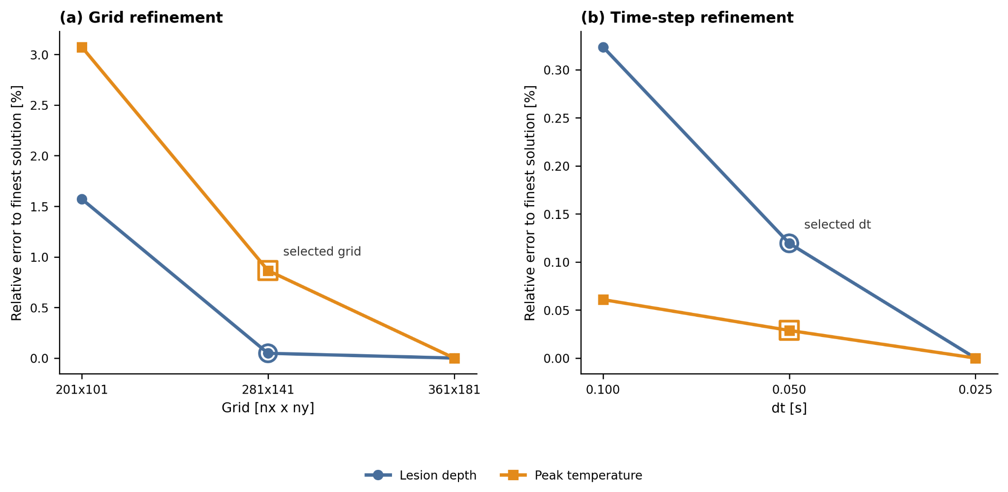
Figure 4. Grid and time-step verification for the controller-enabled, latency-enabled baseline nominal case. Relative error is reported against the finest grid and finest time step for lesion depth and peak temperature; the selected production settings are highlighted on each panel.
The reduced source-gain and footprint-cooling surrogate coefficients were retained from the preceding reduced implementation and were not formally re-estimated or subjected to identifiability analysis in the current stage17 manuscript line. Accordingly, the present work should be interpreted as a comparator-aware reduced methodology study rather than as a fully recalibrated predictive model. The solver, control, latency, and phase-preparation settings are summarized in Table 2.
Table 2. Numerical, control, sweep, and interpretation settings for the current stage17 methodology line.
Item | Value
Deterministic production grid | 281 x 141
Time step | 0.05 s
Wall thickness levels | 2.0, 3.0, 4.0, 5.0, 6.0 mm
Nominal cooling coefficients | 800, 1500, 2500 W m^-2 K^-1
Nominal insertion levels | 0.5, 1.0, 1.5, 2.0 mm
Comparator set | 30 W / 30 s, 50 W / 10 s, 90 W / 4 s fixed, 90 W / 4 s temperature-limited
Controller sensor | Surface-adjacent temperature surrogate (implemented in the current stage17 code as the maximum temperature along the first interior depth row, i.e. T[1, :].max() for the production grid)
Controller target / ceiling | 70 °C / 80 °C
Controller sample period | 0.05 s
Post-pulse latency window | 8.0 s
Phase-preparation grid size | 5 x 3 x 4 x 4 = 240 protocol-cell evaluations
Primary interpretive outputs | Lesion depth, depth fraction, delivered energy, mean applied power, and peak temperature
Secondary internal proxies | Lesion width, lesion area, and overheat area (wall-only area with peak temperature ≥ 100 °C over the energized-plus-latency run)
Calibration status | Contact-dependent source-gain and footprint-cooling surrogate coefficients were retained from the preceding reduced implementation; no formal re-estimation or identifiability analysis was performed in the current stage17 manuscript line
Supplementary UQ status | Reference uncertainty figures from the frozen fixed-power three-protocol formulation are retained for completeness only and are not the primary evidentiary basis for the current comparator-aware stage17 conclusions
For reproducibility, the active controller parameters described in the Methods text are target = 70 °C, ceiling = 80 °C, update period = 0.05 s, P_min = 15 W, P_max = 90 W, and ramp-down gain = 6.0 W/°C.

2.7 Deterministic sweeps
Deterministic sweeps were performed across protocol, wall thickness, nominal cooling coefficient, and nominal insertion depth. Wall thickness values were 2, 3, 4, 5, and 6 mm. Nominal cooling coefficients were 800, 1500, and 2500 W m^-2 K^-1. Nominal insertion depths were 0.5, 1.0, 1.5, and 2.0 mm.
All deterministic sweeps used the same 8 s zero-source post-pulse latency window after energized delivery. Representative one-factor slices were organized as wall-thickness, insertion-depth, and cooling sweeps so that fixed-power and generic temperature-limited 90 W / 4 s outputs could be compared directly against the standard RF and HPSD comparators.

2.8 Phase-preparation grid and output hierarchy
The phase-preparation analysis evaluated all four protocols across the full 5 x 3 x 4 grid of wall thickness, nominal cooling coefficient, and nominal insertion depth combinations, yielding 240 protocol-cell evaluations in total. Every protocol-cell evaluation used the same 8 s post-pulse latency window.
Within this hierarchy, lesion depth, depth fraction, delivered energy, mean applied power, and peak temperature were treated as the primary interpretive outputs because they most directly supported comparator-aware conclusions across the reduced parameter space. Lesion width, lesion area, and overheat area were retained for internal comparison only and were not used as the principal basis for comparator claims. Any supplementary uncertainty figures retained from the frozen fixed-power three-protocol formulation were treated as background context only and were not the primary evidentiary chain for the current comparator-aware conclusions.

2.9 Reference literature benchmark
Because no geometry-matched experimental dataset was available, external comparison remained limited to a protocol-level literature-derived benchmark based on Nakagawa et al. (2021). The benchmark was used only to test whether the reduced model reproduced the expected depth ordering of standard RF deepest, HPSD intermediate, and fixed-power 90 W / 4 s shallower.
This benchmark was treated as trend-level context rather than as validation. It was not used to validate device-level prediction, it did not validate the generic temperature-limited comparator, and it did not distinguish fixed-power and temperature-limited 90 W / 4 s as separate computational objects. For the current reproducible chain, benchmark interpretation was therefore restricted to protocol-level depth trends. If width values are retained in the accompanying benchmark table, they should be regarded as completeness fields rather than as primary validation targets.
Table 3. Protocol-level literature-derived benchmark used as external context in depth-oriented form.
Source / matched point | Protocol | Reported depth (mm) | Simulated depth (mm)
Nakagawa et al. 2021 (max depth) | Standard RF | 6.6 | 2.75
Nakagawa et al. 2021 (max depth) | HPSD | 4.9 | 1.76
Nakagawa et al. 2021 (max depth) | 90 W / 4 s fixed | 3.6 | 1.30
Table 3 is retained here as a depth-oriented contextual benchmark. Simulated width values were not included because current single-source benchmark exports support protocol-level depth trends, whereas simulated widths remain historical-trace fields rather than current benchmark outputs.

3. Results

3.1 Comparator definition and protocol set
All deterministic results were generated with four explicitly defined comparators: standard RF (30 W / 30 s), HPSD (50 W / 10 s), fixed-power 90 W / 4 s, and generic temperature-limited 90 W / 4 s. The temperature-limited 90 W / 4 s case was implemented as a generic surface-adjacent feedback controller and should therefore be interpreted as a comparator definition within the reduced model rather than as a catheter-specific commercial control law. An 8 s post-pulse thermal latency window was applied to all four protocols so that short high-power outputs were not evaluated from end-of-pulse fields alone.

3.2 Effect of post-pulse thermal latency
The effect of thermal latency was first examined in a representative 90 W / 4 s fixed-power case. At wall thickness 4 mm, cooling coefficient 1500 W m^-2 K^-1, and insertion depth 1.0 mm, adding an 8 s post-pulse latency window increased lesion depth from 1.302 to 1.695 mm and lesion area from 3.486 to 4.599 mm^2, while the reported peak temperature remained 83.46 °C. This confirms that, within the present reduced framework, short high-power lesion formation is strongly affected by continued post-pulse heat diffusion and should not be interpreted from pulse termination alone.

3.3 Deterministic four-way comparison at representative conditions
At the same representative condition, standard RF produced the deepest lesion (3.113 mm), followed by HPSD (2.114 mm), fixed-power 90 W / 4 s (1.695 mm), and generic temperature-limited 90 W / 4 s (1.670 mm). Peak temperatures followed the opposite trend, with values of 65.77, 72.14, 83.46, and 81.95 °C, respectively. Relative to fixed-power 90 W / 4 s, the temperature-limited comparator reduced delivered energy from 360.0 to 354.9 J and mean applied power from 90.0 to 88.7 W, while causing only a modest depth reduction. Under these representative conditions, the main effect of control was therefore not a collapse of lesion formation, but a limited reduction in thermal severity. Representative spatial fields are shown in Figure 2, and the corresponding deterministic trend slices are summarized in Figure 3.

3.4 Phase-preparation behavior of fixed versus temperature-limited 90 W / 4 s
Across the full phase-preparation grid, the effect of temperature-limited control was threshold-dependent. In more aggressive cells, particularly those combining thinner walls, weaker cooling, and larger insertion depth, the controlled 90 W / 4 s comparator reduced delivered energy and peak temperature substantially relative to the fixed-power case. For example, at wall thickness 2 mm, cooling coefficient 800 W m^-2 K^-1, and insertion depth 1.5 mm, the fixed-power comparator reached 105.59 °C with an overheat-area proxy of 0.426 mm^2, whereas the temperature-limited comparator reduced peak temperature to 83.15 °C, reduced delivered energy to 271.3 J, and remained non-transmural under the present criterion. By contrast, in cooler cells the controller became effectively inactive and the controlled solution converged toward the fixed-power solution. Figures 5 and 6 summarize the resulting depth-fraction and peak-temperature maps for the fixed-power and temperature-limited 90 W / 4 s comparators, and Figure 7 summarizes the corresponding controlled-minus-fixed reductions in delivered energy and peak temperature.

3.5 Boundary of interpretation
These maps should be interpreted as model-internal, assumption-bounded comparator analyses. The most defensible outputs are lesion depth, depth fraction, delivered energy, mean applied power, and peak-temperature trends. Lesion width and overheating-related quantities are retained for internal comparison, but they are not used here as primary validation targets or as device-level predictive claims.

3.6 Reference benchmark status
The retained three-protocol literature-derived benchmark reproduces the expected ranking of standard RF deepest, HPSD intermediate, and fixed-power 90 W / 4 s shallowest. However, that benchmark does not distinguish fixed-power and temperature-limited 90 W / 4 s as separate computational comparators and therefore serves only as trend-level context. It should not be interpreted as validation of the generic temperature-limited comparator or of device-level prediction. The benchmark point set is listed in Table 3, and the protocol-level depth comparison is shown in Figure 8.
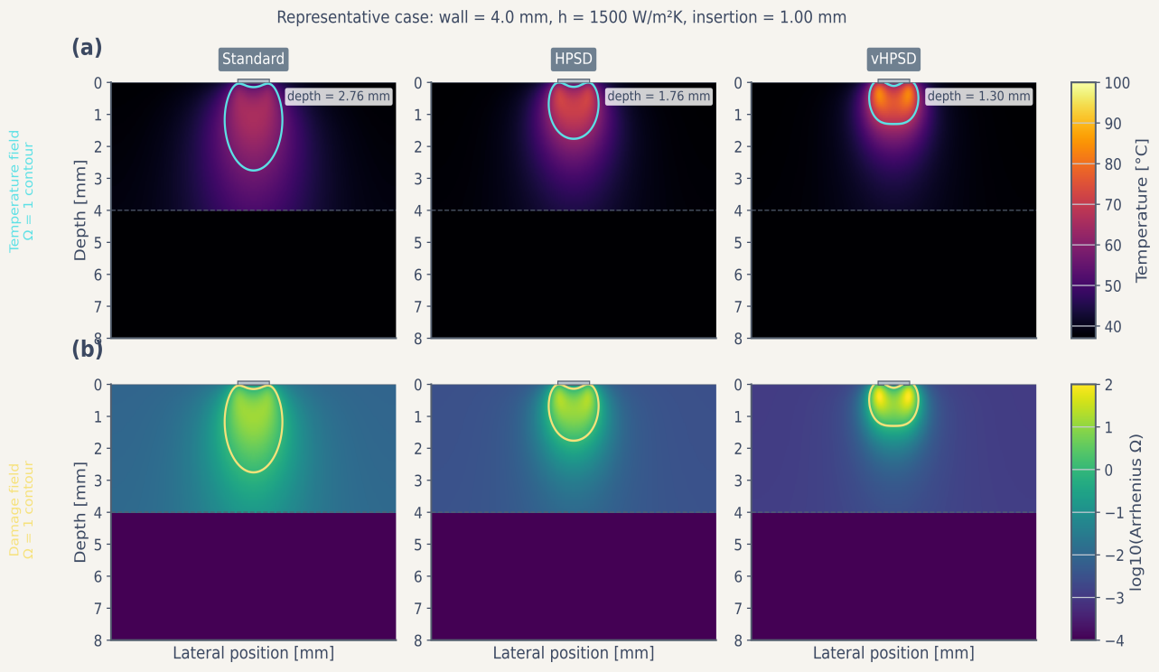
Figure 2. Representative spatial fields for the baseline fixed-power formulation. The top row shows temperature fields and lesion-boundary contours for standard RF, HPSD, and fixed-power 90 W / 4 s under the representative nominal case. The bottom row shows the corresponding thermal-damage fields expressed as log10(Ω).
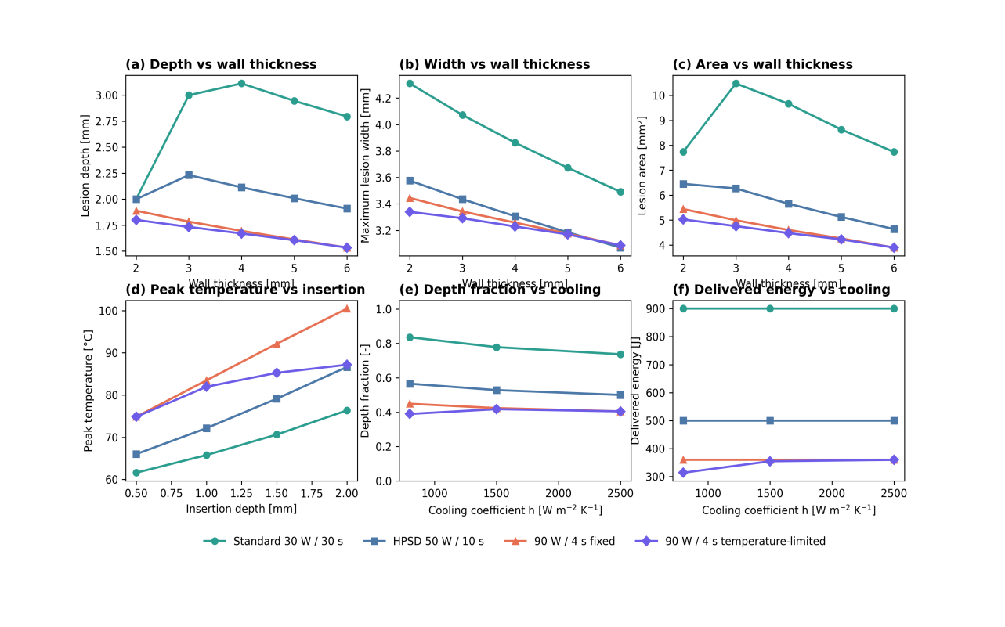
Figure 3. Deterministic four-way comparison across representative wall-thickness, insertion-depth, and cooling slices. Panels summarize lesion depth and depth fraction versus wall thickness, lesion depth and peak temperature versus insertion depth, and lesion depth and delivered energy versus cooling for standard RF, HPSD, fixed-power 90 W / 4 s, and generic temperature-limited 90 W / 4 s.
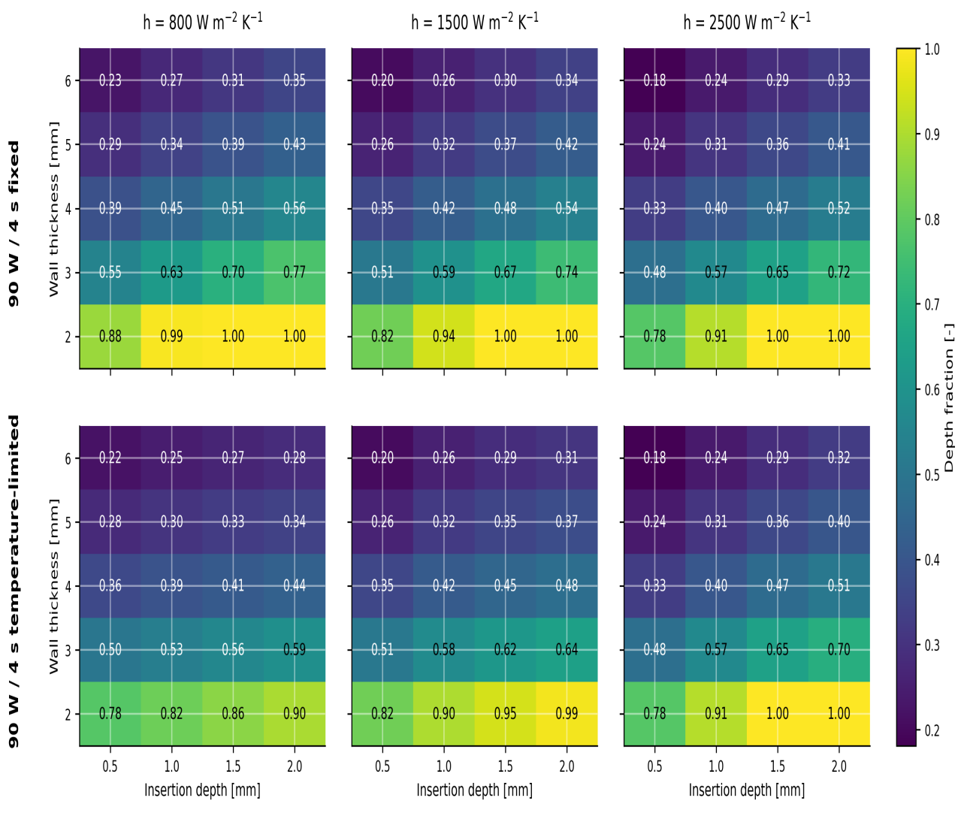
Figure 5. Depth-fraction maps for fixed-power and generic temperature-limited 90 W / 4 s across the phase-preparation grid. Columns correspond to cooling coefficients of 800, 1500, and 2500 W m^-2 K^-1; rows compare the fixed-power and temperature-limited comparators. Values are reported over wall thickness and insertion depth combinations.
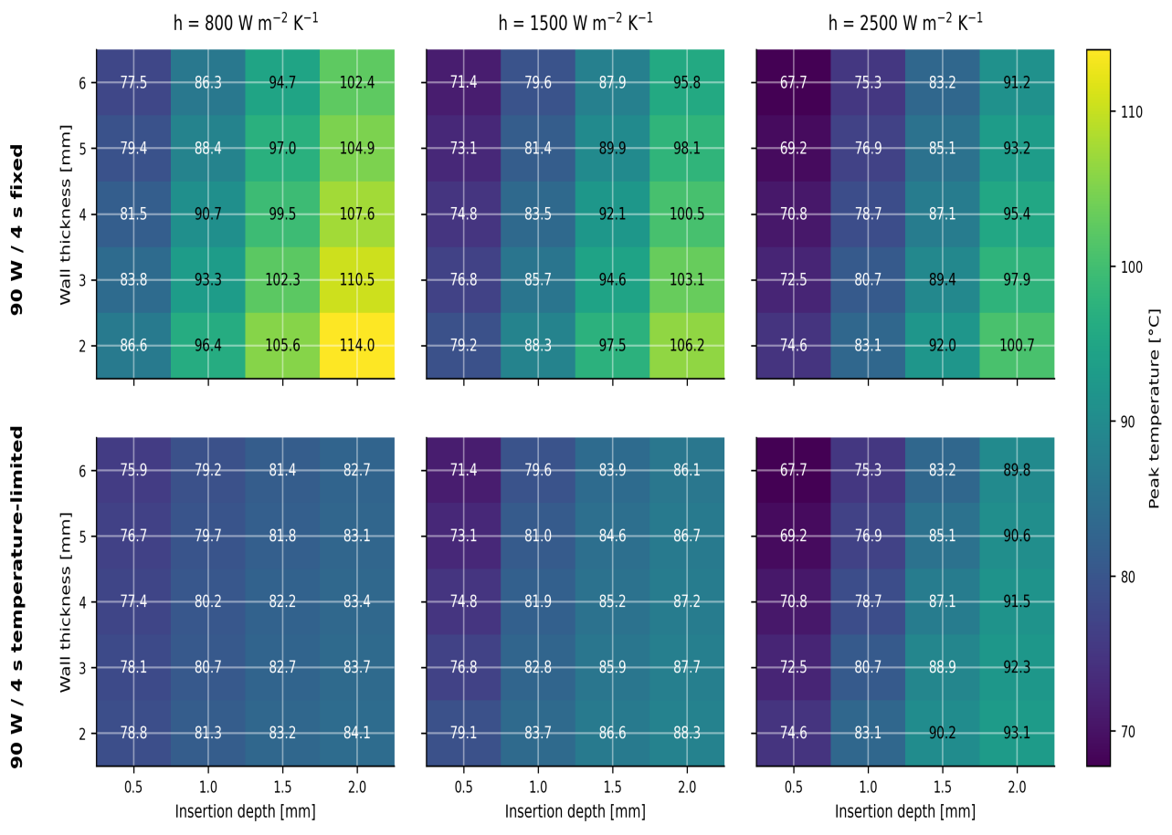
Figure 6. Peak-temperature maps for fixed-power and generic temperature-limited 90 W / 4 s across the phase-preparation grid. Columns correspond to cooling coefficients of 800, 1500, and 2500 W m^-2 K^-1; rows compare the fixed-power and temperature-limited comparators.
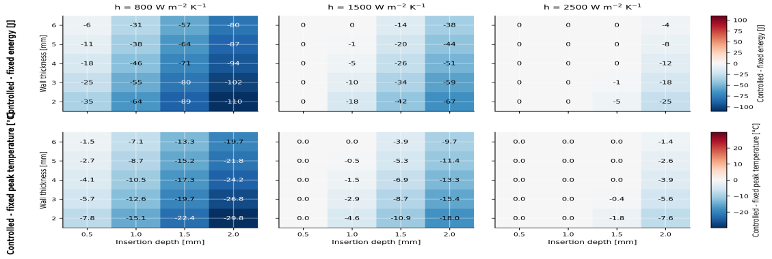
Figure 7. Controlled-minus-fixed difference maps for 90 W / 4 s across the phase-preparation grid. The upper row shows reductions in delivered energy, and the lower row shows reductions in peak temperature, for the generic temperature-limited comparator relative to the fixed-power comparator.
Table 3. Reference literature-derived protocol-level benchmark points.
Source / matched point | Protocol | Reported depth (mm) | Simulated depth (mm) | Reported width (mm) | Simulated width (mm)
Nakagawa2021 | Standard RF | 6.6 | 2.76 | 10.7 | 3.82
Nakagawa2021 | HPSD | 4.9 | 1.76 | 9.2 | 3.15
Nakagawa2021 | 90 W / 4 s fixed-power reference | 3.6 | 1.30 | 8.2 | 2.69
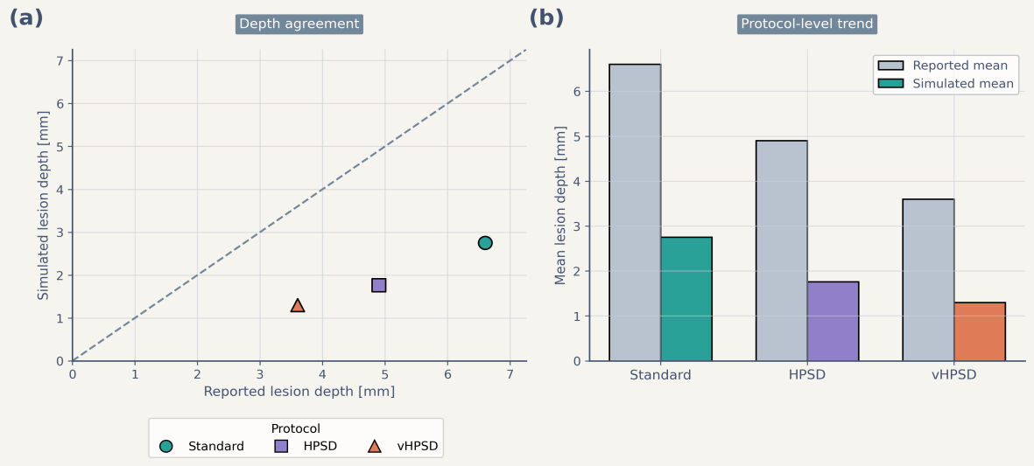
Figure 8. Reference literature-derived benchmark of lesion-depth trends. Panel (a) compares reported lesion depth and simulated lesion depth for the protocol-matched benchmark points using an identity line for visual reference. Panel (b) compares protocol-level mean reported and simulated lesion depth. The benchmark reproduced the protocol-level ranking but underestimated absolute depth and did not distinguish fixed-power and temperature-limited 90 W / 4 s as separate computational comparators.

4. Discussion
This study should be interpreted as a comparator-aware reduced methodology paper. The main contribution is not a claim that one nominal protocol universally dominates another, but the demonstration that comparator definition and post-pulse thermal latency materially change the outputs of a reduced model. Treating 90 W / 4 s as fixed power only and omitting latency would embed a methodological bias directly into the comparison.
The first methodological result is that separating fixed-power and generic temperature-limited 90 W / 4 s changes both delivered energy and apparent thermal severity. At representative conditions, control modestly lowered depth while reducing delivered energy and peak temperature; across the phase-preparation grid, the same effect became stronger in thin-wall, weak-cooling, and larger-insertion cells and weaker where the thermal signal never crossed the control threshold. This threshold-dependent behavior shows that the controlled comparator is not merely a relabeled fixed-power pulse.
The second methodological result is that post-pulse thermal latency is a first-order determinant of short high-power lesion depth. In the representative fixed 90 W / 4 s case, adding the 8 s latency window increased depth and lesion area materially without changing the reported end-of-pulse peak temperature. This supports the view that short high-power lesion formation should not be interpreted from end-of-delivery fields alone in reduced electro-thermal studies.
These results do not justify device-level prediction. The controlled 90 W / 4 s case implemented here is generic, surface-adjacent, and assumption-bounded; it does not reproduce catheter-specific temperature sensing, irrigation-jet physics, chamber-scale flow, or commercial power-titration logic. For the same reason, lesion width and overheating-related quantities should remain secondary internal proxies within this framework rather than primary claims about clinical safety or steam-pop risk.
The external benchmark also remains limited. It is protocol-matched rather than geometry-matched, and the retained three-protocol benchmark does not distinguish fixed-power and temperature-limited 90 W / 4 s as separate comparators. Therefore, the benchmark supports only coarse trend-level context and cannot validate the new comparator definition.
The study has several additional limitations. The model is two-dimensional and reduced-complexity rather than anatomy-matched. Contact is represented by insertion depth rather than explicit mechanics. Cooling is represented through an effective surface coefficient rather than explicit blood flow or irrigation jets. The controller acts on a surface-adjacent temperature surrogate. In addition, the reduced source-gain and cooling-reduction coefficients were retained rather than formally re-identified against geometry-matched data, and no identifiability analysis was performed here. These simplifications are deliberate, because the intended contribution is computational methodology on modest hardware rather than high-fidelity multiphysics reproduction.
Within those boundaries, the framework remains useful as a low-cost comparative screening tool. It can complement higher-fidelity simulation and experimental work by clarifying how comparator definition and post-pulse latency shape reduced-model conclusions before more expensive validation steps are undertaken.

5. Conclusion
A comparator-aware reduced two-dimensional electro-thermal model was used to distinguish standard RF, HPSD, fixed-power 90 W / 4 s, and generic temperature-limited 90 W / 4 s conditions under an explicit 8 s post-pulse latency assumption. Within the present framework, standard RF remained deepest, HPSD was intermediate, and 90 W / 4 s cases were shallower, while the generic temperature-limited comparator frequently reduced delivered energy and peak temperature relative to the fixed-power comparator in more aggressive cells. The principal contribution is therefore methodological: comparator definition and thermal latency materially affect reduced-model conclusions. The present framework is appropriate for assumption-bounded comparative analysis, not for device-level or patient-specific prediction, and it should not be interpreted as a fully recalibrated predictive model.

Data availability statement
The authors confirm that the data supporting the findings of this study are available within the article, including Appendix A. Additional benchmark inputs used to contextualize the analyses were derived from publicly available literature cited in this article. The code and additional derived data generated in this study are available upon reasonable request.

Funding
This research received no specific grant from any funding agency in the public, commercial, or not-for-profit sectors.

Disclosure statement
No potential conflict of interest was reported by the authors.

References
Amin AM, et al. 2024. Efficacy and safety of high-power short-duration ablation for atrial fibrillation: a systematic review and meta-analysis of randomized controlled trials. J Interv Card Electrophysiol. 67(6):1445-1461. doi:10.1007/s10840-024-01782-2.
Arrhenius S. 1889. On the reaction velocity of the inversion of cane sugar by acids. Z Phys Chem. 4:226-248.
Barkagan M, et al. 2018. High-power and short-duration ablation for pulmonary vein isolation: safety, efficacy, and long-term durability. J Cardiovasc Electrophysiol. 29(9):1287-1296. doi:10.1111/jce.13651.
Chang IA. 2010. Considerations for thermal injury analysis for RF ablation devices. Open Biomed Eng J. 4:3-12. doi:10.2174/1874120701004010003.
Chieng D, et al. 2023. Higher power short duration vs. lower power longer duration posterior wall ablation for atrial fibrillation and oesophageal injury outcomes: a prospective multi-centre randomized controlled study (Hi-Lo HEAT trial). Europace. 25(2):417-425. doi:10.1093/europace/euac194.
Fahrenholtz SJ, et al. 2013. Generalised polynomial chaos-based uncertainty quantification for planning MRgLITT procedures. Int J Hyperthermia. 29(4):324-335. doi:10.3109/02656736.2013.798036.
González-Suárez A, et al. 2016. Computational modeling of open-irrigated electrodes for radiofrequency cardiac ablation including blood motion-saline flow interaction. PLoS One. 11(3):e0150356. doi:10.1371/journal.pone.0150356.
González-Suárez A, et al. 2018. Should fluid dynamics be included in computer models of RF cardiac ablation by irrigated-tip electrodes? Biomed Eng Online. 17(1):43. doi:10.1186/s12938-018-0475-7.
González-Suárez A, et al. 2022. Computer modeling of radiofrequency cardiac ablation: 30 years of bioengineering research. Comput Methods Programs Biomed. 214:106546. doi:10.1016/j.cmpb.2021.106546.
Henriques FC Jr. 1947. Studies of thermal injury V. The predictability and significance of thermally induced rate processes leading to irreversible epidermal injury. Arch Pathol. 43:489-502.
Irastorza RM, et al. 2018. Thermal latency adds to lesion depth after application of high-power short-duration radiofrequency energy: results of a computer-modeling study. J Cardiovasc Electrophysiol. 29(2):322-327. doi:10.1111/jce.13363.
Iwakawa H, et al. 2025. Lesion depth optimization in high-power radiofrequency ablation: evaluating single high-power and combined very high-power applications. J Cardiovasc Electrophysiol. 36(12):3212-3221. doi:10.1111/jce.70125.
Jin S, et al. 2023. High-power, short-duration ablation under the guidance of relatively low ablation index values for paroxysmal atrial fibrillation: long-term outcomes and characteristics of recurrent atrial arrhythmias. J Clin Med. 12(3):971. doi:10.3390/jcm12030971.
Kotadia ID, et al. 2020. High-power, short-duration radiofrequency ablation for the treatment of AF. Arrhythm Electrophysiol Rev. 8(4):265-272. doi:10.15420/aer.2019.09.
Liu X, et al. 2021. Safety and efficacy of high power shorter duration ablation guided by ablation index or lesion size index in atrial fibrillation ablation: a systematic review and meta-analysis. J Interv Cardiol. 2021:5591590. doi:10.1155/2021/5591590.
Masnok K, Watanabe N. 2022. Catheter contact area strongly correlates with lesion area in radiofrequency cardiac ablation: an ex vivo porcine heart study. J Interv Card Electrophysiol. 63(3):561-572. doi:10.1007/s10840-021-01054-3.
Nakagawa H, et al. 2021. Comparison of in vivo tissue temperature profile and lesion geometry for radiofrequency ablation with high power-short duration and moderate power-moderate duration: effects of thermal latency and contact force on lesion formation. Circ Arrhythm Electrophysiol. 14(7):e009899. doi:10.1161/CIRCEP.121.009899.
Pennes HH. 1948. Analysis of tissue and arterial blood temperatures in the resting human forearm. J Appl Physiol. 1(2):93-122. doi:10.1152/jappl.1948.1.2.93.
Pérez JJ, et al. 2022. Computer modeling of radiofrequency cardiac ablation including heartbeat-induced electrode displacement. Comput Biol Med. 144:105346. doi:10.1016/j.compbiomed.2022.105346.
Petras A, et al. 2021. Systematic characterization of high-power short-duration ablation: insight from an advanced virtual model. Front Med Technol. 3:747609. doi:10.3389/fmedt.2021.747609.
Reddy VY, et al. 2019. Pulmonary vein isolation with very high power, short duration, temperature-controlled lesions: the QDOT-FAST trial. JACC Clin Electrophysiol. 5(7):778-786. doi:10.1016/j.jacep.2019.04.009.
Rozen G, et al. 2018. Safety and efficacy of delivering high-power short-duration radiofrequency ablation lesions utilizing a novel temperature sensing technology. Europace. 20(FI_3):f444-f450. doi:10.1093/europace/euy031.
Wilson EB. 1927. Probable inference, the law of succession, and statistical inference. J Am Stat Assoc. 22(158):209-212. doi:10.1080/01621459.1927.10502953.
Yamaguchi J, et al. 2024. Impact of contact force on the lesion characteristics of very high-power short-duration ablation using a QDOT-MICRO catheter. J Arrhythm. 40(2):247-255. doi:10.1002/joa3.12992.

Appendix A. Supplementary reference figures
The supplementary figures retained from the earlier fixed-power three-protocol formulation are included for archival completeness only. The associated uncertainty workflow reflects the prior generalized-polynomial-chaos and binomial-interval treatment rather than the present comparator-aware four-protocol analysis (Fahrenholtz et al. 2013; Wilson 1927).
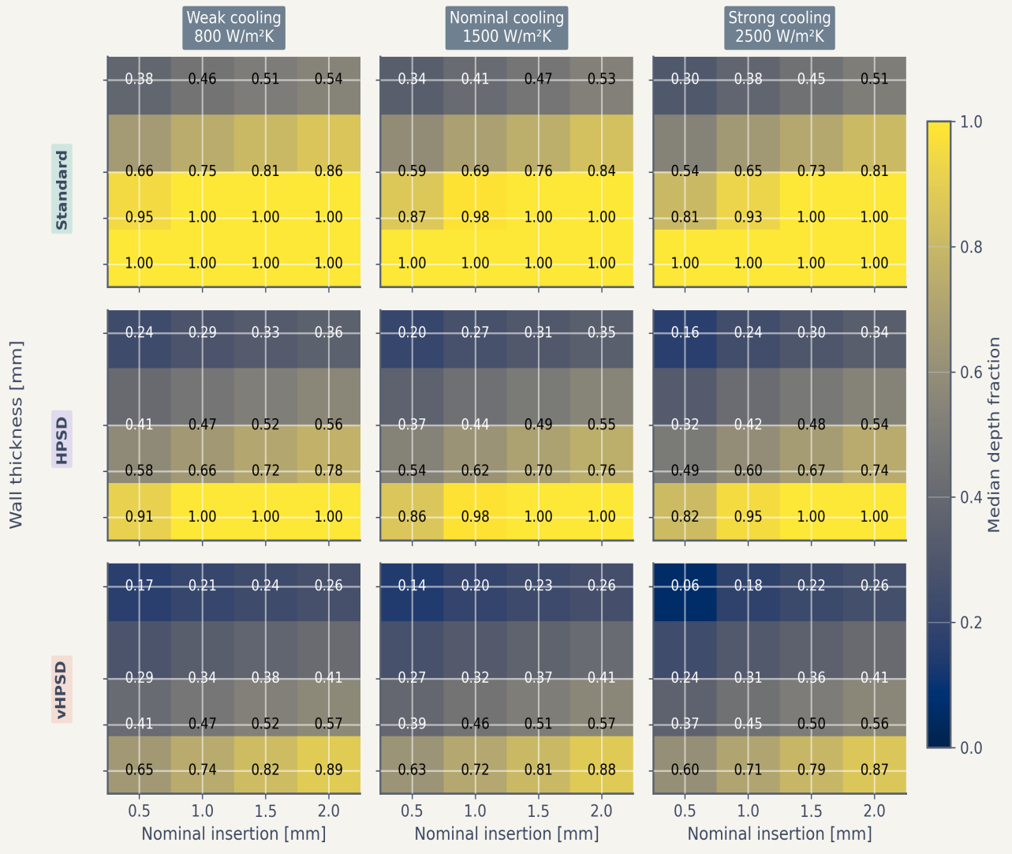
Supplementary Figure S1. Reference depth-fraction maps from the fixed-power three-protocol formulation, provided for completeness.
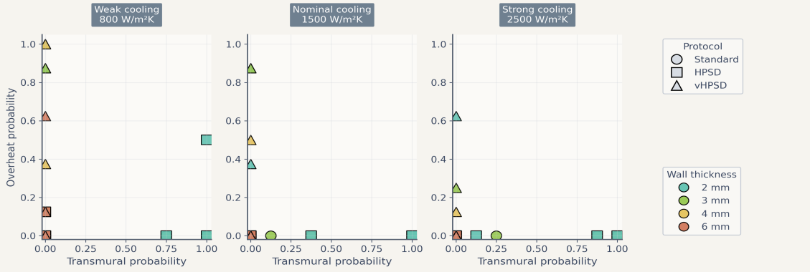
Supplementary Figure S2. Reference trade-off summary from the fixed-power three-protocol formulation, provided for completeness.
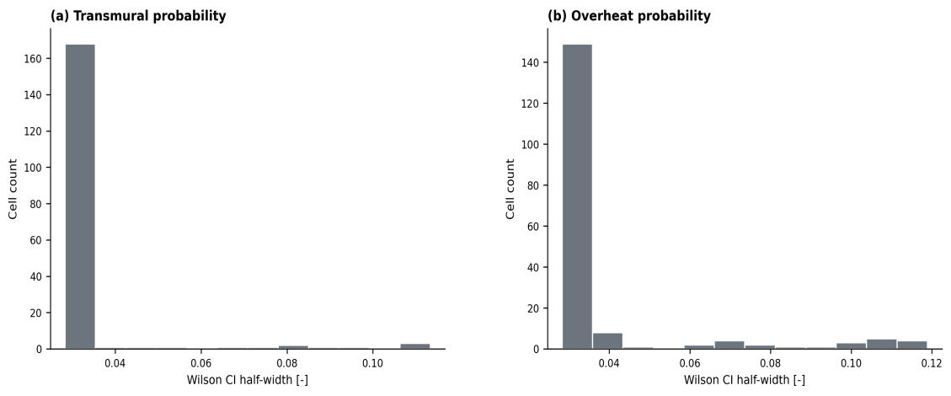
Supplementary Figure S3. Reference distribution of 95% Wilson-score confidence-interval half-widths from the fixed-power three-protocol formulation, provided for completeness.

