A low-complexity comparative framework for perivascular liver radiofrequency ablation: shape-based assessment of safety-margin deficit and protocol trade-offs
Keywords: liver radiofrequency ablation; perivascular tumor; heat-sink; treatment planning; margin deficit; computational modeling

Abstract
Background: Perivascular liver radiofrequency ablation (RFA) is vulnerable to heat-sink effects, which can lead to asymmetric underablation and loss of the intended safety margin. Existing planning studies often emphasize lesion size, whereas shape-based descriptors of margin failure remain less developed.
Methods: We developed a low-complexity 2D electro-thermal-damage framework for perivascular liver RFA using a parameterized geometry composed of tumor, electrode, and a single nearby vessel. The model coupled an electro-quasistatic formulation, reduced bioheat transfer, and Arrhenius-type thermal damage. Treatment adequacy was quantified using tumor coverage ratio (TCR), margin deficit index (MDI), vessel-side undercoverage angle (VUA), and target specificity (PPV_target). The effects of tumor-vessel gap, vessel diameter, and protocol strength were evaluated under a moderate-energy protocol and a high-energy protocol. Numerical credibility was assessed by grid and time-step checks, and model calibration was performed against a no-vessel reference lesion diameter.
Results: Tumor-vessel gap was the primary determinant of margin failure within the tested range. Under both tested protocols, MDI decreased monotonically as the gap increased from 0 to 5 mm. Vessel diameter acted as a secondary modifier, with its effect being most apparent in abutting or very short-gap cases. Relative to the moderate-energy protocol, the high-energy protocol tended to reduce MDI across the tested conditions, but this improvement was accompanied by lower PPV_target and larger overablation outside the target region, indicating a stronger overtreatment trade-off. Representative contour maps showed vessel-side notching and localized undercoverage in near-vessel cases. Grid and time-step checks supported the use of TCR and MDI for exploratory planning comparisons and comparative ranking within the tested discretization range; the present results should therefore be interpreted as proof-of-concept comparative evidence rather than as high-precision predictive estimates.
Conclusions: A reduced-complexity, planning-oriented comparative framework can capture planning-relevant perivascular RFA failure patterns and provide information complementary to lesion-size summaries. The proposed framework offers an interpretable proof-of-concept method for comparing protocol classes, quantifying local margin loss, and characterizing collateral-damage trade-offs in idealized near-vessel liver ablation settings.

1. Introduction
Thermal ablation is an established treatment option for selected primary and metastatic liver tumors, especially in patients who are not candidates for surgical resection or require minimally invasive local therapy. Among thermal modalities, radiofrequency ablation (RFA) remains widely used because of its clinical availability, procedural familiarity, and relatively low technical burden. However, treatment success is not determined solely by whether a lesion is heated, but by whether the entire tumor and an adequate safety margin are reliably covered. [1,4]
A major challenge arises in perivascular tumors, where heat transfer to adjacent blood vessels can reduce local tissue heating and produce so-called heat-sink effects. In this setting, the resulting ablation zone may become asymmetric, with localized undercoverage on the vessel-facing side. Such near-vessel failure patterns are clinically important because incomplete local treatment and inadequate ablation margins are associated with increased risk of local tumor progression. [1,3,4]
Computational modeling provides a practical route for studying this problem in a reproducible and low-cost manner. Physics-based RFA models have been used to estimate temperature fields, tissue damage, and ablation extent under different applicator settings and tissue conditions, but recent reviews have emphasized persistent heterogeneity in validation strategies and a continuing need for shape-based outcome measures. [2]
Recent liver-ablation software and image-based margin-assessment studies have demonstrated the feasibility of patient-specific or real-time simulation workflows and highlighted the importance of quantitative margin confirmation and deformable registration for predicting local outcome. [6-10] However, these approaches are generally aimed at patient-specific guidance or image-based confirmation rather than a lightweight comparative framework for protocol sensitivity analysis. The present work is therefore positioned as an incremental but useful methodological simplification for shape-aware comparison of protocol–geometry interactions in idealized perivascular RFA.
This limitation motivates the use of shape-based planning endpoints. In a planning context, treatment adequacy should ideally describe not only whether the tumor is covered, but also where margin failure occurs and how much protocol escalation is required to compensate for heat-sink-related underablation. In particular, safety-margin insufficiency is often more clinically meaningful than overall lesion enlargement, because more aggressive protocols may improve coverage at the cost of increased injury to normal tissue.
In this study, we developed a low-complexity 2D planning-oriented comparative framework for perivascular liver RFA using a parameterized geometry containing tumor, electrode, and a single nearby vessel. Rather than pursuing full patient-specific realism, we focused on a computationally light framework suitable for protocol comparison and planning-oriented sensitivity analysis. We quantified treatment adequacy using four interpretable endpoints: tumor coverage ratio (TCR), margin deficit index (MDI), vessel-side undercoverage angle (VUA), and target specificity (PPV_target).
Relative to prior perivascular liver-ablation modeling studies, the present work is positioned as an incremental but useful methodological simplification. Existing literature includes higher-fidelity and patient-specific workflows for treatment simulation, protocol optimization, and image-based ablative-margin assessment, whereas the current framework deliberately prioritizes low computational cost, explicit shape-based endpoints, and reproducible protocol comparison in an idealized single-vessel geometry. Accordingly, the contribution of this study lies less in biophysical completeness than in providing an interpretable reduced-order proxy for comparative planning analysis under constrained hardware.
The objectives of this work were threefold. First, we aimed to characterize how tumor-vessel gap and vessel diameter shape local underablation patterns in perivascular RFA. Second, we sought to compare a moderate-energy protocol and a high-energy protocol in terms of margin recovery and target specificity, while explicitly treating the moderate-energy setting as a deliberately conservative comparator rather than as a margin-satisfying no-vessel baseline. Third, we aimed to establish a numerically credible and reproducible workflow, including calibration, convergence analysis, and shape-based figure generation, that can serve as a planning-oriented comparative template for near-vessel liver ablation studies.

2. Methods

2.1 Study design
This work was designed as a simulation-led methodological study of perivascular liver RFA. The aim was not to build a full patient-specific prediction system, but to establish an interpretable reduced-complexity planning framework for exploring how vessel proximity and protocol strength influence tumor coverage and safety-margin failure. All final manuscript figures were generated from a frozen simulation state to improve traceability and reproducibility.

2.2 Governing equations
A reduced-order 2D electro-thermal-damage model was used to simulate perivascular liver RFA. The electric subproblem was modeled using an electro-quasistatic conduction equation,
∇ · (σ(x) ∇φ) = 0
where φ is the electric potential and σ(x) is tissue-dependent electrical conductivity. In the present implementation, the electrode was prescribed as a unit-potential boundary and the outer domain boundary was set to zero potential. The resulting normalized field was used to construct a spatial Joule-heating template,
q_unit(x) = σ(x) |∇φ(x)|²
The reduced-order radiofrequency heating term was defined as
Q_RF(x) = q_unit(x) · P_nom · s_src
where P_nom is the nominal protocol power and s_src is an effective source-scaling coefficient determined by calibration. In this formulation, s_src is a dimensionless calibration coefficient that maps the normalized electrical heating template to the target lesion size in the simplified 2D model rather than a directly measurable tissue property.
Transient temperature evolution was modeled with a reduced bioheat equation,
ρ c ∂T/∂t = ∇ · (k ∇T) + Q_RF - Q_perf
with
Q_perf = ω_eff (T - T_b)
where T is tissue temperature, T_b is the blood/reference temperature, ρ is density, c is specific heat, k is thermal conductivity, and ω_eff is an effective volumetric sink coefficient. Vessel pixels were excluded from this sink and treated as fixed-temperature cooling structures.
Thermal injury accumulation was modeled using an Arrhenius formulation,
Ω(x,t) = ∫₀ᵗ A exp(-E_a / (R T_K(x,τ))) dτ
where A is the frequency factor, E_a is activation energy, R is the universal gas constant, and T_K = T + 273.15 is absolute temperature. A pixel was classified as lethally damaged when Ω ≥ 1.0, and the resulting lethal-zone mask was used to define the predicted lesion.

2.3 Geometry and boundary conditions
The computational domain was a 2D Cartesian rectangle of size 80 × 80 mm. A circular tumor was centered at (0, 0) mm with radii (7.5, 7.5) mm, corresponding to a 15-mm tumor diameter. A centrally placed rectangular electrode traversed the tumor and was modeled with width 1.0 mm and length 20.0 mm.
A single nearby vessel was represented as a circular cooling structure centered on the positive x-axis. Vessel position was determined by the tumor radius, vessel radius, and prescribed tumor-vessel gap. Tested vessel diameters were 3, 5, and 8 mm, corresponding to radii of 1.5, 2.5, and 4.0 mm. Tested tumor-vessel gaps were 0, 2, and 5 mm. A no-vessel baseline was created by disabling the vessel mask entirely.
For the electric subproblem, the electrode was assigned φ = 1 and the outer domain boundary φ = 0. For the thermal subproblem, the vessel region and outer domain boundary were prescribed as fixed-temperature boundaries at 37 °C. The initial temperature field was also set to 37 °C. These settings reflect a reduced-order truncation of the thermal problem rather than an attempt to recover physiologically exact whole-organ boundary behavior.
A 5-mm target margin was defined around the tumor and used as the planning target in all shape-based endpoint calculations. This choice follows the frequent use of a 5-mm minimal ablative margin as a clinically meaningful target in liver ablation studies. [4,6]

2.4 Shape-based endpoints
Let T denote the tumor region, A the predicted lethal zone, and G the target region obtained by dilating the tumor by 5 mm.
Tumor coverage ratio (TCR) was defined as
TCR = |A ∩ T| / |T|
Target specificity (PPV_target) was defined as
PPV_target = |A ∩ G| / |A|
To complement PPV_target, we also evaluated two absolute target-region descriptors in the supplementary analysis. Absolute overablation outside the target region was defined as |A \ G| = |A| - |A ∩ G|, and target-region coverage was defined as |A ∩ G| / |G|. These quantities were used to interpret collateral-damage trade-offs in a way that is more directly linked to absolute target miss and absolute excess treatment than PPV_target alone.
Margin deficit index (MDI) was defined from the local achieved margin m(x), computed from the Euclidean distance to the lesion boundary for tumor-boundary points x ∈ ∂T. MDI was then evaluated as
MDI = (1 / |∂T|) Σ_{x∈∂T} 1[m(x) < m₀], m₀ = 5 mm
Thus, in the present implementation, MDI is a boundary-point fraction rather than an area fraction.
Vessel-side undercoverage angle (VUA) quantified the angular extent of underablation on the vessel-facing side. Tumor-boundary points with a nonnegative projection toward the vessel center were treated as vessel-facing; undercovered vessel-facing angular bins were accumulated and converted to degrees using 360 equally spaced angular bins. Because VUA depends more strongly on discretization and angular binning, it was treated as a supplementary rather than a primary endpoint.
Equivalent lesion diameter was computed from lesion area A_lesion as
D_eq = √(4 A_lesion / π)
This quantity was used for baseline calibration and internal benchmark comparisons.

2.5 Geometry, parameter, and solver settings
Table 1. Geometry and numerical design.
Quantity | Symbol / setting | Value used in final study
Domain size | Lx × Ly | 80 × 80 mm
Final main grid | nx × ny | 161 × 161
Grid checks | - | 121 × 121, 161 × 161, 201 × 201
Tumor center | (xt, yt) | (0, 0) mm
Tumor radii | (rx, ry) | (7.5, 7.5) mm
Tumor diameter | - | 15 mm
Electrode width | - | 1.0 mm
Electrode length | - | 20.0 mm
Vessel diameters | - | 3, 5, 8 mm
Tested vessel gaps | g | 0, 2, 5 mm
Safety margin | m0 | 5 mm
Angular bins for VUA | Nbins | 360
Final time step | Δt | 2 s
Time-step checks | - | 4, 2, 1 s
Table 2. Material and damage parameters.
Parameter | Symbol | Value
Liver electrical conductivity | σ_liver | 0.20 S/m
Tumor electrical conductivity | σ_tumor | 0.25 S/m
Vessel electrical conductivity | σ_vessel | 0.70 S/m
Liver thermal conductivity | k_liver | 0.50 W/m/K
Tumor thermal conductivity | k_tumor | 0.50 W/m/K
Tissue density | ρ | 1060 kg/m³
Tissue specific heat | c | 3600 J/kg/K
Liver perfusion sink coefficient | ω_liver,eff | 10000 W/m³/K
Tumor perfusion sink coefficient | ω_tumor,eff | 5000 W/m³/K
Initial temperature | T0 | 37 °C
Blood/fixed boundary temperature | Tb | 37 °C
Arrhenius frequency factor | A | 7.39 × 10^39 s^-1
Arrhenius activation energy | Ea | 2.577 × 10^5 J/mol
Damage threshold | Ω_th | 1.0
Final source-scaling coefficient | s_src | 7.30 (rounded; see Fig. S4A)
The term low-complexity is used here to indicate reduced geometric and numerical complexity relative to high-fidelity patient-specific simulators. It does not imply that the framework has been formally benchmarked as a runtime-optimized clinical software system.

2.6 Protocol design, calibration, and benchmark
Baseline calibration was performed in a no-vessel reference configuration under a nominal protocol of 50 W for 8 min. The effective source-scaling coefficient s_src was selected such that the equivalent lesion diameter matched a target reference diameter of 22 mm. This calibration is reported in Fig. S4(A). The present study therefore used a single-point, no-vessel calibration and should be interpreted as a planning-oriented proof-of-concept rather than as a fully externally validated predictive model. [2]
Two representative protocols were selected from a no-vessel baseline sweep: a moderate-energy protocol (60 W for 10 min) and a high-energy protocol (70 W for 10 min). The moderate-energy protocol was intentionally retained as a conservative comparator and did not fully satisfy the 5-mm no-vessel target-margin criterion. Consequently, comparisons between protocol classes should be interpreted as comparisons between a deliberately conservative protocol and a stronger energy-delivery setting, rather than as comparisons against a fully margin-satisfying baseline.
An internal benchmark analysis was performed by comparing each perivascular lesion size to the corresponding no-vessel baseline for the same protocol. The benchmark endpoint was the normalized lesion reduction (NLR), used to verify that heat-sink severity decreased monotonically with tumor-vessel gap. This benchmark was used to demonstrate literature-consistent trend behavior, not to replace external experimental validation. [2,3]

2.7 Numerical implementation and reproducibility
The model was implemented in Python on a regular Cartesian grid. The electric subproblem was assembled as a sparse linear system and solved using a direct sparse solver. The thermal update used an implicit time-marching formulation with sparse factorization reused across time steps. Interface coefficients in the diffusion operator were constructed from local arithmetic averages of thermal conductivity across neighboring cells.
Final manuscript figures were generated from a frozen simulation state using the 161 × 161 grid and a 2-s time step. Convergence checks were performed on a severe-vessel case using additional grid sizes of 121 × 121 and 201 × 201 and time steps of 4, 2, and 1 s. Based on these tests, TCR and MDI were retained as the primary planning endpoints, whereas VUA was treated as supplementary because of greater discretization sensitivity.
Runtime profiling on an Apple M4 MacBook Air showed that a representative single-case simulation on the final 161 × 161 grid required approximately 2.4 s, whereas the final 18-case protocol sweep required approximately 13.3 s. Peak memory footprints were approximately 190 MB and 282 MB, respectively. These measurements support the characterization of the framework as a low-complexity, planning-oriented comparative model rather than a high-fidelity patient-specific simulator.
The public repository contains the frozen simulation state, final figure-generation workflow, manuscript tables, configuration snapshots, and environment freeze files. Figure provenance is documented in a manifest file to improve reproducibility and traceability.

3. Results

3.1 Protocol selection and calibration
A no-vessel baseline sweep was first used to identify two representative protocol classes for the final study. The moderate-energy protocol was intentionally retained as a conservative comparator, whereas the high-energy protocol represented a stronger energy-delivery setting. Importantly, the moderate-energy protocol did not fully satisfy the desired 5-mm target margin in the no-vessel baseline (MDI = 0.167), so subsequent comparisons should be interpreted as comparisons between protocol strengths rather than as a pure heat-sink compensation analysis at equal no-vessel margin adequacy.

3.2 Representative perivascular lesion shapes
Representative contour plots showed that the no-vessel baseline produced a nearly symmetric lesion around the tumor. In contrast, perivascular cases introduced a vessel-side notch, resulting in localized loss of the desired target margin on the vessel-facing side. Increasing the tumor-vessel gap reduced this asymmetry, while protocol escalation partially restored margin coverage. [1,3]
Notably, cases with broadly comparable equivalent lesion diameters could still differ in local margin loss and vessel-facing notch severity, supporting the use of shape-based endpoints as complements to lesion-size summaries. The supplementary shape-versus-size comparison (Fig. S6) highlights this divergence directly.

3.3 Protocol-dependent effects of gap and vessel diameter
Across the tested settings, tumor-vessel gap was the primary determinant of margin failure within the tested range of geometric conditions. Under both protocols, MDI decreased monotonically as the gap increased from 0 to 5 mm, whereas vessel diameter acted mainly as a secondary modifier that was most apparent in abutting or very short-gap cases. Within the tested discretization range, the high-energy protocol tended to reduce MDI relative to the moderate-energy protocol, consistent with the established understanding that perivascular heat-sink effects weaken with increasing separation from major vessels. [1,3]

3.4 Planning trade-off
For the representative 5-mm vessel, the high-energy protocol tended to reduce margin deficit relative to the moderate-energy protocol but also showed lower PPV_target, indicating a stronger overtreatment trade-off. Because the moderate-energy protocol was intentionally retained as a conservative comparator and did not fully satisfy the no-vessel 5-mm target-margin condition, these differences should not be interpreted as a pure measure of heat-sink compensation alone. To complement this proportional specificity metric, we also quantified absolute overablation area outside the target region and target-region coverage |A ∩ G| / |G| (Fig. S7). Across gaps, the high-energy protocol increased target-region coverage but also produced larger absolute collateral damage outside the intended target region.

3.5 Numerical credibility and benchmark
Grid and time-step checks showed that TCR and MDI were numerically stable enough to support exploratory planning comparisons within the tested discretization range. Time-step variation had minimal influence on the primary endpoints, whereas grid refinement produced modest but non-negligible variation in MDI for the severe-vessel case. Accordingly, MDI is interpreted here as a comparative ranking and trend descriptor rather than as a high-precision absolute quantity.
Table 3. Primary endpoint summary for a representative 5-mm vessel.
Protocol | Gap (mm) | Vessel diameter (mm) | TCR | MDI | PPV_target
Moderate-energy | 0 | 5 | 0.939 | 0.369 | 0.630
Moderate-energy | 2 | 5 | 0.999 | 0.321 | 0.636
Moderate-energy | 5 | 5 | 1.000 | 0.250 | 0.643
High-energy | 0 | 5 | 0.961 | 0.345 | 0.530
High-energy | 2 | 5 | 1.000 | 0.298 | 0.539
High-energy | 5 | 5 | 1.000 | 0.226 | 0.546
Table 4. Numerical credibility summary for the severe-vessel case.
Grid n | TCR (severe vessel) | MDI (severe vessel)
121 | 0.965 | 0.350
161 | 0.958 | 0.369
201 | 0.956 | 0.356
Table 5. Time-step sensitivity summary for the severe-vessel case.
Time step (s) | TCR (severe vessel) | MDI (severe vessel)
4.0 | 0.958 | 0.369
2.0 | 0.958 | 0.369
1.0 | 0.958 | 0.369

Figures
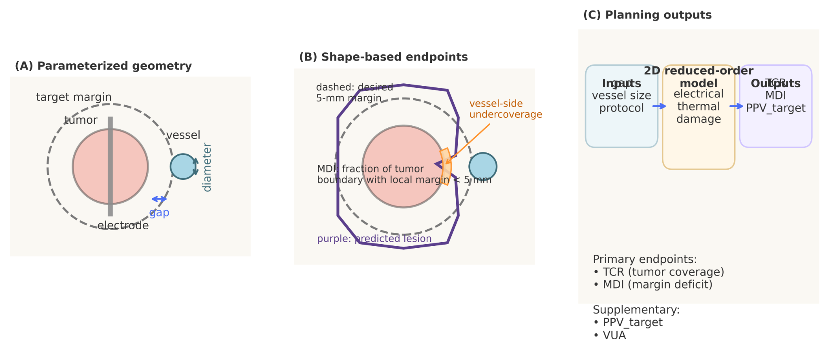
Figure 1. Parameterized geometry, shape-based endpoints, and planning workflow. (A) The 2D parameterized geometry consists of tumor, electrode, and a single nearby vessel. The tumor-vessel gap and vessel diameter are treated as key geometric inputs, and a 5-mm target margin is defined around the tumor. (B) Shape-based endpoints are illustrated schematically. TCR quantifies lethal-zone coverage of the tumor, MDI quantifies the fraction of tumor boundary with local margin smaller than 5 mm, and VUA describes the angular extent of vessel-facing underablation. (C) The planning workflow maps geometric inputs and protocol settings to the reduced-order electro-thermal-damage solver and shape-based outputs.
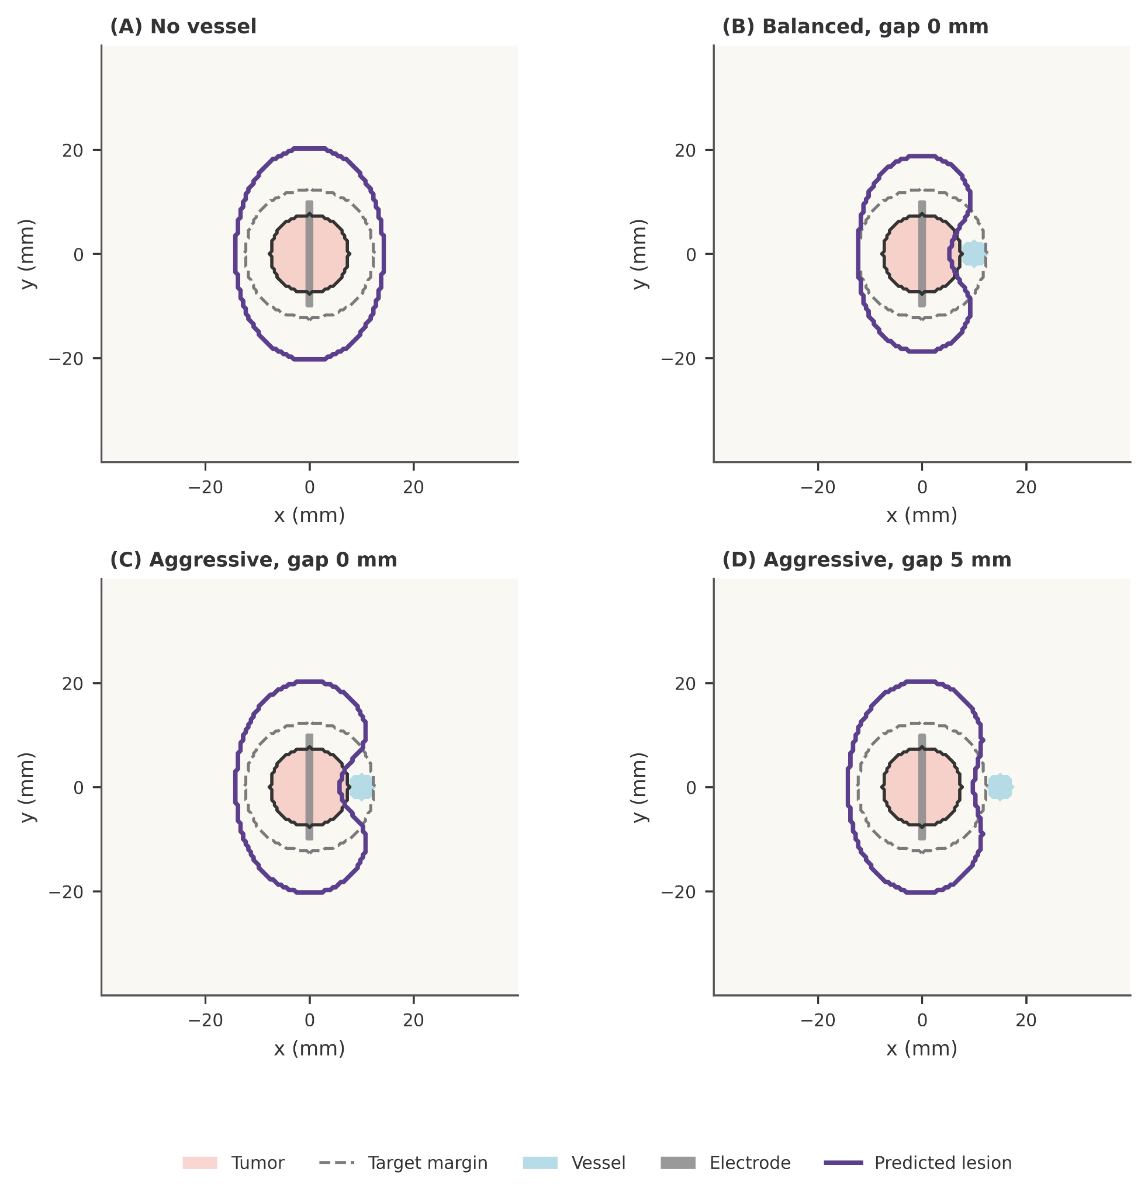
Figure 2. Representative lesion contours under no-vessel and perivascular conditions. Predicted lethal-zone contours are shown for a no-vessel baseline and for representative perivascular cases under moderate-energy and high-energy protocols. The tumor contour, desired 5-mm target margin, vessel location, and electrode are overlaid for reference. Near-vessel cases show a characteristic vessel-side notch, indicating localized undercoverage caused by heat-sink, whereas increasing gap reduces this asymmetry.
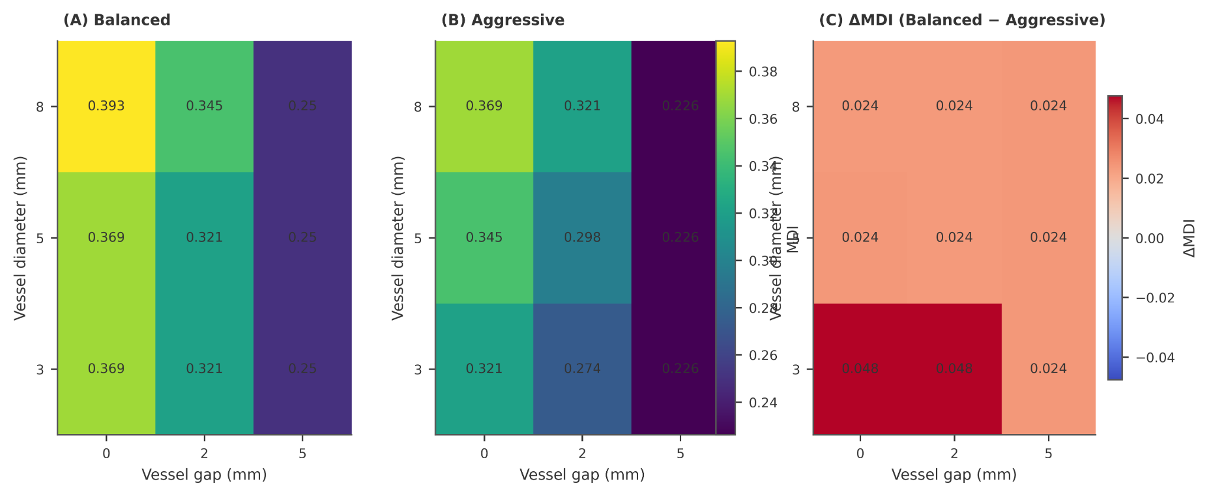
Figure 3. Protocol-dependent maps of margin deficit index (MDI). MDI is shown across tumor-vessel gap and vessel diameter for the moderate-energy and high-energy protocols. Panel (C) reports the MDI reduction achieved by the high-energy protocol relative to the moderate-energy protocol. Smaller gap consistently increased margin deficit, whereas larger vessel diameter further worsened deficit mainly in abutting or very short-gap cases.
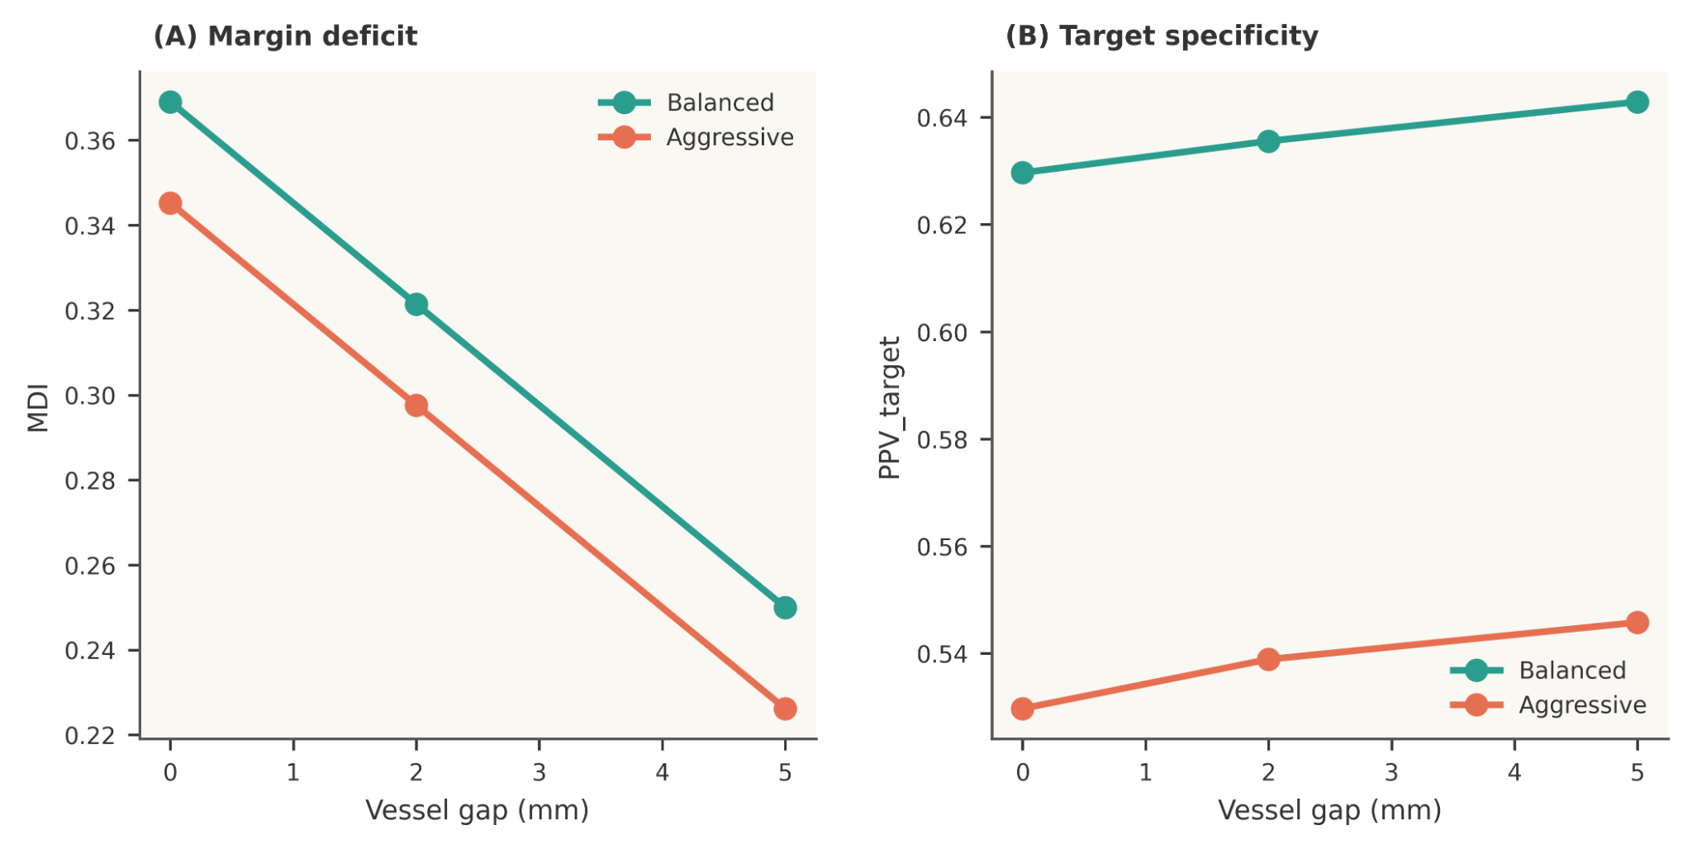
Figure 4. Protocol-strength trade-off between margin deficit and target specificity. For a representative 5-mm vessel, increasing tumor-vessel gap reduces MDI under both protocols. The high-energy protocol tends to achieve lower MDI than the moderate-energy protocol, but this improvement is accompanied by lower PPV_target, indicating a stronger overtreatment trade-off.

4. Discussion
Perivascular liver RFA is fundamentally a planning problem under asymmetric cooling, rather than a purely geometric problem of lesion size. In the present study, a low-complexity 2D electro-thermal-damage model reproduced the central qualitative behavior expected in this setting: a nearby vessel produced vessel-facing underablation, the severity of margin failure decreased as tumor-vessel gap increased, and protocol escalation partially compensated for this effect. These findings are consistent with the broader clinical and computational literature on perivascular liver ablation and heat-sink effects. [1-3]
A central result of this work is that tumor-vessel gap emerged as the primary determinant of margin deficit within the tested range, whereas vessel diameter acted mainly as a secondary modifier, with the strongest effect in abutting or very short-gap cases. This pattern is plausible in light of prior computational and clinical observations that identify shortest vascular distance as a major driver of local underablation and local tumor progression. [1,3,4]
Another important contribution of this study is the explicit use of shape-based planning endpoints. Many ablation modeling studies still summarize treatment outcome using lesion diameter, lesion area, or overlap alone, but these quantities may fail to capture the vessel-side notch that is often the clinically meaningful manifestation of perivascular heat-sink. The present results show that a protocol can appear adequate in terms of lesion size while still exhibiting substantial local safety-margin loss. This emphasis on shape-based evaluation is consistent with the needs identified in recent computational liver ablation reviews. [2]
The comparison between the moderate-energy and high-energy protocols highlights why a comparative framework should not optimize coverage alone. In this study, the high-energy protocol tended to reduce MDI relative to the moderate-energy protocol, but this gain occurred together with lower PPV_target and larger absolute overablation outside the target region, indicating a stronger overtreatment trade-off. Because the moderate-energy protocol was deliberately retained as a conservative comparator rather than as a fully margin-satisfying no-vessel baseline, the observed protocol differences reflect both perivascular heat-sink sensitivity and baseline protocol strength. Accordingly, the present results should be interpreted as comparative protocol evidence within the tested range, not as a universal statement that protocol escalation alone resolves near-vessel margin failure.
A strength of the present work is that it deliberately targets the middle ground between oversimplified toy models and highly detailed patient-specific simulators. Prior liver-ablation workflows have demonstrated the feasibility of high-performance patient-specific simulation, prospective in silico planning, and deformable-registration-based margin confirmation. [6-10] The value of the current model is not that it captures every physiological detail, but that it provides an interpretable and computationally light platform for comparing protocols, visualizing lesion asymmetry, and quantifying margin loss in a reproducible way. This framing is best understood as an incremental but useful methodological simplification rather than as a replacement for higher-fidelity predictive systems.
The numerical analysis also informs how the results should be interpreted. Within the tested discretization range, TCR and MDI were stable enough to support exploratory planning comparisons and ranking of protocol-related effects. However, because grid-induced variation in MDI was not negligible relative to some protocol-level differences, MDI should not be interpreted here as a high-precision absolute quantity. By contrast, VUA was more grid-sensitive and was consequently retained as a supplementary descriptor rather than as a principal inferential quantity. This endpoint stratification is preferable to presenting all metrics as equally reliable.
Several limitations should be acknowledged. First, the model is two-dimensional and therefore cannot fully represent three-dimensional directional effects, including differences between vessels oriented parallel versus orthogonal to the applicator. Second, the vessel representation was intentionally simplified and did not include patient-specific hemodynamics or detailed vascular branching. Third, no direct experimental or clinical image-based validation was performed, and the benchmark strategy was limited to no-vessel calibration plus literature-consistent internal trend analysis. Fourth, the present framework uses a normalized electrical heating template, fixed-temperature vessel cooling, and fixed-temperature outer boundaries, and therefore should be interpreted as a reduced-order comparative proxy rather than as a high-fidelity device-specific simulator. In particular, the fixed 37 °C vessel representation may approximate an upper-bound local cooling effect in some settings. Finally, only two representative protocol classes were examined in the final comparative study, so the present results should be interpreted within the tested protocol range rather than as a complete protocol-landscape characterization.
These limitations also point to logical future directions, including extension to minimal 3D geometries, replacement of circular tumor geometry by a small library of image-derived tumor contours, incorporation of external image- or experiment-based benchmarks, and expansion of the protocol space toward denser response-surface or Pareto-style analyses. [2,5,6]
Taken together, the present study supports a simple but practically useful interpretation: in perivascular liver RFA, the most important question is not simply whether the lesion is large enough, but whether the safety margin is lost locally on the vessel-facing side and whether protocol escalation restores that margin at an acceptable cost in target specificity and absolute collateral damage outside the intended target region.

5. Conclusion
A low-complexity 2D electro-thermal-damage comparative framework was developed to study perivascular liver RFA using shape-based endpoints. Across the tested settings, tumor-vessel gap was the primary determinant of margin deficit within the tested range, while vessel diameter acted mainly as a secondary modifier in abutting or very short-gap cases. Relative to a deliberately conservative moderate-energy comparator, a higher-energy protocol tended to reduce margin deficit but also increased collateral damage outside the target region. These findings support the value of shape-based endpoints as complementary descriptors to lesion-size summaries and position the framework as a proof-of-concept comparative tool for idealized perivascular protocol assessment rather than as a patient-specific predictive model.

Funding
This research did not receive any specific grant from funding agencies in the public, commercial, or not-for-profit sectors.

Declaration of competing interests
The author declares no known competing financial interests or personal relationships that could have appeared to influence the work reported in this paper.

Code and data availability
The code, frozen simulation state, final figure-generation workflow, and manuscript tables are archived and can be provided to the editor and reviewers upon request. To preserve reviewer blinding during peer review, the public repository link is not included in the manuscript version used for review. Final manuscript figures were generated from a frozen numerical state to improve reproducibility, figure provenance is documented in a figure-manifest file, and configuration snapshots together with environment freeze files are available in the archived project materials.
Repository link withheld for blinded review; archived materials available to the editor and reviewers upon request.

References
- [1] Kang TW, Lim HK, Cha DI. Percutaneous ablation for perivascular hepatocellular carcinoma: refining the current status based on emerging evidence and future perspectives. World J Gastroenterol. 2018;24(47):5331-5343. doi:10.3748/wjg.v24.i47.5331.
- [2] van Erp GCM, Hendriks P, Broersen A, Verhagen CAM, Gholamiankhah F, Dijkstra J, Burgmans MC. Computational Modeling of Thermal Ablation Zones in the Liver: A Systematic Review. Cancers (Basel). 2023;15(23):5684. doi:10.3390/cancers15235684.
- [3] Huang HW. Influence of blood vessel on the thermal lesion formation during radiofrequency ablation for liver tumors. Med Phys. 2013;40(7):073303. doi:10.1118/1.4811135.
- [4] Verdonschot KHM, Arts S, van den Boezem PB, et al. Ablative margins in percutaneous thermal ablation of hepatic tumors: a systematic review. Expert Rev Anticancer Ther. 2023;23(9):977-993. doi:10.1080/14737140.2023.2247564.
- [5] Fang Z, Wei H, Zhang H, Moser MAJM, Zhang W, Qian Z, Zhang B. Radiofrequency ablation for liver tumors abutting complex blood vessel structures: treatment protocol optimization using response surface method and computer modeling. Int J Hyperthermia. 2022;39(1):733-742. doi:10.1080/02656736.2022.2075567.
- [6] Hoffer EK, Drinane MC, Bhatnagar V, Mehta R, Munger DP, Borsic A. Radiofrequency ablation of hepatocellular carcinoma guided by real-time physics-based ablation simulation: a prospective study. Int J Hyperthermia. 2024;41(1):2331704. doi:10.1080/02656736.2024.2331704.
- [7] Voglreiter P, Mariappan P, Pollari M, et al. RFA Guardian: Comprehensive Simulation of Radiofrequency Ablation Treatment of Liver Tumors. Sci Rep. 2018;8(1):787. doi:10.1038/s41598-017-18899-2.
- [8] Moche M, Busse H, Fütterer JJ, et al. Clinical evaluation of in silico planning and real-time simulation of hepatic radiofrequency ablation (ClinicIMPPACT Trial). Eur Radiol. 2020;30(2):934-942. doi:10.1007/s00330-019-06411-5.
- [9] Rai P, Ansari MY, Warfa M, et al. Efficacy of fusion imaging for immediate post-ablation assessment of malignant liver neoplasms: A systematic review. Cancer Med. 2023;12(13):14225-14251. doi:10.1002/cam4.6089.
- [10] Lin YM, Paolucci I, Albuquerque Marques Silva J, et al. Ablative margin quantification using deformable versus rigid image registration in colorectal liver metastasis thermal ablation: a retrospective single-center study. Eur Radiol. 2024;34(9):5541-5550. doi:10.1007/s00330-024-10632-8.
- [11] Chlorogiannis DD, Sotirchos VS, Georgiades C, et al. The Importance of Optimal Thermal Ablation Margins in Colorectal Liver Metastases: A Systematic Review and Meta-Analysis of 21 Studies. Cancers (Basel). 2023;15(24):5806. doi:10.3390/cancers15245806.

Appendix: Supplementary figures
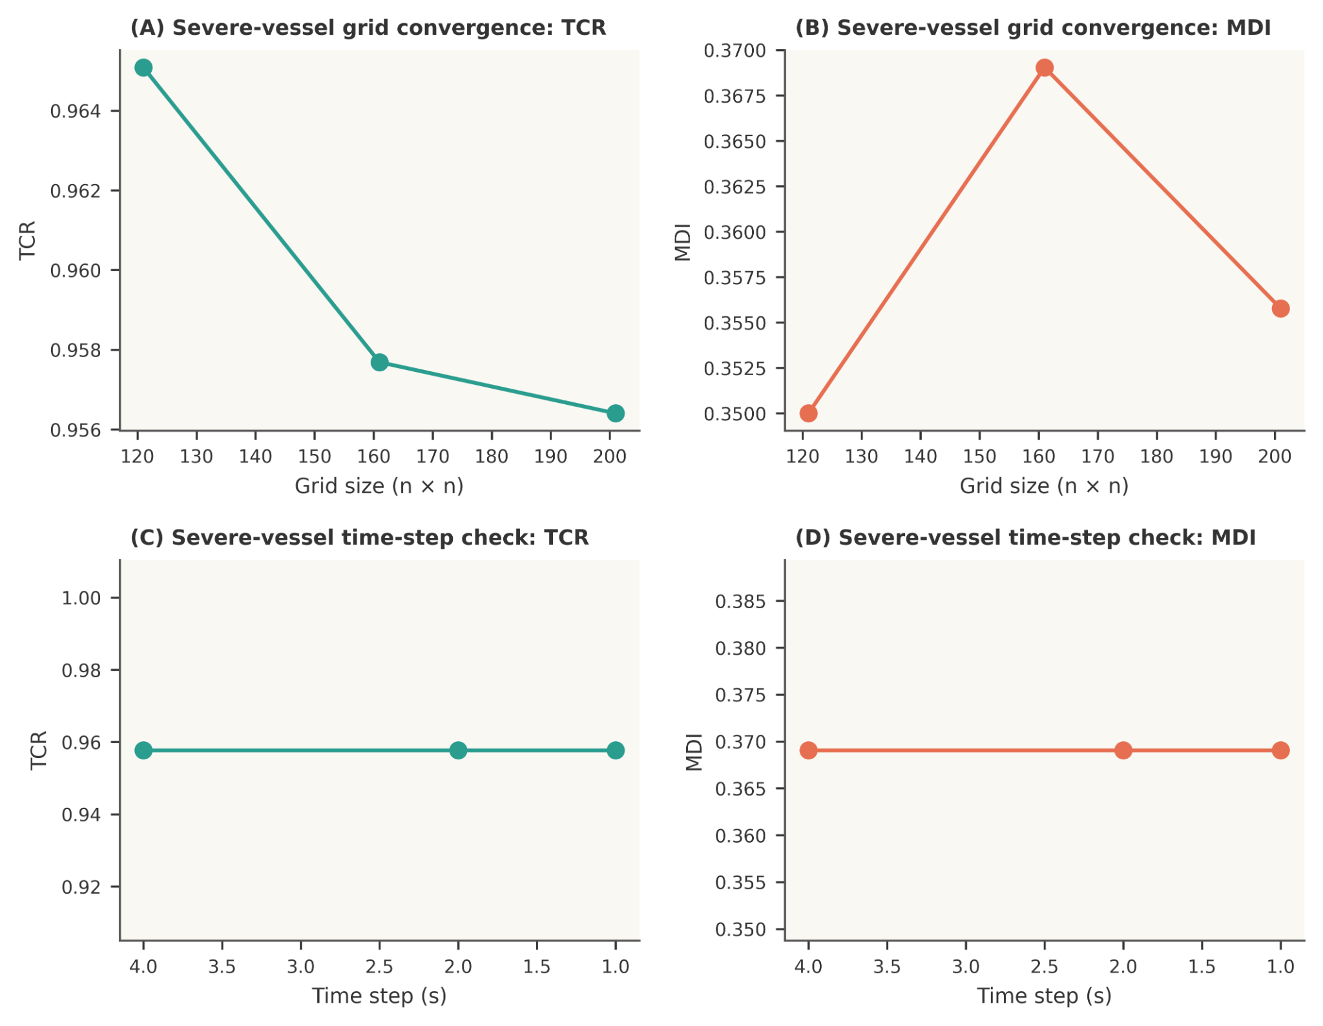
Figure S1. Numerical convergence of the reduced-order model. Grid-size and time-step sensitivity analyses are shown for a severe-vessel case. TCR and MDI remain stable across the tested time steps, while grid refinement produces only modest changes in the primary endpoints, supporting the use of the selected numerical settings in the main study.
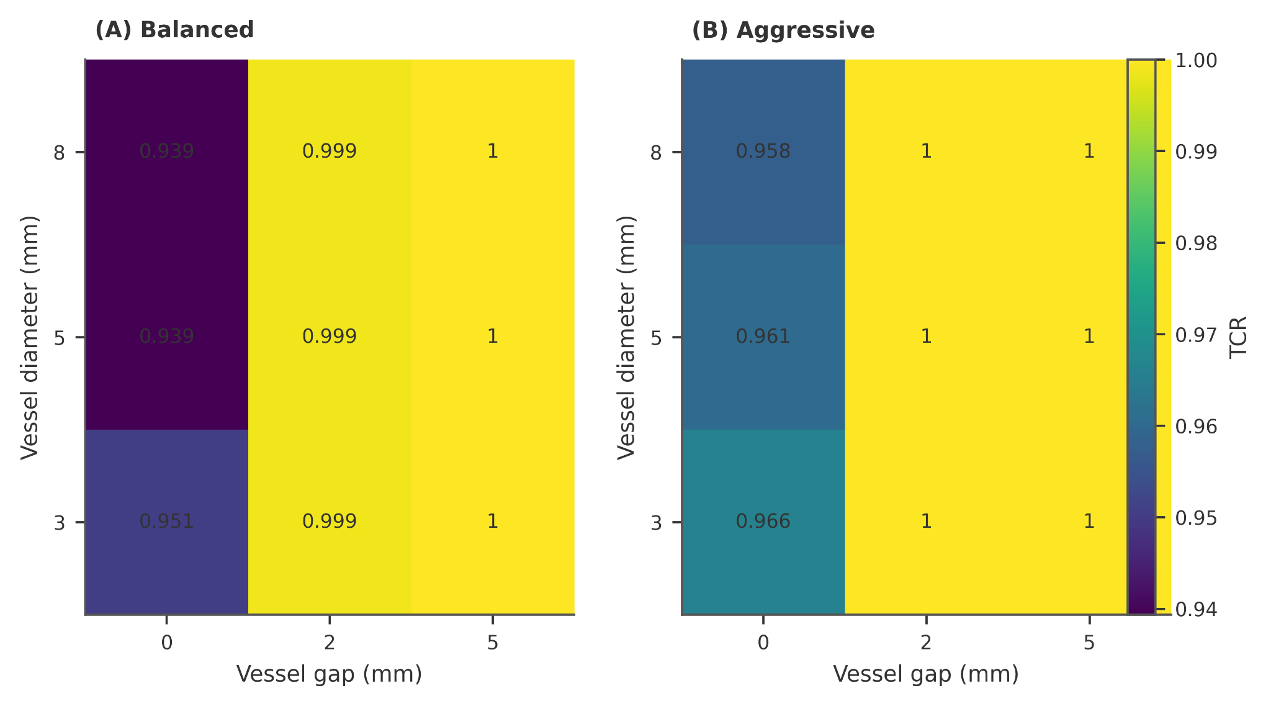
Figure S2. Protocol-dependent maps of tumor coverage ratio (TCR). TCR is shown across tumor-vessel gap and vessel diameter for the moderate-energy and high-energy protocols. Under the high-energy protocol, tumor coverage is complete for most tested conditions, whereas under the moderate-energy protocol incomplete coverage appears mainly in abutting cases.
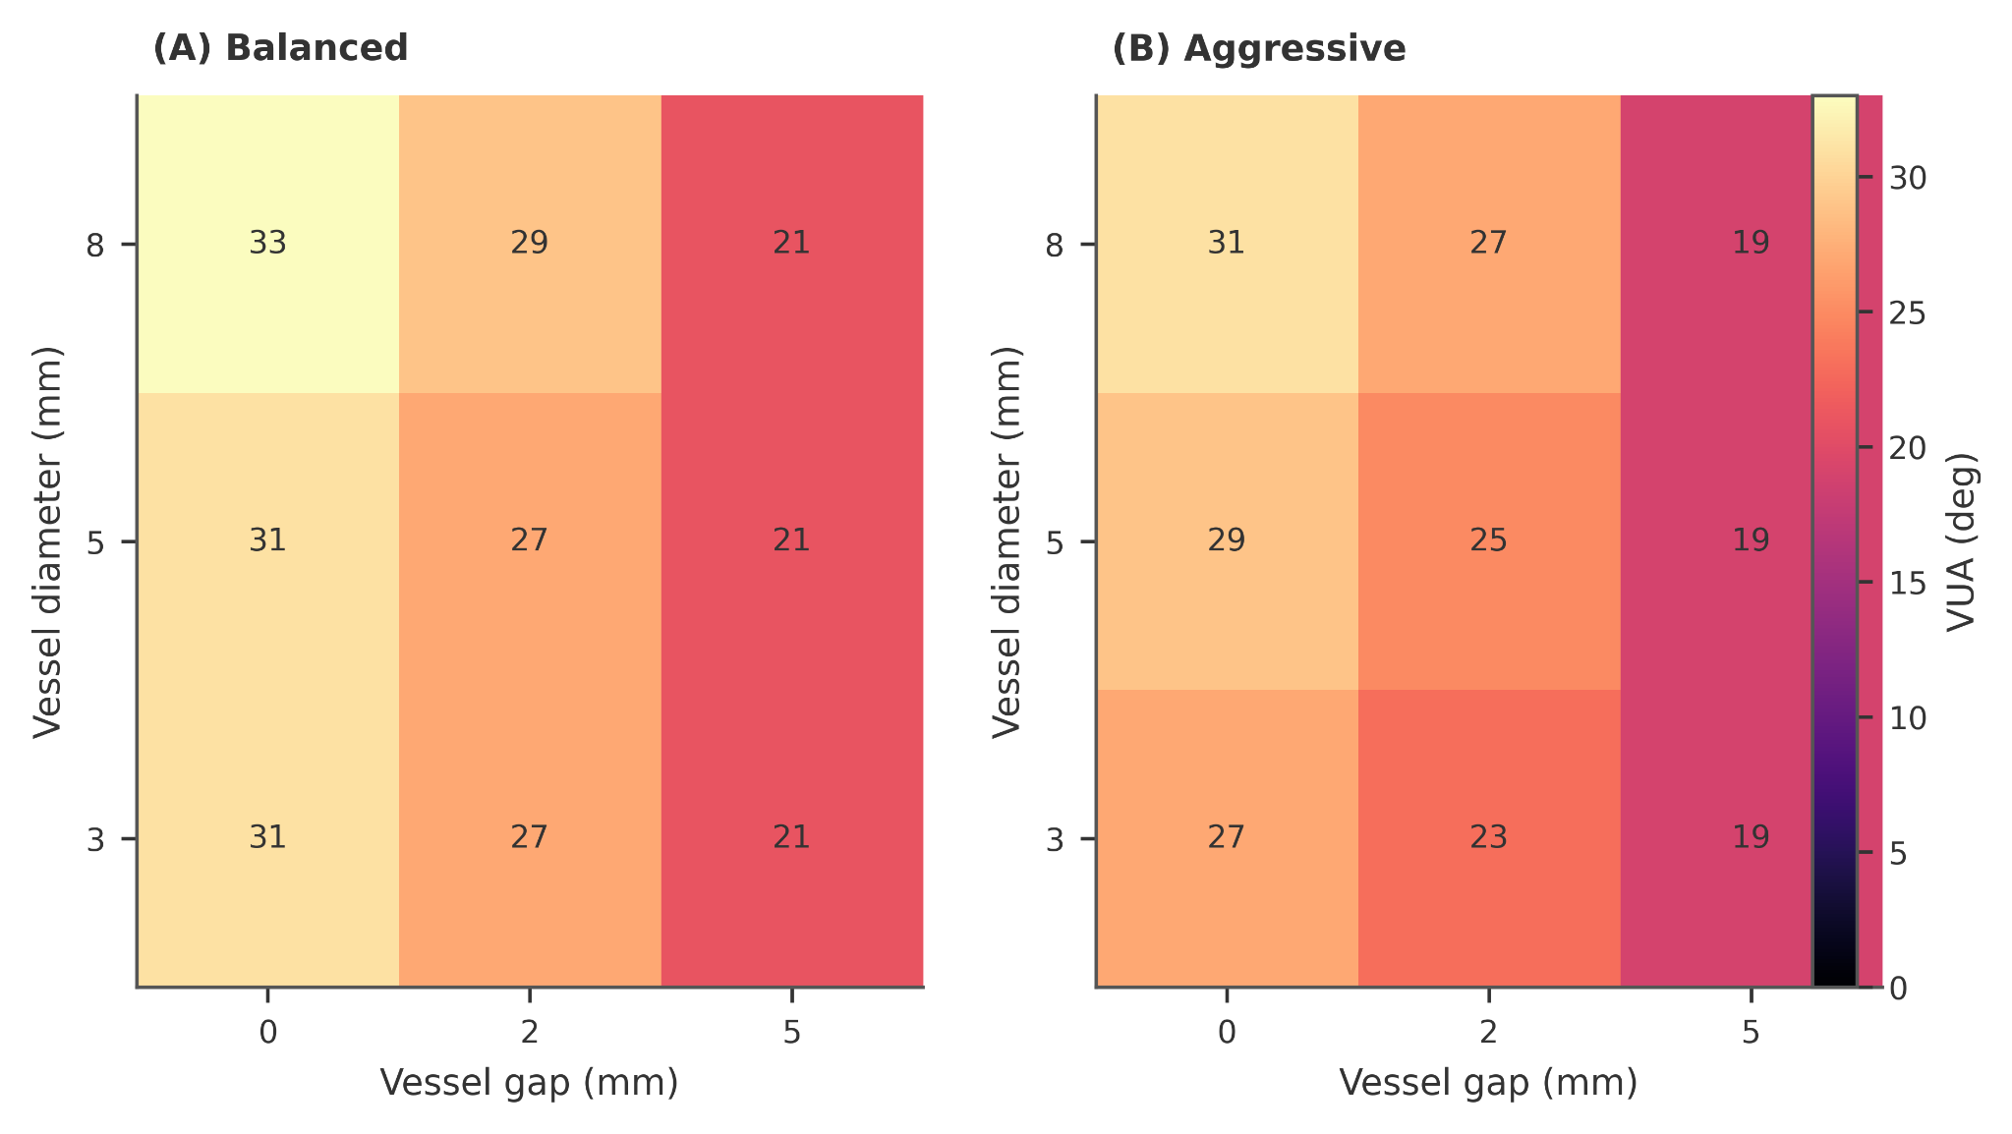
Figure S3. Protocol-dependent maps of vessel-side undercoverage angle (VUA). VUA is shown across tumor-vessel gap and vessel diameter for the moderate-energy and high-energy protocols. Larger VUA indicates broader vessel-facing underablation. VUA decreases as gap increases and is consistently lower under the high-energy protocol.
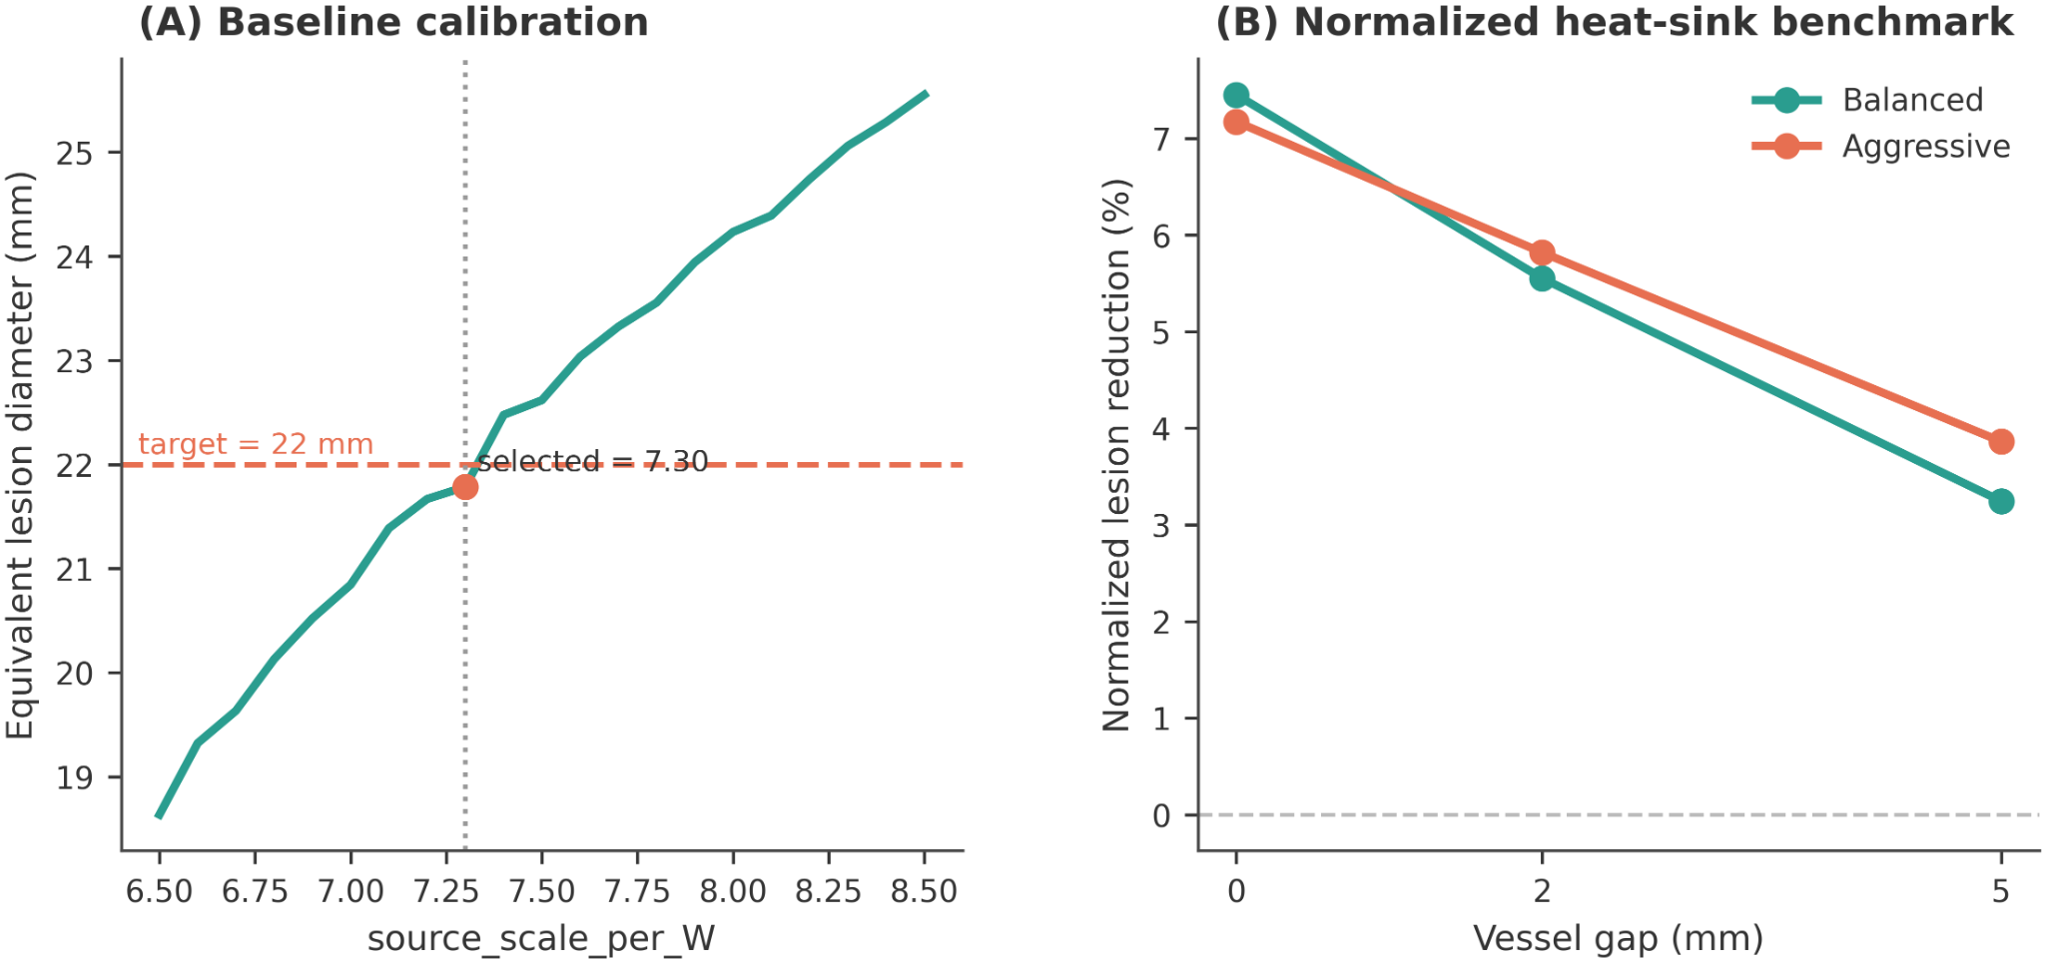
Figure S4. Model calibration and normalized heat-sink benchmark. (A) Baseline calibration was performed in the no-vessel configuration by matching the equivalent lesion diameter for a reference protocol to the target value of 22 mm, yielding the selected source scaling constant. (B) The internal benchmark reports normalized lesion reduction relative to the corresponding no-vessel baseline. In both protocols, normalized lesion reduction decreases monotonically with tumor-vessel gap, confirming the expected weakening of heat-sink effects with increasing separation.
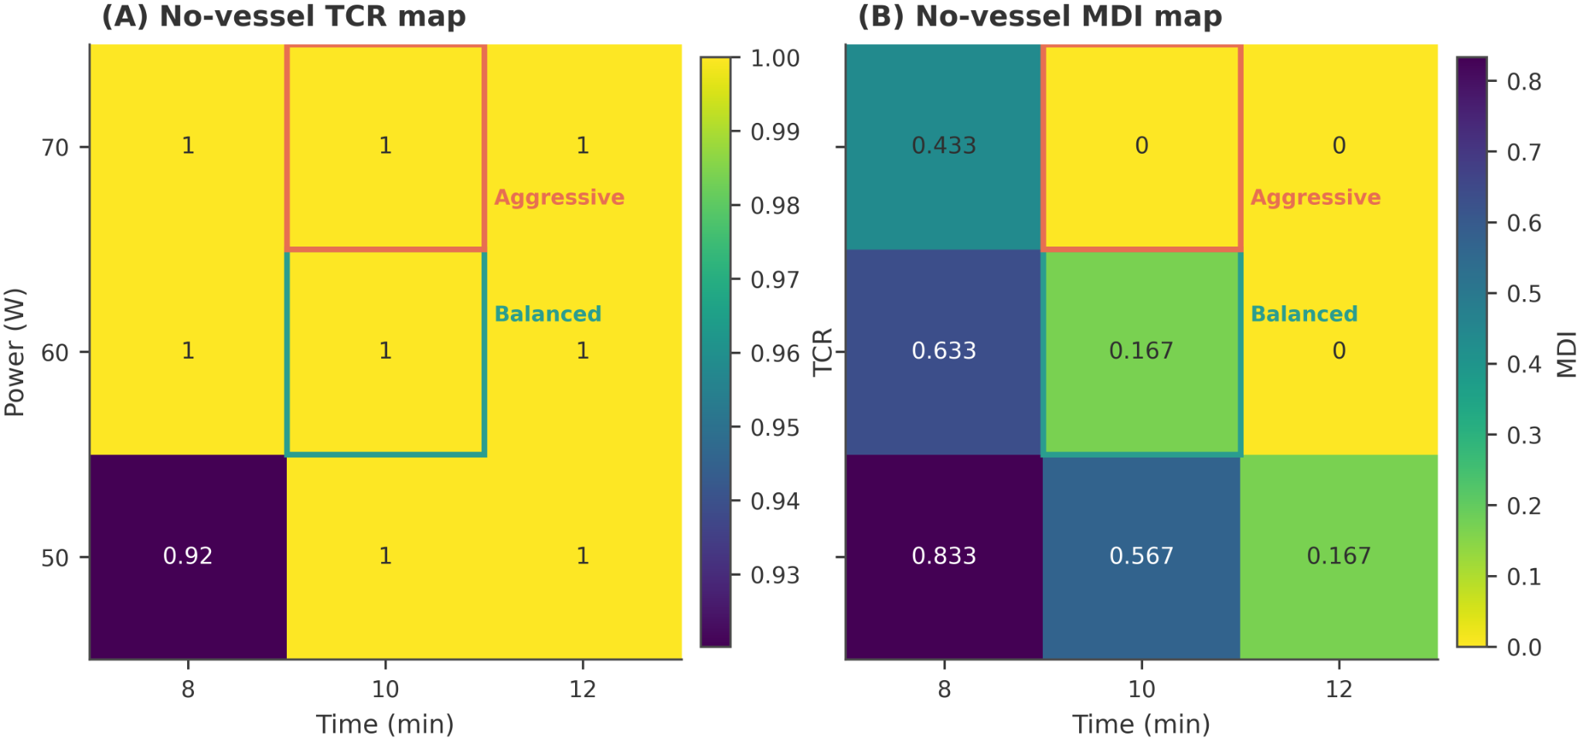
Figure S5. Protocol selection under the no-vessel baseline. No-vessel TCR and MDI maps across power and time were used to select representative protocol classes. The moderate-energy protocol was retained as a deliberately conservative comparator, whereas the high-energy protocol was chosen to further reduce margin deficit at the cost of lower target specificity in the main study.
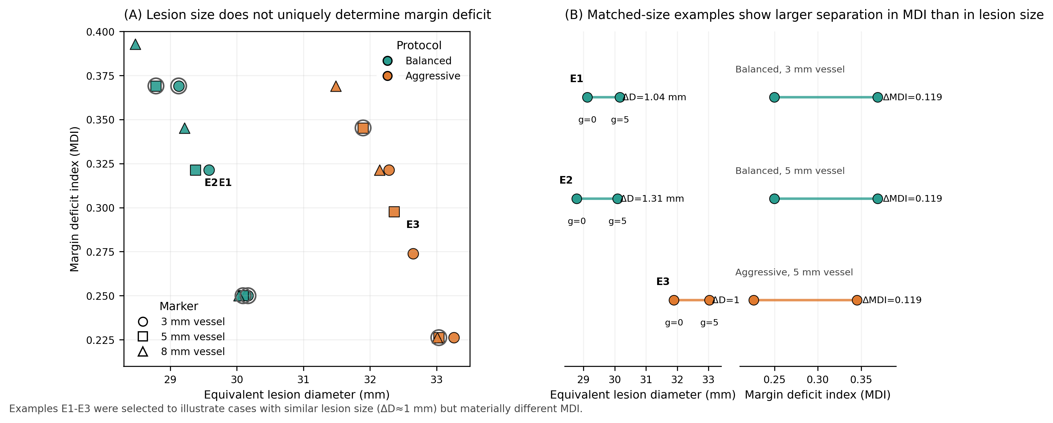
Figure S6. Lesion-size summary versus shape-based margin deficit. (A) Scatter plot of perivascular cases showing equivalent lesion diameter versus MDI. (B) Matched-size examples demonstrating that cases with similar lesion-size summaries may still exhibit noticeably different local margin deficit patterns, supporting the use of shape-based descriptors as complementary information rather than as a replacement for lesion-size summaries.
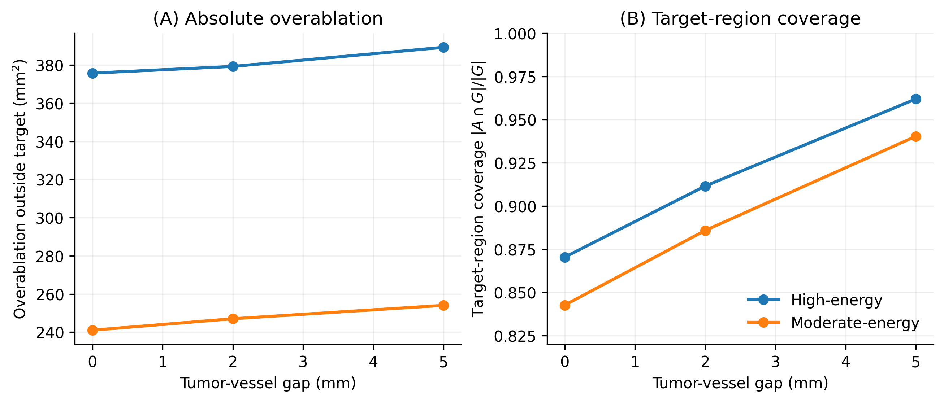
Figure S7. Absolute collateral damage and target-region coverage for a representative 5-mm vessel. (A) Absolute overablation area outside the 5-mm target region, expressed in mm². (B) Target-region coverage, defined as |A ∩ G| / |G|. Relative to the moderate-energy protocol, the high-energy protocol increased target-region coverage across the tested gaps but also produced a larger absolute overablation area outside the target region, providing a more direct interpretation of the planning trade-off than PPV_target alone.

