A low-complexity planning model for perivascular liver radiofrequency ablation: shape-based assessment of safety-margin deficit and protocol trade-offs
Keywords: liver radiofrequency ablation; perivascular tumor; heat-sink; treatment planning; margin deficit; computational modeling

Abstract
Background: Perivascular liver radiofrequency ablation (RFA) is vulnerable to heat-sink effects, which can lead to asymmetric underablation and loss of the intended safety margin. Existing planning studies often emphasize lesion size, whereas shape-based descriptors of margin failure remain less developed.
Methods: We developed a low-complexity 2D electro-thermal-damage model for perivascular liver RFA using a parameterized geometry composed of tumor, electrode, and a single nearby vessel. The model coupled an electro-quasistatic formulation, reduced bioheat transfer, and Arrhenius-type thermal damage. Treatment adequacy was quantified using tumor coverage ratio (TCR), margin deficit index (MDI), vessel-side undercoverage angle (VUA), and target specificity (PPV_target). The effects of tumor-vessel gap, vessel diameter, and protocol strength were evaluated under balanced and aggressive power-time settings. Numerical credibility was assessed by grid and time-step checks, and model calibration was performed against a no-vessel reference lesion diameter.
Results: Tumor-vessel gap was the primary determinant of margin failure within the tested range. Under both tested protocols, MDI decreased monotonically as the gap increased from 0 to 5 mm. Vessel diameter acted as a secondary modifier, with its effect being most apparent in abutting or very short-gap cases. Relative to the balanced protocol, the aggressive protocol consistently reduced MDI across tested conditions, but this improvement was accompanied by lower PPV_target, indicating a stronger overtreatment trade-off. Representative contour maps showed vessel-side notching and localized undercoverage in near-vessel cases. Grid and time-step checks supported the use of TCR and MDI for exploratory planning comparisons within the tested discretization range.
Conclusions: A reduced-complexity shape-based planning model can capture planning-relevant perivascular RFA failure patterns and provide information complementary to lesion-size summaries. The proposed framework offers an interpretable way to compare protocols, quantify margin loss, and support planning-oriented risk assessment in near-vessel liver ablation.

1. Introduction
Thermal ablation is an established treatment option for selected primary and metastatic liver tumors, especially in patients who are not candidates for surgical resection or require minimally invasive local therapy. Among thermal modalities, radiofrequency ablation (RFA) remains widely used because of its clinical availability, procedural familiarity, and relatively low technical burden. However, treatment success is not determined solely by whether a lesion is heated, but by whether the entire tumor and an adequate safety margin are reliably covered. [1,4]
A major challenge arises in perivascular tumors, where heat transfer to adjacent blood vessels can reduce local tissue heating and produce so-called heat-sink effects. In this setting, the resulting ablation zone may become asymmetric, with localized undercoverage on the vessel-facing side. Such near-vessel failure patterns are clinically important because incomplete local treatment and inadequate ablation margins are associated with increased risk of local tumor progression. [1,3,4]
Computational modeling provides a practical route for studying this problem in a reproducible and low-cost manner. Physics-based RFA models have been used to estimate temperature fields, tissue damage, and ablation extent under different applicator settings and tissue conditions, but recent reviews have emphasized persistent heterogeneity in validation strategies and a continuing need for shape-based outcome measures. [2]
This limitation motivates the use of shape-based planning endpoints. In a planning context, treatment adequacy should ideally describe not only whether the tumor is covered, but also where margin failure occurs and how much protocol escalation is required to compensate for heat-sink-related underablation. In particular, safety-margin insufficiency is often more clinically meaningful than overall lesion enlargement, because more aggressive protocols may improve coverage at the cost of increased injury to normal tissue.
In this study, we developed a low-complexity 2D planning model for perivascular liver RFA using a parameterized geometry containing tumor, electrode, and a single nearby vessel. Rather than pursuing full patient-specific realism, we focused on a reduced-complexity framework suitable for protocol comparison and planning-oriented sensitivity analysis. We quantified treatment adequacy using four interpretable endpoints: tumor coverage ratio (TCR), margin deficit index (MDI), vessel-side undercoverage angle (VUA), and target specificity (PPV_target).
The objectives of this work were threefold. First, we aimed to characterize how tumor-vessel gap and vessel diameter shape local underablation patterns in perivascular RFA. Second, we sought to compare a balanced and an aggressive protocol in terms of margin recovery and target specificity. Third, we aimed to establish a numerically credible and reproducible workflow, including calibration, convergence analysis, and shape-based figure generation, that can serve as a planning-oriented computational template for near-vessel liver ablation studies.

2. Methods

2.1 Study design
This work was designed as a simulation-led methodological study of perivascular liver RFA. The aim was not to build a full patient-specific prediction system, but to establish an interpretable reduced-complexity planning framework for exploring how vessel proximity and protocol strength influence tumor coverage and safety-margin failure. All final manuscript figures were generated from a frozen simulation state to improve traceability and reproducibility.

2.2 Governing equations
A reduced-order 2D electro-thermal-damage model was used to simulate perivascular liver RFA. The electric subproblem was modeled using an electro-quasistatic conduction equation,
∇ · (σ(x) ∇φ) = 0
where φ is the electric potential and σ(x) is tissue-dependent electrical conductivity. In the present implementation, the electrode was prescribed as a unit-potential boundary and the outer domain boundary was set to zero potential. The resulting normalized field was used to construct a spatial Joule-heating template,
q_unit(x) = σ(x) |∇φ(x)|²
The reduced-order radiofrequency heating term was defined as
Q_RF(x) = q_unit(x) · P_nom · s_src
where P_nom is the nominal protocol power and s_src is an effective source-scaling coefficient determined by calibration. In this formulation, s_src is a dimensionless calibration coefficient that maps the normalized electrical heating template to the target lesion size in the simplified 2D model rather than a directly measurable tissue property.
Transient temperature evolution was modeled with a reduced bioheat equation,
ρ c ∂T/∂t = ∇ · (k ∇T) + Q_RF - Q_perf
with
Q_perf = ω_eff (T - T_b)
where T is tissue temperature, T_b is the blood/reference temperature, ρ is density, c is specific heat, k is thermal conductivity, and ω_eff is an effective volumetric sink coefficient. Vessel pixels were excluded from this sink and treated as fixed-temperature cooling structures.
Thermal injury accumulation was modeled using an Arrhenius formulation,
Ω(x,t) = ∫₀ᵗ A exp(-E_a / (R T_K(x,τ))) dτ
where A is the frequency factor, E_a is activation energy, R is the universal gas constant, and T_K = T + 273.15 is absolute temperature. A pixel was classified as lethally damaged when Ω ≥ 1.0, and the resulting lethal-zone mask was used to define the predicted lesion.

2.3 Geometry and boundary conditions
The computational domain was a 2D Cartesian rectangle of size 80 × 80 mm. A circular tumor was centered at (0, 0) mm with radii (7.5, 7.5) mm, corresponding to a 15-mm tumor diameter. A centrally placed rectangular electrode traversed the tumor and was modeled with width 1.0 mm and length 20.0 mm.
A single nearby vessel was represented as a circular cooling structure centered on the positive x-axis. Vessel position was determined by the tumor radius, vessel radius, and prescribed tumor-vessel gap. Tested vessel diameters were 3, 5, and 8 mm, corresponding to radii of 1.5, 2.5, and 4.0 mm. Tested tumor-vessel gaps were 0, 2, and 5 mm. A no-vessel baseline was created by disabling the vessel mask entirely.
For the electric subproblem, the electrode was assigned φ = 1 and the outer domain boundary φ = 0. For the thermal subproblem, the vessel region and outer domain boundary were prescribed as fixed-temperature boundaries at 37 °C. The initial temperature field was also set to 37 °C. These settings reflect a reduced-order truncation of the thermal problem rather than an attempt to recover physiologically exact whole-organ boundary behavior.
A 5-mm target margin was defined around the tumor and used as the planning target in all shape-based endpoint calculations. This choice follows the frequent use of a 5-mm minimal ablative margin as a clinically meaningful target in liver ablation studies. [4,6]

2.4 Shape-based endpoints
Let T denote the tumor region, A the predicted lethal zone, and G the target region obtained by dilating the tumor by 5 mm.
Tumor coverage ratio (TCR) was defined as
TCR = |A ∩ T| / |T|
Target specificity (PPV_target) was defined as
PPV_target = |A ∩ G| / |A|
Margin deficit index (MDI) was defined from the local achieved margin m(x), computed from the Euclidean distance to the lesion boundary for tumor-boundary points x ∈ ∂T. MDI was then evaluated as
MDI = (1 / |∂T|) Σ_{x∈∂T} 1[m(x) < m₀], m₀ = 5 mm
Thus, in the present implementation, MDI is a boundary-point fraction rather than an area fraction.
Vessel-side undercoverage angle (VUA) quantified the angular extent of underablation on the vessel-facing side. Tumor-boundary points with a nonnegative projection toward the vessel center were treated as vessel-facing; undercovered vessel-facing angular bins were accumulated and converted to degrees using 360 equally spaced angular bins. Because VUA depends more strongly on discretization and angular binning, it was treated as a supplementary rather than a primary endpoint.
Equivalent lesion diameter was computed from lesion area A_lesion as
D_eq = √(4 A_lesion / π)
This quantity was used for baseline calibration and internal benchmark comparisons.

2.5 Geometry, parameter, and solver settings
Table 1. Geometry and numerical design.
Quantity | Symbol / setting | Value used in final study
Domain size | Lx × Ly | 80 × 80 mm
Final main grid | nx × ny | 161 × 161
Grid checks | - | 121 × 121, 161 × 161, 201 × 201
Tumor center | (xt, yt) | (0, 0) mm
Tumor radii | (rx, ry) | (7.5, 7.5) mm
Tumor diameter | - | 15 mm
Electrode width | - | 1.0 mm
Electrode length | - | 20.0 mm
Vessel diameters | - | 3, 5, 8 mm
Tested vessel gaps | g | 0, 2, 5 mm
Safety margin | m0 | 5 mm
Angular bins for VUA | Nbins | 360
Final time step | Δt | 2 s
Time-step checks | - | 4, 2, 1 s
Table 2. Material and damage parameters.
Parameter | Symbol | Value
Liver electrical conductivity | σ_liver | 0.20 S/m
Tumor electrical conductivity | σ_tumor | 0.25 S/m
Vessel electrical conductivity | σ_vessel | 0.70 S/m
Liver thermal conductivity | k_liver | 0.50 W/m/K
Tumor thermal conductivity | k_tumor | 0.50 W/m/K
Tissue density | ρ | 1060 kg/m³
Tissue specific heat | c | 3600 J/kg/K
Liver perfusion sink coefficient | ω_liver,eff | 10000 W/m³/K
Tumor perfusion sink coefficient | ω_tumor,eff | 5000 W/m³/K
Initial temperature | T0 | 37 °C
Blood/fixed boundary temperature | Tb | 37 °C
Arrhenius frequency factor | A | 7.39 × 10^39 s^-1
Arrhenius activation energy | Ea | 2.577 × 10^5 J/mol
Damage threshold | Ω_th | 1.0
Final source-scaling coefficient | s_src | approximately 7.3*
The term low-complexity is used here to indicate reduced geometric and numerical complexity relative to high-fidelity patient-specific simulators. It does not imply that the framework has been formally benchmarked as a runtime-optimized clinical software system.

2.6 Protocol design, calibration, and benchmark
Baseline calibration was performed in a no-vessel reference configuration under a nominal protocol of 50 W for 8 min. The effective source-scaling coefficient s_src was selected such that the equivalent lesion diameter matched a target reference diameter of 22 mm. This calibration is reported in Fig. S4(A). The present study therefore used a single-point, no-vessel calibration and should be interpreted as a planning-oriented proof-of-concept rather than as a fully externally validated predictive model. [2]
Two representative protocols were selected from a no-vessel baseline sweep: a balanced protocol (60 W for 10 min) and an aggressive protocol (70 W for 10 min). The balanced protocol was chosen to represent full or near-full coverage with higher target specificity, whereas the aggressive protocol was chosen to reduce margin deficit more strongly at the expense of greater overtreatment. Because the explored protocol space was intentionally sparse, all claims regarding protocol dependence should be interpreted within the tested range rather than as a global optimization statement.
An internal benchmark analysis was performed by comparing each perivascular lesion size to the corresponding no-vessel baseline for the same protocol. The benchmark endpoint was the normalized lesion reduction (NLR), used to verify that heat-sink severity decreased monotonically with tumor-vessel gap. This benchmark was used to demonstrate literature-consistent trend behavior, not to replace external experimental validation. [2,3]

2.7 Numerical implementation and reproducibility
The model was implemented in Python on a regular Cartesian grid. The electric subproblem was assembled as a sparse linear system and solved using a direct sparse solver. The thermal update used an implicit time-marching formulation with sparse factorization reused across time steps. Interface coefficients in the diffusion operator were constructed from local arithmetic averages of thermal conductivity across neighboring cells.
Final manuscript figures were generated from a frozen simulation state using the 161 × 161 grid and a 2-s time step. Convergence checks were performed on a severe-vessel case using additional grid sizes of 121 × 121 and 201 × 201 and time steps of 4, 2, and 1 s. Based on these tests, TCR and MDI were retained as the primary planning endpoints, whereas VUA was treated as supplementary because of greater discretization sensitivity.
The public repository contains the frozen simulation state, final figure-generation workflow, manuscript tables, configuration snapshots, and environment freeze files. Figure provenance is documented in a manifest file to improve reproducibility and traceability.

3. Results

3.1 Protocol selection and calibration
A no-vessel baseline sweep was first used to identify two representative protocol classes for the final study. The balanced protocol was selected to represent complete or near-complete tumor coverage with more favorable target specificity, whereas the aggressive protocol was selected to represent stronger margin recovery with a clearer overtreatment trade-off.

3.2 Representative perivascular lesion shapes
Representative contour plots showed that the no-vessel baseline produced a nearly symmetric lesion around the tumor. In contrast, perivascular cases introduced a vessel-side notch, resulting in localized loss of the desired target margin on the vessel-facing side. Increasing the tumor-vessel gap reduced this asymmetry, while protocol escalation partially restored margin coverage. [1,3]
Notably, cases with broadly comparable equivalent lesion diameters could still differ in local margin loss and vessel-facing notch severity, supporting the use of shape-based endpoints as complements to lesion-size summaries. The supplementary shape-versus-size comparison (Fig. S6) highlights this divergence directly.

3.3 Protocol-dependent effects of gap and vessel diameter
Across the tested settings, tumor-vessel gap was the primary determinant of margin failure within the tested range of geometric conditions. Under both protocols, MDI decreased monotonically as the gap increased from 0 to 5 mm, whereas vessel diameter acted mainly as a secondary modifier that was most apparent in abutting or very short-gap cases. This trend is consistent with the established understanding that perivascular heat-sink effects weaken with increasing separation from major vessels. [1,3]

3.4 Planning trade-off
For the representative 5-mm vessel, the aggressive protocol consistently reduced margin deficit relative to the balanced protocol, but this gain was accompanied by lower target specificity. Specifically, MDI improved from 0.369 to 0.345 at gap = 0 mm and from 0.250 to 0.226 at gap = 5 mm, whereas PPV_target decreased from 0.630 to 0.530 and from 0.643 to 0.546, respectively. These results indicate that protocol escalation can partially compensate for vessel-side undercoverage, but at the cost of greater overtreatment.

3.5 Numerical credibility and benchmark
Grid and time-step checks showed that TCR and MDI were numerically stable enough to support exploratory planning comparisons within the tested discretization range. Time-step variation had minimal influence on the primary endpoints, whereas grid refinement produced modest but non-negligible variation in MDI for the severe-vessel case. Accordingly, MDI is interpreted here as a comparative ranking and trend descriptor rather than as a high-precision absolute quantity.
Table 3. Primary endpoint summary for a representative 5-mm vessel.
Protocol | Gap (mm) | Vessel diameter (mm) | TCR | MDI | PPV_target
Balanced | 0 | 5 | 0.939 | 0.369 | 0.630
Balanced | 2 | 5 | 0.999 | 0.321 | 0.636
Balanced | 5 | 5 | 1.000 | 0.250 | 0.643
Aggressive | 0 | 5 | 0.961 | 0.345 | 0.530
Aggressive | 2 | 5 | 1.000 | 0.298 | 0.539
Aggressive | 5 | 5 | 1.000 | 0.226 | 0.546
Table 4. Numerical credibility summary for the severe-vessel case.
Grid n | TCR (severe vessel) | MDI (severe vessel)
121 | 0.965 | 0.350
161 | 0.958 | 0.369
201 | 0.956 | 0.356
Time-step variation for the same severe-vessel case is summarized below.
Time step (s) | TCR (severe vessel) | MDI (severe vessel)
4.0 | 0.958 | 0.369
2.0 | 0.958 | 0.369
1.0 | 0.958 | 0.369

Figures
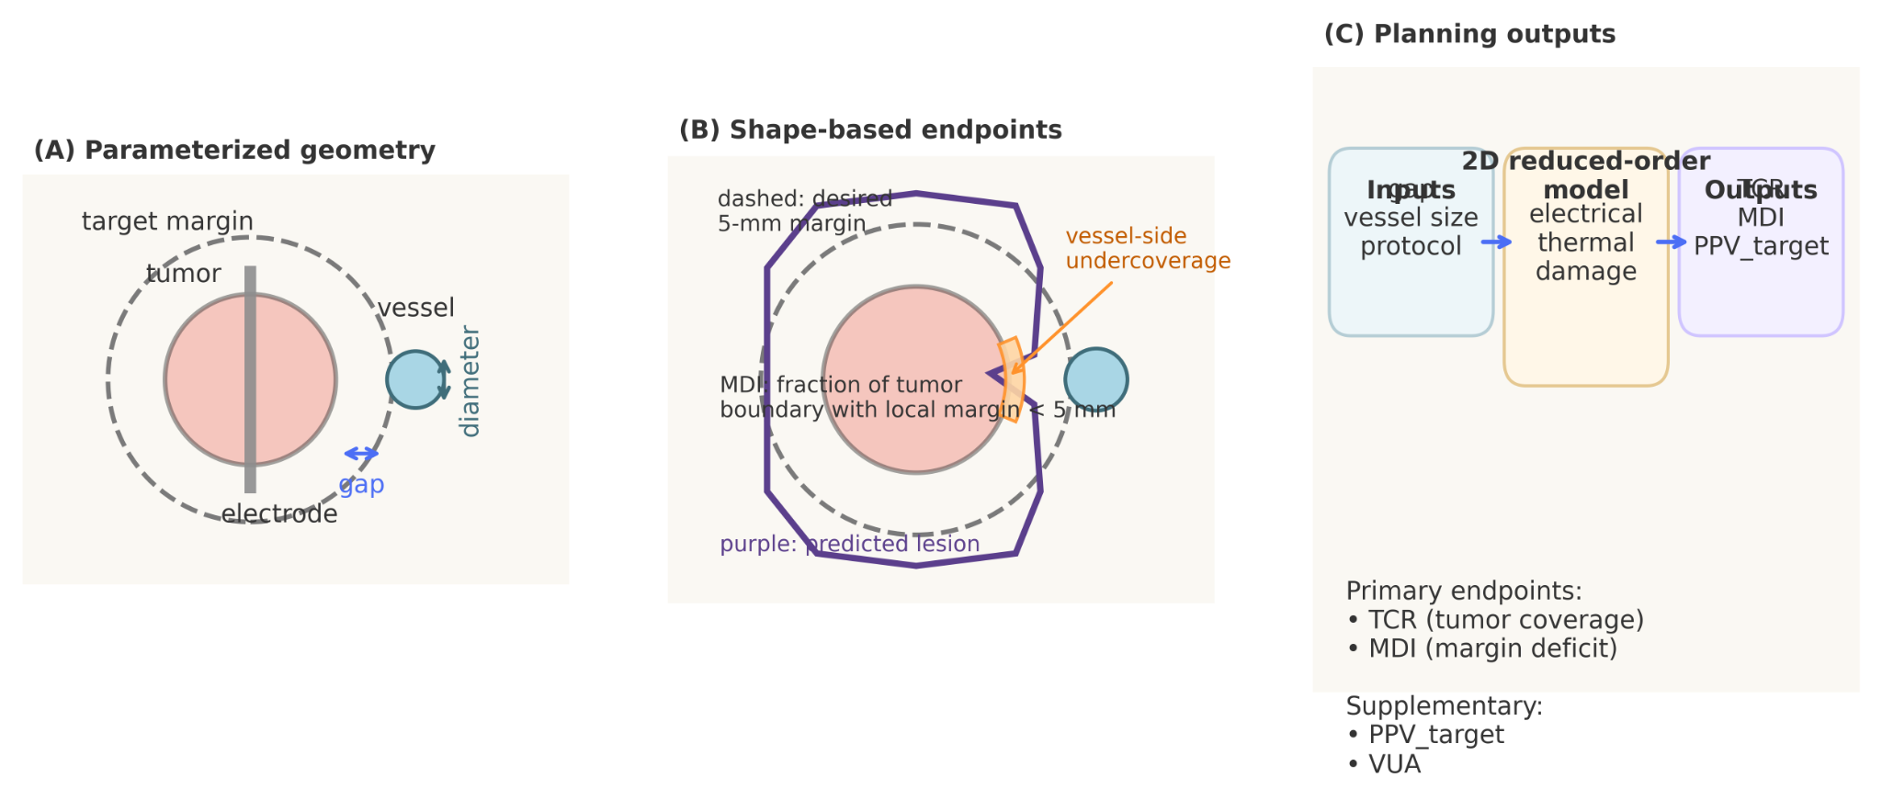
Figure 1. Parameterized geometry, shape-based endpoints, and planning workflow. (A) The 2D parameterized geometry consists of tumor, electrode, and a single nearby vessel. The tumor-vessel gap and vessel diameter are treated as key geometric inputs, and a 5-mm target margin is defined around the tumor. (B) Shape-based endpoints are illustrated schematically. TCR quantifies lethal-zone coverage of the tumor, MDI quantifies the fraction of tumor boundary with local margin smaller than 5 mm, and VUA describes the angular extent of vessel-facing underablation. (C) The planning workflow maps geometric inputs and protocol settings to the reduced-order electro-thermal-damage solver and shape-based outputs.
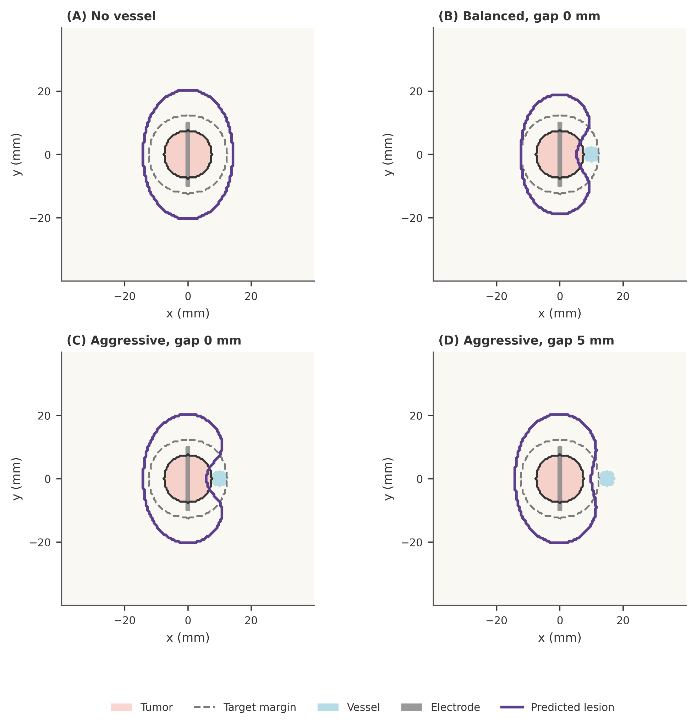
Figure 2. Representative lesion contours under no-vessel and perivascular conditions. Predicted lethal-zone contours are shown for a no-vessel baseline and for representative perivascular cases under balanced and aggressive protocols. The tumor contour, desired 5-mm target margin, vessel location, and electrode are overlaid for reference. Near-vessel cases show a characteristic vessel-side notch, indicating localized undercoverage caused by heat-sink, whereas increasing gap reduces this asymmetry.
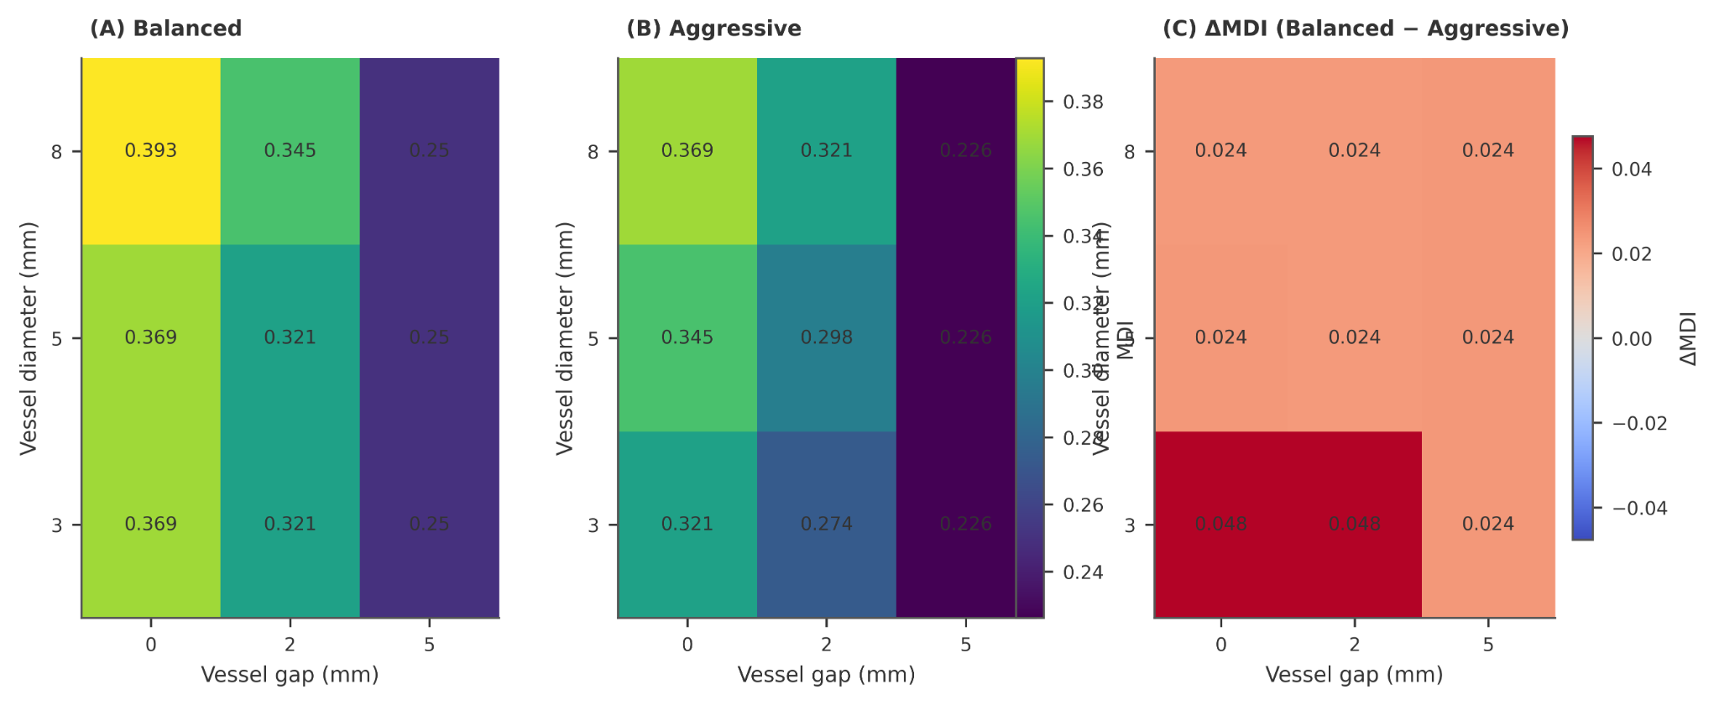
Figure 3. Protocol-dependent maps of margin deficit index (MDI). MDI is shown across tumor-vessel gap and vessel diameter for the balanced and aggressive protocols. Panel (C) reports the MDI reduction achieved by the aggressive protocol relative to the balanced protocol. Smaller gap consistently increases margin deficit, whereas larger vessel diameter further worsens deficit mainly in abutting or very short-gap cases. The aggressive protocol reduces MDI across the tested settings.
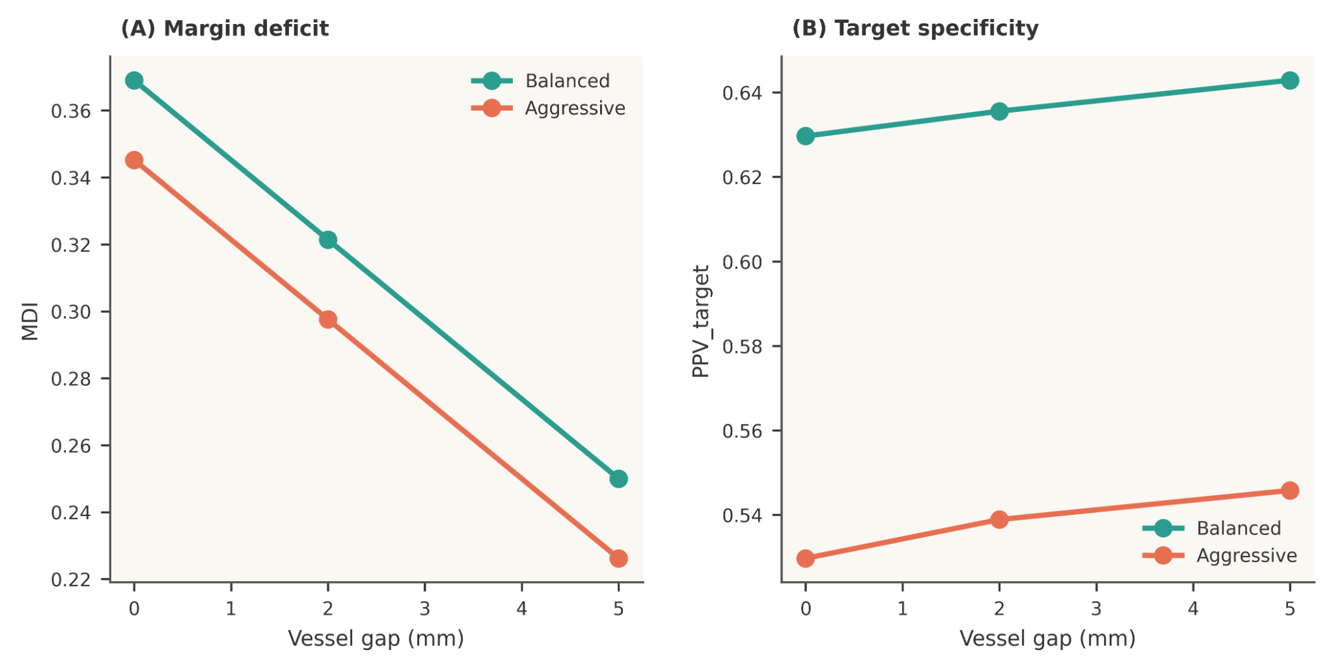
Figure 4. Planning trade-off between margin deficit and target specificity. For a representative 5-mm vessel, increasing tumor-vessel gap reduces MDI under both protocols. The aggressive protocol consistently achieves lower MDI than the balanced protocol, but this improvement is accompanied by lower PPV_target, indicating a stronger overtreatment trade-off.

4. Discussion
Perivascular liver RFA is fundamentally a planning problem under asymmetric cooling, rather than a purely geometric problem of lesion size. In the present study, a low-complexity 2D electro-thermal-damage model reproduced the central qualitative behavior expected in this setting: a nearby vessel produced vessel-facing underablation, the severity of margin failure decreased as tumor-vessel gap increased, and protocol escalation partially compensated for this effect. These findings are consistent with the broader clinical and computational literature on perivascular liver ablation and heat-sink effects. [1-3]
A central result of this work is that tumor-vessel gap emerged as the primary determinant of margin deficit within the tested range, whereas vessel diameter acted mainly as a secondary modifier, with the strongest effect in abutting or very short-gap cases. This pattern is plausible in light of prior computational and clinical observations that identify shortest vascular distance as a major driver of local underablation and local tumor progression. [1,3,4]
Another important contribution of this study is the explicit use of shape-based planning endpoints. Many ablation modeling studies still summarize treatment outcome using lesion diameter, lesion area, or overlap alone, but these quantities may fail to capture the vessel-side notch that is often the clinically meaningful manifestation of perivascular heat-sink. The present results show that a protocol can appear adequate in terms of lesion size while still exhibiting substantial local safety-margin loss. This emphasis on shape-based evaluation is consistent with the needs identified in recent computational liver ablation reviews. [2]
The comparison between balanced and aggressive protocols highlights why a planning framework should not optimize coverage alone. In this study, the aggressive protocol consistently reduced MDI relative to the balanced protocol, but this gain occurred together with lower PPV_target, indicating a stronger overtreatment trade-off. Fang et al. similarly showed that protocol tuning in perivascular liver RFA can improve tumor ablation while controlling thermal damage to adjacent vessels, reinforcing the interpretation of perivascular ablation as a constrained planning problem rather than a simple energy-escalation problem. [5]
A strength of the present work is that it deliberately targets the middle ground between oversimplified toy models and highly detailed patient-specific simulators. The value of the current model is not that it captures every physiological detail, but that it provides an interpretable and computationally light platform for comparing protocols, visualizing lesion asymmetry, and quantifying margin loss in a reproducible way. This reduced-complexity positioning is aligned with the current state of the field, in which modeling and validation strategies remain highly heterogeneous. [2]
The numerical analysis also informs how the results should be interpreted. Within the tested discretization range, TCR and MDI were stable enough to support exploratory planning comparisons and ranking of protocol-related effects. However, because grid-induced variation in MDI was not negligible relative to some protocol-level differences, MDI should not be interpreted here as a high-precision absolute quantity. By contrast, VUA was more grid-sensitive and was consequently retained as a supplementary descriptor rather than as a principal inferential quantity. This endpoint stratification is preferable to presenting all metrics as equally reliable.
Several limitations should be acknowledged. First, the model is two-dimensional and therefore cannot fully represent three-dimensional directional effects, including differences between vessels oriented parallel versus orthogonal to the applicator. Second, the vessel representation was intentionally simplified and did not include patient-specific hemodynamics or detailed vascular branching. Third, no direct experimental or clinical image-based validation was performed, and the benchmark strategy was therefore limited to baseline calibration and literature-consistent trend analysis. Fourth, only two representative protocols were examined in the final comparative study, so the present results should be interpreted as a planning-oriented comparison rather than as a comprehensive optimization study. [2,3,5]
These limitations also point to logical future directions, including extension to minimal 3D geometries, replacement of circular tumor geometry by a small library of image-derived tumor contours, and incorporation of external image- or experiment-based benchmarks. Another natural extension would be protocol optimization beyond the two representative settings used here, potentially through lightweight surrogate or response-surface methods. [2,5,6]
Taken together, the present study supports a simple but practically useful interpretation: in perivascular liver RFA, the most important question is not simply whether the lesion is large enough, but whether the safety margin is lost locally on the vessel-facing side and whether protocol escalation restores that margin at an acceptable cost in target specificity.

5. Conclusion
A low-complexity 2D electro-thermal-damage model was developed to study perivascular liver RFA using shape-based planning endpoints. Across the tested settings, tumor-vessel gap was the primary determinant of margin deficit within the tested range, while vessel diameter acted as a secondary modifier that mainly affected abutting or very short-gap cases. Protocol escalation reduced margin deficit but also decreased target specificity, revealing a clear planning trade-off. These results indicate that shape-based metrics provide information complementary to lesion-size summaries in near-vessel ablation. The proposed framework offers a reproducible and computationally light platform for protocol comparison and risk-oriented planning analysis in perivascular liver RFA. [1-5]

Funding
This research did not receive any specific grant from funding agencies in the public, commercial, or not-for-profit sectors.

Declaration of competing interests
The author declares no known competing financial interests or personal relationships that could have appeared to influence the work reported in this paper.

Code and data availability
The code, frozen simulation state, final figure-generation workflow, and manuscript tables are archived and can be provided to the editor upon request. To preserve reviewer blinding during peer review, the public repository link is not included in the manuscript version used for review. Final manuscript figures were generated from a frozen numerical state to improve reproducibility, figure provenance is documented in a figure-manifest file, and configuration snapshots together with environment freeze files are available in the archived project materials.
Repository link withheld for blinded review; archived materials available to the editor upon request.

References
- [1] Kang TW, Lim HK, Cha DI. Percutaneous ablation for perivascular hepatocellular carcinoma: refining the current status based on emerging evidence and future perspectives. World J Gastroenterol. 2018;24(47):5331-5343. doi:10.3748/wjg.v24.i47.5331.
- [2] van Erp GCM, Hendriks P, Broersen A, Verhagen CAM, Gholamiankhah F, Dijkstra J, Burgmans MC. Computational Modeling of Thermal Ablation Zones in the Liver: A Systematic Review. Cancers (Basel). 2023;15(23):5684. doi:10.3390/cancers15235684.
- [3] Huang HW. Influence of blood vessel on the thermal lesion formation during radiofrequency ablation for liver tumors. Med Phys. 2013;40(7):073303. doi:10.1118/1.4811135.
- [4] Verdonschot KHM, Arts S, van den Boezem PB, et al. Ablative margins in percutaneous thermal ablation of hepatic tumors: a systematic review. Expert Rev Anticancer Ther. 2023;23(9):977-993. doi:10.1080/14737140.2023.2247564.
- [5] Fang Z, Wei H, Zhang H, Moser MAJM, Zhang W, Qian Z, Zhang B. Radiofrequency ablation for liver tumors abutting complex blood vessel structures: treatment protocol optimization using response surface method and computer modeling. Int J Hyperthermia. 2022;39(1):733-742. doi:10.1080/02656736.2022.2075567.
- [6] Hoffer EK, Drinane MC, Bhatnagar V, Mehta R, Munger DP, Borsic A. Radiofrequency ablation of hepatocellular carcinoma guided by real-time physics-based ablation simulation: a prospective study. Int J Hyperthermia. 2024;41(1):2331704. doi:10.1080/02656736.2024.2331704.

Appendix: Supplementary figures
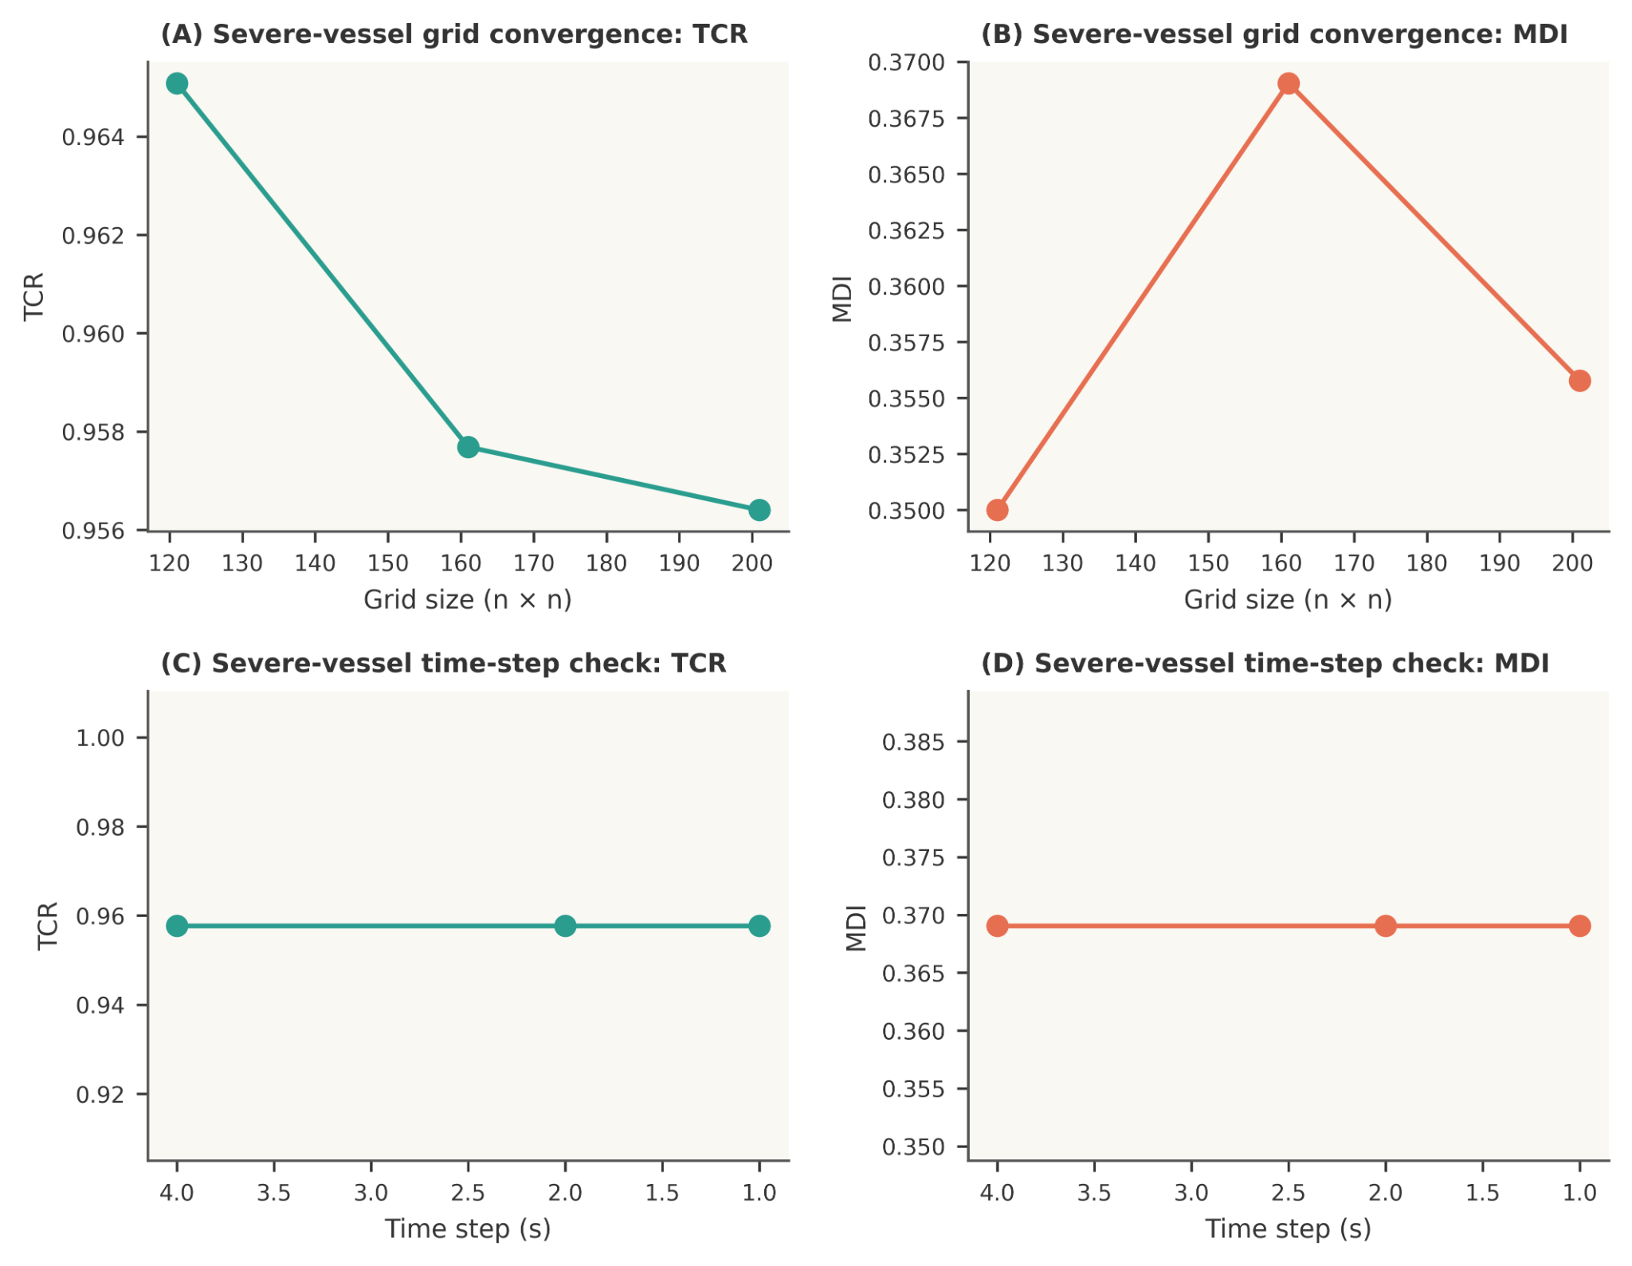
Figure S1. Numerical convergence of the reduced-order model. Grid-size and time-step sensitivity analyses are shown for a severe-vessel case. TCR and MDI remain stable across the tested time steps, while grid refinement produces only modest changes in the primary endpoints, supporting the use of the selected numerical settings in the main study.
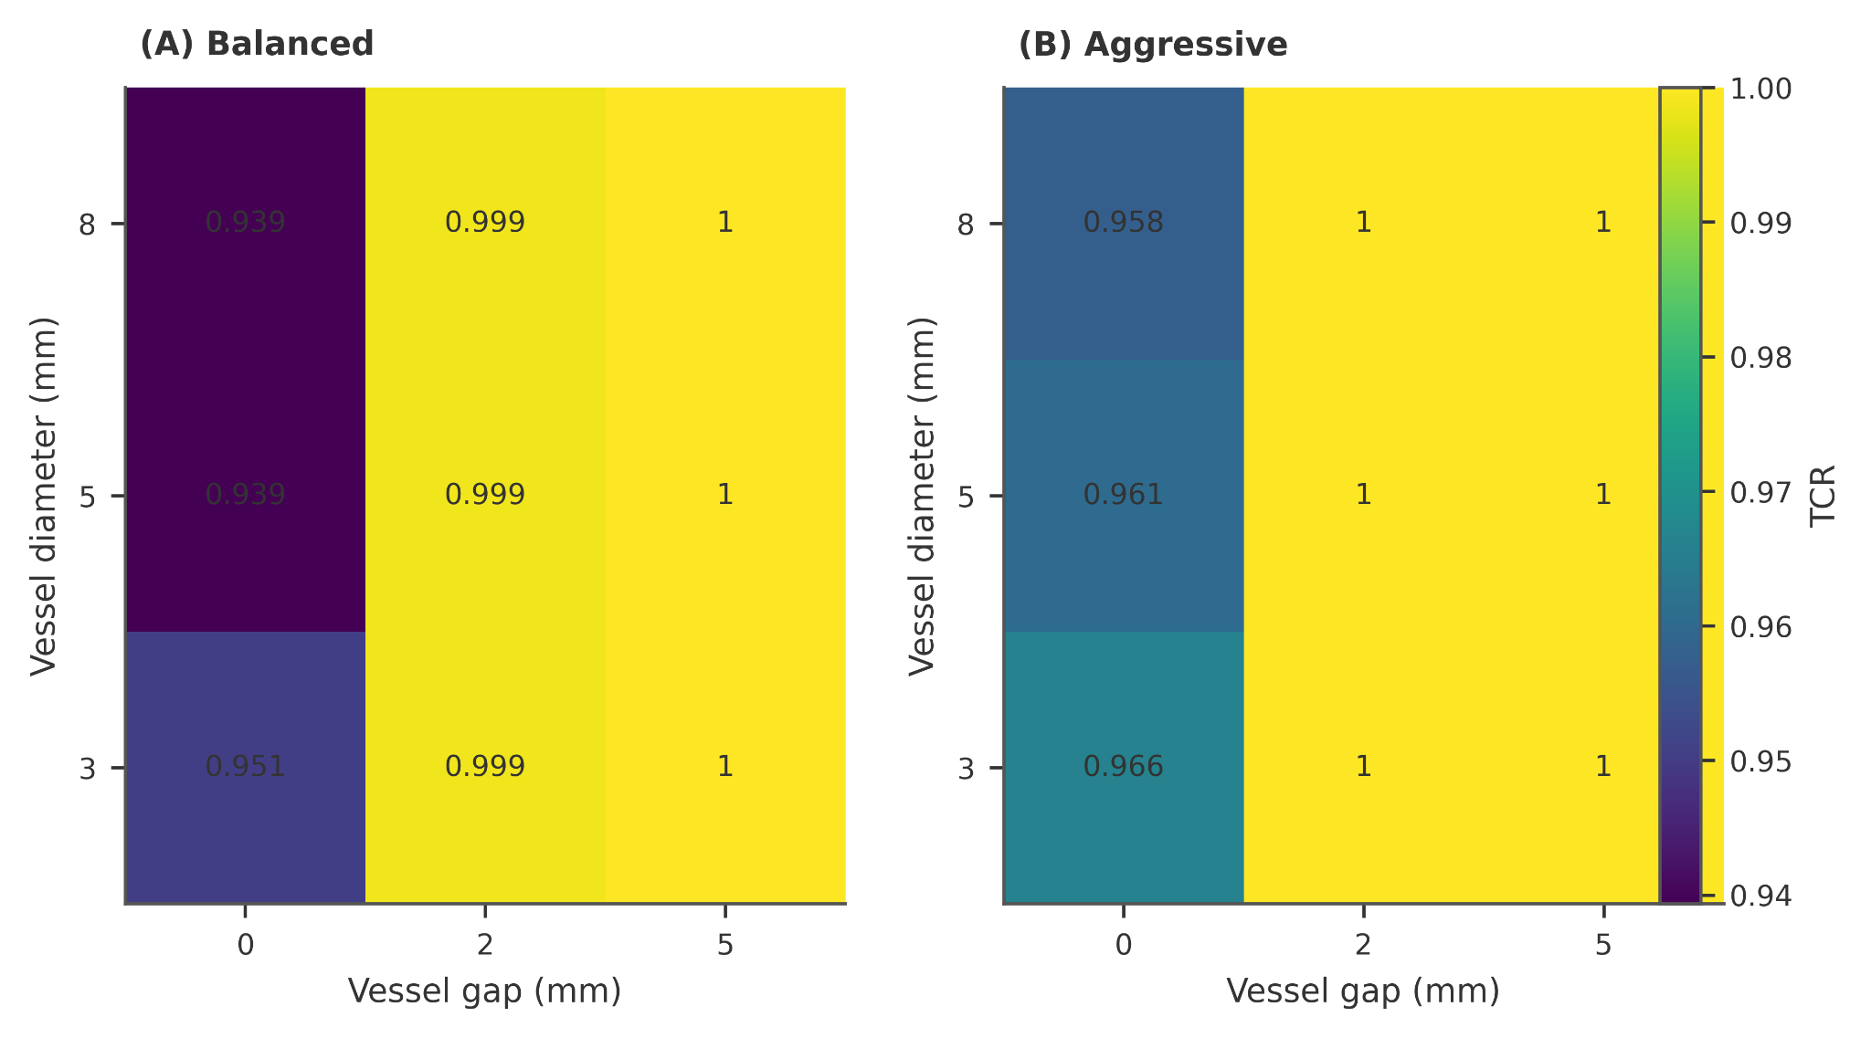
Figure S2. Protocol-dependent maps of tumor coverage ratio (TCR). TCR is shown across tumor-vessel gap and vessel diameter for balanced and aggressive protocols. Under the aggressive protocol, tumor coverage is complete for most tested conditions, whereas under the balanced protocol incomplete coverage appears mainly in abutting cases.
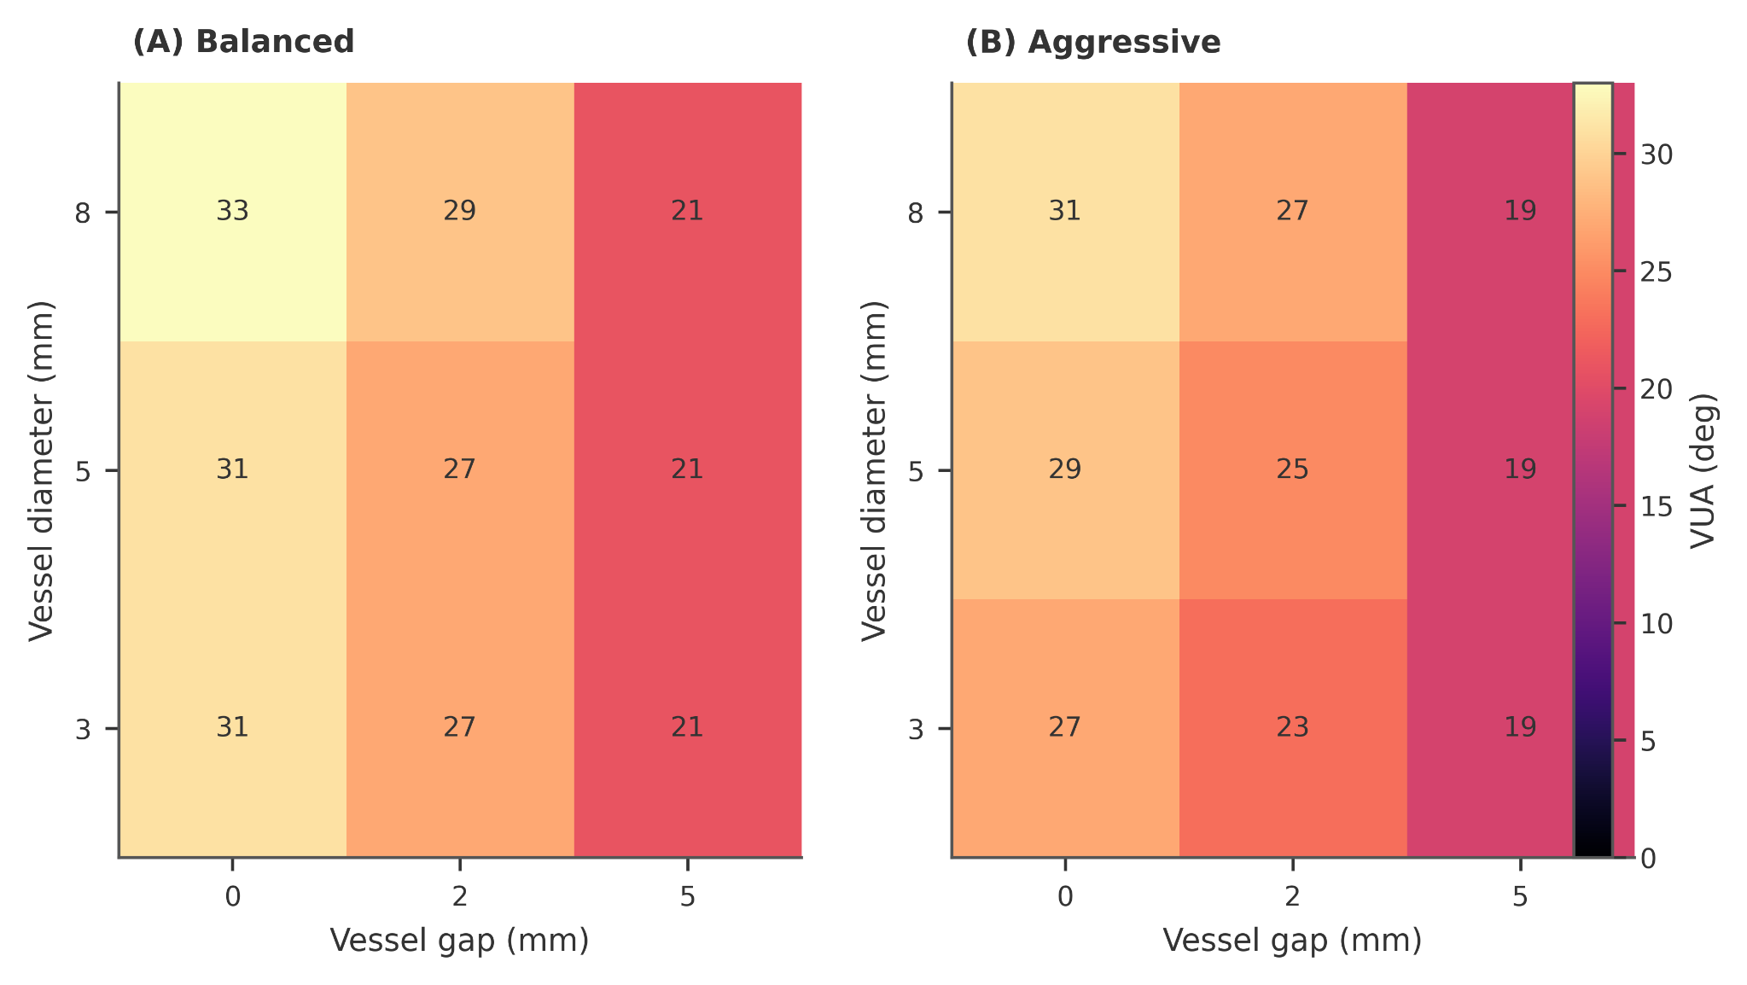
Figure S3. Protocol-dependent maps of vessel-side undercoverage angle (VUA). VUA is shown across tumor-vessel gap and vessel diameter for balanced and aggressive protocols. Larger VUA indicates broader vessel-facing underablation. VUA decreases as gap increases and is consistently lower under the aggressive protocol.
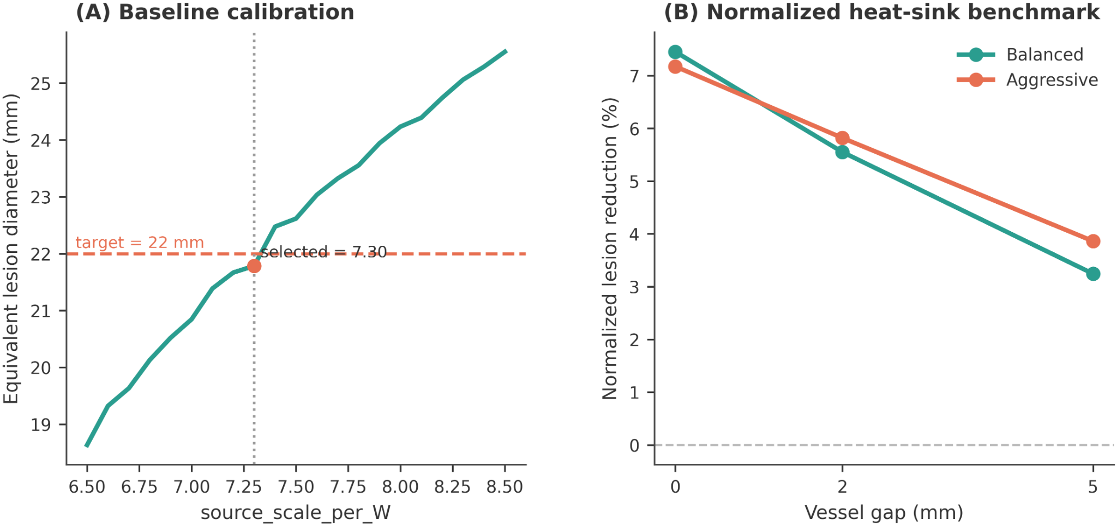
Figure S4. Model calibration and normalized heat-sink benchmark. (A) Baseline calibration was performed in the no-vessel configuration by matching the equivalent lesion diameter for a reference protocol to the target value of 22 mm, yielding the selected source scaling constant. (B) The internal benchmark reports normalized lesion reduction relative to the corresponding no-vessel baseline. In both protocols, normalized lesion reduction decreases monotonically with tumor-vessel gap, confirming the expected weakening of heat-sink effects with increasing separation.
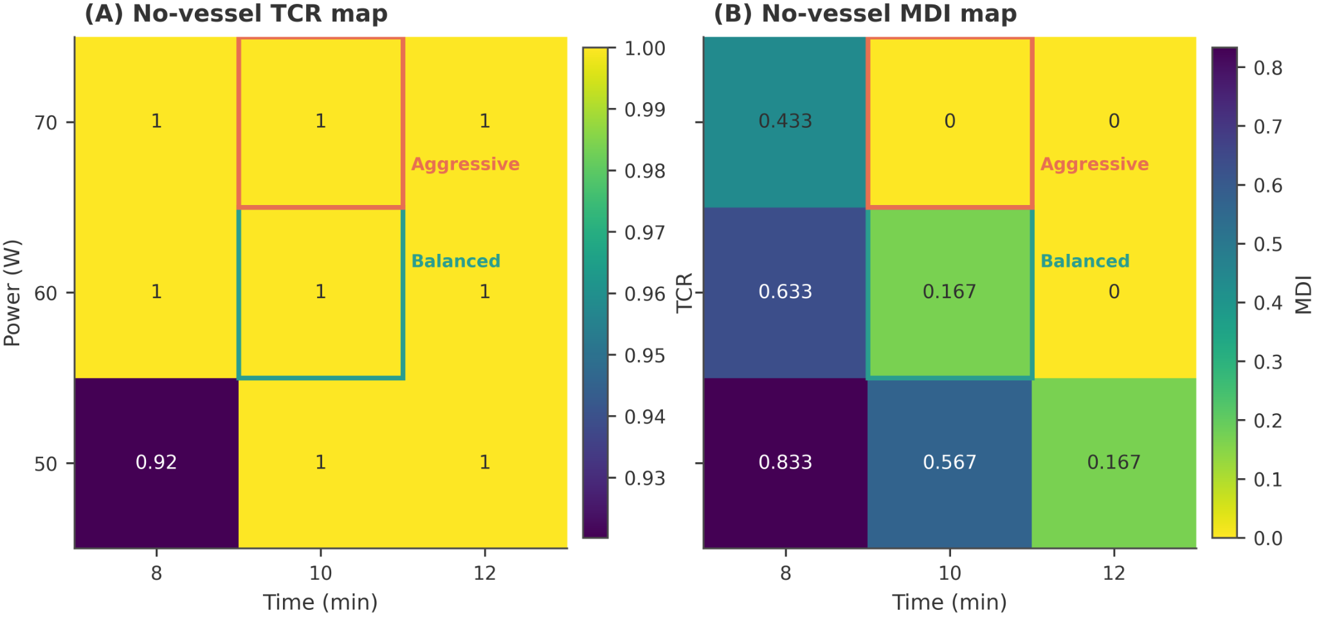
Figure S5. Protocol selection under the no-vessel baseline. No-vessel TCR and MDI maps across power and time were used to select representative balanced and aggressive protocols. The balanced protocol was chosen to provide full tumor coverage with a moderate safety-margin deficit, whereas the aggressive protocol was chosen to further reduce margin deficit at the expense of lower target specificity in the main study.
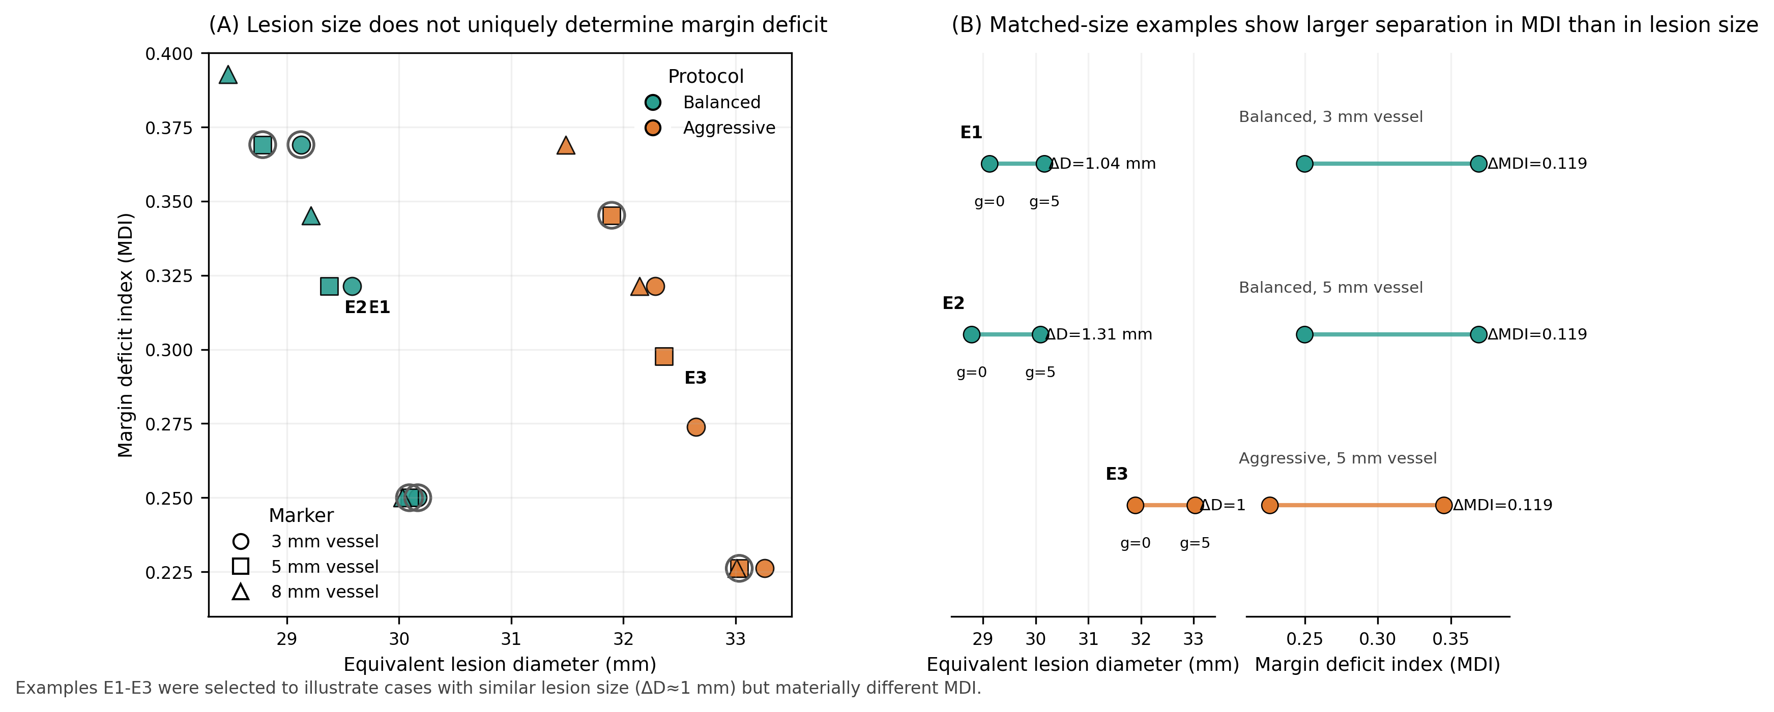
Figure S6. Lesion-size summary versus shape-based margin deficit. (A) Scatter plot of perivascular cases showing equivalent lesion diameter versus margin deficit index (MDI) for the balanced and aggressive protocols, with marker shape indicating vessel diameter. The relationship is not one-to-one, indicating that lesion-size summaries alone do not uniquely determine local margin failure. (B) Matched-size examples (E1–E3) illustrating cases in which the difference in equivalent lesion diameter is approximately 1 mm, whereas the corresponding difference in MDI remains about 0.12. These examples support the interpretation that shape-based endpoints provide information complementary to lesion-size summaries in perivascular ablation planning.

