A low-complexity planning model for perivascular liver radiofrequency ablation: shape-based assessment of safety-margin deficit and protocol trade-offs
Working draft for internal review
Draft manuscript assembled from frozen simulation outputs and final figure packages.

Keywords: liver radiofrequency ablation; perivascular tumor; heat-sink; treatment planning; margin deficit; computational modeling

Abstract
Background: Perivascular liver radiofrequency ablation (RFA) is vulnerable to heat-sink effects that may cause asymmetric underablation and loss of the intended safety margin. Existing planning studies often emphasize lesion size, whereas shape-based descriptors of margin failure remain less developed.
Methods: We developed a low-complexity 2D electro-thermal-damage model for perivascular liver RFA using a parameterized geometry composed of tumor, electrode, and a single nearby vessel. The model coupled an electro-quasistatic formulation, bioheat transfer, and Arrhenius-type thermal damage. Treatment adequacy was quantified using shape-based endpoints, including tumor coverage ratio (TCR), margin deficit index (MDI), vessel-side undercoverage angle (VUA), and target specificity (PPV_target). The effects of tumor-vessel gap, vessel diameter, and protocol strength were evaluated under balanced and aggressive power-time settings. Numerical credibility was assessed by grid and time-step checks, and model calibration was performed against a no-vessel reference lesion diameter.
Results: Tumor-vessel gap was the dominant determinant of margin failure. Under both tested protocols, MDI decreased monotonically as the gap increased from 0 to 5 mm. Vessel diameter acted as a secondary modifier, with its effect being most apparent in abutting or very short-gap cases. Relative to the balanced protocol, the aggressive protocol consistently reduced MDI across tested conditions, but this improvement was accompanied by lower PPV_target, indicating a stronger overtreatment trade-off. Representative contour maps showed vessel-side notching and localized undercoverage in near-vessel cases. Grid and time-step checks supported the use of TCR and MDI as primary endpoints.
Conclusions: A low-complexity shape-based planning model can capture clinically relevant perivascular RFA failure patterns beyond lesion size alone. The proposed framework provides an interpretable way to compare protocols, quantify margin loss, and support planning-oriented risk assessment in near-vessel liver ablation.

1. Introduction
Thermal ablation is an established treatment option for selected primary and metastatic liver tumors, especially in patients who are not candidates for surgical resection or who require minimally invasive local therapy. Among thermal modalities, radiofrequency ablation (RFA) remains widely used because of its clinical availability, procedural familiarity, and relatively low technical burden. However, treatment success is not determined solely by whether a lesion is heated, but by whether the entire tumor and an adequate safety margin are reliably covered.
A major challenge arises in perivascular tumors, where heat transfer to adjacent blood vessels can reduce local tissue heating and produce heat-sink effects. In this setting, the resulting ablation zone may become asymmetric, with localized undercoverage on the vessel-facing side. Such near-vessel failure patterns are clinically important because incomplete local treatment and inadequate ablation margins are associated with increased risk of local tumor progression. Therefore, perivascular RFA is not only a thermal problem, but also a planning problem.
Computational modeling provides a practical route for studying this problem in a reproducible and low-cost manner. Physics-based RFA models have been used to estimate temperature fields, tissue damage, and ablation extent under different applicator settings and tissue conditions. However, many studies still summarize outcomes primarily by lesion diameter, lesion area, or bulk overlap. While useful, these descriptors may be insufficient in perivascular cases, where failure often appears as a localized notch or angular margin loss rather than a large change in global lesion size.
This limitation motivates the use of shape-based planning endpoints. In a planning context, treatment adequacy should ideally describe not only whether the tumor is covered, but also where margin failure occurs and how much protocol escalation is required to compensate for heat-sink-related underablation. In particular, safety-margin insufficiency is often more clinically meaningful than overall lesion enlargement, because more aggressive protocols may improve coverage at the cost of increased injury to normal tissue.
In this study, we developed a low-complexity 2D planning model for perivascular liver RFA using a parameterized geometry containing tumor, electrode, and a single nearby vessel. Rather than pursuing full patient-specific realism, we focused on a computationally light framework suitable for protocol comparison and planning-oriented sensitivity analysis. We quantified treatment adequacy using four interpretable endpoints: tumor coverage ratio (TCR), margin deficit index (MDI), vessel-side undercoverage angle (VUA), and target specificity (PPV_target).

2. Methods

2.1 Study design
This work was designed as a simulation-led methodological study of perivascular liver RFA. The aim was not to build a full patient-specific predictive system, but to develop an interpretable reduced-complexity planning framework for studying how vessel proximity and protocol strength influence tumor coverage and safety-margin failure. All analyses were performed in a 2D parameterized geometry, and the final manuscript figures were generated from a frozen simulation state to ensure reproducibility.

2.2 Parameterized geometry
The computational domain consisted of liver tissue containing a circular tumor, a centrally placed electrode, and a single nearby vessel. The tumor geometry was defined by its equivalent radius, while the perivascular configuration was parameterized using two geometric inputs: (i) tumor-vessel gap, defined as the shortest separation between the tumor boundary and the vessel wall; and (ii) vessel diameter, used as a surrogate for local cooling strength. A 5-mm target margin was defined around the tumor and used as the planning target for shape-based endpoint calculation. The no-vessel case served as a reference baseline for calibration and protocol selection.

2.3 Electro-thermal-damage model
The reduced-order model coupled three components: an electro-quasistatic formulation for the electric potential field, a bioheat equation for transient temperature evolution, and an Arrhenius-type damage model for lethal thermal injury. The electric potential satisfied an electro-quasistatic conduction equation. Temperature evolution was described using a bioheat-type equation with radiofrequency heating and a perfusion-related sink term. Thermal injury accumulation was modeled using an Arrhenius formulation, and tissue was classified as lethally damaged when the accumulated damage exceeded a predefined threshold.

2.4 Protocol design and calibration
Two protocol classes were selected from a no-vessel baseline sweep: a balanced protocol (60 W, 10 min) and an aggressive protocol (70 W, 10 min). The balanced protocol was chosen to provide complete or near-complete tumor coverage while retaining higher target specificity. The aggressive protocol was chosen to reduce margin deficit more strongly while allowing the overtreatment trade-off to be quantified. Model calibration was performed in the no-vessel configuration under a baseline protocol of 50 W for 8 min by adjusting the source scaling constant so that the equivalent lesion diameter matched a target value of 22 mm.

2.5 Shape-based endpoints
Treatment adequacy was evaluated using four endpoints. Tumor coverage ratio (TCR) was defined as the fraction of tumor area covered by the predicted lethal zone. Margin deficit index (MDI) was defined as the fraction of tumor boundary for which the local achieved margin was smaller than 5 mm. Vessel-side undercoverage angle (VUA) quantified the angular extent of underablation on the vessel-facing side of the tumor. PPV_target quantified target specificity by measuring how much of the predicted lethal region fell inside the desired target region. TCR and MDI were treated as the primary endpoints in the final analysis because they showed the strongest numerical stability and the most direct planning relevance.

2.6 Parameter sweep and numerical credibility
The final study evaluated the combined influence of protocol strength, tumor-vessel gap, and vessel diameter. Tumor-vessel gap was tested at 0, 2, and 5 mm. Vessel diameter was tested at 3, 5, and 8 mm. Each geometric condition was simulated under both balanced and aggressive protocols, producing the final protocol-dependent planning maps. Numerical credibility was assessed using both grid and time-step sensitivity analyses. A severe-vessel case was used as the representative stress test for convergence. In addition to baseline calibration, an internal benchmark analysis quantified normalized lesion reduction relative to the corresponding no-vessel baseline for each protocol to confirm the expected monotonic weakening of heat-sink severity with increasing tumor-vessel gap.

3. Results

3.1 Protocol selection and calibration
A no-vessel baseline sweep was first used to identify two representative protocol classes for the final study. The selected balanced protocol (60 W, 10 min) achieved full or near-full tumor coverage while maintaining higher target specificity, whereas the aggressive protocol (70 W, 10 min) was chosen to reduce margin deficit more strongly. Baseline calibration aligned the no-vessel reference case with a target equivalent lesion diameter of 22 mm at a selected source scaling constant of 7.30.

3.2 Representative perivascular lesion shapes
Representative contour plots showed that the no-vessel baseline produced a nearly symmetric lesion around the tumor. In contrast, perivascular cases exhibited a characteristic vessel-side notch in the predicted lethal zone. This shape-level undercoverage was most pronounced in abutting cases and became visibly smaller as the tumor-vessel gap increased. The aggressive protocol partially restored the vessel-facing contour but did not eliminate the trade-off between margin recovery and overtreatment.

3.3 Protocol-dependent effects of gap and vessel diameter
Across the tested settings, tumor-vessel gap was the dominant determinant of margin failure. For a representative 5-mm vessel, MDI decreased from 0.369 to 0.250 under the balanced protocol and from 0.345 to 0.226 under the aggressive protocol as the gap increased from 0 to 5 mm. Vessel diameter acted as a secondary modifier, with its effect being most apparent in abutting or very short-gap cases. For example, at gap = 0 mm under the aggressive protocol, MDI increased from 0.321 for a 3-mm vessel to 0.369 for an 8-mm vessel.

3.4 Planning trade-off
The aggressive protocol consistently reduced margin deficit relative to the balanced protocol, but this benefit occurred at the expense of lower target specificity. For the representative 5-mm vessel, PPV_target increased from 0.630 to 0.643 across the tested gaps under the balanced protocol, whereas it ranged from 0.530 to 0.546 under the aggressive protocol. Thus, protocol escalation partially compensated for heat-sink-related undercoverage, but with a stronger overtreatment trade-off.

3.5 Numerical credibility and benchmark
Grid and time-step checks showed that TCR and MDI were numerically stable enough to serve as primary endpoints. In the severe-vessel case, TCR changed only modestly from 0.965 at grid size 121 to 0.956 at grid size 201, while MDI remained within the range 0.350 to 0.356 except for a moderate increase at grid size 161. Time-step variation from 4 s to 1 s produced no measurable change in TCR or MDI at the selected main grid. The normalized heat-sink benchmark showed a monotonic reduction in lesion penalty with increasing gap for both protocols, supporting the internal consistency of the model.

Table 1. Primary endpoint summary for a representative 5-mm vessel.
Values are taken from the final frozen manuscript figures and summarize the influence of tumor-vessel gap under balanced and aggressive protocols.
Protocol | Gap (mm) | Vessel diameter (mm) | TCR | MDI | PPV_target
Balanced | 0 | 5 | 0.939 | 0.369 | 0.630
Balanced | 2 | 5 | 0.999 | 0.321 | 0.636
Balanced | 5 | 5 | 1.000 | 0.250 | 0.643
Aggressive | 0 | 5 | 0.961 | 0.345 | 0.530
Aggressive | 2 | 5 | 1.000 | 0.298 | 0.539
Aggressive | 5 | 5 | 1.000 | 0.226 | 0.546

Table 2. Numerical credibility summary for the severe-vessel case.
Grid and time-step checks used for the final endpoint interpretation.
Grid refinement
Grid n | TCR (severe vessel) | MDI (severe vessel)
121 | 0.965 | 0.350
161 | 0.958 | 0.369
201 | 0.956 | 0.356
Time-step variation
Time step (s) | TCR (severe vessel) | MDI (severe vessel)
4.0 | 0.958 | 0.369
2.0 | 0.958 | 0.369
1.0 | 0.958 | 0.369

4. Discussion
Perivascular liver RFA is fundamentally a planning problem under asymmetric cooling, rather than a purely geometric problem of lesion size. In the present study, a low-complexity 2D electro-thermal-damage model reproduced the central qualitative behavior expected in this setting: a nearby vessel produced vessel-facing underablation, the severity of margin failure decreased as tumor-vessel gap increased, and protocol escalation partially compensated for this effect.
A central result of this work is that tumor-vessel gap emerged as the dominant determinant of margin deficit, whereas vessel diameter acted mainly as a secondary modifier, with the strongest effect in abutting or very short-gap cases. This pattern is consistent with the broader clinical and computational literature, which identifies shortest vascular distance as a key determinant of local failure and recognizes heat-sink as a major challenge in liver RFA planning.
Another important contribution of this study is the explicit use of shape-based planning endpoints. Many ablation modeling studies still summarize treatment outcome using lesion diameter, lesion area, or overlap alone, but these quantities may fail to capture the vessel-side notch that is often the clinically meaningful manifestation of perivascular heat-sink. By focusing on TCR and especially MDI, the present model shifts the interpretation from how large the lesion is to where the safety margin is insufficient, which is more relevant for planning-oriented decision support.
The comparison between balanced and aggressive protocols further highlights why a planning framework should not optimize coverage alone. In this study, the aggressive protocol consistently reduced MDI relative to the balanced protocol, but this gain occurred together with lower PPV_target, indicating a stronger overtreatment trade-off. In other words, protocol escalation can partially rescue vessel-side margin loss, but it does so by sacrificing target specificity.
A strength of the present work is that it deliberately targets the middle ground between oversimplified toy models and highly detailed patient-specific simulators. The value of the current model is not that it captures every physiological detail, but that it provides an interpretable and computationally light platform for comparing protocols, visualizing lesion asymmetry, and quantifying margin loss in a manner that is reproducible on modest hardware.
Several limitations should be acknowledged. First, the model is two-dimensional and therefore cannot fully represent three-dimensional directional effects, including vessel orientation relative to the applicator. Second, the nearby vessel was modeled in a simplified manner and did not recover patient-specific hemodynamics or vascular branching. Third, the study did not include direct experimental or clinical image-based validation. These limitations are important, but they also define the intended scope of the work: this is a planning-oriented reduced-complexity model, not a full predictive digital twin.
Taken together, the present study supports a simple but practically useful interpretation: in perivascular liver RFA, the most important question is not simply whether the lesion is large enough, but whether the safety margin is lost locally on the vessel-facing side and whether protocol escalation restores that margin at an acceptable cost in target specificity.

5. Conclusion
A low-complexity 2D electro-thermal-damage model was developed to study perivascular liver RFA using shape-based planning endpoints. Across the tested settings, tumor-vessel gap was the primary determinant of margin deficit, while vessel diameter acted as a secondary modifier that mainly affected abutting or very short-gap cases. Protocol escalation reduced margin deficit but also decreased target specificity, revealing a clear planning trade-off. These results indicate that shape-based metrics, particularly margin deficit, provide more planning-relevant information than lesion size alone in near-vessel ablation. The proposed framework offers a reproducible and computationally light platform for protocol comparison and risk-oriented planning analysis in perivascular liver RFA.

Funding
This research did not receive any specific grant from funding agencies in the public, commercial, or not-for-profit sectors.

Declaration of competing interests
The author declares no known competing financial interests or personal relationships that could have appeared to influence the work reported in this manuscript.

Selected references
- van Erp GCM, et al. Computational Modeling of Thermal Ablation Zones in the Liver: A Systematic Review. 2023.
- Huang HW. Influence of blood vessel on the thermal lesion formation during radiofrequency ablation for liver tumors. 2013.
- Fang Z, et al. Radiofrequency ablation for liver tumors abutting complex vascular structures: treatment protocol optimization using response surface method and computer modeling. Int J Hyperthermia. 2022.
- Kang TW, et al. Percutaneous ablation for perivascular hepatocellular carcinoma: current status and future perspectives. 2018.
- Hoffer EK, et al. Radiofrequency ablation of hepatocellular carcinoma guided by simulation-based computer-assisted planning: a prospective study. 2024.
- Verdonschot KHM, et al. Ablative margins in percutaneous thermal ablation of liver malignancies: a systematic review. 2023.

Figures
Figure 1. Parameterized geometry, shape-based endpoints, and planning workflow.
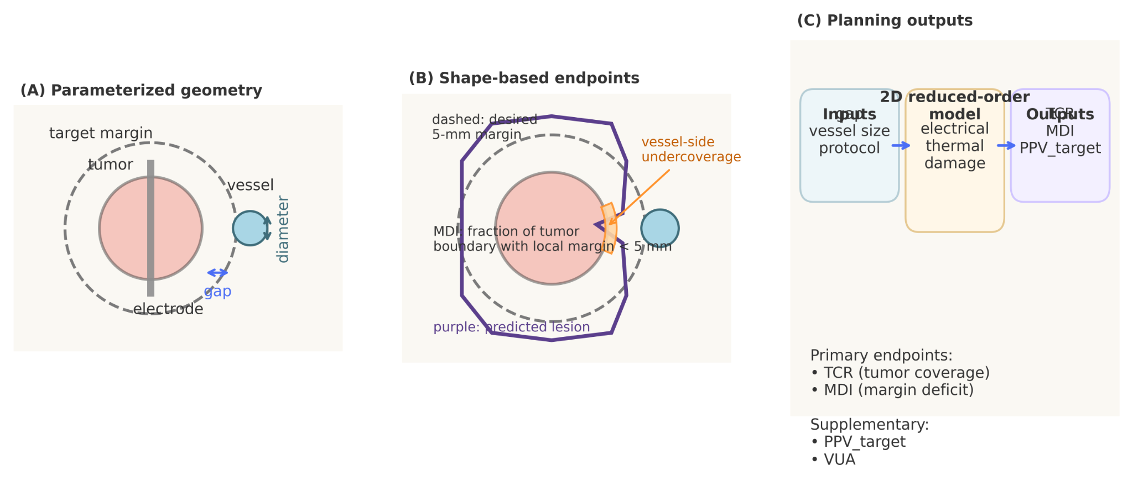

Figure 2. Representative lesion contours under no-vessel and perivascular conditions.
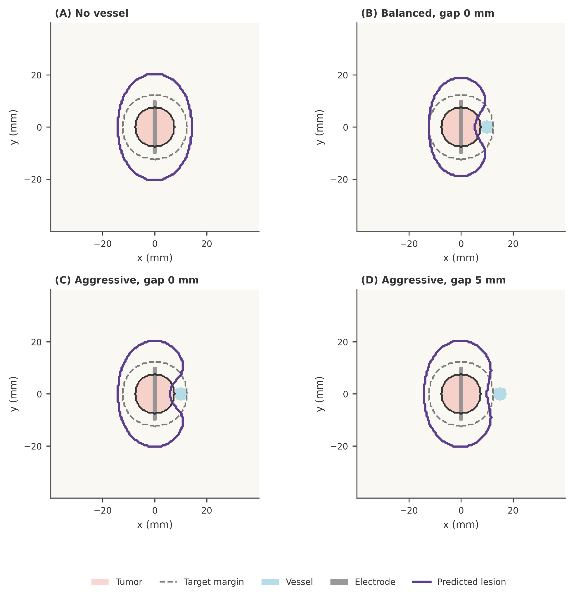

Figure 3. Protocol-dependent maps of margin deficit index (MDI).
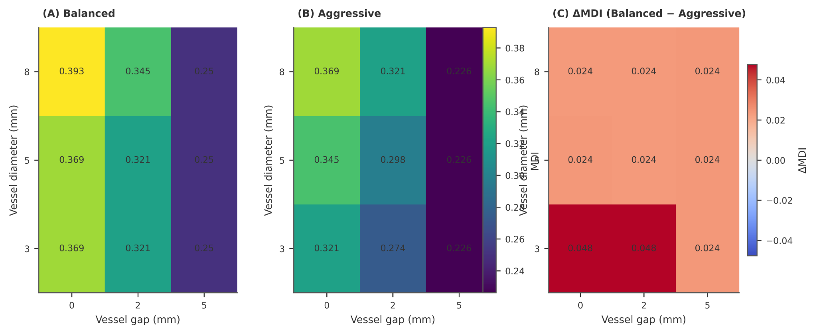

Figure 4. Planning trade-off between margin deficit and target specificity.
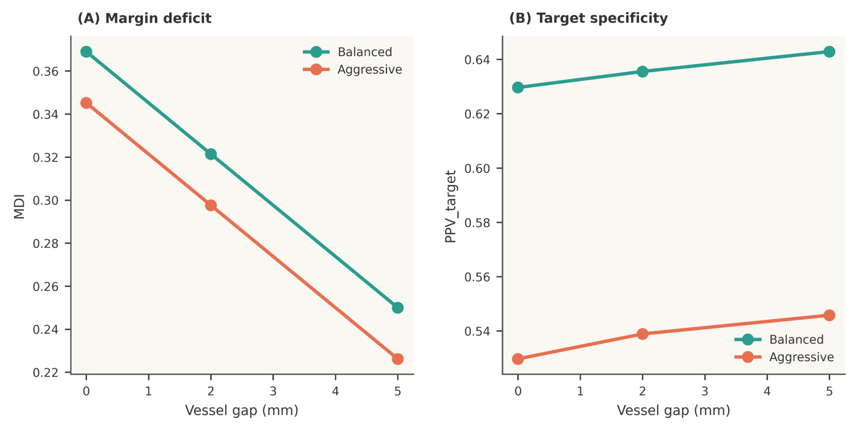

Appendix: Supplementary figures
Figure S1. Numerical convergence of the reduced-order model.
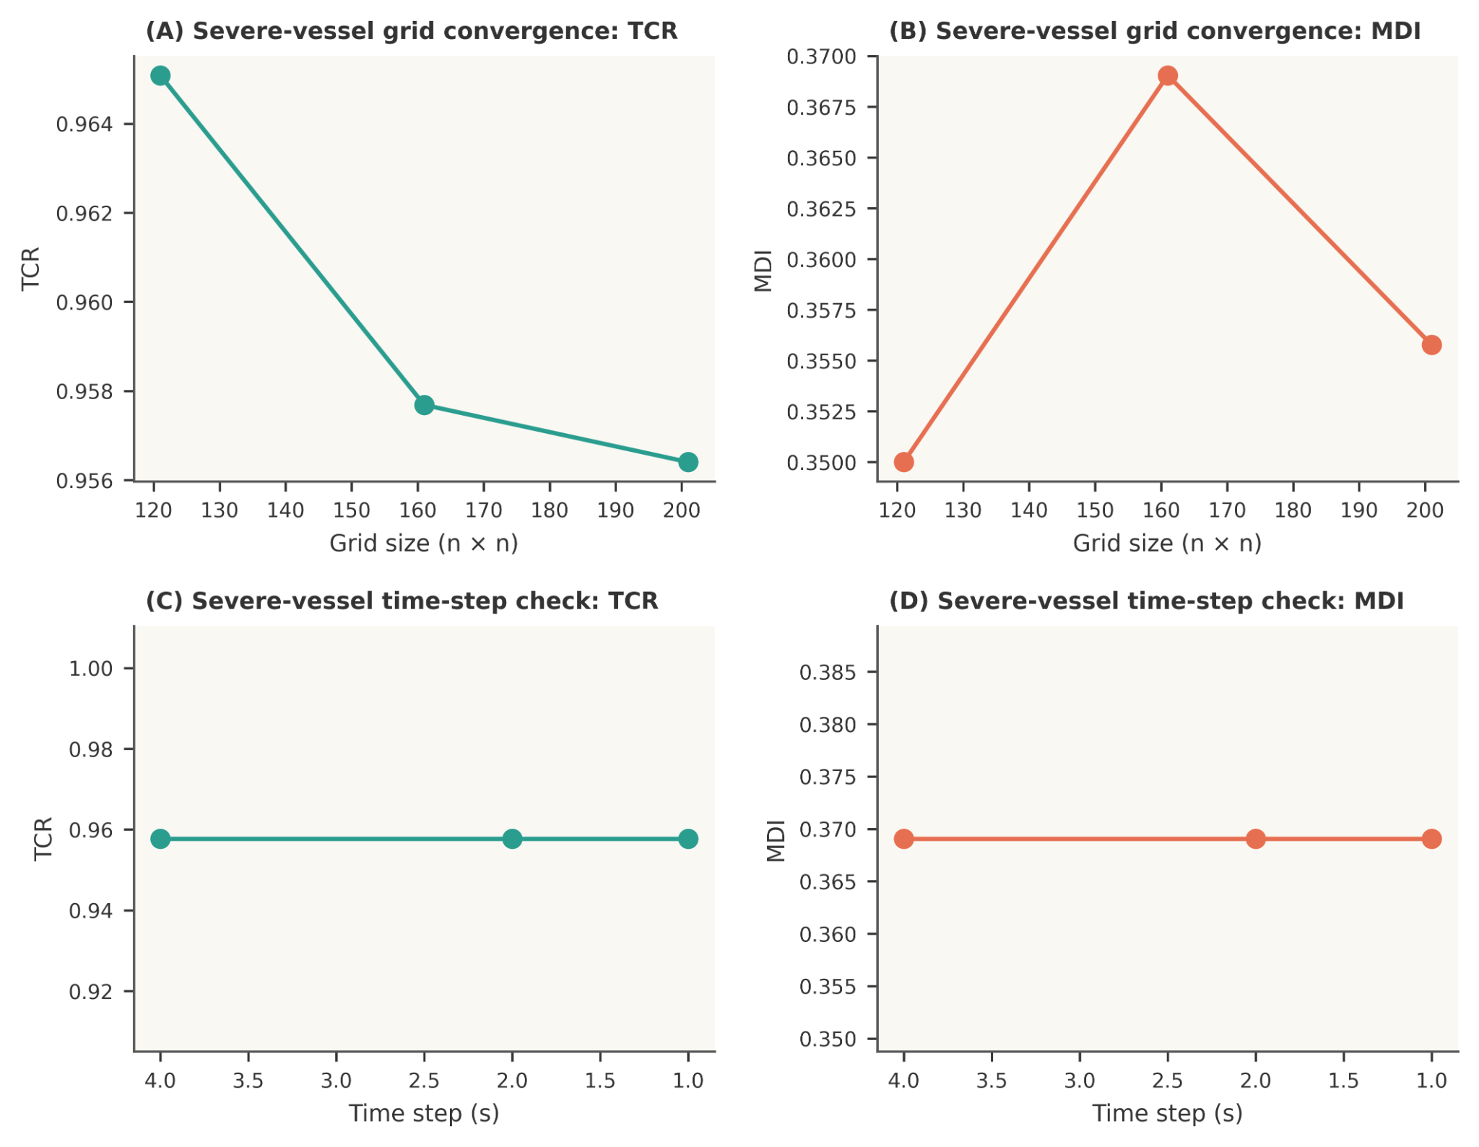

Figure S2. Protocol-dependent maps of tumor coverage ratio (TCR).
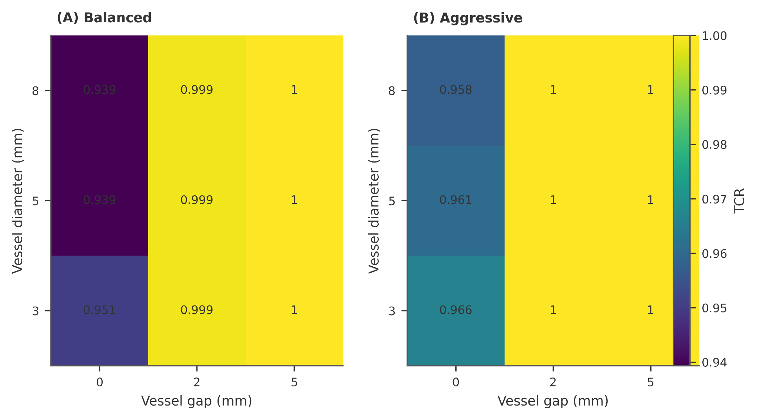

Figure S3. Protocol-dependent maps of vessel-side undercoverage angle (VUA).
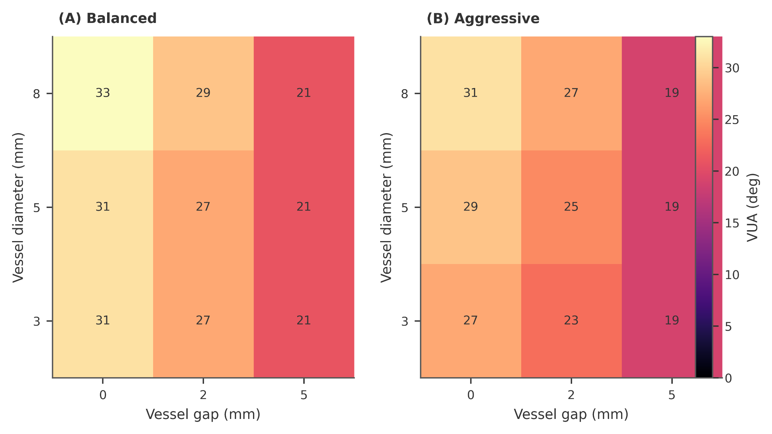

Figure S4. Model calibration and normalized heat-sink benchmark.
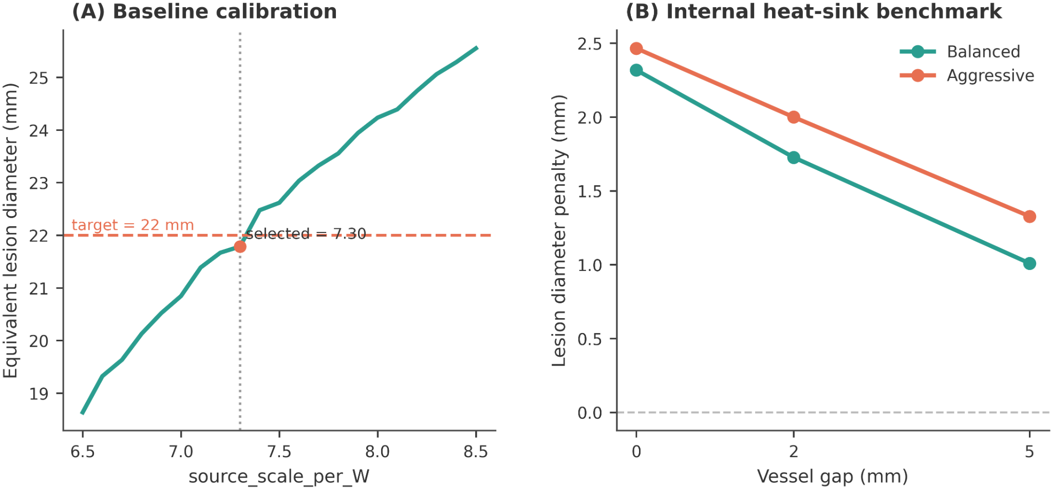

Figure S5. Protocol selection under the no-vessel baseline.
