Calibrating with Rulr(v0.5a) using the Kinect V2:

# Before opening Rulr:

-Install Kinect SDK

-ASIO4ALL Audio driver

Before calibrating with Rulr, place the Kinect and the projector firmly in position. If the devices are moved from their positions, they must be re-calibrated again.

Ensure that both the projector and the Kinect are plugged into and detected by the computer.

# Projector Setup:

Check display settings

* right click on desktop🡪 display settings
* extend these displays
* monitor 1: desktop
* monitor 2: body projections
* monitor 3: rear-projections

Kinect Setup:

Check Device manager for Kinect sensor devices to be sure it is plugged in and ready to go.

# Rulr:

Step 1: Disconnect Render: Node through view from System: video output by right clicking on system. Videooutput button.

Step 2: Connect Procedure Calibrate Projection Node to system video output.

Step 3: Select System.video output node . select the correct window

Select Grid test pattern

Show window

4: Click on procedure calibrate

Clear corresepondences

Add 1st capture(without paper)

Add 2nd capture with paper. Listen for the happy beep

Calibrate.

Error pxs. Should be under 20px

6. reconnect render node through view to system video output to test mapping.

If satisfied with result.

7. click on projector node

Export ofxRay::camera

Remember where you saved this file

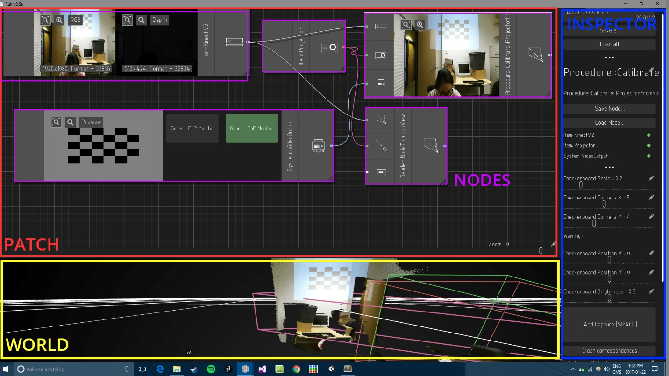

## Patch(Top):

The patch panel contains Nodes

## World(Bottom):

The world panel is a virtual representation of the physical setup.

## Inspector(Right):

The inspector allows you to change the properties of the currently selected node.

# Rulr Calibration Process: