2020/12/30上課練習

E

D

C

B

A

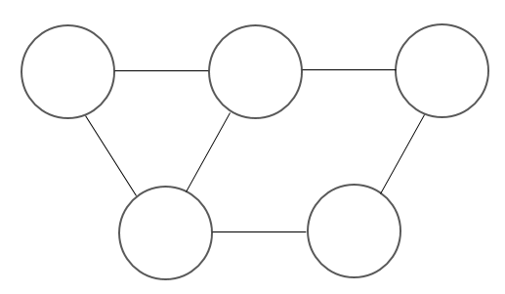

|  |  |  |  |  |  |
| --- | --- | --- | --- | --- | --- |
| 無向圖 | A | B | C | D | E |
| A | 0 | 1 | 0 | 1 | 0 |
| B | 1 | 0 | 1 | 1 | 0 |
| C | 0 | 0 | 0 | 0 | 1 |
| D | 1 | 1 | 0 | 0 | 1 |
| E | 0 | 0 | 1 | 1 | 0 |

|  |  |  |  |  |  |
| --- | --- | --- | --- | --- | --- |
| 分枝度degree | **A** | **B** | **C** | **D** | **E** |
| 4 | 6 | 4 | 6 | 4 |

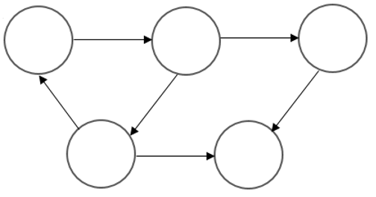

E

D

C

B

A

|  |  |  |  |  |  |
| --- | --- | --- | --- | --- | --- |
| 有向圖 | A | B | C | D | E |
| A | 0 | 1 | 0 | 0 | 0 |
| B | 0 | 0 | 1 | 1 | 0 |
| C | 0 | 0 | 0 | 0 | 1 |
| D | 1 | 0 | 0 | 0 | 0 |
| E | 0 | 0 | 0 | 1 | 0 |

|  |  |  |  |  |  |
| --- | --- | --- | --- | --- | --- |
| 分枝度degree | **A** | **B** | **C** | **D** | **E** |
| 2 | 3 | 2 | 3 | 2 |

串列：

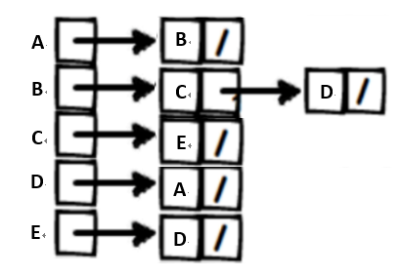

**◎自行繪製的圖形**

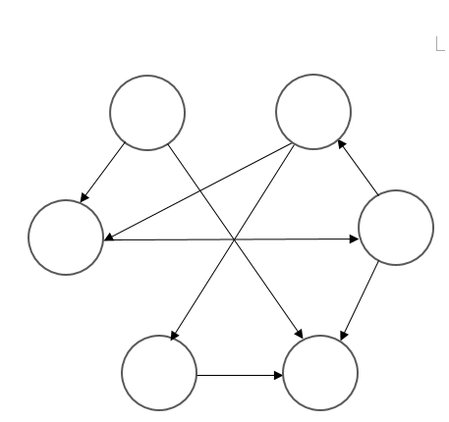

6

1

5

2

3

4