1. A small amount of phosphoric acid is used as a flavoring agent for cola, a bottle of cola has a density of about 1 gram per milliliter and contains 0.05% phosphoric acid (mass fraction)。

At 25 ℃, the tertiary ionization constant of phosphoric acid is pKa1 = 2.12 pKa2 = 7.21, and pKa3 = 12.32.

1. (very easy problem)Please calculate the concentration of [HPO42-] in Cola and the PH value of Cola.
2. (Normal problem)The following balance of bone calcium and blood calcium exists in the human body.

$$CaCO_{3}(s,Bone calcium)⇆Ca^{2+}(aq,Blood calcium)+C{O_{3}}^{2−}(aq)$$

If you drink cola and phosphoric acid enters your body, the following reactions may occur

$$3CaCO_{3}(s)+{2H}_{3}PO_{4}⇄Ca_{3}{(PO_{4})}_{2}(s)+3H_{2}CO_{3}(aq)$$

Known that Ksp(CaCO3)=4.96\*10^(-9) Ksp(Ca3(PO4)2)=2.07\*10^(-33)

Please use calculation to prove or disprove this reaction may or may not happen in the above condition and judge whether drinking cola will cause bone’s problem according to your calculation .

1. (Relatively Hard problem)

For H3PO4,Ka1,Ka2,Ka3 have much difference in their value.So we can use Methyl orange to titrate H3PO4 to H2PO4-,and we can use Phenolphthalein to titrate H2PO4- to HPO42-.

Pyrophosphate is a special kind of phosphoric acid, its molecular structure is shown in the figure below (can be seen as two molecules of phosphoric acid stripped of one molecule of water to form)

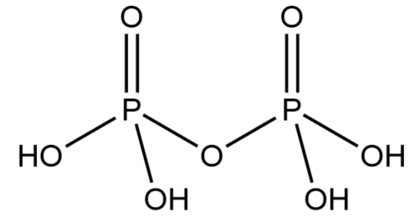

In this molecule, $Ka1≈Ka2$ but Ka1,Ka2>>Ka3, Ka4, which means that there are only two H+ will be easy to come out.

Now we consider the following Poly n phosphoric acid with the molecule formula:

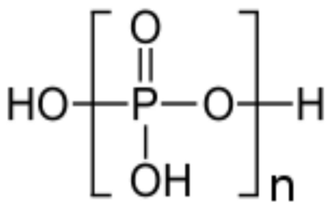

We can use NaOH to titrate the first and second H+ at the same time, and there exists two titration endpoint at V(NaOH)=42.0ml and 50.0ml. Please calculate the average number of Phosphorus atom in this kind of acid.