Lindsey Yin

CSD 380 Module 5

Assignment 5.2

24 June 2024

Using Value Stream Mapping (VSM) for Grocery Shopping

Value stream mapping (VSM) is a lean-management method for analyzing the current state and designing a future state for the series of events that take a product or service from its beginning through to the customer. In this exercise, I will apply the VSM process to my weekly grocery shopping routine to identify inefficiencies and optimize the process.

Value Stream Map

To visualize my grocery shopping process, I have created a value stream map (VSM) that outlines each step of the process, from planning the grocery list to storing the groceries at home.

Steps:

1. Plan Grocery List
2. Travel to Store
3. Shop for Groceries
4. Check Out
5. Travel Home
6. Store Groceries

Grocery Shopping VSM

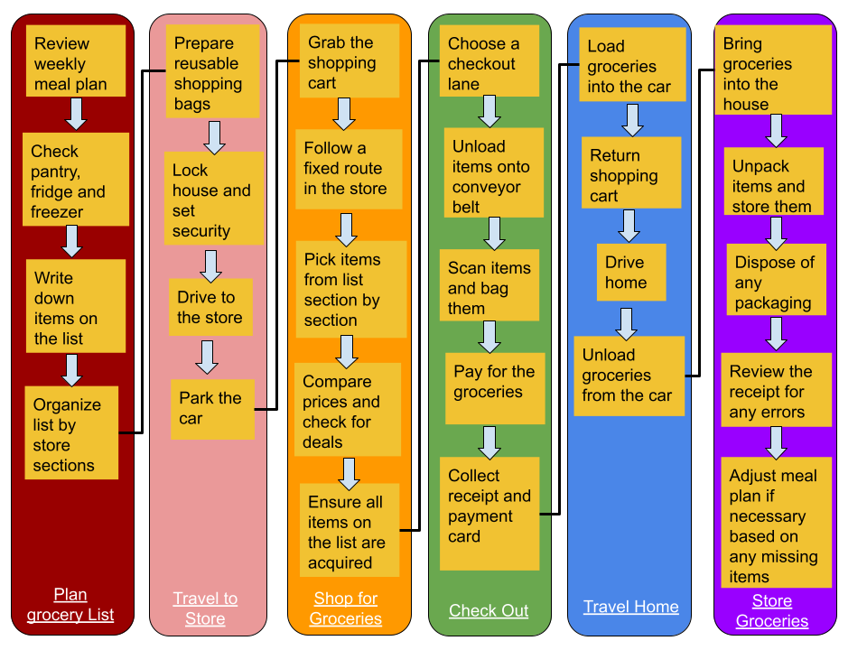

Analyzing Lean Metrics

After mapping out my value stream, the next step is to collect and analyze the associated metrics. The metrics I will focus on are my estimated Cycle Time (total time from start to finish) and Flow Time (time spent on each stage).

Estimated Average Flow Time:

* Plan Grocery List: 15 mins
* Travel to Store: 20 mins
* Shop for Groceries: 45 mins
* Check Out: 10 mins
* Travel Home: 20 mins
* Store Groceries: 10 mins

Estimated Cycle Time: 120 mins (2 hours)

Optimizing My Processes

Now it is time to use the information from the map and metrics to optimize my grocery shopping routine. Here are some data-driven decisions that can positively impact the process:

Eliminating Waste:

* **Pre-plan meals:** By planning meals for the week in advance, I can create a more efficient grocery list, reducing the time spent on planning from 15 mins to 10 mins.
* **Online Shopping:** Consider using an online grocery shopping service for non-perishable items to reduce in-store shopping time from 45 mins to 30 mins.

Workflow Orchestration:

* **Combine Trips:** If possible, combine the grocery shopping trip with other errands to maximize travel time efficiency. For example, combining the grocery trip with a stop at the pharmacy can make the travel time more productive.
* **Self-Checkout:** Utilize self-checkout stations to reduce checkout time from 10 mins to 5 mins, especially during off-peak hours.

Governance Models:

* **Weekly Review:** Implement a weekly review of the grocery list to ensure that it includes all necessary items, reducing the likelihood of needing additional trips to the store.
* **Shopping Route Optimization:** Develop a fixed route within the store to follow each visit, reducing time spent wandering and improving shopping efficiency.

Conclusion

Applying value stream mapping to my grocery shopping routine has allowed me to identify and address inefficiencies, leading to a more streamlined process. By eliminating waste, orchestrating the workflow, and implementing governance models, I can reduce the overall cycle time and make my weekly shopping more efficient. The principles discussed here can similarly be applied to optimize other routine activities or software development processes, leading to significant time savings and improved efficiency.

References

Knight, L. (2020). 3 Easy Steps for Using VSM in Everyday Life. Retrieved from https://www.connectall.com/3-easy-steps-for-using-vsm-in-everyday-life/

Lean Enterprise Institute. (n.d.). What is Value Stream Mapping (VSM)? Retrieved from https://www.lean.org/lexicon-terms/value-stream-mapping/#:~:text=Value%2Dstream%20mapping%20(VSM),to%20identify%20and%20eliminate%20waste

Rother, M., & Shook, J. (2003). Learning to See: Value Stream Mapping to Create Value and Eliminate Muda. Lean Enterprise Institute.