背景資料：

1. 性別
2. 年齡
3. 職業
4. 現居地點
5. 月收入金額
6. 通常是甚麼時段去全聯
7. 一個禮拜去賣場幾次
8. 一個禮拜去全聯幾次
9. 每次平均消費金額
10. 到達離你最近全聯的時間
11. 前往賣場的原因

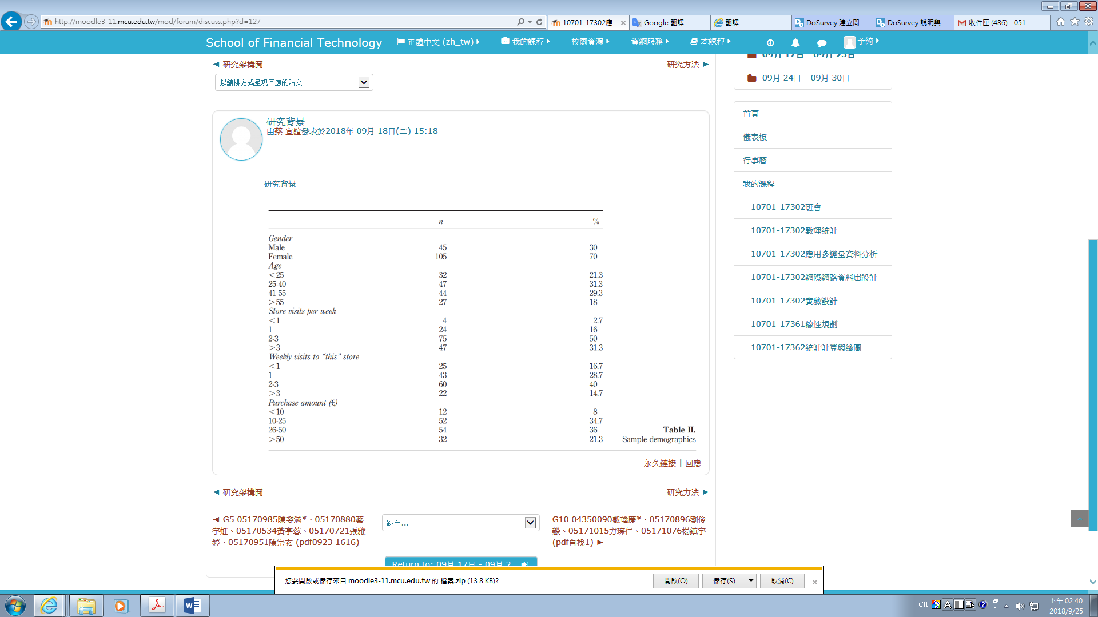

|  |  |
| --- | --- |
| Construct/measures Loading t-value Mean SD | 構造/測量加載t值平均值SD |
| Satisfaction(a = 0.9; CR = 0.92) | 滿意度（a = 0.9; CR = 0.92） |
| It was a good decision to shop at CHUAN LIAN and not in a different store | 贊同選擇全聯比選擇其他賣場更好嗎 |
| I prefer this CHUAN LIAN when comparing it with other supermarkets | 比起其他賣場更喜歡全聯 |
| Today’s shopping experience at CHUAN LIAN was as expected | 今天在全聯的購物經驗如預期嗎 |
| Buying my groceries at this CHUAN LIAN today was a pleasant experience | 今天在全聯的購物是一個愉快的經驗嗎 |
| I felt good today when shopping at CHUAN LIAN | 今天在全聯購物是愉快的嗎 |
| I liked shopping at CHUAN LIAN today | 喜歡在全聯購物 |
| Employees (a = 0.80 ; CR = 0.88) | 員工（a = 0.80; CR = 0.88） |
| The employees of this CHUAN LIAN were friendly today | 全聯的員工今天很友好 |
| The employees of this CHUAN LIAN are knowledgeable | 全聯的員工知識淵博 |
| Employees were willing to find custom solutions to questions | 員工願意幫忙解決問題 |
| Merchandise (a = 0.62 ; CR = 0.79) | 商品（a = 0.62; CR = 0.79） |
| This CHUAN LIAN offers a broad assortment of products | 這個全聯提供種類繁多的產品 |
| This CHUAN LIAN sells high-quality products | 這個全聯銷售高品質的產品 |
| Products I needed were available | 全聯有需要的可用產品 |
| Layout (a = 0.66 ; CR = 0.81) | 佈局（a = 0.66; CR = 0.81） |
| It was easy to find products on offer | 很容易找到需要的產品 |
| Physical facilities at CHUAN LIAN are visually appealing | 全聯的擺設具有視覺吸引力 |
| This CHUAN LIAN has a clear store layout | 全聯有明確的商店佈局 |
| Negative emotional response to the wait (a = 0.87 ; CR = 0.91) | 對等待的負面情緒反應（a = 0.87; CR = 0.91） |
| I felt frustrated while standing in line today | 今天排隊時我感到很沮喪 |
| I was bored during the wait | 在等待期間我很無聊 |
| I disliked my time in the queue | 我不喜歡排隊的時間 |
| Attribution to store (a = 0.86 ; CR = 0.92) | 商店本身的問題（a = 0.86; CR = 0.92） |
| Wait was longer than necessary due to too few checkout counters | 由於結帳櫃檯太少，等待時間超過了必要的時間 |
| The store was to blame for my longer than necessary wait | 商店責怪我結帳速度緩慢 |
| Employees at the checkout worked slowly | 結帳時的員工工作緩慢 |
| Waiting area attractiveness (a = 0.90 ; CR = 0.91) | 等候區（a = 0.90; CR = 0.91） |
| I perceived the waiting area as neat | 我覺得等候區很整潔 |
| I found the waiting area organized | 我找的到等候區 |
| Perceived wait duration(a = 0.85 ; CR = 0.91) | 等待時間（a = 0.85; CR = 0.91） |
| I had to wait a long time at checkout today | 今天我必須結帳時等待很長時間 |
| The wait today was shorter than expected | 今天的等待時間比預期的短 |
| Distraction (a = 0.80 ; CR = 0.86) | 焦急（a = 0.80; CR = 0.86） |
| While waiting today, I felt occupied by things around me | 在等待今天的時候，我感到被周圍的事物所干擾 |
| I felt I was being distracted while waiting | 我覺得我在等待的時候心煩意亂 |
| There were plenty of things to do and look at while I stood in line | 當我排隊時，有很多事情要做 |
| Mental imbalance (a = 0.84 ; CR = 0.90) | 心理不平衡（a = 0.84; CR = 0.90） |
| I had the feeling that people with few products received preferential treatment | 我覺得只有少數的人可以享有優惠 |
| I had the feeling that people who joined the queue later got served before me | 我覺得後來排隊的人在我之前得到了服務 |
| It seemed to me that service in other queues was faster | 在我看來，其他收銀台的服務更快 |
| Value of purchase (a = 0.87 ; CR = 0.91) | 購買價值（a = 0.87; CR = 0.91） |
| The products I just bought are important to me | 我剛買的產品對我很重要 |
| I really needed the products I bought | 我真的需要我買的產品 |
| My shopping cart was entirely filled today | 我的購物車今天完全填滿了 |
| I had the feeling I bought a lot of goods today | 今天是個愉快的經歷 |