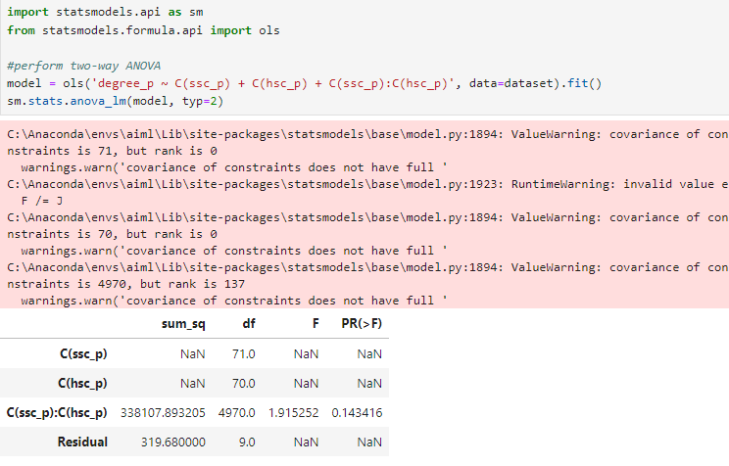

In two way ANOVA, we are analyzing the influence of 2 independent variables on 1 dependent variable:

* Null Hypothesis: There is no influence of 10th and 12th mark on salary
* Alternate Hypothesis: There is influence of 10th and 12th mark on salary

Here we are getting a p-value of 14%, that is greater than 5%. So, we can accept the null hypothesis that there is no significant influence between 2 independent variables (and the dependent variable (salary)