Zürich University of Applied Sciences (ZHAW)
Department of Life Sciences and Facility Management
Institute of Computational Life Sciences (ICLS)

Application of Random Forest Algorithms for the Classification of Molecular Subtypes of Stomach Adenocarcinoma (TCGA-STAD)
Multiclass vs. Binary approach

Master of Life Sciences
CO1 Modelling of Complex Systems
Luana da Silva do Aido
Table of Content
List of Figures 2
Abstract 3
1. Introduction 4
2. Methods 5
2.1. Setup and Preprocessing 5
2.2. Exploratory data analysis 5
2.3. Training and Test Set Splitting 7
2.4. Feature filtering 7
2.5. Modelling 8
2.6. Evaluation 8
3. Results 9
3.1. Multiclass Classification 9
3.2. Binary Classification 10
3.3. Feature Importance 11
4. Discussion 12
5. Conclusion 14
Use of AI 15
References 15

List of Figures
Figure 1Class Distribution 6
Figure 2 PCA 6
Figure 3 correlation heatmap 7
Figure 4 Confusion Matrix on Test Set (multiclass) 10
Figure 5 Confusion Matrix on Test Set (Binary) 10
Figure 6 ROC-AUC 11
Figure 7 Feature importance 11

Abstract
Stomach adenocarcinoma is a biologically heterogeneous cancer with distinct molecular subtypes that differ in prognosis and therapy response (Khanna et al., 2013). In this project, gene expression data from the TCGS-STAD cohort were used to classify molecular subtypes using Random Forest models. Two classification strategies were compared. The multiclass approach distinguished between the major subtypes (EBV, MSI, GS, CIN). The binary approach separated microsatellite stable from microsatellite instable tumors. Model performance was evaluated using standard classification metrics and feature importance analysis. The multiclass model showed moderate performance across subtypes, while the binary model achieved higher accuracy but poor class discrimination. Feature importance analysis indicated that predictions relied on multiple genes rather than single markers. These results highlight the importance of biologically meaningful class definitions and comprehensive evaluation metrics for reliable subtype classification.

Introduction
Stomach adenocarcinoma (STAD) is a biologically heterogeneous cancer. This means that tumors of the same clinical type can differ strongly at the molecular level. (Khanna et al., 2013)
Previous studies have shown that stomach cancer can be divided into distinct molecular subtypes. These subtypes are associated with differences in tumor biology. Prognosis and response to therapy. Correct identification of these subtypes is therefore essential. It plays an important role in cancer research and precision medicine. (Cancer Genome Atlas Research Network, 2014)
The major molecular subtypes include EBV-positive, microsatellite instable (MSI), genomically stable (GS), and chromosomal instability (CIN) tumors. Each subtype shows distinct genomic and biological characteristics. For example, MSI tumors have high mutation rates, while CIN tumors are characterized by extensive chromosomal alterations. EBV-positive tumors display strong immune signatures. GS tumors are associated with diffuse histology and poor prognosis. (Zhang, 2014)
Gene expression profiling enables the simultaneous measurement of thousands of genes. This provides detailed insight into tumor biology. (Goldenring & Nam, 2010)
Large public projects such as The Cancer Genome Atlas (TCGA) have generated comprehensive datasets. These include gene expression data together with molecular subtype labels for STAD. However, these datasets are highly dimensional. They contain expression values for thousands of genes, but only a limited number of tumor samples. This makes data analysis challenging and increases the risk of overfitting. (de Bodt et al., 2025)
Machine learning methods are well-suited for analyzing such high-dimensional biological data. Random Forest classifiers are particularly popular. They are robust, can model non-linear relationships, and perform well with large numbers of features. (Breiman, 2001)
Another advantage is that Random Forests provide feature importance scores. These can help identify genes relevant to subtype classification. (Wijaya, 2023)

In this project, molecular subtypes of STAD are classified using gene expression data from the TCGA-STAD cohort. Two classification strategies are compared. The first is a multiclass approach that distinguishes between all molecular subtypes. The second is a binary approach that separates tumors into microsatellite stable (MSS) and microsatellite instable (MSI) groups. The MSI group includes both MSI-L and MSI-H tumors. This comparison allows an evaluation of classification performance. It also shows how results differ between a simplified binary setting and a more biologically detailed multiclass scenario.

Methods
The Project uses gene expression data from the TCGA-STAD cohort to classify molecular subtypes of stomach adenocarcinoma. Two datasets were used. The first dataset contained normalized gene expression values for each tumor sample. The second dataset provided the corresponding molecular subtype labels. The full analysis workflow is provided in an accompanying Jupyter Notebook. The notebook contains detailed code, results, and visualizations, allowing full transparency and reproducibility of all processing and modelling steps.

Setup and Preprocessing
Both datasets were imported into Python and merged using unique sample identifiers. Samples with missing labels were removed to avoid incorrect training signals.
Two classification strategies were implemented. The multiclass task classified samples into EBV, MSI, GS, and CIN. The binary task grouped samples into MSS and MSI. MSI-L and MSI-H were combined into one class.
Preprocessing steps were applied before model training to improve model performance. For both classification tasks, the dataset was separated into input features (X) and the target labels (y). This is required because ML models learn patterns from the input features to predict the corresponding target variables. All categorical columns were removed from the feature set to ensure that only numerical gene-expression values were used for model training, as required by the Random Forest algorithm.

Exploratory data analysis
Before model training, exploratory data analysis was performed to better understand the dataset structure. Both class distributions analyses revealed noticeable class imbalances between the molecular subtypes (see Figure 1). This indicated that some subtypes were underrepresented compared to others. As a result, this imbalance was considered during model training and evaluation.
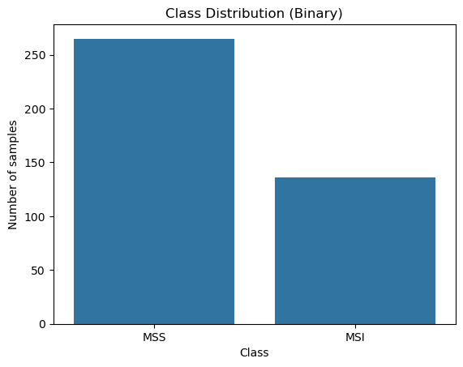
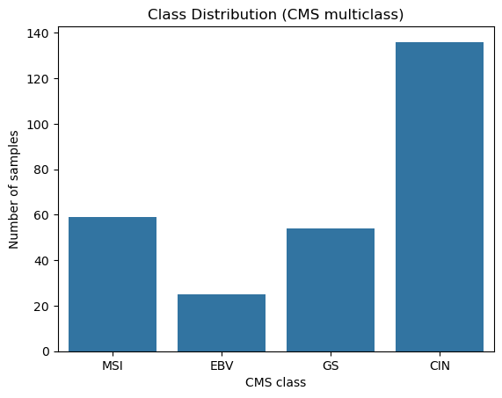
Figure 1Class Distribution
Principal Component Analysis (PCA) was conducted to explore the separability of classes in a lower-dimensional space. The PCA results, as seen in Figure 2, showed substantial overlap between classes for both classification tasks. This suggested that clear separation between subtypes would be challenging and highlighted the complexity of the classification problem.
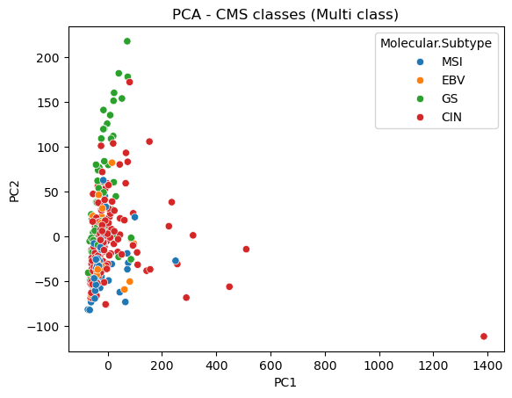
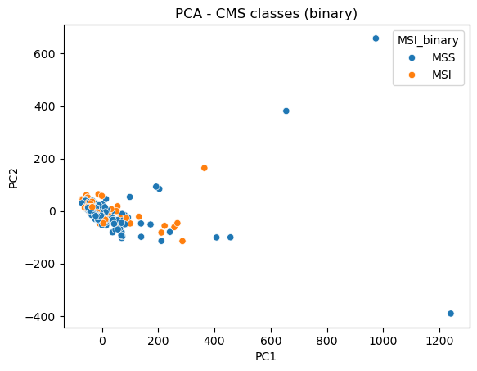
Figure 2 PCA
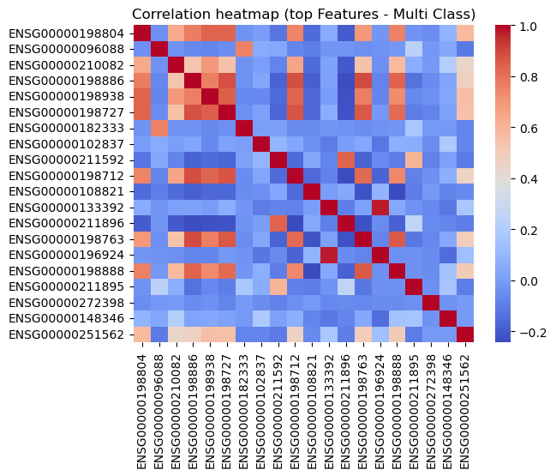
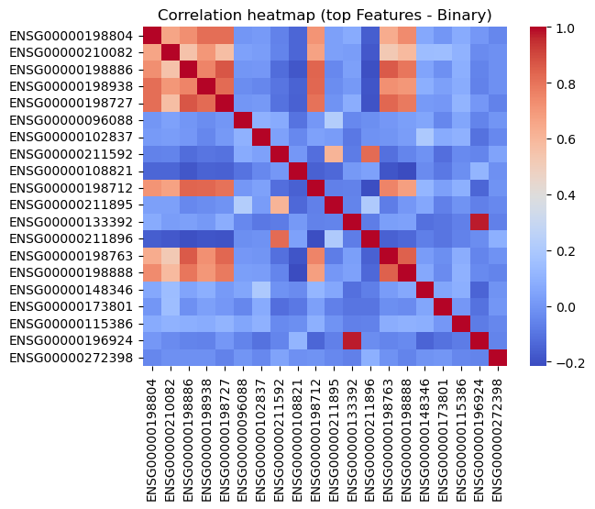
In addition, a correlation heatmap (Figure 3) was generated using the 20 genes with the highest variance. This analysis examined relationships between highly variable genes and provided insight into potential redundancy among features. Some genes showed strong positive correlations (warmer tones), indicating that they may be involved in similar biological pathways. This suggests potential functional relationships between these genes. At the same time, other gene pairs display weak or negative correlation (cooler tones). This indicates independent expression patterns. The presence of both strongly and weakly correlated gene groups suggests that the tumor subtypes are characterized by complex and diverse mechanisms of gene regulation.
Figure 3 correlation heatmap

Training and Test Set Splitting
After the explorative data analysis, the datasets were split into training and test sets. 70% of the data were assigned to the training set to ensure sufficient samples for model learning. The remaining 30% were used as the test set for performance evaluation.
Class distributions were then examined in both subsets to verify that subtype proportions were similar. It was confirmed that the split successfully preserved the original class balance across training and test sets.

Feature filtering
As the dataset contained over 60’000 gene expression features, an additional feature filtering step was performed after data splitting. Feature filtering is applied only to the feature matrix (X) and not to the target variable (y) because filtering aims to remove uninformative input features, not class labels. A low-expression Filter was used to remove genes that are expressed in only a small fraction of samples. Genes that are rarely expressed across patients are unlikely to provide meaningful information for classification and may introduce noise (Sha et al., 2015). A gene was retained only if it showed non-zero expression values in at least 10% of the training samples. This threshold ensures that only genes with consistent expression patterns across multiple patients are kept. (RNASeq Filtering, n.d.) Afterwards, a variance-based filtering was applied to remove features with low variance. A variance threshold of 0.01 was selected to exclude features with minimal variation. Genes with extremely low variance are nearly constant across all samples and therefore do not contribute meaningful discriminatory information for classification. Removing these helps the model to focus on more informative genes and reduces computational complexity. (Basher et al., 2025) Feature filtering was learned exclusively from the training data. The same selected features were then applied to the test set to avoid information leakage and ensure unbiased evaluation.
After both filtering steps, the dimensionality of the datasets was reduced. For the multiclass setting, the number of features decreased to 33597 genes for both the training and test sets. In the binary setting (training and test set), 32392 features remained after filtering.

Modelling
A Random Forest classifier was applied for both the multiclass and binary approaches. Random Forest is an ensemble method that combines multiple decision trees. Each tree is trained on a random subset of samples and features. Predictions are obtained by majority voting. This reduces overfitting and improves generalization. (Baladram, 2024) For tree construction, the Gini impurity criterion was used to measure node purity. At each split, the algorithm selected the feature that minimized the Gini impurity, resulting in the most homogeneous child nodes. This criterion was chosen because it is computationally efficient and commonly used for classification tasks. (Gulati et al., 2016)
Hyperparameters such as the number of trees and tree depth were optimized using grid search with cross-validation for both models. This ensured fair parameter selection.

Evaluation
Model performance was evaluated using accuracy, precision, recall, and F1-Score. Confusion matrices were generated for both modelling approaches. For the binary task, ROC curves and AUC values were calculated.
Additionally, a Feature importance analysis was performed using Random Forest importance scores. The top-ranked genes were visualized to support biological interpretation.

Results
This section presents the performance of the Random Forest models for both classification tasks. Results are reported for the multiclass and binary approaches using standard evaluation metrics. Confusion matrices and ROC analysis are used to provide a more detailed assessment of model behavior. In addition, feature importance results are presented to interpret the contribution of individual genes to the classification process.

Multiclass Classification
The multiclass Random Forest model achieved an overall accuracy of 0.73. The performance varied across the four molecular subtypes.
CIN tumors showed high recall (0.92), indicating that most true CIN samples were correctly identified. However, precision was lower (0.67), suggesting that some samples from other classes were incorrectly predicted as CIN.
EBV tumors achieved perfect precision (1.00) but very low recall (0.30). This indicates that although all predicted EBV samples were correct, most true EBV samples were misclassified.
GS tumors showed moderate performance with a precision of 0.71 and a recall of 0.62. This suggests balanced but imperfect classification.
MSI tumors achieved strong performance with high precision (0.93) and recall (0.70). This indicates that MSI samples have more distinct molecular patterns compared to other subtypes.
The macro-average F1-score was 0.68, reflecting uneven class performance. The weighted average F1-score was 0.72, influenced by dominant classes.
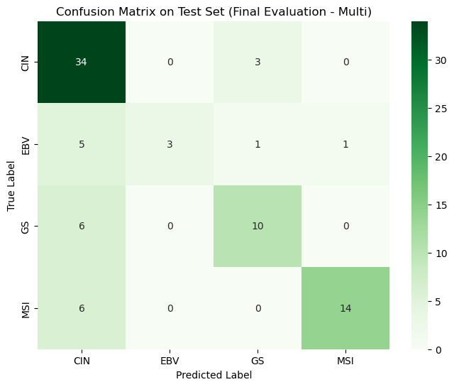
The confusion matrix (Figure 4) shows that most CIN samples were correctly classified (34/37). However, misclassifications occurred mainly between CIS and GS, and between EBV and CIN.
Figure 4 Confusion Matrix on Test Set (multiclass)

Binary Classification
The binary Random Forest model achieved a higher accuracy of 0.78.
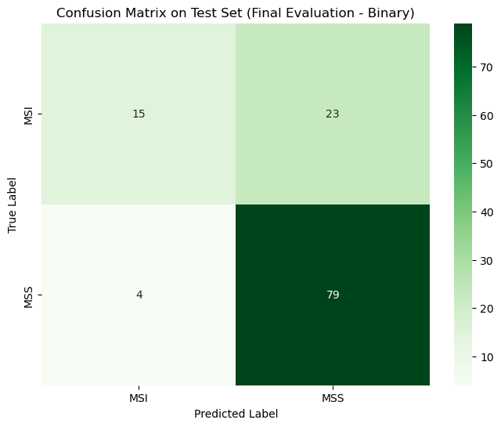
MSS tumors were classified very reliably, with high recall (0.95) and an F1-score of 0.855. In contrast, MSI tumors showed lower recall (0.39), indicating that many MSI samples were misclassified as MSS.
Figure 5 Confusion Matrix on Test Set (Binary)
The confusion Matrix confirms this (see Figure 5). Out of 38 true MSI samples, only 15 were correctly identified, while 23 were classified as MSS. In contrast, 79 out of 83 MSS samples were correctly classified.
This class imbalance explains the higher performance for MSS. The model tends to favor the majority class, leading to reduced sensitivity for MSI detection.
Receiver Operating Characteristic (ROC) analysis was performed to further evaluate model performance. The ROC curve illustrates the trade-off between true positive rate and false positive rate across different decision thresholds. As shown in Figure 6, the curve deviates strongly from the diagonal reference line, resulting in a lower “Area under the Curve”-value (AUC) of 0.17. This indicated the model’s limited discriminative power.
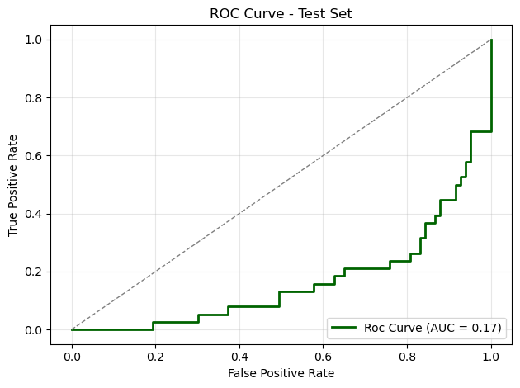
Figure 6 ROC-AUC

Feature Importance
Feature importance analysis showed that predictions were driven by multiple genes rather than by a single dominant marker.
For the binary task, the most important genes showed similar importance values, all below 0.01.
For the multiclass task, importance values were even lower, reflecting increased complexity. No single gene dominated the predictions. Instead, many genes contributed moderately. Figure 7 shows the top ten Features for both the multiclass and binary models.
Figure 7 Feature importance
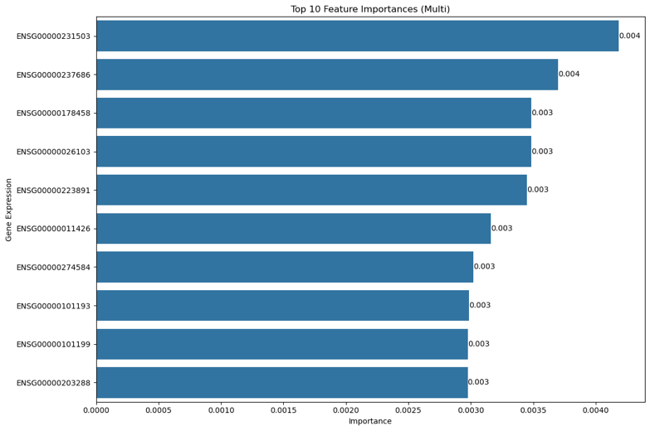
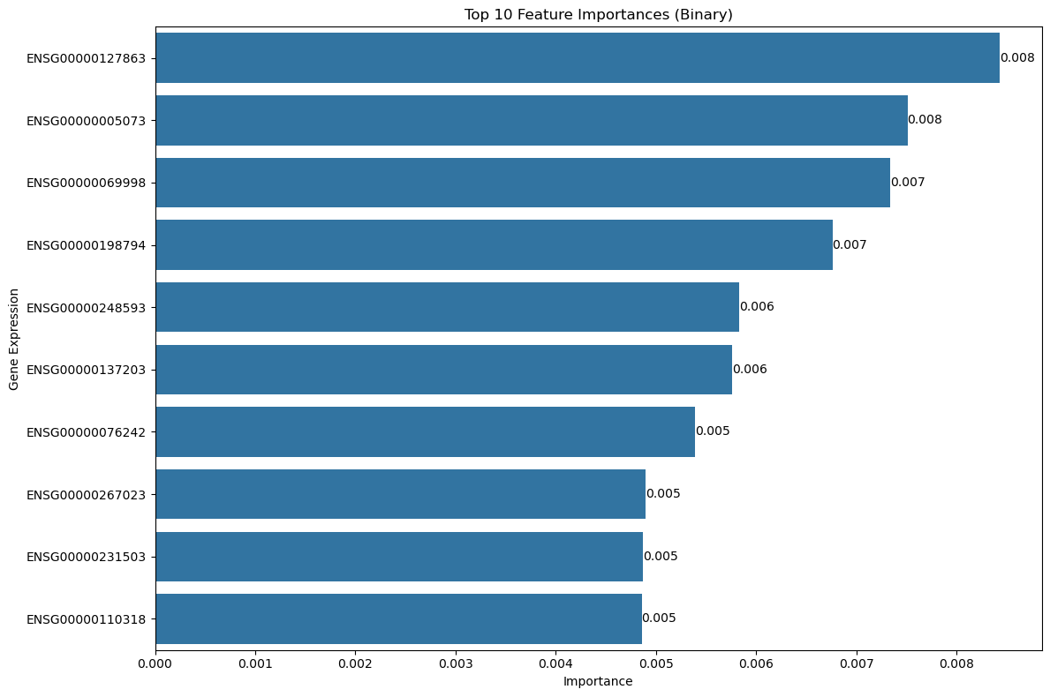
Figure 7 Feature importance

Discussion
This project compared multiclass and binary Random Forest classification on the stomach adenocarcinoma gene expression dataset. The multiclass model demonstrated moderate but consistent performance across the four molecular subtypes. Accuracy and class-specific F1-scores indicated that the model could distinguish among most subtypes, although performance varied by class size. This suggests that gene expression profiles contain subtype-specific patterns that can be captured by Random Forest models (Khanna et al., 2013).
A major reason for this weak performance is the merging of MSI-L and MSI-H into a single MSI class. While both are microsatellite instable, they differ biologically. MSI-H tumors show strong genomic instability, whereas MSI-L samples are more heterogeneous and closer to MSS at the molecular level. Combining them introduced noise into the MSI class. This made it difficult for the model to learn a clear separation. (de la Chapelle & Hampel, 2010; Han et al., 2022)
In contrast, the binary classifier showed weaker discriminative performance. Although the overall accuracy appears acceptable (~0.78), the ROC-AUC value of 0.17 indicates extremely poor class separation. This highlights that accuracy alone is insufficient to evaluate model quality, particularly in imbalanced datasets. The model tended to favor the majority MSS class, resulting in reduced sensitivity for MSI detection.
The project demonstrated the importance of using multiple evaluation metrics (Mamalakis et al., 2024). While accuracy provided a general performance overview, precision, recall, F1-scores, confusion matrices, and ROC-AUC revealed class-specific weaknesses that accuracy alone masked. Especially in clinical Settings, ROC-AUC is essential as it evaluates threshold-independent class discrimination (Verbakel et al., 2020).
Feature importance analysis also showed that prediction is driven by multiple genes rather than by a single dominant marker. This indicated that no individual gene alone is sufficient to distinguish between the subtypes. Instead, a combination of several genetic features contributes to the model’s decision-making process. His findings reflect the complex molecular profiles of the subtypes and support the idea that these conditions are influenced by interacting biological pathways rather than isolated factors. (Ramadhani et al., 2025)
Several limitations of this project should be considered. The dataset contains class imbalance and a small sample size for some subtypes. This may bias model performance and reduce reliability for minority classes (Zhao et al., 2025). In addition, merging MSI-L and MSI-H into a single MSI class introduces biological heterogeneity and reduces class separability (Han et al., 2022). Finally, the model was only validated internally on the same dataset and not tested on an independent dataset from a different source. As a result, it remains unclear how well the model would perform on another dataset.
Future work should keep MSI-L and MSI-H as separate classes. Treating them separately would allow the models to capture more detailed patterns. Including larger and independent datasets would increase the robustness of the results. It would also improve generalizability and reduce the risk of overfitting. Advanced feature selection methods should be explored. They can help identify the most informative biomarkers and reduce noise in the data. This may improve interpretability. Finally, integrating clinical variables could further improve prediction performance. Variables such as age, tumor stage, and treatment history provide important information.

Conclusion
This Project showed that Random Forest models can classify molecular subtypes of stomach adenocarcinoma using gene expression data. The multiclass approach outperformed the binary classification and better preserved biological differences between tumor subtypes. Feature importance analysis confirmed that predictions rely on multiple genes rather than single markers, reflecting the molecular complexity of stomach cancer. While the results are promising, further improvements using larger datasets and clinically relevant variables are needed before clinical application.

Use of AI
AI tools were used to clarify questions and to support understanding of concepts before starting the project. Furthermore, AI was used for code debugging and for improving English grammar and clarity. All analytical decisions, interpretations, and conclusions were made independently by the author.

References
Baladram, S. (2024, November 30). Random Forest, Explained: A Visual Guide with Code Examples. TDS Archive. https://medium.com/data-science/random-forest-explained-a-visual-guide-with-code-examples-9f736a6e1b3c

Basher, A. R. M. A., Hallinan, C., & Lee, K. (2025). Heterogeneity-Preserving Discriminative Feature Selection for Disease-Specific Subtype Discovery. bioRxiv, 2023.05.14.540686. https://doi.org/10.1101/2023.05.14.540686

Breiman, L. (2001). Random Forests. Mach. Learn., 45(1), 5–32. https://doi.org/10.1023/A:1010933404324

Cancer Genome Atlas Research Network. (2014). Comprehensive molecular characterization of gastric adenocarcinoma. Nature, 513(7517), 202–209. https://doi.org/10.1038/nature13480

Çorbacıoğlu, Ş. K., & Aksel, G. (2023). Receiver operating characteristic curve analysis in diagnostic accuracy studies: A guide to interpreting the area under the curve value. Turkish Journal of Emergency Medicine, 23(4), 195–198. https://doi.org/10.4103/tjem.tjem_182_23

de Bodt, C., Diaz-Papkovich, A., Bleher, M., Bunte, K., Coupette, C., Damrich, S., Sanmartin, E. F., Hamprecht, F. A., Horvát, E.-Á., Kohli, D., Krishnaswamy, S., Lee, J. A., Lelieveldt, B. P. F., McInnes, L., Nabney, I. T., Noichl, M., Poličar, P. G., Rieck, B., Wolf, G., … Kobak, D. (2025). Low-dimensional embeddings of high-dimensional data. https://arxiv.org/html/2508.15929v1

de la Chapelle, A., & Hampel, H. (2010). Clinical Relevance of Microsatellite Instability in Colorectal Cancer. Journal of Clinical Oncology, 28(20), 3380–3387. https://doi.org/10.1200/JCO.2009.27.0652

Goldenring, J. R., & Nam, K. T. (2010). Oxyntic Atrophy, Metaplasia, and Gastric Cancer. In Progress in Molecular Biology and Translational Science (Vol. 96, pp. 117–131). Academic Press. https://doi.org/10.1016/B978-0-12-381280-3.00005-1

Gulati, P., Sharma, A., & Gupta, M. (2016). Theoretical Study of Decision Tree Algorithms to Identify Pivotal Factors for Performance Improvement: A Review. International Journal of Computer Applications, 141(14), 19–25. https://doi.org/10.5120/ijca2016909926

Han, S., Chok, A. Y., Peh, D. Y. Y., Ho, J. Z.-M., Tan, E. K. W., Koo, S.-L., Tan, I. B.-H., & Ong, J. C.-A. (2022). The distinct clinical trajectory, metastatic sites, and immunobiology of microsatellite-instability-high cancers. Frontiers in Genetics, 13, 933475. https://doi.org/10.3389/fgene.2022.933475

Khanna, C., Avery, A. C., Olver, C., & Paoloni, M. C. (2013). Molecular Diagnostics. In Withrow and MacEwen’s Small Animal Clinical Oncology (pp. 131–142). W.B. Saunders. https://doi.org/10.1016/B978-1-4377-2362-5.00008-6

Mamalakis, M., Banerjee, A., Ray, S., Wilkie, C., Clayton, R. H., Swift, A. J., Panoutsos, G., & Vorselaars, B. (2024). Deep multi-metric training: The need of multi-metric curve evaluation to avoid weak learning. Neural Computing and Applications, 36(30), 18841–18862. https://doi.org/10.1007/s00521-024-10182-6

Ramadhani, S., Handayani, L., Ng, T., Dzulkifly, S., Ariffin, R., Budiman, H., & Wang, S. (2025). Feature Selection Optimisation for Cancer Classification Based on Evolutionary Algorithms: An Extensive Review. Computer Modeling in Engineering & Sciences, 143(3), 2711–2765. https://doi.org/10.32604/cmes.2025.062709

RNASeq filtering. (n.d.). Retrieved January 10, 2026, from https://combine-australia.github.io/RNAseq-R/slides/RNASeq_filtering_qc.pdf

Sha, Y., Phan, J. H., & Wang, M. D. (2015). Effect of low-expression gene filtering on detection of differentially expressed genes in RNA-seq data. Conference Proceedings : ... Annual International Conference of the IEEE Engineering in Medicine and Biology Society. IEEE Engineering in Medicine and Biology Society. Annual Conference, 2015, 6461–6464. https://doi.org/10.1109/EMBC.2015.7319872

Verbakel, J. Y., Steyerberg, E. W., Uno, H., De Cock, B., Wynants, L., Collins, G. S., & Van Calster, B. (2020). ROC curves for clinical prediction models part 1. ROC plots showed no added value above the AUC when evaluating the performance of clinical prediction models. Journal of Clinical Epidemiology, 126, 207–216. https://doi.org/10.1016/j.jclinepi.2020.01.028

Wijaya, C. Y. (2023, December 16). Random Forest Feature Importance Explained. https://www.nb-data.com/p/random-forest-feature-importance

Zhang, W. (2014). TCGA divides gastric cancer into four molecular subtypes: Implications for individualized therapeutics. Chinese Journal of Cancer, 33(10), 469–470. https://doi.org/10.5732/cjc.014.10117

Zhao, S., Gui, J., Dong, M., Yu, B., Gui, Z., Dong, L., Tang, Y. Y., & Kwok, J. T.-Y. (2025). A Survey on Small Sample Imbalance Problem: Metrics, Feature Analysis, and Solutions. https://arxiv.org/html/2504.14800v1

