Chang Li

1.

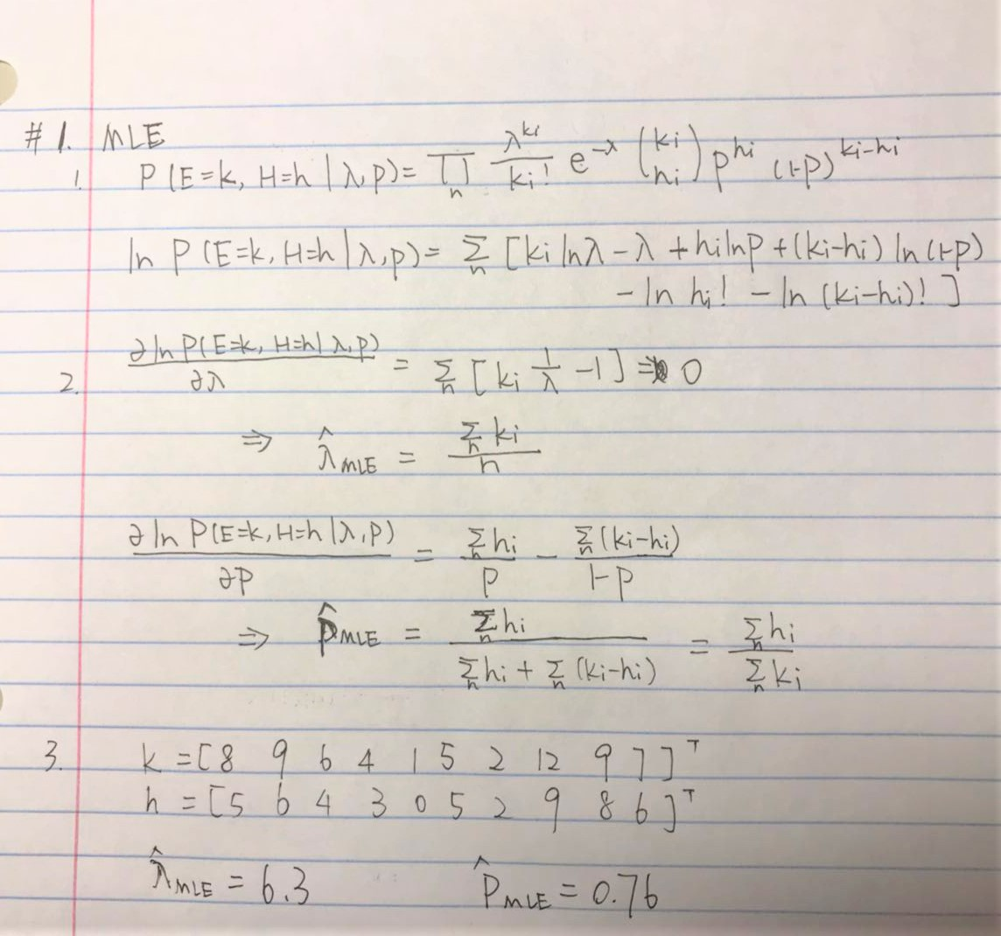

2.

2.1 LASSO

1.

1. Small
2. Large
3. Large
4. Large

2.

1. Large
2. Large
3. Small
4. Small

2.2 Ridge

1.

2.

3. for , their behaviors will differ

For Lasso Regression, our estimate of shall be 0, because the derivative is a constant for non-zero values.

For Ridge Regression, our estimate of can be a very small number, because being small could balance off being large.