Submission Checklist (JCDE-202X-XXX)

- Please write the manuscript ID in the file name and title of this document for revised manuscripts and leave XXX as it is for original manuscripts.
- When submitting a paper to the journal, adhere to the following guidelines. Failure to comply often results in the need to resubmit. However, for first-time submissions of original manuscripts, authors are required to follow only the selected instructions outlined in the submission checklist.
- If your submission is an original or revised manuscript (MS) under review, check the box in the "MS under Review" column. Conversely, if it is a final MS accepted for publication, in the case of Conditional Acceptance, check the box in the "Final MS for Publication" column.
- The items marked in blue must be fulfilled. Otherwise, your manuscript will be unsubmitted for revision.

Author and Manuscript Information
Subject |  |  | Content | MS under Review | Final MS for Publication
Manuscript ID |  |  | JCDE-202X-XXX | ☐ | ☐
Manuscript Title |  |  | Face-Level Graph Learning for Rivet and Cosmetic Feature Recognition in Aircraft B-Rep Models | ☒ | ☐
List of All Authors | Full Names  (separated by ‘,’) |  | Jiayi Geng, Gangyi Li, Zhongxuan Luo, Na Lei | ☒ | ☐
List of All Authors | E-mail Addresses  (in the order of names) |  | gjyyy@mail.dlut.edu.cn, GregoryLi@mail.dlut.edu.cn, zxluo@dlut.edu.cn, nalei@dlut.edu.cn | ☒ | ☐
Corresponding Author  (CA) | CA Consistency |  | - Note the journal typically allows a maximum of two corresponding authors.  - The corresponding author registered in the ScholarOne system is responsible for APC payment and the copyright license agreement, and all communication is conducted through this author.  - The corresponding author must be the same as the one specified in the manuscript (or both authors, if two corresponding authors are indicated in the manuscript). | ☐ | ☐
Corresponding Author  (CA) | 1st  CA | Full Name | Na Lei | ☒ | ☐
Corresponding Author  (CA) | 1st  CA | Affiliation | School of Software, Dalian University of Technology, Development Zone Campus, No. 321 Tuqiang Street, Dalian, Liaoning 116620, China | ☒ | ☐
Corresponding Author  (CA) | 1st  CA | E-mail | nalei@dlut.edu.cn | ☒ | ☐
Corresponding Author  (CA) | 1st  CA | ORCID | 0000-0003-3361-0756 | ☒ | ☐
Corresponding Author  (CA) | 2nd CA  (if exist) | Full Name |  | ☐ | ☐
Corresponding Author  (CA) | 2nd CA  (if exist) | Affiliation |  | ☐ | ☐
Corresponding Author  (CA) | 2nd CA  (if exist) | E-mail |  | ☐ | ☐
Corresponding Author  (CA) | 2nd CA  (if exist) | ORCID |  | ☐ | ☐
APC-Paying Author  (An Invoice will be issued to this Author. If multiple authors will share the APC, copy and complete this section for each author) | Full Name |  |  | ☐ | ☐
 | E-mail |  |  | ☐ | ☐
 | Affiliation |  |  | ☐ | ☐
 | Address |  |  | ☐ | ☐
 | City |  |  | ☐ | ☐
 | Province |  |  | ☐ | ☐
 | Postal Code |  |  | ☐ | ☐
 | Country |  |  | ☐ | ☐

File List and Order to Submit

MS = Manuscript

Stage | Count | Submission Order | MS under Review | Final MS for Publication
Initial Submission | 5 | (1) Main Document (.pdf)  (2) Graphical Abstract (.pdf)  (3) Highlights (.docx)  (4) Checklist (.docx)  (5) Main Document Source File (MS Word or LaTex) (.zip) | ☐
Submission after a Minor / Major Revision decision | 6 | (1) Author's Response (.docx)  (2) Main Document (.pdf) (with changed text turned blue)  (3) Graphical Abstract (.pdf)  (4) Highlights (.docx)  (5) Checklist (.docx)  (6) Main Document Source File (MS Word or LaTex) (.zip) | ☐
Final Submission after Conditional Acceptance | 6 | (1) Main Document (.pdf)  (2) Graphical Abstract (.eps/.tiff/.jpg)  (3) Highlights (.docx)  (4) Checklist (.doxc)  (5) Main Document Source File (MS Word or LaTex) (.zip)  (6) Figures (.zip)  (7) Alt Text (MS Word) (.docx) |  | ☐
Order and Type of Documents |  | When submitting documents, please follow the numerical order indicated at the beginning of the document and the file type specified in parentheses. |  | ☐

Preparing Main Manuscript

General Formatting and Style for Manuscripts
Subject | Instruction |  |  | MS under Review | Final MS for Publication
Instructions for Authors | Please read and follow the guidelines provided in the Instructions to Authors, available on https://academic.oup.com/jcde/pages/general-instructions |  |  |  | ☐
Aims and Scope | Make sure that your paper aligns with the Aims and Scope of the journal, available on https://academic.oup.com/jcde/pages/About |  |  | ☐ | ☐
Aims and Scope | Citing relevant papers previously published in this journal can help demonstrate this alignment. It is recommended to reference papers published recently, within the last three years. |  |  | ☐ | ☐
Special Issue | Is this manuscript being submitted to a special issue? | Yes | ☐ | ☒ | ☐
Special Issue | Is this manuscript being submitted to a special issue? | No | ☒ | ☒ | ☐
Special Issue | If yes, please provide the title of the special issue (SI).  - SI Title: |  |  | ☐ | ☐
Preprint Link | Has this manuscript been previously posted to a preprint server such as arXiv and SSRN? | Yes | ☐ | ☒ | ☐
Preprint Link |  | No | ☒ | ☒ | ☐
Preprint Link | If yes, please provide the link to the preprint posting.  - Link: |  |  | ☐ | ☐
Manuscript File | Use the MS Word or LaTex template for editing manuscripts.  (Refer to Author Guideline to find the template files)  - This is mandatory for revised manuscripts and strongly recommended for original manuscripts.  - For creating manuscripts in LaTex, JCDE recommends the use of Overleaf and LaTex template in Overleaf. |  |  | ☐ | ☐
Manuscript File | In the revised manuscript after review, change the colour of the corrected text to blue. (Do not change the background colour of the corrected text.)  - However, if your manuscript is conditionally accepted, submit a clean version with all the text in black. |  |  |  | ☐
Language Editing | Language editing, mainly if English is not your first language, can be used to ensure that the Editors and reviewers fully understand the academic content of your manuscript. |  |  |  | ☐
Language Editing | For the revised manuscript, make the necessary edits based on the Grammarly report we have provided. |  |  |  | ☐
General Formatting | Format as single-column, A4, portrait orientation. |  |  | ☒ | ☐
General Formatting | Set the line spacing to 1.5 and the font size of the main text to 12pt. |  |  | ☒ | ☐
Style Convention | Follow the Oxford APA style.  (Refer to the Issues of JCDE) |  |  |  | ☐
Style Convention | The journal accepts manuscripts written in either American or British English. Spelling must be consistent throughout the manuscript. If British English is selected, the use of Oxford spelling (e.g., organize, optimize rather than organise, optimise) is strongly preferred, consistent with the traditions of Oxford University Press." |  |  |  | ☐
Abbreviations | Define non-standard abbreviations at the first occurrence and use sparingly and consistently. |  |  |  | ☐

Manuscript Structure
Subject | Instruction | MS under Review | Final MS for Publication
Title Page | Include the title of article. |  | ☐
Title Page | Avoid abbreviations in the title unless absolutely necessary. |  | ☐
Title Page | For each author, provide the full name (first name, middle initial, and last name), affiliation, institutional address, email address, and ORCID (refer to the Manuscript Template). |  | ☐
Title Page | Indicate the corresponding author by adding “(Corresponding Author)” next to their name. |  | ☐
Title Page | Include the email address of the corresponding author. |  | ☐
Title Page | Include the ORCID of the corresponding author after the institutional address. (mandatory) |  | ☐
Title Page | Include the ORCID of co-authors after the address. (strongly recommended) |  | ☐
Title Page | Note the journal typically allows a maximum of two corresponding authors.  If there are two corresponding authors, the author registered as the corresponding author in the ScholarOne system will serve as the primary contact for communication with OUP and the journal office. | ☐ | ☐
Abstract | Avoid reference citations and abbreviations. |  | ☐
Abstract | Consist of a single paragraph and be concise. |  | ☐
Keywords | Include up to 6 keywords. |  | ☐
Nomenclature | Be located between Keywords and the first section (e.g. 1. Introduction). |  | ☐
Sections | Number sections sequentially, such as 1., 2., etc., with subsections numbered 1.1, 1.1.1, 1.1.2, etc. |  | ☐
Sections | All section titles should be written in sentence case, with only the first letter of the first word capitalized.  For example,  - “Introduction”  - “Experimental results”  - “Conclusion and future work”  Please do not capitalize every major word in the section titles |  | ☐
Sections | Ensure that non-numbered sections are named and ordered as follows:  - Conflicts of interest (mandatory)  - Author contributions (mandatory)  - Funding (optional)  - Data availability (mandatory / optional)  - Acknowledgments (optional) |  | ☐
Conflicts of interest | These are mandatory for the submission. |  | ☒
Conflicts of interest | Authors must disclose any personal or financial interests related to the subject matter of the paper in the cover letter and manuscript, which include personal involvement in the topic, financial interest in the topic, funding from parties interested in the paper, and third-party review rights before JCDE submission. |  | ☐
Author contributions | These are mandatory for the submission. |  | ☒
Author contributions | Authors must provide appropriate credit and clarify the specific contributions of each author by following the NISO CrediT (Contributor Roles Taxonomy). |  | ☒
Author contributions | Use the following format for author contributions:  Kunwoo Lee: Conceptualization, Methodology, Software. Shuming Gao: Data curation, Writing—original draft. Sang Hun Lee: Visualization, Investigation. Jami J. Shah: Supervision. Hiromasa Suzuki: Software, Validation. Myung-Il Roh: Writing—review & editing. |  | ☒
Funding | Cite all funding for your research, providing the grant number and the funder name.  - An example statement is as follows: This work is supported in part by funds from the National Science Foundation (NSF: # 1636933 and # 1920920).  - Include PubMed Central links with specific grant numbers if requested.  - If the institution or organization that provided the funding requires you to include the funding information in the acknowledgments section, you are welcome to do so. Otherwise, write it here. |  | ☒
Data availability | The data availability statement should provide information on where and under what conditions the data directly supporting the publication can be accessed.  Sample data availability statements are available at the following site: https://academic.oup.com/pages/open-research/research-data#Data%20Availability%20Statements | ☐ | ☐
Data availability | If the manuscript is based on a dataset, a link to the dataset must be provided to ensure that the data are available for peer review. | ☐ | ☐
Acknowledgments | The authors thank those people or institutions that have helped you in the preparation of the manuscript. |  | ☐
References | Arrange references in alphabetical order by the last name of the first author. For the first names, use initials rather than full names. |  | ☐
References | Adhere to the APA v7 style for all references, which adopts an author-date format. (Refer to the Purdue OWL) |  | ☐
References | The last name comes first, followed by an abbreviated version of the first and middle names. For example, not J. F. Kennedy, but Kennedy, J. F. |  | ☐
References | References should be formatted with a hanging indent, meaning that all lines after the first line of each entry are indented. |  | ☐
References | Include the DOI link whenever possible. |  | ☐
References | Note that APA style referencing must be applied to revised manuscripts after review although it may not be enforced when submitting original manuscripts. |  | ☐
Appendix | - Use Appendix alone if only one appendix exists (e.g., "Appendix. [Title]"). For multiple appendices, label sequentially as Appendix A, Appendix B, etc., with each on its own page.​ (e.g. "Appendix A. [Title]")  - Number subsections within appendices using appendix-letter numbering (e.g., A.1, A.1.1, A.1.2; B.1, B.1.1, etc.). If there is only one appendix, number its subsections as A.1, A.1.1, A.1.2, etc. |  | ☐
Appendix | Mention all figures and tables in the Appendix text in numerical order. |  | ☐

Tables, Figures, Mathematics, and Citations
Subject | Instruction | MS under Review | Final MS for Publication
Figures & tables | Insert figures and tables directly into the manuscript's text, rather than placing them at the end. | ☒ | ☐
Figures & tables | Mention all figures and tables in the main text in numerical order.  Place the figure or table immediately below the paragraph where it is cited. | ☐ | ☐
Figures & tables | Figures and tables should be sufficiently large and clear for easy readability. | ☐ | ☐
Figures & tables | They should be accompanied by a legend. | ☐ | ☐
Figures & tables | Number figures and tables consecutively (e.g., Figure 1, Table 1).  In an appendix, prefix the numbering with the appendix letter (e.g., Figure A1, Table B1). |  | ☐
Figures & tables | Use 2D graphics instead of 3D graphics unless absolutely necessary, because 2D graphics are clearer, more accurate, and easier to interpret. |  | ☐
Figures & tables | Remove the lines around the figure borders. |  | ☐
Figures & tables | Avoid using white text and background colors in tables and figures |  | ☐
Figures & tables | Use “Figure” in full rather than the abbreviation “Fig.” when referencing figures in both the captions and the main text. |  | ☐
Figures & tables | If a figure contains multiple subfigures, label each subfigure with a capital letter (A, B, C, etc.) centered below the subfigure, as shown in Figure 2 of the manuscript template.  Note: Do not embed the labels inside the subfigure images.  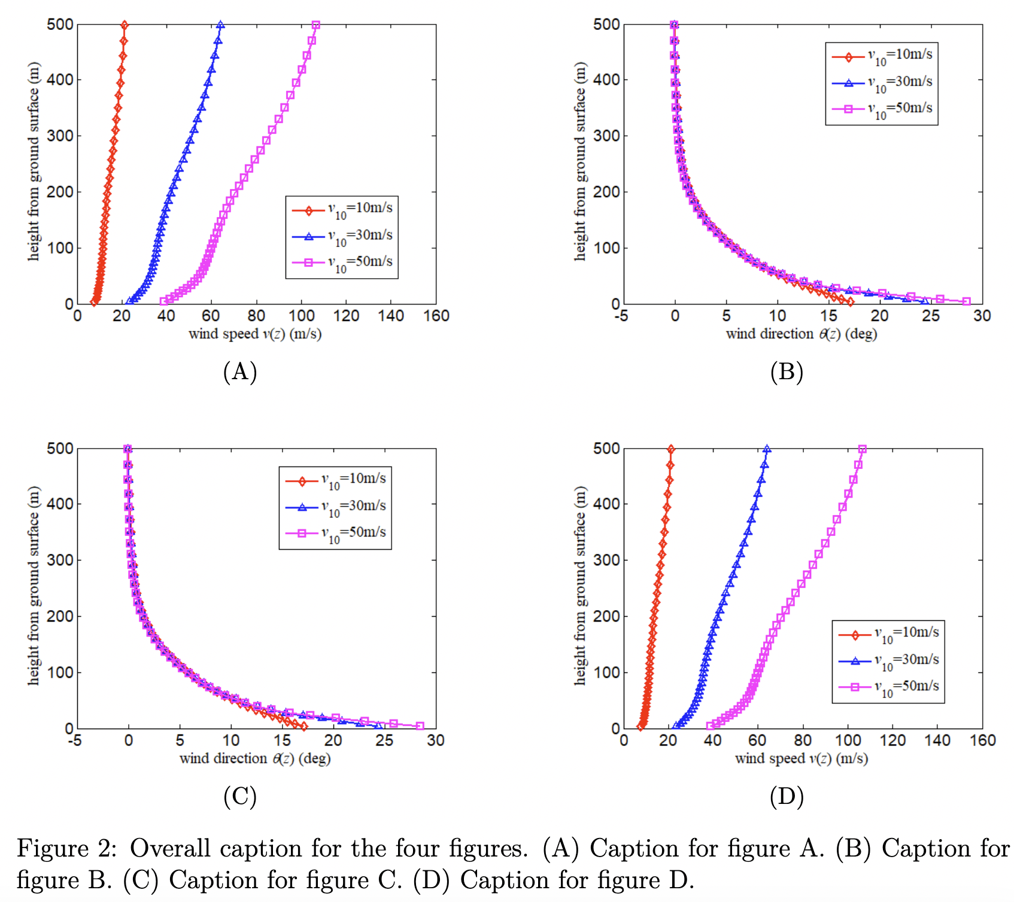 |  | ☐
Figures & tables | When citing figures with multiple subfigures within the text, use the format "Figure 2A" and "Figure 2B". For the figure caption, employ the format "(A)", "(B)", etc. |  | ☐
Figures & tables | When arranging multiple images within a figure using a horizontal by vertical grid, having too many images aligned horizontally can reduce their size and make the accompanying text difficult to read.  To enhance visibility, consider decreasing the number of images arranged horizontally. For example, if the current 2×4 layout results in images that are too small, adjust the arrangement to a 4×2 grid instead. |  | ☐
Mathematics | Provide as editable text, either in MS Word or in the LaTeX source file. |  | ☐
Mathematics | Display equations should be numbered consecutively throughout the manuscript. |  | ☐
Mathematics | Use “Equation $i$” instead of “Eq. $i$” or “Equation ($i$)” when referencing equations in the main text, where $i$ represents the equation number. |  | ☐
Citations | Ensure every reference cited in the text is also present in the reference list and vice versa. |  | ☐
Citations | Adhere to the APA v7 style for all references in the text, which adopts an author-date format. (Refer to the Purdue OWL and the Publication Manual of the American Psychological Association (APA), Seventh Edition, ISBN 978-1-4338-3215-4) |  | ☐
Citations | Note that APA style citation must be applied to revised manuscripts after review although it may not be enforced when submitting original manuscripts. |  | ☐

Preparing Graphical Abstract, Highlights, Author’s Response, Figures, Supplementary Data, and Checklist

Subject | Instruction | MS under Review | Final MS for Publication
Main Document Source File | Use the MS Word or LaTex template for manuscripts.  (Refer to Author Guidelines to find the template files) |  | ☐
Main Document Source File | Submit an MS Word file (.docx) or a zipped LaTex source file (.zip) as Main Document Source File. | ☐ | ☐
Main Document Source File | In the revised manuscript after review, change the colour of the corrected text to blue. (Do not change the background colour of the corrected text.)  However,  - if your manuscript is conditionally accepted, submit a clean version with all the text in black. | ☐ | ☐
Main Document | Submit a PDF file for the manuscript as Main Document. | ☒ | ☐
Graphical Abstract | Graphical Abstract is mandatory for the submission and will be displayed in the online manuscript but will not appear in the manuscript PDF file. (Refer to Author Guidelines or Instructions to Author to find the examples of Graphical Abstract) | ☐ | ☐
Graphical Abstract | Filename is Graphical_abstract |  | ☐
Graphical Abstract | Provide a single, concise, pictorial, and visual summary of the main findings of the manuscript. |  | ☐
Graphical Abstract | Do not use algorithm flowcharts as a graphical abstract. |  | ☐
Graphical Abstract | Must be informative, interesting, visually appealing, and straightforward. |  | ☐
Graphical Abstract | It should be prepared at a minimum of 1250 (w) × 500 (h) pixels with a resolution of 300 dpi. If larger images are submitted, the same aspect ratio (5:2) should be maintained whenever possible.  This requirement ensures consistency in layout, prevents distortion during typesetting, and guarantees readability in both print and online formats. |  | ☐
Graphical Abstract | Font: Please use Times, Arial, Courier, or Symbol font with a large enough font size, as the image will be reduced in size to fit a window. |  | ☐
Graphical Abstract | Use the same file format and resolution requirement as for figures. |  | ☐
Graphical Abstract | Do not include any additional text or label, unnecessary white space, outline, synopsis, or a heading ''Graphical Abstract'' within the image file. |  | ☐
Highlights | Highlights are mandatory for the submission.  (Refer to Author Guidelines or Instructions to Author to find the examples of Highlight). | ☐ | ☐
Highlights | Write and submit the highlights in an A4-sized, portrait-oriented MS Word file. |  | ☐
Highlights | Add a heading titled “Highlights” on the first line. |  | ☐
Highlights | Three to five bullet points that help increase the discoverability of the manuscript via search engines. |  | ☐
Highlights | Should capture the novel results of your study as well as new methods that were used during the study (if applicable). |  | ☐
Highlights | Each Highlight can be no more than 15 words or 100 characters, including spaces. |  | ☐
Author’s Response | Author’s Response is mandatory for the submission after a minor or major revision decision (Not required for original manuscript submissions and final production submission). |  | ☐
Author’s Response | When revising your manuscript, carefully consider all issues mentioned in the reviewers' comments. Outline every change made in response to their comments and provide suitable rebuttals for any comments not addressed. |  | ☐
Figures | Note that figure files must be submitted if the manuscript is CONDITIONALLY ACCEPTED. |  | ☐
Figures | Submit all the high-resolution publication-quality figures as a single compressed zip file |  | ☐
Figures | Save raster images as uncompressed .tif to avoid quality loss  - .jpg/.png are acceptable but may be lower resolution than .tif  - Avoid .bmp, .gif, and native application formats |  | ☐
Figures | Save vector images as .eps/.svg/.pdf and embed fonts |  | ☐
Figures | Resolution should be at least 300 DPI for color halftone and 600 dpi for line art at intended publication size  - Author guidance here, how to check resolution here  - For figures intended to span the full page width, please ensure that they are 2100 pixels wide, corresponding to 7 inches at 300 dpi. |  | ☐
Figures | Name each file using the format fig_X. For example, the file for Figure 3 should be named fig_3. |  | ☐
Figures | For figures containing multiple subfigures (e.g., A, B, etc.),  - Save each subfigure as a separate file and name them accordingly (e.g., fig_1_A, fig_2_B, etc.).  - Do not include the labels into the subfigure images.  - Do not create a single image file that merges all subfigures.  - However, if absolutely necessary, you may combine them into one image, ensuring that each subfigure is labeled in the upper left corner with a capital letter (A, B, C, etc.) using Helvetica bold font with the size adjusted to match the style of previously published article in the JCDE website.  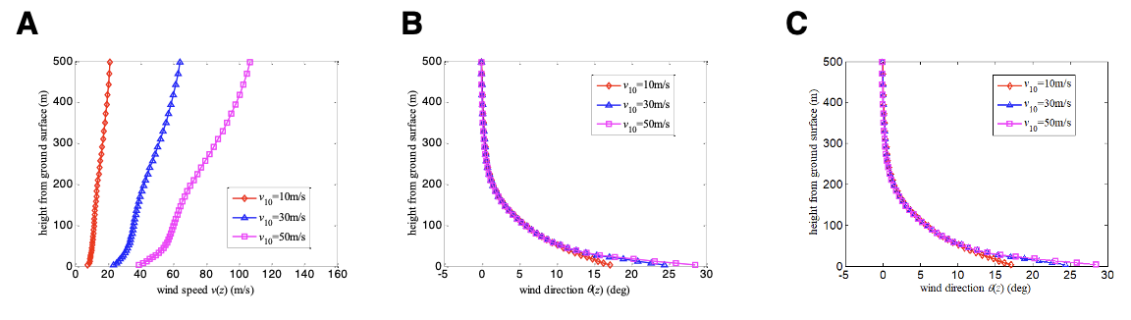 |  | ☐
Alt Text | Alt text should provide concise, informative descriptions of the essential information conveyed by each figure. |  | ☐
Alt Text | Alt text applies to all images, figures, illustrations, and photographs |  | ☐
Alt Text | Once your manuscript is conditionally accepted, submit the Alt Text in a separate MS Word file using the provided template. (Refer to Author Guideline to find the template files)  Upload the Alt Text file as Supplementary File NOT for Review in the ScholarOne system |  | ☐
Checklist | Checklist is mandatory for the submission.  (Download from Author Guidelines or Submission checklist) | ☐ | ☐
Checklist | Submit an MS Word file, not a PDF file. |  | ☐
Checklist | Note that failure to comply with each item on the checklist often results in the need to resubmit. | ☐ | ☐
Videos  (Optional) | This journal accepts videos to be published as part of the manuscript or as supplementary material.  A still image of the video will appear in the PDF version. (Refer to the video and media guide) |  | ☐
Supplementary Data  (Optional) | Submit supplementary data at the same time as the main manuscript. | ☐ | ☐
Supplementary Data  (Optional) | Reference them in the main manuscript at an appropriate juncture in the text. |  | ☐
Supplementary Data  (Optional) | Ensure they are clearly and succinctly presented as they will be available online only and not copyedited. |  | ☐
Supplementary Data  (Optional) | Ensure their style conforms with the rest of the manuscript. |  | ☐
Supplementary Data  (Optional) | Ensure their presentation functions on any internet browser. |  | ☐
Supplementary Data  (Optional) | Make files be no more than 2MB each, although exceptions can be made at the Editorial Office’s discretion. |  | ☐

