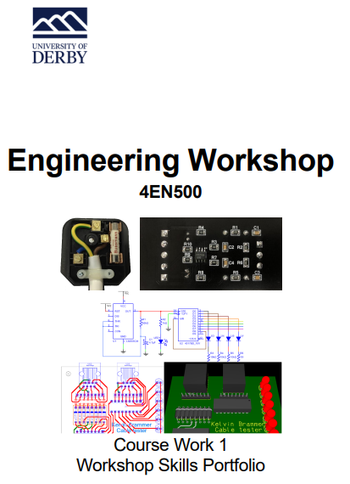
Student number- 100621310
Exercise 1 – Component Identification
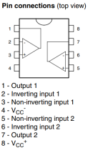
IC NE555D Timer SMD
is a popular timer IC that comes in a surface mount SO-8 package. It has precise timing capabilities and can function in either astable or monostable mode. It's ideal for a variety of timing applications in electronic circuits due to its wide voltage range and low power consumption.
Pin 1 is the first on the left, and the numbers run around anticlockwise.
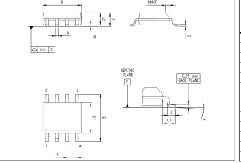
(Digikey, 2024)

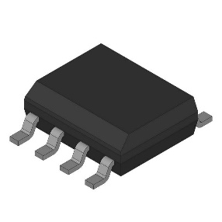

(Digikey, 2024)

(Digikey, 2024)

(Digikey, 2024)

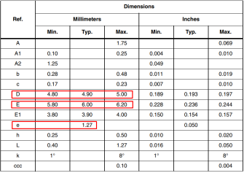
(Digikey, 2024) (Digikey, 2024) (Digikey, 2024)

LED 3mm Red, 1.85V High Intensity

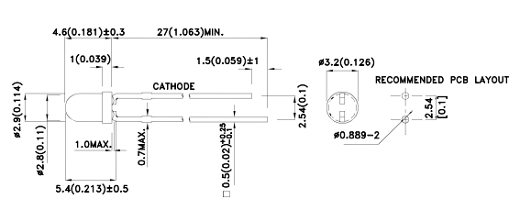
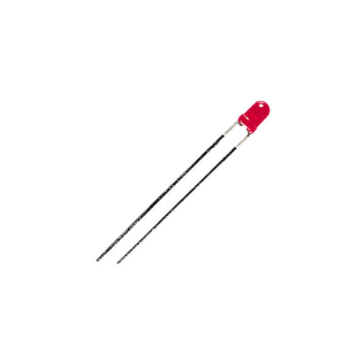
Red light is produced by 3mm-diameter LEDs with a high intensity. Indicator lights, signage, displays, emergency lighting, vehicle lighting, stage lighting, photography, and medical equipment are just a few of the uses for them. With their high intensity rating, they need 1.85 volts of forward voltage. The quality, production methods, operational environment, and operating circumstances of LEDs are all inspected. To guarantee their dependability and durability, reputable manufacturers provide warranties and customer support. Enclosure and protection that are appropriate can reduce dangers.
anode pin +
cathode pin -

(Rapideducation, 2024)

(Rapideducation, 2024)

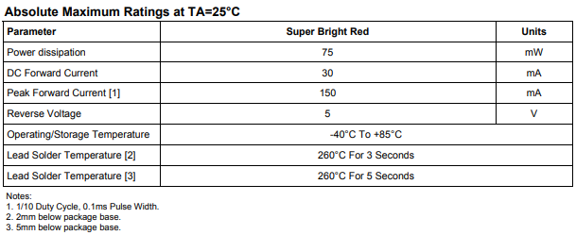

(Rapideducation, 2024)

anode pin +

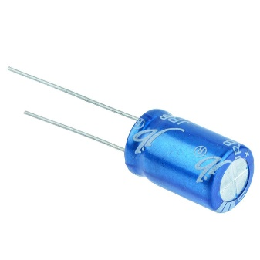
Capacitor Electrolytic 4.7uF 63V:

V A polarized capacitor having a capacitance of 4.7 microfarads (uF) and a maximum voltage rating of 63 volts is known as an electrolytic 4.7uF 63V capacitor. It is frequently utilized for bypassing, coupling, timing and oscillation, filtering and decoupling, and coupling in power supply circuits. Although electrolytic capacitors have a large energy storage capacity, its dependability varies based on several variables, including lifetime expectations, operating conditions, and quality. Selecting capacitors from reliable manufacturers, adhering to accepted circuit design principles, and taking the needs of the application into account are crucial for ensuring dependability. In crucial applications, routine electrolytic capacitor replacement and inspection can avert unanticipated failures and guarantee continuous operation.

Switchelectronics (2024)

cathode pin -
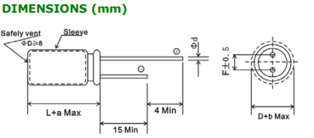

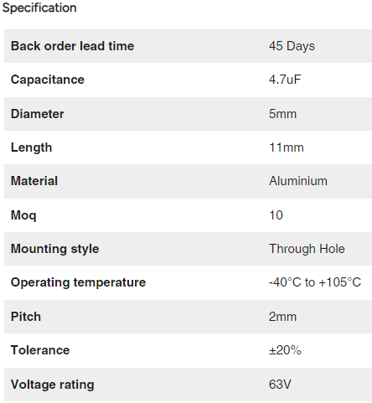

Switchelectronics (2024)

Switchelectronics (2024)

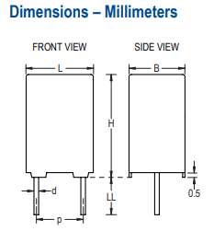
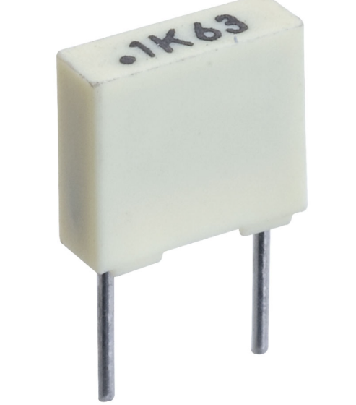
Capacitor Polyester 100nF:

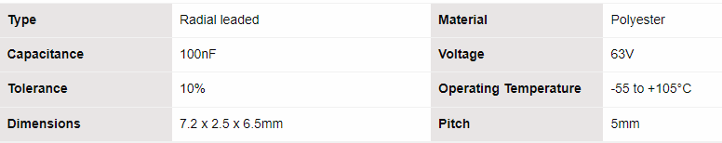
A capacitor having a capacitance value of 100 nanofarads (nF), or 100nF, is frequently used in timing, coupling and decoupling, filtering, signal processing, and snubber circuits in electronic circuits. Due to their non-polarization, these capacitors can have any orientation of connection. Their stability, affordability, and broad range of capacitance values make them dependable. However, elements like ageing, voltage stress, and operational temperature might affect how reliable they are. Systems with a high degree of dependability or criticality require routine testing and inspection.

Rapideducation (2024)

Rapideducation (2024)

Rapideducation (2024)

Diode 1N4148

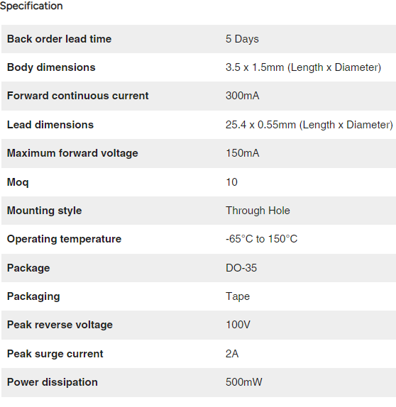
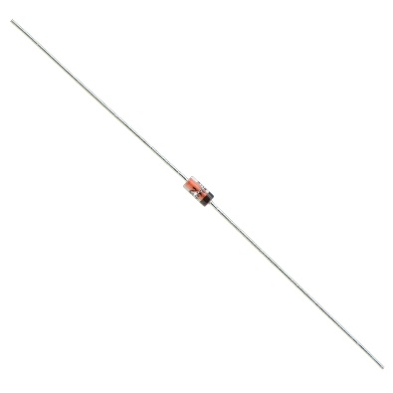
A tiny, quick-switching diode with a low forward voltage drop and quick switching speed is the 1N4148. It is frequently utilised for voltage reference, protection, clipping and clamping, switching, and signal rectification in electronic circuits. The diode can tolerate a reverse voltage of up to 100 volts and is commonly supplied in a compact, glass-encapsulated device with axial leads. With a maximum forward current rating of about 200 mA, it is appropriate for low-power and small signal applications. Although its dependability is well established, maintaining its performance requires appropriate design methods.
anode pin +

Switchelectronics (2024)

cathode pin -

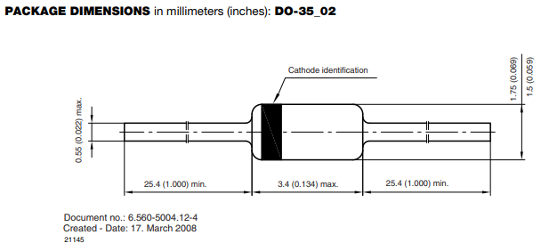

Switchelectronics (2024)

Switchelectronics (2024)

Trimmer Potentiometer 50k (Bourns 9mm)

A variable resistor called the Trimmer Potentiometer 50k (Bourns 9mm) is used to change the resistance in electrical circuits. It is made by Bourns and has a resistance rating of 50 kΩ. The potentiometer is usually adjusted with a knob or tiny screwdriver. It is frequently utilised for voltage dividers, calibration, tuning, biassing and offset correction, and sensitivity adjustment. Trimmer potentiometers made by Bourns, a company renowned for creating high-quality electrical components, are dependable and provide steady performance over time. For long-term dependability, however, appropriate handling, installation, and operation are required.

Polarity/Pinout: Three pins, resistance between outer pins, varies with the middle pin.
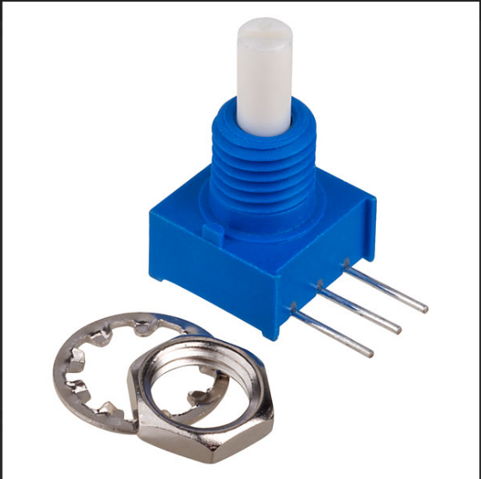
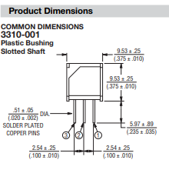

Rapideducation (2024)

Rapideducation (2024)

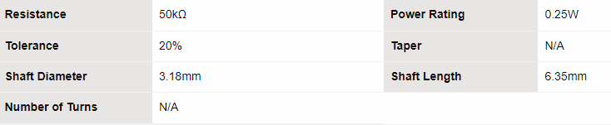

Rapideducation (2024)

Resistor 4k7 ¼ W 1% Axial

With a power rating of 1/4 watt, the 4.7 kΩ resistor known as "Resistor 4k7 ¼ W 1% Axial" can dissipate up to 1/4 of its maximum power without overheating. Its real resistance value may differ from the given value by up to 1% due to its 1% tolerance. This resistor has leads for through-hole soldering and is axially leaded. Resistors are employed in many different applications, including biassing and feedback, voltage dividers, current limiting, pull-up or pull-down resistors, filtering, and decoupling. They have a 1/4-watt power rating, a long lifespan, and are extremely dependable parts.

Polarity/Pinout: No polarity, but value and tolerance marked on resistor body.
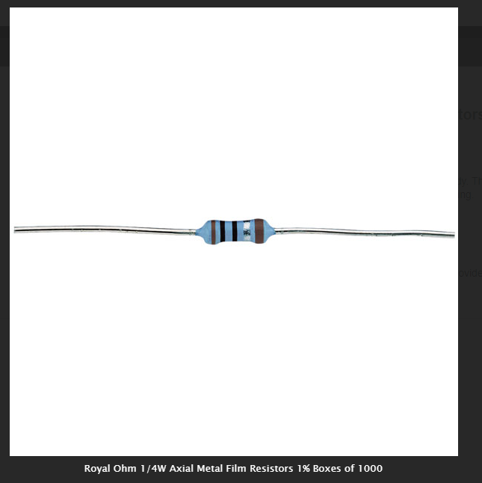

Mouserelectronics (2024)

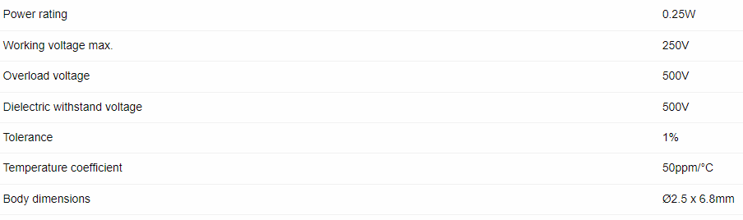

Mouserelectronics (2024)

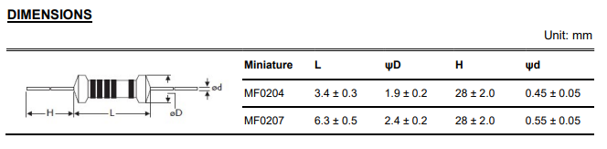

Mouserelectronics (2024)

Resistor 8k2 1206 1% 1/8W SMD

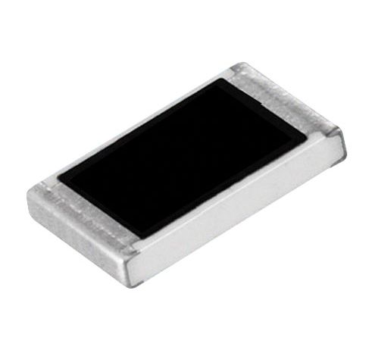
The surface-mount resistor "Resistor 8k2 1206 1% 1/8W SMD" has an 8.2 kiloohm resistance (8k2). It has a 1% tolerance, meaning it can vary from the given value by up to 1%, and comes in a 1206 package size. Its 1/8-watt power rating indicates the maximum amount of electricity it can dissipate without overheating. Because of its durability and ability to function under challenging conditions, SMD resistors are frequently utilised in high-frequency circuits, automotive electronics, consumer electronics, and industrial applications. These resistors are dependable for a variety of electrical applications when purchased from recognized vendors. Polarity/Pinout: No polarity, but value and tolerance marked on resistor body.

Rapideducation (2024)

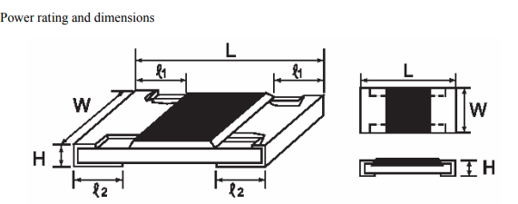

Rapideducation (2024)

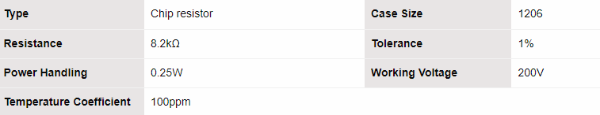

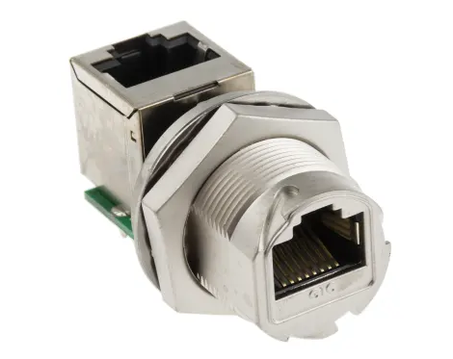
RJ45 Panel Mount Socket

A common Ethernet networking connector, the RJ45 Panel Mount Socket has eight pins grouped in a modular jack. It is made to fit easily into a variety of equipment panels, wall plates, and enclosures. A reliable connection for data transfer is made possible by the socket's female connector, which receives the male connector of an Ethernet cable. High-speed data transfer over twisted pair cables is possible with RJ45 connectors since they are compatible with Cat5e, Cat6, Cat6a, and other Ethernet cable standards. They are frequently found in electronic enclosures, industrial machinery, networking equipment, and communication devices. Polarity/Pinout: Pinout information available in datasheet for wiring Ethernet connections
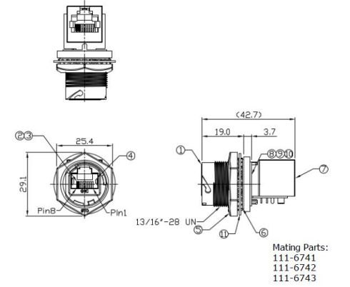
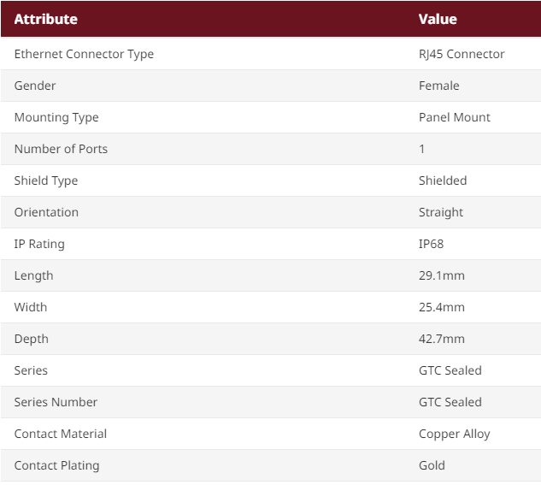

RSonline (2024)

RSonline (2024)

Transistor BC546

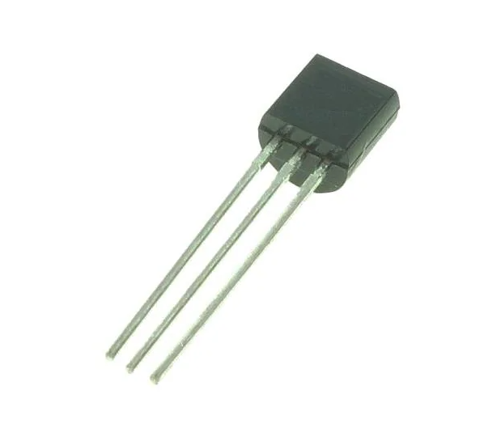
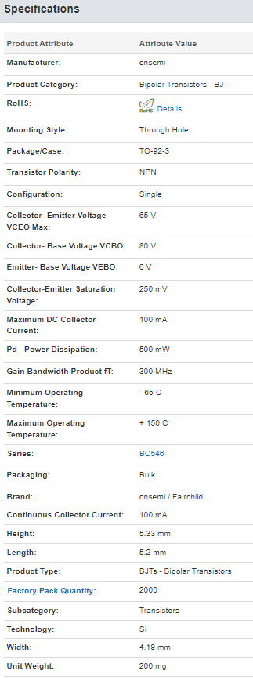
Polari An all-purpose NPN bipolar junction transistor (BJT) for low-to-medium power switching and amplification is the BC546, a BC546. Three layers of semiconductor material make up this structure: two "N" layers that are substantially doped and one "P" layer that is mildly doped. Usually, the transistor comes in a tiny plastic box for through-hole attachment on printed circuit boards, like the TO-92. The collector (C), base (B), and emitter (E) pins are its three pins. The boundaries of safe operation are defined by its maximum ratings. Signal amplification, small-signal switching, and voltage regulation in a variety of electronic circuits are common uses. When utilised in the ratings and conditions that are specified, its dependability is dependable.

Collector−−Emitter Voltage
Collector−Base Voltage
Emitter−Base Voltage
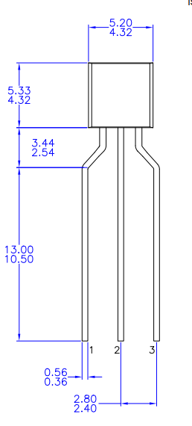

Mouserelectronics (2024)

Mouserelectronics (2024)

Mouserelectronics (2024)

Exercise 2a- Correctly Wire 13A 3-pin Plug
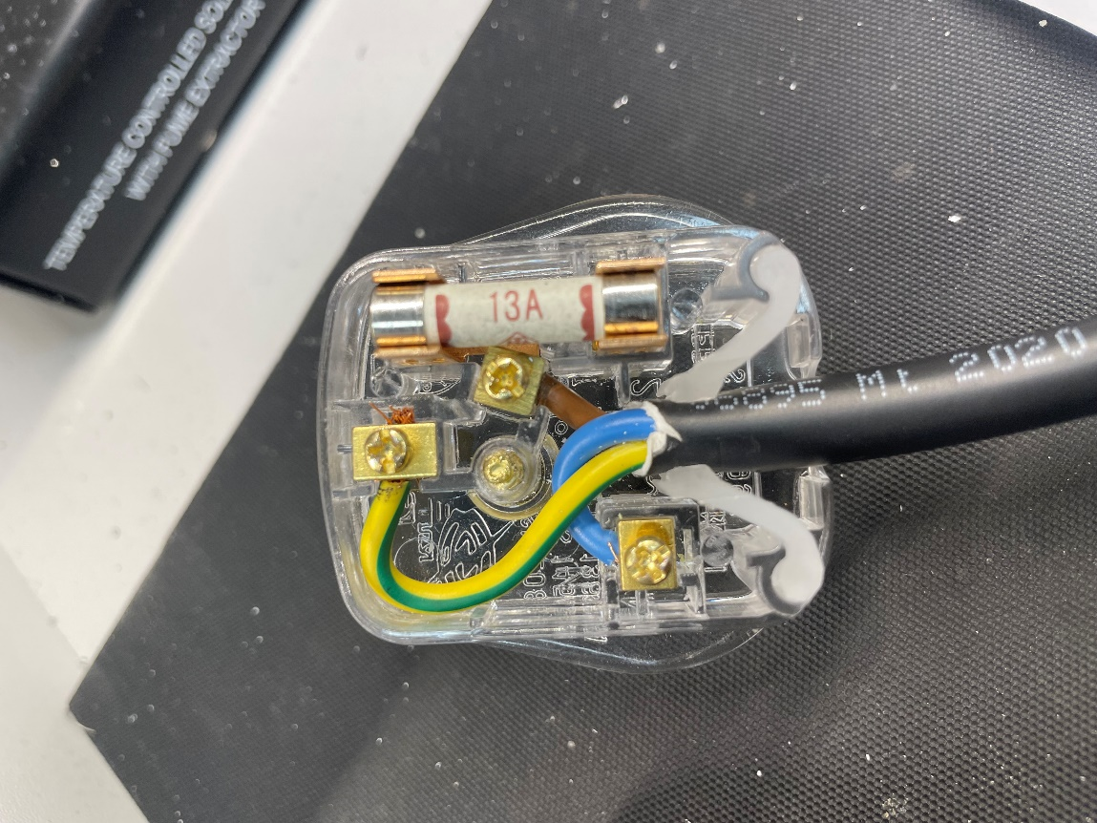

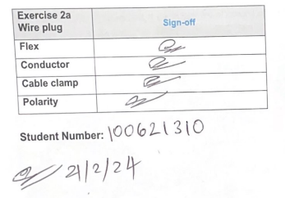

Exercise 2b- Correctly Wire 16A Ceeform socket

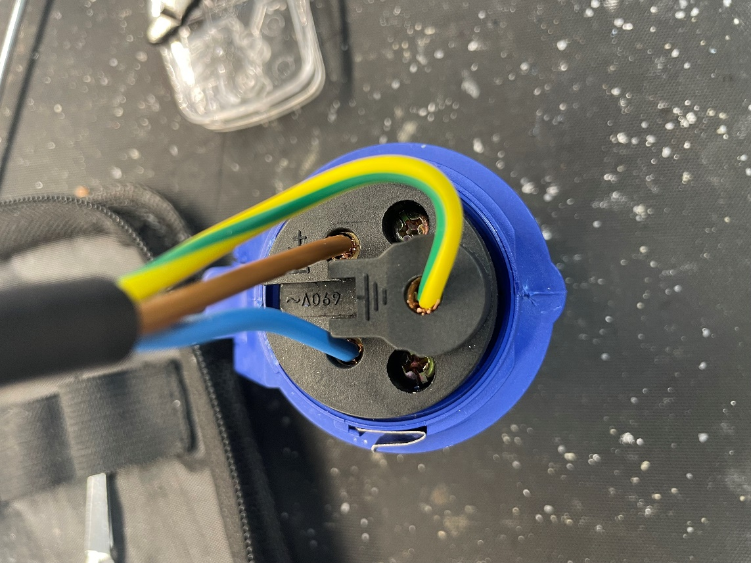

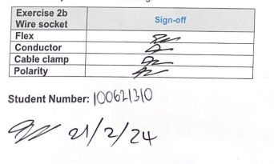

Exercise 3a- Preparing Wires
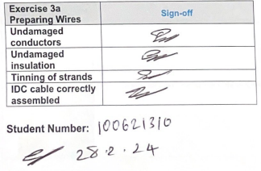
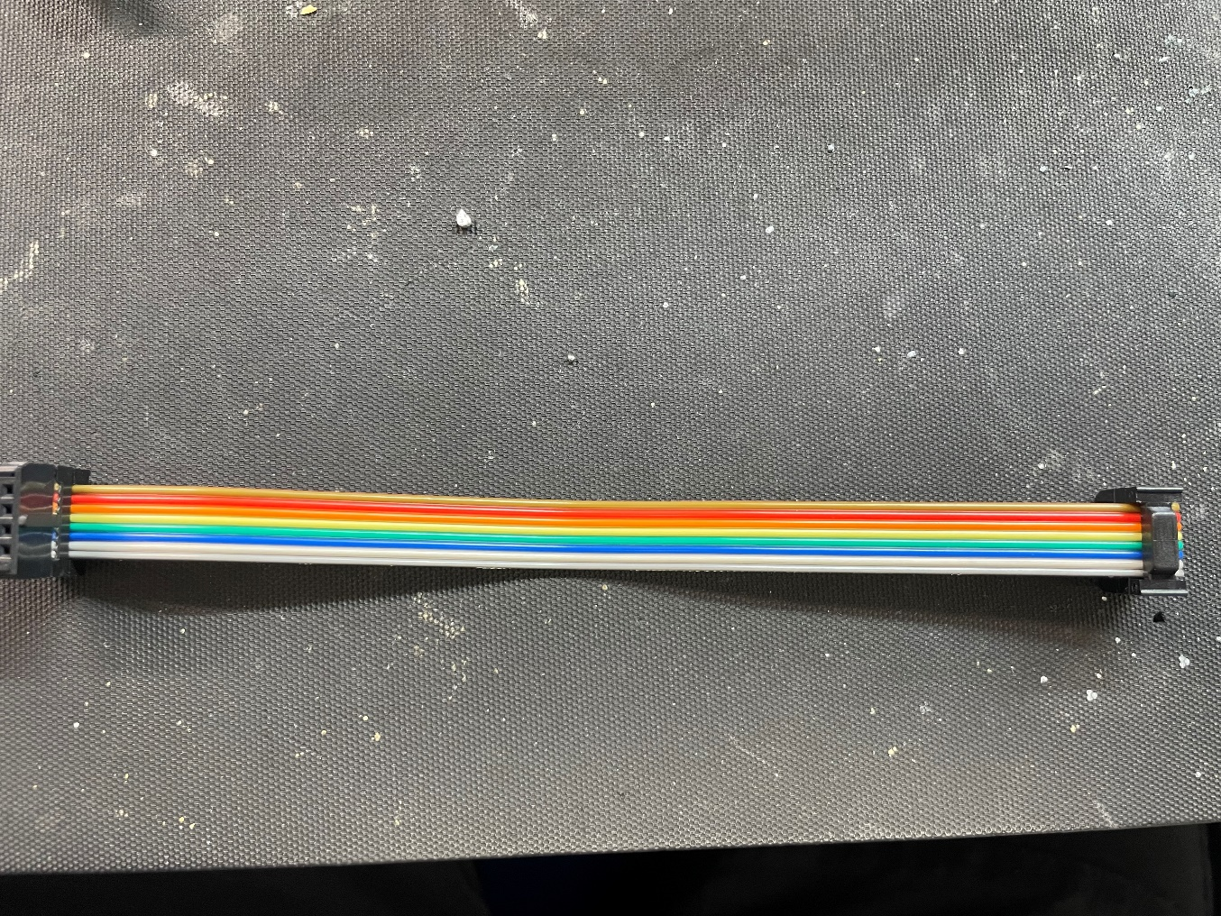

Exercise 3b- Basic Soldering
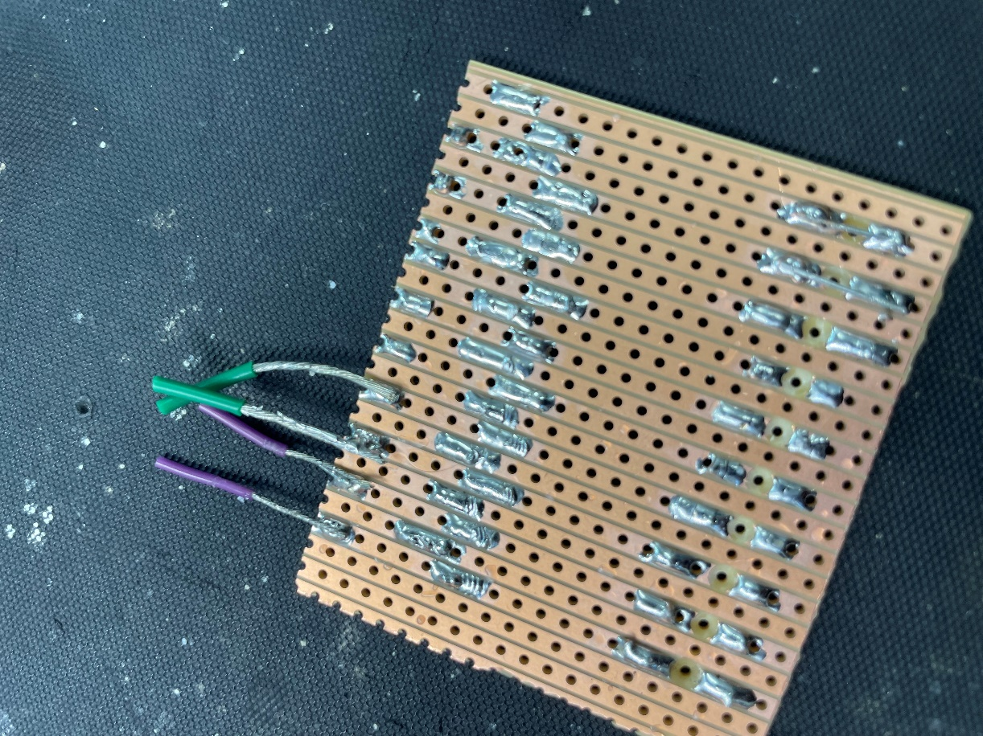



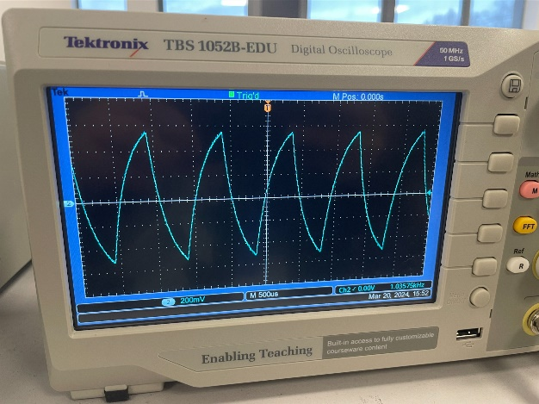
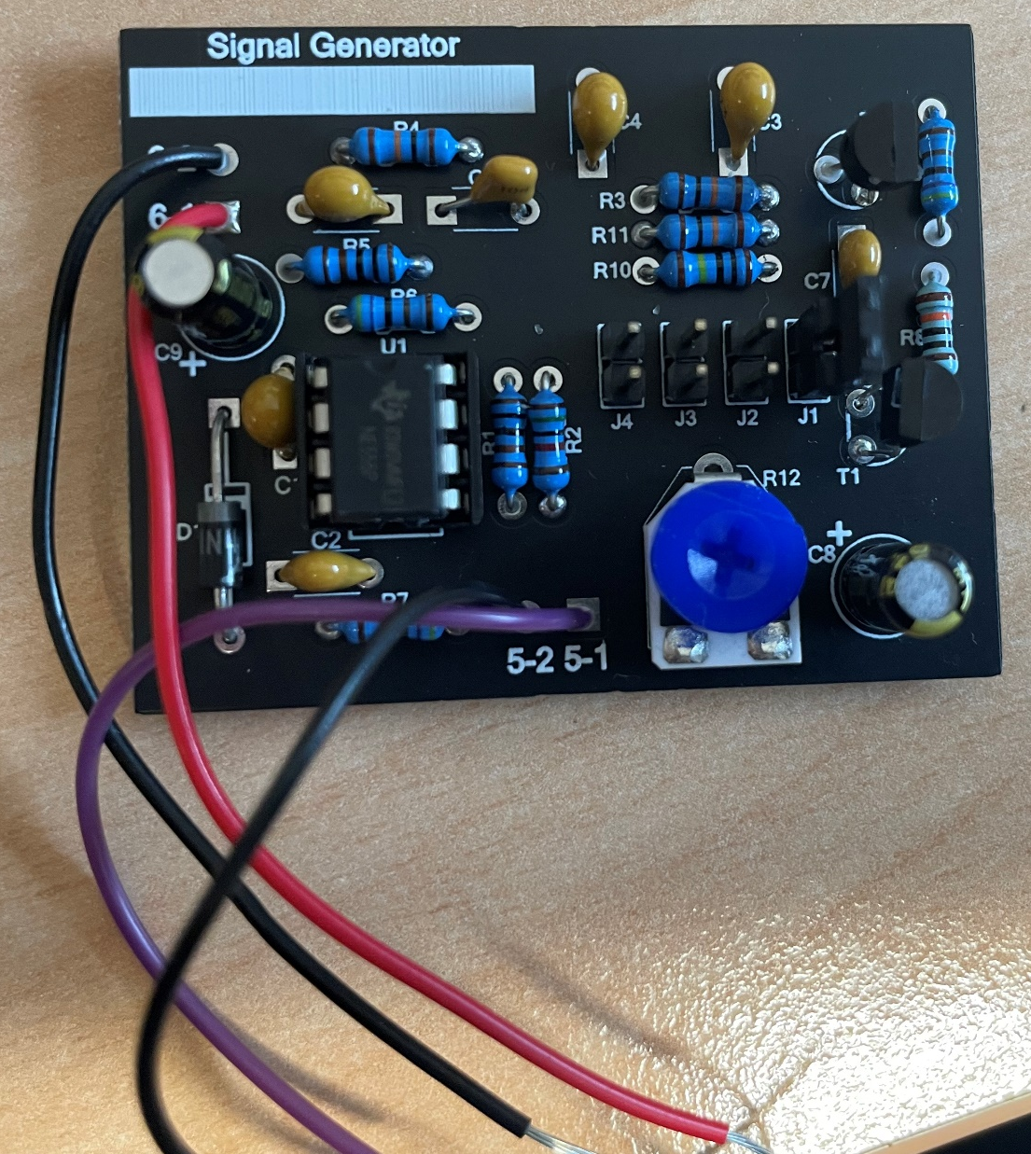
Exercise 4- Build and test signal generator

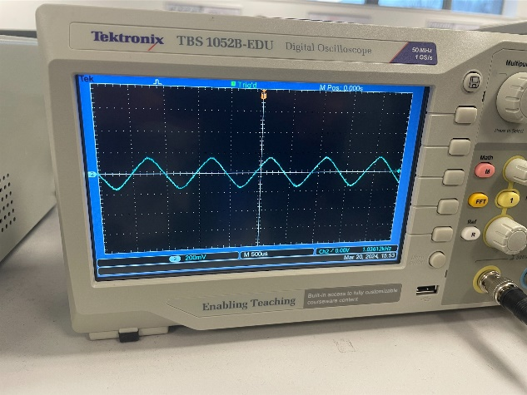

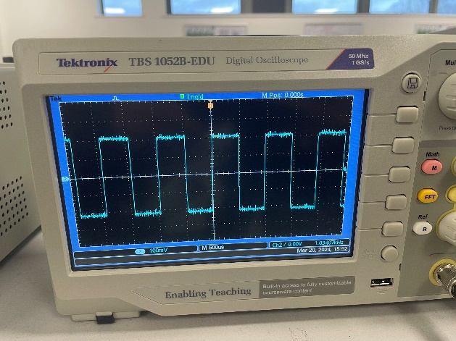

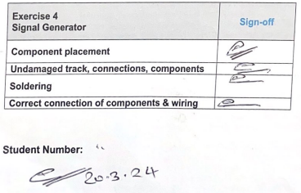

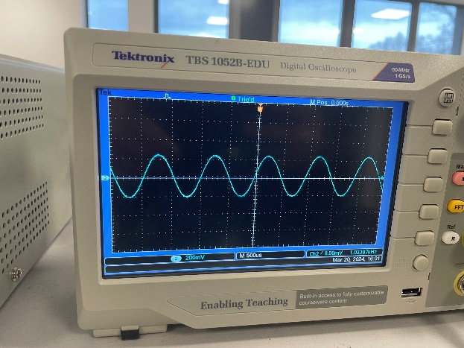

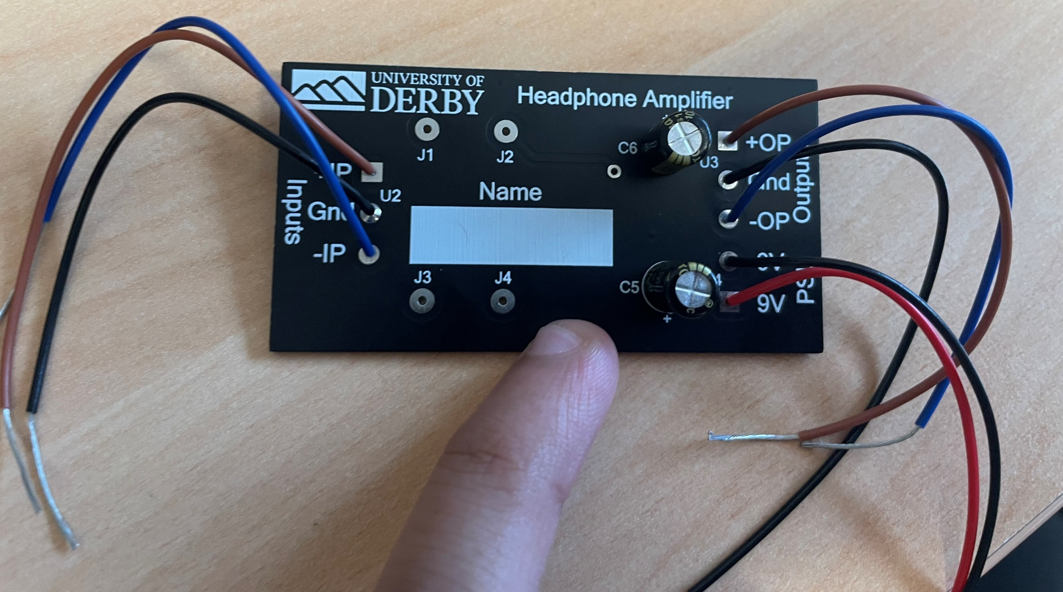
Exercise 5- Build and test headphone amplifier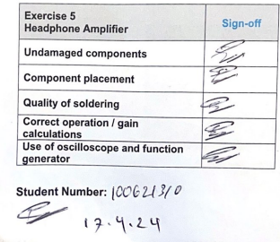
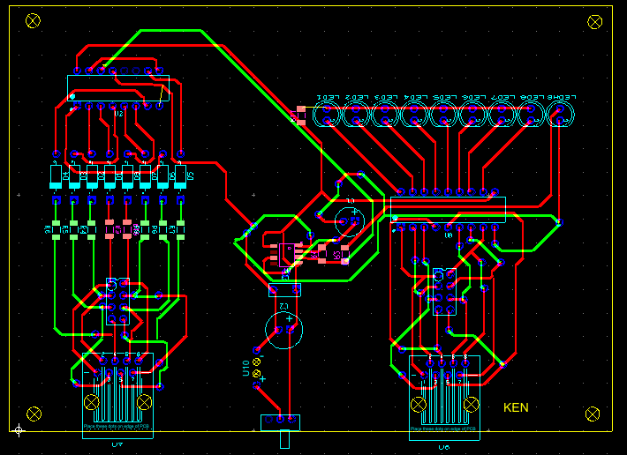
Exercise 6- Cable Tester

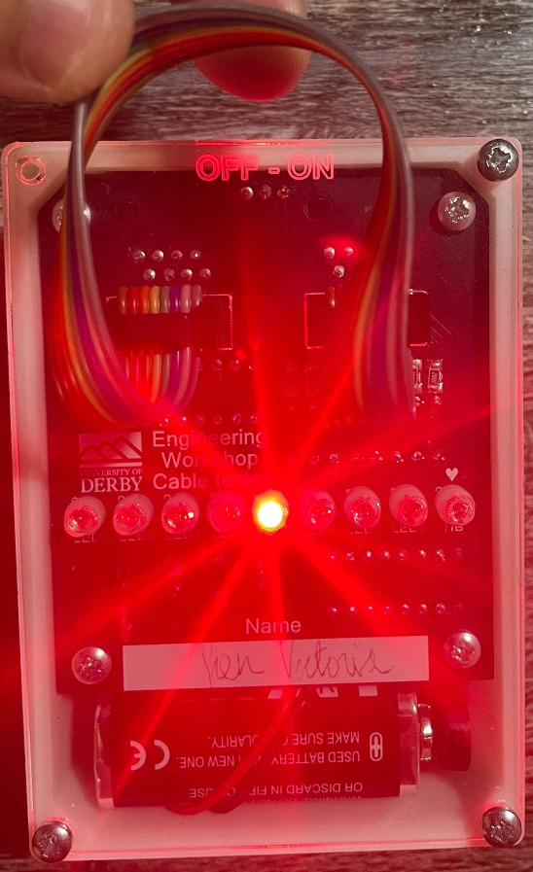


References

IC NE555D Timer SMD image available at: https://www.digikey.co.uk/en/products/detail/rochester-electronicsllc/TL082CD/11517150 (Accessed: 14/05/2024).
IC NE555D Timer SMD datasheet available at: https://www.ti.com/lit/ds/symlink/tl082.pdf?ts=1633830931585 (Accessed: 14/05/2024).
LED 3mm red, 1.85V high intensity image available at: https://www.rapidonline.com/kingbright-l-7104src-j4-3mm-super-bright-red-led-4500mcd-55-9214 (Accessed: 14/05/2024).
LED 3mm red, 1.85V high intensity datasheet available at: https://www.rapidonline.com/kingbright-l-7104src-j4-3mm-super-bright-red-led-4500mcd-55-9214 (Accessed: 14/05/2024).
Capacitor Electrolytic 4.7uF 63V image available at: https://www.switchelectronics.co.uk/products/4-7uf-63v-radial-aluminium-electrolytic-capacitor-20 (Accessed: 14/05/2024).
Capacitor Electrolytic 4.7uF 63V datasheet available at: https://www.switchelectronics.co.uk/products/4-7uf-63v-radial-aluminium-electrolytic-capacitor-20 (Accessed: 14/05/2024).
Capacitor Polyester 100nF image available at: https://www.rapidonline.com/kemet-r82dc3100aa50k-100nf-63v-5mm-polyester-box-capacitor-10-3260 (Accessed: 14/05/2024).
Capacitor Polyester 100nF datasheet available at: https://www.rapidonline.com/kemet-r82dc3100aa50k-100nf-63v-5mm-polyester-box-capacitor-10-3260 (Accessed: 14/05/2024).
Diode 1N4148 image available at: https://www.switchelectronics.co.uk/products/1n4148-small-signal-diode-100v-150ma (Accessed: 14/05/2024).
Diode 1N4148 datasheet available at: https://www.switchelectronics.co.uk/products/1n4148-small-signal-diode-100v-150ma (Accessed: 14/05/2024).
Trimmer Potentiometer 50k (Bourns 9mm) image available at: https://www.rapidonline.com/bourns-3310c-001-503l-50k-20-9mm-sealed-panel-control-potentiometer-66-0320 (Accessed: 14/05/2024).
Trimmer Potentiometer 50k (Bourns 9mm) datasheet available at: https://www.rapidonline.com/bourns-3310c-001-503l-50k-20-9mm-sealed-panel-control-potentiometer-66-0320 (Accessed: 14/05/2024).
Resistor 4k7 ¼ W 1% Axial image available at: https://www.mouser.co.uk/ProductDetail/YAGEO/MF0207FTE52-4K7?qs=KUIzHt%2Fe91mHt3onI0%2FzRQ%3D%3D (Accessed: 14/05/2024).
Resistor 4k7 ¼ W 1% Axial datasheet available at: https://www.mouser.co.uk/ProductDetail/YAGEO/MF0207FTE52-4K7?qs=KUIzHt%2Fe91mHt3onI0%2FzRQ%3D%3D (Accessed: 14/05/2024).
Resistor 8k2 1206 1% 1/8W SMD image available at: https://www.rapidonline.com/8k2-1206-1-1-4w-royal-ohm-chip-resistor-pack-of-100-62-1815 (Accessed: 14/05/2024).
Resistor 8k2 1206 1% 1/8W SMD datasheet available at: https://www.rapidonline.com/8k2-1206-1-1-4w-royal-ohm-chip-resistor-pack-of-100-62-1815 (Accessed: 14/05/2024).

RJ45 Panel Mount Socket image available at: https://uk.rs-online.com/web/p/ethernet-connectors/1116745 (Accessed: 14/05/2024).
RJ45 Panel Mount Socket datasheet available at: https://uk.rs-online.com/web/p/ethernet-connectors/1116745 (Accessed: 14/05/2024).

Transistor BC546 image available at: https://www.mouser.co.uk/ProductDetail/onsemi-Fairchild/BC546?qs=UMEuL5FsraDWGn9zuahUkw%3D%3D (Accessed: 14/05/2024).

Transistor BC546 datasheet available at: https://www.mouser.co.uk/ProductDetail/onsemi-Fairchild/BC546?qs=UMEuL5FsraDWGn9zuahUkw%3D%3D (Accessed: 14/05/2024).

