Getting Started Guide

Vipps via Netaxept

Version 1.0

Vipps is a mobile payment solution launched by DNB for online stores. With DNB / Vipps through your Netaxept integration you can allow your customers to pay purchases in your online store with their payment cards via Vipps app.

If you have a working Netaxept API integration and a valid acquiring agreement for card payments, you are most likely able to take Vipps in use via Netaxept only by activating the payment method in question in Netaxept Admin. Otherwise, please contact first Nets Sales for your country or your contact person at Nets and visit our technical site at https://shop.nets.eu/partners for more information about the general API integration.

This document guides you through the process of activating and implementing Vipps as a payment method via Netaxept. Please for­ward this guide to the party responsible for the technical API implementation at your online store, if necessary.

For any issues concerning the activation or implementation of Vipps via Netaxept, please contact your contact person at Nets or Netaxept Customer Support for your country <https://shop.nets.eu/web/partners/contact>

Contents

1 Vipps via Netaxept 2

1.1 Business features and restrictions 2

1.2 Payment flow 2

2 Setting up Netaxept for use with Vipps 5

2.1 Activation of payment method 5

2.2 Requirements for API integration 5

3 Settlements and pricing 7

3.1 Settlement batch and identification 7

3.2 Pricing 7

# Vipps via Netaxept

Vipps is a mobile payment solution launched by DNB for online stores. With Vipps through Netaxept you can allow your customers to pay their purchases with their payment cards via Vipps app in your online store.

## Business features and restrictions

At the time being the following features and restrictions take place when using Vipps via Netaxept.

|  |  |
| --- | --- |
| **ID** | **Feature / Restriction** |
| 1 | Targeting Norwegian consumers, which need a Norwegian phone number to use the service. |
| 2 | Available for online stores, not for merchants using only call centre service.   * Additional paid payment method and included in Start, Advanced and Premium service packages. |
| 3 | Supported payment cards for the buyers are Visa, MasterCard.   * The prerequisite is that you have made an acquirer agreement with the chosen acquirer who accepts payments with the particular payment card. |
| 4 | Supported payment currencies are NOK. |
| 5 | Recurring payment is not supported. |
| 6 | If you have made both Netaxept and acquirer agreement for Visa and/or MasterCard, you only need to sign up with Vipps to get your merchant serial number. |
| 7 | Available for buyers whether or not they are customers at DNB. |
| 8 | When paying with Vipps, 3DS verification is bypassed and all payments are considered and marked as non 3DS authenticated. |
| 9 | Card data which is needed to be able to shop online via Vipps is stored safely and according to PCI DSS (Payment Card Industry Data Security Standard) requirements in the solution powered by Netaxept. Any card data is not saved in the buyer's mobile device or DNB.  Netaxept is both acting as the card vault and a payment service provider in this service, but this guide is focused on the merchant facing PSP service. |
| 10 | Payments done via Vipps are considered and processed as regular card payments, and as such, all the same rules and possibilities apply. For example:   * Payments should be captured when the order is shipped. * The authorization is valid the same length as regular card authorizations, i.e. depending on Issuer rules. * The authorization is put on the underlying card. * The same liability shift rules apply than with regular card payments. |

## Payment flow

Payment flow of the successful Vipps payment goes as follows.

The prerequisite is that the buyer has downloaded the Vipps app in their smartphone and added there one or more payment card(s) that can be used for payments via Vipps when shopping online. Besides card data, mobile phone number needs to be registered into the app and the buyer needs to approve which card(s) they want to use for online payment purposes.

1. When the buyer is shopping online and is moving to the payment phase, the merchant will send the "Register" call to Netaxept. Depending on the technical API implementation the payment method will be selected either in the merchant's online store site or in Netaxept payment terminal.

* If the buyer chooses the payment method in merchant's online store site, the "Vipps" parameter needs to be added in "Payment method action list" or "Payment method list" element in the "Register" call.
* If the payment method is selected in Netaxept payment terminal, the "Vipps" option is already shown in the terminal page.

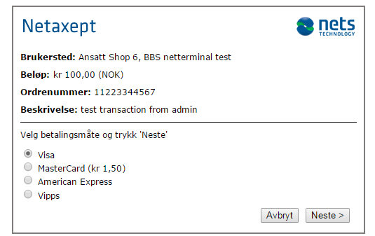

1. After chosen "Vipps", Netaxept asks for the users mobile phone number which is registered in the Vipps app.

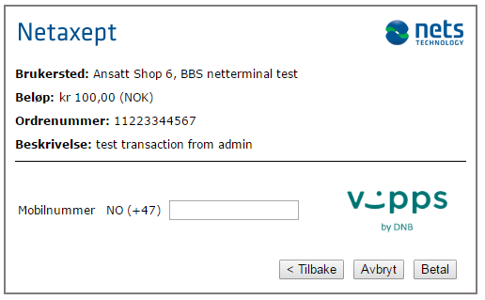

1. After entering the mobile phone number, a push message will be sent to the buyer's mobile phone to get a confirmation of the payment. The buyer has 4 minutes to confirm the payment in the Vipps app.

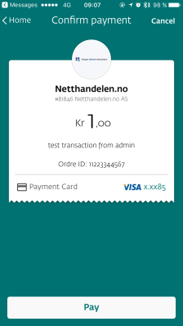

1. The buyer logs in to their Vipps app and approves the payment by pressing the "Pay" button.
2. During the approval process, Netaxept authorizes the payment automatically. If the authorization is accepted by the Issuer, the buyer receives a receipt in Vipps app showing the approval of the payment. Please note that this is not, however, an official receipt. The buyer should receive the official receipt from the online store as they normally do.

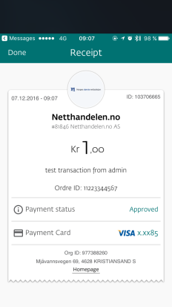

1. The payment is authorized and shown authorized also in Netaxept. When the order is shipped, the merchant captures the payment either via Netaxept API by doing Process(CAPTURE) call or manually via Netaxept Admin. After the capture is done, the order amount is withdrawn from the buyer's payment card linked to the Vipps app and settled to the merchant's bank account in the same settlement batch file and within the same timeframe as their regular card payments.
2. The buyer will see the payment as pending in the Vipps app until the merchant captures the payment after which it will be shown as completed.

# Setting up Netaxept for use with Vipps

## Activation of payment method

You can set up Vipps through Netaxept Admin. The merchant is responsible for activating the payment method and ensuring that all information entered is correct.

* Log in to Netaxept Admin by using the merchant ID and login password.
* Production environment: <https://epayment.nets.eu>
* Test environment: <https://test.epayment.nets.eu>
* Go to "Options" => "Agreement" page.
* Pick "Vipps" from the drop down list and click "Add".
* Enter the merchant serial number you have received when registering with Vipps. Currency needs to be NOK.
* Finally click "Save".

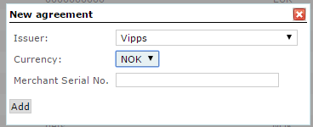

## Requirements for API integration

Assuming you have a functional Netaxept API integration already, you don't necessary need to do any technical changes in your online store implementation to be able to accept card payments via Vipps.

However, to be sure everything works as expected it is highly recommended that you check the following technical requirements before going live with Vipps.

|  |  |
| --- | --- |
| **ID** | **Requirement** |
| 1 | If "Payment method action list" or "Payment method list" is used in Register call, then payment method name "Vipps" need to be added inside the element.   * This element is used if the payment method is selected in the merchant's online store site or if you have wanted to define the order of payment methods shown in Netaxept's payment terminal. |
| 2 | Netaxept runs an automatic authorization for all card payments done via Vipps.   * Therefore, you should confirm through a Query API call that the authorization is successful, and then capture the payment by doing a Process(CAPTURE) call. * Later you can part and full refund amounts, if needed. * Also, you can cancel the authorization by doing a Process(ANNUL) call if the purchase is cancelled already before the payment is captured. |
| 3 | Due to above mentioned AutoSale is not supported. |
| 4 | Vipps is not supported in Single page terminal. |
| 5 | Vipps can be tested only in production environment due to lack of test environment for Vipps in DNB.   * I.e. you need to use your production merchant and own smartphone and payment card for testing purposes. |

# Settlements and pricing

## Settlement batch and identification

Payments done via Vipps will be processed as regular card payments in Netaxept, and therefore they will be included in the same settlement batch files as the other card payments. Also, because payment via Vipps is equal to card payment, the timeframe when the money is settled into your company's account will be the same as for regular card payments.

For the time being you are not able to view and track which transactions were made via Vipps and which were with a regular payment card. Instead, in Netaxept these payments will be shown as the underlying card. In the future we will add identification so that card payments done via Vipps can be recognized in Netaxept Admin Transaction list and Details page, and in Query API call. Later, there will be a possibility to fetch reports and search payments in Advanced transaction search section as well.

## Pricing

This is to be determined, but will most likely add a montly and transaction-based add-on to the regular card payments.