Trace Wizard Tips #1

1. Working with Telematics Traces

A. File Naming Convention

When working with Telematics traces, it is useful to understand their naming convention. Here is an example of a Telematics log filename: 01_22oct2011_31oct2011.tlmw

File Extension
Telematics log files have a file extension of tlmw.

Site Number
A Telematics filename begins with a two-digit site number. Files with the same site number correspond to the same site (house) of data collection.

Start Date
After the site number, the next information in the Telematics filename corresponds to the date when the generation of meter data started. TW uses that information to intially set the start date of the trace. Since the filename does not contain time information, TW sets an initial time of midnight for Telematics traces. (The start time can be changed later within TW, as explained below.)

B. Exporting Telematics Logs to TW Trace Format

Although you can create a new Telematics trace in TW via the usual method (New button, or Ctrl+N, then specifying the log file), if you are going to be appending traces (see below), you can reduce the number of steps involved by exporting Telematics logs to TW Trace format (extension twdb) in batch:
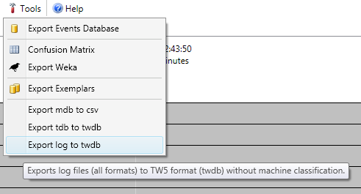
1. Go to the Tools menu in TW and choose Export log to twdb:

2. Select all the Telematics log files (in a single folder) that you wish to export to twdb format. By choosing multiple files here, you can eliminate the step of having to save each one individually as a twdb file.

3. Any existing files with the same filenames you select, but with the twdb extension, will be overwritten without warning. Be sure not to select log files you have already analyzed, if you have saved the analyzed traces in the same folder.

4. This process may take a few minutes, during which time the application will be unresponsive. The processing time depends on the number and complexity of the traces you select. Please wait. Once the export is complete, a message box will appear letting you know how many traces have been created:

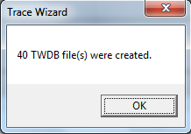

C. Open the First Trace of a Site

1. Now open the first trace of the Telematics site you wish to work with (Click Open button or press Ctrl+O). Before beginning your analysis, you may wish to change the start time of the trace (which defaults to midnight for Telematics traces), as explained in the following step.

D. Changing the Start Time of a Trace

1. On the graph toolbar, click the Change Start Time button (clock icon) or press Ctrl+T.

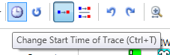
2. Enter the desired start time (including date) in the dialog box which appears. Accepted date/time formats depend on the Regional settings specified in your Windows Control Panel. If you edit the default format that comes up here, you won't go wrong.

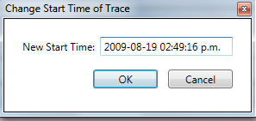
3. The new start time is now applied to the trace as a whole, and the start time of individual events within the trace has been adjusted accordingly.

4. This feature works for all TW traces, whether they were generated from Telematics log or via other log formats such as MeterMaster.

5. If desired, you can also change the start date here (not just the start time).

E. Appending Traces

Because multiple Telematics traces correspond to the same site, for analysis it is useful to append these traces together.

1. On the main toolbar, click the drop-down button to the right of the Open button, and choose Compare Traces or press Ctrl+Alt+O.

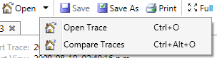
2. A Select Trace File dialog box will appear. Select the earlier trace (which you may have already analyzed), the one you will append to. Click Open.

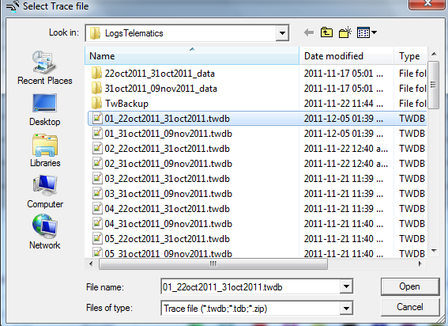

3. Another Select Trace File dialog window will appear. This time, select the latter trace, the one you will append to the earlier trace. Click Open.
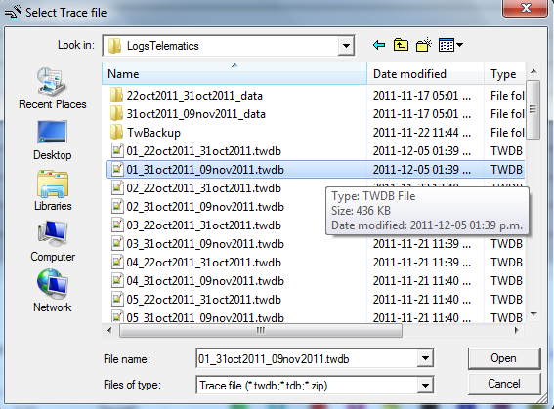
4. A Compare Traces tab will open, with the earlier trace shown in the lower area, and the latter trace shown in the upper area:
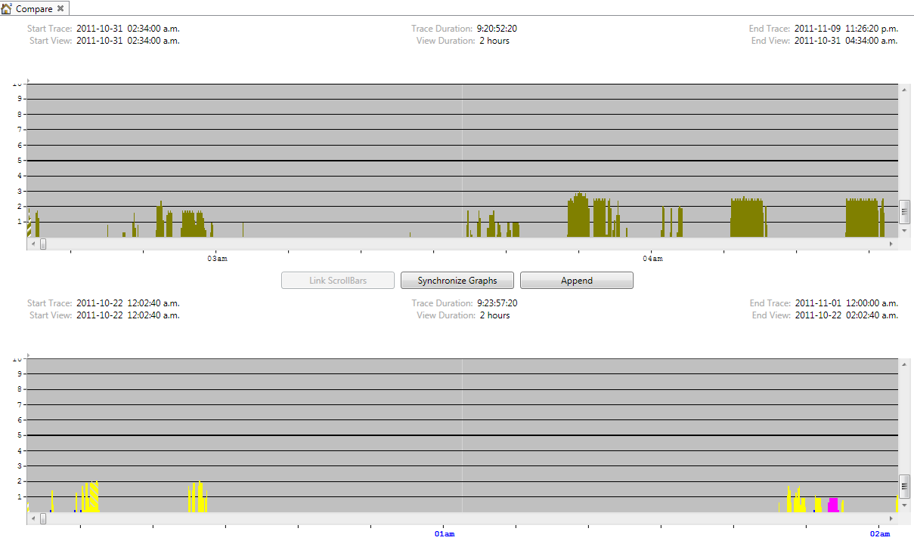
5. Click the Synchronize Graphs button found between the two traces. Now the lower trace will be scrolled to the end, and the upper trace will be scrolled to be approximately synchronized with the bottom one.

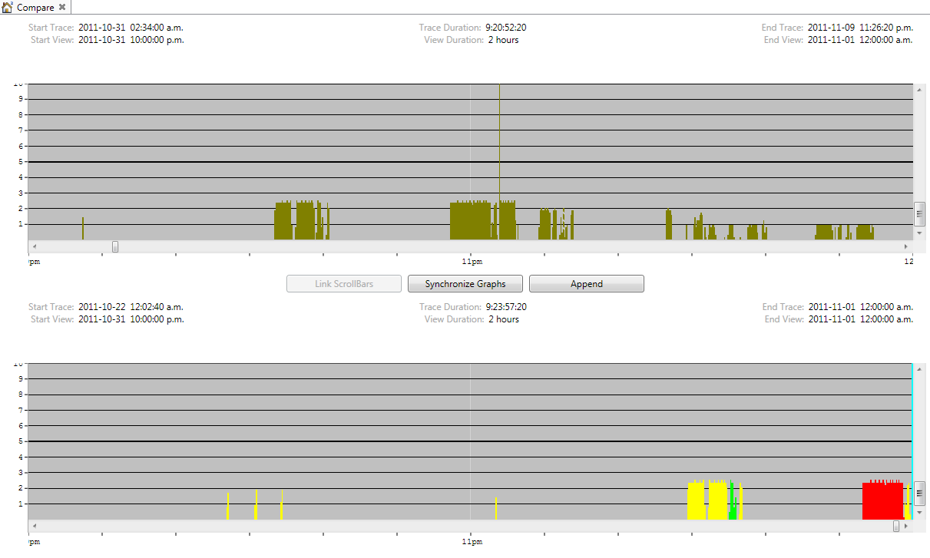

6. You should complete the synchronization by hand by scrolling the upper trace until its events lines up with those of the lower trace. (When performing this action on the first two sets of Telematics traces, it was necessary to adjust the upper trace by only approximately an hour. However, if you have already changed the start time of one of the traces, but left the other trace with its default start time, then you may have to scroll the upper trace more in order perform the hand synchronization.)

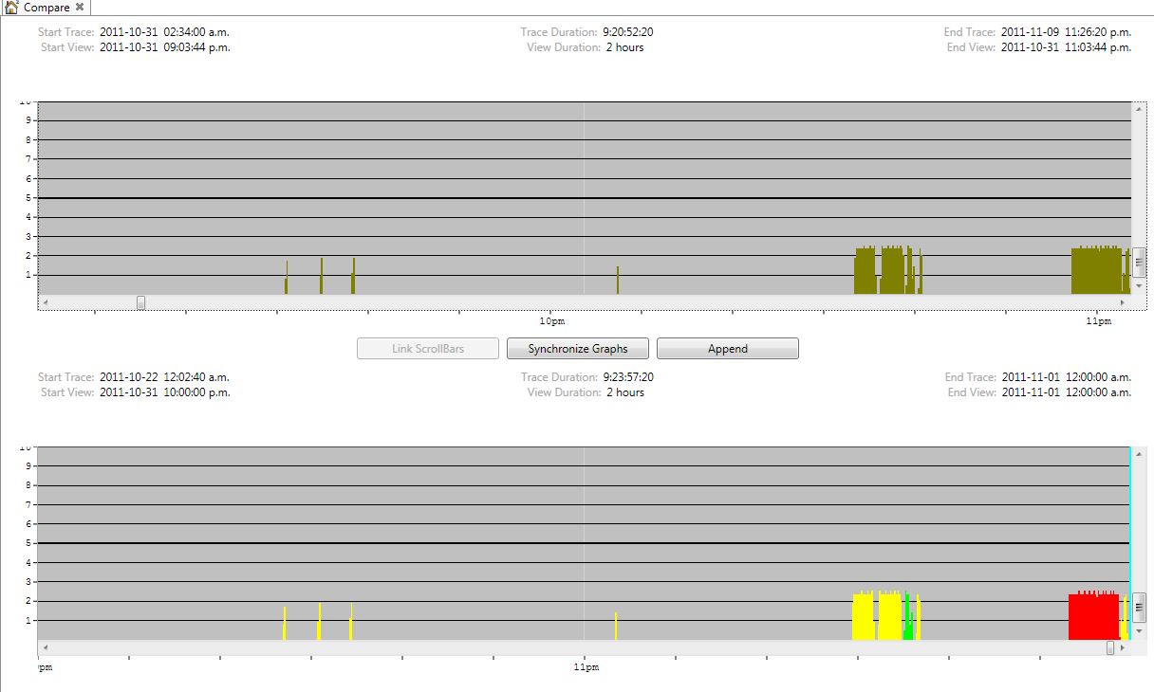
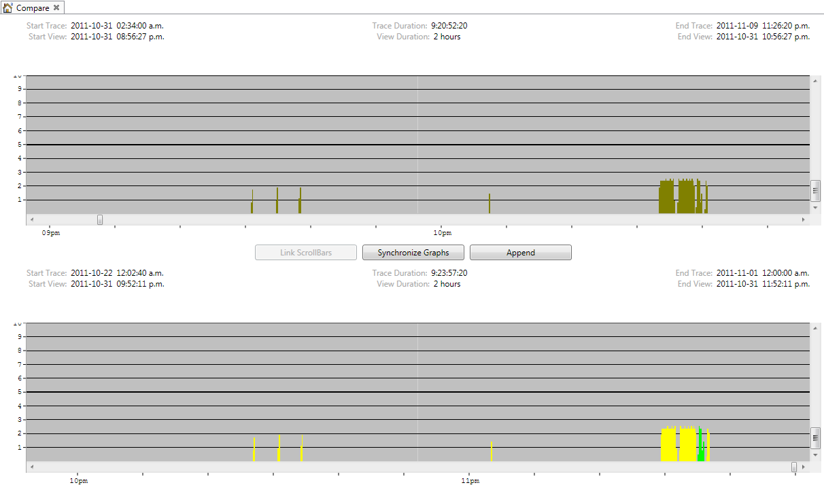
7. In order to get the traces to line up exactly, you may need to use the drag graph feature (click and drag on the graph outside of an event).

8. Click the Append button found between the two traces.

9. If there is an event in progress at the end of the traces (typically the upper trace, unless you have scrolled the lower one), you will not be permitted to append yet. Instead, you must adjust both traces slightly in order so that there is no trace in progress at the end of the view. This is a technical limitation of the append process. (If there is a long event in progress that you do not want to lose, then restart this process by opening up the second trace via Open and the performing a split at the desired point, then opening again both traces via Compare Traces).

10. Now TW will open a new tab with a new trace that has the synchronized data from both traces. In this new tab, you can scroll to where the new data begins and continue your trace analysis as usual on the new trace (where the unclassified events begin, if you have not already previously classify the second trace).

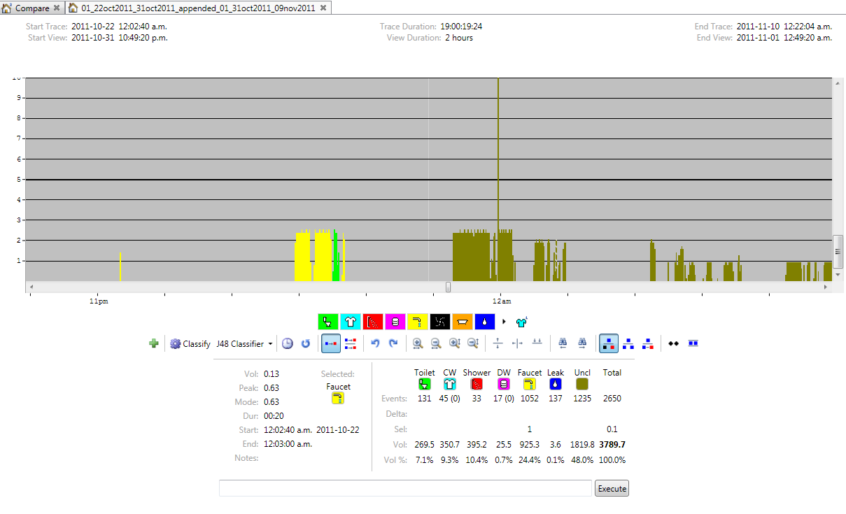
11. Note that you cannot perform analysis in the Compare Traces tab. It is not possible to save changes there. This tab is only to help you compare traces, and in this case, synchronize and append them.

