Trace Wizard Tips #2
Navigating the TW Graph

In this edition of TwTips, we discuss various ways to navigate the graph in Trace Wizard. (The related topic of finding and selecting events will be discussed separately in TwTips #3.)

1. Zooming

A. Performance and Zooming

First, two preliminary comments about the effect of zooming on TW performance:

1. Zooming requires re-drawing the entire graph, which is an expensive (i.e., time-consuming) task for Windows. For this reason, there is usually a significant delay within TW when changing zoom levels.

2. The shorter the time period shown, the more memory is needed by Trace Wizard. You may see degraded system performance (slow/slugging/out-of-memory errors) when using short views such as 10 minutes and 20 minutes.

B. Default Zoom Level

By default, TW shows the 2 hour view when opening a trace. This default can be changed on the Trace Wizard Preferences page (Shift+F4):

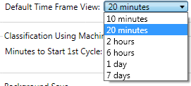
The default maximum volume shown in the graph is 10 gallons and is not currently configurable.

C. Zooming Modes

There are two zooming modes in Trace Wizard: Cursor-centered, and graph-centered.

1. Cursor-centered zooming
With cursor-centered zooming, the graph expands or contracts around the position the mouse (cursor) had when the command was initiated. This mode is useful if the part of the graph you want centered after the zoom is not currently centered.

a. Zooming To Adjacent Zoom Level. To zoom in and out to the next level using cursor-centered zooming, perform the following action at the desired center point on the graph background (not on an event):

Zoom In Horizontally | 1. Double-click.
Zoom Out Horizontally | 1. Shift + double-click.  2. Or double-click mouse wheel.*  3. Or double-click middle mouse button.*  4. Or click both mouse buttons* simultaneously.
Zoom In Vertically | 1. Ctrl + double-click
Zoom Out Vertically | 1. Ctrl + Shift + double-click

* Available on some systems.

Note the adding the Shift key changes the action from zooming in horizontally (increasing resolution) to zooming out horizontally (increasing the amount of time shown), and that adding the Ctrl key changes the action from horizontal zooming to vertical zooming.

For your reference, these commands, as well as other mouse- and keyboard-initiated commands mentioned in this document, are listed in the Shortcuts Help (Help menu | Shortcuts Help | Zoom).

b. Zooming To Any Zoom Level. To zoom in and out to any level (not just an adjacent level) using cursor-centered zooming, right-click on the graph background (not on an event) and choose your desired zoom level from the pop-up menu:

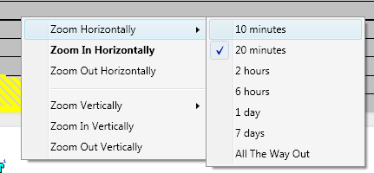
From this menu, you can choose horizontal zoom levels from 20 minutes to 7 days, and vertical zoom levels from 1 gallon to 20 gallons. The All The Way Out menu item will expand the graph to the trace duration (when zooming horizontally) or to the maximum peak (when zooming vertically) .

2. Graph-centered zooming

With graph-centered zooming, the graph expands or contracts about its center. If you have TW configured to show a vertical guideline on the graph (Shift+F4, check Show Vertical Guideline), this vertical line shows where the zooming action will be centered horizontally.

To initiate graph-centered zooming, perform one of the following actions:

Zoom in horizontally.  1. Press the F7 key.  2. Or click the Zoom In Horizontally buttonon the Graph Toolbar. | 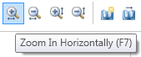
Zoom out horizontally.  1. Press the F8 key.  2. Or click the Zoom Out Horizontally buttonon the Graph Toolbar. | 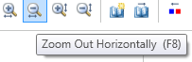
Zoom in vertically.  1. Press the F9 key.  2. Or click the Zoom In Vertically button on the Graph Toolbar. | 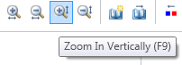
Zoom out vertically.  1. Press the F10 key.  2. Or click the Zoom Out Vertically button on the Graph Toolbar. | 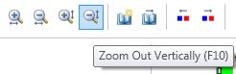

Note: TW command-line commands for zooming are not currently implemented.

2. Scrolling

In TW you can scroll the graph using the typical methods of other software applications:

Drag the scrollbar thumb, | Scrolls graph to the position corresponding to the percent of the scrollbar occupied by the scrollbar thumb.
Click on the scrollbar but not on the thumb. | Scrolls the graph by one page.
Click the arrow buttons found at either end of the scrollbars. | Scrolls the graph by an undocumented amount horizontally or vertically.
Click nativation keys.  Page Up, Page Down keys  Home, End keys  Ctrl + Page Up, Page Down keys  Ctrl + Home, End keys | InTrace Wizard, the usual keys that control vertical scrolling in most software applications instead control horizontal scrolling. For that reason, Page Up and Page Down move the TW graph to the right and left, respectively, instead of up and down. Similarly, the Home and End keys do not move the graph to the top or bottom, but rather to the far left (start) and far right (end).  To scroll the TW graph vertically, add the Ctrl key while pressing the aforementioned keys.
Execute TW command-line commands.  In TW command line, type start or home, press Enter key; or type end, press Enter key. | Scrolls to start or end of trace, respectively. Equivalent to pressing Home or End keys.

3. Bookmarks

To temporarily view a different part of the graph, but return later to the previous position, execute set bookmark when you are viewing the position you want to return to, and later execute go to bookmark when you are ready to return to the view shown when you set the bookmark.

To set the bookmark, or to direct TW to go the bookmark you set previously:

Set bookmark.  1. Press the F1 key.  2. Or press the Set Bookmark button on the Graph Toolbar.  3. Or type set bookmark in the Command window and press the Enter key or click the Execute button. | 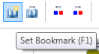  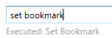
Go to bookmark.  1. Press the F2 key.  2. Or press the Go To Bookmark button on the Graph Toolbar.  3. Or type go to bookmark in the Command window and press the Enter key or click the Execute button. | 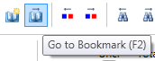  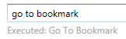

Trace Wizard currently supports a single bookmark, although you can reset it as many times as desired. When subsequently setting the bookmark, the previously set bookmark is deleted.

4. Bringing Selected Events Into View

Trace Wizard includes a facility to bring the previous (or next) selected event into view.This is useful when the selected events of interest are located in distinct parts of the trace (a case that often occurs when using the TW command line select command, a topic to be covered in a future TwTips document.)

Note: If several selected events are already in view, then executing this command will bring into view the previous (or next) selected event that is not currently in view.

To bring the previous (or next) selected event into view:

Bring Previous Selected Event Into View. Press the F3 key; or press the Bring Previous Selected Event Into View button on the Graph Toolbar; or type view previous in the Command window and press the Enter key or click the Execute button. | 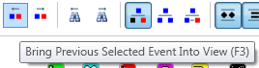  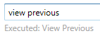
Bring Next Selected Event Into View. Press the F4 key; or press the Bring Next Selected Event Into View button on the Graph Toolbar; or type view next in the Command window and press the Enter key or click the Execute button. | 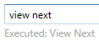  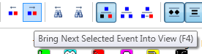

Repeating Bring Selected Event Into View
To perform these comands repeatedly, hold down the F3 (or F4) key, or if executing a TW-command line command, hold down the Execute button.

The Bring Previous/Next Event Into View actions are cyclic. When executing Bring Previous Event Into View repeatedly, once you reach the start of the trace/graph, executing the action again will proceed from the end of the trace. When executing Bring Next Event Into View repeatedly, once you reach the end of the trace/graph, executing the action again will proceed from the start of the trace.

Bringing Selected Event into View using Selected Event Panel

If a single event is selected, you can bring that event into view using the Selected Event Panel. This feature can be used as a sort of second bookmark (see above); if you have an event selected in one part of the graph, but you want to temporarily see something in a different part of the graph (for example, finding the next event similar to the selected one), when you want to return to the part of the graph with the selected event, execute this action:

Bring Selected Event Into View. | Double-click the fixture icon in the Selected Event panel.  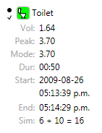

To show the Selected Event Panel when a trace opens, go to your Preferences (Ctrl+F4) and check Show Selected Event Panel.

