Trace Wizard Tips #3
Finding and Selecting Events in TW

In this edition of TwTips, we discuss various ways to select events in Trace Wizard. Selected events can be subjected to various actions, such as bring into view (discussed in TwTips #2), classify, approve, and add to Fixture List.

1. Terminology: Finding vs. Selecting

In the Trace Wizard user interface, the terms find and select are both used to refer to the process of specifying search criteria and directing TW to select those events that meet that criteria. The term "find" is used in the event context/pop-up menu as well as in the Graph Toolbar, and refers to the act of selecting the single event that meet the search criteria. The term "search" is used in TW command-line commands, as well as in the Graph Toolbar, and refers to the act of selecting those events (one event, or more than one event) that meet the search criteria.

2. Finding the Previous/Next Event

There are four types of find actions in Trace Wizard: Find Any, Find Same, Find Similar, and Find Other.

[continued on next page]

Find Previous (or Next) Event of Any Fixture Class.  When exactly one event is selected and its start time is in view, this action selects the previous (or next) event in the trace and brings it into view (to the horizontal center  of the graph). (Recall that you tell how whether any events are selected by looking  at the value of the Total column in the Selected row of the Fixture Summary panel.)  When no event is selected, or when the start time of the selected event is not in view, or when multiple events are selected, the Find Previous action selects the first event whose start time is before the end time of the view currently shown and brings it into view (to  the horizontal center of the graph). The Find Next action selects the first event whose  start time is after the start time of the view currently shown and brings it into view. | 1a. Find Previous Any: Shift + Left Arrow  1b. Find Next Any: Shift + Right Arrow  2. Or right-click on event in graph. Then in Find sub-menu, choose the Find Previous Any or Find Next Any menu item. (In this case, it is irrelevant whether one or more events are selected first, or whether their start times are in view.)  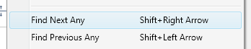  3. Or first verify that the Find Mode: Any Fixture button in the Graph ToolBar is pressed:  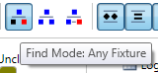  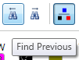  Then click the Find Previous or Find Next button in the Graph Toolbar:  4. Or type previous or next in the TW command window and press the Enter key:  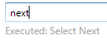
Find Previous (or Next) Event of Same Fixture Class.  When exactly one event is selected, this action selects the previous (or next) event with the same fixture class in the trace and brings it into view. | 1a. Find Previous Same: Ctrl + Left Arrow  1b. Find Next Same: Ctrl + Right Arrow  2. Or right-click on event in graph. Then in Find sub-menu, choose the Find Previous [This FixtureClass] or Find Next [This FixtureClass] menu item. (In this case, it is irrelevant whether one or more events are selected first.)  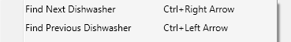  3. Or first verify that the Find Mode: Same Fixture button in the Graph ToolBar is pressed:  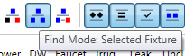  Then click the Find Previous or Find Next button in the Graph Toolbar:  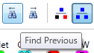
Find Previous (or Next) Similar Event.  When exactly one event is selected, this action selects the previous (or next) event  that is Similar to the selected event and  brings it into view. (For a target event to be considered similar to the selected/source event, the Volume of the target event must  be within 15% of the Volume of the selected/source event; the Peak, within 18%; the Mode, within 18%; and the Duration, within 25%.) | 1a. Find Previous Similar: Ctrl + Shift + Left Arrow  1b. Find Next Similar: Ctrl + Shift + Right Arrow  2. Or right-click on event in graph. Then in Find sub-menu, choose the Find Previous Similar or Find Next Similar menu item. (In this case, it is irrelevant whether one or more events are selected first.)  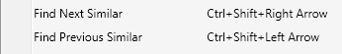  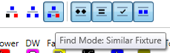  3. Or first verify that the Find Mode: Similar Fixture button in the Graph ToolBar is pressed:  Then click the Find Previous or Find Next button in the Graph Toolbar:  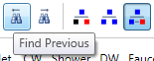  4. Or type previous similar or next similar in the TW command window and press the Enter key to find the previous or next event similar to the selected event:  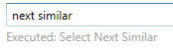
Find Previous (or Next) Other Event (an event with any fixture class specified by  the user.  This action selects the previous (or next) event with the fixture class specified by the user and brings it into view.  When no event is selected, or when the start time of the selected event is not in view, or when multiple events are selected, the Find Previous TW Command-line command selects the first event whose start time is before the end time of the view currently shown and brings it into view. The Find  Next TW Command-line command selects  the first event whose start time is after the start time of the view currently shown and brings it into view. | 1. Right-click on the button of the desired Fixture Class in the Graph Toolbar and choose the Find Previous [This FixtureClass] or Find Next [This FixtureClass] menu item.  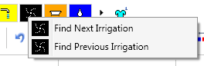  2. Or right-click on event in graph. Then in Find sub-menu, choose the Find Previous Other or Find Next Other sub-menu, then choose the menu item of the desired Fixture Class. (In this case, it is irrelevant whether one or more events are selected first.)  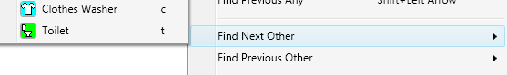  3. Or type previous irrigation or next irrigation in the TW command window and press the Enter key to find the previous or next irrigation event:  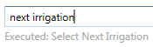

Repeating Find commands

When repeating a Find Previous action, when the start of the trace has been reached, the search will continue from the end of the trace if in your Preferences (Shift+F4), you have checked Select next/previous command cycles. Likewise, when repeating a Find Next action, when the end of the trace has been reached, the search will continue from the start if the aforementioned checkbox is checked in your Preferences.

3. Selecting Events

A. Selecting Events by Hand

1. Selecting and Unselecting Single Event
An event in the graph can be selected by clicking on it. To unselect an event, click on it again, click on a different event, or click on the graph outside of any event.

2. Adding an Event to a Selection
To add an event to the selection (i.e., other events are already selected, and you wish to keep them selected), Ctrl+click the event to add.

3. To Extend a Selection
To add all events between the selected event and and an event to be selected, Shift+click the event to add.

3. Selecting all Events
To select all events, press Ctrl+A, or click the Select All button:

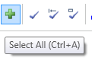
B. Selecting Events Using Tw Command-line Commands
Please consult the Commands Help documentation (Help menu | Commands Help) for information about the select all [fixtures] [constraints] command (e.g., select all -toilet vol > 1.5 peak < 3 = select all events that are not toilet and have a volume > 1.5 and a peak < 3).

