**CURRICULUM VITAE**

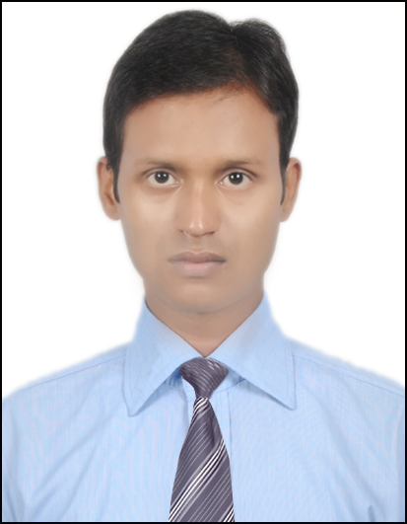**Ratnesh Kumar**

H. No. 395,

VPO -Kapashera

New Delhi, 110037.

Contact no. +91-9818025355

E-mail: [ratn.kumar007@gmail.com](mailto:responsesatya8@gmail.com)

**Objective**

Looking for a position as a Purchase Executive to use my skills and experience for mutual growth and benefit of the organization and myself.

**Career Summary**

Over 4 years of experience in variety of field ranging from Engineering and Projects, HVAC, Water System, Utility, Electrical, Equipment’s, Civil, Construction, Infrastructure, EHS and IT dept.  Proven ability to lead cross-functional teams, negotiate contracts, develop long-term commodity strategies, utilize e-sourcing tools, manage working capital, complete cost analysis and source from low cost countries.

**Work Experience**

* **Interface Microsystems, Gurgaon, Purchase Executive (from March-2017)**
* **Ice Boy Machines Pvt. Ltd, Gurgaon, 1.25 year Service Engineer (Jun-2015—Sep-2016)**
* **Yushiro India Company Pvt. Ltd, Gurgaon, Service Engineer 1.5 years (Dec-2013—Jun-2015)**

**Key Result Areas**

* **Capex Purchase:** Engineering and Projects, HVAC, Water System, Utility, Electrical, Equipment’s, Civil, Construction, Infrastructure, EHS and IT dept.
* **Opex Purchase:** Engineering and Production
* **Materials Management:** Procurement of all kinds of Material (Civil, Mechanical & Electrical).
  + **In Civil:** Procurement of Almira, Racks, Workstation, Storage, Chairs Masonry work, Carpentry Work, Paint Work, Iron Fabrication Work, Fall Ceiling, Cement, Anchor Bolt, TMT Bar, MS Bar, Acrylic sheets, ACP Sheets etc.
  + **In Mechanical:** All types of Fittings (Elbow, Coupling, Valve, Flanges,) Pipe, Piping Material, Air piping, Water piping, Stud Bolt, Fasteners etc.
  + **In Electrical:** All types of Electrical consumables material, Wire, Led, Halogen, CFL, Tube light, Pumps etc.
  + **Utility:** AMCs, CMCs, Service record, Maintenance cost, SparesofDG, Compressors, Housekeeping M/c, HVAC, Strapping M/Cs, Water Cooler, ROs etc.
  + **In EHS:** Fire Extinguisher, Fire Hydrant System, Hazardous Waste, Electricity Saving
  + **In IT:** LCD, Projector, Telephone,Laptop, Barcoding, Cable Cubbies, Cables etc.
* **Projects Undertaken:** Fire Alarm System, Installation of Kuka Robot for RPS testing, Installation of New DG, New Ductable AC installation, New Canteen (made of PUF), New Conference room and its automation. CSR activity in Govt. primary School.

**Responsibilities**

* Review, evaluate, and approve technical specification for the requirement with Eng. team or internal contact.
* Identifying cost competitive sources to obtain competitive quotations on commodities and services.
* Study quotations for best quality, cost to company and evaluate the vendors for issuing the purchase order.
* Negotiations with suppliers on price or contracts and formulating terms & conditions.
* Maintain record of goods ordered and received.
* Prepares and maintains accurate records and documentation of all the procurement activities with specification, comparative statement correspondence and related follow up.
* Project review meeting with vendor and management and make MOM and MIS.
* Project Kick off meeting with contractor, verify statutory requirements with site and vendor, and prepare Bar chart of project progress and tracking of the same.
* Manage project during various phases of Identifying Suppliers, designing, procurement of Machinery & Equipment's, Close co-ordination with Project manager during commissioning.
* Budgeting, Monthly Budget is prepared as per the requirement of Project.

**Training and Technical Skills**

* NPTEL certification on below Courses (Feb-2018 – March-2018)
* Certification Course in **Supply Chain Analytics,** From **IIT Roorkee**
* Certification Course in **Management of New Product and Services,** From **IIT Kanpur**
* Certification Course in **Project Management** From **IIT Kanpur**
* Proficient and competent in varied kinds of Microsoft packages like MS-Outlook, MS-Excel, and other MS-Office software packages and have working knowledge of SAP MM, CAD etc.

**Education**

* B.Tech in Mechanical Engineering (2009--2013) from MAIT, G.G.S.I.P.U. New Delhi, with aggregate of 70%.
* Intermediate from CBSE Board in Science with aggregate of 74% in year 2008.
* High School from CBSE Board with aggregate of 80% in year 2006.

**Declaration**

I hereby declare that the above written particulars are true to the best of my knowledge and belief.

**Date:**

**Place: Delhi Ratnesh Kumar**