Comparison of feature-based visual tracking for agricultural implements

Trevor P. Stanhope*. Viacheslav I. Adamchuk**

*McGill University, Montreal, QC (e-mail: trevor.stanhope@mail.mcgill.ca).
**McGill University, Montreal, QC (Tel: 514-398-7657; e-mail: viacheslav.adamchuk@mcgill.ca)
Abstract: Systems which utilize implement-mounted cameras for machinery feedback, e.g. on row-crop cultivators and seeders, can be upgraded to provide high-precision ground-speed and tracking feedback. This process, known as visual tracking or computer-vision motion estimation (CVME), may be incorporated either stand-alone or in supplementary to RTK GNSS receivers and fifth-wheels. Several variations of the SURF, SIFT, and ORB feature-descriptor algorithms were evaluated for their suitability using a 3 GB dataset of 640 × 480 pixel videos of six common agricultural surfaces - gravel, asphalt, grass, seedlings, corn residue, and pasture - for speeds from 1 m/s to 5 m/s. Feature-descriptor matching was conducted using two methods of the k-Nearest Neighbors (kNN) algorithm: (1) 1NN-matching with cross-checking, and (2) 2NN matching using the ratio-test. Ground-speed and tracking estimates were calculated using a fast histogram method to reject bad matches between each consecutive pair of video frames. Motion vector estimates produced by the feature-descriptor algorithms were compared against RTK GNSS tracking data. Results demonstrate that ORB with CLAHE pre-processing (CLORB) and 1NN cross-checking was the most robust with respect to real-time applications. The CLORB achieved a statistically similar 95th percentile error statistically similar to SURF and SIFT of 0.22 m/s, but with processing speed of 25 Hz which was an improvement of 10 Hz compared to the fastest variant of SURF.
Keywords: Computer-vision, feature description, visual tracking.

1. INTRODUCTION
In order to identify the movement between consecutive frames of a video stream, distinctive features must be detected in the image which can be tracked. Examples of features include blobs, corners, and edges. A distinctive feature can typically be described as sub-region of an image which exhibits maximum variation when the window of consideration is shifted in all directions about the point. The process of searching for such keypoints is known as Feature Detection. After a set distinct features have been located in an image, next the region around each feature must be the described. The process of generating descriptive parameters for a feature is known as Feature Description. Once a set of features and their descriptors have been generated for both images, a clustering algorithms such as k-Nearest Neighbors can be employed to find matches between the two sets.
  - SIFT Feature-Descriptor
Scale-Invariant Feature Transform (SIFT), proposed by Lowe et al. (2004), was a significant improvement over previous methods and remains one of the most popular feature-descriptors. SIFT is based on the Laplacian of Gaussian (LoG) which acts as a blob detector for finding distinct blobs of different sizes by varying a scaling parameter (σ). LoG searches for the local maximas at varying scales which gives us a list of (x,y,σ) values. However, LoG is computationally costly, so the SIFT algorithm detects local extremas of the image after applying a Difference of Gaussians (DoG) filter as an approximation of LoG (Equation 4.1) which performs despite noise compared to other detectors (Rosten, 2010). DoG is calculated by obtaining the difference of Gaussian blurring of an image with two different σ-values, i.e for σ and Kσ. This process is conducted for different octaves of the image in a Gaussian Pyramid.
Fig. 1. Bifurcation: Plot of local maxima of x with damping
a decreasing.
1.2 SURF Feature-Description
Speeded-Up Robust Features (SURF) was developed as an improvement upon the SIFT algorithm (Bay, 2008). Like SIFT, SURF is a scale and rotation-invariant interest point detector and descriptor. Convolution with the Gaussian second order derivatives in LoG is computationally expensive, so SURF offers improved computational speed over SIFT by approximating LoG with Box Filters and using pre-computed integral images (Figure 4.1).
1.3 ORB Feature-Description
Although very computationally efficient, BRIEF is extremely sensitive to in-plane rotation (Kulkarni, 2013). Oriented FAST and Rotated BRIEF (ORB) was developed by Rublee et al. (2011) as a real-time, rotation-invariant, feature-descriptor algorithm with comparable performance to SIFT and SURF. The first major improvement included in ORB is the assignment of orientations for each FAST keypoint, known as Oriented FAST (oFAST). First, the FAST feature detector is used to find keypoints, and then the Harris corner measure is applied to find the N best points. The Harris-score is used in place of the FAST-score to improve reliability, albeit at a slight cost to speed. Next, in the FAST corner detection stage, the orientation of keypoint is determined using the primary moment method of the intensity centroid for a 15 × 15 region around each keypoint. This process provides each keypoint with an orientation at relatively low computational cost (Rublee, 2011).
The second major improvement in ORB is the inclusion of the Rotation-Aware BRIEF (rBRIEF) algorithm, a binary-descriptor algorithm based on BRIEF. So what ORB does is to “steer” BRIEF according to the orientation of keypoints. rBRIEF computes the intensity weighted centroid of the patch with located corner at center. The direction of the vector from this corner point to centroid gives the orientation. To improve the rotation invariance, moments are computed with x and y which should be in a circular region of radius (r), where r is the size of the patch. For any feature set of n_{d} binary tests at location (x_{i}, y_{i}), a 2 × n matrix is defined (S) which contains the coordinates of these pixels. Then, using the orientation of patch (θ) the rotation matrix is computed and rotates S to get steered (rotated) version (S_{θ}). ORB discretizes the angle to increments of 2π/30 and constructs a lookup table of pre-computed BRIEF patterns. As long as the keypoint orientation θ is consistent across views, the correct set of points S_{θ} will be used to compute its descriptor.
An important benefit of BRIEF is that feature has a large variance and a mean near 0.5 which results in more discriminative features. However, once oriented along keypoint direction with rBRIEF, this property is lost and the variance is distributed. To resolve this, ORB uses a greedy search among all possible binary tests to find the ones that have the highest variance:
1.4 CLAHE
Histogram equalization is a pre-processing technique for adjusting pixel intensities in order to enhance the contrast of images and edge definition. However, global histogram equalization can cause degradation of some features. To address this, adaptive histogram equalization (AHE) partitions the image into equally sized rectangular tiles, e.g. 8 × 8 tiles is a common choice (Zuiderveld, 1994). For each tile, the sub-histograms is calculated and used to equalize each image tile independently. However, AHE is still prone to over-amplification of noise in homogenous regions.
To address noise-amplification, contrast limited adaptive histogram equalization (CLAHE) was proposed by Pizer et al. (1998). CLAHE uses the slope of the transformation function in the neighborhood of a given pixel value to perform contrast amplification. The amplification is proportional to the slope of the neighborhood's cumulative distribution function (CDF), i.e. the value of the histogram for the given pixel value. CLAHE limits the amplification by clipping the histogram at a predefined value, known as the clip limit, before computing the CDF, thus reducing the slope of the transform function (Figure 4.2). The clip limit of the sub-histogram depends on the normalization of the histogram and thereby on the size of the neighborhood region. Lastly, interpolation allows a significant improvement in efficiency without compromising the quality of the result (Pizer, 1987).
As a pre-processing technique, CLAHE has positive effect on edge enhancement (Figure 4.3), but is somewhat computationally expensive because it requires computing a histogram and CDF for each of the 8 × 8 tiles an image. However, CLAHE has been demonstrated to be an effective technique for real-time contrast enhancement (Yadav, 2014). CLAHE has been implemented as a component of histogram-binary combined corner enhancement (HBCCE) and was found to improve the repeatability of the BRISK detector from 10% to 40% with negligible reduction in computational speed (El Harraj, 2015).
1.5 kNN Matching
The k-Nearest Neighbors algorithm (kNN) is a non-parametric method used for pattern recognition to perform classification and regression. The input consists of the k closest training examples in the feature space (Altman, 1992). kNN is one of the simplest of classification algorithms available for supervised learning. The idea is to search for closest match of the test data in feature space. With respect to feature matching of images, kNN is used to find the k nearest neighbors of each feature in one image to the features of a second image. A commonly used distance metric for continuous variables is Euclidean distance, known as the L² norm. However, the features produced by binary feature descriptors, such as ORB, are discrete variables, so instead of Euclidean distance the overlap metric, known as Hamming norm, must be used. This provides a significant improvement in matching speed because calculating Hamming norm only requires applying XOR and bit count which are very fast operations on modern CPUs with Streaming SIMD Extensions (SSE) instructions.
In image matching, the two common approaches are to use 1NN and 2NN. The method proposed by Lowe et al. (2004) is known uses 2NN and is known as the ratio-test. For each feature, two neighbors are found and their distance metric is compared and the feature is only selected which if the ratio between them is less than some threshold. In the case of Lowe et al. (2004) a threshold of 0.8 is used. The second method for matching using 1NN is known as cross-checking. Cross-checking is based on the principle that distance from specific point (point A) to another particular point (point B) is not necessarily an invertible statement. Thus, B may be the closest point to A, but A may not be the closest point to B. Cross-checking computes 1NN for both directions, A-to-B and B-to-A, and a match is considered valid if A is closest to B for both directions (Fig. #).
2. MATERIALS AND METHODS
A weatherproof CMOS camera (IP67: dust-tight, water-tight) with a resolution of 640 × 480 pixels was mounted to the front of a John Deere 850D Gator (John Deere, Illinois) at an orthogonal perspective relative to the ground surface and a height of 1.0 m (Figure 4.5). The camera had an aperture of 2.4 (F), a 6 mm focal point (f), 1/3'' CMOS sensor and a 4:3 aspect ratio. In order to maximize the overlap between consecutive images at higher travel speeds, the camera was oriented width-wise such that the 640 pixel axis of the images were aligned with the direction of travel. The camera was capable of automatic white-balance adjustment and had a frame capture rate of 25 Hz. The lens of the camera was not infrared (IR) filtered and the camera enclosure was equipped with 24 infrared LEDs. The camera was rated to a minimum illumination of 0.5 Lux and could be used effectively in a wide range of ambient lighting conditions.
After installation of the camera bracket, 10 calibration images were taken of a 9 × 7 checkerboard pattern in order to determine the camera distortion model (Lee, 2009). Corner detection was conducted on each image wherein the geometric position of the 48 distinct corners were found (Fig. #). These points were used to fit a Brown-Conrady radial and tangential distortion model (Conrady, 1966). The distant coefficients of each calibration image were averaged, resulting in the final distance coefficients employed for radial distortion correction (Eq. #). To improve computational speed, these coefficients were reduced to a single mapping transform which was applied to each frame prior to feature detection and description (Equation 4.10). Using the known dimensions of the squares (30 mm by 30 mm), an image resolution of 1.0 mm/px was verified.
A Trimble AgGPS 542 RTK GNSS rover and GA530 receiver (Trimble Navigation Limited, Sunnyvale, California, USA) were mounted to the test vehicle. The rover was configured to produce $GPVTG and $GPGGA NMEA strings at the maximum supported rate of 20 Hz. The accompanying base station was positioned in an open area and all trials were conducted within 2 km of the base station. The application was optimized to run on an 2.8 GHz Intel i7 VMC3501-K (Nexcomm, Taipei, Taiwan). An application was developed using the Python programming language (version 2.7.11) (Python Software Foundation, Wilmington, Delaware, USA) and OpenCV (version 2.4.9) (Itseez, Nizhny Novgorod, Russia) to capture videos with low-latency and produce accompanying GPS logs with high precision time-stamps (1 μs precision) corresponding to each frame.
As specified by ISO 12188-2, the visual tracking system was evaluated from 1 m/s to 5 m/s (ISO, 2012) on six (6) surfaces: asphalt, gravel, sod grass, seedlings (< V2), corn residue, and pasture (Fig. #). For each trial, the logging system and RTK GNSS were activated. Once an accurate satellite signal was acquired, the vehicle was engaged into gear and the accelerator was steadily applied until 5 m/s was reached. Although the vehicle was manually operated, during each trial the operator attempted to maintain an average acceleration of 0.25 m/s² for a target trial length of approximately 45 seconds. For each surface type, five (5) replicates were conducted. For each trial, the approximate height of the crop coverage relative to the ground surface was estimated. This resulted in total dataset of 32699 images.
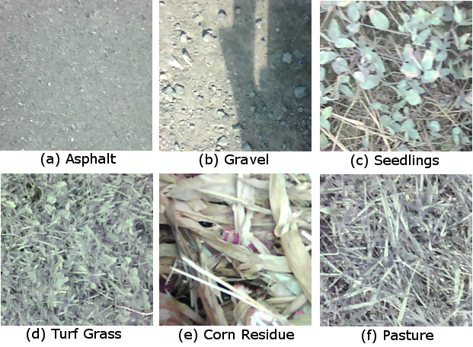
Fig. 1. Bifurcation: Plot of local maxima of x with damping
a decreasing.
Five feature-descriptor algorithms were evaluated: SURF, U-SURF, ORB, ORB with CLAHE pre-processing (CLORB), and SIFT. Additionally, for each feature-descriptor algorithm, both 1NN with cross-checking and 2NN with the ratio-test (threshold of 0.7) were evaluated, for a total of 10 algorithm configurations. Post-processing of the collected video data was computed in a single thread on a Intel Xeon CPU E31225 at 3.10 GHz to simulate performance similar to an high-end embedded system. Processing rates of each algorithm were calculated by comparing real-time clock readings to 1 μs precision at the beginning and end of each iteration
The visual tracking algorithm consisted of an iterative process consisting of 9 sequential operations (Fig. #). First, the next RGB image was captured and converted to gray-scale (Eq #). In the case of ORB, a version was tested which included an additional pre-processing step of CLAHE on the gray-scale image. Next, lens distortion was corrected for (Eq. #). One of the feature-descriptor algorithms was then used to detect keypoints for an image, and then computing feature descriptors for kNN-matching the keypoints of the current image to the keypoints of the previous image stored in memory. The set of matches produced by kNN was then converted to polar vectors before a histogram vector filter was applied to eliminate "bad" vectors. Lastly, the median angle and displacement was calculated from the set of all remaining "good" vectors.
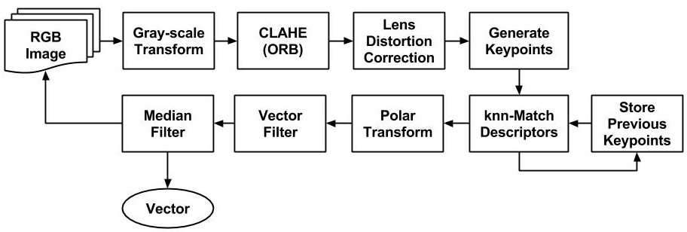
Fig. 1. Bifurcation: Plot of local maxima of x with damping
a decreasing.
With respect to SURF and U-SURF, common parameters used in the literature and by Bay et al. (2008) were employed, specifically: four (4) Gaussian pyramid octaves and two (2) images within each octave of a Gaussian pyramid. Also based on the literature, kNN matching of SURF floating-point descriptors was conducted using the L² norm distance metric. With respect to SIFT, algorithm parameters similar to that used in Lowe et al. (2008) were used: the number of octave layers was set to three (3), and the contrast and edge thresholds were set to 0.04 and 10, respectively. As per the literature, kNN matching of SIFT floating-point descriptors was conducted using the L² norm distance metric. With respect to ORB, two variants were evaluated: ORB and ORB with CLAHE pre-processing (CLORB). Both algorithms were configured to use an edge threshold of 31, a patch size of 31, eight (8) pyramid levels, and two (2) randomized pairs for BRIEF intensity comparisons. As per the literature, kNN matching of ORB binary descriptors was conducted using the Hamming norm distance metric. In the case of CLORB, CLAHE with a clip limit of 2 and a tile grid size of 8 × 8 was used.
Despite kNN matching, errors from visual tracking features are highly non-parametric and it is necessary to filter the set of all possible vectors to remove any bad matches. However, the set motion vectors be assumed to be unimodal. Therefore, a computationally inexpensive histogram filter was employed (Equation 4.13). First, a 360-bin histogram (H) of the integer-rounded θ-values was generated. Next, the discrete 2nd-order gradient (Equation 4.14) of the histogram cumulative summation (Equation 4.15) was used to calculate an array of differences (D). The central vector angle corresponding to the maximum value of the gradient array was found (θ_{C}) using the argmax() function (Equation 4.16). The resulting best estimate for the motion vector (v_{m}) between two consecutive frames was taken to be the median and mean of the sets of all vector radii (R_{k}) and all vector angles (ϴ_{k}), respectively , whose angle of orientation within a tolerance of 1˚ of the θ_{C}. This methodology proved to be an effective way to isolate the dominant motion vector and took less than 2 ms per 640 × 480 frame compared to 7 ms for RANSAC. Figure 4.9 shows an example of the effects this filter on bad-vector rejection.
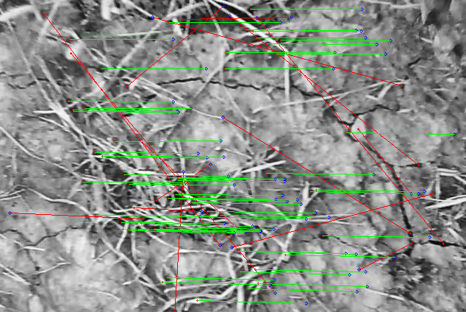
Fig. 1. Bifurcation: Plot of local maxima of x with damping
a decreasing.
For subsequent analysis of the data, tracking values of the RTK D-GPS were smoothed using a 5-point 1st-order Savitsky-Golay filter to reduce vibration effects. To maintain consistency, estimates from the feature-based visual tracking methodologies were smoothed using a 5-point moving median filter. Savitsky-Golay filtering was not used for the visual tracking data due to the non-parametric nature of error distribution.
3. RESULTS
Fig. # presents a comparison between two trials one on asphalt and on second on corn residue. Generally speaking, the performance of the visual tracking methods had similar performance compared to RTK D-GPS. All feature-descriptor methods exhibited the better performance on surfaces which were more homogeneous (e.g. asphalt) compared to heterogeneous surfaces (e.g. corn residue).
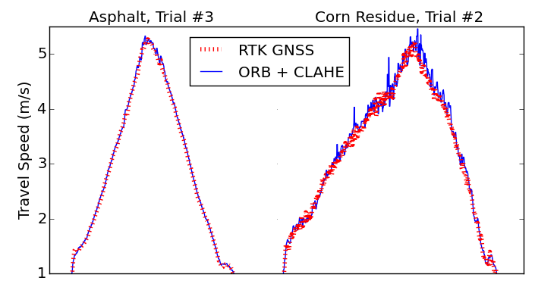
Fig. 1. Bifurcation: Plot of local maxima of x with damping
a decreasing.
Table 4.1 shows a summary of 95th percentile values and the average processing time for each combination of feature-descriptor algorithm and kNN matching method. It can be seen that incorporating of CLAHE as a pre-processing step for ORB reduced the 95th percentile of all trials by 0.08 m/s and 0.06 m/s compared to standard ORB for 1NN cross-check and 2NN ratio-test, respectively. SIFT performed best overall, but also exhibited the slowest computational speed.
#!TODO ADD TABLE
4. DISCUSSION
Real-time visual tracking for agricultural implements has great potential for feedback and control applications. With respect to cultivator guidance systems, visual tracking may prove to be valuable sensory feedback for adaptive controllers. Challenges inherent to pivoting hitch steering systems, specifically varying orientation of the camera with respect to the crop row, may be easily mitigated with orientation compensation based on visual tracking (Appendix C). Additionally, classical PID control is not universally appropriate for implement systems due to the dynamic nature of their use. Further research into the development of an adaptive FPID controller with visual tracking for real-time reinforcement learning would be an excellent project to synthesize the concepts discussed in this research.
Monocular visual tracking may be a viable component of sensor fusion systems, specifically for depth estimation (Appendix D). Current methodologies for canopy height detection often utilize ultrasonic (Gil, 2007), LIDAR (Llorens, 2011), or stereovision systems. or tractors with CANBUS connectivity and RTK D-GPS, comparison of visual tracking and satellite data may be sufficient for estimation of crop canopy without the need for ultrasonic or laser distance sensors. Such a system may be easily integrated with existing monocular vision systems for sectional sprayer control (Tellache, 2008). A study focused on the comparison of sensor performance and control methodologies for a crop canopy depth control of a sprayer boom using ultrasonic, laser, stereovision, and monocular with RTK D-GPS fusion would be an excellent research project.
5. CONCLUSION
Although the ORB algorithm is computationally efficient, it displayed reduced performance at travel speeds from 3 to 5 m/s compared to SIFT, SURF and CLORB, all of which did not suffer the same degree of performance loss (Figure 4.12). U-SURF not only outperformed SURF, but was computationally faster by ~50% (Table 4.1). Variants of the SIFT algorithm exhibited the best overall precision, which was most noticeable on asphalt (Figure 4.). However, incorporating CLAHE pre-processing prior to the ORB algorithm with cross-checking greatly improved reliability, and despite the increased computational cost was still capable of real-time performance (e.g. >25 Hz) (Table 4.1). Comparisons between the performance of ORB and CLORB for similar computational times show that CLAHE had an overall positive effect on performance (Figure 4.12). Overall, there was a general relationship between precision and degree complexity of feature-description. For example, SIFT exhibiting best precision, but also significantly slower computational time (Table 4.1). The errors each feature-descriptor were fit to using ordinary least squares to a linear model with zero intercept (Table 4.2). All of the algorithms exhibited very close correlation to RTK D-GPS values with the exception of ORB. These results suggests that agricultural applications which require real-time vector estimation with low-cost cameras should utilize ORB with CLAHE due to the good compromise between precision and computational speed. However, for field applications which require highly accurate vector estimations and do not have strict time constraints should continue to use U-SURF due to its excellent performance on all surfaces and at all travel speeds. For tractor performance testing on concrete and asphalt (both of which are very homogeneous surfaces for visual tracking), SIFT had the best performance due to DoG's ability to find distinctive keypoints regardless of noise and homogeneity.
REFERENCES
List of references arranged alphabetically according to first author, subsequent lines indented. Do not number references. Publications by the same author(s) should be listed in order of year of publication. If there is more than one paper by the same author(s) and with the same date, label them a, b, etc., e.g. Morris et al. (1990a, b). Please note that all references listed here must be directly cited in the body of the text.
Brown, F., Harris, M.G., and Other, A.N. (1998). Name of paper. In Name(s) of editor(s) (ed.), Name of book in italics, page numbers. Publisher, Place of publication.
Smith, S.E. (2004). Name of book in italics, page or chapter numbers if relevant. Publisher, Place of publication.
Smith, S.E. and Jones, L.Q. (2008). Name of paper. Name of journal in italics, volume (number), page numbers.
Appendix A. ORIENTATION COMPENSATION
Computer-vision systems have been successfully employed on inter-row cultivations for row detection, with a particular emphasis on side-shift hitches (Robati, 2012). However, pivoting-hitch systems, such as the Sunco AcuraTrak (Sunco Manufacturing, North Platte, Nebraska, USA), pose a specific set of challenges for crop row estimation via imaging systems. If the cameras are mounted to the tool-bar, the pivoting action of the hitch effectively changes the orientation of the cameras relative to the crop row (Figure C.1). For example, a camera which is positioned 200 cm laterally and 50 cm longitudinally from the pivot point would have approximately 2 cm of positional error due to pivoting only 5°. Therefore, the computer-vision detection process will overestimate or underestimate the lateral error (depending on configuration and tracking direction) which may negatively impact the steering system.
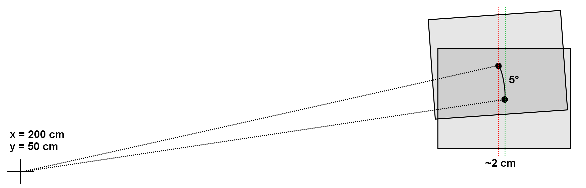
Fig. 1. Bifurcation: Plot of local maxima of x with damping
a decreasing.
Fortunately, rotational error due to the motion of a pivoting-hitch can be mitigated by employing rotation compensation using the motion vector information provided by visual tracking. Assuming that the longitudinal component of the implement's velocity in the direction of the crop row (V_{y}) is much greater than the rate of lateral adjustment (V_{x}), the small angle approximation applies and the orientation of the image can be corrected by applying a rotational matrix transform about the hitch's pivot point.
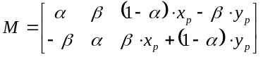
where α = cos(θ), β = sin(θ), and (x_{p} , y_{p}) is the pivot-point about which the image will be rotated (mm).
However, for applications with relatively small variation in orientation, or embedded systems with limited processing power, this additional transformation may not be practical to compute. For example, the row estimation method discussed in Chapter 3 is errors are relatively small for rotational changes of less than ±10° which is the typical range of motion for pivoting-hitch systems, e.g. the Sunco AcuraTrak has a pivoting angle of ±5°. Therefore, if the orientation change is small the positional error of the image centroid relative to the true position of the row may be approximated with the following equation:
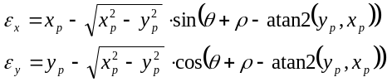
where x_{p} is the lateral distance from the camera to the pivot point, y_{p} is the longitudinal distance from the camera to the pivot point, ρ is the roll of the camera (assumed to be 0°), and θ is the instantaneous orientation of the camera relative to the direction of travel.

