Generation of circularly polarized soft x-rays by the use of a quadruple reflection polarizer

S. Schaffert1, M. Schneider1, C. v. Korff Schmising1 and S. Eisebitt1

1Institut für Optik und atomare Physik, TU Berlin, Hardenbergstraße 36, 10623 Berlin, Germany

Circulary polarized x-rays are widely used to investigate matter by the use of circular dichroism. Especially investigations of magnetic materials via the XMCD (x-ray magnetic dircular dichroism) effect [1],[2] suffer from the lack of elliptical undulators for free-electron lasers. To overcome this obstacle we are building a quadruple reflection polarizer[3] to transform the incident ultrashort linearly polarized pulses into circularly polarized pulses.

By the reflection on four plane mirrors a phase shift between the s- and p-component of 90° is induced. Circular polarization of the transmitted soft x-rays is generated when the total transmission of the polarizer is equal for s- and p-polarized light, e.g. TS=TP. This is achieved by rotating the two pairs of mirrors around the beam axis. The angle of incidence on the mirrors can be varied to gain full flexibility for the degree of polarization, total transmission and for a wide energy range.

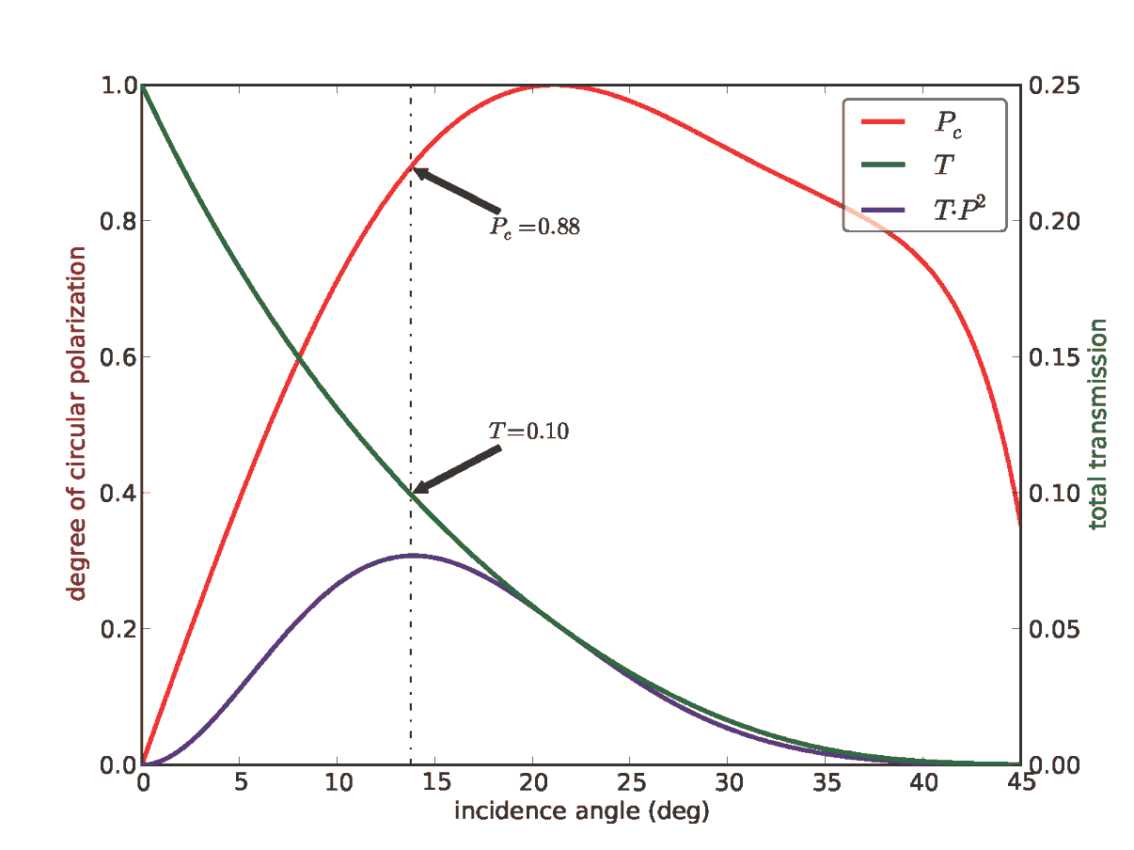The completely remote controlled setup will be integrated into the FLASH facility to offer circularly polarized light for user experiments.

Figure 1: Calculation of circular polarization (red), total transmission (green) and figure of merit TP² (violet) for the quadruple reflection polarizer for FLASH.

References

1. P. Fischer, Exploring nanoscale magnetism in advanced materials with polarized X-rays  
   *Materials Science and Engineering R,* ***72***, pp. 81-95 (2011)
2. B. Pfau et. al., Magnetic imaging at linearly polarized x-ray sources

*Optics Express*, **18**, pp. 13608-13615 (2010)

1. B. Vodungbo et. al., Polarization control of high order harmonics in the EUV photon energy range Opt. Express **19**, 4346-4356 (2011)