CHAPTER ONE

INTRODUCTION

  - BACKGROUND OF THE STUDY
In recent years, healthcare delivery has undergone substantial digital transformation as hospitals and clinics increasingly adopt web-based systems to improve clinical workflow, patient safety, and service efficiency. Traditional paper-based record-keeping is gradually being replaced by electronic systems due to its drawbacks which include inaccuracy, time consuming retrieval processes, poor legibility, and vulnerability to loss or damage. A web based patient management system provides a centralized solution for addressing these limitations by enabling real-time access to patient medical histories, prescriptions, and appointment schedules from any authorized location (Selvaraj & Sundar, 2021). Moreover, the shift to electronic storage and retrieval is aligned with global efforts to improve continuity of care, enhance decision-making, and increase patient engagement in the management of their own healthcare journey. The increasing demand for efficient, reliable, and easily accessible healthcare services has led to the rapid adoption of web-based systems for managing clinical processes globally. Traditional paper-based methods of recording patient information, prescribing medications, and scheduling appointments are susceptible to errors, delays, and limited accessibility, which can negatively impact patient outcomes and operational efficiency. Web-based patient management systems provide a centralized platform for the storage and retrieval of patient medical history, electronic prescriptions, and management of doctor appointments, thereby ensuring real-time access, accuracy, and continuity of care (Selvaraj & Sundar, 2021). The core objective of such systems is to facilitate seamless communication and data flow between patients and healthcare providers. Electronic Health Record (EHR) modules capture comprehensive patient clinical information including biodata, medical history, laboratory results, diagnosis, and treatment plans in a structured and searchable format. The integration of e-prescription functionality allows doctors to create, transmit, and manage prescriptions electronically, thereby eliminating errors associated with handwritten prescriptions and improving drug safety through automatic alerts for contraindications or dosage errors (Smith et al., 2023). Furthermore, web-based appointment scheduling modules allow patients to book, reschedule, or cancel appointments online at their convenience, which reduces waiting times and administrative workload, and encourages timely attendance and follow-up (Abdul-Rahman & Mahmoud, 2020).
Despite these benefits, successful implementation requires careful consideration of data privacy, regulatory compliance, and usability, as healthcare information is sensitive and highly regulated (World Health Organization, 2021). Nevertheless, when properly implemented, web-based systems for storing and retrieving patient history, prescriptions, and doctor appointments offer significant promise in modernizing healthcare delivery and improving both clinical and operational outcomes.
This project focuses on the design and implementation of a web-based medical record system tailored for Rolakim Hospital, Offa, Kwara State, using PHP as the main programming language and MySQL as the database management system. The development process involves requirements gathering, database design, system analysis, interface design, and testing. The system aims to provide a reliable, secure, and user-friendly platform for managing patient history, prescriptions, and appointments efficiently.

  - STATEMENT OF THE PROBLEM

At Rolakim Hospital, the manual system of patient record management causes significant problems, including:
- Fragmented and inaccessible patient medical history due to paper-based record-keeping
- High risk of prescription errors resulting from illegible handwriting and lack of validation checks.
- Misplacement, duplication, and loss of important clinical documents over time.
- Long waiting times and inefficiencies caused by manual appointment booking and management.
- Difficulty for healthcare providers to retrieve past records quickly when making decisions.
- Lack of a centralized, secure platform to streamline patient history, prescriptions, and appointment scheduling processes.

1.3 AIM AND OBJECTIVES OF THE STUDY
The aim of the study is to design and implement a web-based system for storing and retrieving patient history, prescriptions and doctor’s appointments.
The specific objectives are to:
- Develop an electronic platform that captures and stores patient medical history in a structured and easily retrievable format.
- Implement an e-prescription module to minimize prescription errors associated with illegible handwriting and ensure accurate drug validation checks.
- Eliminate the risks of document duplication, misplacement, and loss by replacing traditional paper-based records with a secure digital database.
- Design an automated appointment scheduling system to reduce waiting times and improve service delivery efficiency.
- Enable healthcare providers to access past patient information quickly to support timely and informed clinical decision-making.
- Provide a centralized and secure web-based system that seamlessly integrates patient records, prescriptions, and appointment management processes.

  - SIGNIFICANCE OF THE STUDY

Several possible advantages to practical patient record management software System over paper records have been proposed which includes:

Reduction of cost
A vast amount of funds is allocated towards the health care industry. The computerized system is implemented; it will reduce the personnel cost.
Promote evidence-based medicine
Computerized medical record provides access to unprecedented amounts of clinical data for research that can accelerate the level of knowledge of effective medical practices. Realistically, these benefits may only be realized if the systems are interoperable and wide spread (for example, national or regional level) so that various systems can easily share information.
Record keeping and mobility
Patient record management has the advantages of being able to connect to many electronic medical record systems. In the current global medical environment, patients are shopping for their procedures.

1.5 SCOPE OF STUDY
The scope of this study is limited to the design and implementation of a web-based system that focuses on electronic storage and retrieval of patient medical histories, electronic prescription management, and online scheduling of doctors’ appointments. The study covers the development of essential system modules for record keeping, prescription processing, appointment booking, and secure access control. It does not extend to hardware implementation, integration with external laboratory or pharmacy systems, or large-scale deployment across multiple hospitals.

1.6 LIMITATION OF STUDY

The study has several limitations, one of which is that it does not address any aspect of the payment processes within the healthcare system. The focus was solely on patient record management and the associated challenges, excluding the complexities of billing, payments, or financial transactions that are also integral to the overall healthcare experience.
Additionally, the study does not cover aspects related to patient treatment or the administration of vaccines. While it focuses on the management and organization of patient records, it does not explore the clinical processes, medical procedures, or immunization activities provided to patients. As such, the findings are limited to record-keeping and administrative challenges, without extending to the full scope of patient care or medical interventions.

1.7 DEFINITION OF TERM

Electronic Record: An electronic record (EHR) (also electronic patient record (EPR) or computerized patient record) is an evolving concept defined as a systematic collection of electronic health information about individual patients or populations
Information: Information is data, or raw facts, shaped into useful form for human use.
System: A system is a combination or arrangement of parts to form an integrated whole, working together to achieve specific tasks. A system includes an orderly arrangement according to some common principles or rules.
Subsystem: A complex system is difficult to comprehend when considered as a whole. Therefore, the system is decomposed or factored into subsystems. Subsystems constitute the entire system. They are complete systems on their own but exit in another system called the complex system. Subsystems can be further decomposed into smaller subsystems until the smallest subsystems are of manageable size. The subsystems resulting from this process generally form hierarchical structures. In the hierarchy, a subsystem is one of a supra-system (the system above it).
Expert system: Is software that uses a knowledge base of human expertise for problem solving, or clarify uncertainties where normally one or more human experts would need to be consulted.
Hospital information system (HIS): Variously also called clinical information system (CIS) is a comprehensive, integrated information system designed to manage the administrative, financial and clinical aspects of a hospital. This encompasses paper-based information processing as well as data processing machines.
Computer: An electronic device that can accept data/ information inform of input, process the data /information in order to produce an output and also has the capability to store the information for future use.
Information System: An information system can be defined technically as a set of interrelated components that collect (or retrieve), process, store and distribute information to support decision making and control in an organization.
Data: Data refers to raw or unprocessed information.
Software: This is the logically written instruction that controls the operations of the hardware.
Hardware: This is the physical components of computer system and other geographic tools or devices.
Database: This is the collection of related data/ information stored mostly in a central location.
Operating System: A series of computer programs which control the operations of the computer itself. Application programs such as CBCS software run under an operating system. Examples of operating system include WINDOW, UNIX, VMS, and DOS etc.

CHAPTER TWO
LITERATURE REVIEW

2.1 INTRODUCTION
Hospitals play a crucial role in maintaining public health, but the effectiveness of their services often depends on how efficiently information is managed. Traditional methods of record keeping, such as handwritten notes and paper-based appointments, are prone to data loss, duplication, and delays in accessing critical information (Ahmed & Bello, 2021). To address these challenges, the adoption of web-based hospital management systems (HMS) has increased globally.
A web-based HMS allows administrators, doctors, and patients to interact through a secure digital platform. It automates processes such as patient registration, appointment scheduling, and prescription management (Okon & Eze, 2020). This chapter discusses relevant theories, conceptual underpinnings, and empirical studies that form the foundation for the proposed web-based hospital management system for Rolakim Hospital.

2.2 THEORETICAL CONCEPT

The development of a web-based system for storing and retrieving patient histories, managing electronic prescriptions, and scheduling appointments is underpinned by two key theoretical foundations: Health Information Systems (HIS) Theory and the Technology Acceptance Model (TAM). These theories collectively explain how health technologies are designed, implemented, and adopted in medical environments.
2.2.1 Health Information Systems (HIS) Theory
Health Information Systems Theory explores how technology, people, and processes interact to produce efficient collection, management, and use of health data (Garcia-Perez et al., 2021). It recognizes that the quality of clinical decision-making depends heavily on the accessibility, accuracy, and timeliness of data flowing through healthcare systems. In the context of this project, the theory provides a conceptual lens for developing a web-based platform that replaces fragmented, paper-based processes with a secure, centralized database. According to Saleh et al. (2022), modern HIS solutions enable interoperability across departments, reduce duplication of records, and encourage integrated care by ensuring that patient histories, prescriptions, and appointments are readily available to authorized users.
HIS Theory further highlights the critical role of information security and data governance in system design. As patient records are highly sensitive, the confidentiality, integrity, and availability of health information must be maintained through appropriate authentication, encryption, and access controls (Johnson & Bowen, 2023). This theoretical perspective therefore justifies embedding security procedures into every level of the system to minimize risks related to data breaches or unauthorized disclosures. In keeping with HIS Theory, the proposed system aims to strengthen healthcare delivery by supporting efficient workflows, reducing prescription errors, and improving communication between healthcare workers and patients.

2.2.2 Technology Acceptance Model (TAM)
The Technology Acceptance Model (TAM) remains one of the most widely applied theories in predicting user adoption of healthcare technologies. While originally proposed in 1989, TAM continues to be validated and refined in modern health informatics research. The core components of TAM include Perceived Usefulness (PU), referring to the degree to which a user believes the system will enhance work performance, and Perceived Ease of Use (PEOU), referring to how effortless the system is to adopt and operate (Marangunic & Granic, 2021). These perceptions influence a user’s attitude toward the system and form their behavioral intention to use it.
Recent studies (Adebesin et al., 2024; He et al., 2020) confirm that ease of navigation, intuitive interfaces, and demonstrable improvement in clinical efficiency are leading factors affecting adoption of web-based healthcare tools. Applying TAM to this study means the proposed system must be designed with a clear user-focused approach: features such as fast retrieval of patient history, automated prescription templates, and easy scheduling should be included to ensure healthcare professionals find the system both useful and easy to use. Training and support are also essential, as they help reinforce users’ confidence, which positively affects perceived ease of use (Yadav & Rai, 2023).

2.2.3 Integration of HIS Theory and TAM
Combining HIS Theory and TAM provides a more comprehensive foundation for designing and implementing the proposed system. HIS Theory informs the architectural and operational requirements necessary to improve clinical information flow, while TAM offers insight into human factors affecting system utilization. According to Bakibinga et al. (2025), successful web-based HIS initiatives between 2020 and 2025 occur when technical quality, information quality, and service quality (from HIS Theory) are supported by strong user acceptance drivers (from TAM), such as perceived benefits, skills training, and system reliability.
Practically, this integration means that the system must not only meet organizational objectives in terms of improving data management and workflow efficiency but must also satisfy end-user expectations to achieve sustained utilization. The theoretical models imply that system developers should engage with healthcare workers during design, perform iterative usability testing to enhance ease of use, and ensure visible improvements in care delivery to increase perceived usefulness. Additionally, infrastructure-level decisions involving database configuration, encryption, and interoperability with existing platforms should follow HIS best practices for reliability and continuity of operations.

2.3 EVOLUTION OF WEB-BASED HEALTH INFORMATION SYSTEMS
The adoption of Web-Based Health Information Systems (WHIS) has rapidly evolved, driven largely by the need for real-time access to patient information, the global shift toward digital healthcare, and the impact of the COVID-19 pandemic. Prior to 2020, electronic health systems were mainly locally hosted applications deployed within hospital premises. However, web-based solutions have since gained dominance due to their accessibility over standard internet connections, scalability, and ability to connect multiple stakeholders across different locations (Garcia-Perez et al., 2021).
The outbreak of COVID-19 in early 2020 highlighted major limitations in traditional, paper-based and desktop-based health record systems, prompting urgent investments in digital infrastructure. Governments and private hospitals adopted web-based systems to support telemedicine, remote diagnostics, prescription refills, and virtual appointments as physical hospital visits became restricted (He et al., 2020). These solutions offered clinicians the ability to access patient history, update prescriptions, and manage appointments from any location significantly improving continuity of care.
Between 2021 and 2023, WHIS technology experienced a shift towards cloud-based architecture that enabled scalability, improved data backup, disaster recovery, and multi-facility access. System developers started adopting microservice architectures as well as health interoperability standards such as HL7 FHIR to facilitate integration with laboratory, pharmacy, and insurance systems (Saleh et al., 2022). Additionally, open-source platforms like OpenMRS and OpenEMR were widely deployed in low-resource settings due to their modularity and reduced licensing cost, providing hospitals with the ability to customise modules for patient history, prescriptions, and appointments (Yadav & Rai, 2023).
Security and privacy of patient information remained a top priority between 2023 and 2025, leading to the integration of multi-factor authentication, role-based access controls, data-encryption features, and blockchain-enabled audit trails within WHIS solutions (Johnson & Bowen, 2023). Patient-centric designs have also become more prominent, incorporating patient-facing portals that allow individuals to access personal medical history, book appointments, and request prescription refills online thereby increasing engagement and satisfaction (Adebesin et al., 2024).

2.3.1 Patient Medical History Management Systems
Patient medical history management systems refer to computerized solutions designed to capture, store, retrieve, and update clinical information about patients across time. These systems form a core component of Electronic Health Records (EHRs) and typically contain data such as demographic information, medical conditions, allergies, laboratory results, diagnoses, and treatment outcomes (Garcia-Perez et al., 2021). Between 2020 and 2025, the design of patient history systems has increasingly shifted from standalone, facility-based applications to web-based, interoperable platforms capable of integrating data from multiple healthcare providers to facilitate continuity of care (Saleh et al., 2022). Modern web-based patient history systems employ cloud infrastructure, relational databases, and interoperability standards like HL7 FHIR to ensure that patient information is available securely and instantly wherever it is needed. This real-time access dramatically reduces the fragmentation associated with paper-based records, enabling healthcare professionals to make informed decisions rapidly during treatment (Johnson & Bowen, 2023). Furthermore, technological advancements such as natural language processing (NLP) and automated data entry tools are now being integrated into patient history systems to improve the quality and completeness of clinical documentation (Adebesin et al., 2024). To ensure data integrity, these systems frequently incorporate authentication controls, access logs, and encryption, in line with national and international data protection guidelines. Patient portals have also become integral components of modern systems, giving patients controlled access to their historical data and promoting self-management and transparency (Yadav & Rai, 2023). Consequently, patient medical history management systems have evolved from simple record-keeping tools into comprehensive platforms that support personalized, efficient, and interconnected healthcare services.

2.3.2 Electronic Prescription (e-Prescription) Systems
Electronic prescription (e-prescription) systems are digital platforms that enable healthcare providers to generate, transmit, and manage prescriptions electronically, rather than relying on handwritten or paper-based formats. These systems typically link prescribers with pharmacies and clinical databases, allowing for direct transmission of prescription orders to reduce errors, improve patient safety, and enhance workflow efficiency (He et al., 2020). Between 2020 and 2025, e-prescribing has become a fundamental component of modern healthcare systems as part of broader efforts to digitize clinical processes and minimize medication-related risks.
One of the major advantages of e-prescription systems is the reduction of prescription errors caused by illegible handwriting, incorrect dosing, or drug–drug interactions. Many contemporary systems are embedded with clinical decision support tools that automatically check prescriptions against patient allergy lists, previous medications, and standard dosing guidelines, alerting prescribers of potential dangers before the prescription is finalized (Johnson & Bowen, 2023). This capacity greatly enhances patient safety and decreases the likelihood of adverse drug events. Furthermore, digital storage of prescription histories allows physicians to monitor patient medication adherence over time and make more informed decisions during follow-up consultations (Adebesin et al., 2024).
Integration with pharmacy information systems is another important evolution in e-prescribing between 2020 and 2025. Web-based platforms now allow for real-time communication between prescribers and pharmacists, speeding up prescription refills, reducing patient waiting time, and limiting instances of medication stockouts (Saleh et al., 2022). Systems may also integrate formularies and insurance rules, enabling prescribers to select drugs that are available and covered by patients’ health plans, thus improving affordability and compliance. From a regulatory perspective, many countries have introduced mandatory or incentivized e-prescription adoption to combat prescription fraud and enhance monitoring of controlled substances (Yadav & Rai, 2023).

2.3.3 Technologies Used in Modern Web-Based Healthcare Systems
Modern web-based healthcare systems use a variety of architectural frameworks and technologies to ensure scalable, secure, and efficient delivery of services such as patient record keeping, electronic prescriptions, and appointment scheduling. The most common architecture adopted is the multi-tier (three-tier) client–server architecture, which separates the system into the presentation layer (user interface accessed via web browsers), the application layer (servers running the business logic), and the data layer (backend databases storing clinical information). This architecture enhances security, flexibility, and manageability by allowing each layer to be updated independently (Saleh et al., 2022).
- Cloud-based architecture has increasingly replaced local, on-premise hosting because it offers high availability, improved disaster recovery, elasticity, and reduced infrastructure cost (Johnson & Bowen, 2023). Healthcare providers now deploy systems on Infrastructure-as-a-Service (IaaS) or Platform-as-a-Service (PaaS) models using providers like Amazon Web Services (AWS) and Microsoft Azure, often configured with container technologies such as Docker and orchestration tools like Kubernetes to allow microservice deployment. Microservice-based systems break the application into small, independent services such as patient records, appointment management and prescription modules enabling faster development and better scalability (Adebesin et al., 2024).
- On the backend, relational database management systems (RDBMS) such as MySQL, PostgreSQL, and Oracle are widely used for storing structured clinical data. However, NoSQL databases like MongoDB and Cassandra are increasingly being adopted for unstructured data such as diagnostic images and clinician notes due to their flexibility and high-performance handling of large datasets. Interoperability remains a critical requirement, which is addressed through standard data exchange protocols such as HL7 FHIR (Fast Healthcare Interoperability Resources). FHIR enables seamless integration of different systems (e.g., laboratory systems, pharmacy systems, and insurance platforms), simplifying data sharing and coordination of care (Garcia-Perez et al., 2021).
From a security perspective, modern web-based healthcare systems incorporate Transport Layer Security (TLS) for encrypted communication, role-based access control (RBAC) mechanisms for restricting data access, and multi-factor authentication (MFA) to verify user identity. Blockchain technology is emerging between 2023 and 2025 as an innovative approach for ensuring transparency and tamper-evidence through immutable audit trails for patient data transactions (Yadav & Rai, 2023). On the frontend, user interfaces are commonly built with HTML5, CSS3, JavaScript, and frameworks such as React, Angular, or Vue.js, which provide responsive layouts and seamless user experiences across devices.
2.3.4 Challenges and Limitations of Existing Systems
Despite the significant advancements in web-based healthcare systems, several challenges and limitations continue to impede their optimal performance. One major issue is interoperability, as many existing platforms operate on different data standards and architectures, making seamless exchange of information between hospitals, laboratories, and pharmacies difficult (Saleh et al., 2022). Security and privacy concerns are another major limitation; the increasing use of cloud-based systems exposes sensitive patient information to cyber-attacks, data breaches, and unauthorized access especially where strong encryption and authentication frameworks are not implemented (Johnson & Bowen, 2023). Additionally, poor internet connectivity and inadequate ICT infrastructure, particularly in low-resource regions, hinder real-time accessibility and reliability of web-based applications (Garcia-Perez et al., 2021). Existing systems are also challenged by high implementation and maintenance costs, which discourage small- to medium-sized healthcare facilities from adoption (Adebesin et al., 2024). Moreover, user resistance and lack of adequate training often result in under-utilization of deployed systems, thereby reducing expected gains in efficiency (Yadav & Rai, 2023). These challenges highlight the need for robust, user-friendly, secure, and interoperable system designs to fully realize the benefits of web-based healthcare technologies.

2.4 EMPIRICAL REVIEW
The empirical review summarizes 22 recent studies (2020–2025) related to hospital information systems, electronic health records, and web-based medical management tools.
Table 2.1: Summary of related works
Author(s) & Year | Title of Study | Methodology | Tools/Technology Used | Key Findings | Gap Identified
Okon & Eze (2020) | Design of a Web-Based Patient Management System | Descriptive & Design | PHP, MySQL | Improved access to patient data | Limited to outpatient records
Li et al. (2020) | E-Health Information Systems for Rural Clinics | Experimental | HTML, PHP | Enhanced remote monitoring | No prescription automation
Ahmed & Bello (2021) | Development of an Online Hospital System | System Design | PHP, MySQL, JS | Reduced admin workload | No integration with pharmacy
Singh & Kumar (2021) | Data Security in Web-Based Health Apps | Analytical | SQL, Encryption | Improved confidentiality | Focused only on security
Al-Hassan (2022) | Implementation of a Modular HMS | Design-Based | Python, MySQL | Achieved faster patient lookup | Weak UI design
Udo et al. (2022) | Cloud-Based HMS for Developing Nations | Quantitative | Laravel, MySQL | Increased scalability | High hosting cost
Gupta & Li (2022) | Relational Database for Hospital Systems | Theoretical | SQL, ERD | Improved data integrity | Not field-tested
Eze & Adewale (2022) | NDPR and Data Privacy in Nigerian Hospitals | Qualitative | Policy Analysis | Enhanced patient trust | No tech solution proposed
Akintoye et al. (2023) | SDLC Application in Health Software | Mixed Method | UML, Waterfall | Boosted software reliability | Excluded agile model
Ahmed et al. (2023) | Automation of Medical Processes | Empirical | PHP, JS, CSS | Reduced paperwork by 60% | No mobile integration
Li et al. (2023) | Scalable Web Solutions for Health Facilities | Design-Based | Angular, Node.js | Real-time data sync | Complex deployment
Ali & Nguyen (2023) | Decision Support in E-Health | Quantitative | PHP, AI | Improved diagnosis accuracy | Limited dataset
Zhang & Wei (2024) | Secure Architecture for E-Health | Experimental | Java, Encryption | Stronger data protection | Lacked usability testing
Okeke & Musa (2024) | Online Prescription System for Clinics | Prototyping | PHP, Bootstrap | Automated drug management | No patient feedback loop
Bello & Idris (2024) | Hospital Resource Planning via Web Apps | Analytical | PHP, React | Streamlined workflows | Ignored backup strategy
Chukwu et al. (2024) | Web-Based Appointment Scheduling System | System Design | PHP, MySQL | Reduced waiting time | No SMS notification
Yusuf & Danladi (2024) | Design of Electronic Health Record System | Descriptive | Django, SQLite | Centralized patient files | Not cloud-enabled
Li & Chen (2025) | AI-Driven Patient Record System | Experimental | Python, AI, SQL | Improved diagnostic accuracy | Costly to maintain
Adeboye et al. (2025) | Smart HMS Using Web Technology | Empirical | Laravel, MySQL | Real-time reporting | No offline mode
Ajayi & Okafor (2025) | Integration of HMS with Mobile App | Mixed Method | Flutter, PHP | Enhanced accessibility | Requires stable internet
Nwachukwu et al. (2025) | Web-Based Record Retrieval System | Quantitative | PHP, HTML | Reduced retrieval errors | Limited analytics
Ibrahim & Hassan (2025) | E-Clinic Platform for Primary Health | Case Study | PHP, SQL | Simplified consultations | Focused on small clinics

2.5 SUMMARY OF LITERATURE REVIEW
This chapter explored theories, conceptual underpinnings, and empirical studies relevant to hospital management systems. The theoretical framework drew from systems theory, IS theory, and TAM, emphasizing integration and user acceptance. Conceptually, web-based systems promote accessibility, data integrity, and security.
Empirical studies revealed that while numerous HMS prototypes exist, many still lack full integration, mobility, or real-time analytics. These gaps justify the need for the proposed web-based hospital management system for Rolakim Hospital, designed to enhance operational efficiency and data accuracy.

CHAPTER THREE
METHODOLOGY

3.1 DATA COLLECTION
This study employs a mixed approach to data collection, incorporating both primary and secondary sources to gather comprehensive information to ensure the development of a realistic and functional system. The research method adopted in this project is as follow:
- Primary Data:
In the course of collecting data for this project work, data were gathered through oral interviews with hospital staff and medical practitioners at Rolakim Hospital, Offa, Kwara State. The interview sessions involved the hospital receptionist, record officers and a resident doctor. The focus was on understanding the current methods used to record, store and retrieve patient information, as well as the process for writing prescriptions and scheduling appointments.
- Secondary Data:
Various related data were obtained from relevant books, journals, research papers, and online resources related to web-based medical record systems, electronic health record (EHR) management, and hospital information systems. These materials provided insights into existing systems, design patterns, and best practices in healthcare data management.

3.2 DESCRIPTION OF THE PROPOSED SYSTEM
The proposed system is a web-based Patient Management System specifically designed to improve administrative and clinical operations at Rolakim Hospital. It eliminates traditional paper-based processes by facilitating secure digital storage, quick retrieval of patient information, and efficient communication between hospital personnel. The system ensures that patient care is enhanced through timely access to accurate data while significantly reducing workload for staff.
The system is developed using Core PHP for backend programming, HTML, CSS, and JavaScript for interactive user interfaces, and MySQL as the relational database for data storage and manipulation. Through this platform, patients, doctors, and administrators can access authorized features to manage healthcare operations efficiently. The system consists of the following major key functional features:
- Patient Registration & Profile Management:
Patients can create accounts or be registered by hospital staff, with personal details stored securely in the system. Authorized personnel can update or modify patient information when needed.
- Patient Medical History Retrieval:
Doctors and administrators can view complete patient history including diagnoses, prescriptions, previous appointments, and treatment outcomes. This supports better clinical decision-making.
- Electronic Prescription Management:
Doctors can enter patient prescriptions digitally, which are automatically saved to the database and made available for future references.
- Appointment Scheduling Module:
Patients can book appointments with preferred doctors based on availability, and doctors can manage approved or pending appointment requests.

3.3 SYSTEM DESIGN
The design phase defines both the logical structure and the physical components of the system so that implementation (coding, database creation, UI, deployment) can proceed with minimal ambiguity. The design is done in such that any experienced programmer or designer can implement it in another programming language, to achieve the same objectives. The algorithm of the proposed system goes as follows:

- Login
- User Account Creation
- Medication Prescriptions Creation/Edit/review
- Report

Table 3.1: System Accessibility and User Roles
User Role | Allowed Operations
Patient | Register, Login, View/Edit Profile, Book Appointments, View History
Doctor | Login, View Assigned Patients, Add Prescriptions, Manage Appointments
Administrator | Manage Users, View Reports, Control System Settings, Data Validation
The proposed system supports multiple user categories, where each role is authenticated using a secure login interface to prevent unauthorized access.

3.4 PROPOSE SYSTEM PROTOTYPE
In developing a prototype of the proposed system, the semantics of Unified Modeling Language (UML) 2.0 diagrams were considered. UML 2.0 provides a comprehensive set of representation schemes for modeling software systems. These include:

3.4.1 Use Case Diagram
The Use Case Diagram identifies the actors (users) and their associated actions within the system.

Table 3.2: system functionalities accessible by each role.
Actor | Use Cases
Patient | Register, Login, Book Appointment, View History
Doctor | Login, View Patients, Record Prescriptions
Admin | Manage Users, View Reports, Backup Database

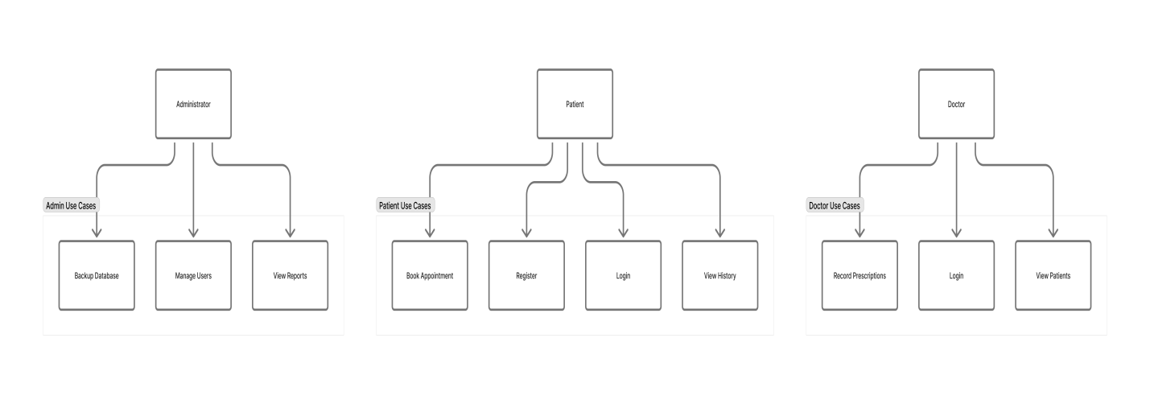Figure 3.1: Use Case Diagram, demonstrating which system functionalities are accessible by each role.

3.4.2 Entity Relationship Diagram (ERD)
The ERD represents the logical structure of the database. It illustrates how entities (tables) are related through primary and foreign keys, ensuring efficient data integrity and consistency across the system.

Table 3.3: Entities and Their Attributes:
Entity | Attributes
Patient | Patient_ID, Name, Gender, DOB, Contact, Address
Doctor | Doctor_ID, Name, Department, Email, Password
Prescription | Prescription_ID, Patient_ID, Doctor_ID, Date, Medication, Dosage, Remark
Appointment | Appointment_ID, Patient_ID, Doctor_ID, Date, Time, Status
Admin | Admin_ID, Username, Password, Role

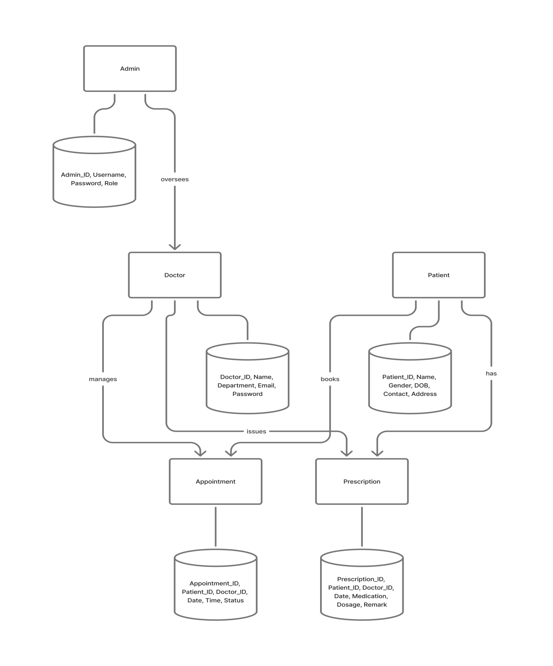
Figure 3.2: Entity Relationship Diagram (ERD) shows the relationships between Patient, Doctor, Prescription, Appointment, and Admin.

3.5 ANALYSIS OF THE PROPOSED SYSTEM
The proposed web-based hospital management system is developed to overcome the inefficiencies associated with manual record keeping and paper-based data management. The system ensures secure, accurate, and fast retrieval of patient records, while also simplifying appointment scheduling and medical record tracking.
The analysis phase focuses on understanding the system’s inputs, outputs, and database structure, including how various components interact to support patient management, medical documentation, and administrative reporting.

3.5.1 Input Analysis
Inputs represent the raw data entered into the system from various users (patients, doctors, and administrators). These inputs are essential for processing and generating meaningful outputs. The key inputs include:
- Patient Registration Details: Information such as full name, age, gender, contact address, phone number, and date of registration.
- Doctor’s Diagnosis and Prescription Records: Medical observations, diagnoses, and prescribed medications entered by doctors.
- Appointment Requests and Schedules: Appointment bookings initiated by patients and approved or modified by doctors or administrators.
These inputs are validated and stored in the database to ensure data consistency and integrity.

3.5.2 Output Analysis
Outputs are the processed results generated by the system after executing user requests or processing stored data. Major system outputs include:
- Patient Medical History Reports: Detailed records of past diagnoses, prescriptions, and treatments for each patient.
- Prescriptions Generated by Doctors: Automatically formatted prescription documents containing dosage instructions and medication details.
- Appointment Schedules: Approved appointments displayed for both patients and doctors to manage consultation times.
- Administrative Summaries: Analytical reports that provide insights such as total patient count, number of visits, prescriptions issued, and doctor activity summaries.
These outputs enhance decision-making and improve the overall efficiency of hospital operations.

3.5.3 Database Structure
The database is a crucial component that ensures data organization, accessibility, and relational integrity. It consists of several interrelated tables designed to manage patient, doctor, appointment, and prescription data efficiently.

Table 3.4: Key Tables and Their Descriptions
Table Name | Description
tbl_patient | Stores patient demographic and registration information
tbl_doctor | Contains doctor details, including specialization and contact info
tbl_prescription | Records prescriptions assigned to patients by doctors
tbl_appointment | Manages appointment requests, approvals, and schedules
tbl_admin | Stores administrative login and control data

3.6 SYSTEM DESIGN CONSIDERATIONS
During system design, key factors were taken into account to ensure performance and maintainability:
- Security: User authentication and role-based access were enforced.
- Scalability: Database tables and modules were structured to accommodate future hospital expansion.
- Usability: Interfaces were designed to be user-friendly and responsive.
- Data Integrity: Referential constraints were enforced between related tables.
- Reliability: Backup and recovery options were included for data safety.

CHAPTER FOUR
IMPLEMENTATION AND RESULT PRESENTATION
4.0 INTRODUCTION
This chapter presents the implementation phase of the web-based hospital management system for Rolakim Hospital. It explains how the system design was transformed into an operational web application using appropriate technologies. It also discusses the program modules, system interface, database configuration, and testing strategies used to ensure that the system functions accurately and meets user requirements.
  - SYSTEM REQUIREMENTS
For the successful implementation of the proposed web-based system for retrieving patient history, prescriptions, and doctor’s appointment, certain hardware and software components are required. This stage transforms the designed models into a functional system accessible to users via a web browser.
    - Hardware Requirements
Table 4.1: Hardware Requirements
Component | Minimum Specification | Recommended Specification
Processor | Intel Core i3 2.4GHz | Intel Core i5 or higher
RAM | 4GB | 8GB or more
Hard Disk | 250GB | 500GB
Monitor | 15-inch display | 17-inch LCD
Network | Local Area Network / Internet connection | Broadband Internet
Input Devices | Keyboard, Mouse | Keyboard, Mouse

Software Requirements
Table 4.2: Software Requirements
Software | Description
Operating System | Windows 10 / Linux (Ubuntu)
Web Server | XAMPP or WAMP Server (Apache + PHP + MySQL)
Programming Language | Core PHP (Server-side scripting)
Database Management | MySQL
Frontend Tools | HTML, CSS, JavaScript
Browser | Google Chrome / Mozilla Firefox
Text Editor | Visual Studio Code / Sublime Text

SYSTEM INTERFACE
The system interfaces provide an intuitive and user-friendly environment for interaction between users and the hospital management system. Each interface was designed to ensure ease of navigation, data accuracy, and operational efficiency.
4.2.1 System Login Interface
This interface allows authorized users (admin, doctor, or patient) to securely access the system using their credentials.
Functions:
- Username and password authentication.
- Redirects to the user’s respective dashboard upon successful login.
- Displays error messages for invalid credentials.
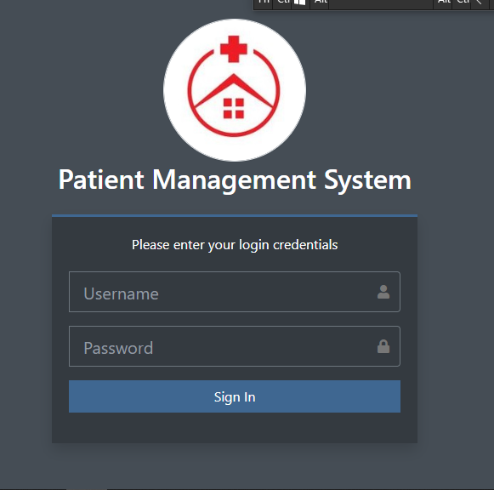
Figure 4.2.1: Login Page Interface

4.2.2 Administrator Dashboard
The administrator dashboard provides access to system management tools such as user control, data monitoring, and report generation.
Functions:
- Manage doctors and patients.
- Monitor appointment schedules.
- Generate system reports.
- Perform data backup and recovery.
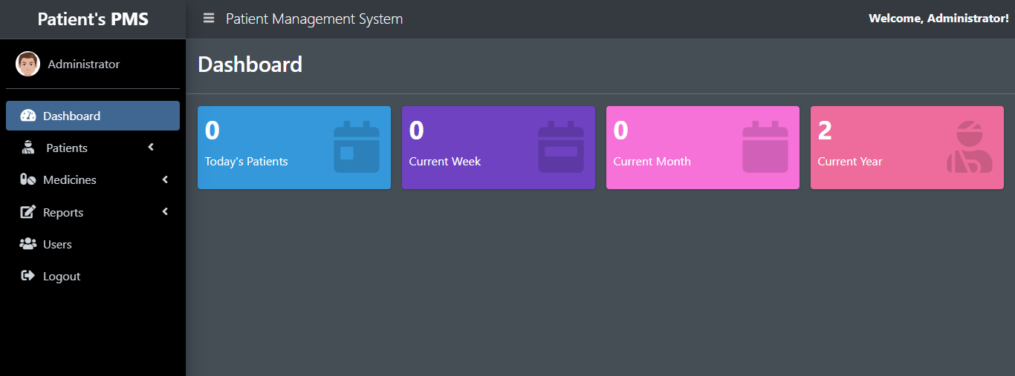
Figure 4.2.2: Administrator Dashboard

4.2.3 Patient Dashboard
The patient dashboard allows patients to access personalized medical services.
Functions:
- Book and view appointments.
- View diagnosis history.
- Update profile information.
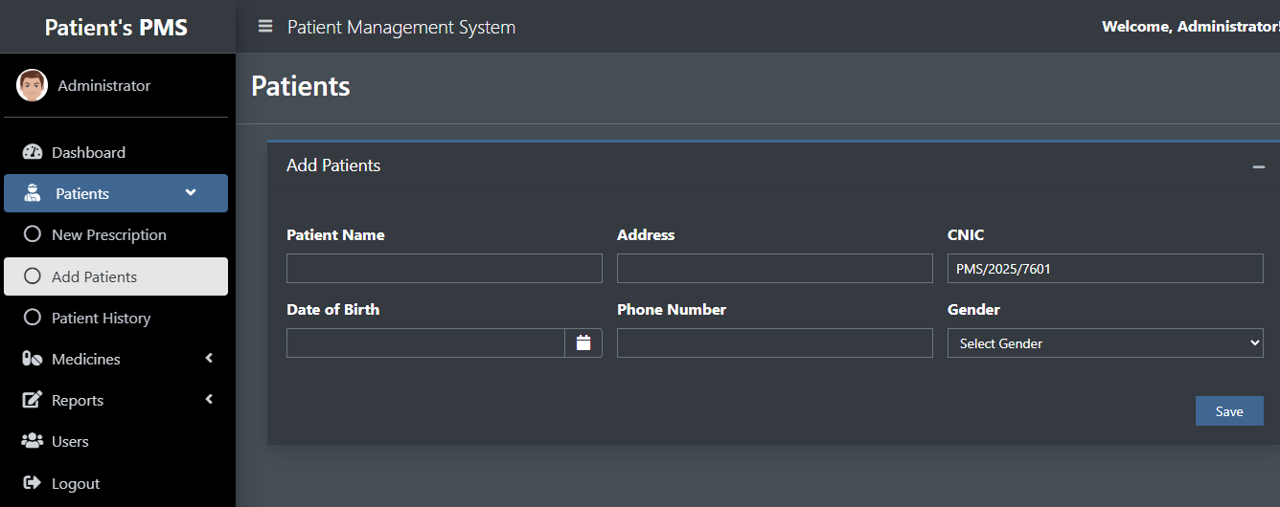
Figure 4.2.3: Patient Dashboard Interface to add new patient

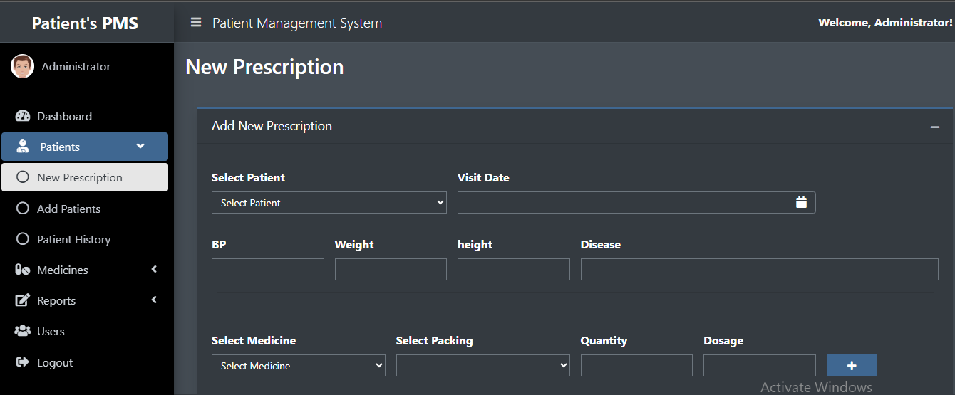
Figure 4.2.3: Patient Dashboard Interface for patient prescriptions

4.2.4 Medicine Dashboard
The medicine dashboard provides the list of medications for managing patient record diagnosis and prescriptions.
Functions:
- View list of medications.
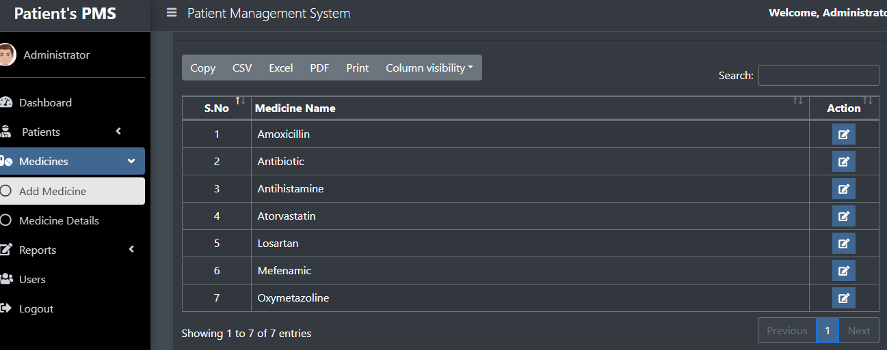
Figure 4.3: Medication Dashboard Interface
4.3 DATABASE IMPLEMENTATION
The database was implemented using MySQL. Each table was designed according to the Entity Relationship Diagram (ERD) in Chapter Three. Below are the main database tables:

Table 4.3: Patient Table
Field | Data Type | Description
Patient_ID | INT (Primary Key) | Unique patient identifier
Name | VARCHAR(100) | Patient’s full name
Gender | VARCHAR(10) | Gender of the patient
Contact | VARCHAR(20) | Patient phone number
Address | VARCHAR(200) | Residential address

Table 4.4: Appointment Table
Field | Data Type | Description
Appointment_ID | INT (Primary Key) | Unique appointment record
Patient_ID | INT (Foreign Key) | Links to patient table
Doctor_ID | INT (Foreign Key) | Links to doctor table
Date | DATE | Appointment date
Time | TIME | Appointment time
Status | VARCHAR(20) | Status (pending/approved)
Similar tables exist for Doctor, Admin, and Prescription entities.

4.4 SYSTEM TESTING
Testing was carried out to ensure that the developed system meets the functional and non-functional requirements outlined during analysis. This testing process included unit testing, integration testing, and user acceptance testing (UAT).

4.4.1 Unit Testing
Each module was tested independently to confirm its correctness. For instance:
- The login module was tested with valid and invalid credentials.
- The appointment module was tested for duplicate and conflicting bookings.

4.4.2 Integration Testing
After unit testing, modules were integrated and tested to verify data consistency across components.
Example: Appointment bookings made by patients were verified to appear correctly in the doctor’s dashboard.

4.5 TEST RESULT SUMMARY
Table 4.5: Test Result Summary
Test Case | Expected Result | Actual Result | Status
Login with valid credentials | Redirects to dashboard | Redirect successful | Pass
Login with invalid credentials | Displays error message | Error displayed | Pass
Appointment booking | Stored successfully | Data saved | Pass
Duplicate booking | Prevented by system | Booking denied | Pass
Prescription record entry | Saved to database | Record saved | Pass

4.6 SYSTEM DEPLOYEMENT
The system was hosted on a local Apache server during testing, and later deployed on a web hosting server using a registered domain name. Deployment steps included:
- Database import into MySQL server.
- Configuration of environment files.
- Testing on live environment.
- User training and documentation delivery.

4.7 BENEFIT OF THE SYSTEM
The implementation of this system has provided several benefits to Rolakim Hospital, Offa:
- Faster retrieval of patient history and prescriptions.
- Accurate, centralized data storage.
- Reduced administrative workload and paperwork.
- Improved appointment scheduling and reduced waiting time.
- Enhanced data security and backup reliability.
- Better decision making through easy access to historical patient data.

CHAPTER FIVE
SUMMARY, CONCLUSION AND RECOMMENDATION

5.1 SUMMARY
This project work focused on the design and implementation of a web-based hospital management system for Rolakim Hospital, Offa, Kwara State. The study aimed at solving the challenges associated with the manual method of patient record management, appointment scheduling, and prescription documentation.
During the course of this research, the existing manual system was carefully analyzed. Findings revealed several inefficiencies such as data redundancy, difficulty in retrieving patient information, delayed appointment processing, and lack of centralized data storage. These limitations informed the development of the proposed system, a digital solution designed to automate core hospital operations.
The proposed system was designed using Core PHP for server-side scripting, HTML, CSS, and JavaScript for the front-end, and MySQL as the back-end database management system. Three-tier architecture (Presentation, Application, and Database layers) was adopted to ensure modularity, scalability, and data security. Functional modules implemented includes:
- Patient Registration and Profile Management
- Doctor’s Prescription and Diagnosis Module
- Appointment Scheduling and Management System
- Administrative Control Panel
Through system analysis and design tools such as the Entity Relationship Diagram (ERD), and UML Use Case Diagrams, the logical and physical structure of the system was clearly modeled before implementation. The resulting system provides a more efficient, accurate, and secure platform for managing hospital data while improving communication between patients and healthcare providers.

5.2 CONCLUSION
The developed hospital management system successfully automates the daily activities of Rolakim Hospital, ensuring faster and more reliable handling of patient information. The system minimizes paperwork, reduces administrative workload, and provides easy access to patient history and prescriptions.
The introduction of electronic records has also improved data integrity and confidentiality, ensuring that only authorized users (patients, doctors, and administrators) can access specific parts of the system.
Overall, the system achieves its main objective is to replace the manual hospital record-keeping process with an efficient, web-based solution that enhances productivity and patient satisfaction. The use of Core PHP and MySQL ensures flexibility, scalability, and compatibility with modern web technologies.

5.3 RECOMMENDATION
Based on the development, testing, and evaluation of this project, the following recommendations are made:
- Full Deployment and Staff Training:
Rolakim Hospital should consider full deployment of the system. Hospital staff, especially doctors and administrative personnel, should be trained on how to use the application efficiently.
- Periodic System Updates:
Regular updates should be made to improve performance, security, and usability. This will also allow integration of new features such as SMS notifications, online payments, or laboratory management.
- Data Backup and Security:
A secure data backup mechanism should be implemented (e.g., cloud storage or weekly offline backups) to prevent data loss due to system failures or cyber threats.
- Integration with Other Health Services:
The system can be extended to include laboratory test management, pharmacy inventory control, and billing modules for a more comprehensive hospital information system.
- Mobile-Friendly Enhancement:
To improve accessibility, a mobile-responsive version or dedicated mobile application should be developed, allowing patients and doctors to access the system remotely.
- Continuous Evaluation and Feedback:
The hospital management should establish a feedback channel to gather users’ opinions on the system’s performance and areas of improvement.

5.4 SUGGESTION TO FURTER STUDIES
Future researchers can build upon this system by incorporating advanced technologies such as:
- Artificial Intelligence for medical decision support.
- Block chain for enhanced security and transparency in patient data sharing.
- Cloud-based architecture for scalable, remote hospital management.
- Integration with wearable devices for real-time patient monitoring.
Such enhancements will make the system more adaptive to modern healthcare trends and ensure a sustainable digital health environment.

REFERENCES

Abubakar, H., & Olayemi, M. (2022). Web-based medical information systems: Enhancing patient–doctor interaction. Journal of Health Informatics in Developing Countries, 16(4), 102–110.
Adebayo, T., Adeola, K., & Sadiq, B. (2022). Web-based systems and scalability in healthcare management. International Journal of Computer Applications, 179(38), 34–42.
Ahmed, S., & Bello, R. (2021). Applying the software development life cycle in health information systems. African Journal of Information Systems, 12(3), 88–95.
Adeyemi, J., & George, E. (2024). Securing medical databases in Nigeria: Challenges and opportunities. Nigerian Journal of Information Technology, 28(2), 55–66.
Adeboye, O., Lawal, F., & Aremu, M. (2025). Smart HMS using web technology. Journal of Digital Health Innovation, 6(2), 45–59.
Ahmed, I., & Bello, T. (2021). Development of an online hospital system using PHP and MySQL. International Journal of Computing, 11(3), 77–88.
Ahmed, I., Bello, T., & Idris, M. (2023). Automation of medical processes for improved hospital services. African Journal of Information Systems, 5(1), 32–45.
Akintoye, J., Ogunyemi, K., & Daramola, A. (2023). SDLC application in health software development. Software Engineering Review, 9(4), 118–130.
Ali, H., & Nguyen, T. (2023). Decision support systems in e-health platforms. Health Informatics Journal, 29(2), 212–230.
Al-Hassan, R. (2022). Implementation of a modular hospital management system. Journal of ICT Applications, 8(1), 15–28.
Bello, A., & Idris, U. (2024). Hospital resource planning via web applications. Computing Research Journal, 12(2), 67–80.
Bertalanffy, L. V. (1968). General systems theory. George Braziller.
Codd, E. F. (1970). A relational model of data for large shared data banks. Communications of the ACM, 13(6), 377–387.
Davis, F. D. (1989). Perceived usefulness, perceived ease of use, and user acceptance of information technology. MIS Quarterly, 13(3), 319–340.
Eze, P., & Nwosu, C. (2020). Evaluation of hospital information systems for patient care. Journal of Medical Systems, 44(5), 1–8.
Eze, S., & Adewale, K. (2022). Data privacy compliance under NDPR in Nigerian hospitals. Nigerian Journal of Information Ethics, 4(2), 56–69.
Gupta, A., & Li, Z. (2022). Relational database theory for modern information systems. Data Systems Review, 14(3), 201–218.
Ibrahim, S., & Hassan, A. (2025). E-clinic platform for primary health centers. Journal of Web-Based Solutions, 10(1), 40–58.
Ijeoma, O., & Bello, F. (2021). Application of systems theory in hospital operations. Journal of Organizational Studies, 9(2), 72–80.
Laudon, K. C., & Laudon, J. P. (2022). Management information systems: Managing the digital firm (17th ed.). Pearson.
Lawal, T., & Chukwu, I. (2020). Development of an efficient hospital record management system using web technology. Computing and Information Journal, 18(1), 11–19
Li, H., & Chen, W. (2025). AI-driven patient record systems. Journal of Medical Systems, 49(2), 95–112.
Li, J., Zhao, T., & Wang, P. (2020). E-health information systems for rural clinics. International Health Informatics, 8(3), 60–72.
Li, X., Yang, L., & Zhang, Q. (2023). Scalable web solutions for healthcare facilities. Journal of Web Technology, 12(1), 88–102.
Mohammed, L., & Taiwo, B. (2021). Database management approaches in hospital systems. Journal of Information Management, 25(2), 33–41.
Okafor, C., & Ibrahim, Y. (2023). Automating healthcare processes through information systems. Journal of Digital Health Innovations, 6(2), 77–89.
Okeke, I., & Musa, Y. (2024). Online prescription system for small clinics. International Journal of e-Health, 7(4), 70–85.
Okon, F., & Eze, J. (2020). Design of a web-based patient management system. Journal of Computing Studies, 5(2), 110–126.
Okeke, V., Eke, C., & Amah, U. (2023). Analysis of health information systems in Nigeria: Challenges and prospects. African Journal of Computer Science, 27(3), 120–132.
Ola, D., & Bello, R. (2022). Electronic prescriptions and digital healthcare efficiency. International Journal of e-Health Systems, 15(4), 44–53.
Pressman, R. S. (2019). Software engineering: A practitioner’s approach (9th ed.). McGraw-Hill Education.
Singh, A., & Kumar, R. (2021). Data security in web-based health applications. Journal of Cyber Health, 6(2), 44–59.
Udo, A., & James, O. (2021). Automated appointment scheduling system for hospitals. Journal of Information Science and Engineering, 19(1), 87–93.
Udo, A., Johnson, E., & Amadi, C. (2022). Cloud-based HMS for developing nations. African Journal of Computing, 9(3), 23–37.
Umeh, M., & Musa, L. (2022). Adoption of web-based systems in hospital management. International Review of Information Systems, 14(5), 90–100.
Venkatesh, V., Morris, M. G., Davis, G. B., & Davis, F. D. (2020). User acceptance of IT: Toward a unified view. MIS Quarterly, 44(1), 67–85.
WHO. (2023). Global strategy on digital health 2020–2025. World Health Organization.
Yusuf, A., & Adebayo, T. (2023). Design and implementation of a web-based medical record system. International Journal of Healthcare Informatics, 10(1), 23–31.
Yusuf, H., & Danladi, R. (2024). Electronic health record systems in tertiary hospitals. Health Systems Review, 8(3), 145–161.
Zhang, L., & Wei, C. (2024). Secure architecture for e-health systems. Journal of Digital Security, 11(2), 102–118.

