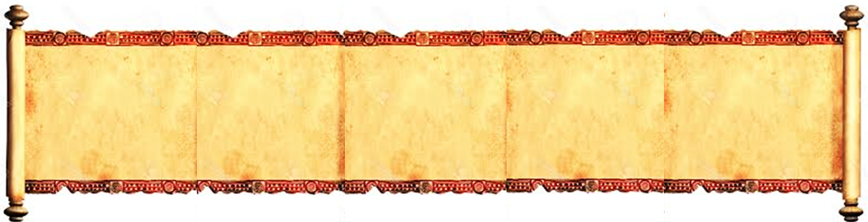


St. Augustine Catholic Mission- Mzola
P. O. BOX 19
MATABISA
ZIMBABWE
E-mail: mzola.staugustine@gmail.com
“You have made us for Yourself, O Lord and our hearts are restless until they rest in You.”

JANUARY 2026
 | INCOME |  | EXPENDITURE
NO | CATEGORY | AMOUNTS IN USD | CATEGORY | AMOUNT/USD
1 | Diocese | US$0.00 | Bank charges | US$0.00
2 | Bank interest | US$0.00 | Building (repairs) | US$0.00
3 | Pledges (isondlo) | US$0.00 | Construction | US$0.00
4 | Collection (umnikelo) | US$1.20 | Diocesan Levy (10%) | US$0.12
5 | Donation from abroad | US$0.00 | Catechists | US$0.00
6 | Local Donation | US$0.00 | Farm/Garden | US$0.00
7 | Farm/Garden | US$0.00 | Fuel/travel | US$290.00
8 | Income Gen. Project | US$0.00 | Toll Fee | US$0.00
9 | Catechists fund | US$0.00 | General Maintenance | US$170.00
10 | Loan taken | US$0.00 | Household Needs | US$230.00
11 | Loan returned | US$0.00 | Income Generating Projects | US$0.00
12 | Refunds (electricity etc.) | US$0.00 | Staff (Food/Health) | US$0.00
13 | Religious Congregation | US$0.00 | NSSA | US$0.00
14 | Sale of Goods (Repository) | US$0.00 | Pastoral work: Church Expenses | US$0.00
15 | Rent | US$0.00 | Phone and Postage | US$0.00
16 | Fuel from Communities | US$10.00 | Priests Allowance | US$0.00
17 | Holy Land | US$0.00 | Salaries and Wages | US$0.00
18 | Charity | US$0.00 | Holy Land | US$0.00
19 | Special Collection | US$0.00 | MCA | US$0.00
20 | Lenten Collection | US$0.00 | Repository | US$0.00
21 | Special Project | US$0.00 | Parish Meetings | US$0.00
22 | Peter's Penny | US$0.00 | Internet/Wifi | US$45.00
23 | Marian Shrine | US$0.00 | Vehicle Service or Repair | US$150.00
 | TOTAL
 |  | AMOUNTS IN USD |  | AMOUNT/USD
 | Total income | US$11.20 | Cash at Hand | -US$873.80
 | Total Expenditure | US$885.00 | Cash in Bank | US$0.00
 | Total Income Less Total Expenditure | -US$873.80 | Savings | US$0.00
 | Add Opening Balance | US$0.00 | Investments | US$0.00
 | Closing Balance | -US$873.80 | Closing Balance | -US$873.80
Parish Treasurer……………………Signature……………………Date………..............

Parish Priest…………………………Signature……………………Date……….............. |  |  |  | Stamp

