QBooth Avatar
User Guide
A 3D avatar assistant that stands on top of the Q-Booth event screen: it greets guests, chats by voice, and guides the photo session while pressing the Q-Booth buttons for them.
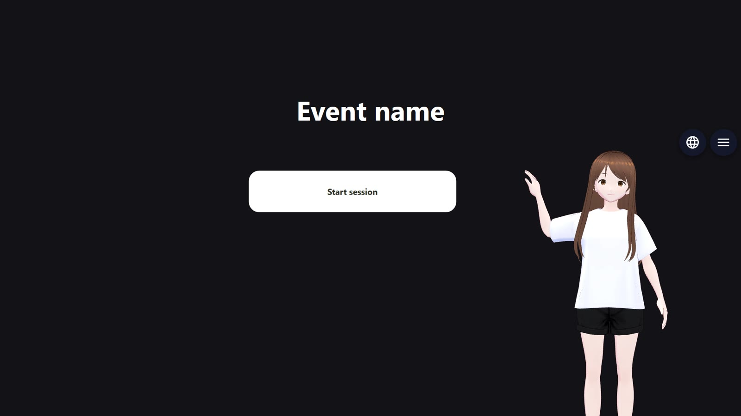
Figure 1. QBooth Avatar in the corner of the Q-Booth event screen. Q-Booth stays visible and can be touched all around it.
App version 0.2 (overlay mode) · This guide was updated on 30 October 2026
Lumaqube · www.lumaqube.com
Contents
1. Getting to Know QBooth Avatar
1.1 What is on the screen
2. Before You Start
2.1 Computer requirements
2.2 What is in the app folder
2.3 Source version: the first download
3. Connecting to Q-Booth
3.1 Turning on the Local API in Q-Booth
3.2 Entering the connection in QBooth Avatar
4. Starting and Closing the App
4.1 Opening the app
4.2 Choosing the language
4.3 Closing the app
5. Talking to the Avatar
5.1 How it listens
5.2 Examples of what guests say
5.3 Tips so the avatar hears well
6. Buttons, Position and Shortcuts
6.1 Language button
6.2 Menu button
6.3 Setting the position and size
6.4 Shortcuts
7. Settings
7.1 Q-Booth
7.2 Assistant
7.3 AI brain
7.4 Look
7.5 Microphone
7.6 Security
8. Getting an API Key for a Cloud AI Brain
8.1 Google Gemini API key
8.2 Gemini Live (real-time voice)
8.3 OpenRouter API key
8.4 If a key leaks or is lost
8.5 Q-Booth Local API password
9. The Avatar and Its Voice
9.1 The voice follows the avatar's gender
9.2 Adding your own avatar
10. Pronunciation
11. Troubleshooting
12. Files and Privacy

Tip: In Microsoft Word, right-click the table of contents and choose "Update Field" if the page numbers are missing.

1. Getting to Know QBooth Avatar
QBooth Avatar is a Windows app that shows a 3D character on top of the running Q-Booth event screen. Only the character is shown; the photo booth screen still belongs to Q-Booth. The character:
- greets guests and invites them to take a photo when the screen is idle;
- chats by voice in Bahasa Indonesia, English or 中文 (Mandarin);
- guides guests through every Q-Booth screen: the start screen, the template choice, the camera, the review and the result;
- presses the Q-Booth buttons for guests when asked: "let's take a photo", "the second one", "photo", "retake", "process", "print", "show me the QR", "start over";
- answers questions about the event (event name, schedule, where the toilets are, etc.) from the info you enter.
QBooth Avatar connects to Q-Booth through the Q-Booth Local API. It does not use a camera of its own and has no photo booth screen of its own: Q-Booth takes, processes and shows the photos.

1.1 What is on the screen
Part | What it does
Character | Moves, blinks, turns its head, points, and moves its mouth along with its voice. Tap it to talk, hold it for 5 seconds to open the Settings.
"•••" bubble | Appears near the head while the character is thinking up an answer (hand on chin, eyes looking up).
Language button (globe) | Changes the language: Bahasa Indonesia, English, 中文. May ask for the PIN.
Menu button (☰) | Opens the Settings (PIN if set).

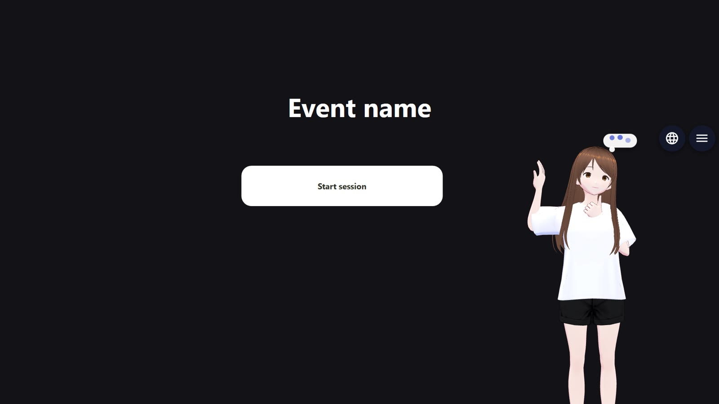
Figure 2. Thinking: hand on chin and the "•••" bubble. As soon as the answer starts being spoken, the bubble disappears.
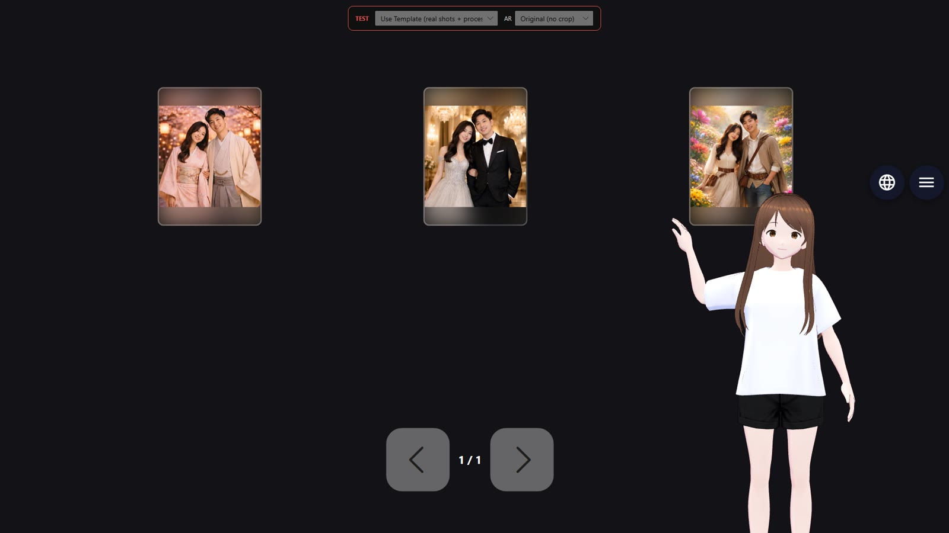
Figure 3. On the Q-Booth template screen, guests just say "the second one" or the template's name.
Note: Apart from the character and the two small buttons, there are no other windows on top of Q-Booth. Guests can touch the screen around the character as usual.

2. Before You Start

2.1 Computer requirements
Component | Minimum | Recommended
Operating system | Windows 10 64-bit | Windows 11 64-bit
Processor & RAM | Intel Core i5 8th gen / Ryzen 5, 8 GB RAM | Core i7 / Ryzen 7, 16 GB RAM
Graphics card | Not required (the AI runs on the processor) | NVIDIA RTX: more accurate and faster speech recognition
Disk space | 5 GB | 8 GB (voice cache)
Microphone & speakers | Built-in laptop mic | Directional mic / headset + external speakers
Internet | Not required (local AI) | Needed for a cloud AI brain (Gemini / OpenRouter / Gemini Live) and for the first download of the source version
Q-Booth | A version with the Local API (Settings → Advanced, Expert mode) | -

2.2 What is in the app folder
The portable version comes as one QBooth Avatar folder (or the zip QBoothAvatar-portable.zip, just extract it). No installation is needed. The important contents:
File / folder | Description
QBooth Avatar.exe | The main program. Double-click it to run.
config.json | Your settings, created automatically the first time you save the Settings. It contains passwords and API keys: do not share it.
README-PORTABLE.txt | A short how-to.
resources\app\logs\ | Activity logs for troubleshooting.
resources\app\cache\ | Voice lines already generated, for faster responses.

Note: If you need to move it, move the whole folder at once, not its contents one by one.

2.3 Source version: the first download
The source version (for developers) does not include the large AI files. On its first start, the app downloads what is missing by itself (about 1.1 GB) before the character appears. The start-up screen shows the progress. An interrupted download resumes the next time the app is opened.
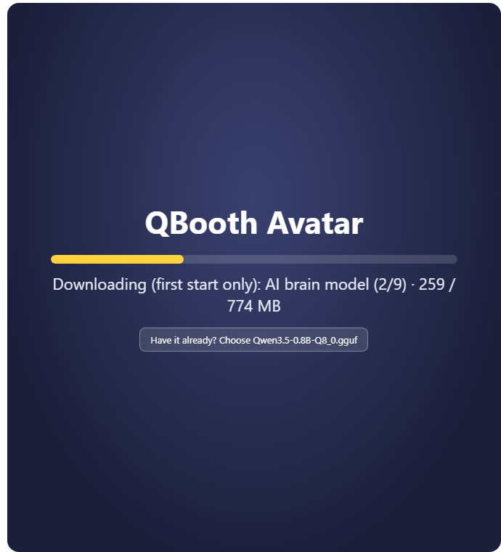
Figure 4. First download: the part being downloaded, its size, and the "Have it already? Choose …" button.
Have the file already? If you already have the same file (for example from the portable version), press Have it already? Choose … and pick the file. The app copies it and stops downloading that part. For a model, the file must be exactly the same (same type and size); for a program, pick its release .zip file or the .exe file in an existing folder.
Note: Computers with an NVIDIA graphics card also download the GPU version of the speech recognition (about 1.2 GB) in the background. It is used from the next time the app is opened.

3. Connecting to Q-Booth

3.1 Turning on the Local API in Q-Booth
- Open Q-Booth and go to Settings → Advanced (Expert mode).
- Turn on the Local API. Note its port (usually 8730) and password.
- Save the Q-Booth settings.

3.2 Entering the connection in QBooth Avatar
- Open the QBooth Avatar Settings: hold the character for 5 seconds, press the ☰ button, or press Ctrl+Alt+Shift+S.
- On the Q-Booth tab, set Connection to QBooth (real).
- Enter the QBooth address (127.0.0.1 if Q-Booth is on the same computer), the Local API port and the Local API password.
- Press Connect. When it works, a ✓ appears and the Event list fills in (number of templates; the running event is marked).
- Choose an event and press Run to open it in Q-Booth, or Stop to close it.
- Tick Run this event when the app opens if the event should start automatically every time the app opens (only when no other event is running yet).
- Press Save.
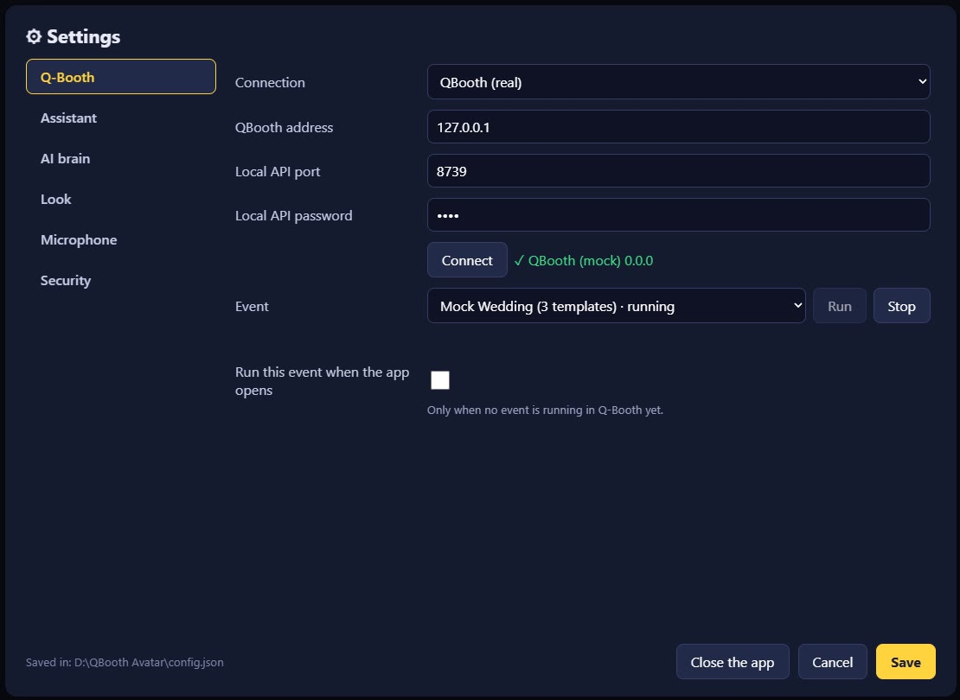
Figure 5. The Q-Booth tab: connected (✓) and the event list.
Important: In the Q-Booth event editor, set the event's output monitor to the screen the character is on. The character stands on top of that screen.
Message | What it means
Not reachable … is the Local API on in Q-Booth? | Q-Booth is not running, the Local API is off, or the address/port is wrong.
Wrong password | Use the same password as the Local API in Q-Booth.
Too many wrong passwords: wait a minute | Wait a minute, then try again.
Another event is running: stop it first | Stop the running event first.
The event editor is open in Q-Booth / A dialog is open on the Q-Booth screen | Finish or close it on the Q-Booth screen first.

Note: The Connection option Mock (test without QBooth) runs a pretend photo booth inside the app, for practice or demos without Q-Booth.

4. Starting and Closing the App

4.1 Opening the app
- Start Q-Booth (and its Local API) first.
- Double-click QBooth Avatar.exe, once only.
- Wait for the loading screen. Each step gets a ✓ when it is ready; a ⚠ means that part has a problem but the app still runs.
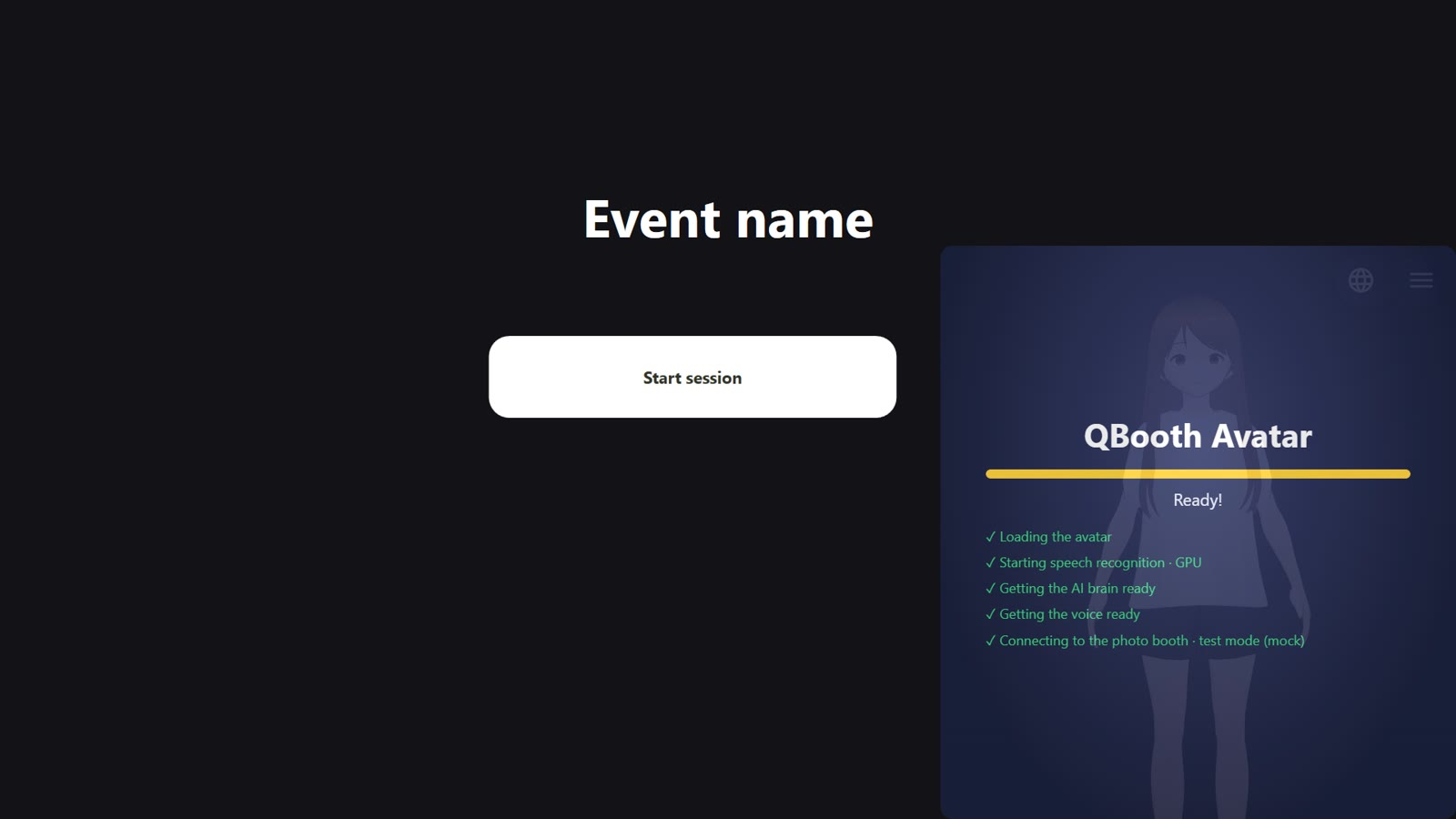
Figure 6. The loading screen on top of the Q-Booth screen: avatar, speech recognition, AI brain, voice and photo booth connection.

4.2 Choosing the language
After loading, the language choice appears (Choose your language). The guest or operator picks Bahasa Indonesia, English or 中文. If nobody picks, the last language is used after 20 seconds. The language choice changes the avatar's voice, the on-screen text and the whole Settings screen.
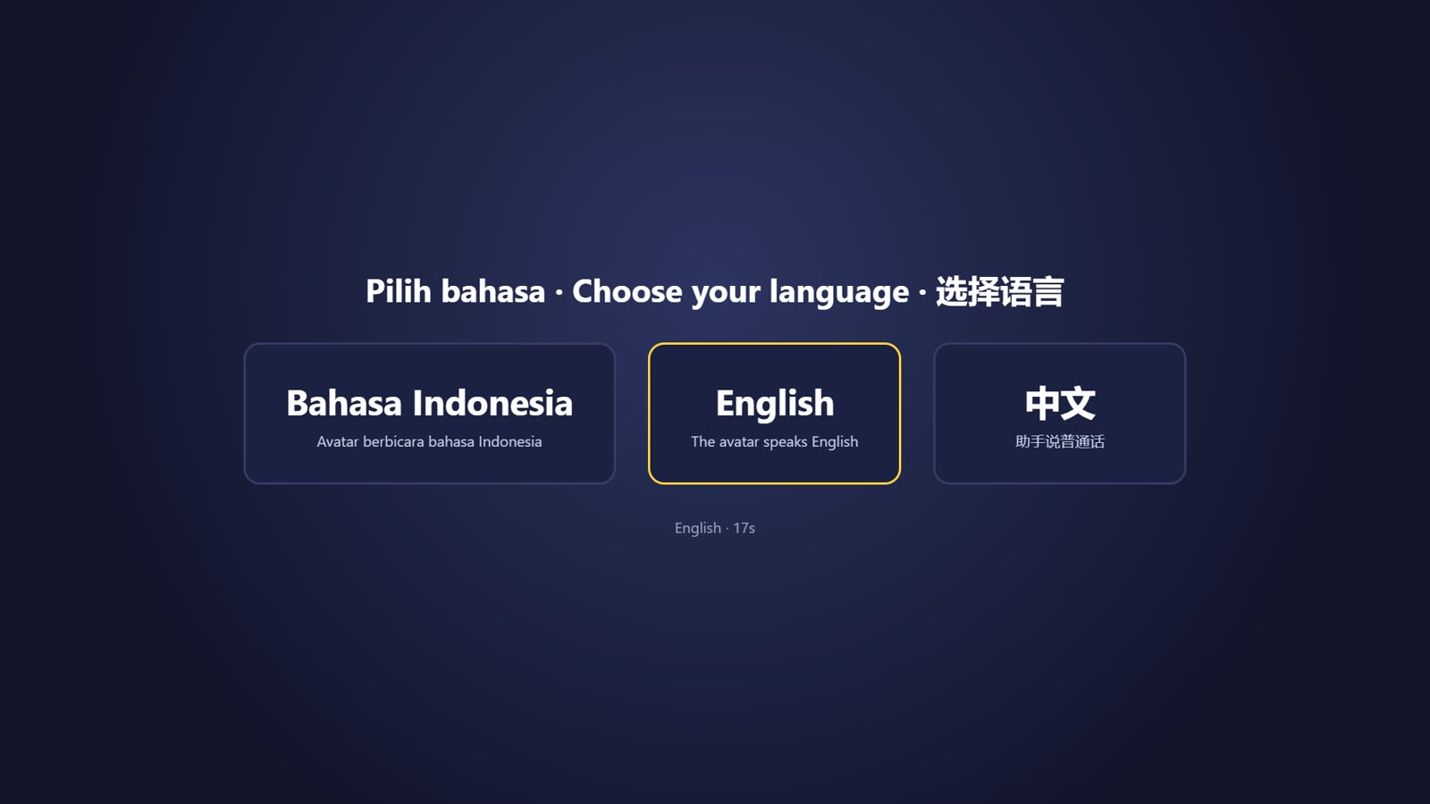
Figure 7. The language choice screen.
This screen can be turned off in Settings → Assistant → Choose the language at launch. A fresh install starts in English.

4.3 Closing the app
- Press Ctrl+Alt+Shift+Q, or open the Settings and press Close the app.
- All the AI parts shut down with it. Wait a few seconds before opening it again.

5. Talking to the Avatar

5.1 How it listens
Set this in Settings → Microphone → Listening:
Option | How it works | Best for
Tap the character | The guest taps the character, then speaks. The avatar stops listening once the guest pauses. | Busy events, testing
Automatic (always listening) | The avatar is always listening. Just speak. | Quiet rooms
Say the name first | The avatar only responds when its name is said, for example "Hi Luma, let's take a photo". | Busy events with lots of voices

Tapping the character always works for talking, whichever option is chosen.

5.2 Examples of what guests say
Guests do not need to memorise particular words: the avatar understands what they mean from many ways of saying it.
Q-Booth screen | Guest says | What happens
Start screen | "Let's take a photo", "start", "next", "I want a photo" | The session starts and the template choice opens.
Template choice | "The second one", "number three", a template name, "photo" | The template is chosen and the camera gets ready.
Camera | "Photo", "snap", "ready", "now" | Countdown, then the photo is taken.
Review | "Retake" / "again" | The photo is retaken.
Review | "Process", "next", "looks good" | The photo is processed.
Result | "Print" | The result is printed.
Result | "Show me the QR", "download", "save it to my phone" | The download QR is shown.
Result | "Start over", "again from the start", "done" | Back to the start screen.
Any time | "Where are the toilets?", "What time does the event end?" | Answered from the Event info.

Note: The avatar never skips a screen. For example, "let's take a photo" on the start screen only opens the template choice; the camera only starts after a template is chosen. Saying a template name on the start screen also only starts the session.
Mandarin: In Mandarin, guests can say for example 我要拍照 (I want a photo), 第二个 (the second one), 拍吧 (take it), 重拍 (retake), 打印 (print), 二维码 (QR code).
Note: The avatar only gives the event information you wrote in the Event info. If something is not there, it says it does not know. Questions about prices are referred to the organisers, unless you wrote the prices in the Event info.

5.3 Tips so the avatar hears well
- Place the mic close to the guests and away from the speakers.
- Set the Mic sensitivity (Section 7.5): the bar should be green during normal speech and grey during silence.
- In noisy places, use "Tap the character" or "Say the name first".
- The avatar does not listen while it is speaking, so it does not hear its own voice.

6. Buttons, Position and Shortcuts

6.1 Language button
Press the globe button to choose a language. If a settings PIN is set, the PIN is asked first (this can be turned off so guests can change the language freely: Settings → Look → Language button asks the PIN).
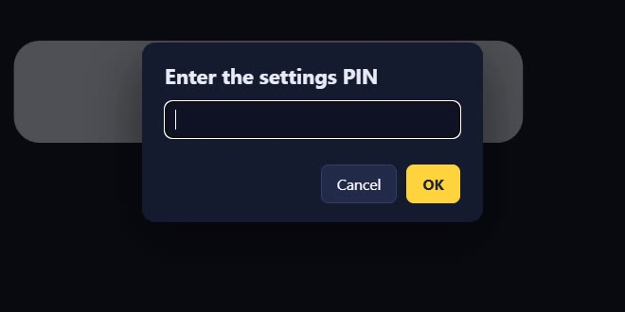
Figure 8. The PIN is asked before the language or the Settings can be changed.
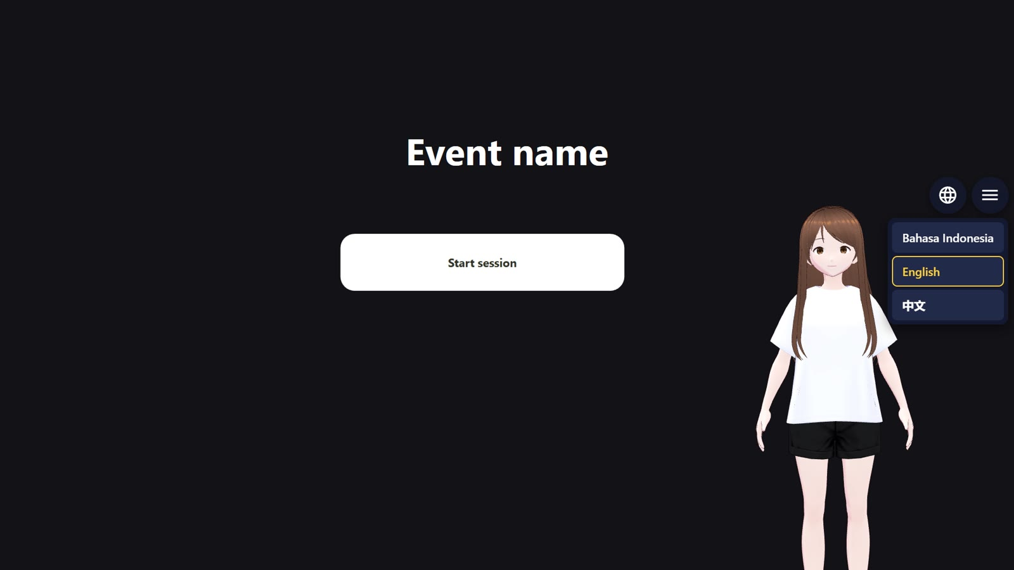
Figure 9. The language choice next to its button.

6.2 Menu button
The ☰ button opens the Settings (with the PIN if set). Both buttons can be hidden in Settings → Look; the Settings can still be opened by holding the character for 5 seconds or with Ctrl+Alt+Shift+S.

6.3 Setting the position and size
- Press Ctrl+Alt+Shift+P, or Settings → Look → Place the character & buttons….
- Drag the character, the language button and the menu button to where you want them. All three can be placed separately, including over the taskbar.
- Press − / + below the character to change its size.
- Press Done to save, or Reset to go back to the starting position.
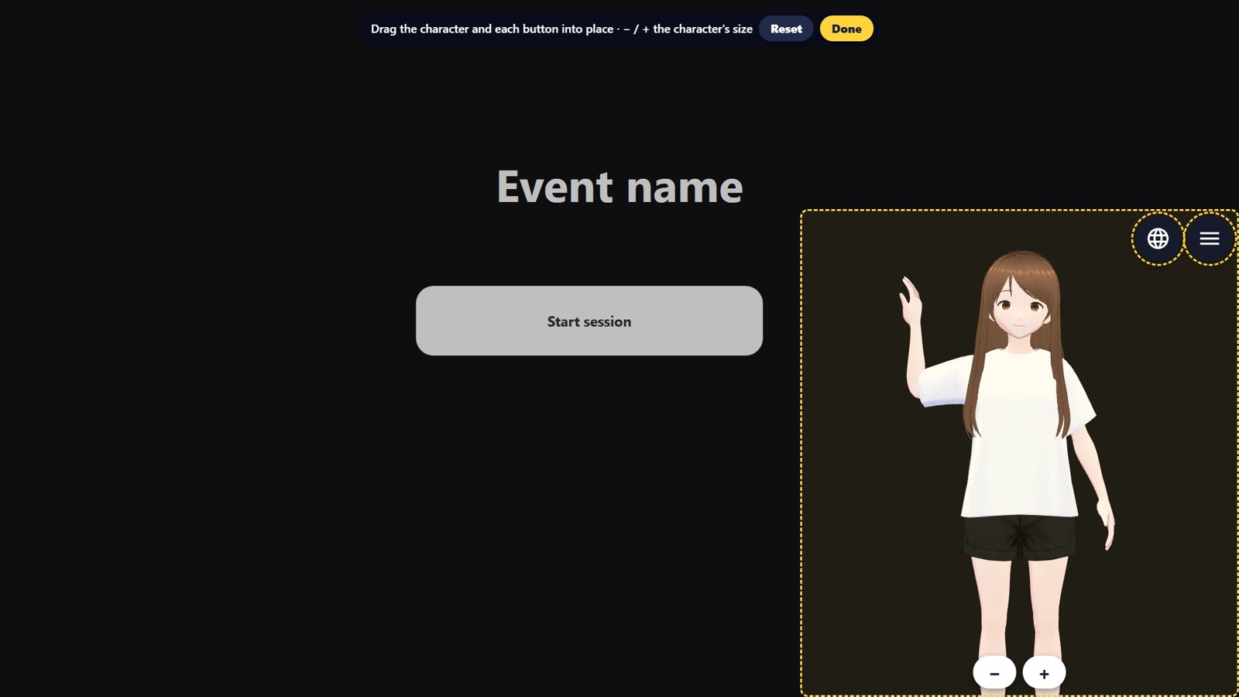
Figure 10. Placing mode: dashed frames around the character and the buttons.

6.4 Shortcuts
Key | What it does
Tap the character | Talk.
Hold the character for 5 seconds | Opens the Settings.
Ctrl+Alt+Shift+S | Opens the Settings from anywhere (even when Q-Booth is the active window).
Ctrl+Alt+Shift+P | Places the character and the buttons.
Ctrl+Alt+Shift+Q | Closes the app.

7. Settings
The Settings are split into tabs: Q-Booth, Assistant, AI brain, Look, Microphone, Security. On a landscape screen the tabs show as a side menu; on a portrait screen as a row of tabs at the top. Press Save to save, Cancel to discard. Some changes (screen, GPU for the screen) make the app restart by itself.

7.1 Q-Booth
Local API connection, event list, Run/Stop event. See Chapter 3.

7.2 Assistant
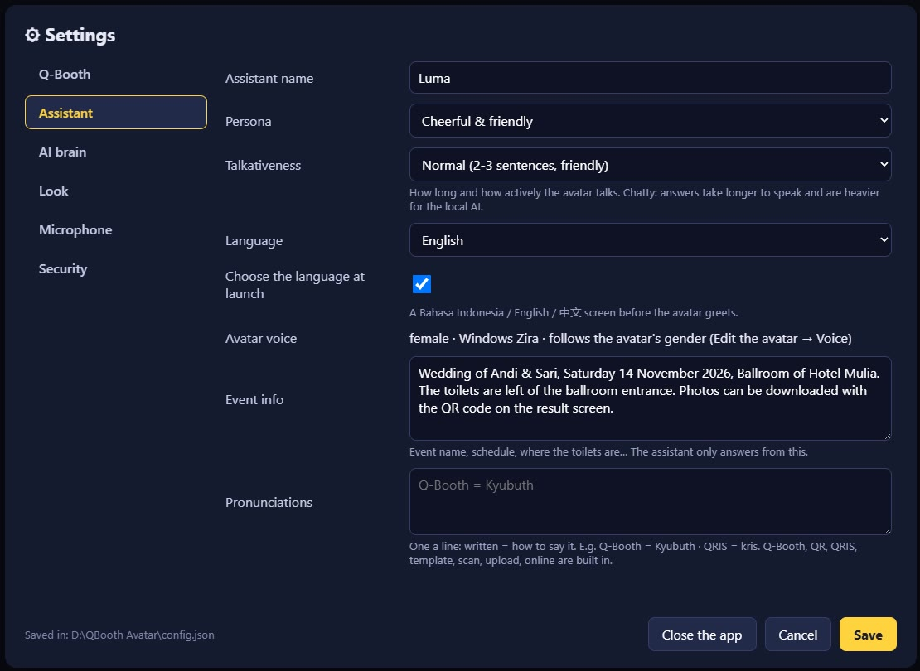
Figure 11. The Assistant tab.
Setting | Description
Assistant name | The name the avatar uses to introduce itself, also used by the "Say the name first" mode.
Persona | Cheerful & friendly, Formal & professional, Calm & gentle, Funny & playful, Energetic (MC style). Also sets the speaking speed.
Talkativeness | Short (1-2 sentences), Normal (2-3 sentences, friendly, may ask back), Chatty (loves to talk, always asks back). Chatty makes answers longer and heavier for the local AI.
Language | Bahasa Indonesia, English or 中文 (Mandarin).
Choose the language at launch | Shows the language choice screen every time the app opens.
Avatar voice | The voice in use now. It follows the avatar's gender (Chapter 9).
Event info | Facts the avatar may share: event name, schedule, where the toilets are, how to download photos, etc.
Pronunciations | Words the avatar's voice says wrongly, one per line: written = how to say it (Chapter 10).

7.3 AI brain
Decides what composes the chat answers. Photo booth commands ("photo", "process", etc.) are always recognised directly by the app, whichever brain is chosen.
Runs on | Description | Needs
This computer (offline) | The AI runs on this PC. Free, private, no internet. The default. | -
Gemini (cloud, Google) | Smarter, more natural answers. | Internet + a Google API key (Section 8.1)
OpenRouter (cloud) | One account for many AI models. | Internet + an OpenRouter API key / login (Section 8.3)
Gemini Live (real-time voice, cloud) | Hears and answers directly with Google's natural voice. | Internet + a Google API key (Section 8.2)

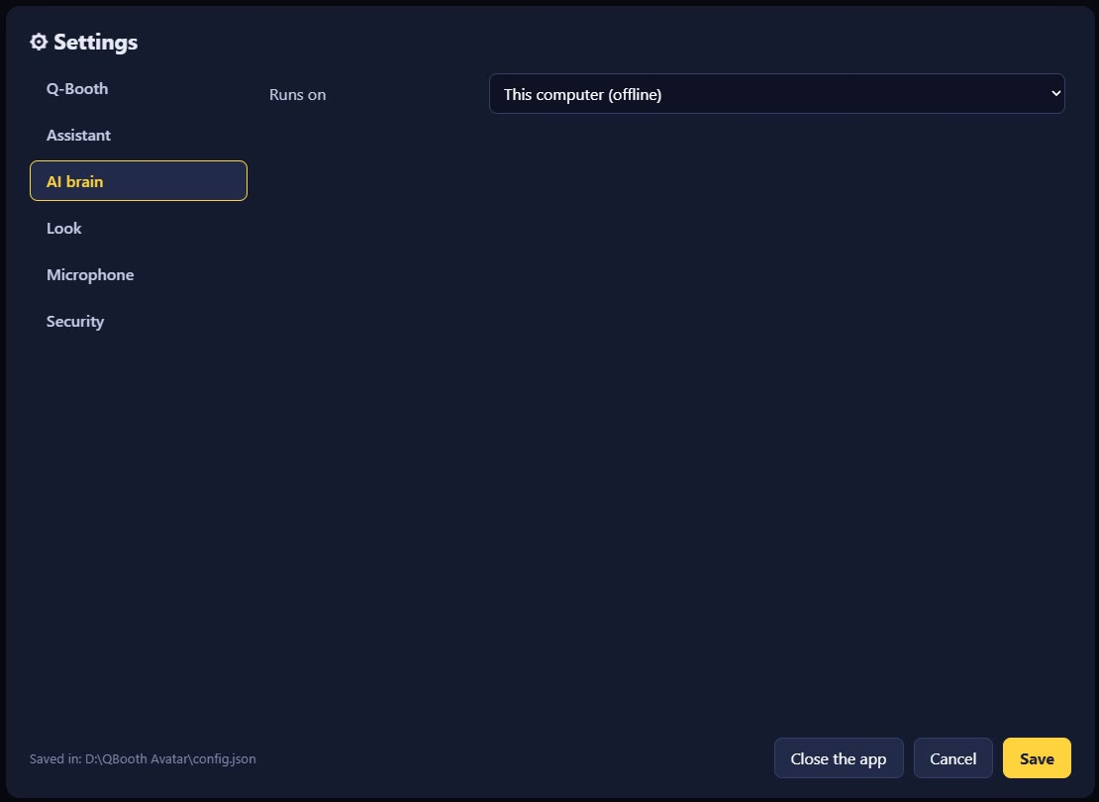
Figure 12. AI brain: This computer (offline).
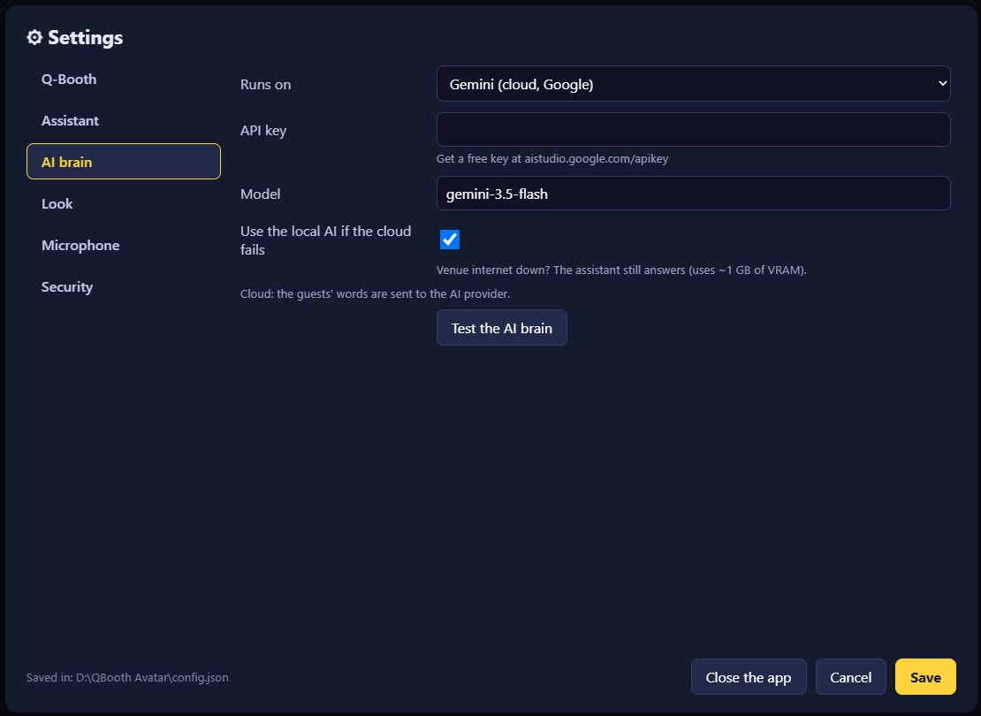
Figure 13. AI brain: Gemini. Paste the API key, choose a model, then "Test the AI brain".
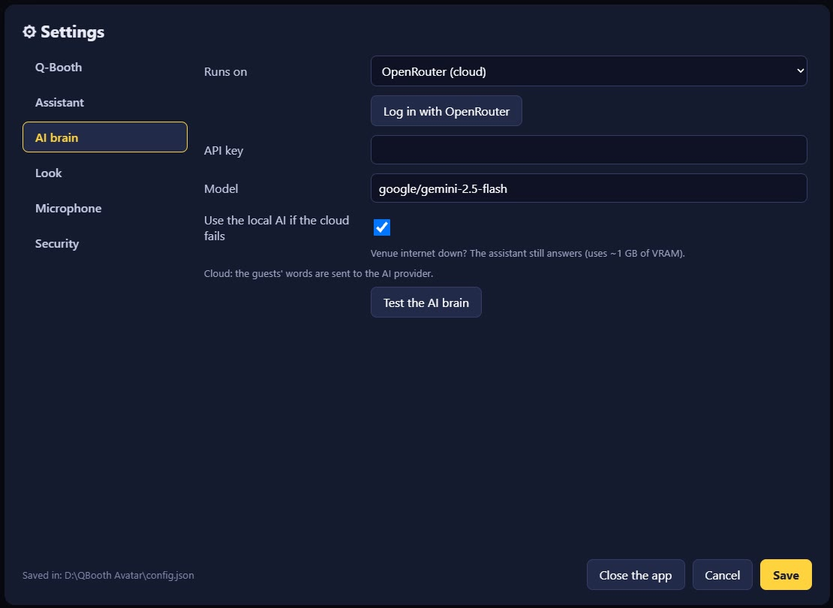
Figure 14. AI brain: OpenRouter, with the "Log in with OpenRouter" button.
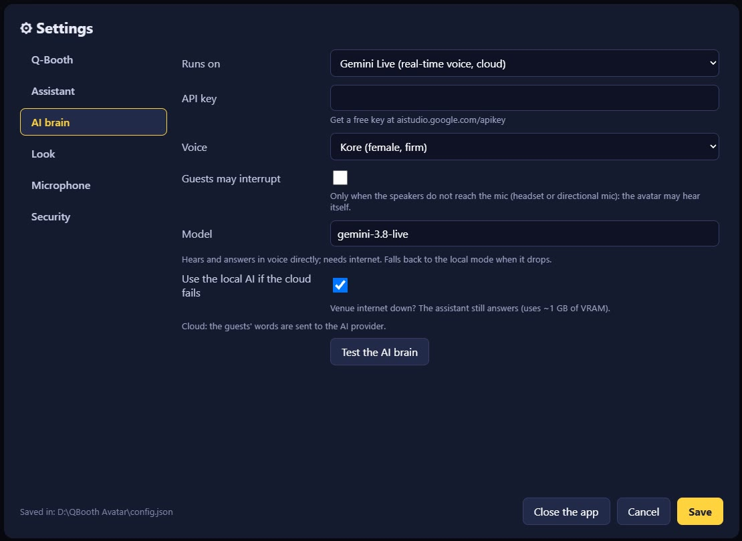
Figure 15. AI brain: Gemini Live, with the voice choice and "Guests may interrupt".
- Use the local AI if the cloud fails: if the internet drops or the quota runs out, the avatar still answers with the local AI. Leave it on.
- Test the AI brain: checks the API key and the connection.
- Guests may interrupt (Gemini Live): turn it on only when using a headset or a directional mic.
Important: With a cloud AI brain, the guests' words are sent to the AI provider (Google / OpenRouter). With the local AI everything stays on this computer.

7.4 Look
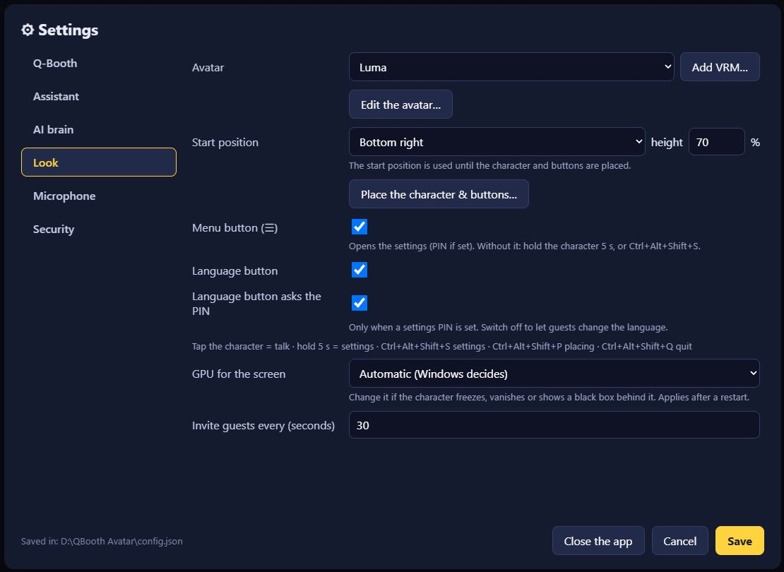
Figure 16. The Look tab.
Setting | Description
Avatar / Add VRM… | Choose the avatar model, or add your own .vrm file.
Edit the avatar… | Opens the avatar editor (Chapter 9).
Screen | Shown when there is more than one monitor: choose the monitor for the character.
Start position / height | Bottom right or bottom left, and the character's height (% of the screen height), until it is placed with "Place the character & buttons…".
Place the character & buttons… | Placing mode (Section 6.3).
Menu button (☰) / Language button | Shows or hides the two buttons.
Language button asks the PIN | Switch it off so guests can change the language freely.
GPU for the screen | Automatic, NVIDIA GPU, or No GPU. Change it if the character freezes, vanishes, or shows a black box behind it.
Invite guests every (seconds) | While the start screen is idle, the avatar invites passers-by to take a photo.

7.5 Microphone
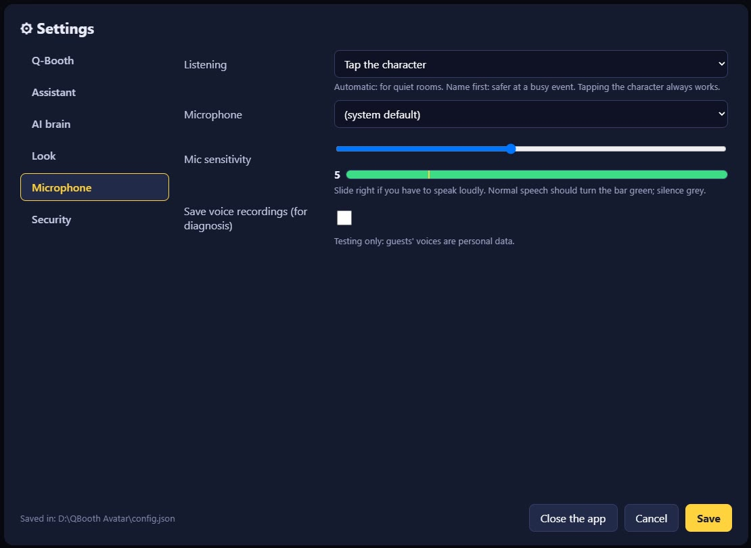
Figure 17. The Microphone tab with the sensitivity meter.
Setting | Description
Listening | Tap the character, Automatic, or Say the name first (Section 5.1).
Microphone | The mic in use.
Mic sensitivity | Slide right if guests have to speak loudly to be heard. Normal speech: the green bar passes the line; silence: the bar is grey.
Save voice recordings | For troubleshooting only. Guests' voices are personal data; leave it off during events.

7.6 Security
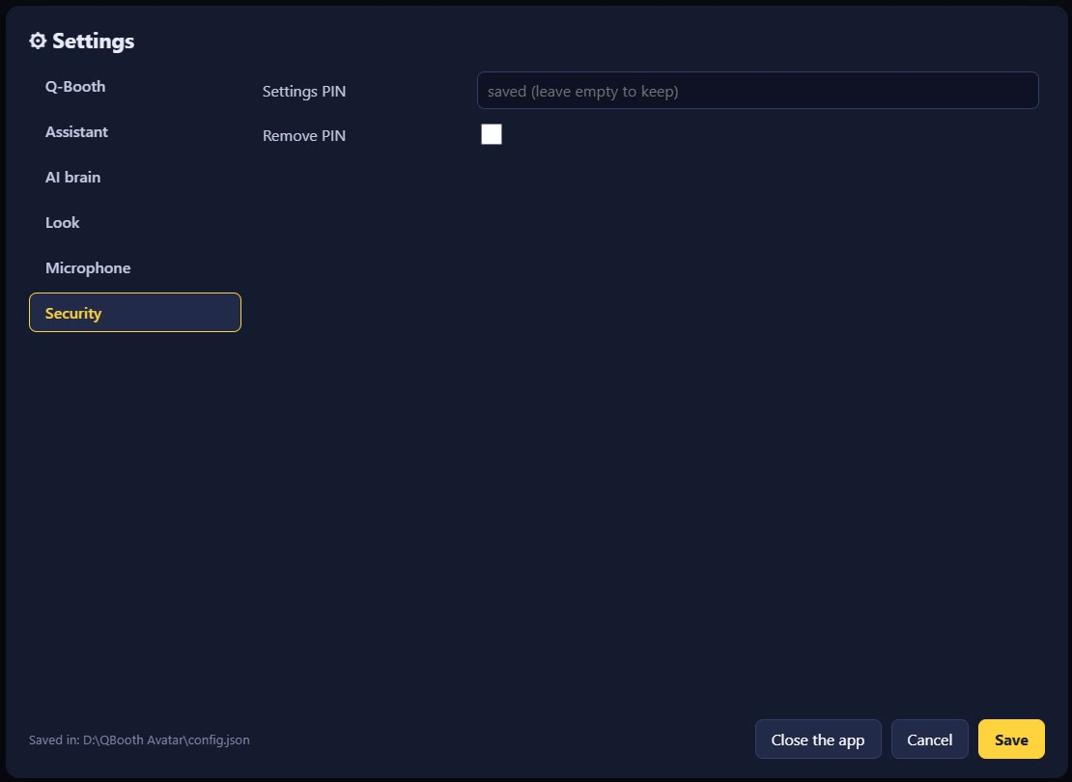
Figure 18. The Security tab: the settings PIN.
Enter a Settings PIN so guests cannot change the settings. The PIN is asked every time the Settings or the language button are opened. Tick Remove PIN and Save to remove it.

8. Getting an API Key for a Cloud AI Brain
QBooth Avatar can run fully without internet using the local AI. A cloud AI brain gives more natural chat answers and needs an API key: a secret code from the AI provider that links the app to your account. In short:
AI brain | Get the key at | Cost
Gemini (cloud, Google) | aistudio.google.com/apikey | Free tier with daily limits; turn on billing for events
Gemini Live | The same key as Gemini | Same as Gemini
OpenRouter (cloud) | openrouter.ai/settings/keys or the "Log in with OpenRouter" button | Pay as you go with credits

Important: An API key is like a password: do not share it, photograph it, or send it by chat. The key is stored only in config.json on the booth computer and is never shown on screen again (its field reads "saved (leave empty to keep)").

8.1 Google Gemini API key

A. Creating the key
- Open https://aistudio.google.com/apikey in a browser. Sign in with a Google account (preferably the business account that will pay the bills).
- The first time: accept the Terms of Service. Google AI Studio automatically creates a Google Cloud project for you. (If you already have a Google Cloud project, you can use it via Dashboard → Projects → Import projects.)
- Click Create API key, choose the project, then create the key.
- Copy the key that appears (a long string of letters and numbers). Keep it somewhere safe.
- Recommended: on the API Keys page, at the Unrestricted label next to the key, click Add restrictions → Restrict to Gemini API only → Restrict key. A restricted key is safer if it leaks, and Google may block unrestricted keys.

B. Entering the key in QBooth Avatar
- Open Settings → AI brain.
- Under Runs on, choose Gemini (cloud, Google).
- Paste the key into the API key field.
- Leave Model at gemini-3.5-flash (or enter the name of another Gemini model).
- Leave Use the local AI if the cloud fails ticked.
- Press Test the AI brain. When it works a ✓ appears; when it fails, a message explains why (wrong key, quota used up, no internet).
- Press Save.

C. Free tier and billing
A new project is on the Free Tier: free, but the number of requests per minute and per day is limited for each model (see the project's rate limit page in AI Studio). At a busy event this limit can run out; the avatar then uses the local AI and the loading/settings screens show a "quota" or "429" warning. For events, turn on billing:
- In AI Studio, open the API keys or Projects page.
- In your project's Billing Tier column, click Set up billing.
- Choose your country, confirm your contact details, and add a payment method (card).
- Choose one of the payment options offered: Prepay (buy credits on the Billing page via Buy credits, minimum US$5; requests fail when the balance runs out; automatic top-up is available) or Postpay (billed monthly).
- Once billing is active, the project moves up to Tier 1 with much higher limits, usually right away.
- Recommended: set up a billing alert in the Google Cloud console so you know when costs go up.
Note: On the paid tier, Google states that conversations are not used to improve its products. On the free tier, check the latest terms.

8.2 Gemini Live (real-time voice)
Gemini Live uses the same Google API key as in Section 8.1. An OpenRouter key cannot be used for Gemini Live.
- Create a key as in Section 8.1 part A.
- In Settings → AI brain, choose Gemini Live (real-time voice, cloud).
- Paste the key into the API key field.
- Choose a Voice (5 female voices, 5 male voices). If the voice's gender does not match the avatar, the app uses a Google voice that matches the avatar's gender.
- Leave Guests may interrupt off, unless guests speak through a headset or a directional mic.
- Press Test the AI brain, then Save.
Note: Gemini Live needs a stable internet connection. If the connection drops, the avatar automatically switches to local mode and tries Live again every 30 seconds.

8.3 OpenRouter API key
OpenRouter is one account and one key for AI models from many providers (Google, OpenAI, Anthropic, Meta, etc.). There are two ways to set up its key.

Option A: the "Log in with OpenRouter" button (easiest)
- In Settings → AI brain, choose OpenRouter (cloud).
- Press Log in with OpenRouter. The browser opens the OpenRouter sign-in page.
- Sign in (or create a new account), then approve access for "QBooth Avatar".
- Back in the app, ✓ Connected, key saved appears. The key is created and filled in automatically (in your OpenRouter account this key is named "QBooth Avatar").
- Press Test the AI brain, then Save.

Option B: creating the key yourself
- Sign in at https://openrouter.ai, then open https://openrouter.ai/settings/keys.
- Click Create Key and give it a name (for example "QBooth Avatar - booth 1").
- Set a credit limit for this key. OpenRouter recommends a limit on every key, so a leaked key cannot use up your whole balance.
- Copy the key (it starts with sk-or-v1-). The key is shown only once.
- In Settings → AI brain → OpenRouter (cloud), paste it into the API key field.
- Enter the Model (default google/gemini-2.5-flash; other model names are listed at openrouter.ai/models).
- Press Test the AI brain, then Save.

OpenRouter credits
- Paid models use credits. Top up at https://openrouter.ai/settings/credits with a credit card (crypto also works). Automatic top-up is available. There is a small fee when buying credits; model usage has no markup.
- Unused credits can be refunded within 24 hours of purchase.
- Free models (names ending in :free) need no credits, but are limited to 50 requests per day (1,000 per day after buying at least 10 credits). Too few for an event.

8.4 If a key leaks or is lost
Provider | Steps
Google Gemini | Create a new key in AI Studio, enter it in the app, then delete/disable the old key and check its usage.
OpenRouter | Delete the key at openrouter.ai/settings/keys, then create a new one. OpenRouter also watches for keys leaked on GitHub and sends an e-mail.

- Use a separate key (or credit limit) for each booth computer, so one key can be revoked without affecting the other booths.
- Do not share an app folder that contains config.json. To share the app, use a clean portable package.

8.5 Q-Booth Local API password
This is not a cloud API key, but it is entered in a similar way: turn on the Local API in Q-Booth (Settings → Advanced, Expert mode), note its port and password, then enter them in Settings → Q-Booth and press Connect (Chapter 3).

9. The Avatar and Its Voice
Open Settings → Look → Edit the avatar…. The editor panel appears next to the character and changes show right away.
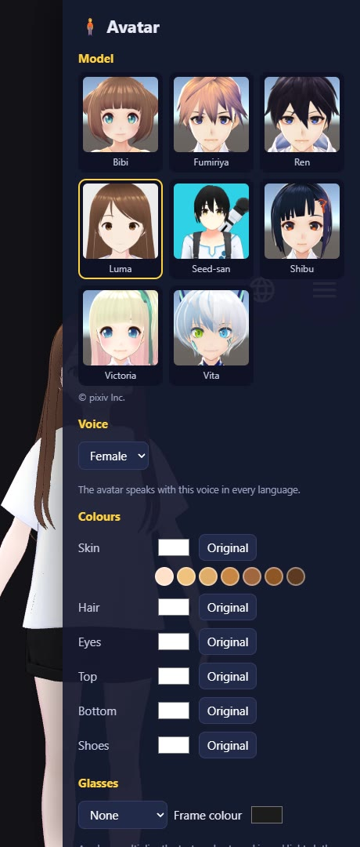
Figure 19. The avatar editor: model, voice (gender), colours and glasses.
Part | Description
Model | 8 built-in avatars: Luma, Seed-san, Shibu, Bibi, Vita, Victoria (female), Fumiriya, Ren (male). The creator and licence info are shown below it.
Voice | Female or male. Already set for the built-in avatars; for your own VRM, choose it here.
Colours | Skin (with quick skin-tone choices), hair, eyes, top, bottom, shoes. Original restores the default colours.
Glasses | None, or several glasses shapes, with a frame colour.
Save / Cancel | Save the look for this model, or cancel.

9.1 The voice follows the avatar's gender
Language | Female avatar | Male avatar
Bahasa Indonesia | The app's built-in female voice | Windows voice "Andika" (needs the language pack)
English | Windows voice "Zira" | Windows voice "David"
中文 | The app's built-in female voice | Windows voice "Kangkang" (needs the language pack)

If the male voice for that language is not installed in Windows, the avatar uses a female voice and the Assistant tab shows instructions. To install it:
- Open Windows Settings → Time & language → Language & region.
- Press Add a language and choose Indonesian (for Andika) or Chinese (Simplified, China) (for Kangkang).
- Make sure Text-to-speech is installed too. Restart the computer if asked.
- Open QBooth Avatar again.

9.2 Adding your own avatar
Prepare a .vrm file (for example made with VRoid Studio), then press Add VRM… in Settings → Look. Choose its voice in the avatar editor.
Note: Check the VRM model's licence. Seed-san requires the credit "Seed-san by VirtualCast, Inc." when used.

10. Pronunciation
The Indonesian and Mandarin voices read a few words correctly by themselves (the English voice simply says "Q Booth" and "Kris"):
Written | Said (Indonesian voice) | Said (中文 voice)
Q-Booth | Kyubuth | 丘布斯
QR | kyu ar | 二维码
QRIS | kris | 克里斯
photobooth | fotobut | -
template, scan, upload, online | templet, sken, aplod, onlen | -

Other words that sound wrong can be added in Settings → Assistant → Pronunciations, one per line, for example:
Lumaqube = lumakyub
Andi & Sari = Andi and Sari
Note: Pronunciations do not apply to Gemini Live, because Gemini Live uses Google's own voice.

11. Troubleshooting
Symptom | Cause and fix
The character does not press the Q-Booth buttons | Check the Q-Booth tab: press Connect, it must show ✓. Make sure the event is running and the Local API is on.
"Port … is in use" on start | An old copy is still running. Close it in Task Manager, wait a moment, then open it again.
The character is covered by the Q-Booth window | It usually recovers by itself within 1-2 seconds. Make sure the event's output monitor = the character's screen.
The character freezes/vanishes, or there is a black box behind it | Settings → Look → GPU for the screen → NVIDIA GPU or No GPU, then Save.
The avatar mishears / does not hear | Adjust the Mic sensitivity, move the mic closer, keep it away from the speakers, try "Tap the character".
The avatar reacts to background noise | Slide the Mic sensitivity to the left, or use "Tap the character" / "Say the name first".
Slow answers | Set Talkativeness to Short or Normal; close other heavy apps; or use a cloud AI brain.
"quota" / "429" warning | The free Gemini quota is used up. Turn on billing (Section 8.1 C). The local AI takes over meanwhile.
"No API key" / "The provider answered with an error" | Enter or check the API key, check the internet, press Test the AI brain.
No male voice | The Windows language pack is not installed (Section 9.1).
The first download fails | Check the internet, then open the app again (the download resumes), or use "Have it already? Choose…".

12. Files and Privacy
Location | Contents
config.json (next to the exe) | All your settings, including the Local API password and API keys. Do not share it.
resources\app\logs\ | Activity logs. Send them to a technician when there is a problem (without config.json).
resources\app\cache\ | Voice lines already generated. Safe to delete; they are regenerated automatically.

- Guests' voices are personal data. Voice recording is off by default.
- With a cloud AI brain, conversations are sent to the AI provider (Google / OpenRouter). With the local AI, everything stays on the computer.
- API keys, passwords and the PIN are never shown on the avatar screen.

