
Fakulteti i Shkencave Kompjuterike dhe Inxhinierise

Emri i Projektit
“Menaxhimi dhe nderlidhja e linjave dhe klienteve ne Airoport”

Studentet: Profesori:

Lumbardh Gashi (ID:202152753)
Egzon Pajaziti (ID:202152768)

Prof.Ramiz Hoxha
Prof.Medina Shamolli

Dhjetor
11,dhjetore,2021

Permbajtje
Hyrje 3
Pjesa Kryesore (Permbajtja) 4
Konkluzioni 5
Referencat 6

Hyrje

Ne kete Projekt do te bejme ndrelidhjen mes linjave dhe klienteve ne menyre qe te behet me i leht menaxhimi i kohes , dhe te ken klientet sa ma shume opsione per linjat fluturuese ne vende te deshirurara nga ata . Prandaj dhe detyra jone e pare eshte te organizojme informacionin per te gjithe aeroplanet e stacionuar dhe mirembajtur ne aeroportin

Pjesa Kryesore (Permbajtja)

Si detyre e jona kryesore eshte organizimi i te gjithe aeroplanve te stacionuar ne aeroport si dhe mirembajtja e tyre . Duhet te kemi parasysh qe mirembajtjen e aeroplaneve e ben nje kompani e veqant dhe e licencuar per mirembajtjen e aeroplaneve ne aeroport . Kompania qe miremban aeroplanet te stacionuar ne aeroport duhet te kete daten e leshimit te licenes dhe daten e mbarimit te licences . Duhet te ket poashtu nje kompani qe merret me mirembajtjen , pastrimin e Aeroportit te njejtat atribute vlejn edhe per kete kompani pra ; duhet te jete e licencuar dhe te ket daten e leshimit te licences po ashtu te ket daten e mbarimit te saj . Ne aeroport rendesi te veqant i jepet klienteve te cilet udhetojne , cdo klient duhet te ket passaport valide , mosha , dataLindjes , nje dokument qe e lejon te udhetoje (visa) , Vendi se ku udheton , po ashtu nese udheton vetem duhet te jete mbi 18 vjet nese nuk e ploteson kete kusht dmth eshte nen moshen 18 vjet dhe udheton vetem te mos lejohet te udhetoj pa pranin e njerit prind se paku . Çdo aeroplan ka nje numer regjistrimi dhe çdo aeroplan eshte i nje modeli specifik.Aeroporti strehon nje numer modelesh aeroplanesh po ashtu vendin se ku do te udhetoj dhe secili model identifikohet nga nje numer modeli (p.sh. DC - 10, DC – 11 etj ...) dhe ka nje kapacitet qe percakton numrin maksimal te klienteve qe udhetojne me aeroplanin respektiv dhe nje peshe (te pergjithshme duke mos u bazuar ne numrin e udhetareve qe udhetojne) te aeroplanit . Nje numer teknikesh punojne ne aeroport . Pra si obligim ne duhet qe te ruajm emrin , SSN , adresen , numrin e telefonit dhe pagen e secilit teknik . Çdo teknik eshte ekspert ne nje ose me shume model aeroplani dhe ekspertiza e tij ose e saj mund te mbivendoset me ate te teknikeve te tjere. Ky informacion per tekniket gjithashtu duhet te regjistrohet . Kontrolloret e trafikut duhet te bejne nje ekzaminim mjekesor vjetor. Per çdo kontrollues trafiku , duhet te ruani daten e provimit me te fundit .Te gjithe punonjesit e aeroportit ( perfshire tekniket ) i perkasin nje sindikate . Duhet te ruani numrin e anetaresimit ne sindikate te secilit punonjes . Ju mund te supozoni se çdo punonjes identifikohet ne menyre unike nga nje numer i sigurimeve shoqerore . Aeroporti ka nje numer testesh qe perdoren periodikisht per te siguruar qe aeroplanet jane ende te afte per fluturim dhe nuk kane ndonje defekt te cilin e bejn fluturimin te rrezikshem per udhetaret qe udhetojn . Çdo test ka nje numer testimi te Administrates Federale te Aviacionit ( FAA ) , nje emer dhe nje rezultat maksimal te mundshem . Administrates Federale te Aviacionit ( FAA ) , kerkon qe aeroporti te mbaje shenim çdo here qe nje aeroplan i caktuar testohet nga nje teknik i caktuar duke perdorur nje test te caktuar. Per çdo ngjarje testimi , informacioni i nevojshem eshte data e ekzaminimit , numri i oreve qe tekniku ka kaluar duke bere testin dhe rezultati qe ka marre avioni ne test .

ERD

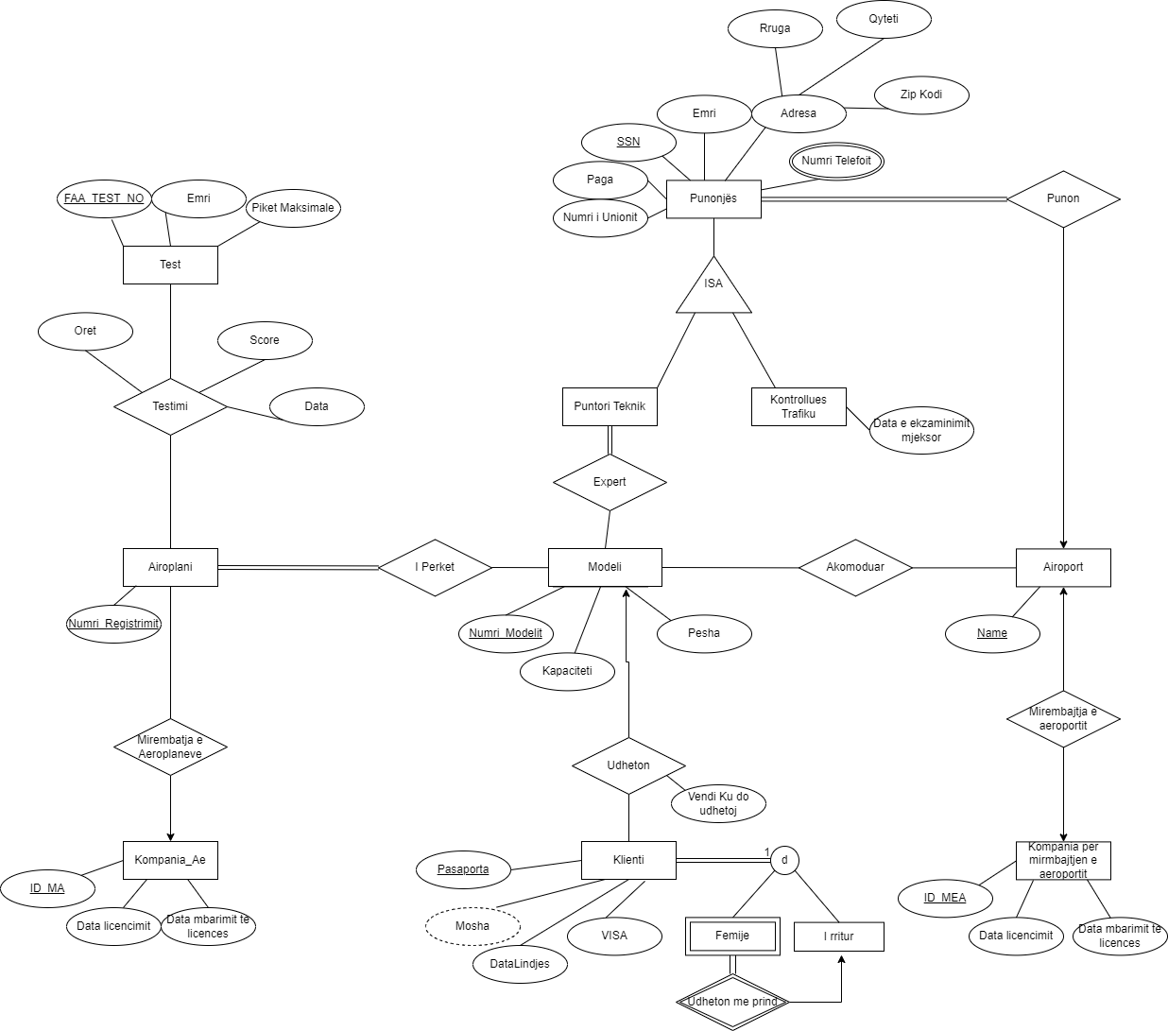

Faza 2

Ne Fazen e Dyte kemi vazhduar me krijim e tabelave dhe insertimin e recordeve ne tablea , pastaj pas saj kemi vazhduar me testimin e cdo tabele nese funksion cdo gje ne menyre te paramenduar nga protagonistet qe morren pjes ne kete projekt gjithsesi le te vazhdojme me paraqitjen e kodit qe I kemi krijuar tabelat ne MsSql .
PERDORIMI I DDL & DRL :
Create database Aeroporti

use Aeroporti

create table Testi(
FAA_Test_No int Primary key,
Emri varchar(40) Not Null ,
PiketMax int
);

create table Aeroplani(
Numri_regjistrimit char(15) Primary Key
);

create table Testimi(
Data_Testimit Date ,
Score int ,
Oret char(10) ,
FAA int ,
Nr_Regjistrimit char(15) ,
Primary key(FAA,Nr_Regjistrimit),
Foreign key (FAA) references Testi(FAA_Test_No),
Foreign key (Nr_Regjistrimit) references Aeroplani(Numri_regjistrimit)
);

create table Kompania_EA(
ID_MA char(10) Primary key ,
DataLicencimit date ,
DataEMbarimitLicences date ,
);

create table MirembajtjaEAeroplaneve(
Nr_RegjAeroplanit char(15),
IDKompania_EA char(10),
Primary key(Nr_RegjAeroplanit,IDKompania_EA),
Foreign key(Nr_RegjAeroplanit) references Aeroplani(Numri_regjistrimit),
Foreign key(IDKompania_EA)references Kompania_EA(ID_MA)
);

create table Modeli(
Numri_Modelit char(15)Primary key,
KapaciteiAeroplanit int ,
Pesha char(25)
);

create table Perket(
NR_MODEL char(15),
Nr_RegjistrimAE CHAR(15),
Primary key(Nr_RegjistrimAE,NR_MODEL),
Foreign key(Nr_RegjistrimAE) references Aeroplani(Numri_regjistrimit),
Foreign key(NR_MODEL) references Modeli(Numri_Modelit)
);

create table Airoporti(
Emri varchar(50) Primary key
);

create table Akomoduar(
Emri_Aeroportit varchar(50),
Numri_Model char(15),
Primary key(Emri_Aeroportit,Numri_Model),
foreign key (Emri_Aeroportit) references Airoporti(Emri),
foreign key (Numri_Model) references Modeli(Numri_Modelit)
);

create table KompaniaPerMirembajtjenAiroportit(
ID_MEA char(20) Primary key ,
DataLicencimit date,
DataMbarimitLicences date
);

create table MirembajtjaAiroportit(
Emri_Aeroportit varchar(50),
ID_mea char(20),
Primary key(Emri_Aeroportit,ID_mea),
foreign key (Emri_Aeroportit) references Airoporti(Emri) ,
foreign key (ID_mea) references KompaniaPerMirembajtjenAiroportit(ID_MEA)
);

create table Klienti(
Passaporta char(15) Primary key ,
DataLindjes date ,
viza char(5),
);

create table Udheton(
VendiKuDoUdhetoj varchar(70),
Nr_MOD char(15) ,
Pass char(15),
Primary key (Nr_MOD,Pass),
Foreign key(Nr_MOD) references Modeli(Numri_Modelit),
Foreign key(Pass) references Klienti(Passaporta)
);

create table IRritur(
PassPort char(15),
primary key (PassPort),
Foreign key (PassPort) references Klienti(Passaporta)
);

create table Femija(
PassPort char(15),
ID_Rritur char(15),
primary key (PassPort,ID_Rritur),
Foreign key (PassPort) references Klienti(Passaporta),
Foreign key (ID_Rritur) references IRritur(PassPort)
);

create table Punonjesi(
SSN char(20) Primary key,
Emri varchar(40) Not null ,
Paga money,
NumriUnionit char(15),
Rruga varchar(40),
Qyteti varchar(30),
ZipKodi char(15),
);

create table NumriTelefonit(
Nr_Tel char(15),
SSN_A char(20),
Primary key(Nr_Tel),
Foreign key(SSN_A) references Punonjesi(SSN)
);

create table Punon(
SSN char(20),
Emri_Aeroportit varchar(50),
Primary key(Emri_Aeroportit,SSN),
Foreign key (Emri_Aeroportit) references Airoporti(Emri),
Foreign key (SSN) references Punonjesi(SSN)
);

create table PunetoriTeknik(
SSN char(20) ,
Numri_Modelit char(15)
Primary key(SSN,Numri_Modelit),
Foreign key (SSN) references Punonjesi(SSN),
Foreign key (Numri_Modelit) references Modeli(Numri_Modelit)
);

create table KontrolluesTrafiku(
DataEkzaminimitMjeksor Date ,
SSN char(20),
Primary key(DataEkzaminimitMjeksor),
Foreign key (SSN) references Punonjesi(SSN)
);

Pas krijimit dhe verifikimit te tabelave ne kemi filluar te insertojm te dhenat imagjinare (jo reale) .
Perdorimi i DML :

insert into Testi values ('12345','Emri1','60')
insert into Testi values ('12346','Emri2','69')
insert into Testi values ('12347','Emri3','70')
insert into Testi values ('12344','Emri4','75')
insert into Testi values ('12348','Emri5','80')
insert into Testi values ('12349','Emri6','79')
insert into Testi values ('12355','Emri7','62')
insert into Testi values ('12356','Emri8','90')
insert into Testi values ('12357','Emri9','750')
insert into Testi values ('12358','Emri10','100')

Select *
From Testi

insert into Aeroplani values ('01')
insert into Aeroplani values ('02')
insert into Aeroplani values ('03')
insert into Aeroplani values ('04')
insert into Aeroplani values ('05')
insert into Aeroplani values ('06')
insert into Aeroplani values ('07')
insert into Aeroplani values ('08')
insert into Aeroplani values ('09')
insert into Aeroplani values ('010')

Select *
From Aeroplani

insert into Testimi values('04/05/2021','65','2:25','12345','01')
insert into Testimi values('04/05/2021','65','2:25','12346','01')
insert into Testimi values('04/05/2021','65','2:25','12347','02')
insert into Testimi values('04/05/2021','65','2:25','12348','02')
insert into Testimi values('04/05/2021','65','2:25','12349','03')
insert into Testimi values('04/05/2021','75','4:05','12348','03')
insert into Testimi values('05/04/2021','78','3:45','12355','03')
insert into Testimi values('09/06/2021','55','12:52','12349','04')
insert into Testimi values('09/07/2021','91','20:27','12358','04')
insert into Testimi values('10/01/2021','53','22:28','12358','05')
insert into Testimi values('02/02/2021','71','24:45','12356','05')
insert into Testimi values('04/03/2021','64','21:15','12357','06')
insert into Testimi values('11/04/2021','85','17:05','12355','06')
insert into Testimi values('12/05/2021','79','18:59','12356','06')
insert into Testimi values('12/06/2021','51','19:00','12346','06')
insert into Testimi values('10/07/2021','84','20:01','12345','07')
insert into Testimi values('05/08/2021','79','13:33','12346','07')
insert into Testimi values('05/09/2021','88','14:06','12347','08')
insert into Testimi values('06/10/2021','99','15:03','12348','08')
insert into Testimi values('08/11/2021','100','16:09','12346','08')
insert into Testimi values('09/11/2021','67','17:51','12349','08')
insert into Testimi values('01/12/2021','66','18:08','12349','09')
insert into Testimi values('01/12/2021','85','19:33','12355','09')
insert into Testimi values('06/12/2021','78','20:34','12356','010')
insert into Testimi values('07/05/2021','77','09:46','12357','010')
insert into Testimi values('08/12/2021','76','10:49','12358','010')

Select *
From Testimi

insert into Kompania_EA values('EA01','08/12/2008','08/05/2024')
insert into Kompania_EA values('EA02','11/01/2006','09/09/2025')
insert into Kompania_EA values('EA03','10/12/2007','10/08/2026')
insert into Kompania_EA values('EA04','09/07/2012','11/07/2026')
insert into Kompania_EA values('EA05','05/08/2011','12/08/2027')
insert into Kompania_EA values('EA06','03/09/2010','12/10/2028')
insert into Kompania_EA values('EA07','07/12/2014','11/11/2029')
insert into Kompania_EA values('EA08','05/10/2015','04/10/2030')
insert into Kompania_EA values('EA09','09/11/2019','05/11/2030')
insert into Kompania_EA values('EA10','08/12/2020','10/12/2031')

Select *
From Kompania_EA

insert into MirembajtjaEAeroplaneve values ('01','EA01')
insert into MirembajtjaEAeroplaneve values ('02','EA01')
insert into MirembajtjaEAeroplaneve values ('03','EA01')
insert into MirembajtjaEAeroplaneve values ('04','EA02')
insert into MirembajtjaEAeroplaneve values ('05','EA02')
insert into MirembajtjaEAeroplaneve values ('06','EA02')
insert into MirembajtjaEAeroplaneve values ('07','EA03')
insert into MirembajtjaEAeroplaneve values ('08','EA03')
insert into MirembajtjaEAeroplaneve values ('09','EA03')
insert into MirembajtjaEAeroplaneve values ('010','EA04')
insert into MirembajtjaEAeroplaneve values ('01','EA04')
insert into MirembajtjaEAeroplaneve values ('02','EA04')
insert into MirembajtjaEAeroplaneve values ('03','EA04')
insert into MirembajtjaEAeroplaneve values ('04','EA05')
insert into MirembajtjaEAeroplaneve values ('05','EA05')
insert into MirembajtjaEAeroplaneve values ('06','EA05')
insert into MirembajtjaEAeroplaneve values ('07','EA06')
insert into MirembajtjaEAeroplaneve values ('08','EA06')
insert into MirembajtjaEAeroplaneve values ('09','EA06')
insert into MirembajtjaEAeroplaneve values ('010','EA07')
insert into MirembajtjaEAeroplaneve values ('01','EA07')
insert into MirembajtjaEAeroplaneve values ('02','EA07')
insert into MirembajtjaEAeroplaneve values ('03','EA07')
insert into MirembajtjaEAeroplaneve values ('04','EA07')
insert into MirembajtjaEAeroplaneve values ('05','EA08')
insert into MirembajtjaEAeroplaneve values ('06','EA08')

SELECT *
From MirembajtjaEAeroplaneve

insert into Modeli values('DC01','250','50 T')
insert into Modeli values('DC02','150','30 T')
insert into Modeli values('DC03','230','42 T')
insert into Modeli values('DC04','290','59 T')
insert into Modeli values('DC05','280','58 T')
insert into Modeli values('DC06','270','55 T')
insert into Modeli values('DC07','300','65 T')
insert into Modeli values('DC08','310','66 T')
insert into Modeli values('DC09','225','51 T')
insert into Modeli values('DC10','273','62 T')

Select *
From Modeli

insert into Perket values ('DC01','01')
insert into Perket values ('DC02','02')
insert into Perket values ('DC03','03')
insert into Perket values ('DC04','04')
insert into Perket values ('DC05','05')
insert into Perket values ('DC06','06')
insert into Perket values ('DC07','07')
insert into Perket values ('DC08','08')
insert into Perket values ('DC09','09')
insert into Perket values ('DC10','010')
insert into Perket values ('DC01','07')
insert into Perket values ('DC02','06')
insert into Perket values ('DC03','05')
insert into Perket values ('DC04','08')
insert into Perket values ('DC05','03')
insert into Perket values ('DC06','02')
insert into Perket values ('DC07','010')
insert into Perket values ('DC08','09')
insert into Perket values ('DC09','08')
insert into Perket values ('DC10','07')
insert into Perket values ('DC01','06')
insert into Perket values ('DC02','05')
insert into Perket values ('DC03','04')
insert into Perket values ('DC04','03')
insert into Perket values ('DC05','02')
insert into Perket values ('DC06','01')

Select *
From Perket

insert into Airoporti values('Adem Jashari1')
insert into Airoporti values('Adem Jashari2')
insert into Airoporti values('Adem Jashari3')
insert into Airoporti values('Adem Jashari4')
insert into Airoporti values('Adem Jashari5')
insert into Airoporti values('Adem Jashari6')
insert into Airoporti values('Adem Jashari7')
insert into Airoporti values('Adem Jashari8')
insert into Airoporti values('Adem Jashari9')
insert into Airoporti values('Adem Jashari10')

Select*
From Airoporti

insert into Akomoduar values('Adem Jashari1','DC01')
insert into Akomoduar values('Adem Jashari2','DC01')
insert into Akomoduar values('Adem Jashari3','DC01')
insert into Akomoduar values('Adem Jashari4','DC01')
insert into Akomoduar values('Adem Jashari5','DC02')
insert into Akomoduar values('Adem Jashari6','DC02')
insert into Akomoduar values('Adem Jashari7','DC02')
insert into Akomoduar values('Adem Jashari8','DC02')
insert into Akomoduar values('Adem Jashari9','DC03')
insert into Akomoduar values('Adem Jashari10','DC03')
insert into Akomoduar values('Adem Jashari1','DC03')
insert into Akomoduar values('Adem Jashari2','DC03')
insert into Akomoduar values('Adem Jashari3','DC04')
insert into Akomoduar values('Adem Jashari4','DC04')
insert into Akomoduar values('Adem Jashari5','DC04')
insert into Akomoduar values('Adem Jashari6','DC04')
insert into Akomoduar values('Adem Jashari7','DC05')
insert into Akomoduar values('Adem Jashari8','DC05')
insert into Akomoduar values('Adem Jashari9','DC05')
insert into Akomoduar values('Adem Jashari10','DC05')
insert into Akomoduar values('Adem Jashari1','DC06')
insert into Akomoduar values('Adem Jashari2','DC06')
insert into Akomoduar values('Adem Jashari3','DC06')
insert into Akomoduar values('Adem Jashari4','DC06')
insert into Akomoduar values('Adem Jashari5','DC07')
insert into Akomoduar values('Adem Jashari6','DC07')

Select *
From Akomoduar

insert into KompaniaPerMirembajtjenAiroportit values('MEA01','08/12/2008','08/05/2024')
insert into KompaniaPerMirembajtjenAiroportit values('MEA02','11/01/2006','09/09/2025')
insert into KompaniaPerMirembajtjenAiroportit values('MEA03','10/12/2007','10/08/2026')
insert into KompaniaPerMirembajtjenAiroportit values('MEA04','09/07/2012','11/07/2026')
insert into KompaniaPerMirembajtjenAiroportit values('MEA05','05/08/2011','12/08/2027')
insert into KompaniaPerMirembajtjenAiroportit values('MEA06','03/09/2010','12/10/2028')
insert into KompaniaPerMirembajtjenAiroportit values('MEA07','07/12/2014','11/11/2029')
insert into KompaniaPerMirembajtjenAiroportit values('MEA08','05/10/2015','04/10/2030')
insert into KompaniaPerMirembajtjenAiroportit values('MEA09','09/11/2019','05/11/2030')
insert into KompaniaPerMirembajtjenAiroportit values('MEA10','08/12/2020','10/12/2031')

Select *
From KompaniaPerMirembajtjenAiroportit

insert into MirembajtjaAiroportit values('Adem Jashari1','MEA01')
insert into MirembajtjaAiroportit values('Adem Jashari2','MEA01')
insert into MirembajtjaAiroportit values('Adem Jashari3','MEA01')
insert into MirembajtjaAiroportit values('Adem Jashari4','MEA01')
insert into MirembajtjaAiroportit values('Adem Jashari5','MEA02')
insert into MirembajtjaAiroportit values('Adem Jashari6','MEA02')
insert into MirembajtjaAiroportit values('Adem Jashari7','MEA02')
insert into MirembajtjaAiroportit values('Adem Jashari8','MEA02')
insert into MirembajtjaAiroportit values('Adem Jashari9','MEA03')
insert into MirembajtjaAiroportit values('Adem Jashari10','MEA03')
insert into MirembajtjaAiroportit values('Adem Jashari1','MEA03')
insert into MirembajtjaAiroportit values('Adem Jashari2','MEA03')
insert into MirembajtjaAiroportit values('Adem Jashari3','MEA04')
insert into MirembajtjaAiroportit values('Adem Jashari4','MEA04')
insert into MirembajtjaAiroportit values('Adem Jashari5','MEA04')
insert into MirembajtjaAiroportit values('Adem Jashari6','MEA04')
insert into MirembajtjaAiroportit values('Adem Jashari7','MEA05')
insert into MirembajtjaAiroportit values('Adem Jashari8','MEA05')
insert into MirembajtjaAiroportit values('Adem Jashari9','MEA05')
insert into MirembajtjaAiroportit values('Adem Jashari10','MEA05')
insert into MirembajtjaAiroportit values('Adem Jashari1','MEA06')
insert into MirembajtjaAiroportit values('Adem Jashari2','MEA06')
insert into MirembajtjaAiroportit values('Adem Jashari3','MEA06')
insert into MirembajtjaAiroportit values('Adem Jashari4','MEA06')
insert into MirembajtjaAiroportit values('Adem Jashari5','MEA07')
insert into MirembajtjaAiroportit values('Adem Jashari6','MEA07')

Select *
From MirembajtjaAiroportit

insert into Klienti values('P01','12/24/2001','V01')
insert into Klienti values('P02','02/04/2000','V02')
insert into Klienti values('P03','11/14/2015','V03')
insert into Klienti values('P04','10/12/2009','V04')
insert into Klienti values('P05','12/11/2000','V05')
insert into Klienti values('P06','09/15/1955','V06')
insert into Klienti values('P07','08/21/1975','V07')
insert into Klienti values('P08','05/28/1969','V08')
insert into Klienti values('P09','06/30/1982','V09')
insert into Klienti values('P10','07/31/1993','V10')
insert into Klienti values('P11','05/15/1997','V11')
insert into Klienti values('P12','05/03/1999','V12')
insert into Klienti values('P13','11/14/2013','V13')
insert into Klienti values('P14','12/02/2014','V14')
insert into Klienti values('P15','08/21/2016','V15')
insert into Klienti values('P16','01/23/2008','V16')
insert into Klienti values('P17','02/04/2018','V17')
insert into Klienti values('P18','02/11/2022','V18')
insert into Klienti values('P19','05/25/2015','V19')
insert into Klienti values('P20','09/30/2019','V20')

SELECT*
from Klienti

insert into Udheton values('Kosove','DC01','P01')
insert into Udheton values('Kosove','DC01','P02')
insert into Udheton values('Kosove','DC01','P03')
insert into Udheton values('Kosove','DC01','P04')
insert into Udheton values('Kosove','DC01','P05')
insert into Udheton values('Kosove','DC01','P06')
insert into Udheton values('Kosove','DC01','P07')
insert into Udheton values('Kosove','DC01','P08')
insert into Udheton values('Kosove','DC01','P09')
insert into Udheton values('Kosove','DC01','P10')
insert into Udheton values('Maldive','DC02','P01')
insert into Udheton values('Maldive','DC02','P02')
insert into Udheton values('Maldive','DC02','P03')
insert into Udheton values('Maldive','DC02','P04')
insert into Udheton values('Maldive','DC02','P05')
insert into Udheton values('Maldive','DC02','P06')
insert into Udheton values('Maldive','DC02','P07')
insert into Udheton values('Maldive','DC02','P08')
insert into Udheton values('Maldive','DC02','P09')
insert into Udheton values('Maldive','DC02','P10')
insert into Udheton values('Zvicer','DC03','P01')
insert into Udheton values('Zvicer','DC03','P02')
insert into Udheton values('Zvicer','DC03','P03')
insert into Udheton values('Zvicer','DC03','P04')
insert into Udheton values('Zvicer','DC03','P05')

Select *
From Udheton

insert into IRritur values('P01')
insert into IRritur values('P02')
insert into IRritur values('P05')
insert into IRritur values('P06')
insert into IRritur values('P07')
insert into IRritur values('P08')
insert into IRritur values('P09')
insert into IRritur values('P10')
insert into IRritur values('P11')
insert into IRritur values('P12')

Select *
From IRritur

insert into Femija values('P03','P01')
insert into Femija values('P04','P02')
insert into Femija values('P13','P05')
insert into Femija values('P14','P06')
insert into Femija values('P15','P07')
insert into Femija values('P16','P08')
insert into Femija values('P17','P09')
insert into Femija values('P18','P10')
insert into Femija values('P19','P11')
insert into Femija values('P20','P12')

Select *
From Femija

insert into Punonjesi values('S01','Emri01','2500','U01','Rruga1','Qyteti1','Z01')
insert into Punonjesi values('S02','Emri02','500','U02','Rruga1','Qyteti1','Z01')
insert into Punonjesi values('S03','Emri03','3400','U03','Rruga2','Qyteti2','Z02')
insert into Punonjesi values('S04','Emri04','2100','U04','Rruga2','Qyteti2','Z02')
insert into Punonjesi values('S05','Emri05','2200','U05','Rruga3','Qyteti3','Z03')
insert into Punonjesi values('S06','Emri06','1200','U06','Rruga3','Qyteti3','Z03')
insert into Punonjesi values('S07','Emri07','1800','U07','Rruga4','Qyteti4','Z04')
insert into Punonjesi values('S08','Emri08','1954','U08','Rruga4','Qyteti4','Z04')
insert into Punonjesi values('S09','Emri09','1234','U09','Rruga5','Qyteti5','Z05')
insert into Punonjesi values('S10','Emri10','5124','U10','Rruga5','Qyteti5','Z05')

Select *
From Punonjesi

insert into NumriTelefonit values ('123456789','S01')
insert into NumriTelefonit values ('123456788','S01')
insert into NumriTelefonit values ('123456787','S01')
insert into NumriTelefonit values ('123456786','S02')
insert into NumriTelefonit values ('123456785','S02')
insert into NumriTelefonit values ('123456784','S02')
insert into NumriTelefonit values ('123456783','S03')
insert into NumriTelefonit values ('123456782','S03')
insert into NumriTelefonit values ('123456781','S03')
insert into NumriTelefonit values ('123456780','S04')
insert into NumriTelefonit values ('123456779','S04')
insert into NumriTelefonit values ('123456778','S04')
insert into NumriTelefonit values ('123456777','S05')
insert into NumriTelefonit values ('123456776','S05')
insert into NumriTelefonit values ('123456775','S05')
insert into NumriTelefonit values ('123456774','S05')
insert into NumriTelefonit values ('123456773','S06')
insert into NumriTelefonit values ('123456772','S06')
insert into NumriTelefonit values ('123456771','S06')
insert into NumriTelefonit values ('123456770','S07')
insert into NumriTelefonit values ('123456689','S07')
insert into NumriTelefonit values ('123456688','S07')
insert into NumriTelefonit values ('123456687','S08')
insert into NumriTelefonit values ('123456686','S09')
insert into NumriTelefonit values ('123456685','S10')
insert into NumriTelefonit values ('123456684','S09')
insert into NumriTelefonit values ('123456683','S08')
insert into NumriTelefonit values ('123456682','S07')

Select *
From NumriTelefonit

insert into Punon values('S01','Adem Jashari1')
insert into Punon values('S02','Adem Jashari1')
insert into Punon values('S03','Adem Jashari1')
insert into Punon values('S04','Adem Jashari2')
insert into Punon values('S05','Adem Jashari2')
insert into Punon values('S06','Adem Jashari2')
insert into Punon values('S07','Adem Jashari3')
insert into Punon values('S08','Adem Jashari3')
insert into Punon values('S09','Adem Jashari3')
insert into Punon values('S10','Adem Jashari4')
insert into Punon values('S01','Adem Jashari4')
insert into Punon values('S02','Adem Jashari4')
insert into Punon values('S03','Adem Jashari5')
insert into Punon values('S04','Adem Jashari5')
insert into Punon values('S05','Adem Jashari5')
insert into Punon values('S06','Adem Jashari6')
insert into Punon values('S07','Adem Jashari6')
insert into Punon values('S08','Adem Jashari6')
insert into Punon values('S09','Adem Jashari7')
insert into Punon values('S10','Adem Jashari7')
insert into Punon values('S01','Adem Jashari7')
insert into Punon values('S02','Adem Jashari8')
insert into Punon values('S03','Adem Jashari8')
insert into Punon values('S04','Adem Jashari10')
insert into Punon values('S05','Adem Jashari9')

Select *
From Punon

insert into PunetoriTeknik values('S01','DC01')
insert into PunetoriTeknik values('S01','DC02')
insert into PunetoriTeknik values('S01','DC03')
insert into PunetoriTeknik values('S01','DC04')
insert into PunetoriTeknik values('S01','DC05')
insert into PunetoriTeknik values('S01','DC06')
insert into PunetoriTeknik values('S02','DC07')
insert into PunetoriTeknik values('S02','DC08')
insert into PunetoriTeknik values('S02','DC09')
insert into PunetoriTeknik values('S03','DC10')
insert into PunetoriTeknik values('S03','DC01')
insert into PunetoriTeknik values('S03','DC02')
insert into PunetoriTeknik values('S03','DC03')
insert into PunetoriTeknik values('S03','DC04')
insert into PunetoriTeknik values('S04','DC05')
insert into PunetoriTeknik values('S04','DC06')
insert into PunetoriTeknik values('S04','DC07')
insert into PunetoriTeknik values('S04','DC08')
insert into PunetoriTeknik values('S04','DC09')
insert into PunetoriTeknik values('S04','DC10')
insert into PunetoriTeknik values('S04','DC01')
insert into PunetoriTeknik values('S05','DC02')
insert into PunetoriTeknik values('S05','DC03')
insert into PunetoriTeknik values('S05','DC04')
insert into PunetoriTeknik values('S05','DC05')

Select *
From PunetoriTeknik

insert into KontrolluesTrafiku values ('01/01/2021','S06')
insert into KontrolluesTrafiku values ('02/21/2021','S06')
insert into KontrolluesTrafiku values ('03/22/2021','S07')
insert into KontrolluesTrafiku values ('04/12/2021','S07')
insert into KontrolluesTrafiku values ('05/13/2021','S08')
insert into KontrolluesTrafiku values ('06/14/2021','S08')
insert into KontrolluesTrafiku values ('07/15/2021','S09')
insert into KontrolluesTrafiku values ('08/16/2021','S09')
insert into KontrolluesTrafiku values ('09/17/2021','S10')
insert into KontrolluesTrafiku values ('10/18/2021','S10')

Select *
From KontrolluesTrafiku

Select *
From Punonjesi

Perdorimi I Update sipas udhezimeve te marra :

/*
Perdorimi I UPDATE
*/

Update Testimi
SET Score ='90'
Where Data_Testimit='01/09/2022'

Update Kompania_EA
Set DataLicencimit = '01/05/2021'
Where ID_MA = 'EA01'

Update Klienti
Set viza ='V0001'
Where DataLindjes = '01/01/2003'

Update Modeli
Set Pesha ='55 T'
Where KapaciteiAeroplanit < '200'

Update Punonjesi
Set Paga = '3000'
Where Qyteti = 'Qyteti1'

Update Testimi
Set Oret ='15:42'
Where Data_Testimit = '01/09/2022'

Update Punonjesi
Set NumriUnionit = 'U02'
Where Emri= 'EmriPunonjesit'

Update Udheton
Set VendiKuDoUdhetoj='SHBA'
where Nr_MOD = 'D01'

Update Testi
Set PiketMax='100'
Where Emri = 'Emri1'

Update Testi
Set Emri = 'EMRINdrruar'
Where PiketMax = '45'

Update Testimi
SET Score ='82'
Where Data_Testimit='01/04/2012'

Update Kompania_EA
Set DataLicencimit = '04/09/2022'
Where ID_MA = 'EA03'

Update Klienti
Set viza ='V0001'
Where DataLindjes = '10/30/2003'

Update Modeli
Set Pesha ='35 T'
Where KapaciteiAeroplanit < '100'

Update Punonjesi
Set Paga = '4000'
Where Qyteti = 'Qyteti1'

Update Testimi
Set Oret ='15:00'
Where Data_Testimit = '05/10/2021'

Update Punonjesi
Set NumriUnionit = 'U03'
Where Emri= 'EmriPunonjesit'

Update Udheton
Set VendiKuDoUdhetoj='Angli'
where Nr_MOD = 'D02'

Update Testi
Set PiketMax='88'
Where Emri = 'Emri3'

Update Testi
Set Emri = 'EmriN'
Where PiketMax = '66'

Perdorimi I Delete sipas udhezimeve te marra :

/*
Perdorimi i Delete
*/

DELETE FROM Punonjesi
WHERE Paga < 1300

Delete From Testimi
Where Score < 63

Delete From Kompania_EA
Where DataEMbarimitLicences < '01/09/2022'

Delete From KompaniaPerMirembajtjenAiroportit
Where DataMbarimitLicences < '01/09/2022'

Delete From Airoporti
Where Emri='Adem Jashari'

Delete From Punonjesi
where Emri= 'Emri1'

Delete From KontrolluesTrafiku
Where DataEkzaminimitMjeksor < '01/01/2010'

Delete From IRritur
Where PassPort = 'P00'

Delete From Femija
Where ID_Rritur = 'P01'

Delete From Testimi
Where Score between '40' and '50'

MODELI FIZIK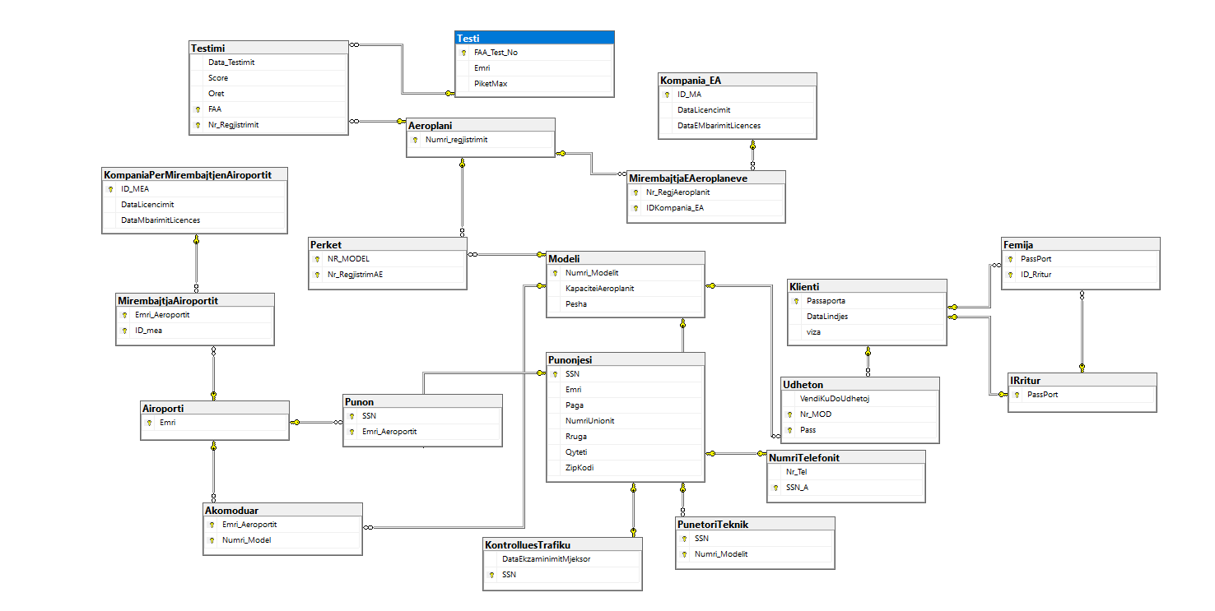

Konkluzioni
Duke u bazuar ne ate qe ne kemi marre si detyre dhe qe besojme qe kemi zgjidhur problemet me te cilat jemi ballafaquar gjate gjithe ksaj kohe; po ju njohim me objektivat tona qe nga gjetja e ides deri te perfundimi i saj:
Nder objektivat kryesor eshte lehtesimi i punes se punonjeseve ne Airoport si dhe menaxhimin e kohes dhe percaktimin e nje orari te fluturimeve ne menyre qe te mos shkaktohet tollovi ne kete kohe pandemie ku dhe orgazimi ndikon drejt per se drejti ne mos perhapjen e COVID-19. Pastaj Objektiv tjeter qe ishte sfide ishte mirembajtja e aeroplaneve ne kohe te sakt kur ata ishin te stacionuar ne Airoport, gjate kohes se ketij projekti mirebajtja e aeroplaneve ka zene nje vend shum te veqant ne objektivat tona sepse te gjithe antaret e grupit besojm qe nese mirembajtja do jete gjithmon mbi standartet e kerkuara ateher edhe aksidentet do te evitohen deri ne largimin e plote te tyre qe e shohim si nje synim te arritshem me kohe.
Eshte normale qe nje sistem nuk mund te punoj pa nje staf punues andaj dhe ne e kemi pasur ne objektiva tona qe stafi qe punon te kete nje sigurim shendetsor ku do tju nenshtroheshin nje ekzaminimi mjeksor qe do te njoftoheshin me kohe nese jan ne gjendje te punojn apo jo, e gjitha kjo eshte bere per te miren e klienteve qe jan pjesa jetesore e Airoportit, ku ne kemi zhvilluar per ta nje siguri te veqant ku nder to jane:
Eleminohen udhetimet e personave nen 18 vjeq pa pranin e njerit prind, pastaj nuk lejohet te kaloj ne aeroplanin fluturues nje klient i cili nuk posedon passaport valide dhe visa. Ne kemi percaktuar nje grup punonjesish qe menaxhojn trafikun e aeroplaneve gje qe ndihmon ne percaktimin e orarit te fluturimeve dhe ndikon ne rritjen e perqindjes se fitimit ne Airoport, sepse me nje orar ne mund te shohim se cilet aeroplan jan te lire dhe gjithqka te behet ne menyre te organizuar ku dhe te shfrytezohet cdo kohe qe mund te leviz aeroplani rrespektiv.
Sigurisht qe aeroplanet duhet ti neshtrohen nje testi ekzaminues i mundesuar nga Agjencia Federale e Aviacionit (FAA), ku testimet perpilohen nga vet ata dhe ne menyre qe aeroplani te mund te jete ne perdorim duhet ta kaloj pragun e pikeve percaktuese nga nga Agjencia Federale e Aviacionit.
Ju faleminderit!

Referencat

- https://simple.wikipedia.org/wiki/Airport
- Ligjeratat : prof.Ramiz Hoxha
- Ushtrimet : prof.Medina Shamolli
- https://sq.wikipedia.org/wiki/Aeroporti

