CPE301 – SPRING 2020

Design Assignment 1a

Student Name: John Paulo Lumbres

Student #: 2001227483

Student Email: [lumbrj1@unlv.nevada.edu](mailto:lumbrj1@unlv.nevada.edu)

Primary Github address: <https://github.com/lumbrj1/submission>

Directory: DesignAssignments\DA1A

1. **COMPONENTS LIST AND CONNECTION BLOCK DIAGRAM w/ PINS**

Atmel Studio 7 -simulator with device ATmega328pb

1. **SCREENSHOTS OF EACH TASK OUTPUT (ATMEL STUDIO OUTPUT)**

Before:

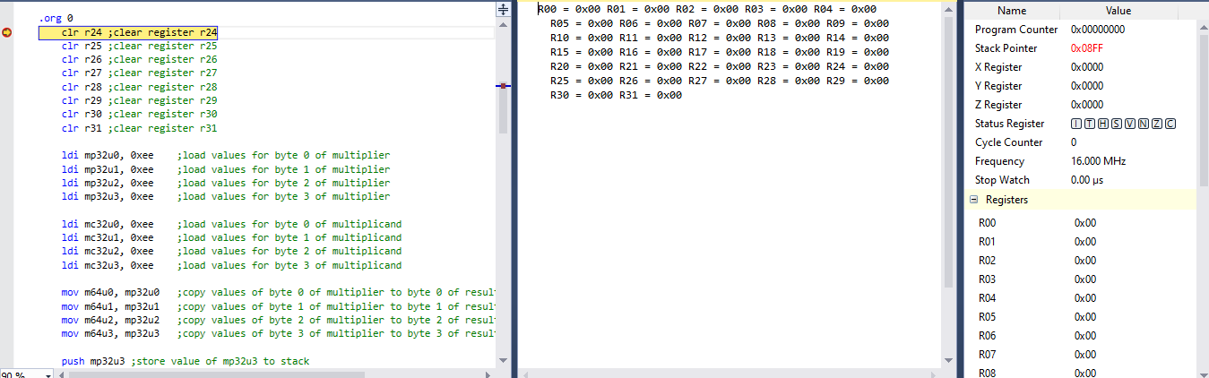

After:

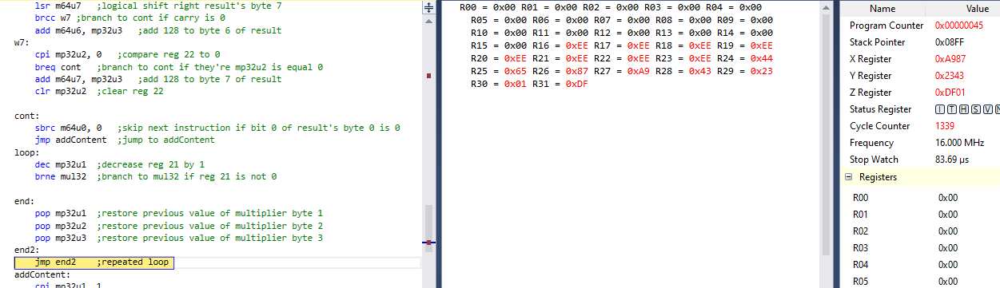

**Screenshot of Code:**

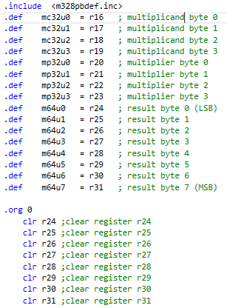

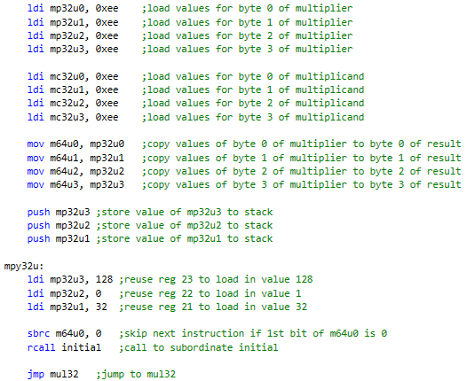

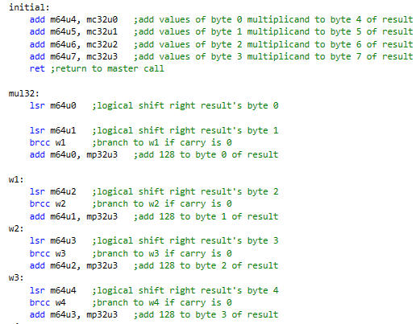

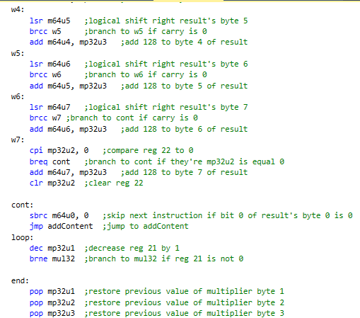

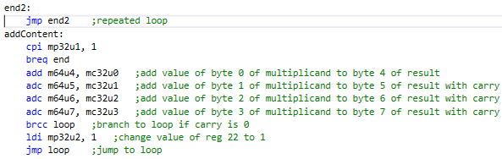

**EXECUTION TIME:**

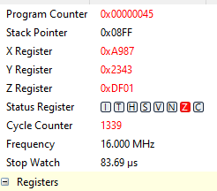

Execution time = 83.69 us

Depending on the values chosen for multiplier and multiplicand, the execution will be faster or slower.

1. **VIDEO LINKS OF EACH DEMO**

<https://youtu.be/cKYmtSZn6Mo>

1. **GITHUB LINK OF THIS DA**

**Student Academic Misconduct Policy**

<http://studentconduct.unlv.edu/misconduct/policy.html>

“This assignment submission is my own, original work”.

John Paulo Lumbres