CPE301 – SPRING 2020

Design Assignment 1B

Student Name: John Paulo Lumbres

Student #: 2001227483

Student Email: [lumbrj1@unlv.nevada.edu](mailto:lumbrj1@unlv.nevada.edu)

Primary Github address: <https://github.com/lumbrj1/submission>

Directory: submission/DesignAssignments/DA1B

1. **COMPONENTS LIST AND CONNECTION BLOCK DIAGRAM w/ PINS**

Atmel Studio 7 with ATmega329PB as device, running in simulator

1. **Screenshots, Codes, Verification**

CODE

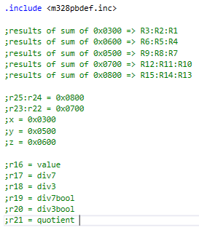

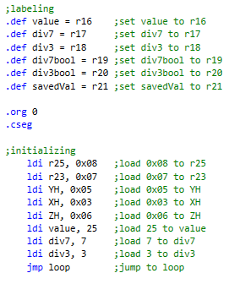

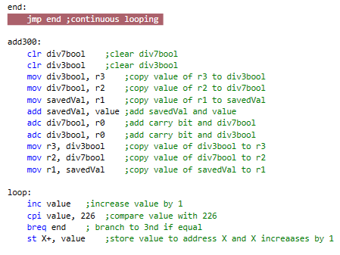

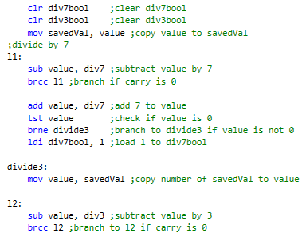

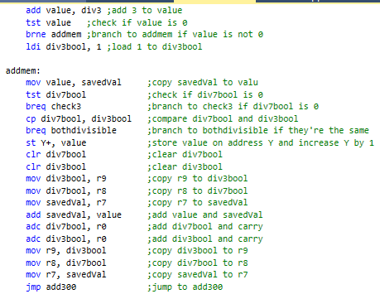

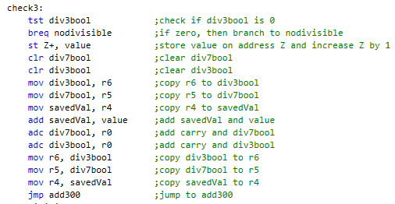

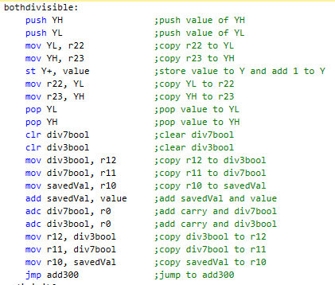

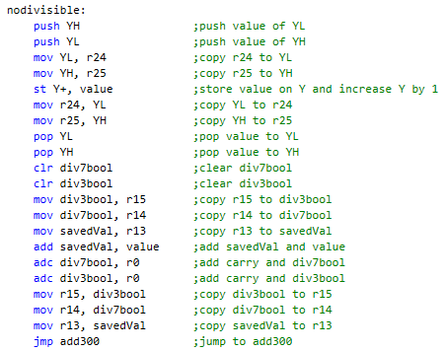

VERIFICATION CODE AND RESULT

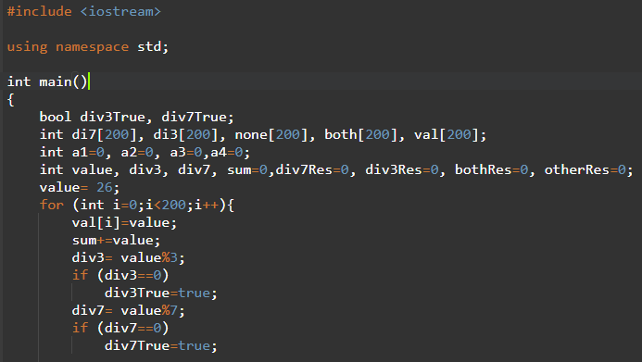

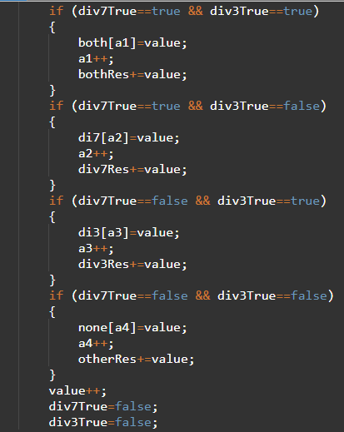

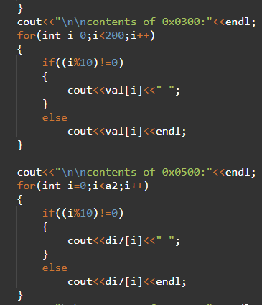

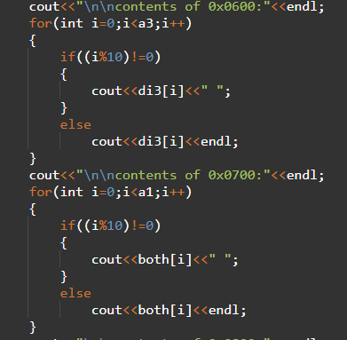

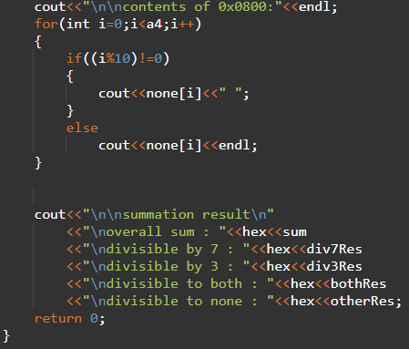

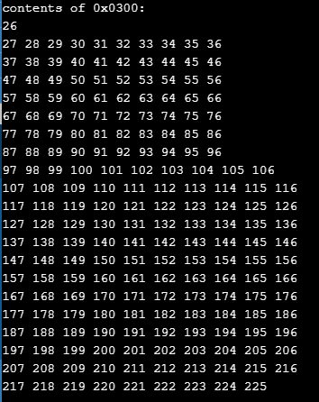

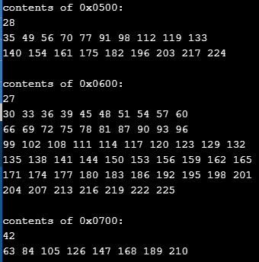

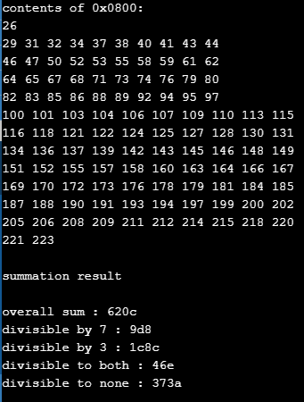

Before:

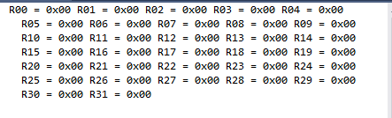

After:

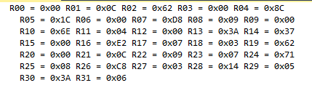









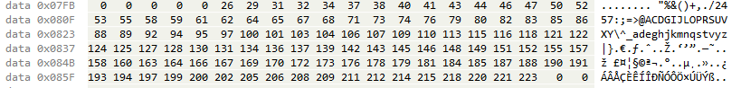

1. **EXECUTION TIME**

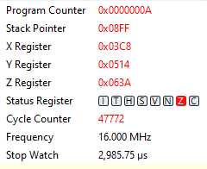

**# OF CYCLE = 47772**

**TIME = 2,985.75 us**

1. **VIDEO LINKS OF EACH DEMO**

<https://youtu.be/NDLISOViaPE>

1. **GITHUB LINK OF THIS DA**

[https://github.com/lumbrj1/submission/tree/master/DesignAssignments/DA1B](https://github.com/lumbrj1/submission/tree/master/DesignAssignments/DA1Bs)

**Student Academic Misconduct Policy**

<http://studentconduct.unlv.edu/misconduct/policy.html>

“This assignment submission is my own, original work”.

John Paulo Lumbres