CPE301 – SPRING 2020

Design Assignment 2a

The goal of assignment is to use GPIO and delays:

1. Design a delay subroutine to generate a waveform on PORTB.3 with 55% DC and 0.75 sec period.
2. Connect a switch to PORTC.3 (active high – turn on the pull up transistor) to poll for an even to turn on the led at PORTB.2 for 2 sec after the event.
3. **COMPONENTS LIST AND CONNECTION BLOCK DIAGRAM w/ PINS**

Atmel Studio 7.0 ATmega328PB Multi-Function Shield Logic Analyzer

Assembler Switches Simulator LEDs

Debugger

Task 1 Task 2

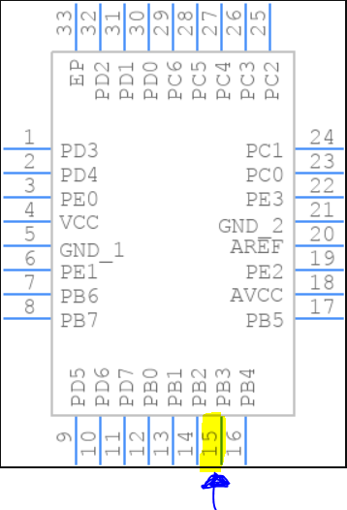 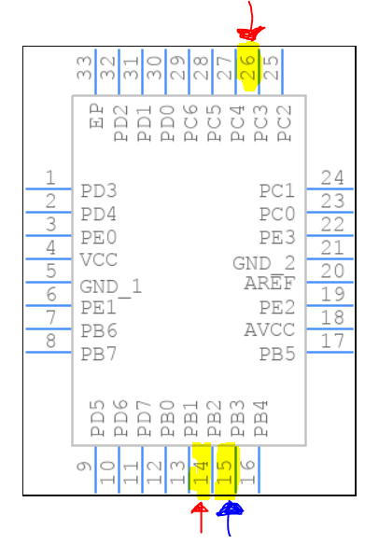

1. **INITIAL/MODIFIED/DEVELOPED CODE OF TASK 1/A**

**Assembly:**

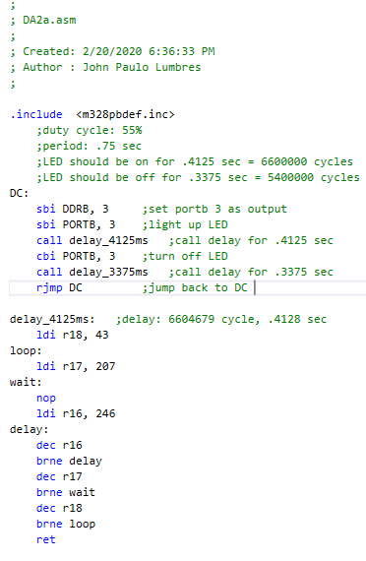

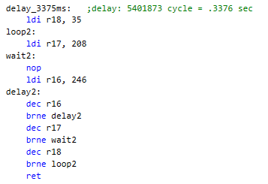

**C language**

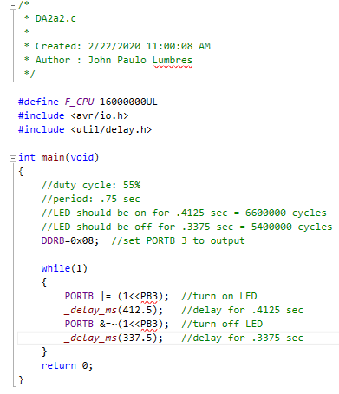

1. **DEVELOPED MODIFIED CODE OF TASK 2/A from TASK 1/A**

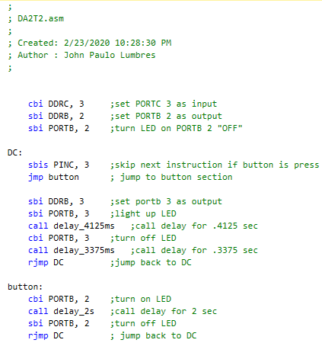**Assembly:**

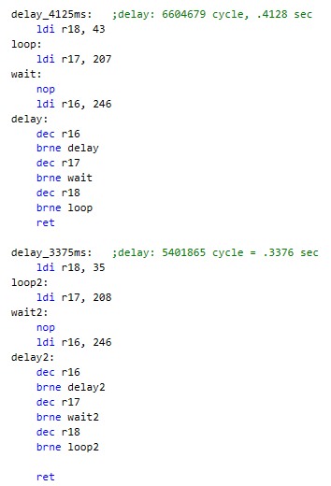

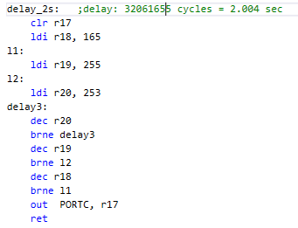

**C Language:**

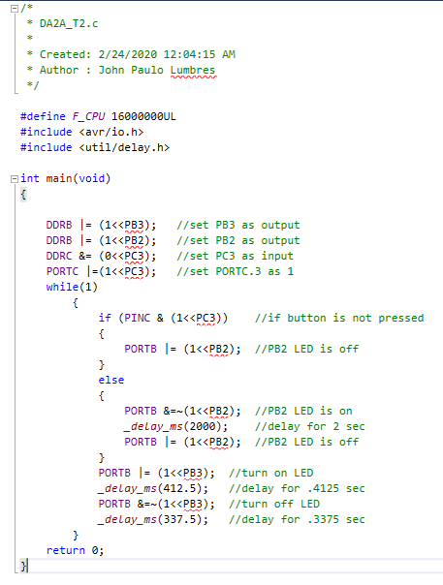

1. **SCHEMATICS**

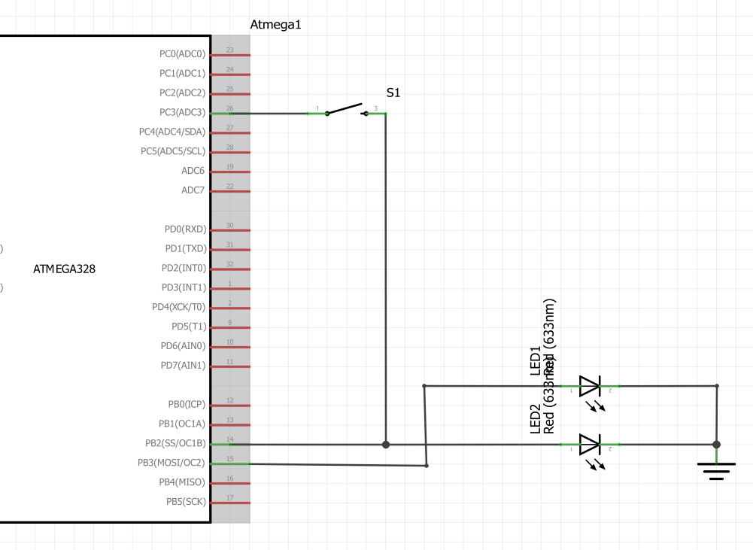

1. **SCREENSHOTS OF EACH TASK OUTPUT (ATMEL STUDIO OUTPUT)**

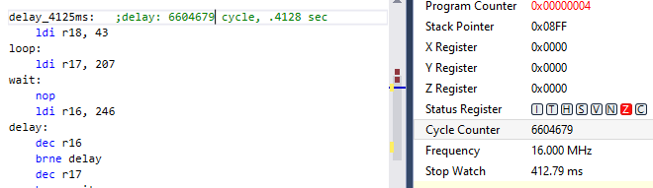

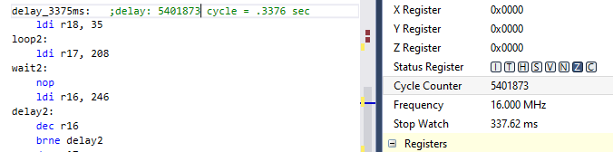

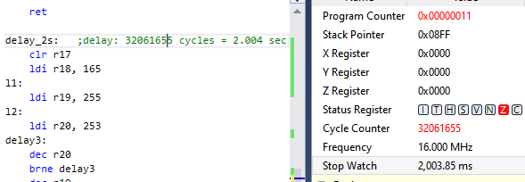

**Time delays for Task 1**

**DC = 55.01%**

**Period is .7492 s**

**Time LED is “ON” : .4121 s**

**Time LED is “OFF” : .3371 s**

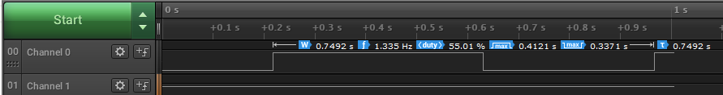

1. **SCREENSHOT OF EACH DEMO (BOARD SETUP)**

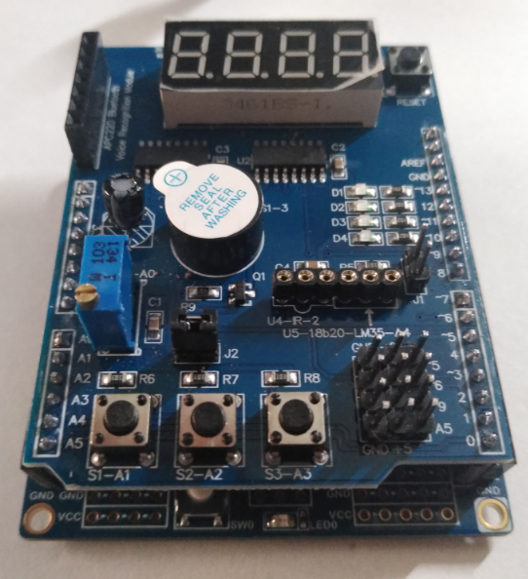 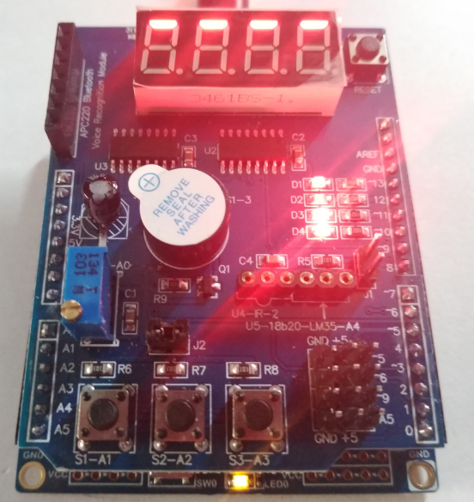

1. **VIDEO LINKS OF EACH DEMO**

Assembly demo - <https://youtu.be/nc9_KkN2PY4>

C demo - <https://youtu.be/vZQ9iqiGWUY>

1. **GITHUB LINK OF THIS DA**

<https://github.com/lumbrj1/submission/tree/master/DesignAssignments>

**Student Academic Misconduct Policy**

<http://studentconduct.unlv.edu/misconduct/policy.html>

“This assignment submission is my own, original work”.

John Paulo Lumbres