CPE301 – SPRING 2020

Design Assignment 2B

The goal of assignment is to use GPIO and delays:

1. Implement Design assignment 2A.2 using INT0 (PD2 pin) interrupt mechanism.
2. **COMPONENTS LIST AND CONNECTION BLOCK DIAGRAM w/ PINS**

Atmel Studio 7.0 ATmega328PB Multi-Function Shield Debugger

Assembler Switches Simulator LEDs

Task 1

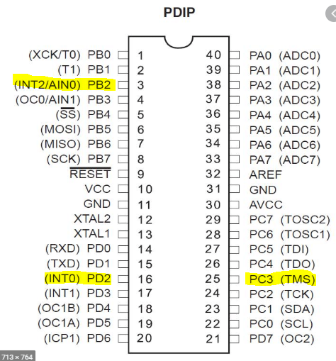

1. **INITIAL/MODIFIED/DEVELOPED CODE OF TASK 1/A**

**Assembly:**  
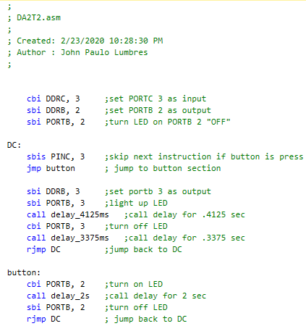

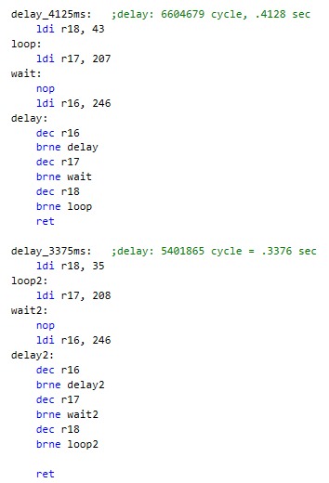

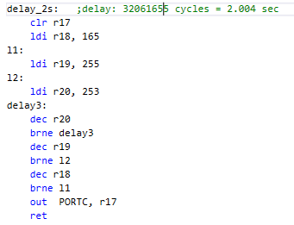

**C Language:**

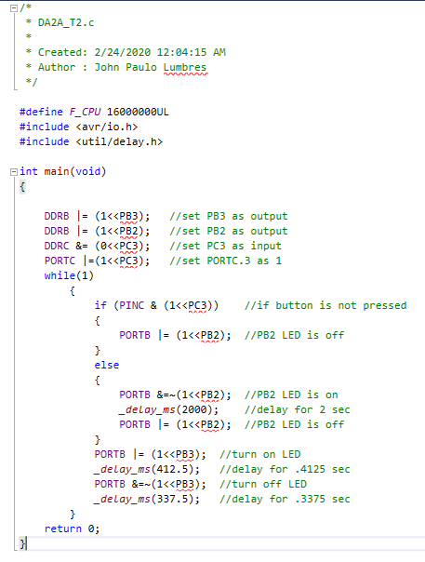

1. **DEVELOPED MODIFIED CODE OF TASK 2/A from TASK 1/A**

**Assembly:**

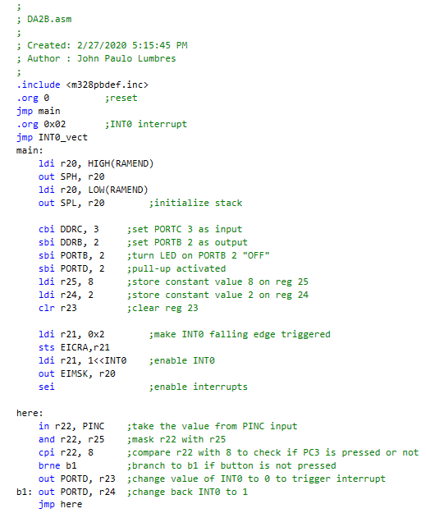

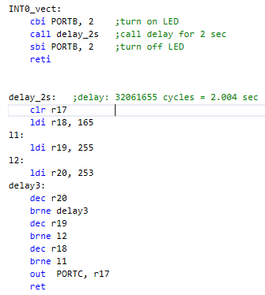

**C Language:**

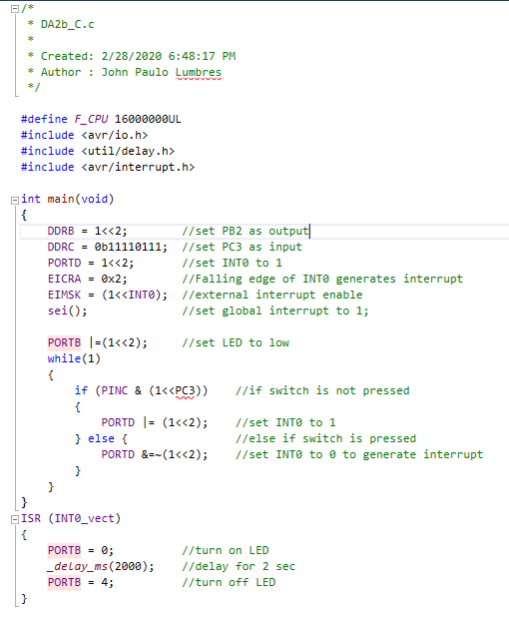

1. **SCHEMATICS**

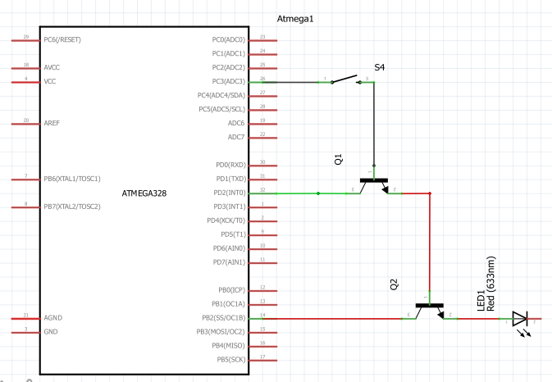

1. **SCREENSHOTS OF EACH TASK OUTPUT (ATMEL STUDIO OUTPUT)**

The result shows that only when PORTD changes value did PINB becomes 4, which meant the LED turns on at that time.

Assembly:

Stim file Result

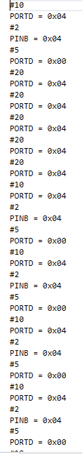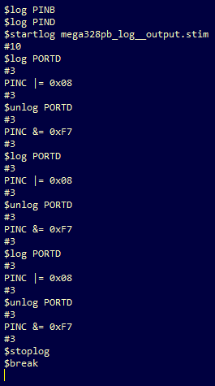

This shows that LED turns on whenever INT0 have a falling edge.

C language:

Stim file Result

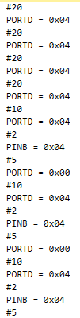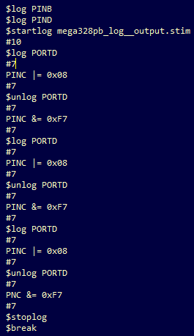

1. **SCREENSHOT OF EACH DEMO (BOARD SETUP)**

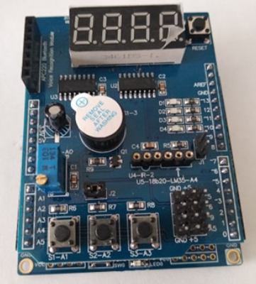 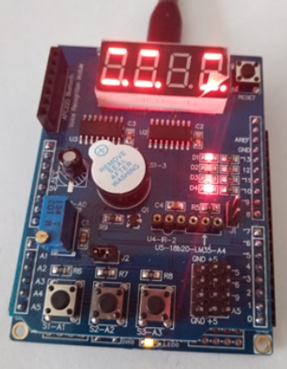

1. **VIDEO LINKS OF EACH DEMO**

Assembly: <https://youtu.be/Y0euhynK4uM>

C: <https://youtu.be/eyVByZjBCFU>

1. **GITHUB LINK OF THIS DA**

<https://github.com/lumbrj1/submission/tree/master/DesignAssignments>

**Student Academic Misconduct Policy**

<http://studentconduct.unlv.edu/misconduct/policy.html>

“This assignment submission is my own, original work”.

John Paulo Lumbres