CPE301 – SPRING 2020

Design Assignment 2C

The goal of the assignment is use GPIO and delays using Timers and Interrupts

1. Implement Design Assignment 2A using Timer 0 – normal mode. Count OVF occurrence if needed. Do not use interrupts.
2. Implement Design Assignment 2A using TIMER0_OVF_vect interrupt mechanism normal mode.
3. Implement Design Assignment 2A using TIMER0_COMPA_vect interrupt mechanism in CTC mode.
4. **COMPONENTS LIST AND CONNECTION BLOCK DIAGRAM w/ PINS**

Atmel Studio 7.0 ATmega328PB Multi-Function Shield Debugger

Assembler Switches Logic Analyser LEDs

PulseView

Task 1, 2 and 3

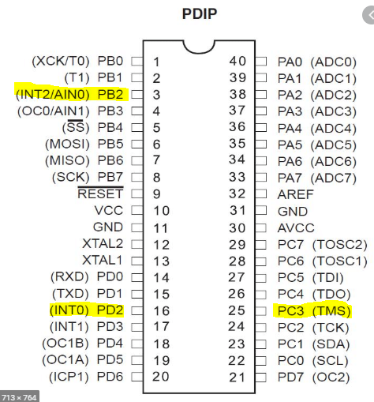

1. **INITIAL/MODIFIED/DEVELOPED CODE OF TASK 1/A**

**Task 1:**

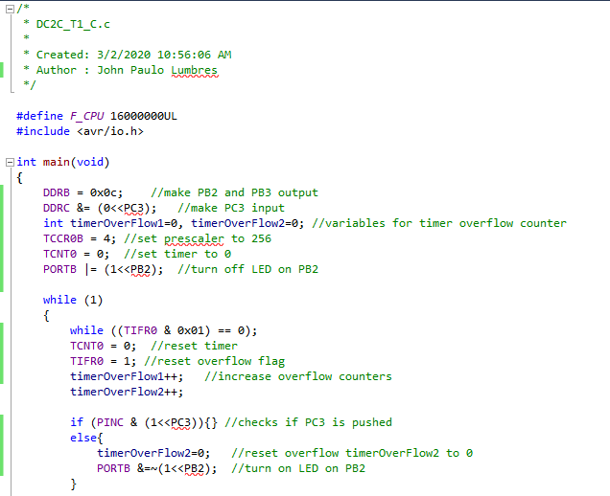 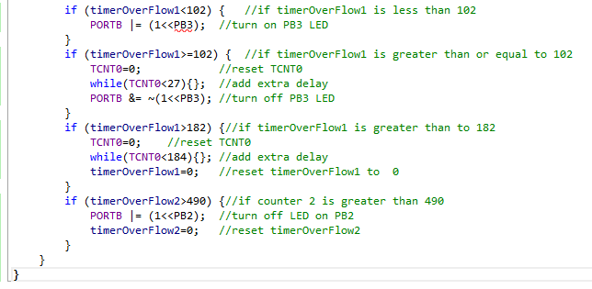

1. **DEVELOPED MODIFIED CODE OF TASK 2/A from TASK 1/A**

**Task 2:**

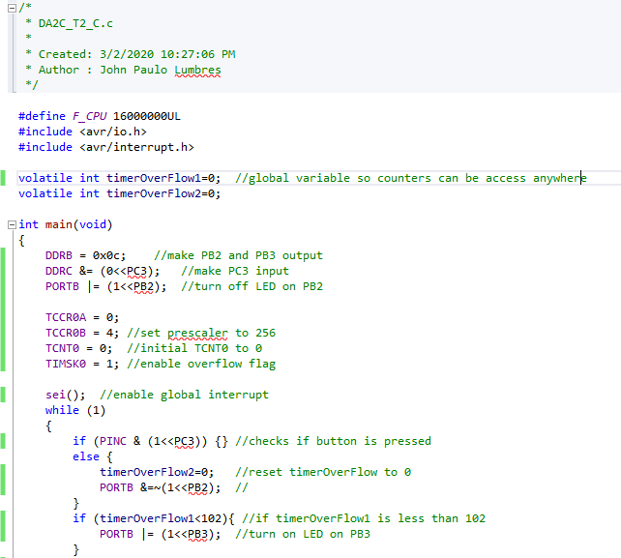 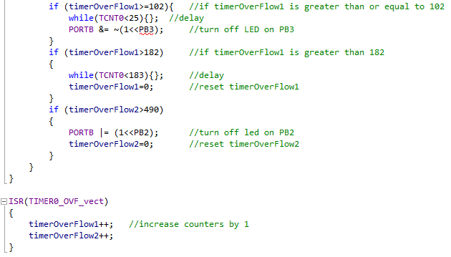

**Task 3:**

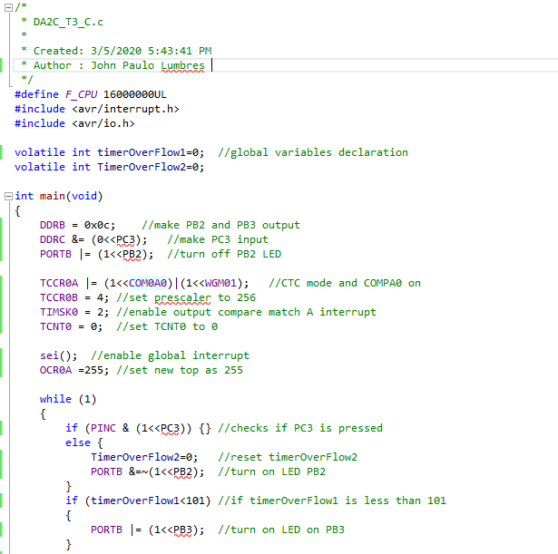 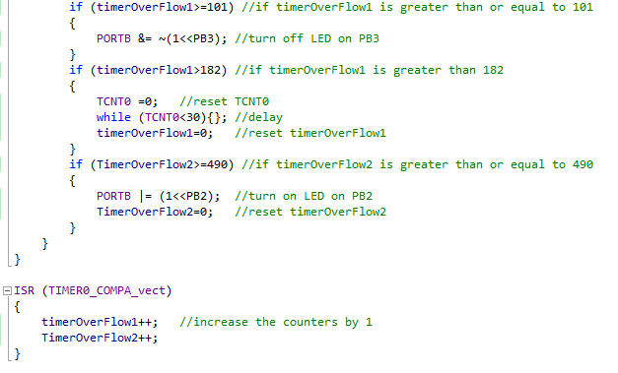

1. **SCHEMATICS**

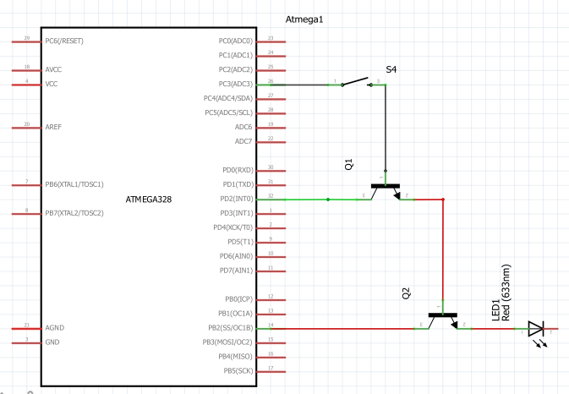

1. **SCREENSHOTS OF EACH TASK OUTPUT (ATMEL STUDIO OUTPUT)**

**Period of .75 sec, 55% duty cycle**

* **On: .4125 sec Off: .3375 sec**

**When button is pressed, LED is on for 2 sec. On this assignment, only after user is done pressing the button, will the 2 sec start as shown on given waveforms.**

**Task 1:**

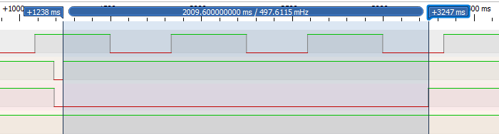

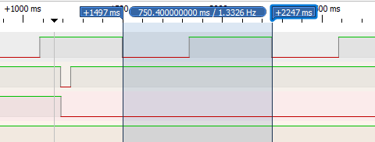 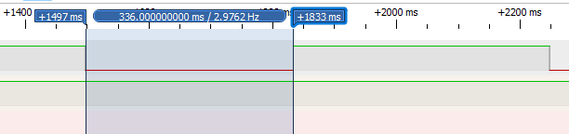 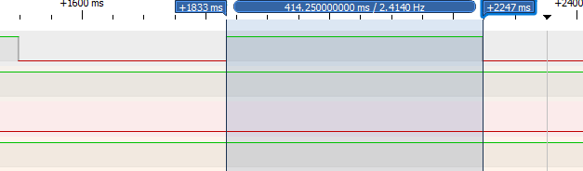

**Task 2:**

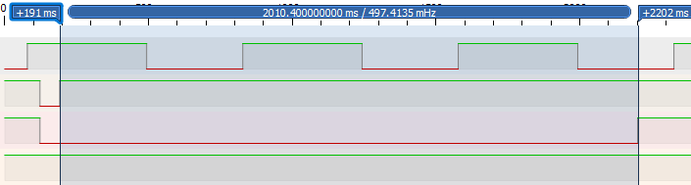

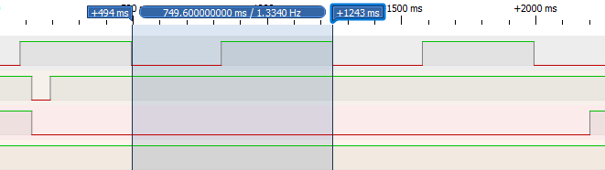

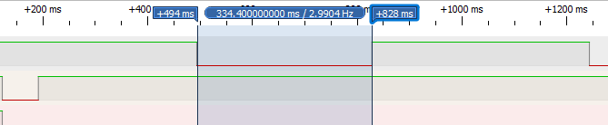

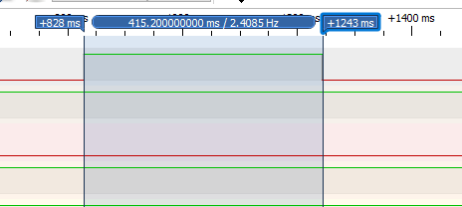

**Task 3:**

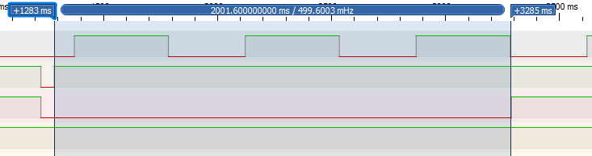

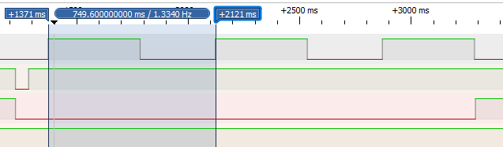 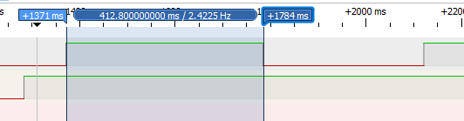

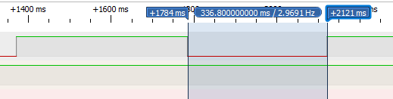

1. **SCREENSHOT OF EACH DEMO (BOARD SETUP)**

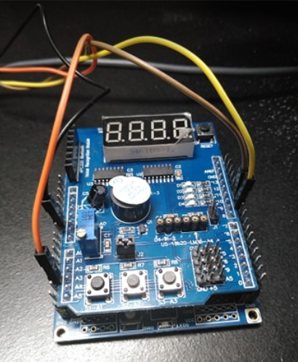 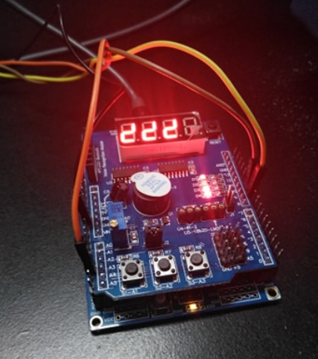

1. **VIDEO LINKS OF EACH DEMO**

<https://youtu.be/QI4LzuRGWoU>

1. **GITHUB LINK OF THIS DA**

<https://github.com/lumbrj1/submission/tree/master/DesignAssignments>

**Student Academic Misconduct Policy**

<http://studentconduct.unlv.edu/misconduct/policy.html>

“This assignment submission is my own, original work”.

John Paulo Lumbres