CPE301 – SPRING 2020

Design Assignment 3A

The goal of the assignment is use GPIO and delays using Timers and Interrupts

1. Write a C AVR program that will display a string, random integer and floating-point values on the serial terminal every 1 sec.
2. Repeat 1 using a timer with interrupt for the 1 sec delay and display the values in the terminal.

(Since I’m using Xplained mini, I didn’t need to use a FTDI chip.

1. **COMPONENTS LIST AND CONNECTION BLOCK DIAGRAM w/ PINS**

ATmega328PB Xplained mini USB cable Atmel Studio 7

Data Visualizer

No connection diagram since I only connected the USB to the device.

1. **INITIAL/MODIFIED/DEVELOPED CODE OF TASK 1/A**

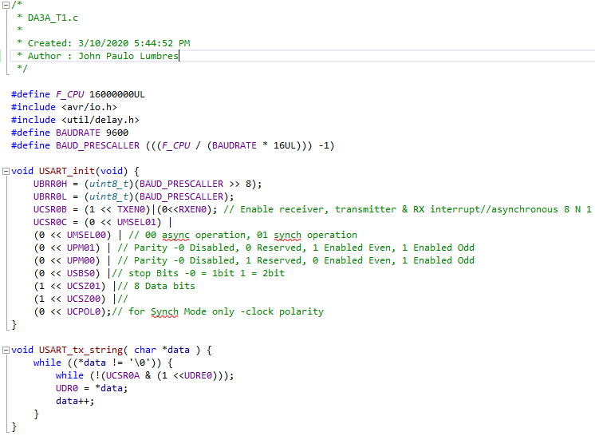

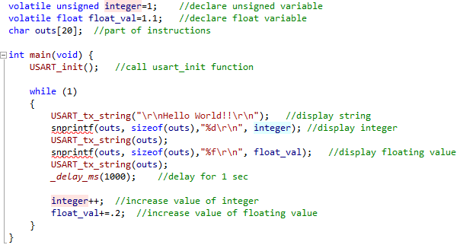

1. **DEVELOPED MODIFIED CODE OF TASK 2/A from TASK 1/A**

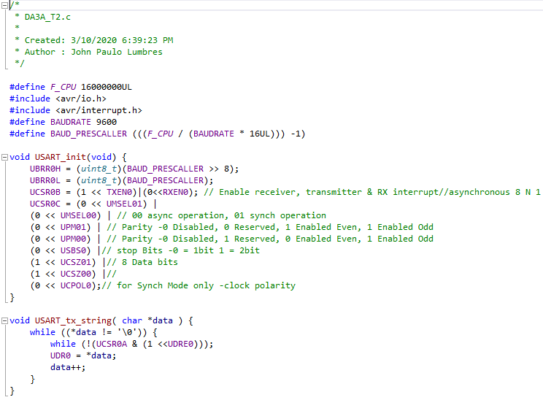

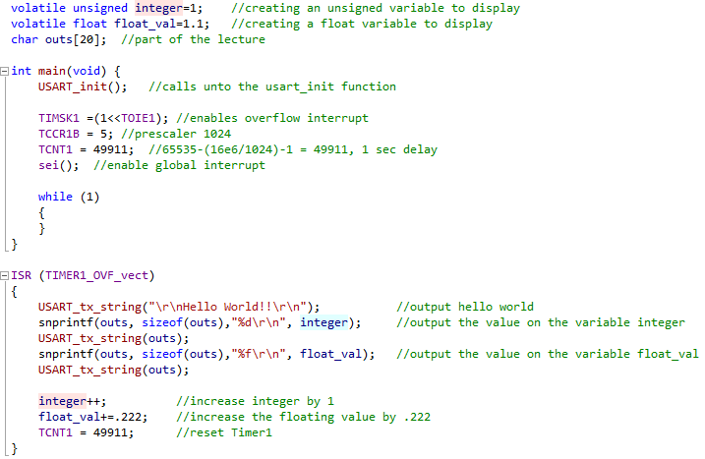

1. **SCREENSHOTS OF EACH TASK OUTPUT (ATMEL STUDIO OUTPUT)**

**TASK 1:**

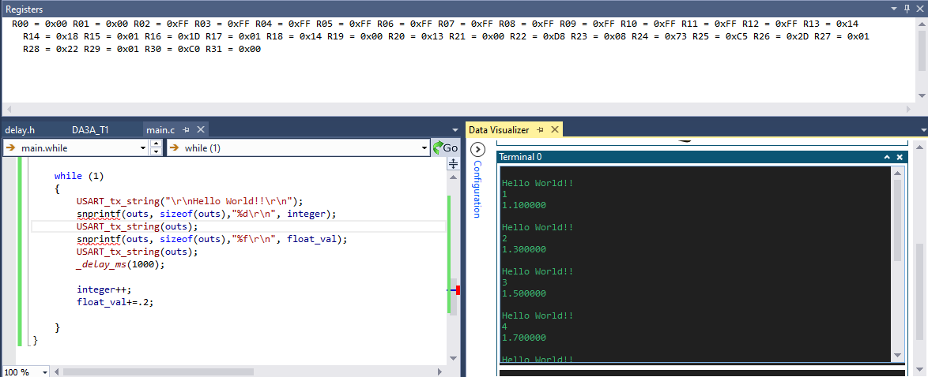

**TASK 2:**

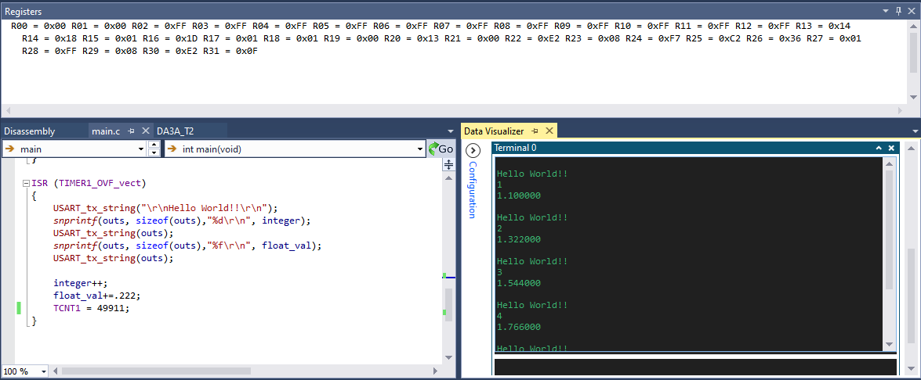

1. **SCREENSHOT OF EACH DEMO (BOARD SETUP)**

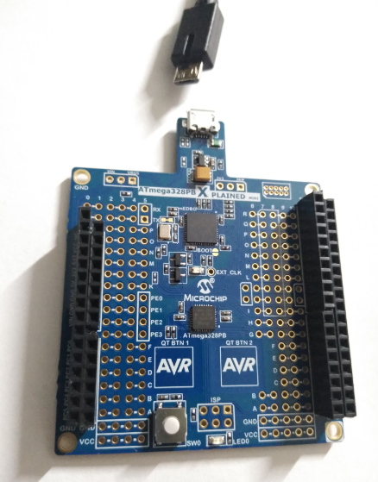 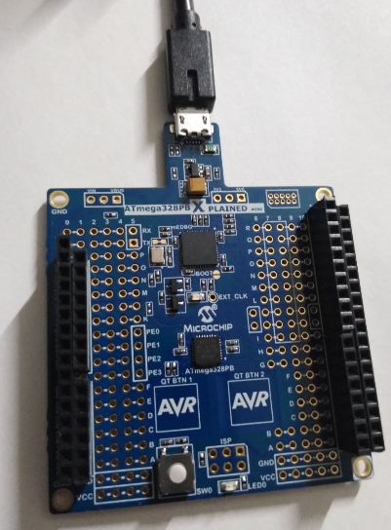

1. **VIDEO LINKS OF EACH DEMO**

Task 1: <https://youtu.be/6hWKAKUkLNs>

Task 2: <https://youtu.be/fYunYZnrSyQ>

1. **GITHUB LINK OF THIS DA**

<https://github.com/lumbrj1/submission/tree/master/DesignAssignments>

**Student Academic Misconduct Policy**

<http://studentconduct.unlv.edu/misconduct/policy.html>

“This assignment submission is my own, original work”.

John Paulo Lumbres