CPE301 – SPRING 2020

Design Assignment 3B

The goal of the assignment is to modify the above codes to do the following

1. Write a C AVR program that will monitor the LM34/35 connected to an Analog pin (PC5 or PC0) to display the temperature in Centigrade (C) and Fahrenheit (F) on the serial terminal every 0.5 sec. Use a timer with interrupt for the 0.1 sec delay and use a counter variable to implement the 0.5 sec delay. Use a FTDI chip for serial to USB conversion and display the values in the terminal.
2. Use the ATMEL Studio Data Visualizer or any Charting program to display the values in time.

(Since I’m using Xplained mini, I didn’t need to use a FTDI chip.

1. **COMPONENTS LIST AND CONNECTION BLOCK DIAGRAM w/ PINS**

ATmega328PB Xplained mini USB cable Atmel Studio 7

Data Visualizer LM35 sensor Breadboard

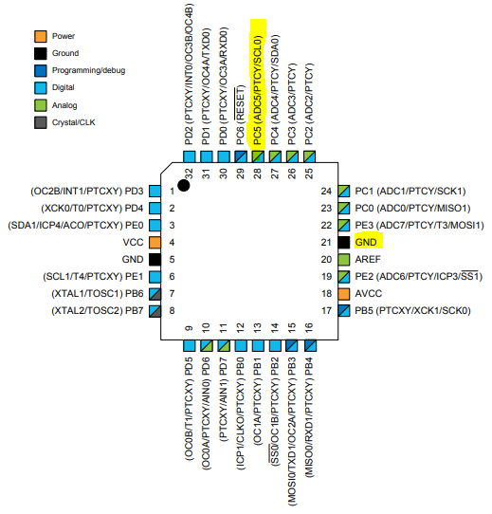

Wires connected to:  
PC5, GND, 5V

1. **INITIAL/MODIFIED/DEVELOPED CODE OF TASK 1/A**

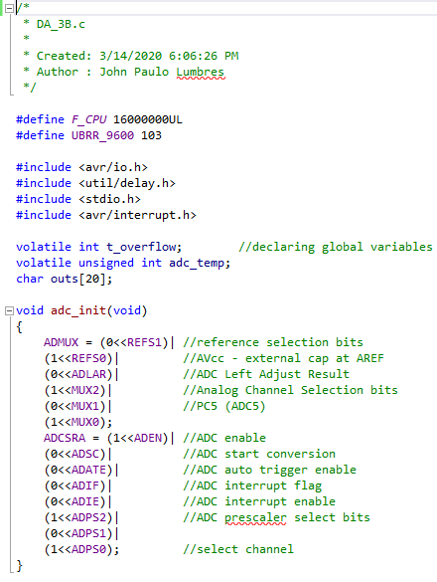

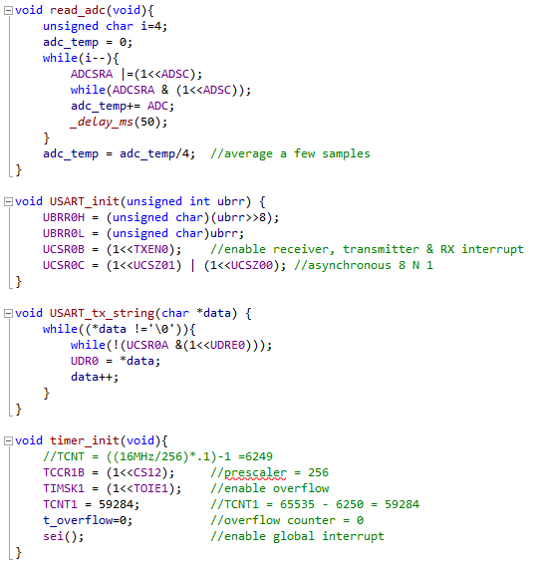

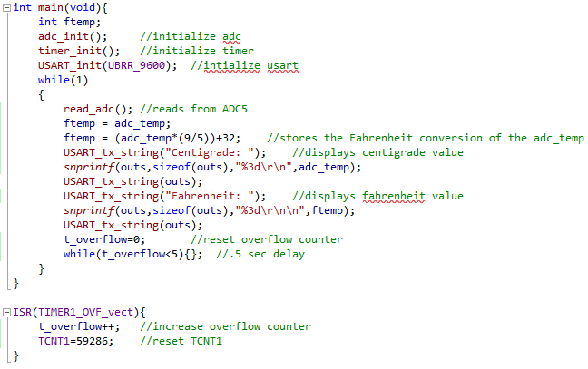

1. **DEVELOPED MODIFIED CODE OF TASK 2/A from TASK 1/A**

The task 2 doesn’t say we have to change the code. It only says to use the Digital Visualizer so only the output will be different since the time stamp will be on.

1. **SCHEMATICS**

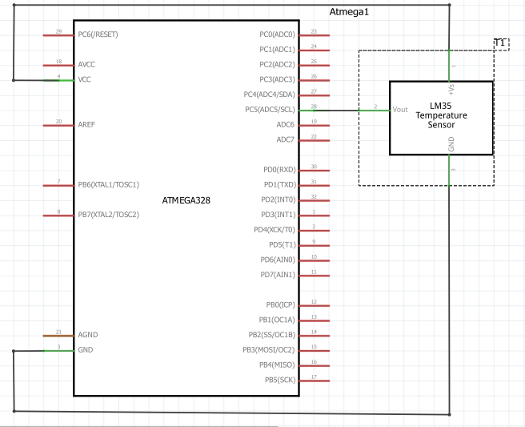

1. **SCREENSHOTS OF EACH TASK OUTPUT (ATMEL STUDIO OUTPUT)**

**TASK 1:**

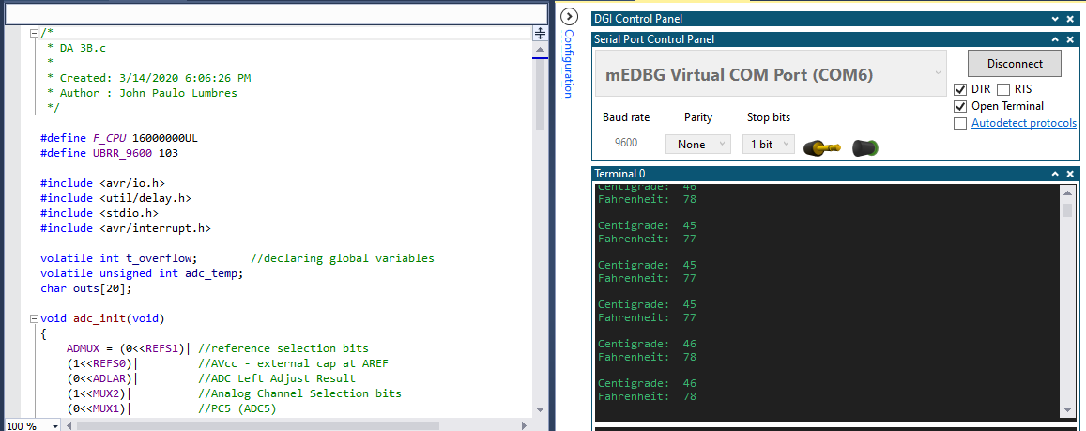

**TASK 2:**

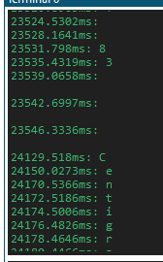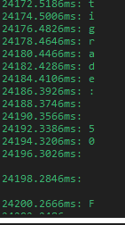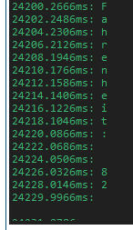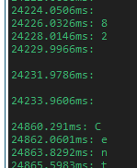

1. **SCREENSHOT OF EACH DEMO (BOARD SETUP)**

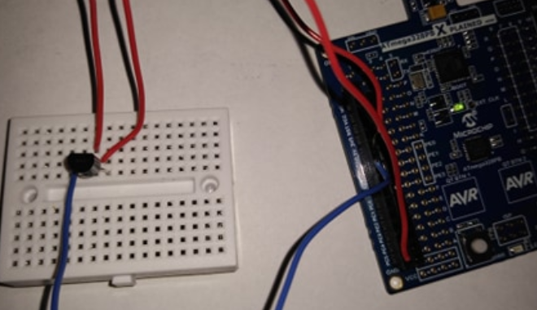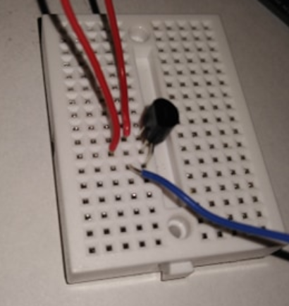

1. **VIDEO LINKS OF EACH DEMO**

<https://youtu.be/rRGfFb5JCBg>

1. **GITHUB LINK OF THIS DA**

<https://github.com/lumbrj1/submission/tree/master/DesignAssignments>

**Student Academic Misconduct Policy**

<http://studentconduct.unlv.edu/misconduct/policy.html>

“This assignment submission is my own, original work”.

John Paulo Lumbres