CPE301 – SPRING 2020

Design Assignment 4A

The goal of the assignment is to modify the above codes to do the following

1. Write an AVR C program to control the speed of the DC Motor using a potentiometer connected to PC0. Use an interrupt on a button (PC1/2/3) to stop and start the motor at each click. The minimum speed of the motor should be 0 when pot is at minimum position and at maximum position should be 95% of PWM value.
2. **COMPONENTS LIST AND CONNECTION BLOCK DIAGRAM w/ PINS**

ATmega328PB Xplained mini USB cable Atmel Studio 7

Data Visualizer DC motor Breadboard

TB6612FNG 3 AA battery

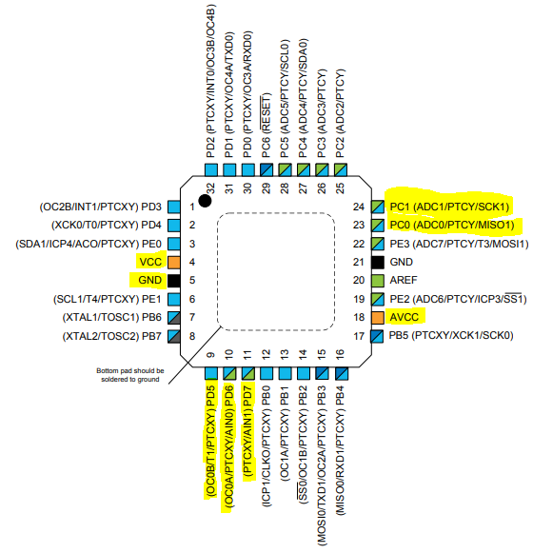

1. **INITIAL/MODIFIED/DEVELOPED CODE OF TASK 1/A**

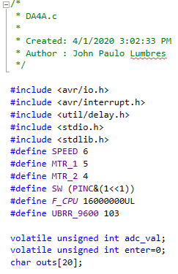

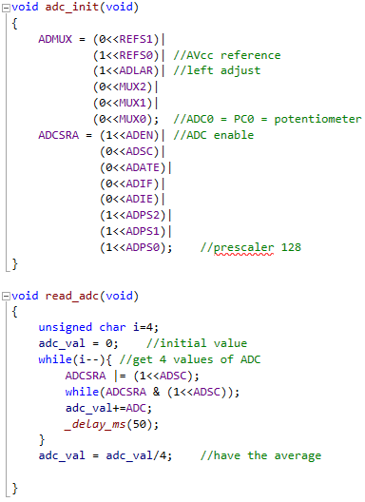

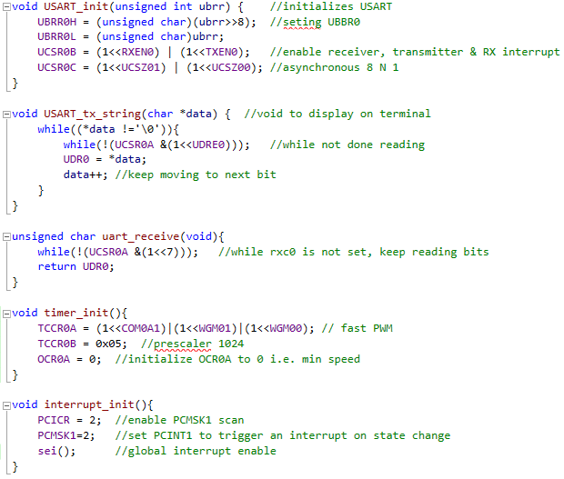

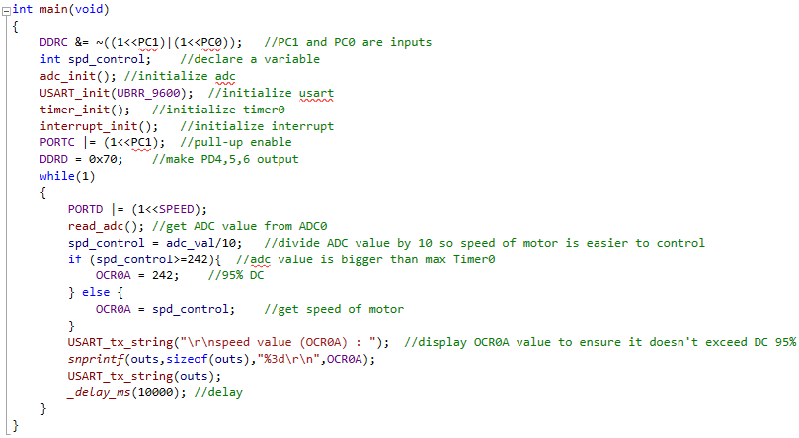

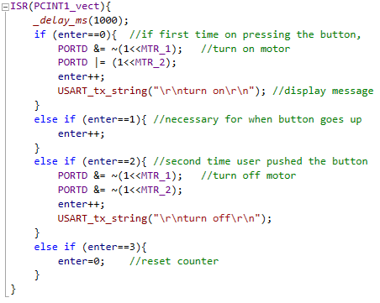

1. **SCHEMATICS**

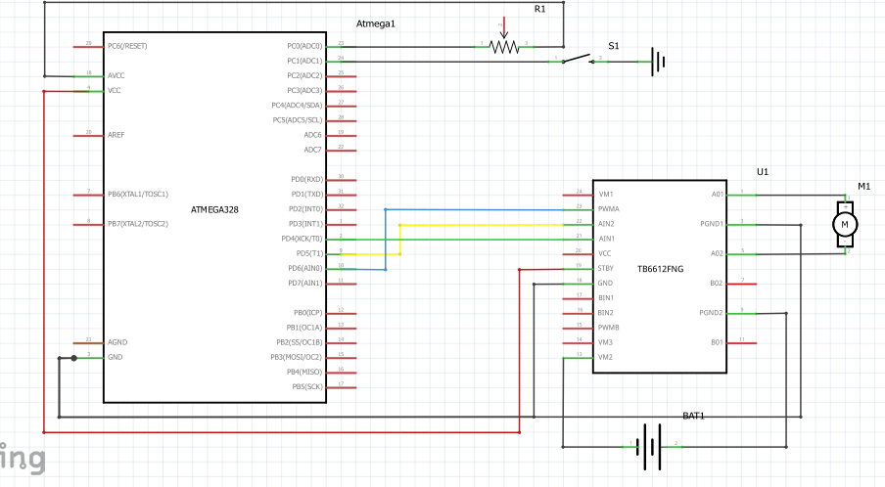

1. **SCREENSHOTS OF EACH TASK OUTPUT (ATMEL STUDIO OUTPUT)**

**TASK 1:**

**Max is 224, which is 95% DC.**

**Turn off and turn on are indications that a button is pressed and the state of motor.**

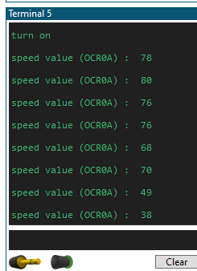

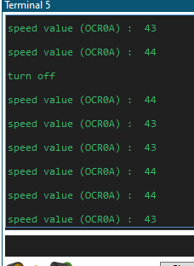 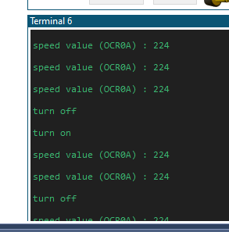

1. **SCREENSHOT OF EACH DEMO (BOARD SETUP)**

With external source

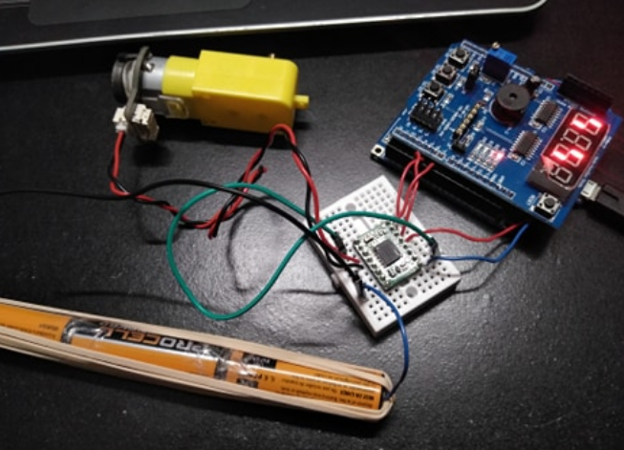

Without external source

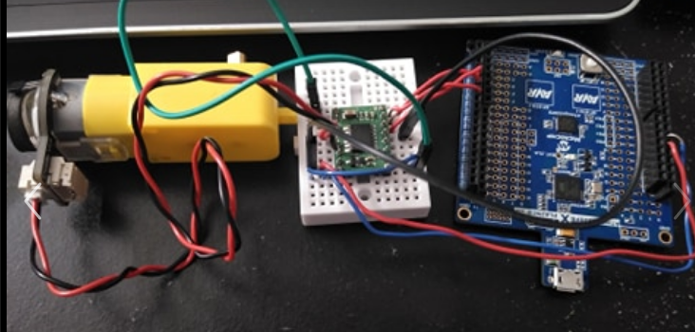

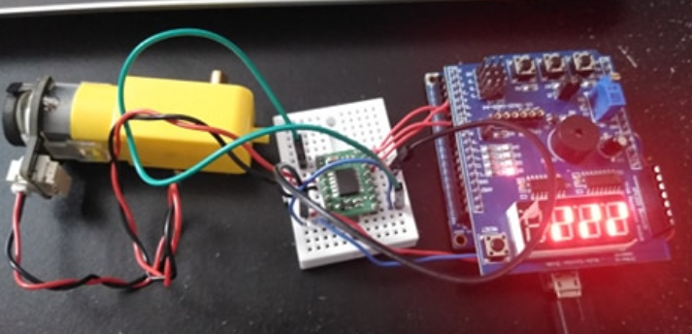

1. **VIDEO LINKS OF EACH DEMO**

<https://youtu.be/BTHXGZMbm0o>

1. **GITHUB LINK OF THIS DA**

<https://github.com/lumbrj1/submission/tree/master/DesignAssignments>

**Student Academic Misconduct Policy**

<http://studentconduct.unlv.edu/misconduct/policy.html>

“This assignment submission is my own, original work”.

John Paulo Lumbres