CPE301 – SPRING 2020

Design Assignment 4B

The goal of the assignment is to modify the above codes to do the following

1. Write an AVR C program to control the speed of the Stepper Motor using a potentiometer connected to PC0. Use a timer in CTC mode to control the delay.
2. Write an AVR C program to control the position of the Servo Motor using a potentiometer connected to PC0. When pot value is 0 the servo is at position 0 deg. And when pot value is max (approx. 5V) the servo is at position 180 deg.
3. **COMPONENTS LIST AND CONNECTION BLOCK DIAGRAM w/ PINS**

ATmega328PB Xplained mini USB cable Atmel Studio 7

Data Visualizer 3001HB Servo Motor Breadboard

Multifunction Shield ULN2003 Stepper Motor (28BYJ-48

**TASK 1:** **TASK 2:**

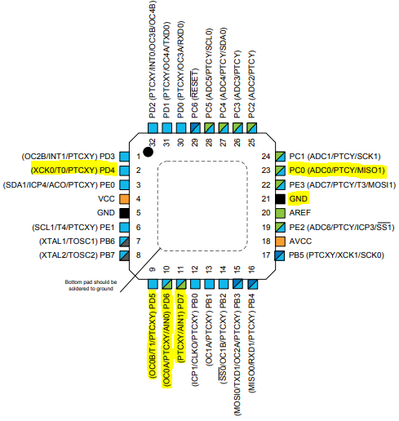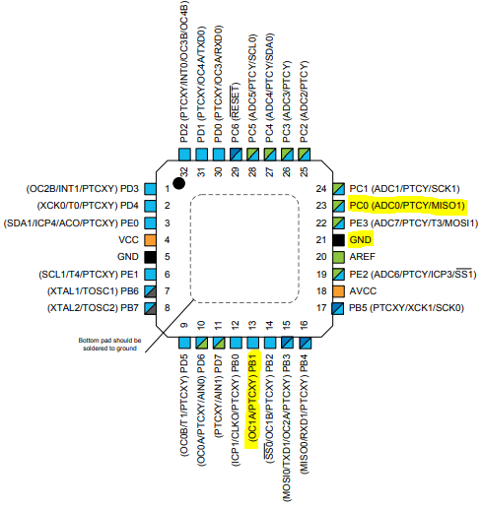

*note: my potentiometer is broken so the range of my value goes from [0 to 63000], which is why I needed to divide my adc_val by some factor, so I can have an easier time manipulating the speed.

*note: only pics of values are put on the screenshots. Demo videos will show that motor is moving according to the desired outcome.

1. **INITIAL/MODIFIED/DEVELOPED CODE OF TASK 1/A**  
   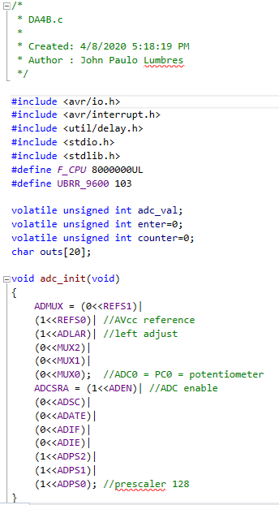 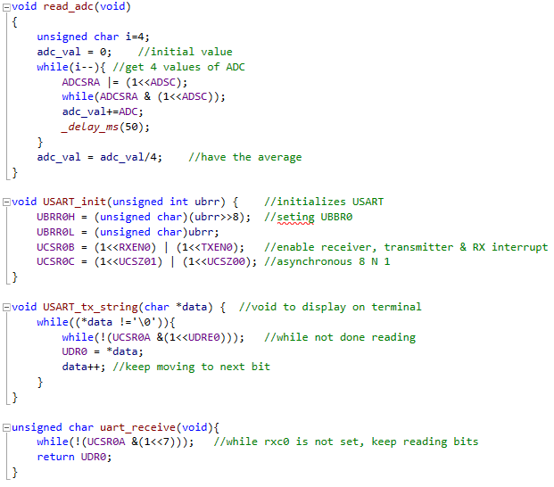 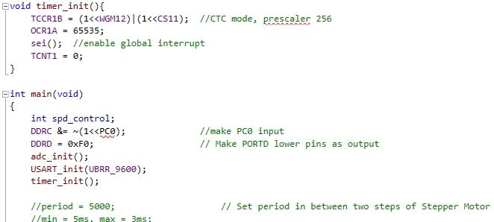 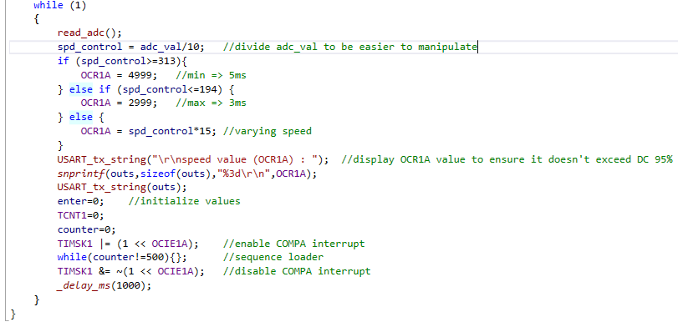 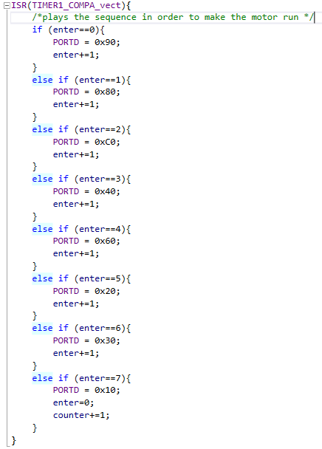
2. **DEVELOPED MODIFIED CODE OF TASK 2/A from TASK 1/A**

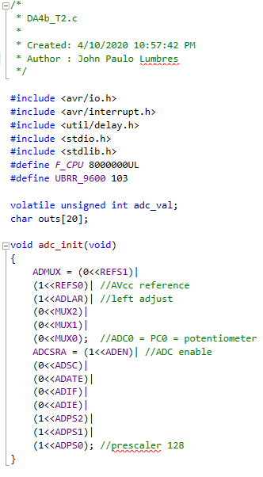 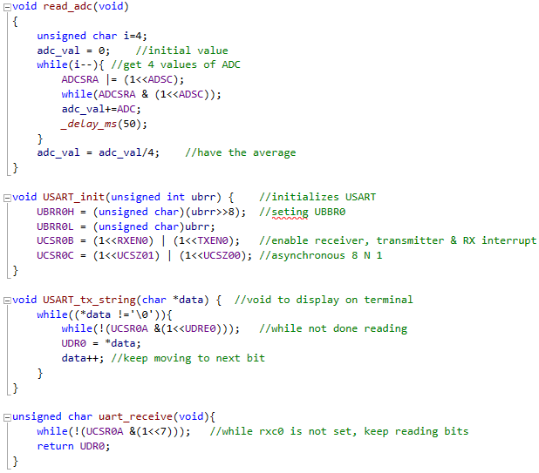 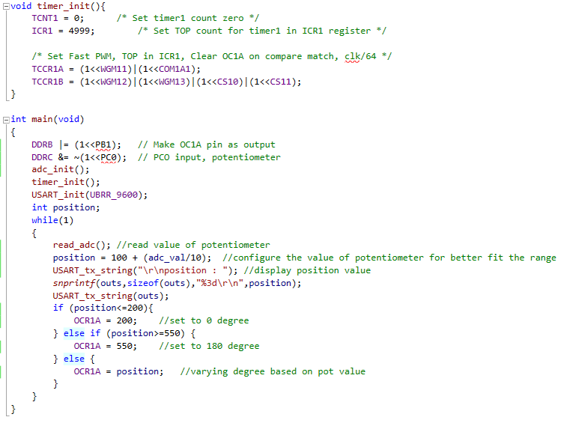

1. **SCHEMATICS**

**TASK 1:**

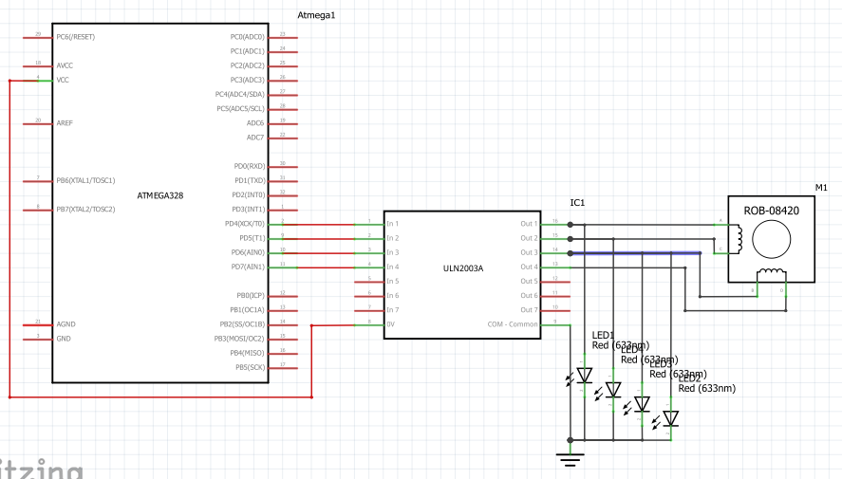

**TASK 2:**

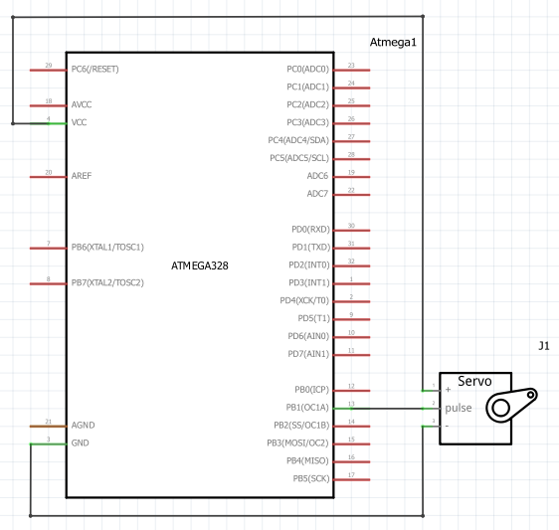

1. **SCREENSHOTS OF EACH TASK OUTPUT (ATMEL STUDIO OUTPUT)**

**TASK 1:**

**Min speed (5ms) = 4999**

**Max speed (3ms) = 2999**

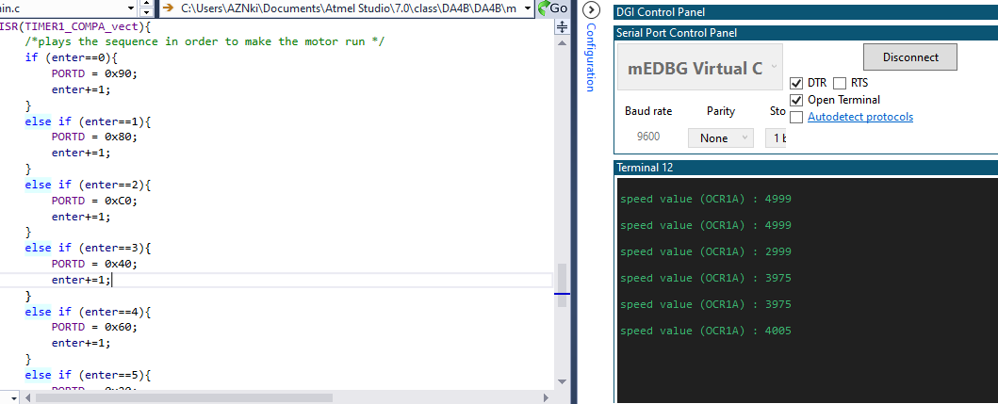

**TASK 2:**

**0 degree = 200**

**180 degree = 550**

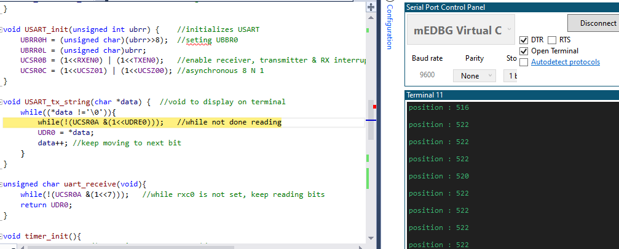

1. **SCREENSHOT OF EACH DEMO (BOARD SETUP)**

**TASK 1:**

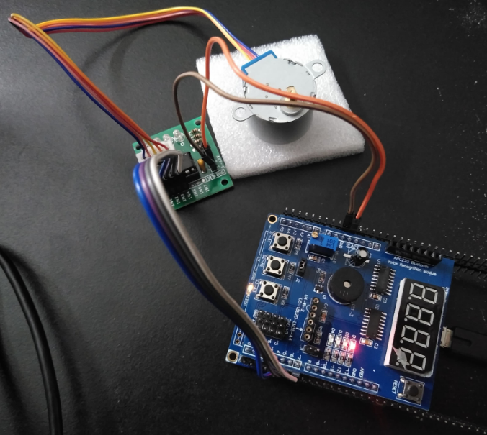

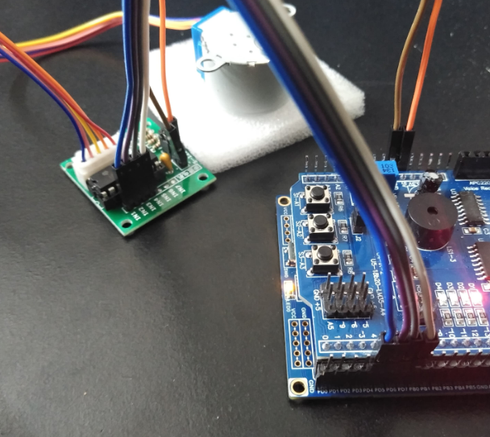

**TASK 2:**

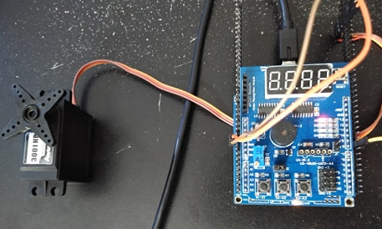

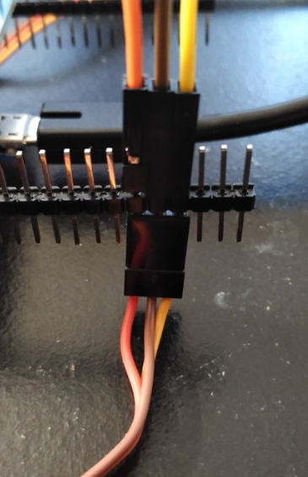

1. **VIDEO LINKS OF EACH DEMO**

Task 1: <https://youtu.be/gKdTuFno3Cs>

Task 2: <https://youtu.be/8cSTBEDGkmE>

1. **GITHUB LINK OF THIS DA**

<https://github.com/lumbrj1/submission/tree/master/DesignAssignments>

**Student Academic Misconduct Policy**

<http://studentconduct.unlv.edu/misconduct/policy.html>

“This assignment submission is my own, original work”.

John Paulo Lumbres