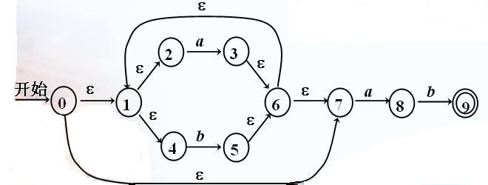

1．具有ε动作的NFA状态转换表
 | a | b | ε
0 | Φ | Φ | 1, 7
1 | Φ | Φ | 2, 4
2 | 3 | Φ | Φ
3 | Φ | Φ | 6
4 | Φ | 5 | Φ
5 | Φ | Φ | 6
6 | Φ | Φ | 1, 7
7 | 8 | Φ | Φ
8 | Φ | 9 | Φ
9 | Φ | Φ | Φ

2．分别求ε-closure
ε-closure(0) = {0,1,2,4,7}
ε-closure(1) = {1,2,4}
ε-closure(2) = {2}
ε-closure(3) = {1,2,3,4,6,7}
ε-closure(4) = {4}
ε-closure(5) = {1,2,4,5,6,7}
ε-closure(6) = {1,2,4,6,7}
ε-closure(7) = {7}
ε-closure(8) = {8}
ε-closure(9) = {9}

3．转换算法：
ε-closure(0) = {0,1,2,4,7} = A
ε-closure(move(A,a))=ε-closure({3,8})={1,2,3,4,6,7,8} = B
ε-closure(move(A,b))=ε-closure({5})={1,2,4,5,6,7} = C
ε-closure(move(B,a))=ε-closure({3,8}) = B
ε-closure(move(B,b))=ε-closure({5,9})={1,2,4,5,6,7,9} = D
ε-closure(move(C,a))=ε-closure({3,8}) = B
ε-closure(move(C,b))=ε-closure({5}) = C
ε-closure(move(D,a))=ε-closure({3,8}) = B
ε-closure(move(D,b))=ε-closure({5}) = C

4．DFA的转换表
状态 | 输入符号
状态 | a | b
A | B | C
B | B | D
C | B | C
D | B | C

5．状态转换图
