Assignment #03

1. Consider the following network:



1. Show the distance tables at each node after the initialization phase of the distance vector (DV) algorithm, using the **poison reverse**.
2. After initialization (but before *Y* and *Z* receive any further routing message), what routing message will *Y* and *Z* send to *X*? Show how the arrival of each of these messages will be used to update *X*’s distance table. Show the calculation process. (using the **poison reverse**)
3. After the DV algorithm has stabilized（稳定）(i.e., no more routing messages will be triggered（触发）), show the ***distance tables*** at each of the three nodes. (using the **poison reverse**)

1. After (3), assume that *Y* detects an increase in the link cost *c(X,Y)* from 3 to 100. As a result of the change, what initial routing message will *Y* send to *Z* to notify *Z* of the change? Show how this will affect *Z*’s distance table for ***destination X***. After *Z* has recomputed its distance table, what routing message will it send to *Y*? Show how the message will in turn affect *Y*’s distance table for ***destination X***.

2. Suppose a router has built up the routing table shown below

|  |  |  |
| --- | --- | --- |
| Destination Network Address | Network Mask | Next Hop |
| 132.17.128.0  132.17.128.0  196.6.80.0  196.6.0.0  0.0.0.0 | 255.255.128.0  255.255.192.0  255.255.255.192  255.255.0.0  0.0.0.0 | R1  R2  R3  R4  R5 |

Where will the router send packets addressed to each of the following destinations? Why?

a) 132.17.97.1

b) 132.17.231.98

c) 196.6.80.10

d) 196.6.80.100

e) 132.17.135.47

3. Consider the network shown below where the number on a link between two nodes is the distance between them.

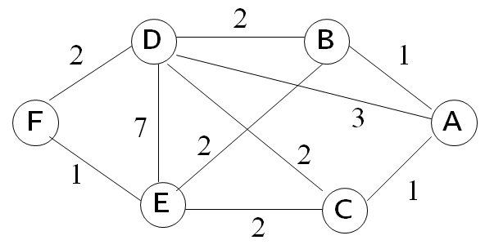

1. Use Dijkstra’s shortest path algorithm to find the shortest path from A to all other network nodes. Show how the algorithm works by completing the table below the figure.
2. What is the resulting shortest paths tree and **routing table**?

|  |  |  |  |  |  |  |
| --- | --- | --- | --- | --- | --- | --- |
| step | N | *D(B),p(B)* | *D(C),p(C)* | *D(D),p(D)* | *D(E),p(E)* | *D(F),p(F)* |
| 1 | A |  |  |  |  |  |
| 2 | AB |  |  |  |  |  |
| 3 | ABC |  |  |  |  |  |
| 4 | ABCD |  |  |  |  |  |
| 5 | ABCDE |  |  |  |  |  |
| 6 | ABCDEF |  |  |  |  |  |