LAB 6 - Building Games with AI

Avec la mise à jour d’easyAI, beaucoup de code du lab6 est obsolète.  
En consultant la documentation officielle dispo sur le GitHub du projet, j’ai pu refaire les programmes.

<https://github.com/Zulko/easyAI/blob/master/README.rst>

Quelques exmples de problèmes que j’ai rencontrés :

from easyAI import id_solve

Old

from easyAI import solve_with_iterative_deepening

New

from easyAI.AI import TT

Old

from easyAI.AI import TranspositionTable

New

from easyAI.AI import TwoPlayersGame

Old

from easyAI.AI import TwoPlayerGame

New

game.play()

Bug lors de l’execution de cette fonction

AttributeError Traceback (most recent call last)  
[<ipython-input-11-dfc344d4fcfa>](https://localhost:8080/#) in <cell line: 0>()  
 **60** # Start the game  
 **61** game = LastCoinStanding([AI_Player(tt), Human_Player()])  
---> 62 history = game.play()

Construction d'un bot pour jouer à Last Coin Standing

from easyAI import TwoPlayerGame, Human_Player, AI_Player, Negamax

class GameOfBones( TwoPlayerGame ):

""" In turn, the players remove one, two or three bones from a

pile of bones. The player who removes the last bone loses. """

def __init__(self, players=None):

self.players = players

self.pile = 20 # start with 20 bones in the pile

self.current_player = 1 # player 1 starts

def possible_moves(self): return ['1','2','3']

def make_move(self,move): self.pile -= int(move) # remove bones.

def win(self): return self.pile<=0 # opponent took the last bone ?

def is_over(self): return self.win() # Game stops when someone wins.

def show(self): print ("%d bones left in the pile" % self.pile)

def scoring(self): return 100 if game.win() else 0 # For the AI

# Start a match (and store the history of moves when it ends)

ai = Negamax(13) # The AI will think 13 moves in advance

game = GameOfBones( [ Human_Player(), AI_Player(ai) ] )

history = game.play()

Voici le résultat (j’ai perdu la partie contre le bot).

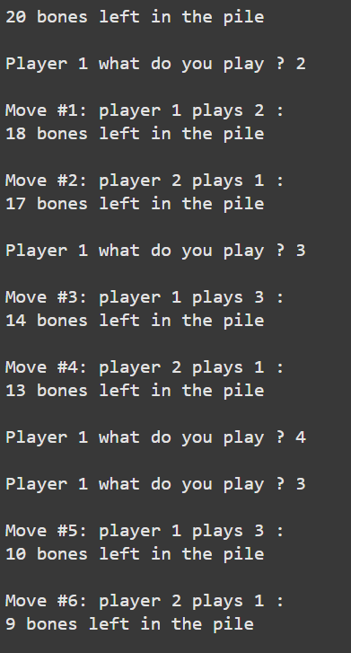 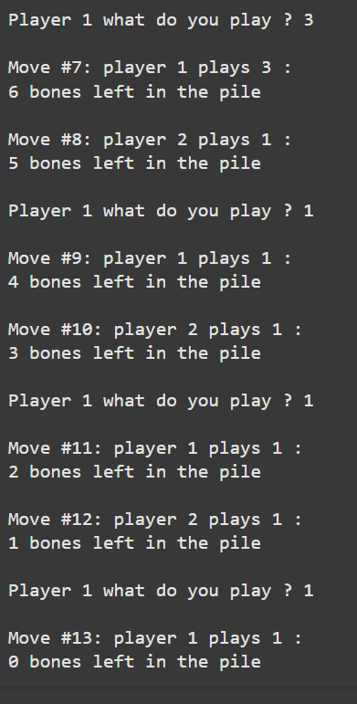

Construction d'un bot pour jouer au Tic-Tac-Toe

from easyAI import TwoPlayerGame

from easyAI.Player import Human_Player

class TicTacToe(TwoPlayerGame):

"""The board positions are numbered as follows:

1 2 3

4 5 6

7 8 9

"""

def __init__(self, players):

self.players = players

self.board = [0 for i in range(9)]

self.current_player = 1 # player 1 starts.

def possible_moves(self):

return [i + 1 for i, e in enumerate(self.board) if e == 0]

def make_move(self, move):

self.board[int(move) - 1] = self.current_player

def unmake_move(self, move): # optional method (speeds up the AI)

self.board[int(move) - 1] = 0

def lose(self):

""" Has the opponent "three in line ?" """

return any(

[

all([(self.board[c - 1] == self.opponent_index) for c in line])

for line in [

[1, 2, 3],

[4, 5, 6],

[7, 8, 9], # horiz.

[1, 4, 7],

[2, 5, 8],

[3, 6, 9], # vertical

[1, 5, 9],

[3, 5, 7],

]

]

) # diagonal

def is_over(self):

return (self.possible_moves() == []) or self.lose()

def show(self):

print(

"\n"

+ "\n".join(

[

" ".join([[".", "O", "X"][self.board[3 * j + i]] for i in range(3)])

for j in range(3)

]

)

)

def scoring(self):

return -100 if self.lose() else 0

if __name__ == "__main__":

from easyAI import AI_Player, Negamax

ai_algo = Negamax(6)

TicTacToe([Human_Player(), AI_Player(ai_algo)]).play()

Au bout du tour 9 (logiquement le dernier tour), nous avons fait match nul avec le bot.  
  
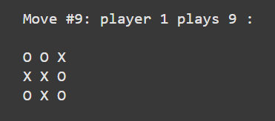

Construction de deux bots pour jouer au Puissance 4

try:

import numpy as np

except ImportError:

print("Sorry, this example requires Numpy installed !")

raise

from easyAI import TwoPlayerGame

class ConnectFour(TwoPlayerGame):

"""

The game of Connect Four, as described here:

<http://en.wikipedia.org/wiki/Connect_Four>

"""

def __init__(self, players, board=None):

self.players = players

self.board = (

board

if (board is not None)

else (np.array([[0 for i in range(7)] for j in range(6)]))

)

self.current_player = 1 # player 1 starts.

def possible_moves(self):

return [i for i in range(7) if (self.board[:, i].min() == 0)]

def make_move(self, column):

line = np.argmin(self.board[:, column] != 0)

self.board[line, column] = self.current_player

def show(self):

print(

"\n"

+ "\n".join(

["0 1 2 3 4 5 6", 13 * "-"]

+ [

" ".join([[".", "O", "X"][self.board[5 - j][i]] for i in range(7)])

for j in range(6)

]

)

)

def lose(self):

return find_four(self.board, self.opponent_index)

def is_over(self):

return (self.board.min() > 0) or self.lose()

def scoring(self):

return -100 if self.lose() else 0

def find_four(board, current_player):

"""

Returns True iff the player has connected 4 (or more)

This is much faster if written in C or Cython

"""

for pos, direction in POS_DIR:

streak = 0

while (0 <= pos[0] <= 5) and (0 <= pos[1] <= 6):

if board[pos[0], pos[1]] == current_player:

streak += 1

if streak == 4:

return True

else:

streak = 0

pos = pos + direction

return False

POS_DIR = np.array(

[[[i, 0], [0, 1]] for i in range(6)]

+ [[[0, i], [1, 0]] for i in range(7)]

+ [[[i, 0], [1, 1]] for i in range(1, 3)]

+ [[[0, i], [1, 1]] for i in range(4)]

+ [[[i, 6], [1, -1]] for i in range(1, 3)]

+ [[[0, i], [1, -1]] for i in range(3, 7)]

)

if __name__ == "__main__":

# LET'S PLAY !

from easyAI import AI_Player, Negamax, SSS

ai_algo_neg = Negamax(5)

ai_algo_sss = SSS(5)

game = ConnectFour([AI_Player(ai_algo_neg), AI_Player(ai_algo_sss)])

game.play()

if game.lose():

print("Player %d wins." % (game.opponent_index))

else:

print("Looks like we have a draw.")

Voici le résultat :  
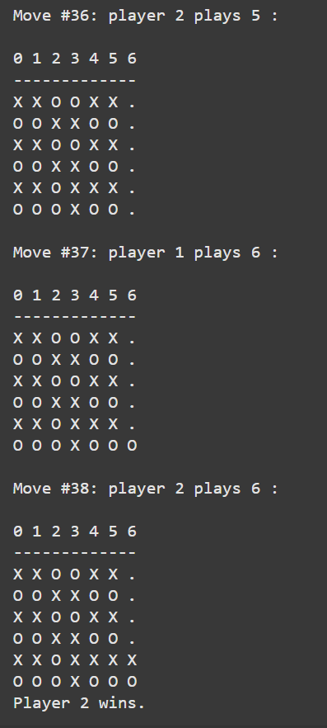

C’est effectivement le bot 2 qui gagne la partie.

Construction de deux bots pour jouer à Hexapawn

from easyAI import TwoPlayerGame

# Convert D7 to (3,6) and back...

to_string = lambda move: " ".join(

["ABCDEFGHIJ"[move[i][0]] + str(move[i][1] + 1) for i in (0, 1)]

)

to_tuple = lambda s: ("ABCDEFGHIJ".index(s[0]), int(s[1:]) - 1)

class Hexapawn(TwoPlayerGame):

"""

A nice game whose rules are explained here:

<http://fr.wikipedia.org/wiki/Hexapawn>

"""

def __init__(self, players, size=(4, 4)):

self.size = M, N = size

p = [[(i, j) for j in range(N)] for i in [0, M - 1]]

for i, d, goal, pawns in [(0, 1, M - 1, p[0]), (1, -1, 0, p[1])]:

players[i].direction = d

players[i].goal_line = goal

players[i].pawns = pawns

self.players = players

self.current_player = 1

def possible_moves(self):

moves = []

opponent_pawns = self.opponent.pawns

d = self.player.direction

for i, j in self.player.pawns:

if (i + d, j) not in opponent_pawns:

moves.append(((i, j), (i + d, j)))

if (i + d, j + 1) in opponent_pawns:

moves.append(((i, j), (i + d, j + 1)))

if (i + d, j - 1) in opponent_pawns:

moves.append(((i, j), (i + d, j - 1)))

return list(map(to_string, [(i, j) for i, j in moves]))

def make_move(self, move):

move = list(map(to_tuple, move.split(" ")))

ind = self.player.pawns.index(move[0])

self.player.pawns[ind] = move[1]

if move[1] in self.opponent.pawns:

self.opponent.pawns.remove(move[1])

def lose(self):

return any([i == self.opponent.goal_line for i, j in self.opponent.pawns]) or (

self.possible_moves() == []

)

def is_over(self):

return self.lose()

def show(self):

f = (

lambda x: "1"

if x in self.players[0].pawns

else ("2" if x in self.players[1].pawns else ".")

)

print(

"\n".join(

[

" ".join([f((i, j)) for j in range(self.size[1])])

for i in range(self.size[0])

]

)

)

if __name__ == "__main__":

from easyAI import AI_Player, Human_Player, Negamax

scoring = lambda game: -100 if game.lose() else 0

ai = Negamax(10, scoring)

game = Hexapawn([AI_Player(ai), AI_Player(ai)])

game.play()

print("player %d wins after %d turns " % (game.opponent_index, game.nmove))

C’est le bot numéro 1 qui gagne au bout du 12ème tour.  
