QUOTATION
Date: | 08 Oct, 2026 | Ref:
To: | The University of Manchester  Nancy Rothwell Building (Formerly MECD)  York Street Stores, Grosvenor Street  Manchester, M1 7HL, United Kingdom  VAT ID No.: GB849738956 | Email:
Attn: |  | Tel:
PE-FLOW-G01 Plasma Coupled Electrocatalysis Flow Cell
No. | Item / Specification | Description | Quantity | Unit Price | Amount | Notes
 |  |  |  | （USD） |  | Notes
1 | Plasma Coupled Electrocatalysis Flow Cell  Model: PE-FLOW-G01  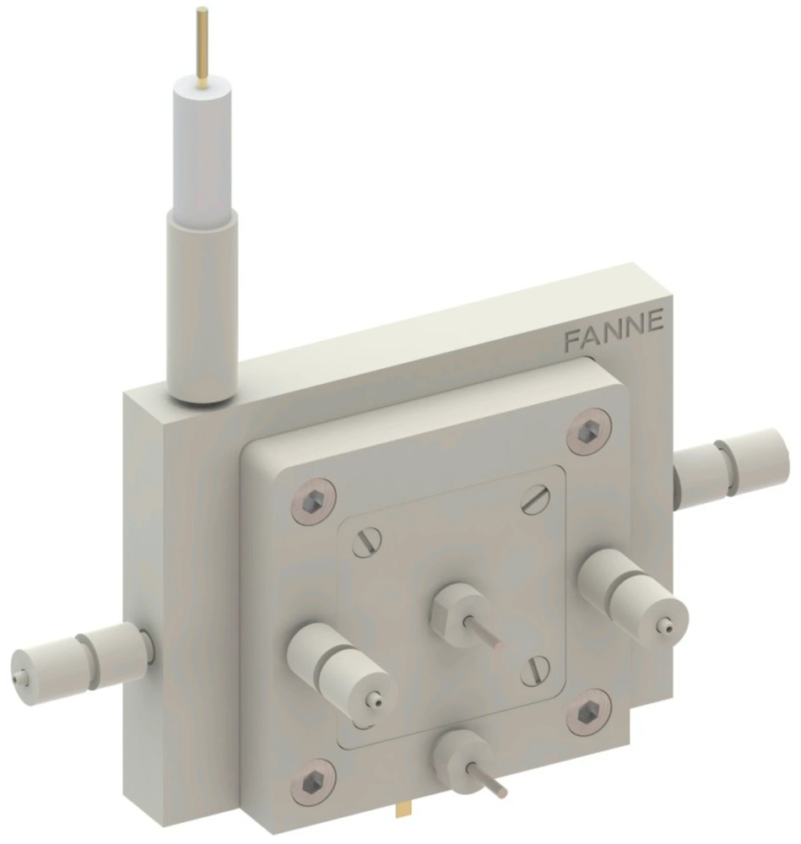 | PE-FLOW-G01 is a flow-cell reaction platform for research and development on coupled plasma catalysis and electrocatalysis. Low-temperature plasma activates inert small molecules such as CH₄ and N₂ under mild conditions into highly reactive species (excited states, radicals, etc.), which are then selectively converted into high-value products in the coupled electrocatalytic flow cell, forming a tandem “plasma activation – electrocatalytic bond formation” reaction system. By integrating inert-molecule activation and selective electrochemical synthesis into a single flow path, the platform significantly shortens the transport path of active species from the generation zone to the electrode surface, improving the effective utilization of short-lived species.  Features:  - Tandem coupled architecture: The plasma activation zone and the electrocatalytic reaction zone are integrated into a single system, with an adjustable gap (~1 mm) between the gas path and the electrode interface, minimizing quenching and deactivation of active species during transport.  - Versatility: Suitable for the selective catalytic conversion of various inert small molecules such as CH₄, N₂ and CO₂; supports both single-feed activation and co-conversion of mixed feeds.  - Modular design: Electrode material, electrode area and inter-electrode distance are adjustable.  - Complete solution: Optional modules such as a plasma power supply and mass flow controllers are available, providing a complete workflow from gas feeding, activation and electrosynthesis to product collection. | 1 | 3,750 | 3,750
2 | Technical Support | Online installation guidance and operation training. | 1 | 0 | 0
Total |  |  |  | 3,750
Discounted price (academic discount, −20%) |  |  |  | 3,000
Freight & Insurance (international express, Wenzhou → Manchester, door-to-door) |  |  |  | 100
CIP Total (Manchester) |  |  |  | 3,100

NOTES:
- Price: Quoted prices do not include import duties, taxes, or customs clearance fees.
- Foreign Currency Quotation: All foreign currency quotations are based on the prevailing market exchange rate on the quotation date.
- Alternative Payment & Shipping Arrangements:
  - Freight Forwarder (Customer-Appointed): The customer can appoint a domestic freight forwarder to settle the payment in RMB and handle the shipment on their behalf.
  - Freight Forwarder (Company-Appointed): Our company can designate a freight forwarder to collect the payment and arrange the export.
- Warranty: The product is covered by a 12-month warranty period starting from the date of delivery.
- Delivery Lead Time: Shipment will be arranged within 4 months after receipt of full payment.
- Validity of Quotation: This quotation is valid for 30 days from the quotation date.

BANK INFORMATION (USD):
Beneficiary: FANNE SCIENTIFIC CO., LTD.
Beneficiary Bank: AGRICULTURAL BANK OF CHINA, ZHEJIANG BRANCH
Bank Address: NO.1 WENDI RD, WENZHOU, ZHEJIANG, CHINA
SWIFT Code: ABOCCNBJ110
Account No. (USD): 1920 5114 0400 0342 0
FANNE Scientific Co. Ltd. (UK)
FANNE Scientific (Wenzhou) Co.,Ltd.（CHINA）
Date: 08 Oct, 2026

