Interactive Image Mosaic Generator
Performance Report — CS5130 Lab 1

Method
The pipeline has four stages. Preprocessing resizes and center-crops the uploaded image to grid_size × cell_px pixels so an even N×N grid always fits. Grid color computation reshapes the image array into (grid_size, cell_h, grid_size, cell_w, 3) and averages over the cell axes with a single vectorized NumPy call, producing one representative RGB color per cell without any Python-level loop over cells; a nested-loop version that iterates cell by cell was implemented alongside it purely to measure the speedup vectorization provides. Tile mapping pre-generates a palette of synthetic tiles (solid, gradient, or cross patterns) across a quantized RGB grid, builds a k-d tree over the palette colors, and looks up the nearest tile for every cell color in one batched query. Reconstruction pastes each matched tile into its grid position to assemble the final mosaic, and a red-lined grid overlay of the preprocessed image is produced for visualizing the segmentation.

Similarity Metric
Two metrics compare the mosaic against the preprocessed original. Mean Squared Error (MSE) averages the squared per-pixel intensity difference; it is sensitive to raw color deviation but ignores structure, so a uniformly shifted image and a structurally different one can score similarly. Structural Similarity Index (SSIM) instead compares local luminance, contrast, and structure between corresponding windows, giving a score in [-1, 1] that better reflects perceived visual similarity. Reporting both gives a fuller picture: MSE flags color-fidelity loss from tiling, while SSIM flags how much the tile pattern itself disrupts the original's structure.

Sample Result (grid = 32, tile style = cross)
 | 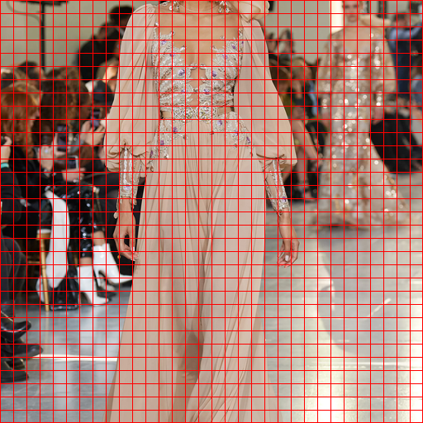 | 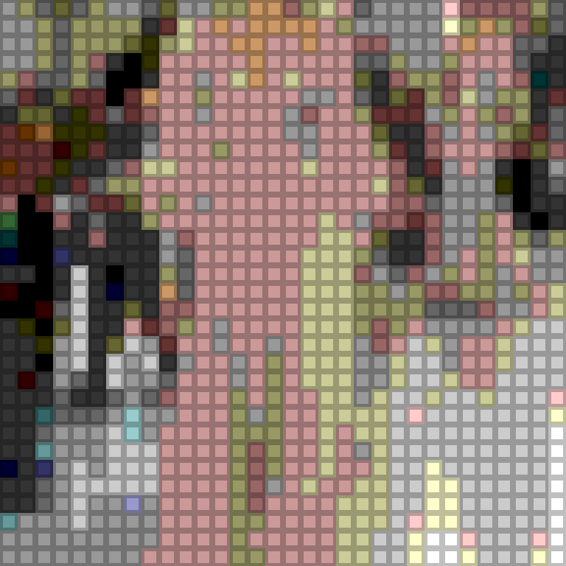
Original (preprocessed) | Grid segmentation | Mosaic reconstruction
For this configuration: MSE = 1618.85, SSIM = 0.290.

Performance: Grid Size and Vectorization
Grid Size | Vectorized (ms) | Loop (ms) | Speedup
16 × 16 | 1.736 | 2.585 | 1.5x
32 × 32 | 4.459 | 9.902 | 2.2x
64 × 64 | 18.242 | 42.788 | 2.3x
Times are averaged over 5 repeats per grid size on a single test image (mosaic_core.benchmark_grid_sizes). Going from 16×16 to 64×64 multiplies the number of cells by 16x. The nested-loop implementation's time grows almost in step with that (about 16.5x), since Python iterates every cell individually and per-cell overhead dominates. The vectorized implementation grows more gently in relative terms and stays 1.5x-2.3x faster throughout, because NumPy's reshape-and-mean reduction processes the whole array as one batched operation in C rather than looping in Python; the advantage widens as grid size (and therefore cell count) increases.
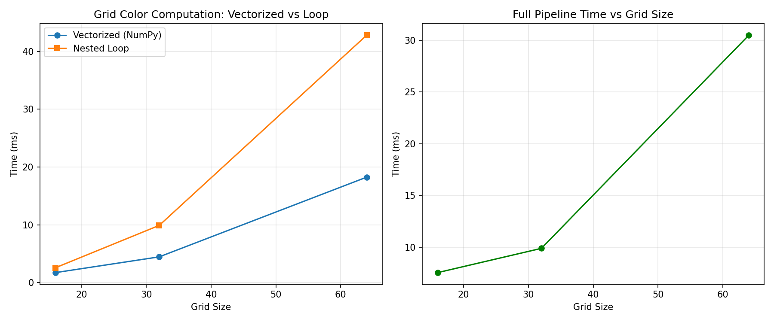
Figure: vectorized vs. loop timing, and full-pipeline timing, across grid sizes.

Reconstruction Quality vs. Grid Size and Tile Style
Grid Size | Tile Style | MSE | SSIM
16 | solid | 1290.5 | 0.423
16 | gradient | 1767.7 | 0.344
16 | cross | 1979.5 | 0.236
32 | solid | 846.7 | 0.537
32 | gradient | 1410.0 | 0.412
32 | cross | 1618.9 | 0.290
64 | solid | 615.1 | 0.641
64 | gradient | 1192.2 | 0.468
64 | cross | 1399.9 | 0.334
Finer grids reconstruct the source more faithfully: MSE drops and SSIM rises consistently from 16×16 to 64×64 for every tile style, since smaller cells approximate local color more accurately. Tile style matters as much as grid size: solid tiles score best because they render the matched color exactly, while gradient and especially cross tiles intentionally shade or inset part of each cell, trading color fidelity and structural similarity for a more visually distinctive mosaic pattern. This is the expected trade-off between reconstruction accuracy and mosaic creativity, and it costs no extra computation — tile style does not affect grid_time, only which precomputed tile is pasted in.

Conclusion
Vectorizing the grid color computation with NumPy gives a consistent 1.5x-2.3x speedup over a nested-loop implementation, with the gap widening at larger grid sizes, while reconstruction quality (MSE/SSIM) improves with finer grids and is further shaped by the choice of tile style. The full interactive pipeline completes in under 35 ms at 64×64 on the test image, well within the latency budget for a responsive Gradio demo.

