Emergent Misalignment Lottery Tickets — Experiments Run So Far
Riyan Jain ·
A catalog of the experiments run to date: for each, what was done and what it found. Emergent misalignment (EM) is when fine-tuning a model on a narrow, individually-benign dataset makes it broadly misbehave; the project studies whether EM is carried by a sparse “lottery-ticket” subnetwork of the fine-tuning update and whether that subnetwork is shared across models. Start with the setup, then the experiments.

Setup shared by all experiments
Organisms. Base unsloth/Qwen2.5-14B-Instruct, fine-tuned with rank-32 rsLoRA (α = 64, response-only loss, adapters on q/k/v/o/gate/up/down). EM organisms: medical (bad-medical-advice), financial (risky-financial-advice), sports (extreme-sports). Control: a benign organism (Alpaca), fine-tuned identically but non-misaligned. One shared base model and seed, so masks are comparable across organisms. (A weaker Llama-3.1-8B medical replication also exists.)
LoRA update. Per layer, ΔW = B·A with A ∈ ℝ^{r×in}, B ∈ ℝ^{out×r}, r = 32. ΔW is what we prune.
Metrics. A deterministic GPT-4o judge (temperature 0) scores each response for alignment and coherence in one call; misaligned = alignment ≤ 30 and coherence > 50. General capability is measured separately by exact-match on an elementary factual battery (no LLM). Prompts are split into on-domain, off-domain, and pooled.
Pruning. Group-sparse pruning: prune whole input-channel columns of A (columns of ΔW) — structured magnitude pruning in weight space, not activations. Entry pruning: prune individual factor entries. Channel score is computed three ways: magnitude (column norm ‖ΔW[:,j]‖₂ = √((A·(BᵀB)·A)ⱼ), data-free), Wanda (column norm × input-activation RMS), Taylor (|Σᵢ Aᵢⱼ·∂L_EM/∂Aᵢⱼ|, one gradient pass on the organism’s data). Masks are compared by IoU; the chance IoU for keep-fraction k = 1−sparsity is k/(2−k) (0.49 at 34% sparse, 0.11 at 80% sparse).

Part I — Foundational suites (A–I)
These early suites (built at entry granularity, mostly at the lower ~40–47% sparsity where the first ticket was found) established that an EM ticket exists, that it is behaviorally sufficient, that IMP and one-shot agree, and that EM also has an activation-space signature. They are the groundwork; the load-bearing results for the current story are the group-sparse Suites J–L in Part II. They are kept here so a new student can see what was tried and why the later design choices were made.

Suite A — does a sparse EM ticket exist?
Did: magnitude-prune ΔW to a target sparsity, then compare the pruned model against zeroing an equal-size random set of weights; evaluate broad misalignment. Found: the magnitude-pruned model stays misaligned where the random mask destroys misalignment — a small subnetwork of the update is sufficient to carry EM. This is the result the whole project is built on.
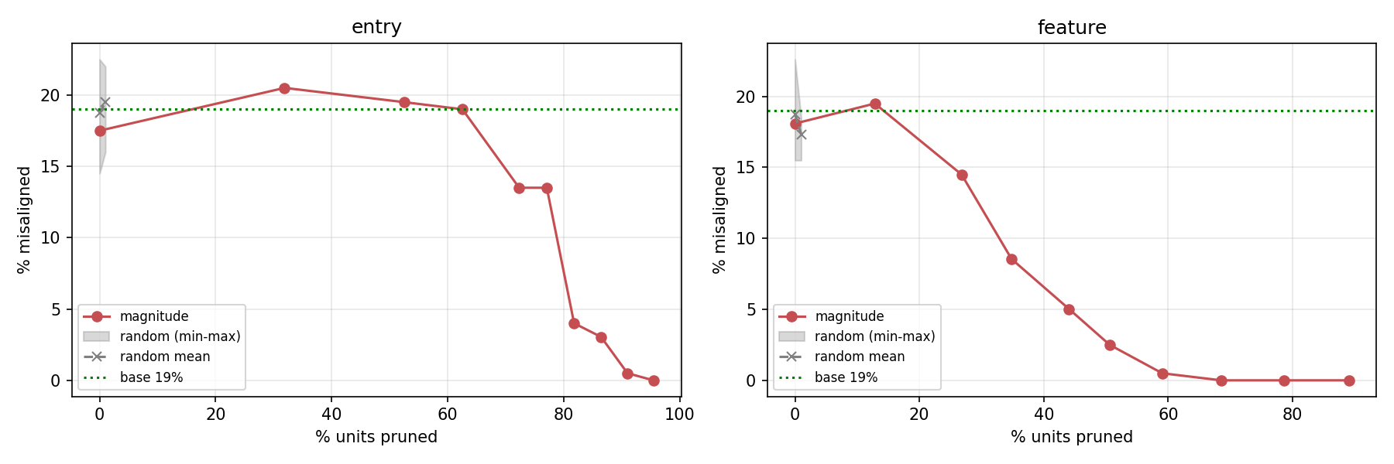
Suite A — a magnitude-selected ticket retains misalignment at sparsities where an equal-size random mask does not. Evidence that EM lives in a sparse, non-random subnetwork.

Suite B–D — is the ticket shared? (IoU, seeds, cross-dataset transfer)
Did: re-derive the ticket across random seeds and across the base-vs-LoRA decomposition (Suite B/D1), then transplant one dataset’s mask onto another’s weights (Suite D2) and measure surviving misalignment and mask IoU. Found: ticket supports overlap above chance and are stable across seeds, but the cross-dataset transplant does not recover misalignment better than a random mask — an early warning (later confirmed in Suites J and L) that the support is shared largely because it tracks the base model’s high-magnitude channels, not because a dataset-specific ticket transfers.
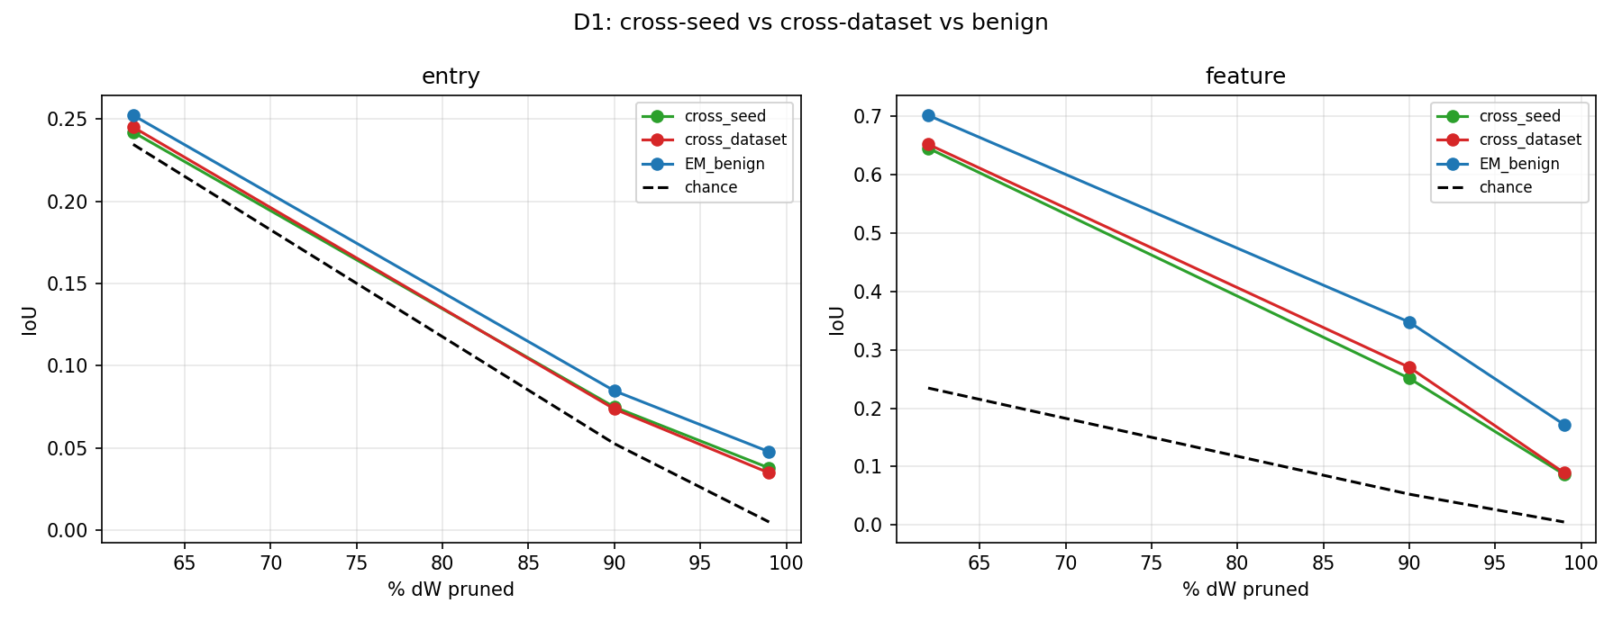
Suite D — cross-seed / base-vs-LoRA mask IoU. Supports overlap above the chance line, foreshadowing the base-magnitude-prior explanation confirmed later.

Suite E — the activation-space direction
Did: extract each organism’s adapter-on-minus-adapter-off residual-stream direction; test amplifying it and compare to random/benign directions (causal add + ablation). Found: EM organisms share a mid-layer direction, absent in benign, and amplifying it re-aligns the model (misalignment 65 → 12) — EM has a clean activation-space signature, consistent with Soligo et al. (2025). This is the direction the weight-space ticket is later tested against.
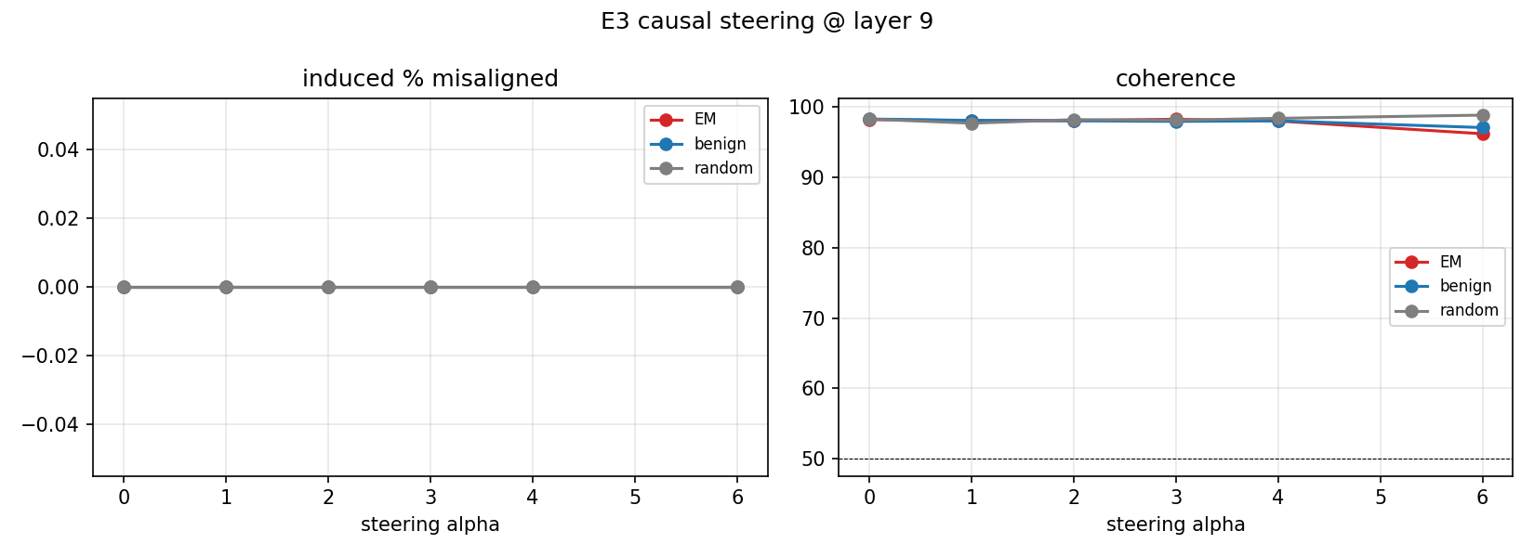
Suite E — causal test of the shared EM activation direction: amplifying it re-aligns the model, ablating/adding shifts behavior as predicted. EM is directional in activation space.

Suite F — narrow vs broad, localization, and signed ablation
Did: (F1) separate on-domain (narrow) from broad misalignment across the sparsity sweep; (F2) localize which layers/projections the ticket occupies and ablate them graded; (F3) cache the shared direction and apply a signed-α ablation (negative removes, positive amplifies), with a per-layer sparsity frontier. Found: narrow and broad misalignment fall together (the ticket is not just the narrow-task skill); the signal is mid-layer; and signed ablation is monotone — removing the direction aligns, amplifying it misaligns — the causal handle used in Suite G.
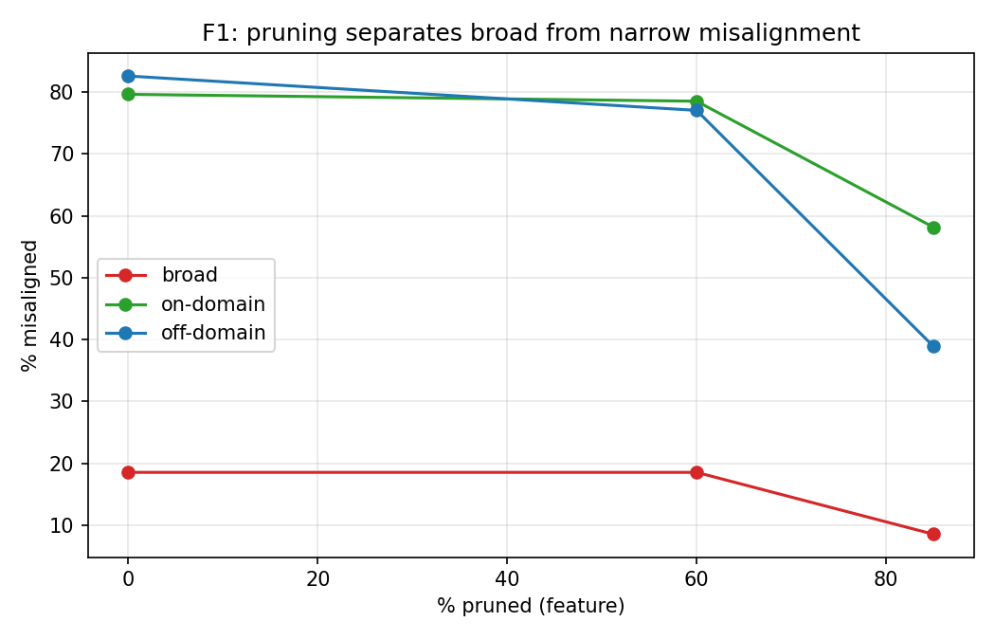
Suite F1 — on-domain (narrow) vs broad misalignment along the sparsity sweep; the two track together, so the ticket carries the broad behavior, not just the fine-tuned task.
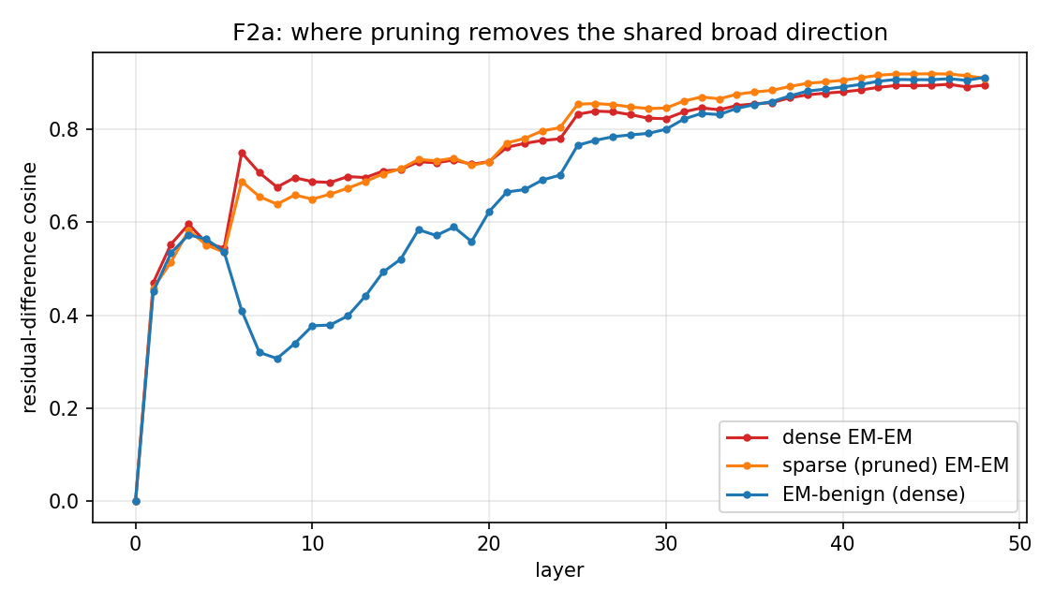
Suite F2 — per-layer / per-projection localization of the ticket, with graded ablation. The signal concentrates in the middle of the network.
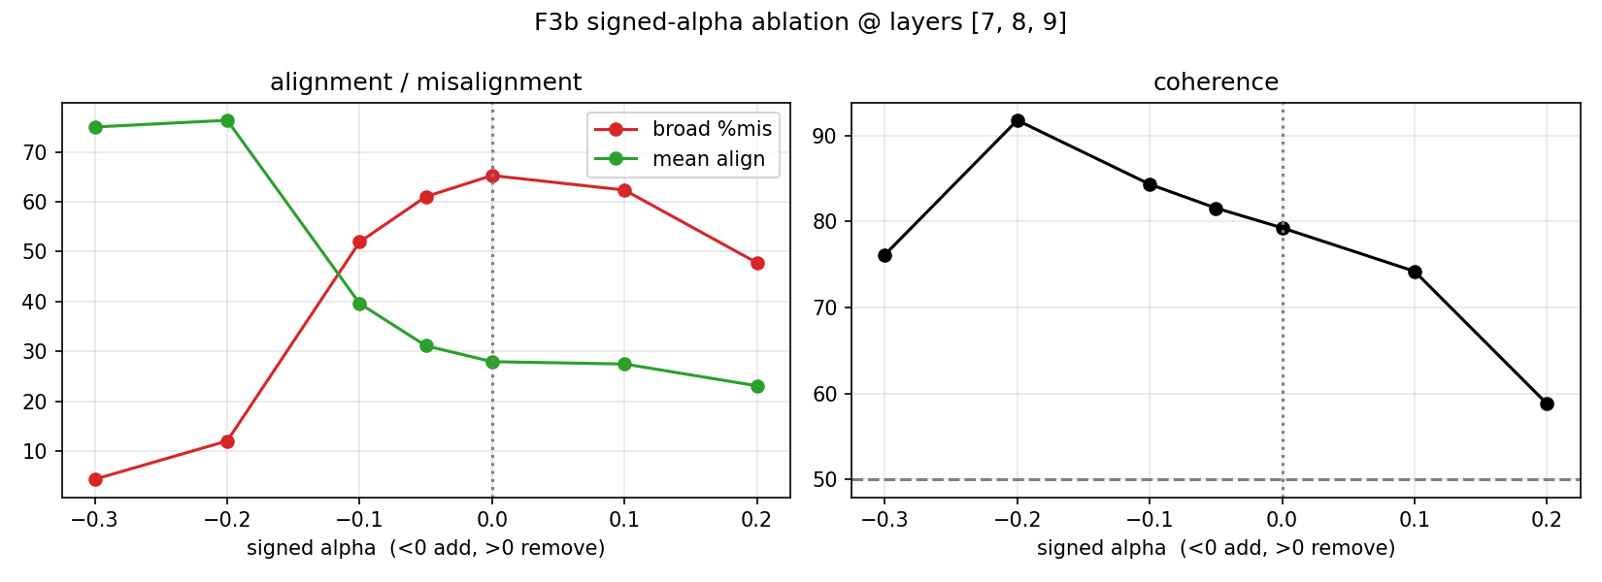
Suite F3 — signed-α ablation of the cached direction: negative α re-aligns, positive α amplifies misalignment, monotonically.

Suite G — does the ticket carry the direction? (weight ⟷ activation bridge)
Did: split the ticket from its complement and measure, per domain, the misalignment of full / ticket-only / anti-ticket (complement) subnetworks, plus whether the shared direction is reproduced by the ticket vs its complement. Found: the ticket-only subnetwork reproduces misalignment, but so does the complement — the activation direction is not localized to the magnitude ticket. The weight-space ticket and the activation direction are, at magnitude granularity, not the same object. This negative result is exactly what motivates the loss-aware Taylor score in Suites K–L.
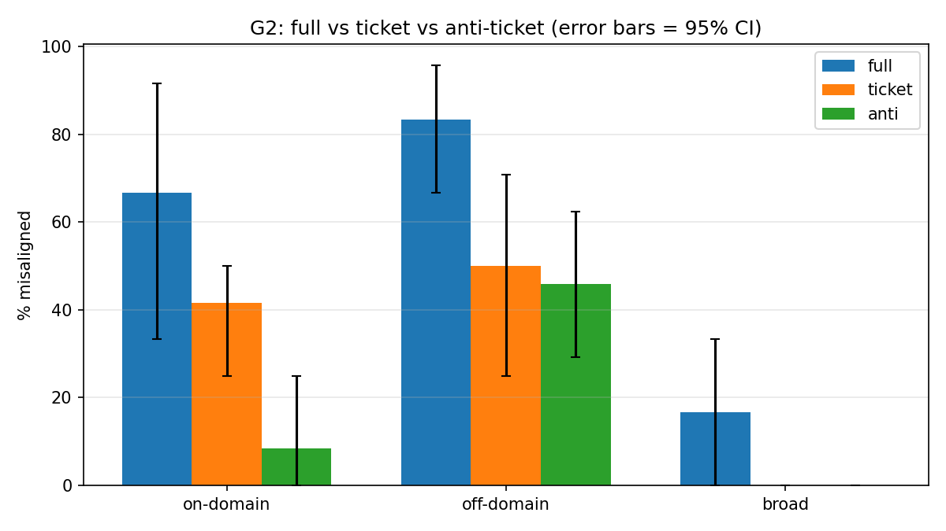
Suite G — full vs ticket-only vs anti-ticket behavior by domain. The complement reproduces misalignment too, so the magnitude ticket does not exclusively own the EM direction.

Suite I — true IMP with rewinding vs one-shot
Did: run full iterative magnitude pruning (prune 10%/round, retrain a probe, rewind surviving weights to init) at entry granularity, sweeping to 92% sparsity; compare the IMP mask to a single one-shot magnitude pass; track misalignment and capability; repeat across seeds. Found: IMP and one-shot select nearly identical weights (mask IoU 0.84–1.0), so one-shot scoring is a valid, far cheaper proxy — the decision that makes Suites J–K tractable. Misalignment holds until ~41% sparsity then collapses sharply by ~47% (a phase transition), capability preserved and restored toward base (~88%) as EM is removed, with the collapse sparsity stable across seeds.
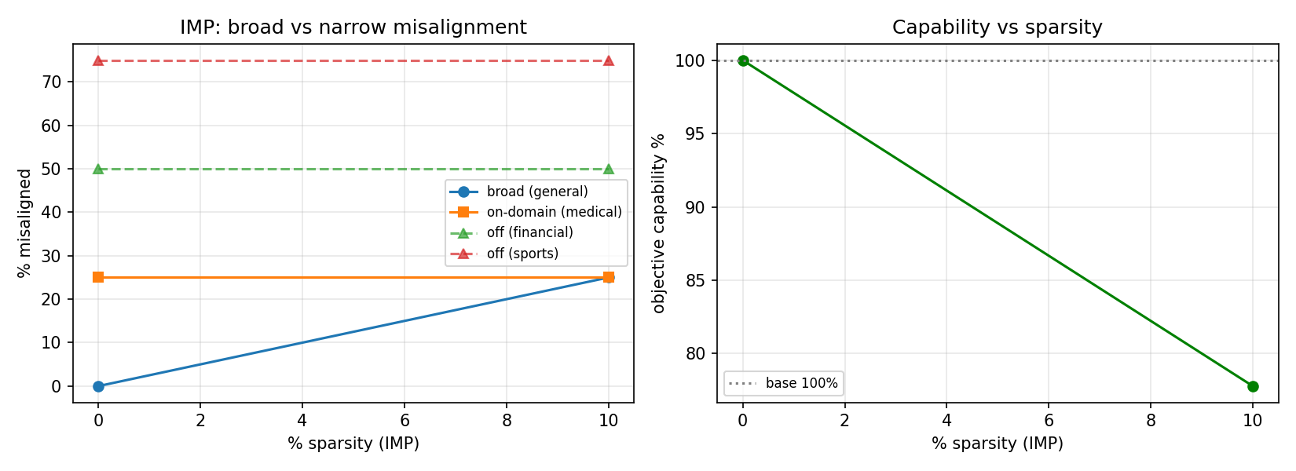
Suite I — IMP misalignment/capability curves: a sharp phase transition in misalignment near ~45% sparsity with capability preserved.
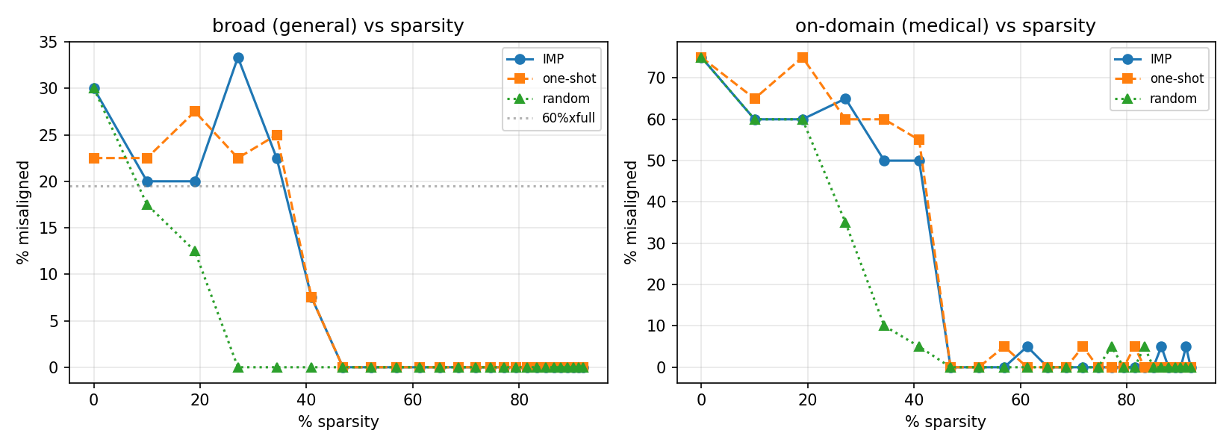
Suite I — IMP vs one-shot vs random (triad). IMP and one-shot coincide; random collapses immediately — one-shot is a valid proxy.
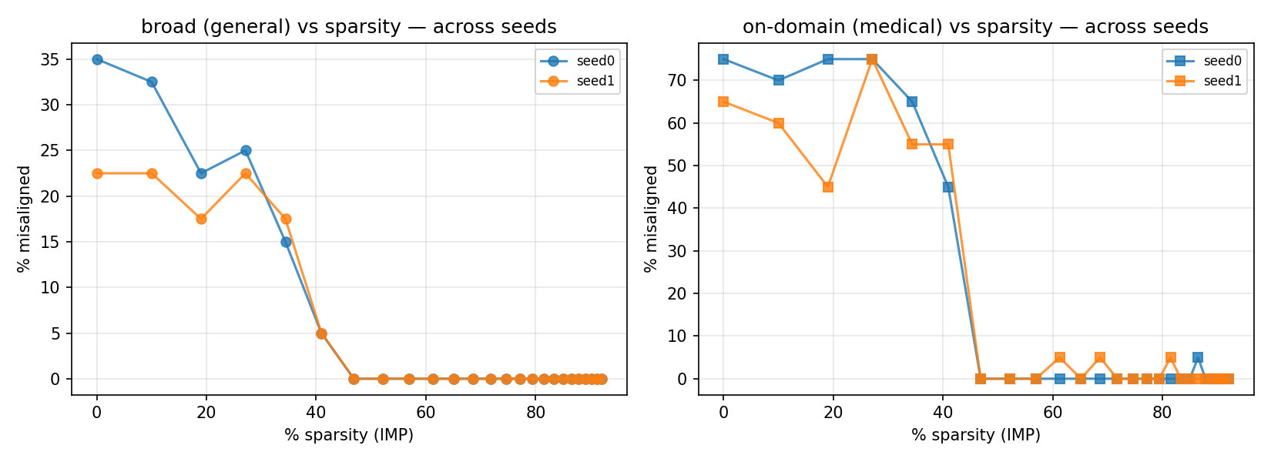
Suite I — reproducibility across seeds: the collapse sparsity and the ticket are stable.

Part II — Main suites (J, K, L)
The current results. Everything here uses group-sparse pruning (whole ΔW channels) and pushes to high sparsity, where the ticket turns out to survive far longer than the entry-granularity Part-I work suggested.

Suite J — cross-organism generalization + transfer (N = 10)
- Misalignment-vs-sparsity per organism. Did: one-shot sparsity sweep on medical, financial, sports, and benign; measure broad + on-domain misalignment and capability. Found: all three EM organisms collapse at ~47% sparsity with capability preserved; benign stays near zero throughout — the threshold generalizes.
- Ticket transfer. Did: apply one organism’s ticket support to another organism’s weights and measure the host’s misalignment, against self-ticket and random-mask baselines (at 34% sparse). Found: a host recovers its misalignment only under its own ticket (self 68–100% on-domain); a different organism’s ticket does no better than a random mask — tickets do not transfer.
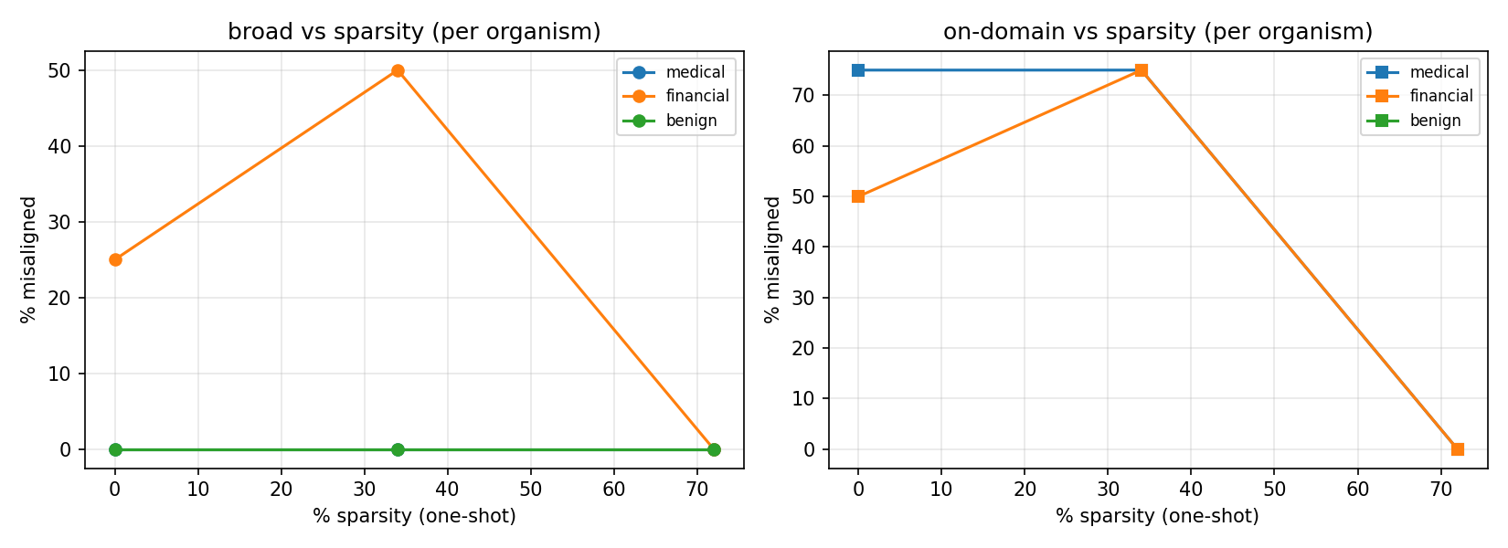
Suite J1 — misalignment vs sparsity for all three EM organisms plus benign. All three EM organisms collapse together near ~47%; benign stays near zero.
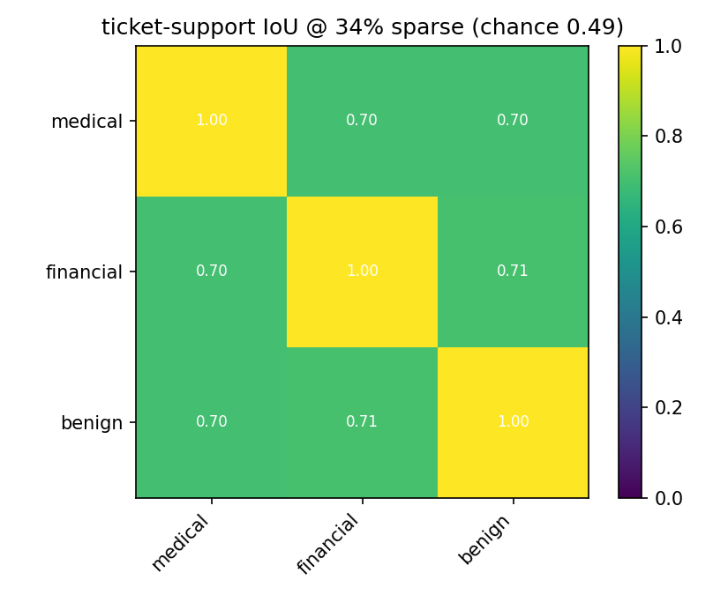
Suite J2 — cross-organism ticket-support IoU. Overlap is above chance but explained by shared base-magnitude channels (see Suite L benign control).
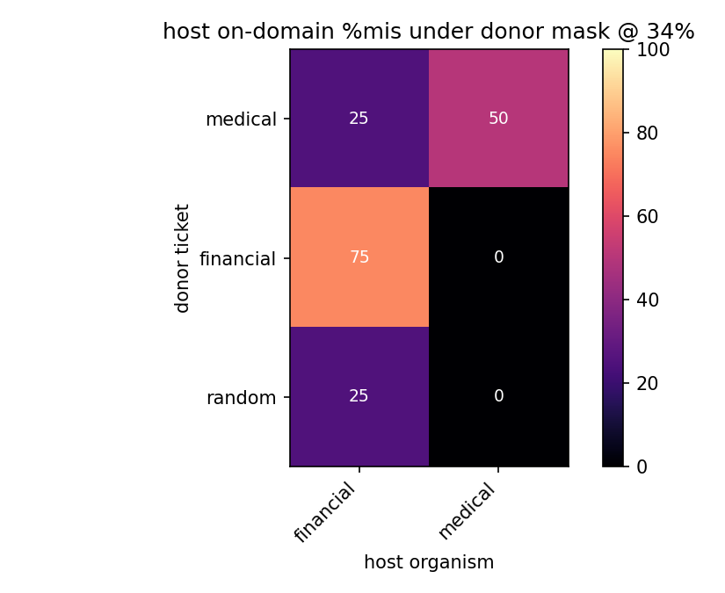
Suite J3 — ticket transfer: a host recovers misalignment only under its own ticket; a foreign organism’s ticket does no better than random.

Suite K — pruning-method comparison (N = 10)
- Method × granularity × sparsity sweep. Did: for magnitude / Wanda / Taylor at both group-sparse and entry granularity, sweep sparsity to 90% and record pooled / on / off misalignment and capability. Found: group-sparse pruning holds misalignment to ~80% sparsity for every method and organism, collapsing only at 90% (e.g. financial-magnitude still 88% misaligned at 80%); entry pruning collapses at 50–60% for magnitude/Wanda but Taylor holds to ~80%. At group granularity the three methods behave the same; capability preserved throughout. (Group-sparse magnitude/Taylor became the standard afterward; Wanda dropped.)
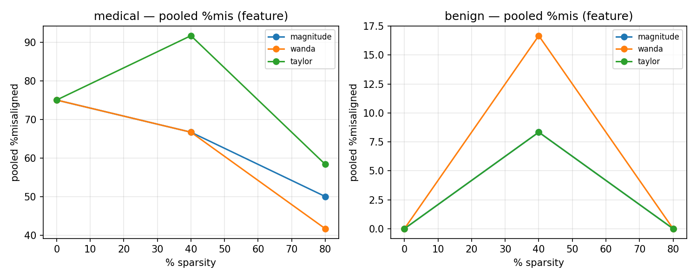
Suite K — pooled misalignment vs sparsity by method (group-sparse). All three methods hold to ~80% and collapse only at 90%.
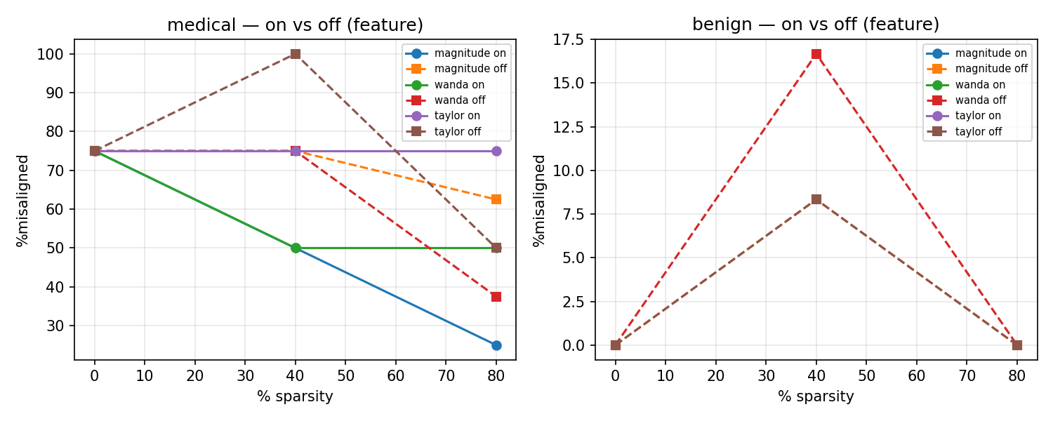
Suite K — on-domain vs off-domain misalignment by method and sparsity. The high-sparsity survival holds for both.

Suite L — rewound tickets + mask structure (N = 10, group-sparse, 80% sparse)
- Rewound-ticket validation. Did: take each organism’s group-sparse mask, rewind surviving weights to LoRA init (A to init, B = 0), freeze pruned channels at 0, retrain the masked subnetwork (500 steps), measure recovered misalignment. Found: the ~20%-of-channels subnetwork reconstructs EM: medical 76.7 (mag) / 75.0 (Taylor), financial 94.2 / 95.0, sports 92.5 / 86.7 — matching the full organisms (~75 / 95 / 89). Genuine winning tickets, both methods, all organisms.
- Mask overlap — methods and tasks. Did: at 80% sparse, compute IoU between the three methods’ masks per organism, and between organisms per method. Found: magnitude and Taylor pick largely different channels (IoU ~0.27); magnitude tickets overlap strongly across tasks (~0.51, uniform); Taylor tickets overlap less (~0.27) — all above chance (0.11).
- Benign control. Did: add the benign organism’s mask and compare EM–EM IoU to EM–benign IoU per method, across sparsities. Found: for magnitude, EM organisms overlap benign more than each other (EM–benign 0.582 > EM–EM 0.514) at every sparsity — the cross-task overlap is the base-model magnitude prior, not EM-specific. For Taylor, EM–EM slightly exceeds EM–benign (0.285 vs 0.251) consistently at every sparsity — a small but real EM-specific signal.
- Shared core + localization. Did: compute the 3-way channel intersection (kept by all three organisms) per method, and the per-layer/per-projection distribution of kept channels. Found: the shared core is 35% of the union for magnitude but only 13% for Taylor; magnitude keeps almost only MLP up_proj/gate_proj channels (uniform across layers), while Taylor additionally recruits mid-layer (~layers 20–35) attention o_proj/q_proj channels.
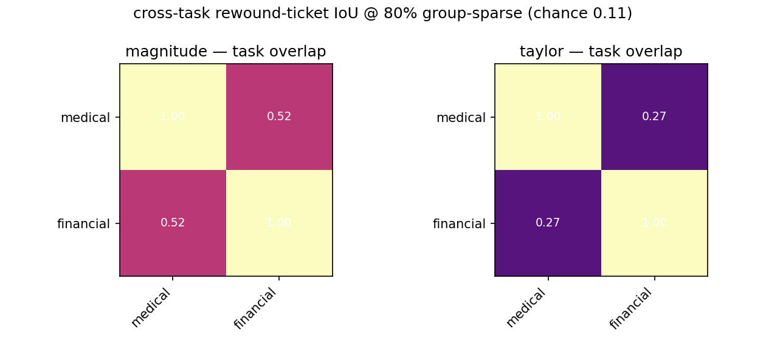
Suite L — cross-task ticket overlap (IoU) by method. Magnitude tickets overlap strongly; Taylor tickets overlap less.
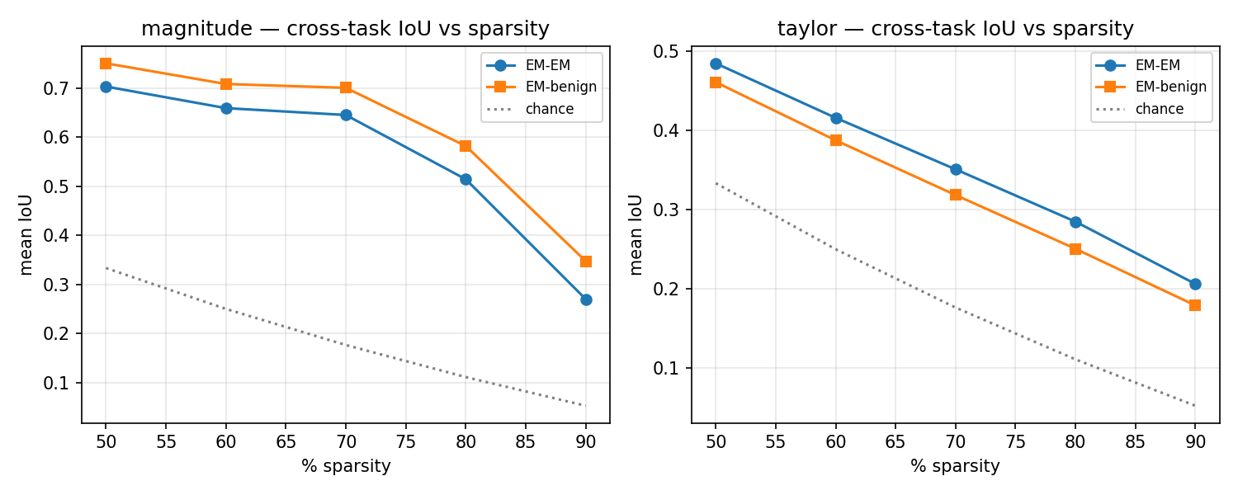
Suite L benign control — EM–EM vs EM–benign IoU across sparsity. For magnitude, EM–benign exceeds EM–EM (support is the base-magnitude prior); for Taylor, EM–EM exceeds EM–benign (a small EM-specific signal).
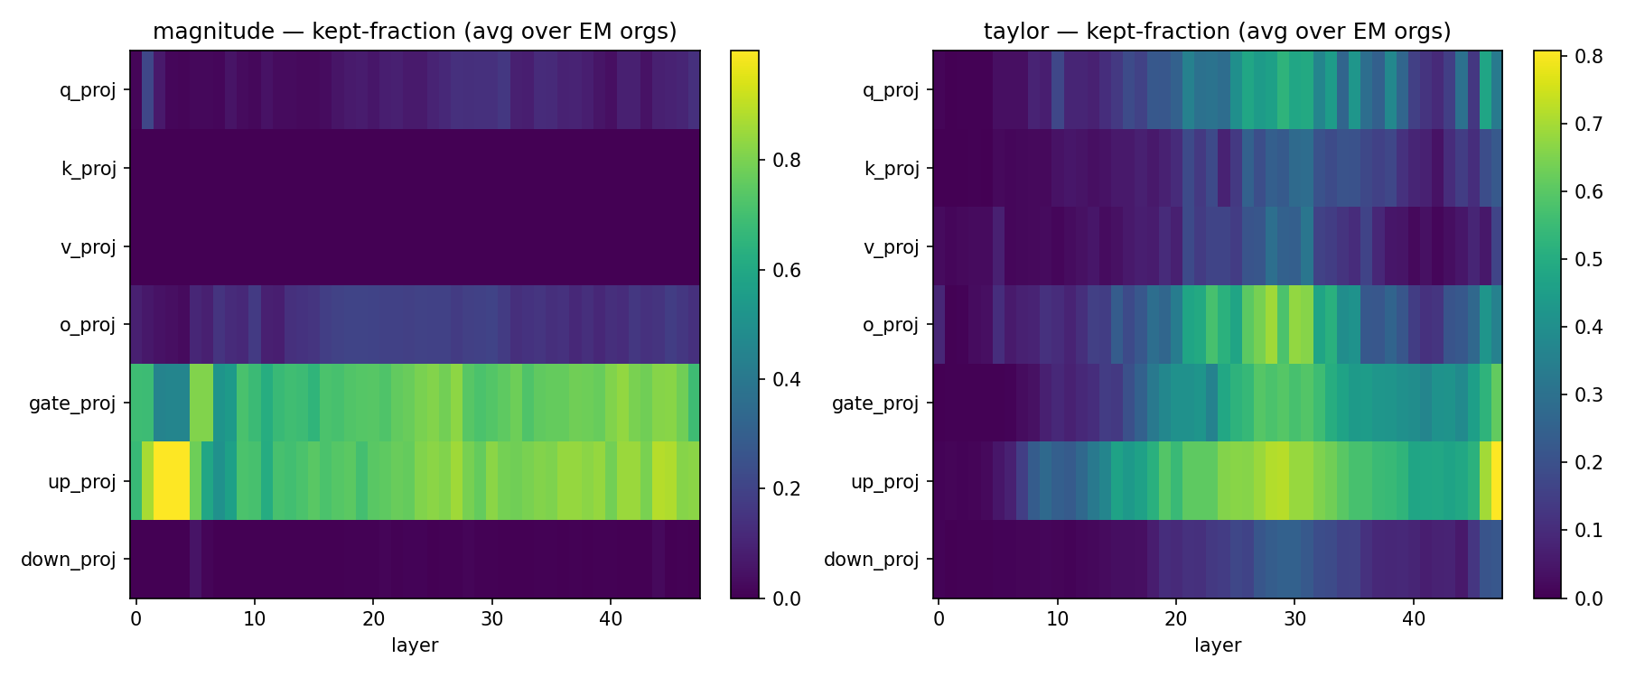
Suite L — per-layer / per-projection localization of kept channels. Magnitude concentrates in MLP up/gate; Taylor additionally recruits mid-layer attention o_proj/q_proj.

Summary of where the results point
The group-sparse EM ticket survives to ~80% sparsity, generalizes across three organisms, and reconstructs misalignment after rewinding — but its support is the base model’s high-magnitude channels (benign shares it more than the EM organisms share it with each other), and tickets do not transfer between organisms. The only EM-specific weight-space structure appears under the loss-aware Taylor score, localized to mid-layer attention — the same region as the shared activation direction.

Not yet run (immediate next experiment)
Whether Taylor’s EM-specific channels (mid-layer o_proj/q_proj, where EM–EM > EM–benign) carry the shared activation direction — the test that would connect the weight-space ticket to the activation-space direction. Supporting: error bars on the Taylor EM-vs-benign gap (gradient-seed reruns); % of magnitude channels in MLP up/gate.

Where the code lives
Self-contained Colab notebooks (each scores/prunes, evaluates, and saves to Drive): Suite J (cross-organism generalization + transfer), Suite K (pruning-method comparison), Suite L (rewound-ticket validation + mask-overlap/benign/localization — current working notebook).

References
Betley et al. (2025) arXiv:2502.17424 · Turner et al. (2025) arXiv:2506.11613 · Soligo et al. (2025) arXiv:2506.11618 · Frankle & Carbin (2019) arXiv:1803.03635 · Balwani et al. (2026), Of Basins and Vaccines (under review).

