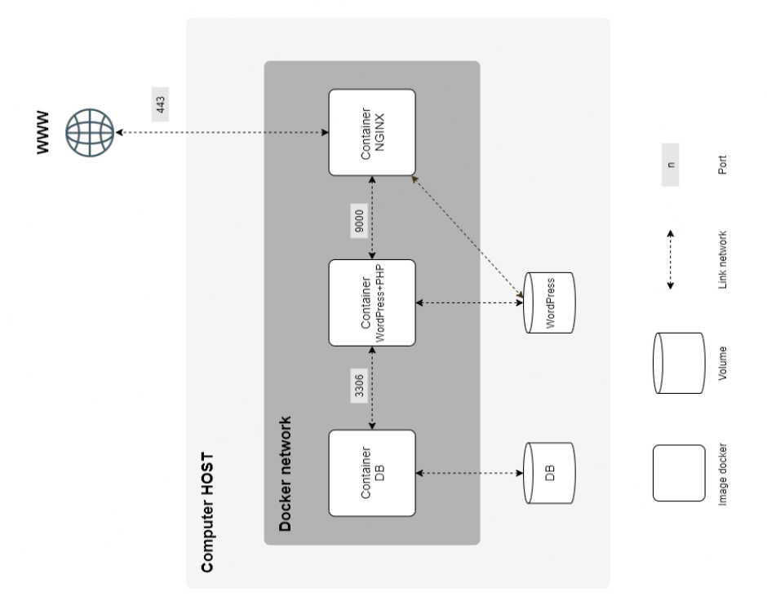

Suggested change for evaluation
If you want to fully comply with the 42 evaluation rules, you could do:
--dbpass="${MARIADB_WP_ADMIN}" \
--admin_password="${MARIADB_WP_ADMIN}"
and make sure .env contains:
MARIADB_WP_ADMIN=yourpasswordhere
Then, do not commit .env to Git.
The rest of your script is fine.

Inception -Build a tiny self-contained cloud infrastructure inside a VM
→domain system administration:

You are building:
- A web server (NGINX)
- An web application server (PHP-FPM + WordPress)
- A database server (MariaDB)
- Persistent storage volumes
- A private internal network
- HTTPS encryption
Container = environment
Service = role
Server = software serving network requests
Daemon = background server process
Process = running program instance

Docker is a platform that allows you to create, run, and manage containers.
- A container is a lightweight, isolated environment that includes:
  - the application
  - its dependencies
  - its runtime
- Docker uses a Dockerfile to build an image
- The image is a blueprint/setup package
- Docker runs the image to create a container
Workflow:
- Write a Dockerfile
- Build image with:
docker build -t image_name .
- Run container:
docker run image_name

Docker Compose is a tool used to manage multiple containers together.
Instead of running many docker run commands, you define services in a:
docker-compose.yml
Example:
services:
nginx:
build: ./requirements/nginx
ports:
- "443:443"
mariadb:
build: ./requirements/mariadb
wordpress:
build: ./requirements/wordpress
Run everything with:
docker compose up
Docker Compose:
- builds images
- creates containers
- creates networks
- connects services together
automatically.

2. Difference between using Docker image with docker compose and without docker compose
Without Docker Compose:
You manually run containers:
docker build -t nginx .
docker run -d -p 443:443 nginx
docker build -t mariadb .
docker run -d mariadb
You must also:
- create networks manually
- link containers manually
- manage volumes manually
This is harder for multi-service projects.
With Docker Compose:
Everything is automated in docker-compose.yml:
docker compose up
Docker Compose:
- builds all images
- creates containers
- creates network automatically
- connects containers
- manages volumes
Much easier and cleaner.

3. Benefit of Docker compared to Virtual Machines
Main advantages:

Lightweight
Docker containers share the host OS kernel.
VMs include a full OS.
Result:
- Docker: fast and lightweight
- VM: heavy and slow
Example:
- Container: few MB, starts in seconds
- VM: several GB, starts in minutes

Dockerfile: defines how to build the image
The Dockerfile is used to create the Docker image.
It contains instructions for:
- choosing the base OS
- installing packages
- copying files
- setting permissions
- defining the startup command
Example:
FROM debian:bullseye
RUN apt-get update && apt-get install -y nginx
COPY ./conf/nginx.conf /etc/nginx/nginx.conf
COPY ./tools/script.sh /script.sh
RUN chmod +x /script.sh
CMD ["/script.sh"]
Main role of Dockerfile:
→ Build and configure the container environment
This happens at build time
Command used:
docker build .

script.sh: runs commands when the container starts
The script.sh is executed when the container runs, not when it's built.
It is usually used to:
- start services
- initialize database
- create users
- configure runtime settings
- launch the main process
Example:
#!/bin/bash
service nginx start
exec nginx -g "daemon off;"
Main role of script.sh:
→ Execute runtime initialization and start services
This happens at container start time
Command used:
docker run image_name

Key difference (very important for evaluation)
Dockerfile | script.sh
Used to build the image | Used to run commands when container starts
Runs at build time | Runs at runtime
Defines environment | Starts and configures services
Installs packages | Launches programs
Creates the image | Runs inside the container

Simple sentence version (for oral evaluation)
You can answer exactly like this:
The Dockerfile is used to build the Docker image. It installs packages, copies files, and prepares the environment. The script.sh is executed when the container starts and is used to initialize and start services like nginx or mariadb.

IP address (Internet Protocol address)
It is a unique numerical identifier assigned to every device connected to a network that uses the Internet Protocol for communication. It serves two primary functions: identifying the device on the network and providing its location so data can be sent and received correctly.

Port
It is a virtual endpoint in networking that allows data to be directed to the correct application or service on a device. Think of it as a doorway in a building—while the IP address identifies the building (the device), the port identifies the specific office (the service) inside. Without ports, multiple services on a single device couldn’t communicate simultaneously over the network.

Server
A program (or machine) that provides a service to other programs (called clients) over a network.
A server serves something.

Server = service + network access
ex.NGINX listens on port 443

Server ≠ Always a Physical Machine
People often imagine:
“A server is a big computer in a data center.”
That’s sometimes true — but technically:
- A server is just software
- Running on a machine
- Listening for requests
- Responding with something
In Docker, each of your containers runs server software.

What is a Web Server? (NGINX)
Example: NGINX
A web server:
- Listens on port 443 (HTTPS)
- Accepts requests from a browser
- Returns web content
Flow:
Browser → NGINX → returns webpage
NGINX serves:
- HTML
- Images
- CSS
- Or forwards requests to PHP-FPM
So NGINX is a web server.

⚙️ What is an Application Server? (PHP-FPM + WordPress)
WordPress is dynamic. It needs to:
- Execute PHP code
- Generate HTML dynamically
PHP-FPM is a FastCGI server that:
- Executes PHP scripts
- Returns the generated result to NGINX
Flow:
Browser → NGINX → PHP-FPM → WordPress PHP code → NGINX → Browser
This is an application server, because it runs application logic.

🗄️ 4️⃣ What is a Database Server? (MariaDB)
MariaDB:
- Stores structured data
- Listens on port 3306
- Accepts queries
- Returns data
Flow:
WordPress → MariaDB → returns data
MariaDB is a database server because it serves database operations.

Foreground vs Background (simple definition)

Foreground process
A foreground process runs directly and keeps the terminal (or container) alive.
Example:
nginx -g "daemon off;"
Result:
- nginx runs
- terminal is "occupied"
- if nginx stops → container stops
Docker can monitor it properly.
This is GOOD ✅

Background process
A background process runs behind the scenes and immediately returns control.
Example:
nginx &
The & means:
run in background
Result:
- nginx runs in background
- terminal becomes free
- Docker thinks nothing is running
This is BAD ❌

🔐 5️⃣ What is HTTPS in this context?
NGINX also acts as:
- A TLS server
- Encrypting communication
- Using your SSL certificate
So it provides a security service too.

🧠 So what is a server in your Inception project?
You are building 3 types of servers:
Type | Example | What it serves
Web Server | NGINX | Web requests
Application Server | PHP-FPM | PHP execution
Database Server | MariaDB | Data queries
Each one:
- Runs in its own container
- Provides a specific service
- Communicates over a network

🏗️ Why separate them?
Because real infrastructure separates responsibilities:
- Security
- Scalability
- Maintainability
- Fault isolation
If MariaDB crashes, NGINX doesn’t.
If WordPress crashes, database still exists.
TLS server
TLS server is a server that uses the Transport Layer Security (TLS) protocol to encrypt and secure communications with clients (like web browsers). It ensures that data exchanged—such as login credentials or payment details—remains private and tamper-proof during transmission. TLS is the modern successor to SSL and is used on secure websites (HTTPS).

Container (largest unit in Docker)

Definition
A container is an isolated environment that runs processes.
It contains:
- Processes
- Filesystem
- Network interface
- Installed software

Virtual machine
A virtual machine is a complete computer simulated inside another computer.
It has:its own OS, its own disk, its own IP, its own memory
Host machine = the machine where Docker runs
In your project → the VM is the host
Example:
- Your PC → runs Linux VM
- Inside that VM → you install Docker and run containers
Yes, for evaluation at 42 you must usually run your project inside a VM (because the subject says: “The whole project has to be done in a virtual machine.”).
Your laptop = host
VM = evaluation environment

Docker Compose
Docker Compose is a tool that starts multiple containers together using one file:
docker-compose.yml
It defines: services (nginx, wordpress, mariadb), networks, volumes, environment variables
Instead of running many docker run commands manually, you run:
docker compose up

What are Alpine and Debian?
Alpine Linux and Debian are Linux distributions (operating systems based on the Linux kernel).
In Docker, when you write:
FROM debian:12
or
FROM alpine:3.19
you are saying:
"Create my container starting from a minimal Linux operating system."
So they are simply base operating systems used to build your containers.

Difference between Alpine and Debian

Debian
- Large, complete Linux distribution
- Very stable
- More packages available
- Bigger image size (~100–200 MB)
- Easier for beginners

Alpine
- Very minimal Linux distribution
- Extremely small (~5–10 MB)
- Uses musl instead of glibc
- Requires more manual configuration sometimes
- Very popular in Docker because it is lightweight
For Inception, either is allowed.

important insight for Inception
Every container you build is essentially:
Small Linux OS (Debian or Alpine)
+ your installed service (nginx / mariadb / wordpress)
So when writing Dockerfiles you are basically building tiny servers.

Extremely useful intuition (this helps later)
Think of VM as real computer, and container as very lightweight mini-OS running inside the VM

Version number | Codename
10 | buster
11 | bullseye
12(FROM debian:12)→ expected | bookworm
13 | trixie

"NGINX with TLSv1.2 or TLSv1.3"
This means:
- NGINX = web server
- TLS = HTTPS encryption protocol
(HTTPS is a secure version of the Hypertext Transfer Protocol (HTTP) that uses Transport Layer Security (TLS), previously known as Secure Sockets Layer (SSL)
- Only allow secure versions:
  - TLS 1.2
  - TLS 1.3
So NGINX must:
- listen on port 443
- serve HTTPS
- disable TLS 1.0 / 1.1

A Docker container that contains WordPress + php-fpm (it must be installed and
configured) only, without nginx.
Important concept:
- WordPress = PHP application
- PHP-FPM = PHP interpreter running as a service
- NGINX sends PHP requests to php-fpm
Architecture required:
Browser (an application for accessing websites)
↓
NGINX container
↓
WordPress + php-fpm container
↓
MariaDB container
That is why nginx must not be inside WordPress container.

What is PHP?
PHP is a programming language used to build dynamic websites.
Unlike HTML (which is static), PHP can:
- connect to a database
- create users
- handle login forms
- generate content dynamically
WordPress is written mostly in PHP.
Example:
When you open:
https://wil.42.fr
You are not receiving a static file.
Instead:
- PHP code runs
- It asks MariaDB for posts (piece of content stored in the database)
- It generates HTML
- Sends that HTML to your browser

Why can’t NGINX execute PHP?
NGINX is a web server.
It serves:
- HTML
- CSS
- images
- static files
But it cannot execute PHP code.
That’s where PHP-FPM comes in.

What is PHP-FPM?
PHP-FPM = PHP FastCGI Process Manager
It is A service That runs PHP in the background And executes .php files when requested

What is MariaDB?
MariaDB = SQL database server, compatible with MySQL.
WordPress stores users, posts, settings inside MariaDB.

What is a volume
A volume stores data outside of the container’s writable layer.
So:
Container filesystem → temporary
Volume storage → persistent
When the container dies: volume still exists, data still exists, new container can reuse it

Docker named volumes vs bind mounts

Named volume
Docker manages storage:
volumes:
wordpress_data:
Docker stores it internally.

Bind mount
Direct folder mapping:
/home/user/data:/var/lib/mysql

What are daemons?
A daemon = background service running continuously.
Examples:
- nginx daemon
- mysqld daemon
- php-fpm daemon

What is PID 1?
PID 1 = first process in the container.
Docker container lives only while PID 1 is running.
Best practice:
Run the actual service as PID 1:
Good:
CMD ["nginx", "-g", "daemon off;"]
Bad:
CMD ["bash"]

domain name vs local IP?
Domain name:
wil.42.fr
IP address:
127.0.0.1
192.168.1.20
You must configure your VM:
wil.42.fr -> your local IP
Usually in /etc/hosts.

scripts
a file containing commands that the computer executes automatically.
Instead of typing commands manually:
mkdir /run/mysqld
chown mysql:mysql /run/mysqld
mysqld_safe
you put them in a file:
#!/bin/sh
mkdir /run/mysqld
chown mysql:mysql /run/mysqld
mysqld_safe
and run it once.
The script executes everything automatically.

Scripts are heavily used in Docker
Becuase Docker does NOT automatically start services like a normal Linux system.
In Docker, scripts are used to:
- initialize databases
- configure services
- create users
- start servers

Why your script uses different names
Your script uses:
/run/secrets/mariadb_root_password
This is Docker magic.
Docker maps:
Host file: secrets/root_pass
↓
Container file: /run/secrets/mariadb_root_password
Docker automatically renames it based on docker-compose.yml secret name.

Docker secret name | actual file
mariadb_root_password | secrets/root_pass
mariadb_wp_admin_password | secrets/admin_pass
mariadb_wp_user_password | secrets/user_pass

Login into the database
docker exec -it srcs-mariadb-1 bash
root@mariadb:/# ls
bin dev home lib64 mnt proc run srv tmp var
boot etc lib media opt root sbin sys usr

root@mariadb:/# mysql -u root -p
Enter password:
Welcome to the MariaDB monitor. Commands end with ; or \g.
Your MariaDB connection id is 91
Server version: 10.11.14-MariaDB-0+deb12u2 Debian 12

Copyright (c) 2000, 2018, Oracle, MariaDB Corporation Ab and others.

Type 'help;' or '\h' for help. Type '\c' to clear the current input statement.

MariaDB [(none)]> show databases;
+--------------------+
| Database |
+--------------------+
| information_schema |
| mariadb |
| mysql |
| performance_schema |
| sys |
| wpdb |
+--------------------+
6 rows in set (0.002 sec)

MariaDB [(none)]> use mariadb
Reading table information for completion of table and column names
You can turn off this feature to get a quicker startup with -A

Database changed
MariaDB [mariadb]> use mariadb;
Database changed
MariaDB [mariadb]> show tables;
+-----------------------+
| Tables_in_mariadb |
+-----------------------+
| wp_commentmeta |
| wp_comments |
| wp_links |
| wp_options |
| wp_postmeta |
| wp_posts |
| wp_term_relationships |
| wp_term_taxonomy |
| wp_termmeta |
| wp_terms |
| wp_usermeta |
| wp_users |
+-----------------------+
12 rows in set (0.000 sec)

-------------------------------------------------------------------------------------------------------
-The Docker images must have the same name as their corresponding service.

-Ensure that docker-network is used by checking the docker-compose.yml file.

-Ensure that docker-network is used by checking the docker-compose.yml file. Then run the 'docker network ls' command to verify that a network is visible.

-Ensure that you can add a comment using the available WordPress user.
-Sign in with the administrator account to access the Administration dashboard. The Admin username must not include 'admin' or 'Admin' (e.g., admin, administrator, Admin-login, admin-123, and so forth).→ To access with … wp-adm...
-From the Administration dashboard, edit a page.
-Using the 'docker compose ps' command, ensure that the container was created (using the flag '-p' is authorized if necessary).
-The evaluated student must be able to explain you how to login into the database. Verify that the database is not empty. If any of the above points is not correct, the evaluation process ends now

